Henry Cooney
CS510 – Computer Vision
Project 1 – Color Transfer

Algorithm Description:

I implemented the color-transfer algorithm from Reinhard, Ashikhmin, Gooch, and Shirley's 2001 paper, Color Transfer between Images. I used a OpenCV and Clojure to accomplish this. Since there is no native Clojure implementation of OpenCV, I wrote Clojure wrappers for OpenCV Java 3.1.0. I used Seesaw (https://github.com/daveray/seesaw) to create a simple GUI. Images were first loaded into OpenCV Mat objects, then transferred into nested Clojure vectors. I then used Incanter (https://github.com/incanter/incanter) to calculate statistics, and transferred the data back into OpenCV Mat objects before saving.

My program supports 4 color type settings for image transfer. It assumes that input images are in RGB format. Images are then converted to LAB, LUV, RGB, or HSV format, processed, and converted back to RGB (conversions are done via OpenCV cvtColor function). LAB transfer gives the most accurate result, but LUV and RGB color transfers are often visually appealing.

All images used to test are available in the resources/ directory. You may find code for this project at https://github.com/hacoo/colortron.

Inputs/Outputs:

Conversion setting: LAB
Source: paper_sunset.jpg
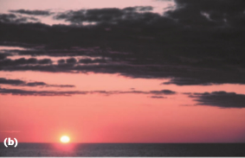

Target: paper_day.jpg
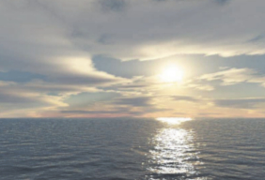

Result (LAB conversion):
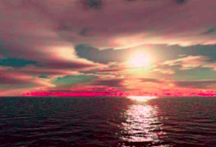

Unfortunately, while I got good results with other images, I did not have good luck with this test image (an obvious red anomaly is visible). I believe this may be due to the low resolution / poor quality of the image, since it was extracted from a .pdf file. The resulting file has the correct statistics (i.e., it has the mean and standard deviations of paper_sunset.jpg).

Other images yield better results:

Source: sunset.jpg
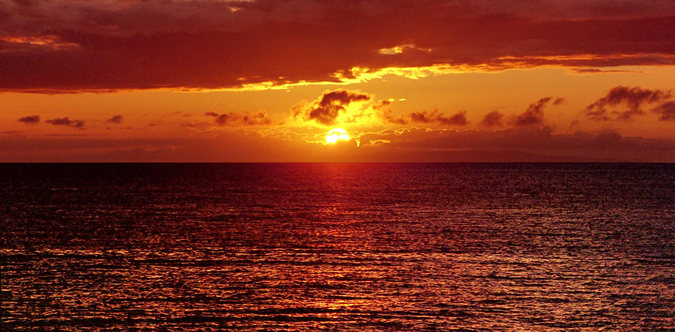

Target: ocean_day.jpg

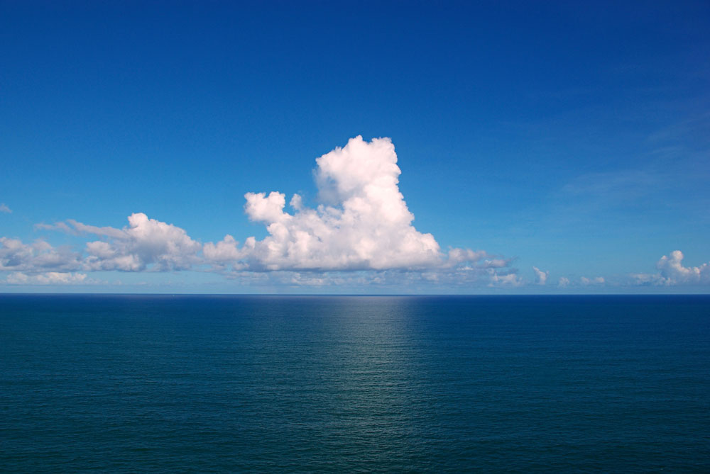

Result (LAB conversion):

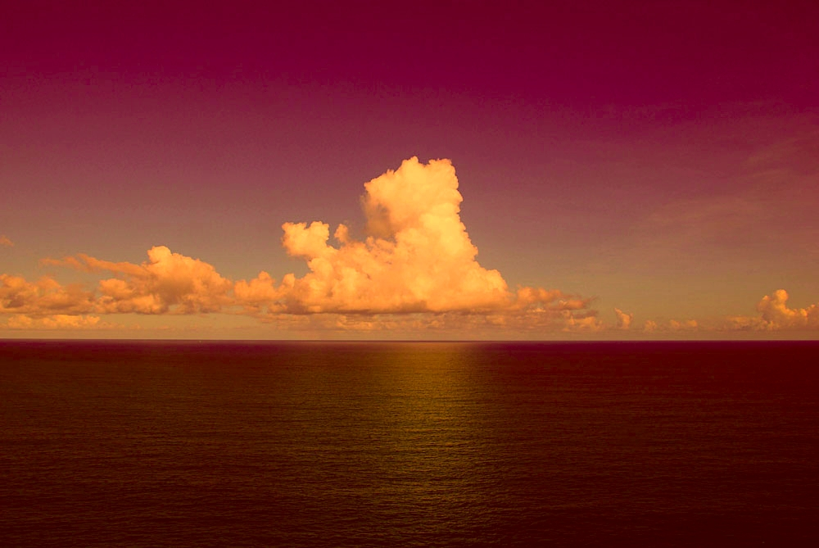
For this image, LUV conversion give and interesting result:

Result (LUV conversion):

