**National College of Computer Studies**

Paknajol, Kathmandu

**Report on Electricity Billing System**

**Using Java language**

**Submitted by: Submitted to:**

Anshu Hada Nischal Shakya

BSc.CSIT 4th Sem

Section: A

**Submission Date:** 24th August 2025

**Contents**

Abstract i

1. Introduction 1

2. Problem Statement 2

3. Objectives 3

4. Diagrams 4-5

5. Screenshot of the Application 6-7

6. Conclusion 8

7. Future Implementation 9

8. References 10

# Abstract

The Electricity Billing System Project is a Java-based application designed to automate the billing process for electricity usage. The system allows users to record, update, and process electricity consumption data for individual customers. The system uses Java’s object-oriented features and database to manage customer records, calculate monthly usage charges, and generate bills. This project aims to simplify and enhance the accuracy of electricity billing while reducing the manual workload for utility companies. This report summarizes the Electricity Billing System, including its architecture, functionalities, implementation details, and potential areas for future improvement.

# 1. Introduction

The Electricity Billing System is a Java-based application developed to automate and streamline the process of electricity bill management. It provides a centralized platform where administrators can manage customer records and generate bills, while customers can securely log in, view their consumption, and pay bills with ease. The system is built using Java Swing for the interface, JDBC for database connectivity, and MySQL for secure data storage and retrieval.

Traditionally, electricity companies relied on manual record-keeping, which is prone to errors, delays, and inefficiencies. This system overcomes those challenges by automating customer management, bill calculation, and payment tracking. Administrators are able to add, update, search, view and delete customer details, as well as generate bills based on units consumed, while customers can access their billing information anytime and make payments conveniently.

With its robust backend logic and user-friendly interface, the system ensures accurate bill generation, reduces duplication, and maintains reliable customer records. Overall, the Electricity Billing System provides an efficient, scalable, and dependable solution that meets the modern needs of electricity providers and their customers.

# 2. Problem Statement

Managing electricity billing manually is slow and often leads to mistakes. Using paper records or spreadsheets makes it hard to keep track of customer details, electricity usage, and bills. As the number of customers grows, errors like wrong bills, lost records, or delays can happen, which can upset customers and affect the service’s reliability.

Without a digital system, finding customer information, checking payment history, or updating rates takes a lot of time. Administrators struggle to create accurate bills on time, and customers may face delays or confusion about their payments.

Therefore, a computerized Electricity Billing System is needed to make billing faster, reduce errors, keep records safe, and make it easier for both administrators and customers to manage electricity usage and payments.

# 3. Objectives

The primary objective of the **Electricity Billing System** is to provide an efficient and reliable solution to the limitations of manual electricity billing. By automating customer records, electricity usage tracking, and bill generation, the system aims to improve accuracy, save time, and enhance customer satisfaction. The system allows both administrators and customers to use it easily through a user-friendly interface, while all data is securely stored in a centralized database.

**Objectives:**

1. **Automate Customer Records** – Allow administrators to add, update, and delete customer information easily without relying on paper records.
2. **Efficient Bill Generation** – Automatically calculate electricity usage charges and generate bills quickly and accurately.
3. **Centralized Data Management** – Store all customer and billing information in a structured database for easy access and accurate records.
4. **User-Friendly Interface** – Provide an easy-to-use interface for smooth interaction between the system and its users.
5. **Reduce Errors** – Minimize mistakes by automating calculations, record-keeping, and bill generation.

# 4. Diagrams

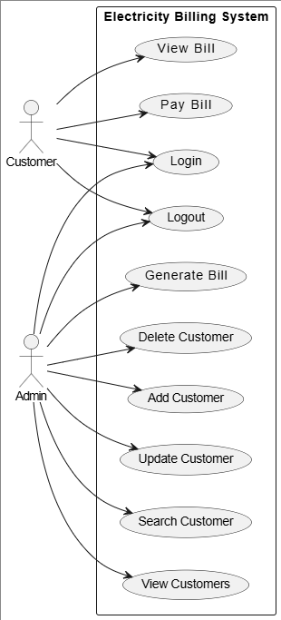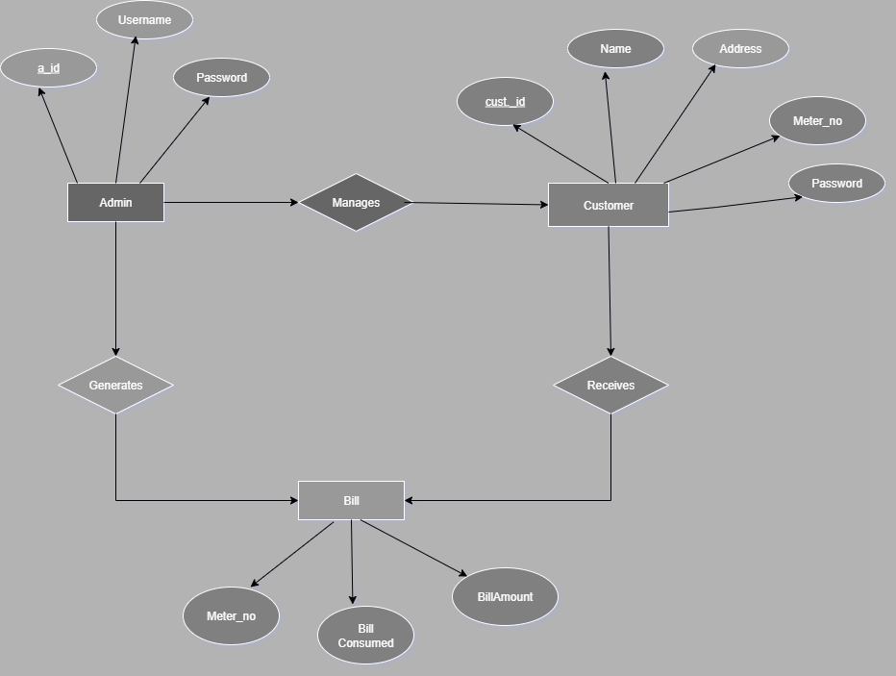

Fig: Use Case Diagram of Electricity Billing System

Fig: ER diagram of Electricity Billing System

# 5. Screenshot of the Application

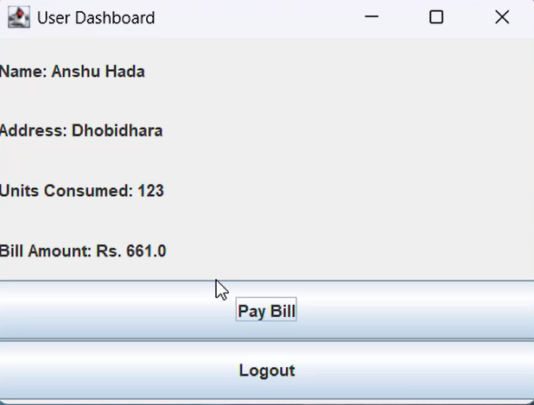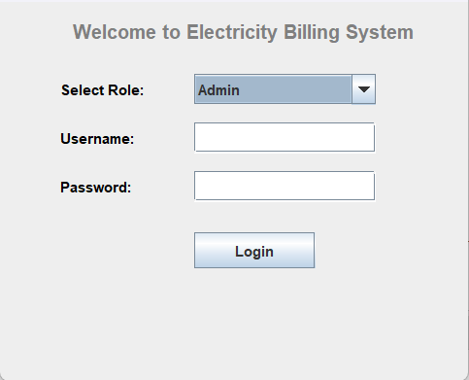

Fig: User Dashboard

Fig: Main Menu

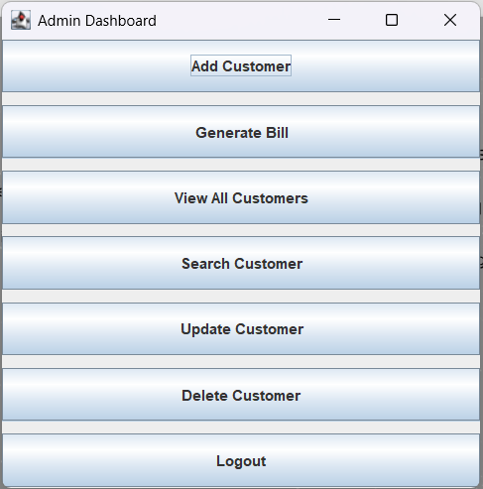

Fig: Admin Dashboard

# 6. Conclusion

The **Electricity Billing System** provides an efficient digital solution to replace the traditional manual billing process. By automating customer management, meter tracking, and bill generation, the system ensures accurate calculations and reduces the chances of errors. Administrators can easily manage customer information, generate and update bills, and track billing history, while customers can conveniently access their bills and make payments through a straightforward interface.

This system enhances operational efficiency, saves time, and improves customer satisfaction by streamlining the billing process. Its design also allows for future enhancements, such as integration with online payment systems, automated notifications, and mobile accessibility.

Overall, the **Electricity Billing System** offers a reliable, scalable, and user-friendly platform that meets the needs of electricity service providers and their customers.

# 7. Future Implementation

To further improve the Electricity Billing System, the following enhancements can be implemented:

* **Graphical User Interface (GUI):** A GUI will make the system more user-friendly and intuitive.
* **Database Integration:** Using a database like MySQL or SQLite will improve data storage, retrieval, and scalability.
* **Advanced Billing Features:** Features such as peak-hour pricing, payment reminders, and early payment discounts can be added.
* **Security:** Adding user authentication and encrypting sensitive customer data will enhance system security.
* **Online Payment & Mobile Support:** Enable online bill payments and provide a mobile app for convenient access.
* **Analytics & Smart Meter Integration:** Include usage reports and connect with smart meters for real-time billing.

# 8. References

1. Javatpoint - Electricity Billing System in Java: https://www.javatpoint.com/electricity-billing-system-in-java
2. Java Programming Blog: <https://javaprogrammingblog.com>
3. StackOverflow Discussions on Billing Systems: <https://stackoverflow.com/questions/tagged/billing>