Lab 1:

1. Write SQL code to create table Student.
2. Write SQL code to create Employee table having attributes Eid, Ename, Eaddress, Ephone, Ecity, Eage and Esalary.
3. Insert 15 records on Employee table.
4. Display records from table using ‘WHERE’ clause.

SQL Queries:

1. To create a table student:

CREATE DATABASE STD;

USE STD;

CREATE TABLE student(

SID INT(3) PRIMARY KEY,

f_name VARCHAR(20),

l_name VARCHAR(20),

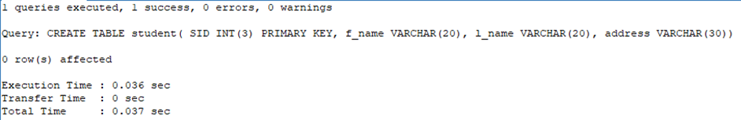address VARCHAR(30));

1. To create a table employee:

CREATE DATABASE Employeee

USE Employeee

CREATE TABLE Employeee(

e_id INT(3) PRIMARY KEY,

f_name VARCHAR(15),

l_name VARCHAR(15),

current_address VARCHAR(15),

age INT(3),

phone_no NUMERIC,

permanent_address VARCHAR(15),

esalary NUMERIC );

1. Inserting values in Employee Table:

INSERT INTO Employeee VALUES

(1,"Barsha","Pandey","MangalBazzar",23, 9877421454,"Lamjung",500000),

(2,"Kamana","Shrestha","Ghatekullo",20, 9849887765,"Chitwan",7000),

(3,"Krisma","Maharjan","Jarankhu",21, 9849128542,"Kathmandu",30000),

(4,"Manila","Aryal","Shivapuri",31, 9849448770,"Syanja",200000),

(5,"Shrisa","Tuladhar","Sorakhutee",28, 9854663672,"Kathmandu",9000),

(6,"Abhilekh","Subedi","Nagpokhari",25, 9877429874,"Pokhara",51000),

(7,"Alisha","Pandey","Chettrapati",27, 9877654324,"Kathmandu",900),

(8,"Anshu","Hada","Dhobidhara",20, 9849843265,"Kathmandu",500),

(9,"Anush","Shrestha","Maharajgunj",25, 9890087765,"Jhapa",27000),

(10,"Ashlesha","Shrestha","Swayambhu",20, 9849887765,"Kathmandu",18000),

(11,"Diya","Gartaula","Kalimati",26, 9845687765,"Lalitpur",29000),

(12,"Gaurav","Thapa","kapan",19, 9849809875,"Bhaktapur",37000),

(13,"Hrikesh","Aran","Dhobichaur",18, 9809887765,"Sindhupalchowk",87000),

(14,"Sudip","Khadka","Sorakhutte",19, 9765487765,"Gorkha",10000),

(15,"Ayush","Tuladhar","Gwarko",20, 9849812345,"Latitpur",17000);

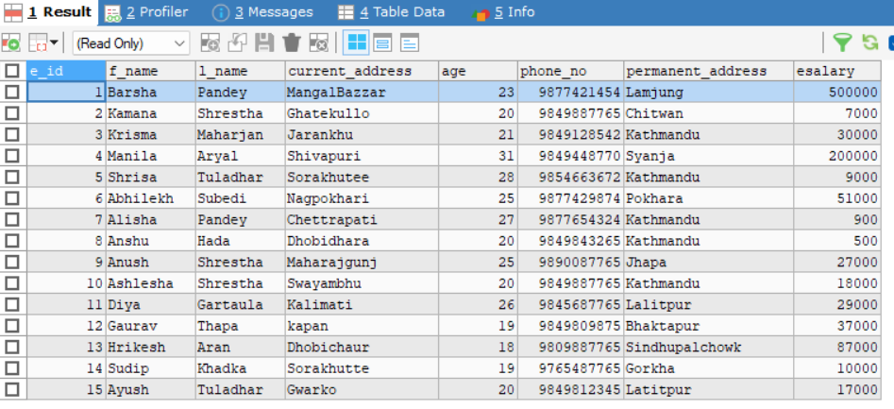Select * from Employee

1. Using WHERE clause:

Select * from Employeee

where permanent_address = "Kathmandu";

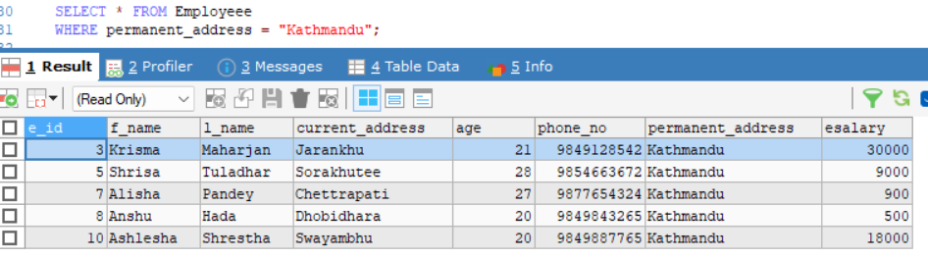

SELECT * FROM Employeee

WHERE age > 25;

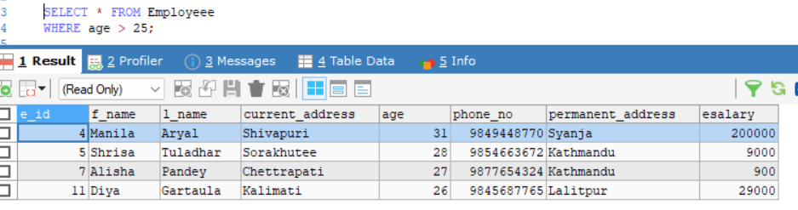

SELECT * FROM Employeee

WHERE esalary <= 10000;

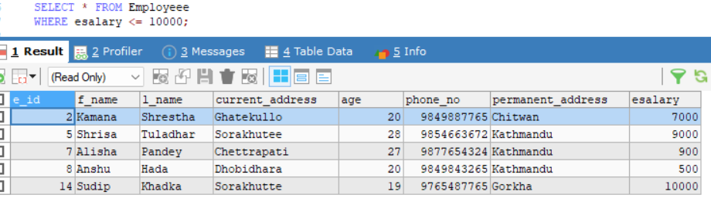

SELECT * FROM Employeee

WHERE f_name LIKE 'A%';

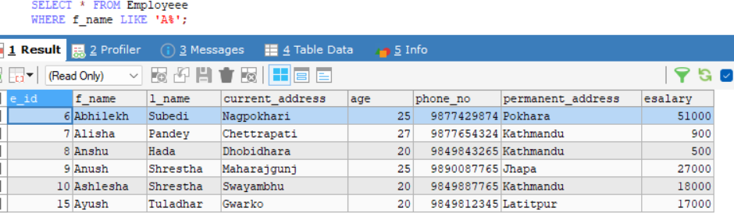

Lab 2:

1. Create table employee with attributes Empid, Empname, Empaddress, Empphone, Emppost, Empsalary, Empage and insert 10 records.
2. Find the employee records whose salary is greater than 30k.
3. Find the employee records whose salary is less than 25k and address is ‘Dharan’.
4. Find the employee records using IN/NOT IN operator.
5. Find the Empid, Empname, Empsalary and Emppost from table who is ‘Manager’.

SQL queries:

1. Create Employee Table:

CREATE DATABASE Ansu

USE ansu

CREATE TABLE EMPLOYEE

(eid INT(3),

ename VARCHAR(20),

eaddress VARCHAR(20),

ephone NUMERIC(10),

ecity VARCHAR(20),

eage INT(3),

esalary INT(8),

epost VARCHAR(30)

);

Insert 10 records:

INSERT INTO EMPLOYEE VALUES

(1, 'Anshu Hada', 'Dhobidhara', 9812345601, 'Kathmandu', 22, 100000,'CEO'),

(2, 'Barsha Pandey', 'Dillibazar', 9812345602, 'Lalitpur', 25, 20000,'Manager'),

(3, 'Gaurav Thapa', 'Baneshwor', 9812345603, 'Bhaktapur', 30, 40000,'Cashier'),

(4, 'Manila Aryal', 'Kalanki', 9812345604, 'Pokhara', 28, 10000,'Sales Associate'),

(5, 'Kamana Shrestha', 'Putalisadak', 9812345605, 'Dharan', 27,20000,'Security Guard'),

(6, 'ShrishaTuladhar', 'Kirtipur', 9812345606, 'Itahari', 24, 910000,'Cleaning staff'),

(7, 'Krisma Maharjan', 'Gausala', 9812345607, 'Dharan', 31, 40000,'Project Manager'),

(8, 'Sudip Khadka', 'Maitidevi', 9812345608, 'Hetauda', 29,10000,'Front desk coordinator'),

(9, 'Ayush Tuladhar', 'Balkot', 9812345609, 'Nepalgunj', 26, 20000,'Clerk'),

(10, 'Sangam Adhikari', 'Sankhamul', 9812345610, 'Butwal', 23, 30000,'Security Guard');

SELECT * FROM Employee

1. 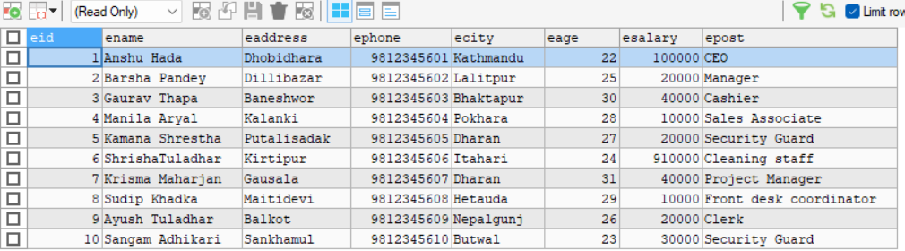Employee whose salary is greater than 30k:

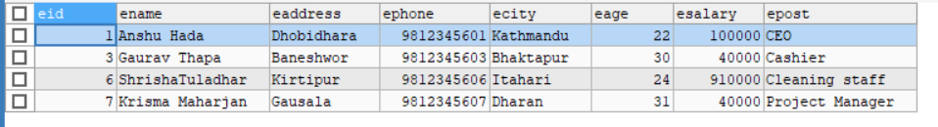SELECT * FROM EMPLOYEE WHERE esalary >30000;

1. Employee whose salary is less than 25k and address is ‘Dharan’:

SELECT * FROM EMPLOYEE WHERE esalary <25000 AND ecity = 'Dharan';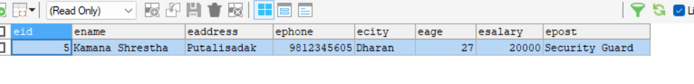

4) Employee records using IN/NOT IN operator:

SELECT * FROM EMPLOYEE

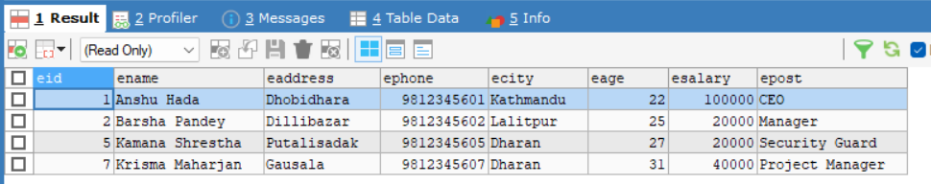WHERE ecity IN ('Dharan', 'Kathmandu', 'Lalitpur');

SELECT * FROM EMPLOYEE

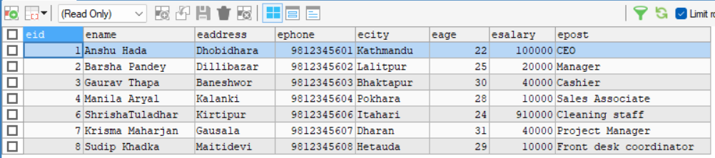WHERE epost NOT IN ('Clerk', 'Security Guard');

5) Empid, Empname, Empsalary and Emppost from table who is ‘Manager’:

SELECT eid, ename, esalary, epost FROM EMPLOYEE

WHERE epost = 'Manager';

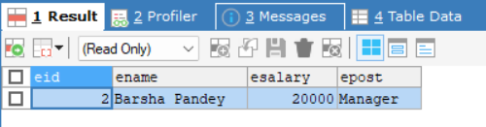

Lab 3:

1. Create table student on SQL
2. Add one column on existing table.
3. Delete column from existing table.
4. Change datatypes of existing columns.
5. Display student records who read in grade 12 and have marks above 90.

SQL Queries:

1. Create Table Student and Insert Values in it:

CREATE DATABASE STD

USE STD

CREATE TABLE student(

s_id INT(3) PRIMARY KEY,

s_name VARCHAR(30),

s_address VARCHAR(20),

s_age INT(3),

s_class INT (2),

s_marks NUMERIC);

INSERT INTO student VALUES

(1,"Anshu Hada","Dhobhidhara",14,12,99),

(2,"Manila Aryal","Balaju",16,12,56),

(3,"Kamana Shrestha","Chitwan",15,12,96),

(4,"Shrisa Ghale","Sorakhutee",17,12,14),

(5,"Barsha Shrestha","Ghattekulo",16,12,45),

(6,"Krisma Maharjan","Jarankhu",17,12,16);

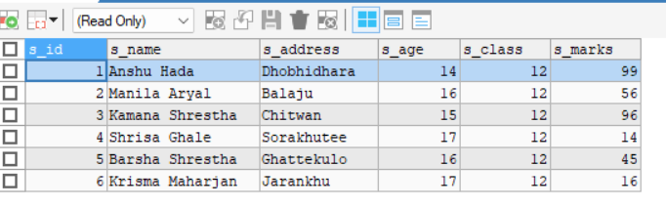 SELECT * FROM student

1. Add one column on existing table:

ALTER TABLE student ADD section VARCHAR(2);

UPDATE student SET section = 'A' WHERE s_id IN (1, 2);

UPDATE student SET section = 'B' WHERE s_id IN (3, 4);

UPDATE student SET section = 'C' WHERE s_id IN (5, 6);

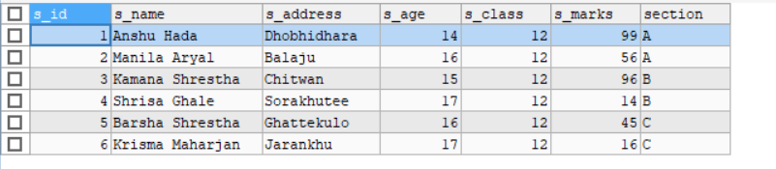SELECT * FROM student

1. Delete column from existing table:

ALTER TABLE student DROP s_address;

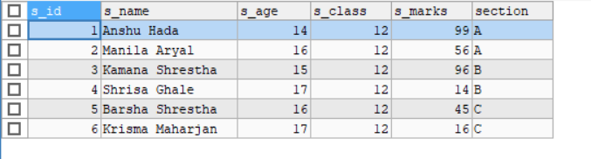SELECT * FROM student

1. Change datatypes of existing columns:

ALTER TABLE student MODIFY s_id VARCHAR(2);

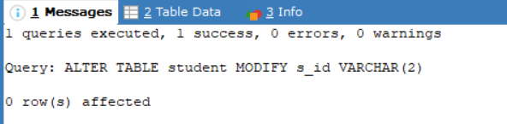SELECT * FROM student

1. Display student records who read in grade 12 and have marks above 90:

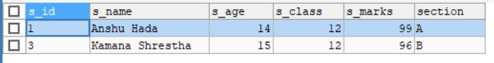SELECT * FROM STUDENT WHERE s_class=12 AND s_marks>90;

Lab 4:

1. Write SQL code to update data whose id is 1.
2. Write SQL code to change address into “London” whose name is “Dilip”.
3. Write SQL code to modify name whose id is 7.
4. Write SQL code to display records from Student table using aggregation function (SUM, MIN, MAX, AVG,COUNT).

SQL Queries:

1. Create Student table and Insert value into it:

CREATE DATABASE AAA

USE AAA

CREATE TABLE student(

s_id INT(3) PRIMARY KEY,

s_name VARCHAR(30),

s_address VARCHAR(20),

s_age INT(3),

s_class INT (2),

s_marks NUMERIC);

INSERT INTO student VALUES

(1,"Anshu Hada","Dhobhidhara",14,12,99),

(2,"Manila Aryal","Balaju",16,12,56),

(3,"Kamana Shrestha","Chitwan",15,12,96),

(4,"Shrisa Ghale","Sorakhutee",17,12,14),

(5,"Barsha Shrestha","Ghattekulo",16,12,45),

(6,"Krisma Maharjan","Jarankhu",17,12,16),

(7,"Sudip Khadka","Anamnagar",18,12,78),

(8,"Dilip Maharjan","Ason",19 ,12,16);

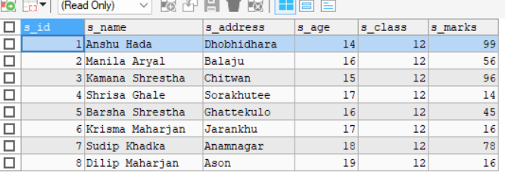 SELECT * FROM student

1. Update data whose id is 1:

UPDATE student SET s_age=15

WHERE s_id =1;

SELECT * FROM student

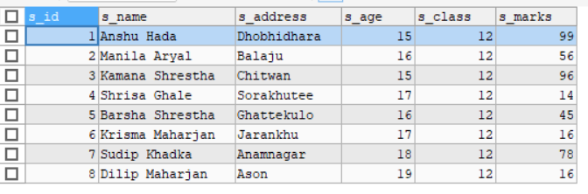

1. Change address into “London” whose name is “Dilip”:

UPDATE student SET s_address="London"

WHERE s_name="Dilip Maharjan";

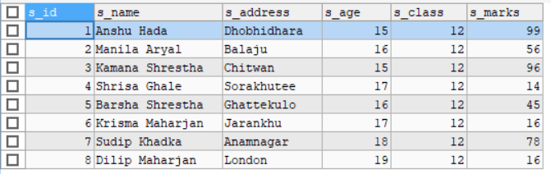SELECT * FROM student

1. Modify name whose id is 7:

UPDATE student

SET s_name = 'Sushila Khadka'

WHERE s_id = 7;

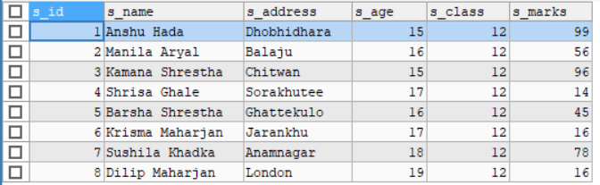SELECT * FROM student

1. Display records from Student table using aggregation function :

SELECT

SUM(s_marks) AS total_marks,

MIN(s_marks) AS min_marks,

MAX(s_marks) AS max_marks,

AVG(s_marks) AS avg_marks,

COUNT(*) AS total_students

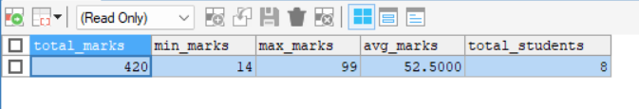FROM student;