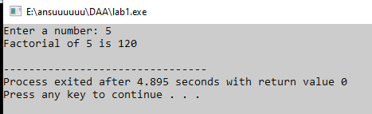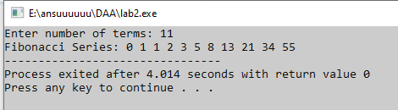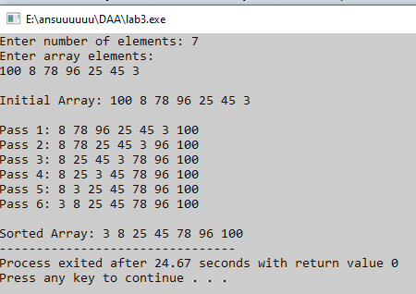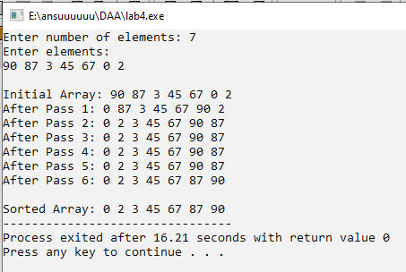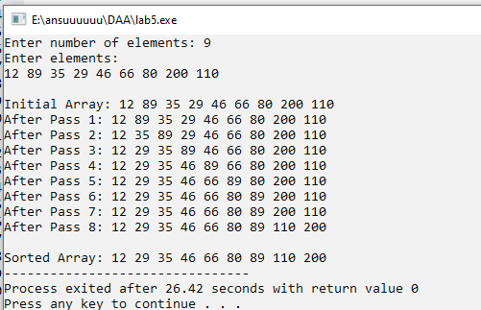

Lab 4
// selection sort
#include <stdio.h>

int main()
{
int a[10], n, i, j, min, temp;

printf("Enter number of elements: ");
scanf("%d", &n);

printf("Enter elements:\n");
for(i = 0; i < n; i++)
scanf("%d", &a[i]);

printf("\nInitial Array: ");
for(i = 0; i < n; i++)
printf("%d ", a[i]);

// Selection Sort with tracing
for(i = 0; i < n - 1; i++)
{
min = i;

for(j = i + 1; j < n; j++)
{
if(a[j] < a[min])
min = j;
}

// Swap
temp = a[i];
a[i] = a[min];
a[min] = temp;

// Tracing step
printf("\nAfter Pass %d: ", i + 1);
for(j = 0; j < n; j++)
printf("%d ", a[j]);
}

printf("\n\nSorted Array: ");
for(i = 0; i < n; i++)
printf("%d ", a[i]);

return 0;
}
Lab5
//insertion sort
#include <stdio.h>

int main()
{
int a[10], n, i, j, key;

printf("Enter number of elements: ");
scanf("%d", &n);

printf("Enter elements:\n");
for(i = 0; i < n; i++)
scanf("%d", &a[i]);

printf("\nInitial Array: ");
for(i = 0; i < n; i++)
printf("%d ", a[i]);

// Insertion Sort with tracing
for(i = 1; i < n; i++)
{
key = a[i];
j = i - 1;

while(j >= 0 && a[j] > key)
{
a[j + 1] = a[j];
j--;
}

a[j + 1] = key;

// Tracing step
printf("\nAfter Pass %d: ", i);
for(j = 0; j < n; j++)
printf("%d ", a[j]);
}

printf("\n\nSorted Array: ");
for(i = 0; i < n; i++)
printf("%d ", a[i]);

return 0;
}
Lab1
//factorial
#include <iostream>
using namespace std;

int main() {
int n;
long long factorial = 1;

cout << "Enter a number: ";
cin >> n;

for (int i = 1; i <= n; i++) {
factorial *= i;
}

cout << "Factorial of " << n << " is " << factorial << endl;

return 0;
}
Lab 2
// fibonnaci
#include <iostream>
using namespace std;

int main() {
int n;
int a = 0, b = 1, c;

cout << "Enter number of terms: ";
cin >> n;

cout << "Fibonacci Series: ";

for (int i = 1; i <= n; i++) {
if (i == 1) {
cout << a << " ";
} else if (i == 2) {
cout << b << " ";
} else {
c = a + b;
cout << c << " ";
a = b;
b = c;
}
}

return 0;
}
Lab3
//wap to sort array usin bubble ssort and analyz it
#include <iostream>
using namespace std;

int main() {
int n;
int arr[50];

cout << "Enter number of elements: ";
cin >> n;

cout << "Enter array elements:\n";
for (int i = 0; i < n; i++) {
cin >> arr[i];
}

cout << "\nInitial Array: ";
for (int i = 0; i < n; i++) {
cout << arr[i] << " ";
}
cout << endl;

// Bubble Sort with tracing
for (int pass = 1; pass <= n - 1; pass++) {
cout << "\nPass " << pass << ": ";

for (int i = 0; i < n - pass; i++) {
if (arr[i] > arr[i + 1]) {
// swap
int temp = arr[i];
arr[i] = arr[i + 1];
arr[i + 1] = temp;
}
}

// Print array after each pass
for (int i = 0; i < n; i++) {
cout << arr[i] << " ";
}
}

cout << "\n\nSorted Array: ";
for (int i = 0; i < n; i++) {
cout << arr[i] << " ";
}

return 0;
}

