PRD — Cross-Team PR Review Dashboard MVP
Product name: PR Review Hub
Status: Draft (Updated)
Version: MVP v1.0

1. Overview

Problem
Teams working across multiple GitLab repositories and teams currently share Merge Request (MR/PR) links manually through private messages. This creates several problems:
- PRs can get lost in messages.
- Other teams and reviewers do not have a central view of requested reviews.
- It is difficult to track the status of cross-team reviews.
- Team members may not know what a PR is about without opening the GitLab link.
- There is no centralized view of who requested a review, who is assigned as a reviewer, and which teams are involved.

Solution
PR Review Hub is a shared dashboard for managing and tracking cross-team Merge Request review requests. The system integrates with GitLab and organizes review tasks into two primary views:
- My PRs: Merge Requests created by the current user.
- Assigned to Me: Merge Requests where the current user is assigned as a reviewer (either automatically imported from GitLab or created manually in the dashboard).

2. Goals

Primary Goals
- Create a centralized place for cross-team PR review requests.
- Provide dedicated workspace tabs for PR authors ("My PRs") and assigned reviewers ("Assigned to Me").
- Reduce sharing PR links manually through chat.
- Automatically retrieve basic PR information from GitLab for both authored MRs and assigned review MRs.
- Allow manual creation or assignment of review tasks directly from the dashboard.
- Track review tasks and their statuses across teams.

3. Users

PR Author
A developer who created a Merge Request and needs a review from another team or developer.
- Main Actions: Connect GitLab, create a PR review task from their authored MRs, add context/teams, and track status under the "My PRs" tab.

Reviewer
A developer or team member responsible for reviewing PRs.
- Main Actions: View MRs assigned to them under the "Assigned to Me" tab, create or claim review tasks manually if needed, open MRs in GitLab, and update review task statuses.

Team Lead / Manager
A user who needs visibility into review activity across teams.
- Main Actions: View all review tasks, filter by team/status/priority, monitor blocked or delayed tasks.

4. Navigation & Layout (2 Pages / Tabs)
The core dashboard is split into two main tabs/pages:

Page / Tab 1: "My PRs"
- Focus: Displays all active PR review tasks created by or authored by the logged-in user.
- Data Sources:
- Automatically imported open MRs where author = current_user.
- PR review tasks created manually where the user is set as the author.
- Primary Actions: + Create PR Task, edit task details, track review status.

Page / Tab 2: "Assigned to Me"
- Focus: Displays all active PR review tasks where the logged-in user is explicitly designated as a reviewer.
- Data Sources:
- GitLab Auto-Fetch: Open MRs fetched directly from GitLab where reviewer = current_user.
- Dashboard Assignment / Manual Creation: Tasks where a user manually selected the current user as a reviewer during task creation or updated an existing task to assign them as a reviewer.
- Primary Actions: Filter assigned PRs, open MR in GitLab, change task review status (In Review, Approved, Changes Requested).

5. Functional Requirements

5.1 Authentication & GitLab Connection
- Users must authenticate with PR Review Hub using GitLab OAuth.
- The system retrieves the logged-in user's GitLab ID and permissions.

5.2 Creating & Managing Tasks
- Entry Point: Create PR Task button available on "My PRs"tab.
- When creating a task, the system allows the user to:
- Select a Repository: Load and search accessible repositories.
- Select a Merge Request: Load the user PRs.
- Assign Reviewers:
- Automatically import existing reviewers from GitLab.
- Allow manual addition/removal of reviewers within the dashboard UI.

5.3 Data Import (GitLab)
When an MR is selected or imported, the following fields are retrieved:
Field | Source | Description
PR Link | GitLab | Direct URL to open PR in GitLab
Title | GitLab | MR Title
Author | GitLab | Creator of the MR
Reviewers | GitLab / Dashboard | List of assigned reviewers
Repository | GitLab | Repository name/path
MR IID / State | GitLab | MR ID and state (opened, closed, merged)

5.4 Manual Fields
Users can add or override additional context for any task:
- Description: Free-text explaining context or what needs review.
- Assigned Reviewers (Manual): Ability to search dashboard users and assign them as reviewers manually.
- Priority: Low, Normal, High, Critical (Default: Normal).

5.5 Task Statuses
Tasks maintain an internal status independent of (but complementary to) GitLab:
Status | Visual Indicator | Description
Waiting for Review |  Yellow | Task created, awaiting assigned reviewer to begin.
In Review |  Blue | Reviewer has actively started reviewing.
Changes Requested |  Red | Reviewer requested changes from the author.
Approved |  Green | Review is complete and approved.
Closed |  Gray | Review task is completed or no longer active.

6. API Requirements
GitLab External APIs:
- Get Authored repos.
- Get user PRs.
- Get PR Details.

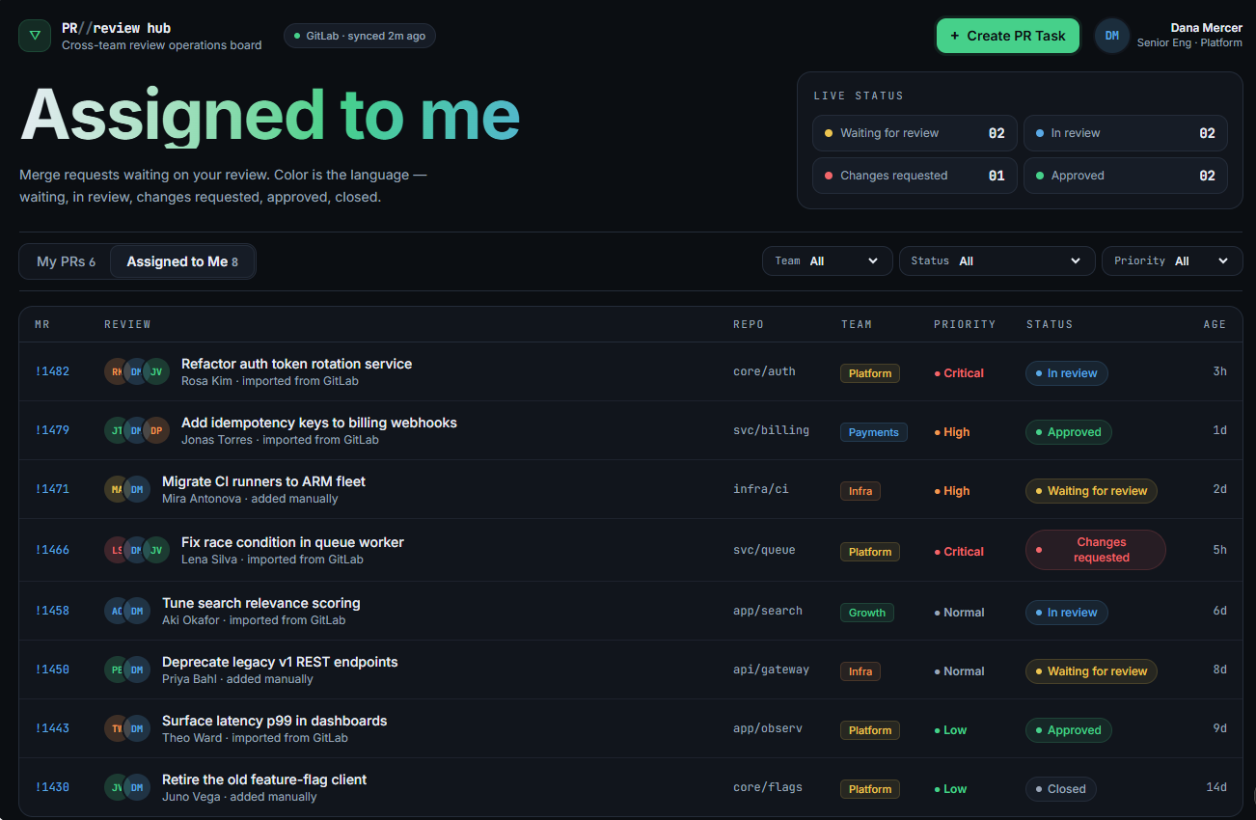
Features:
- Statistic badge for statues
- Filtering based on status (default and Waiting for Review), priority and date.
- Create PR dialog –
- Selecting a repo.
- Selecting a PR.
- Possibly adding reviewers.
- Selecting priority.
- Creating the task.
- Table for each tab with pagination. Each row in the table should include the next data –
- "My PRs" – title, link to repo, status (calculate based on the reviewer's status), priority, age, optional Jira ticket link, reviewers with their statues, edit or delete. Some of them appear on clicking the row. Can change – priority, reviewers, Jira link, reviewers.
- "Assigned to me" - title, link to repo, status, priority, age, optional Jira ticket link, the developer who opened the task. Some of them appear on clicking the row. Can change – status.

