

Assignment 2

Suppliers

אלחנן פרלשטיין 205888829

הדס עטיה 312214109

# Functional Requirements

|  |  |  |  |  |  |  |
| --- | --- | --- | --- | --- | --- | --- |
| ID | Module | Description | functional | Priority | Risk | Status |
|  | Suppliers | The system must allow to open supplier cards that contains all the relevant data | yes | MH | Low | Done |
|  | Suppliers | The system will allow only managers and storekeepers to get Suppliers data: Can not do before having the employees model | yes | NTH | High | Postponed |
|  | Suppliers | The system can display all the registered suppliers | yes | MH | Low | Done |
|  | Suppliers | The system must display document with supplier's orders details | yes | MH | Low | Done |
|  | Suppliers | The system must support display contacts of supplier | yes | MH | Low | Done |
|  | Suppliers | The system must support adding agreements with suppliers regarding discounts | yes | MH | Low | Done |
|  | Suppliers | The system must support add new contact for supplier | yes | MH | Low | Done |
|  | Suppliers | The system must support update suppliers data card | yes | MH | Low | Done |
|  | Suppliers | The system must support display for each supplier list of order not received yet | yes | MH | Low | Done |

1. Open Questions

Table 1: Terms

|  |  |  |
| --- | --- | --- |
| **#** | **Topic** | **Issue** |
|  | Number of contacts to provide | Whether each carrier has multiple contacts or a single contact per carrier? |
|  | Retrieving suppliers' arrival by day | Do need to able to show which suppliers supposed to come in every day of the week? |
|  |  |  |

1. Questions and Assumptions

Table 2: Version History

|  |  |
| --- | --- |
| **Question** | **Answer/Assumption** |
| What are payment terms? Does this require fixed values or open text? | require fixed values |
| Do you need to keep the order date / date of arrival of the goods? | Yes |
| Should the system support add new orders? | No. Module supply does it. |
| Should the system support display list of items? | No. Module supply does it. |

1. Class diagram (UML)

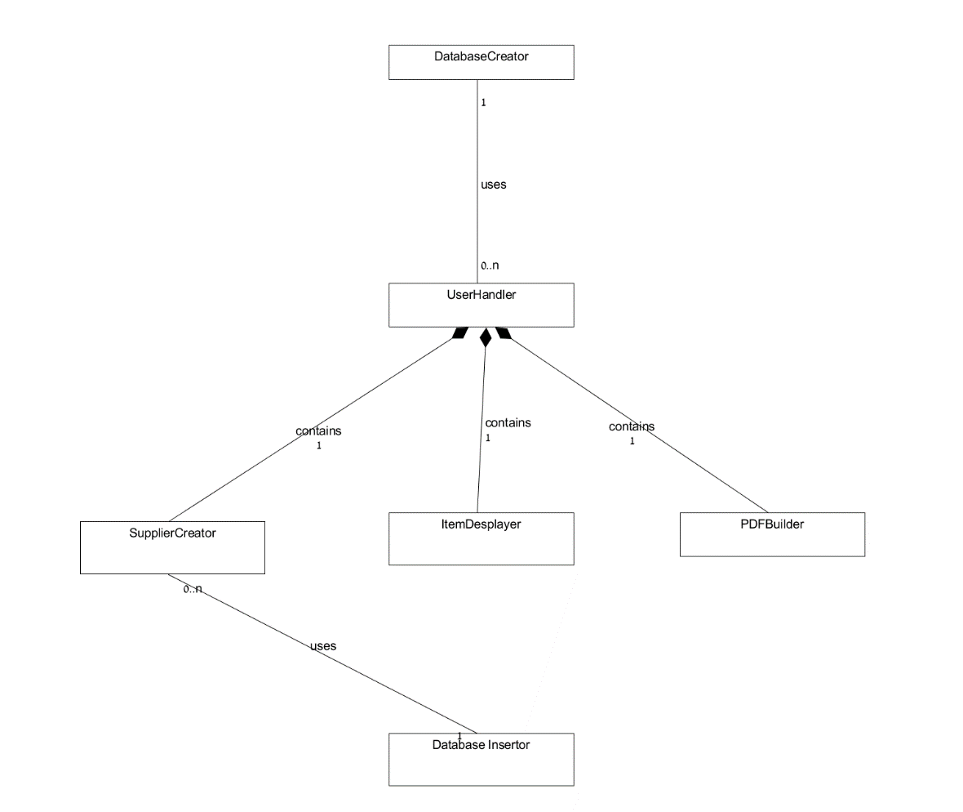

1. Object diagram (UML)

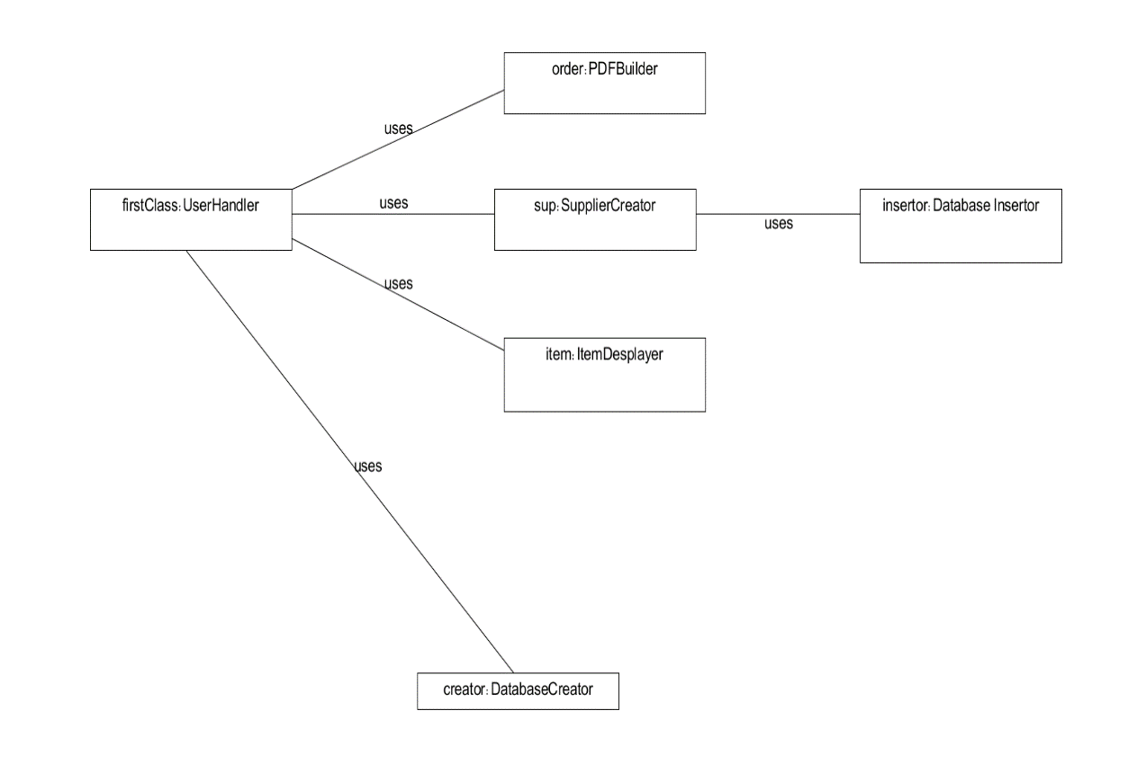**Every run of the program every class is instantiated exactly once, so there is only one way our object diagram can look like**

1. ERD

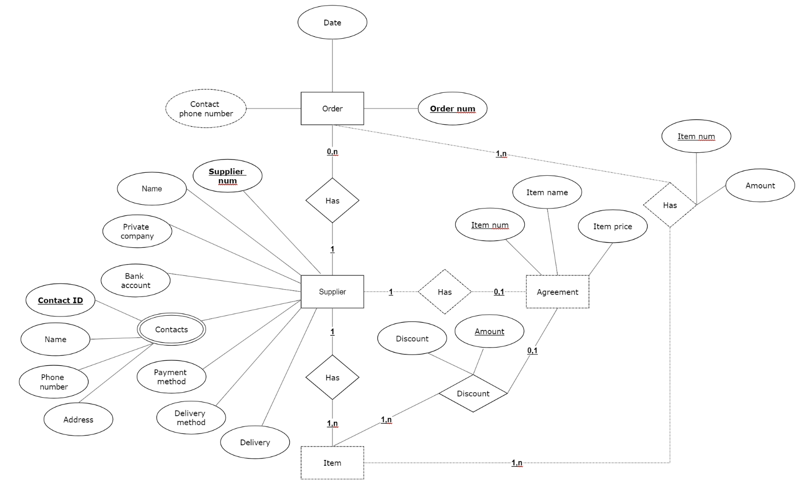

An attribute that is underlined and in bold is primary key/ an underlined attribute is a partial key.

1. The data in our Data-Base

Remark: execution of the unit tests inserts new data to the database

suppliers:

|  |  |  |  |  |  |  |  |  |
| --- | --- | --- | --- | --- | --- | --- | --- | --- |
| supplierNum | firstName | lastName | Address | Company | Bank account | Payment details | Supply day | Delivers? |
| 0 | benny | herzog | benny's castle | banny's company | 1234 | credit | 4 | yes |
| 1 | Galina | Anilag | Galina's fortress | Galina's company | 57 | cash | 7 | no |

contacts:

|  |  |  |  |  |
| --- | --- | --- | --- | --- |
| supplierNum | id | name | phone | address |
| 0 | 201111111 | ronen | 0511111111 | ronen's tree house |
| 0 | 202222222 | zelman | 0522222222 | sheepland |
| 1 | 203333333 | biton | 0409996666 | beer sheva |

contracts:

|  |  |  |  |
| --- | --- | --- | --- |
| supplierNum | itemId | itemName | price |
| 0 | 1 | corn | 40 |
| 0 | 2 | pickle | 29 |
| 0 | 3 | yogurt | 10 |
| 0 | 4 | pants | 55 |
| 1 | 1 | corn | 15 |
| 1 | 2 | socks | 1 |
| 1 | 3 | wisdom | 5 |

discounts:

|  |  |  |  |
| --- | --- | --- | --- |
| supplierNum | itemId | amount | discount |
| 0 | 1 | 3 | 10 |
| 0 | 1 | 10 | 33 |
| 0 | 1 | 13 | 50 |
| 0 | 2 | 10 | 10 |
| 0 | 2 | 12 | 18 |
| 1 | 1 | 10 | 40 |

orders:

|  |  |  |  |
| --- | --- | --- | --- |
| orderNum | supplierNum | date | contact |
| 0 | 0 | 22.04.2018 | 0511111111 |
| 1 | 0 | 23.04.2018 | 0511111111 |
| 2 | 1 | 24.04.2018 | 0533333333 |

orderIems:

|  |  |  |
| --- | --- | --- |
| orderNum | itemId | amount |
| 0 | 1 | 5 |
| 0 | 2 | 12 |
| 1 | 1 | 20 |
| 1 | 3 | 1 |
| 1 | 4 | 2 |
| 2 | 1 | 10 |