**CMSC203 Assignment 1 Implementation**

Class: CMSC203 CRN 21754

 Program: Assignment #1

Instructor: Professor Grinberg

 Summary of Description: Create a guide to help the user fix the internet problem.

 Due Date: 09/12/22

 Integrity Pledge: I pledge that I have completed the programming assignment independently.

 I have not copied the code from a student or any source.

Majd Haddad

**Part1: Pseudo Code:** Here is a pseudo code for Assignment 1 program:

**DECLARE variable repeat1 and initialize the variable to “Reboot the computer and try to connect”**

**DECLARE variable repeat2 and initialize the variable to “Did that fix the problem?”**

**DECLARE variable repeat3 and initialize the variable to “Invalid answer; try again”**

**DISPLAY “If you have a problem with internet connectivity in this WiFi Diagnosis might work.”**

**DISPLAY repeat1**

**DISPLAY repeat2**

**DECLARE variable input**

**READ input**

**IF input is equal to “Yes” or “yes” or “YES” THEN**

**DISPLAY “Good to go!”**

**ELSE IF input is not equal to “No” or “no” or “NO” THEN**

**DISPLAY repeat3**

**ELSE**

**DISPLAY repeat1**

**DISPLAY repeat2**

**READ input**

**IF input is equal to “Yes” or “yes” or “YES” THEN**

**DISPLAY “Good to go!”**

**ELSE IF input is not equal to “No” or “no” or “NO” THEN**

**DISPLAY repeat3**

**ELSE**

**DISPLAY “Make sure the cables connecting the router are firmly plugged in and power is getting to the router”**

**DISPLAY repeat2**

**IF input is equal to “Yes” or “yes” or “YES” THEN**

**DISPLAY “Good to go!”**

**ELSE IF input is not equal to “No” or “no” or “NO” THEN**

**DISPLAY repeat3**

**ELSE**

**DISPLAY “Move the computer closer to the router and try to connect”**

**DISPLAY repeat2**

**IF input is equal to “Yes” or “yes” THEN**

**DISPLAY “Good to go!”**

**ELSE IF input is not equal to “No” or “no” or “NO” THEN**

**DISPLAY repeat3**

**ELSE**

**DISPLAY “Contact your ISP”**

**Part2: Comprehensive Test Plan**

A good test plan should be comprehensive. This means you should have a few test cases that test when the input is in and out of range, division by 0, incorrect Data type, etc (Provide valid and invalid input)

|  |  |  |  |  |
| --- | --- | --- | --- | --- |
| Cases | Input | Expected Output | Actual Output | Did Test Pass? |
| Case 1 | yes | Done | If you have a problem with internet connectivity this WiFi Diagnosis might work.  Reboot the computer and try to connect  Did that fix the problem?  yes  Done  Programmer: Majd Haddad | YES |
| Case 2 | Ok | Invalid answer; try again | If you have a problem with internet connectivity this WiFi Diagnosis might work.  Reboot the computer and try to connect  Did that fix the problem?  Ok  Invalid answer; try again.  Programmer: Majd Haddad | YES |
| Case 3 | No  yes | Reboot the computer and try to connect  Reboot the computer and try to connect  Done | If you have a problem with internet connectivity this WiFi Diagnosis might work.  Reboot the computer and try to connect  Did that fix the problem?  No  Reboot the computer and try to connect  Did that fix the problem?  yes  Done  Programmer: Majd Haddad | YES |
| Case 4 | No  No  yes | Reboot the computer and try to connect  Reboot the computer and try to connect  Make sure the cables connecting the router are firmly plugged in and power is getting to the router  Done | If you have a problem with internet connectivity this WiFi Diagnosis might work.  Reboot the computer and try to connect  Did that fix the problem?  No  Reboot the computer and try to connect  Did that fix the problem?  No  Make sure the cables connecting the router are firmly plugged in and power is getting to the router  Did that fix the problem?  yes  Done  Programmer: Majd Haddad | YES |

**Part3: Screenshots related to the Test Plan:**

**Case 1:**

**Case 2**

**Case 3**

**Case 4**

**Screenshot of uploading file to Github:**

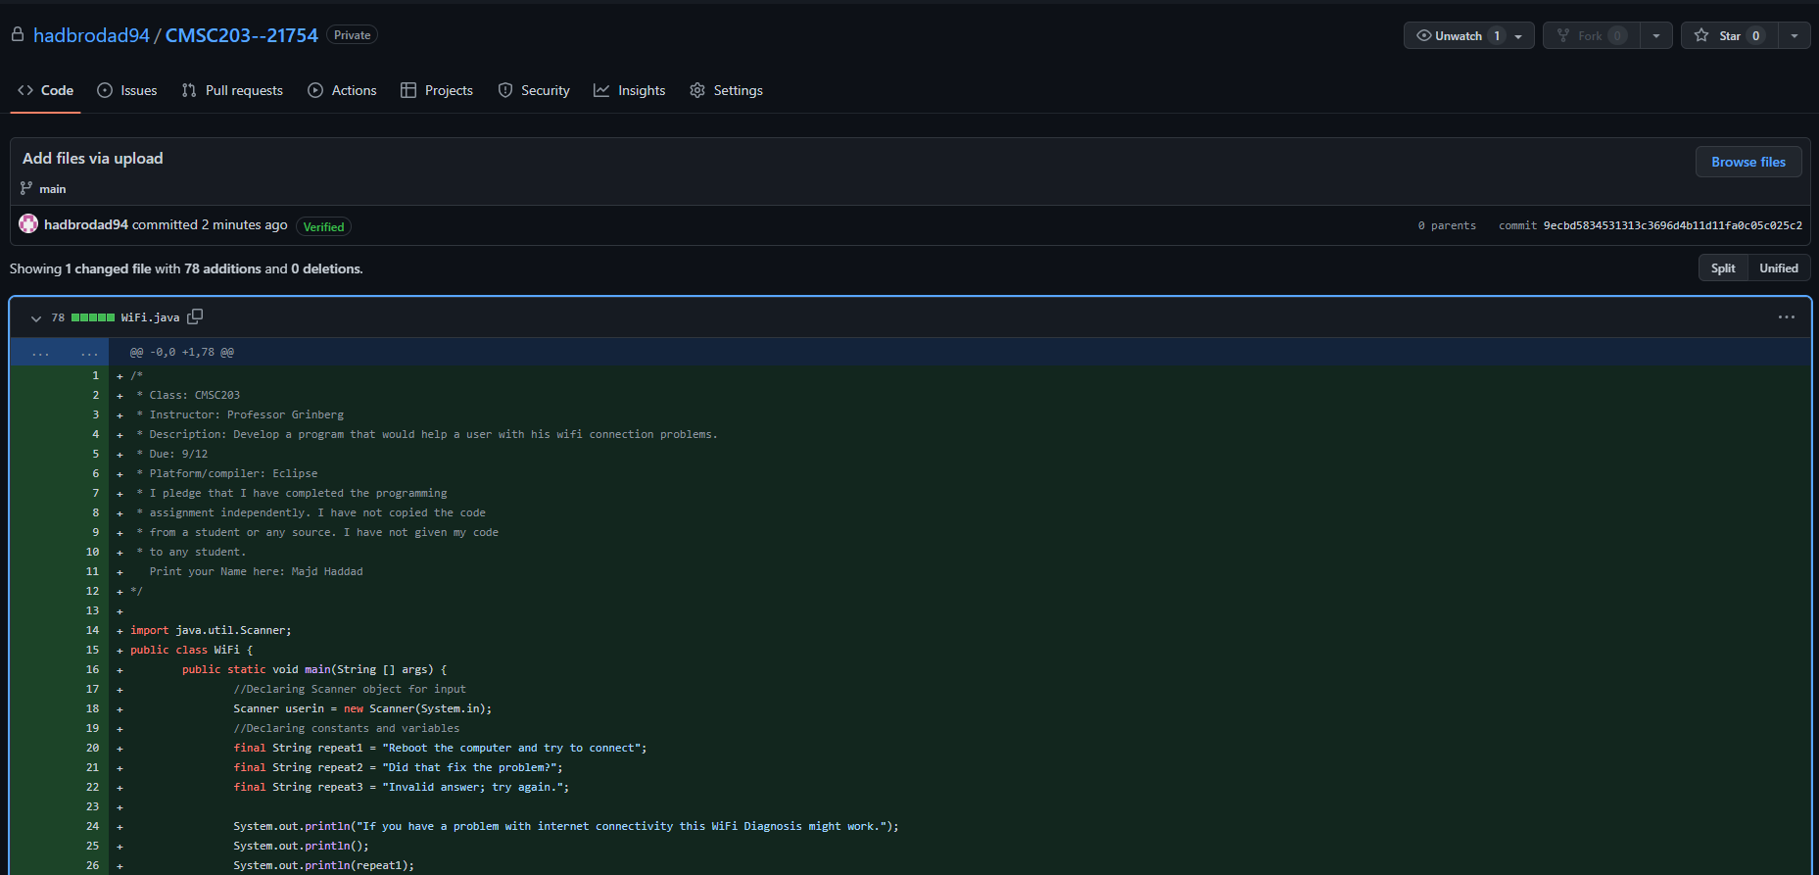

**Screenshot of application running from command prompt line:**

**Screenshot of application running in IDE:**

**Lessons Learned** <Provide answers to the questions listed below>**:**

Write about your Learning Experience, highlighting your lessons learned and learning experience from working on this project.

What have you learned? I learned more about Java and adjusted to it’s properties. I also learned a lot in regards to creating a Scanner object and use .equalsIgnoreCase which ignores whatever way the user types the word.

What did you struggle with? I sort of didn’t struggle with anything because I read the textbook and applied the textbook to when I coded this assignment.

What would you do differently on your next project? Something I would do differently in the next project is to organize myself and read the directions more clearly.

What parts of this assignment were you successful with, and what parts (if any) were you not successful with? I was successful with everything as I accomplished everything required and everything I wanted to do with the code. I don’t have any parts where I was not successful.

Provide any additional resources/links/videos you used to while working on this assignment/project.

**Check List:** <Provide answers to the column Y/N or N/A >**:**

|  |  |  |  |
| --- | --- | --- | --- |
| **#** |  | **Y/N** | **Comments** |
|  | **Assignment files:** |  |  |
|  | * FirstInitialLastName_ Assignment#_Moss.zip | **Yes or No** |  |
|  | * FirstInitialLastName_Assignment#.docx/.pdf | **Yes or No** |  |
|  | * Source java files | **Yes or No** |  |
|  | **Program compiles** | **Yes or No** |  |
|  | **Program runs with desired outputs related to a Test Plan** | **Yes or No** | **Yes** |
|  | **Documentation file:** |  |  |
|  | * Comprehensive Test Plan | **Yes or No** |  |
|  | * Screenshots related to the Test Plan | **Yes or No** |  |
|  | * Screenshots of your GitHub account with submitted Assignment# (if required) | **Yes or No or N/A** | **Yes** |
|  | * UML Diagram (if required) | **Yes or No or N/A** | **N/A** |
|  | * Algorithms/Pseudocode (if required) | **Yes or No or N/A** | **Yes** |
|  | * Flowchart (if required) | **Yes or No or N/A** | **N/A** |
|  | * Lessons Learned | **Yes or No** | **Yes** |
|  | * Checklist is completed and included in the Documentation | **Yes or No** | Yes |