Majd Haddad

Assignment 4

CMSC203 21754

10/24/22

/\*

\* Class: CMSC203

\* Instructor:Grinberg

\* Description: Designs a Property Management that collects the plot, property and combines it together in an organized fashion.

\* Due: 10/24/22

\* Platform/compiler: Eclipse

\* I pledge that I have completed the programming

\* assignment independently. I have not copied the code

\* from a student or any source. I have not given my code

\* to any student.

Print your Name here:Majd Haddad

\*/

Design:

Required Screenshots:

Add management Co information ss:

Add property info:

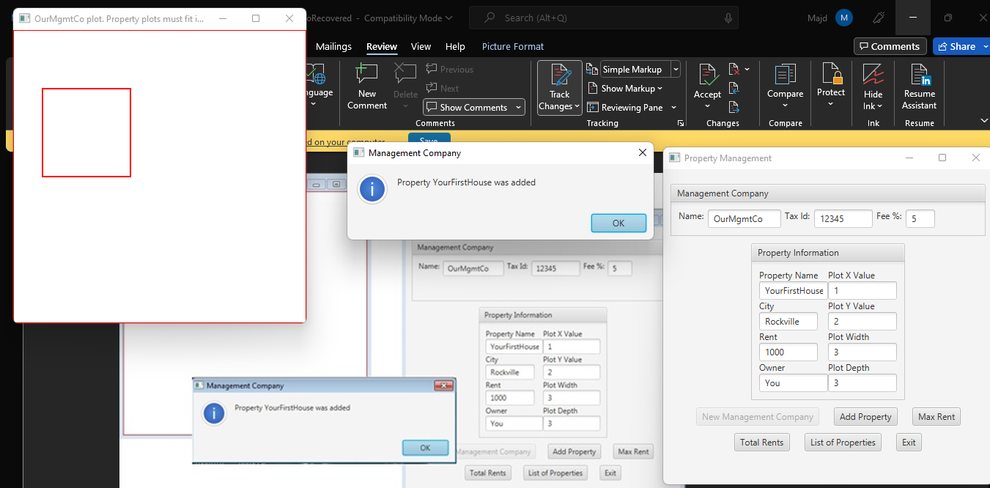

Unsuccessful, overlaps:

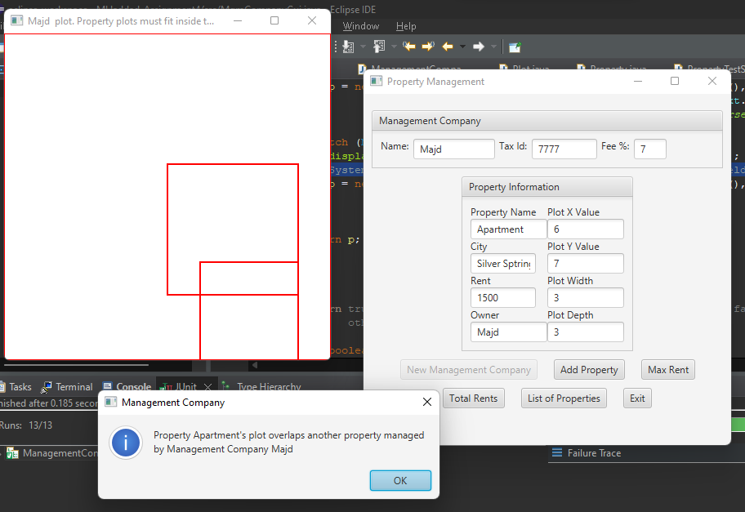

Unsuccessful, Encompass:

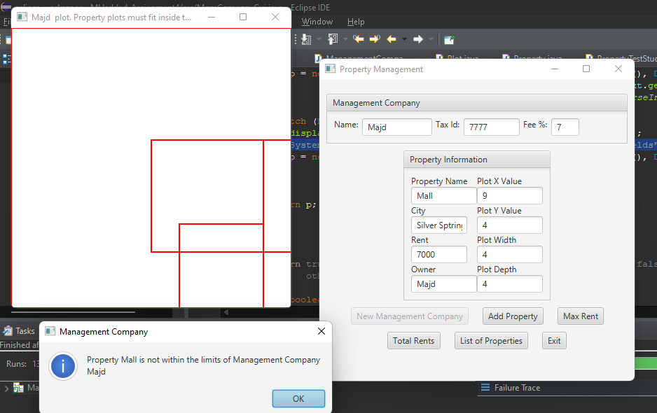

Unsuccessful, too many properties: