Majd Haddad

1/25/23

Professor Monshi

Junit Lab CMSC204

Junit Screenshot:

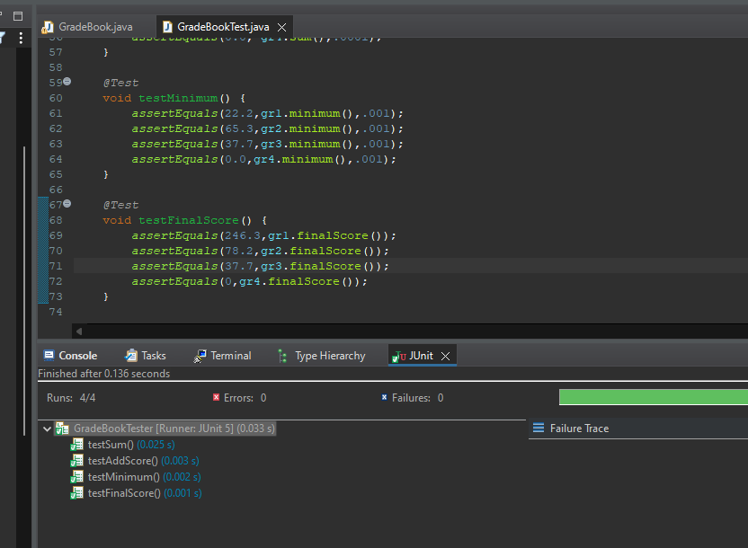

Screenshot of file uploaded to github: