Supplementary Material
Supplementary Table 1. Benchmark dataset PDB IDs, CDR sequences and heavy chain species.
PDB | Nb Chain | CDR1 | CDR2 | CDR3 | Heavy Chain Species
7tgf | B | GFTLDDY | SSSDGR | EEVCTLGIFGHGPDDY | Vicugna pacos
8emz | B | GRFFSSY | SWSGGS | AREGAYYPDSYYRTVRYDY | Vicugna pacos
8h3x | A | GFTFSRY | NSDGGR | PKRTYVPPSQFDD | Vicugna pacos
8gz5 | B | GRTSSVY | TGNGGT | GGWGKERNYAY | Vicugna pacos
8cwu | B | GRTFSTS | DWSNTN | GGWGLTQPISVDY | Lama glama
7x2m | B | GDTLDLY | SPSGSR | SRPSAHYCSHYPTEYDD | Vicugna pacos
7voa | A | GFTLDYY | SGSGGI | VSHTVVAGCAFEAWTDFGS | Vicugna pacos
7ubx | C | GFTFSDY | NTDGS | GRVISASAIRGAV | Camelidae
7th2 | C | PSLDYY | TGSEGS | ADPLPLVCTWGDEYDY | Vicugna pacos
8en2 | D | GLTFSTN | NWNGGN | KMGRRLAVSRTLEEYDF | Vicugna pacos
8ew6 | V | GFTFDDY | RIFDRH | GSFWACTRPEGAMDY | Lama glama
7yz9 | B | GIILSIN | TAGGS | PAGRVGGT | Vicugna pacos
7w1s | B | ISFSSF | GIGG | WRMNDY | Vicugna pacos
7zmv | G | GSIFSIN | TSGGS | YGTYTLAPTGEGEYDDY | Lama glama
7unz | A | GSIFSTN | TSGSS | AGATIDLADFGS | Vicugna pacos
8en3 | C | GRTDSES | NWRYAT | RYIYGSLSDSGSYDN | Vicugna pacos
7tgi | B | GLTLDYY | SSSDGR | DRDRLPSAITYEYNY | Vicugna pacos
7nxx | B | GGDTRPYITY | YTGGSG | GNGALPPGRRLSPQNMDT | Camelus dromedarius
8dtn | E | GFIFDSY | TSSGSS | LDYVIDGY | Lama glama
8h3y | E | GQTFSAW | NWNGER | MMGTYYSGSPKN | Vicugna pacos
7q3q | B | GLTFSSV | RWKFGN | ARVGEIIAVLISPSNYAY | Vicugna pacos
7tpr | E | GYTYSIC | NADGSN | HGTYDKYAPCGGFAGTYTY | Camelus dromedarius
7x2j | B | GRTFSRY | EWDGGT | GGNQYYSATYSIWNEYDF | Vicugna pacos
7b5g | D | GSIFSSN | SSRGDN | GSFYRGNYYGGSS | Lama glama
7x2l | B | GSISTLN | TLDGS | ENGGFFYY | Vicugna pacos
8dtu | A | GSTFSGY | TSSGAS | LDEGYLDYDS | Lama glama
8dqu | B | GLAFSMY | ISSGDS | PKFRYYFSTSPGDFDS | Lama glama
7uia | B | GFTFDDY | DSWSIN | EDRLGVPTINAHPSKYDYNY | Vicugna pacos
7t5f | F | GSIDSLY | QDGGS | KSTISTPLS | Camelidae
7wki | B | GLTVDDY | SSSNGS | AVSPNLECGTGPFGIYASYYGMDY | Vicugna pacos
7x7e | A | GGTLASF | DVINR | HFVPPGSRLRGCLVNELYNY | Lama
7qbg | E | GFTPGIY | SSRGSS | IYQPSNGCVLRPEYSY | Vicugna pacos
7wd2 | D | GFTLDYY | SSNNS | EPDYSGVYYYTCGWTDFGS | Vicugna pacos
7qne | G | GRTFTAY | DQGRI | GAGFWGLRTASSYHY | Lama glama
7r24 | E | GRTFSAY | SWSGNS | RKPMYRVDISKGQNYDY | Vicugna pacos
7r24 | C | GRTSGAL | WWNDGT | RTPSSQTLY | Vicugna pacos
7xqv | B | GDTWWSS | SFYPTEY | IAWGPWMRTSWY | Camelus bactrianus
7whi | G | DFYFDYY | SGLGGA | RSPFGDYAFSY | Homo sapiens
8bb7 | D | GFRLDYY | SSSGGS | SSYNTQRAECYGMDY | Camelidae
8en0 | D | GRTFSSY | TGSGDS | YRTGGPPQ | Vicugna pacos

Supplementary Table 2. Benchmark dataset antigen species and PDB from the used homologous antigens for docking. AF Multimer indicates the antigens that were modelled using AlphaFold2-Multimer.
PDB | Ag Chain | Antigen Species | Antigen Name | PDB (chain) used for docking
7tgf | A | Ricinus communis | Ricin Chain A | 7y07 (A)
8emz | A | Norovirus | Gii.17 P Domain | 5lkk (A)
8h3x | C | Bacteroides fragilis | Fragilysin | AF Multimer
8gz5 | A | Severe Acute Respiratory Syndrome Coronavirus2 | Spike Protein S1 | 7sxt (A)
8cwu | A | Severe Acute Respiratory Syndrome Coronavirus2 | Spike Protein S1 | 7z8o (A)
7x2m | E | Severe Acute Respiratory Syndrome Coronavirus2 | Spike Protein S1 | AF Multimer
7voa | B | Severe Acute Respiratory Syndrome Coronavirus2 | Spike Glycoprotein | 7eam (A)
7ubx | B | Clostridioides difficile | Toxin A | 7u1z (A)
7th2 | A | Ricinus communis | Ricin A Chain | AF Multimer
8en2 | A | Norovirus | Gii.10 P Domain | AF Multimer
8ew6 | W | Homo sapiens | T-Cell Surface Glycoprotein Cd8 Alpha Chain | AF Multimer
7yz9 | A | Mycobacterium tuberculosis H37rv | Adenylate Cyclase | AF Multimer
7w1s | A | Severe Acute Respiratory Syndrome Coronavirus2 | Spike Protein S1 | 7eam (A)
7zmv | A | Homo sapiens | Atp-Dependent Dna Helicase Q5 | AF Multimer
7unz | D | Plasmodium falciparum | Cysteine-Rich Small Secreted Protein Css, Putative | 7uny (A)
8en3 | A | Norovirus | Capsid Protein Vp1 | 8emz (A)
7tgi | A | Ricinus communis | Ricin Chain A | 7y07 (A)
7nxx | A | Homo sapiens | Superoxide Dismutase [Cu-Zn] | 2c9v (A)
8dtn | F | Homo sapiens | B-Cell Lymphoma/Leukemia 11a | AF Multimer
8h3y | C | Bacteroides fragilis | Fragilysin | AF Multimer
7q3q | A | Severe Acute Respiratory Syndrome Coronavirus2 | Spike Glycoprotein | 7q3r (A)
7tpr | C | Severe Acute Respiratory Syndrome Coronavirus2 | Spike Glycoprotein | 7z8o (A)
7x2j | S | Severe Acute Respiratory Syndrome-Related Coronavirus | Spike Protein S1 | 7zh1 (A)
7b5g | C | Escherichia coli K-12 | Lexa Repressor | 7ozj (A)
7x2l | E | Severe Acute Respiratory Syndrome Coronavirus2 | Spike Protein S1 | 7z8o (A)
8dtu | C | Homo sapiens | B-Cell Lymphoma/Leukemia 11a | 8dtn (F)
8dqu | F | Severe Acute Respiratory Syndrome Coronavirus2 | Non-Structural Protein 9 | AF Multimer
7uia | A | Clostridium botulinum | Neurotoxin Type E | 7ovw (A)
7t5f | D | Clostridium botulinum | Botulinum Neurotoxin Type B | 7na9 (A)
7wki | A | Homo sapiens | Complement Factor H | 3sw0 (X)
7x7e | D | Severe Acute Respiratory Syndrome Coronavirus2 | Spike Protein S1 | 7z8o (A)
7qbg | C | B | Homo sapiens | Homo sapiens | Transcobalamin-2 | Cd320 Antigen | AF Multimer
7wd2 | B | Severe Acute Respiratory Syndrome Coronavirus2 | Spike Protein S1 | AF Multimer
7qne | A | E | Homo sapiens | Homo sapiens | Gaba(A) Receptor Subunit Alpha-1 | Gamma-Aminobutyric Acid Receptor Subunit Beta-3 | AF Multimer (considered failed)
7r24 | A | Rattus norvegicus | Activity-Regulated Cytoskeleton-Associated Protein | AF Multimer
7xqv | A | Rattus norvegicus | Rhoa | AF Multimer
7whi | A | Severe Acute Respiratory Syndrome Coronavirus2 | Spike Glycoprotein | 7x66 (R)
8bb7 | B | Mus musculus | Plexin-B1 | AF Multimer
8en0 | A | Norovirus | Capsid Protein Vp1 | 8emz (A)

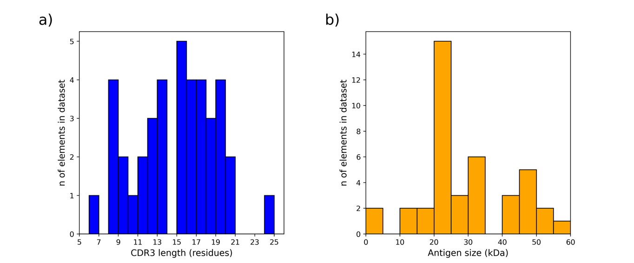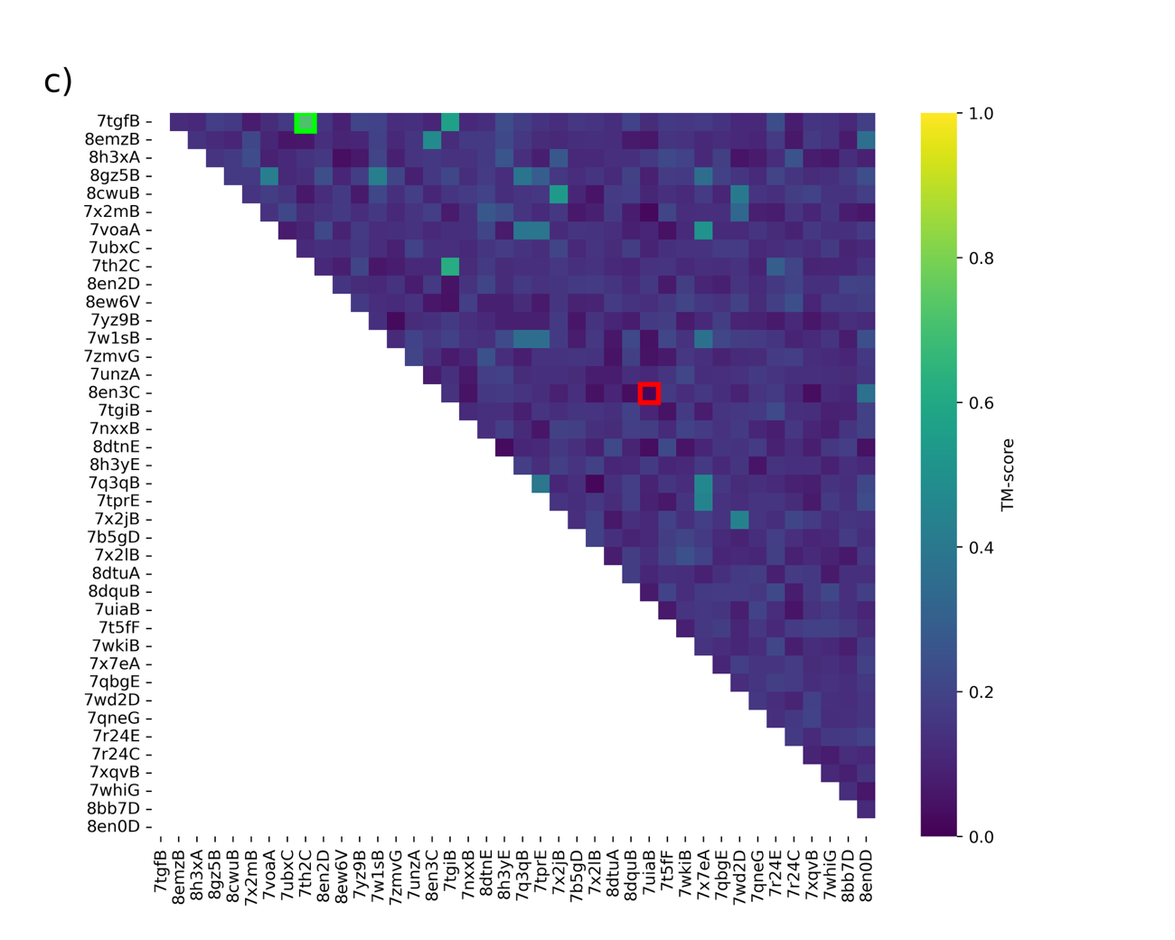 Supplementary Figure 1. Benchmark dataset variability analysis. a) Nanobody CDR3 length distribution in the benchmark dataset. b) Antigen size distribution in the benchmark dataset. c) Pairwise epitope structural comparison by TM-score in the benchmark dataset. Axes show nanobody PDB IDs. Red square shows the minimum value (0.018) and green square shows the maximum value (0.717).

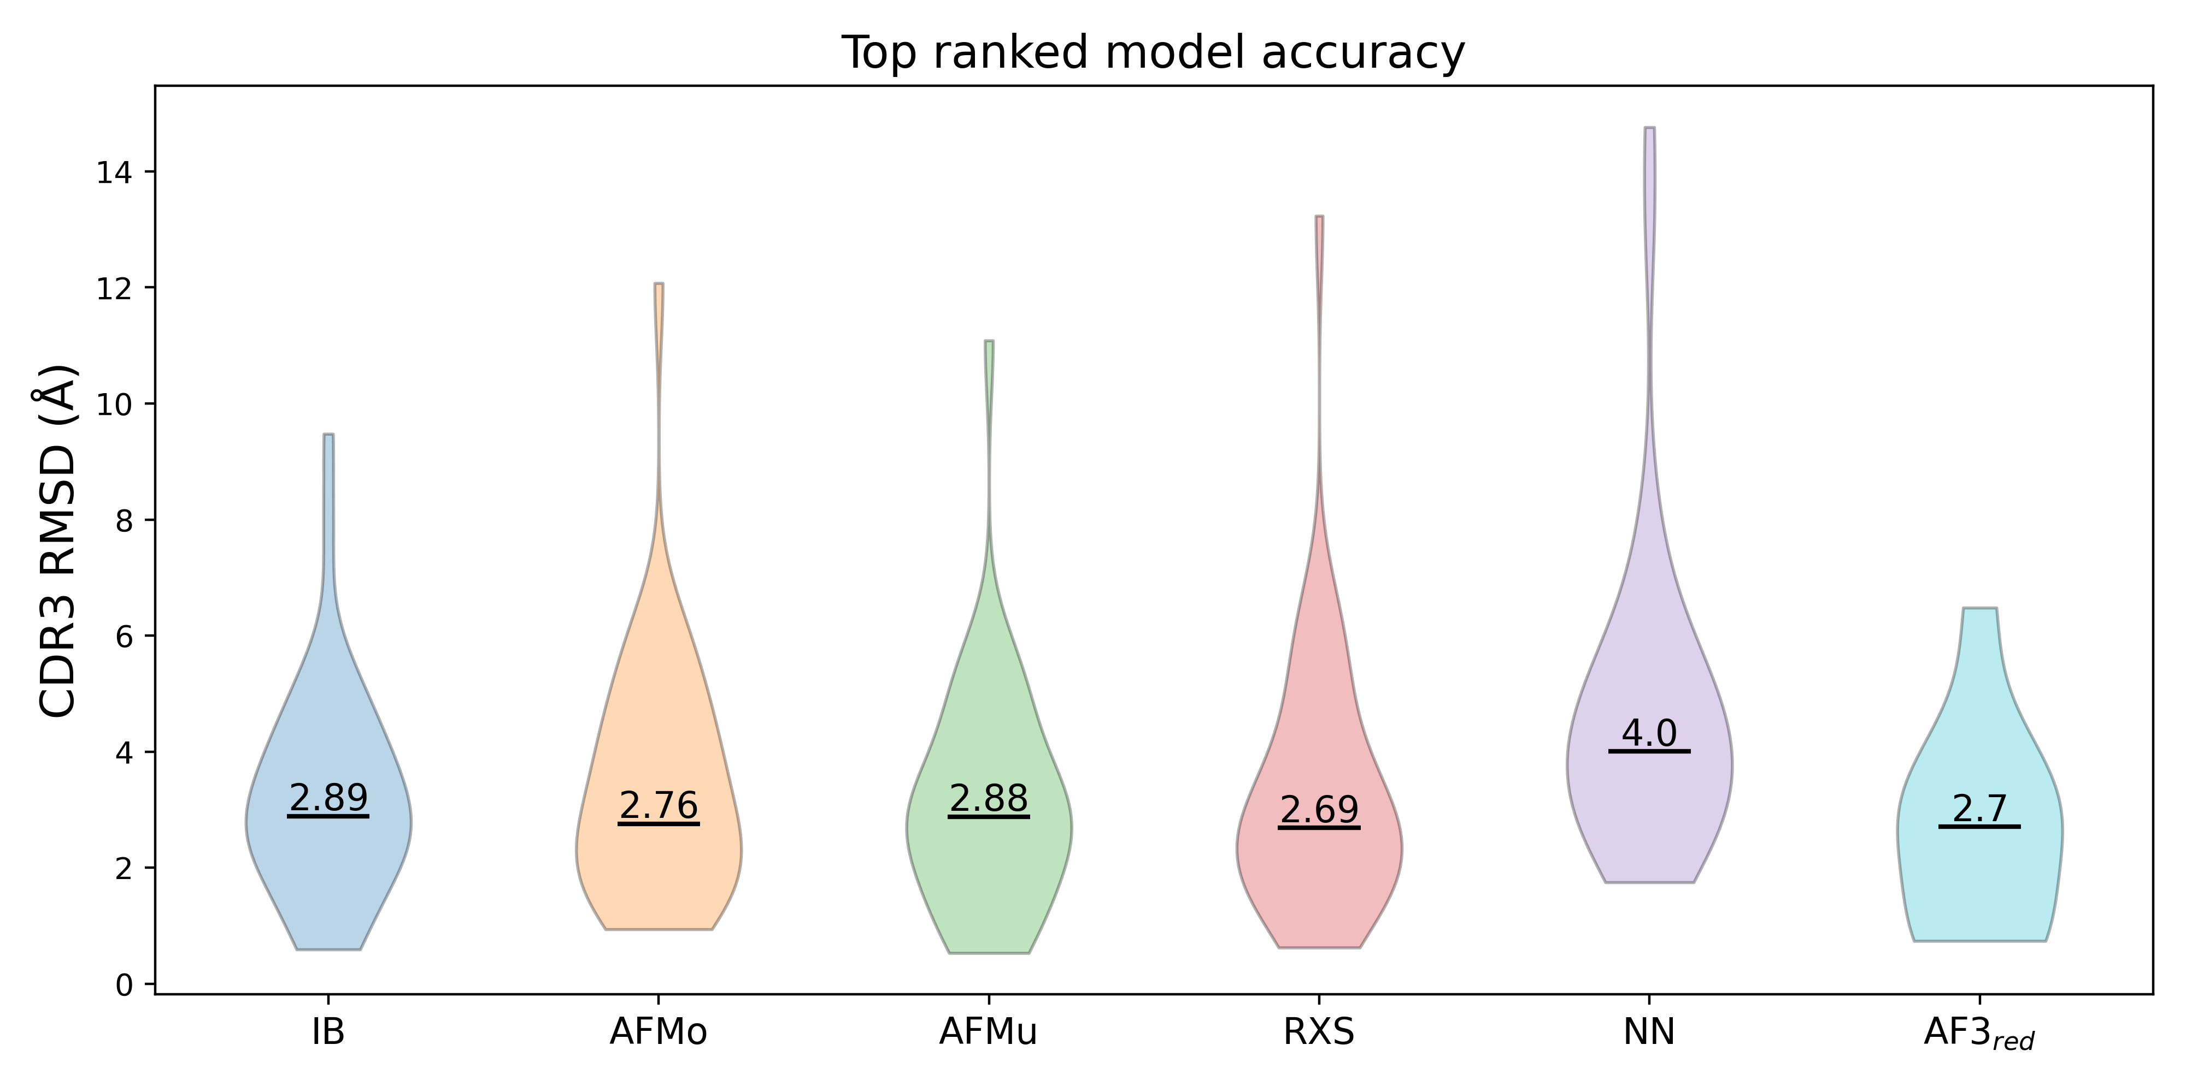
Supplementary Figure 2. Violin plot showing the distribution of the backbone CDR3 RMSD from the best ranked nanobody prediction for the different methods. The prediction methods shown in the plot are AlphaFold2-Multimer (AF Multimer), AlphaFold2 (AF Monomer), ImmuneBuilder (IB), RaptorX-Single (RXS), NanoNet (NN) and AlphaFold3 (AF3). Median values are indicated in the plot.

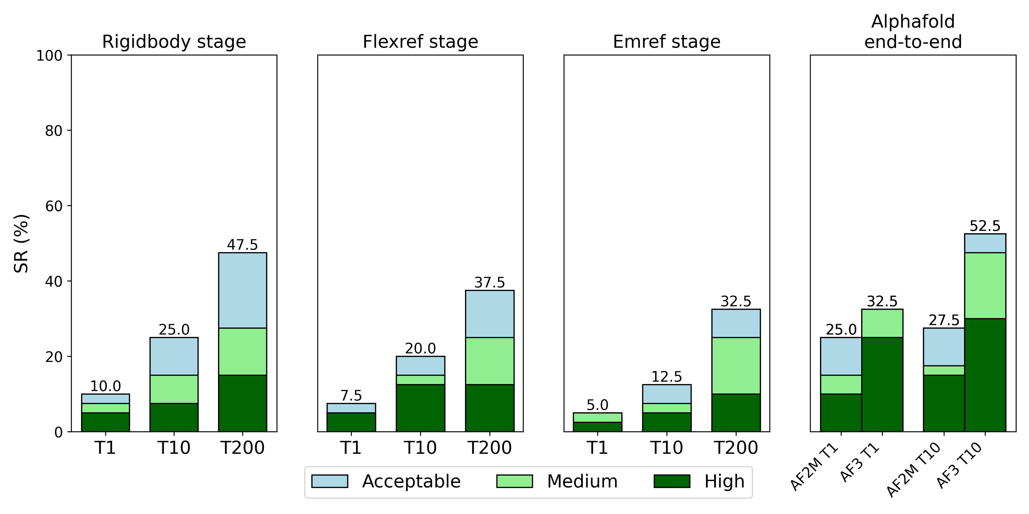
Supplementary Figure 3. Bar plots showing docking success rate (SR) for All Surface scenario as a function of the TopN ranked structures. The results shown are coming from the input ensemble of ImmuneBuilder + AlphaFold2-Multimer (IBMu) nanobody models and the bound antigen structures. The left plot shows results after Rigid Body stage of the pipeline, center left plot after Flexible Refinement (Flexref) stage and center right plot after Energy Minimization (Emref) stage. AlphaFold2-Multimer (AF2M) and Alphafold3 (AF3) results are shown in the right panel. The color scheme indicates the quality of the represented models following CAPRI criteria. From the plot we can observe how AF2M and AF3 outperform HADDOCK when no information is available and should be always preferred in this scenario. In terms of docking, the success rate is higher at the rigid-body docking stage.

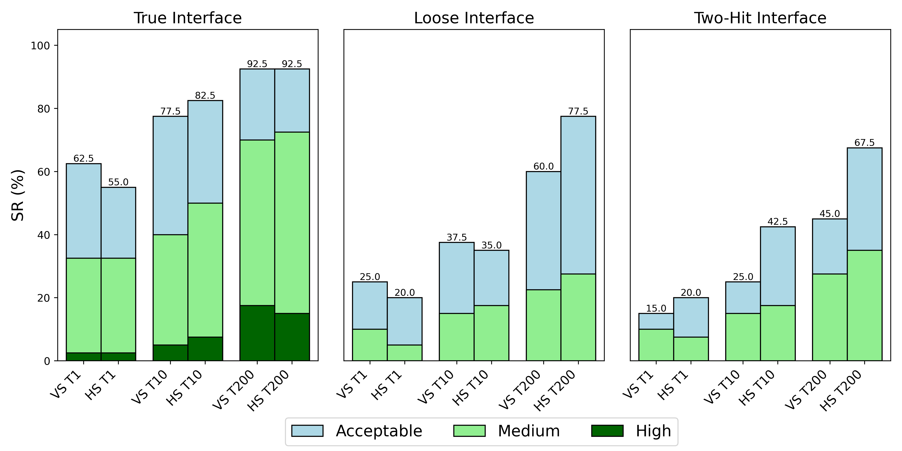
Supplementary Figure 4. VoroIF-GNN scoring does not clearly improve the HADDOCK scoring of nanobody-antigen models. a) Bar plot comparing model docking success rates (SRs) for TopN structures after Voronoi scoring (VS) and HADDOCK scoring (HS) for different information scenarios. Data shown comes from the input ensemble of ImmuneBuilder + AlphaFold2-Multimer nanobody models and unbound antigen structures. All considered models were scored after the Energy Minimization stage. The color scheme shows the quality of the represented models following CAPRI criteria.

Supplementary Table 3. Alphafold modelling and docking results summary for the benchmark dataset. Alphafold and HADDOCK results are reported over the top 10 structures. HADDOCK results come from IBMu ensemble with unbound antigen, true interface scenario and Flexible Refinement stage. IBMu ensemble size as the number of models is reported between brackets in the Max HADDOCK DockQ column.
PDB | Nb Angle Class | Min CDR3 RMSD (Å) | Unbound Epitope RMSD (Å) | Max AF2 iPTM | Max AF3 iPTM | Max HADDOCK DockQ (ensemble size) | HADDOCK Capri class
7tgfB | Extended | 1.738 | 0.463 | 0.88 | 0.90 | 0.819 (5) | Medium
8emzB | Kinked | 2.192 | 1.256 | 0.15 | 0.11 | 0.669 (6) | Medium
8h3xA | Other | 2.420 | 0.611 | 0.44 | 0.86 | 0.604 (7) | Medium
8gz5B | Kinked | 1.020 | 0.441 | 0.27 | 0.85 | 0.814 (2) | Medium
8cwuB | Kinked | 2.541 | 0.791 | 0.20 | 0.80 | 0.294 (5) | Acceptable
7x2mB | Kinked | 1.470 | 1.124 | 0.36 | 0.18 | 0.245 (2) | Acceptable
7voaA | Kinked | 1.740 | 0.557 | 0.38 | 0.14 | 0.400 (7) | Acceptable
7ubxC | Extended | 0.989 | 4.607 | 0.20 | 0.91 | 0.516 (11) | Acceptable
7th2C | Kinked | 2.693 | 0.393 | 0.54 | 0.16 | 0.362 (3) | Acceptable
8en2D | Kinked | 1.171 | 0.398 | 0.750 | 0.820 | 0.587 (5) | Acceptable
8ew6V | Kinked | 1.414 | 2.561 | 0.73 | 0.19 | 0.546 (6) | Medium
7yz9B | Other | 3.285 | 1.191 | 0.16 | 0.86 | 0.182 (5) | Incorrect
7w1sB | Failed | 1.365 | 0.681 | 0.40 | 0.25 | 0.723 (2) | Medium
7zmvG | Extended | 1.066 | 1.680 | 0.23 | 0.70 | 0.566 (6) | Medium
7unzA | Other | 4.543 | 1.036 | 0.17 | 0.23 | 0.127 (11) | Incorrect
8en3C | Kinked | 2.684 | 1.753 | 0.17 | 0.11 | 0.311 (3) | Acceptable
7tgiB | Kinked | 1.157 | 0.585 | 0.92 | 0.92 | 0.854 (7) | High
7nxxB | Kinked | 2.562 | 0.565 | 0.19 | 0.18 | 0.391 (4) | Acceptable
8dtnE | Other | 5.189 | 3.534 | 0.34 | 0.39 | 0.236 (4) | Acceptable
8h3yE | Kinked | 0.565 | 3.575 | 0.60 | 0.15 | 0.635 (3) | Medium
7q3qB | Kinked | 0.529 | 0.571 | 0.85 | 0.89 | 0.870 (3) | High
7tprE | Extended | 2.374 | 2.192 | 0.25 | 0.36 | 0.331 (7) | Medium
7x2jB | Kinked | 2.410 | 1.223 | 0.26 | 0.90 | 0.436 (8) | Acceptable
7b5gD | Kinked | 1.240 | 0.964 | 0.21 | 0.16 | 0.766 (8) | Medium
7x2lB | Extended | 0.784 | 0.779 | 0.86 | 0.79 | 0.721 (3) | Medium
8dtuA | Kinked | 4.090 | 5.644 | 0.50 | 0.60 | 0.317 (6) | Acceptable
8dquB | Kinked | 0.597 | 5.690 | 0.78 | 0.57 | 0.375 (3) | Incorrect
7uiaB | Kinked | 3.485 | 2.220 | 0.21 | 0.60 | 0.079 (8) | Incorrect
7t5fF | Extended | 1.778 | 0.570 | 0.26 | 0.11 | 0.641 (2) | Medium
7wkiB | Kinked | 3.221 | 3.716 | 0.19 | 0.13 | 0.140 (7) | Incorrect
7x7eA | Kinked | 1.283 | 0.875 | 0.66 | 0.18 | 0.586 (5) | Medium
7qbgE | Kinked | 2.326 | 2.520 | 0.62 | 0.57 | 0.030 (2) | Incorrect
7wd2D | Kinked | 1.617 | 0.579 | 0.25 | 0.85 | 0.283 (6) | Acceptable
7qneG | Kinked | 2.106 | 13.376 | 0.62 | 0.80 | 0.130 (1) | Incorrect
7r24E | Kinked | 1.113 | 1.589 | 0.86 | 0.87 | 0.478 (2) | Medium
7r24C | Extended | 2.001 | 1.375 | 0.65 | 0.25 | 0.243 (3) | Incorrect
7xqvB | Extended | 4.077 | 0.632 | 0.32 | 0.64 | 0.641 (7) | Medium
7whiG | Kinked | 0.946 | 1.639 | 0.29 | 0.18 | 0.529 (2) | Medium
8bb7D | Kinked | 1.387 | 1.206 | 0.18 | 0.13 | 0.399 (4) | Acceptable
8en0D | Extended | 3.555 | 2.169 | 0.15 | 0.14 | 0.353 (4) | Acceptable

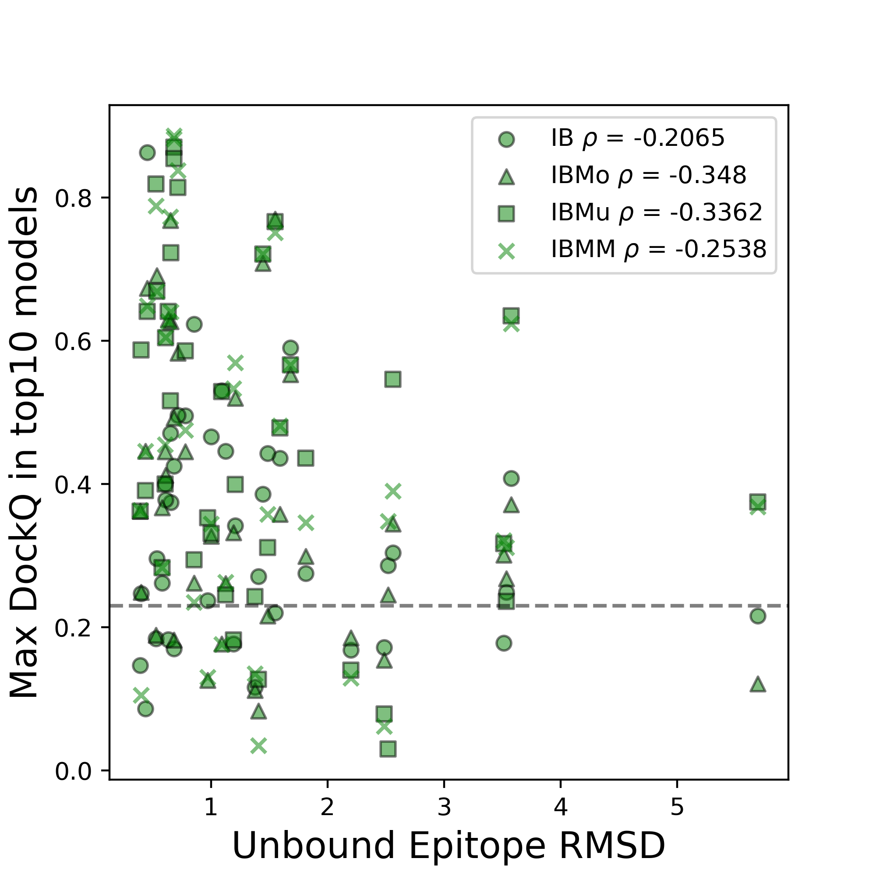
Supplementary Figure 5. Scatter plot showing the relation between maximum DockQ among Top10 nanobody-antigen models and epitope RMSD. The presented data come from the True Interface scenario runs with unbound antigen structures (excluding PDB ID 7QNE, for which unbound runs were not performed). The plotted models were retrieved after Energy Minimization stage. Represented nanobody structure ensembles are ImmuneBuilder (IB), ImmuneBuilder + AlphaFold2 (IBMo), ImmuneBuilder + AlphaFold2-Multimer (IBMu) and ImmuneBuilder + AlphaFold2 + AlphaFold2-Multimer (IBMM). Pearson correlation coefficients are shown for each ensemble. The horizontal dashed line indicates a DockQ score of 0.23 which is the cutoff for an acceptable model.

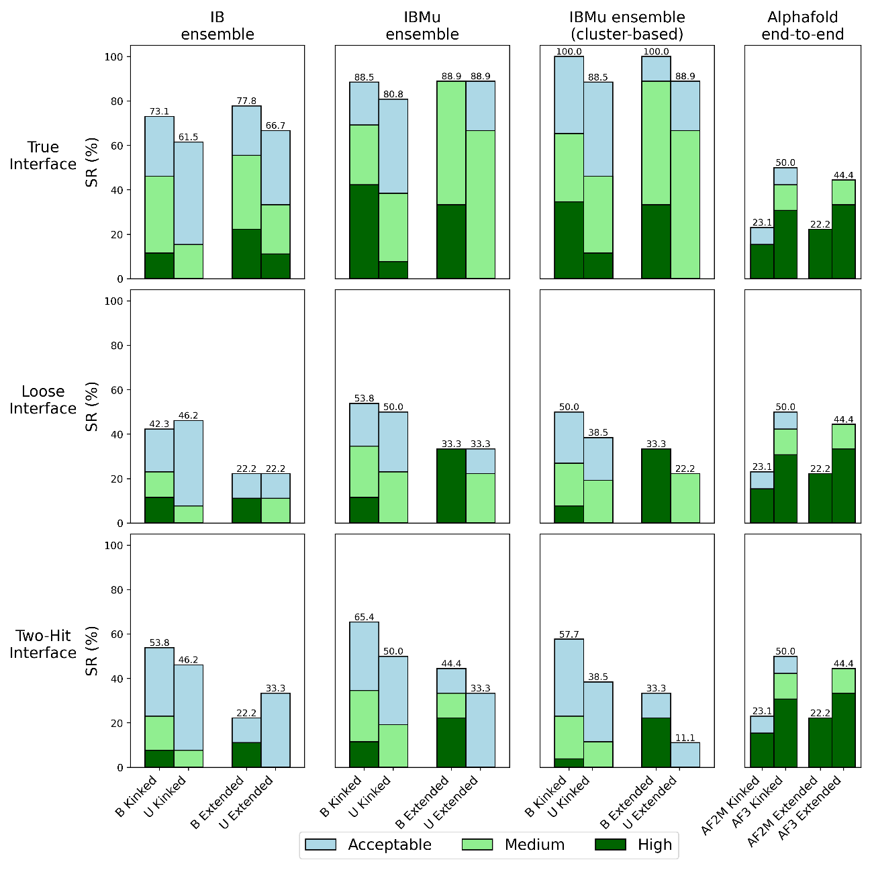
Supplementary Figure 6. HADDOCK3 performance on nanobody-antigen docking for ‘Kinked’ and ‘Extended’ nanobodies. From the original benchmark dataset 29 nanobodies are classified as ‘Kinked’ and 9 as ‘Extended’. HADDOCK success rates (SRs) for nanobody-antigen docking models after Flexible Refinement stage for True, Loose, and Two-Hit Interface scenarios. Docking success is reported for the ensembles ImmuneBuilder (IB) and ImmuneBuilder + AlphaFold2-Multimer (IBMu), both for bound (B) and unbound antigens (U) for Top 10 ranked models. For IBMu we report also the cluster-based success rate. Clusters were defined based on Fraction of Common Contact (FCC) clustering of the models at the end of the workflow. Success is considered when at least one of the four first-ranked models in any of the Top10 ranked clusters is classified as acceptable/medium/high quality. The AlphaFold2-Multimer (AF2M) and AlphaFold3 (AF3) SRs for Top10 structures are provided on the right. Light blue, light green, and dark green indicate acceptable, medium, and high-quality models, respectively, as defined by the CAPRI criteria. Acceptable SRs (%) are shown on top of the bars.

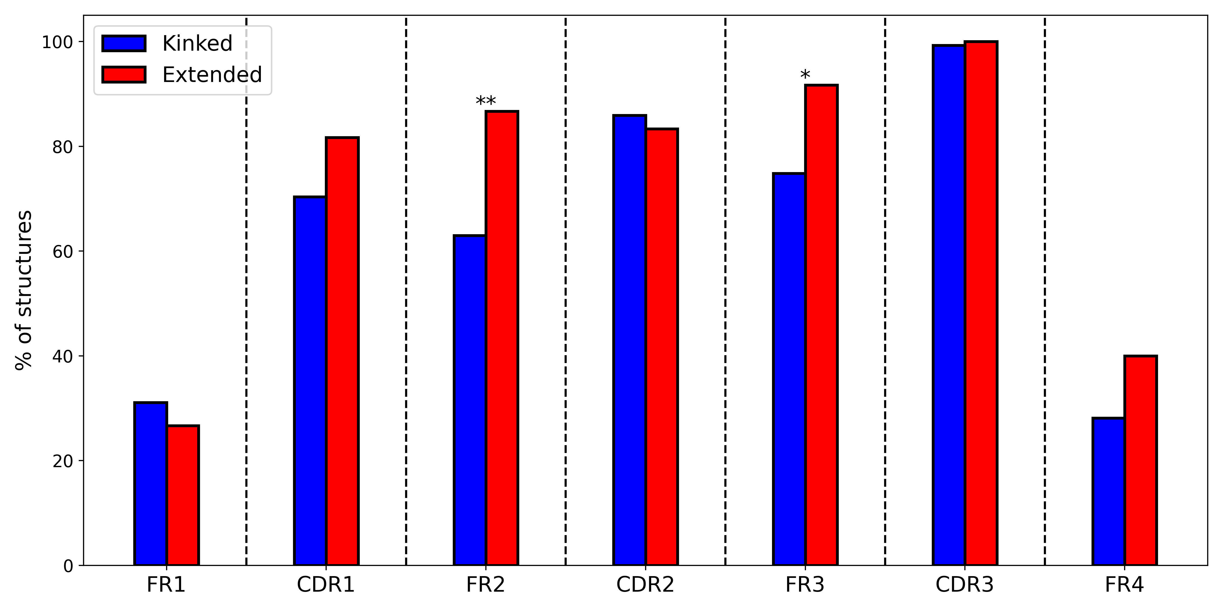
Supplementary Figure 7. Percentage of ‘kinked’ and ‘extended’ CDR3 conformation structures that involve each nanobody region in antigen binding, calculated over the Paratope Dataset (see main text). Structures that did not belong to any of the two classes are not considered in this analysis. Chi-squared significance in contingency tests between both classes for each region is labelled (p-values FR2: 0.0015; FR3: 0.012).

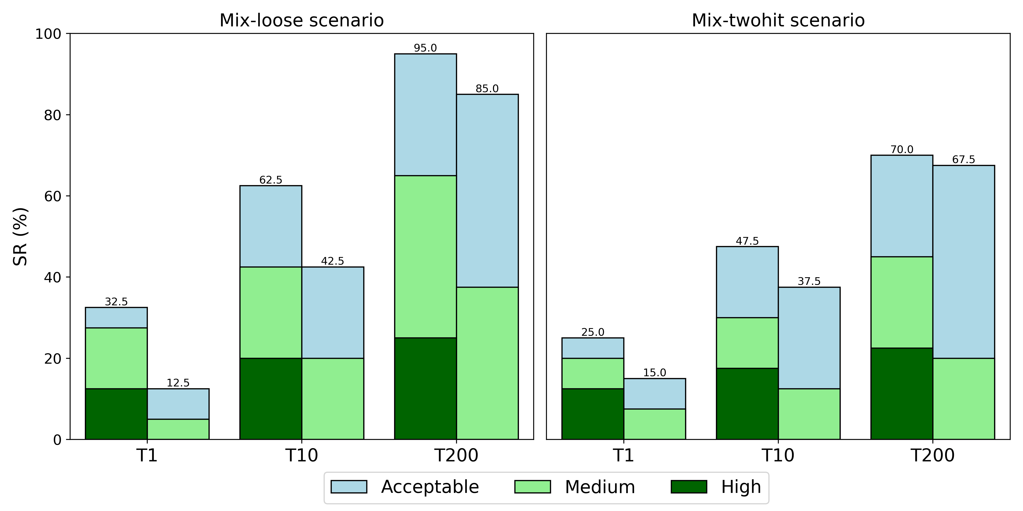
Supplementary Figure 8. Bar plots showing the docking success rates for the IBMu ensemble applying the mixed paratope restraints, namely combining CDR-only restraints (only the three CDR regions are defined as active) and CDR+FR restraints, where CDR3 and some highly interacting CDR1, CDR2, and FR regions are defined as active in HADDOCK. The two columns show Loose Interface and Two-Hit Interface scenarios. The color scheme shows the quality of the represented models following CAPRI criteria. Acceptable SR is plotted on top of the bars.

# ====================================================================
run_dir = “emref_7q3qB_af_multimer_centroids"
molecules = "7q3qB_af_multimer_centroids_ensemble.pdb”
clean = false
# ====================================================================
[topoaa]

[emref]

Supplementary Figure 9. Example workflow for the energy minimization refinement of nanobody or antigen structures from AlphaFold methods.

# ====================================================================
run_dir = "nanobody_antigen_docking"
mode = “local”

molecules = ["7q3qB_ib_af_multimer_ensemble.pdb”,
“7q3q_B_A_alphafold2_multimer_antigen.pdb"]
# ====================================================================
[topoaa]
[rigidbody]
tolerance = 5
ambig_fname = "7q3qB_real_ambig.tbl"
[caprieval]
reference_fname = " 7q3q-B:A_ref.pdb"
[seletop]
select = 200
[caprieval]
reference_fname = " 7q3q-B:A_ref.pdb"
[flexref]
tolerance = 5
ambig_fname = "7q3qB_real_ambig.tbl"
[caprieval]
reference_fname = " 7q3q-B:A_ref.pdb"
[emref]
tolerance = 5
ambig_fname = "7q3qB_real_ambig.tbl"
[caprieval]
reference_fname = " 7q3q-B:A_ref.pdb"
[clustfcc]
[seletopclusts]
top_models = 4
[caprieval]
reference_fname = " 7q3q-B:A_ref.pdb"
# ====================================================================

Supplementary Figure 10. Example workflow of the default nanobody-antigen HADDOCK pipeline.

Supplementary Methods
Statistics and reproducibility
We calculated statistical differences using Chi-squared test using adjusted p-values. Significance levels were labelled as: n.s (non-significant), *(p <=0.05), **(p <=0.01), ***(p<=0.001). Statistical tests were performed using scipy Python package ¹.

Supplementary References
- Virtanen, P. et al. SciPy 1.0: fundamental algorithms for scientific computing in Python. Nat Methods 17, 261–272 (2020).

