The Title of Your Document

Your Name

17. November 2019

Table of Contents

# Introduction

ans <- matrix(rnorm(25),ncol=5,nrow=5,dimnames=list(1:5,1:5))

Table 1: 25 random normal numbers illustrating the use of tab_nums.

|  |  |  |  |  |  |
| --- | --- | --- | --- | --- | --- |
|  | 1 | 2 | 3 | 4 | 5 |
| 1 | -2.033 | 0.617 | -0.363 | -0.008 | -0.082 |
| 2 | 2.001 | -0.310 | 1.921 | 0.621 | -1.432 |
| 3 | -0.675 | 1.274 | 0.380 | -2.311 | -0.300 |
| 4 | 1.424 | -2.047 | 0.502 | 0.838 | -1.618 |
| 5 | -0.224 | 1.627 | -2.426 | 0.409 | 0.060 |

And here is a bunch of informative text.

# Methods

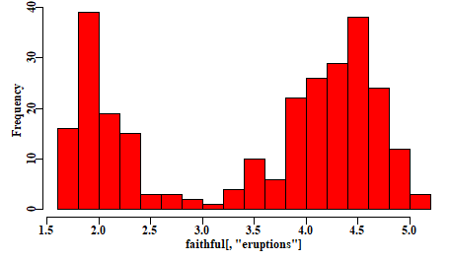

Figure 1: A quick example using the faithful eruption data to illustrate the use of fig_nums.

Yet nore text introducing the following equation.

The concept of confidence intervals (often 90% or 95% CI) is classically defined in Snedecor and Cochran (1967, 1989), and very many others, as:

Equ. 1:

$$\overline{x}±t_{ν}\frac{σ}{\sqrt{n}}$$

where $\hat{x}$ is the mean of the sample of $n$ observations, and we refer to **Equ 1**. Notice that I did not use a fullstop when refering to equation 1. Try running the macro with and without a fullstop to see why.