The Title of Your Document

Your Name

19. November 2019

Table of Contents

Introduction 1

Methods 1

# Introduction

ans <- matrix(rnorm(25),ncol=5,nrow=5,dimnames=list(1:5,1:5))

Table 1: 25 random normal numbers illustrating the use of tab_nums.

|  |  |  |  |  |  |
| --- | --- | --- | --- | --- | --- |
|  | 1 | 2 | 3 | 4 | 5 |
| 1 | -0.829 | -0.573 | 1.527 | -0.033 | -1.338 |
| 2 | -0.134 | -0.095 | 0.602 | -1.368 | 0.078 |
| 3 | 0.145 | 1.031 | 0.448 | -1.350 | -0.105 |
| 4 | 1.191 | -1.234 | -0.832 | 0.163 | -1.205 |
| 5 | 1.058 | 1.366 | 0.694 | 0.188 | 1.525 |

###### l I have defined the 6th level header with a small font and white ink

And here is a bunch of informative text.

# Methods

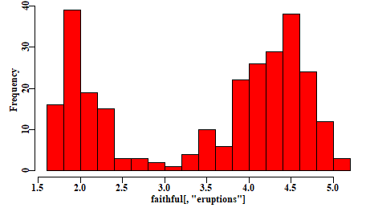

Figure 1: A quick example using the faithful eruption data to illustrate the use of fig_nums.

##### p and the 5th level header as requiring a page break beforehand

Yet nore text introducing the following equation.

The concept of confidence intervals (often 90% or 95% CI) is classically defined in Snedecor and Cochran (1967, 1989), and very many others, as:

Equ. 1:

$$\overline{x}±t_{ν}\frac{σ}{\sqrt{n}}$$

where $\hat{x}$ is the mean of the sample of $n$ observations, and we refer to **Equ 1**. Notice that I did not use a fullstop when refering to equation 1. Try running the macro with and without a fullstop to see why.

Of course you will need to provide your own reference document and modify the styles within that to get the formatting you desire.