|  |
| --- |
| CSIRO Oceans and Atmosphere |
| **Reducing the Number of Undefined Species in Future Status of Australian Fish Stocks Reports: Phase Two - training in the assessment of data-poor stocks**  **Malcolm Haddon, Paul Burch, Natalie Dowling,**  **and Rich Little**  *CSIRO Oceans and Atmosphere,* *GPO Box 1538, Hobart, TAS 7001, Australia.*  July 2019 DRAFT FRDC Project: 2017/102 |

[](http://frdc.com.au/research/info_for_curr_researchers/Pages/frdc_logos.aspx)

|  |
| --- |
|  |

National Library of Australia Cataloguing-in-Publication entry

ISBN: 978-1-4863-1288-7

FRDC Report: Reducing the Number of Undefined Species in Future Status of Australian Fish Stocks Reports: Phase Two - training in the assessment of data-poor stocks. FRDC Project 2017/102. Fisheries Research Development Corporation and CSIRO Oceans and Atmosphere, Hobart. By Haddon, M., Burch, P., Dowling, N., and R. Little (2019) - ONLINE

Notes: Includes bibliographical references.

Subjects: Data-poor fisheries stock assessment.

Author: Malcolm Haddon, Paul Burch, Natalie Dowling, Rich Little

Title: Reducing the Number of Undefined Species in Future Status of Australian Fish Stocks Reports: Phase Two - training in the assessment of data-poor stocks.

FRDC Project: 2017/102

Year of Publication: 2019

CSIRO. Oceans and Atmosphere.

© Copyright: Fisheries Research and Development Corporation (FRDC) and Commonwealth Scientific and Industrial Research Organisation (CSIRO) 2019.

This publication (and any information sourced from it) should be attributed to:

Haddon, M., Burch, P., Dowling, N., and R. Little (2019) *Reducing the Number of Undefined Species in Future Status of Australian Fish Stocks Reports: Phase Two - training in the assessment of data-poor stocks.* CSIRO. FRDC Final Report 2017/102. Hobart. 129 p.

**Creative Commons licence**

All material in this publication is licensed under a Creative Commons Attribution 3.0 Australia Licence, save for content supplied by third parties, logos and the Commonwealth Coat of Arms.

Creative Commons Attribution 3.0 Australia Licence is a standard form licence agreement that allows you to copy, distribute, transmit and adapt this publication provided you attribute the work. A summary of the licence terms is available from creativecommons.org/licenses/by/3.0/au/deed.en. The full licence terms are available from creativecommons.org/licenses/by/3.0/au/legalcode.

Inquiries regarding the licence and any use of this document should be sent to: [frdc@frdc.gov.au](mailto:frdc@frdc.gov.au).

**Important disclaimer**

The authors do not warrant that the information in this document is free from errors or omissions. The authors do not accept any form of liability, be it contractual, tortious, or otherwise, for the contents of this document or for any consequences arising from its use or any reliance placed upon it. The information, opinions and advice contained in this document may not relate, or be relevant, to a reader’s particular circumstances. Opinions expressed by the authors are the individual opinions expressed by those persons and are not necessarily those of the publisher, research provider or the FRDC.

The Fisheries Research and Development Corporation plans, invests in and manages fisheries research and development throughout Australia. It is a statutory authority within the portfolio of the federal Minister for Agriculture, Fisheries and Forestry, jointly funded by the Australian Government and the fishing industry.

|  |  |  |  |
| --- | --- | --- | --- |
| Researcher Contact Details | | FRDC Contact Details | |
| Name:  Address:  Phone:  Fax:  Email: | Malcolm Haddon,  CSIRO Oceans and Atmosphere, Castray Esplanade, Hobart, GPO Box 1538, Tasmania, 7001, Australia  03 6232 5097  Malcolm.Haddon@csiro.au | Address:  Phone:  Fax:  Email:  Web: | 25 Geils Court  Deakin ACT 2600  02 6285 0400  02 6285 0499  frdc@frdc.com.au  www.frdc.com.au |

In submitting this report, the researcher has agreed to FRDC publishing this material in its edited form.

**Contents**

1 Acknowledgments 4

2 Executive Summary 4

2.1.1 Background 4

2.1.2 Aims/objectives 5

2.2 Methodology 5

2.3 Results 6

2.3.1 The simpleSA R package 6

2.3.2 Implications for relevant stakeholders 6

2.3.3 Recommendations 6

2.3.4 Keywords 7

3 Introduction 8

3.1 Background 8

3.2 The Need for Data-Poor Stock Assessment Methods 8

3.3 Project Objectives 9

3.3.1 The Software Strategy 10

4 Methods 11

4.1 Species Selection and Data Preparation 11

4.2 Data-Poor Method Selection and Implementation 12

4.3 The Software Developed 12

4.4 The Workshops 13

5 Results and Discussion 14

5.1 The R Packages 14

5.1.1 The cede package 14

5.1.2 The simpleSA R package 15

5.1.3 Catch-MSY 16

5.1.4 spm surplus production modelling 16

5.1.5 aspm age-structured production models 17

5.2 The Workshops 17

5.3 Different issues in Different Jurisdictions 18

5.3.1 Unrepresentative Data 18

5.3.2 The Assessment of Minor Fisheries 18

5.3.3 The Weight-of-Evidence Context 19

5.3.4 The Characterization of Uncertainty 19

5.4 Lessons Learned 20

5.4.1 Project Limitations 20

5.4.2 Possibilities for Automation 20

5.4.3 The Utility of the R Packages 21

6 Implications 22

7 Recommendations 22

7.1.1 Further Developments 22

8 Extension and Adoption 22

9 Project Material Developed 23

10 Appendix 1: Staff 23

11 Appendix 2: Feedback from participants of the training workshop on data-poor stock assessment methods 24

11.1 Background: 24

11.2 Training materials were developed: 25

11.3 Collective feedback from the jurisdictions: 25

11.3.1 What were the benefits of the workshops to your team? 25

11.3.2 Are you interested in further workshops for your teams? 26

11.3.3 What could have been done better to achieve project outcomes? 26

12 References 28

13 Appendices 31

13.1 Introduction 31

14 *cede* - Catch Effort and Data Exploration 32

14.1 Data Exploration 32

14.1.1 The Addition of CPUE data 37

14.1.2 Plotting Sketch Maps of Lat-Long data 41

14.2 CPUE Standardization 43

14.2.1 Introduction 43

14.2.2 The Limits of Standardization 44

14.3 Methods 44

14.3.1 Initial Data Selection 44

14.3.2 Standardization 45

14.3.3 Alternative Standardization Strategies 50

14.3.4 The Use of GAMs 51

15 *catch-MSY* 55

15.1 Introduction 55

15.1.1 Which Stock Assessment? 55

15.2 Modified Catch-MSY 55

15.3 Some Formal Details 57

15.3.1 Empirical Harvest Strategies 57

15.3.2 Stock Reduction Analyses 58

15.3.3 The data-file format 59

15.3.4 SAFS Status 60

15.3.5 Other Potential Outputs from catch-MSY 61

15.3.6 Interpretation of the plotcMSY6 plot 64

15.3.7 Results from the Catch-MSY Analysis 65

15.3.8 Constant Catch Projections 68

15.3.9 Robustness of MSY Estimate 69

15.4 Significant Unknown Recreational Catches 71

15.5 Plausible Levels of Harvest Rate 75

15.5.1 Other Sensitivities 78

16 spm - Surplus Production Models 81

16.1 Introduction 81

16.1.1 Which Assessment to Apply 81

16.2 Surplus Production Modelling = spm 81

16.3 Application of the spm assessment 82

16.3.1 Are the CPUE data informative? 83

16.3.2 Fitting the spm Model 84

16.3.3 Fitting the Model to the Data 86

16.3.4 Is the Solution the Global Optimum? 90

16.3.5 Produce a Phase Plot 91

16.3.6 Generate Bootstrap Confidence Intervals 93

16.4 Discussion 97

16.4.1 Management Advice with spm 98

16.5 Appendix: Surplus Production Model Equations 99

16.5.1 Sum of Squared Residuals 100

16.5.2 Estimating Management Statistics 101

17 aspm - Age-Structured Production Models 102

17.1 Introduction 102

17.1.1 Which Stock Assessment? 102

17.2 Age-Structured Production Model 102

17.2.1 Introduction to ASPM 102

17.2.2 A Typical Workflow 103

17.2.3 An Example 103

17.3 A three parameter model 111

17.3.1 Testing the Robustness of the Model Fit 113

17.3.2 The Production Curve and Statistics 115

17.3.3 A Phase Plot 117

17.3.4 Characterization of Uncertainty 118

17.3.5 Management Advice with aspm 123

17.4 Appendix: Age-Structured Production Model Equations 124

17.4.1 Initiation of an Age-Structured Model 124

17.4.2 Biological Characteristics 124

17.4.3 Spawning Stock Recruitment Relationship 124

17.4.4 Stock dynamics 125

17.4.5 Likelihoods 127

18 References 128

# Acknowledgments

We wish to acknowledge and thank Carolyn Stewardson and all the State representatives for their assistance and support, especially when conducting the data-poor training workshops at each of their sites. The SAFS Advisory Committee also provided valuable discussion.

Special mention needs to be made of the Darwin Museum and the Charles Darwin University, who each made space available for the presentation and running of the Northern Territory workshop.

# Executive Summary

### Background

The Status of Australian Fish Stocks project is increasing the number of species/stocks to be included, but many of these new stocks may fall into the "undefined" category and, because they suggest a lack of assessment and management, they lower the overall impression of the state of fisheries management within Australia. The FRDC National Priority 1 has two targets relating to the "undefined" category. By 2020, the target is to increase the number of species covered in SAFS to 200, and at the same time, to reduce the percentage of stocks classified as undefined to less than 10%. Most major commercial species by value are already included in SAFS, so increasing that number to 200 will mean including many data-poor fisheries, making the achievement of both targets by 2020 difficult. An earlier project (2016-135) disarticulated the undefined category into sub-groups, at least one of which should be amenable to data-poor assessment techniques.

The Status of Australian Fish Stocks (SAFS) Reports bring together available biological, catch and effort information to determine the status of Australia’s key wild catch fish stocks across eight fisheries management jurisdictions. The reports are based on a consistent national reporting framework developed collaboratively by fisheries scientists across Australia. Almost one hundred fisheries scientists from eight jurisdictions, are responsible for producing the 83-species reports, with a further 52 fisheries scientists anonymously reviewing them. To achieve the goal of extending the number of species, however, requires the jurisdictions to perform additional assessments on many data poor stocks.

This current project is the result of consultation with the fisheries management jurisdictions to help them begin assessing data-poor stocks in a standardised manner, to provide seamless input into the SAFS assessment process. There is thus a need, within each jurisdiction, to identify which of the new species selected for inclusion in SAFS are likely to be classed as undefined and yet are still amenable to a data-poor assessment method. There have been many recent developments with data-poor stock assessment methods and there is thus also a need in all jurisdictions for staff training to develop more local expertise in these new methods, and to transfer suitable custom software for conducting such analyses. With the agreement of all parties involved, there is a need to then apply and document the particular assessment method used that permits a status determination for each species selected, thereby reducing the number of undefined species.

### Aims/objectives

There were four objectives to this work:

1. Of the species proposed for inclusion in the 2018 and 2020 SAFS reports, identify those which may be deemed 'undefined' in each jurisdiction and yet potentially amenable to a data-poor stock assessment.
2. In each jurisdiction with potentially 'undefined' species, arrange a training workshop for local staff using the candidate species from objective 1 to act as case studies for the application of suitable data-poor stock assessment methods.
3. Include the 15 potentially assessable species from SAFS 2016, as identified in Phase one of this project (FRDC Project 2016-135).
4. Ensure that at least the local scientists involved with SAFS assessments understand how to use the illustrated data-poor assessment methods to develop a defensible stock status report and, if required, associated management advice.

## Methodology

Seven data-poor assessment method training workshops were run in seven different jurisdictions (Tasmania, Victoria, South Australia, Western Australia, Northern Territory, Queensland, and New South Wales). Originally the workshops were to have been undertaken from March to the end of May 2018. However, the availability of project staff combined with the availability of people within the jurisdictions meant that time-table had to be extended into June.

Two open source R packages, ***simpleSA*** and ***cede***, were used in the workshops, with additional development of the software contained in each one continuing as experience in the different jurisdictions expanded. ***cede*** contained software to assist with data exploration (simple mapping and data summary functions) and with illustrating and comparing different catch-effort standardization techniques. ***simpleSA*** contained three main data-poor stock assessment techniques (catch-MSY, surplus-production modelling, and age-structured surplus production modelling) plus functions to assist with catch-curve analysis.

The workshops consisted of an introduction to the problems of assessing data-poor fisheries, potential solutions, and their implications for management. The workshops included an introductory lecture and then live demonstrations of the software with explanations of the limitations and assumptions of each approach, followed by hands-on use by participants using either data sets included in the packages or, ideally, their own datasets prepared before the workshops.

Initially the workshops were designed around the idea of being two days long, but after the first two workshops, this was altered to become three days (for all but the Tasmanian workshop, which required only 2 days). This allowed time for participants to more fully explore their data, to make brief presentations of analyses they had conducted, and to receive feedback on these from the workshop presenters and their own colleagues.

The workshops were well received by the participants and detailed feedback from the State jurisdictions on the benefits to the SAFS process, future training needs and areas for improvement is provided in Appendix 2.

## Results

### The *simpleSA* R package

An open source R package named ***simpleSA*** (as in “simple stock assessment”) was developed prior to the commencement of the FRDC contract. This was designed to contain three main stock assessment methods suitable for Australian conditions plus other additional routines or functions for conducting analyses of value in assessments. The three main methods considered were:

1. The catch-MSY methodology (Martell and Froese, 2013)
2. Surplus-production modelling (Prager, 1994, Haddon, 2011)
3. Age-structured production modelling (Punt *et al*., 1995)

Also included were some utility functions for conducting catch-curves.

The second package ***cede*** (as in “catch effort and data exploration”), was developed to provide a few tools to assist participants with data exploration to aid in understanding the factors influencing the fishery data they receive (e.g. by mapping their data, and plotting their data subdivided by years or areas or some other factor).

At each workshop participants successfully applied the methods to local data sets. Not all such analyses led to changing the status of undefined species, but where they stayed undefined, there was a good explanation provided for why the available data failed to provide sufficient information to determine stock status. The software developed and the methods introduced to participants were successfully applied in many instances, however, there were numerous datasets where the assumptions of the methods were violated. Most common were cases where there were major changes in management that broke the time-series of data (either catches, CPUE, or both). This has the capacity to lead to invalid or biased conclusions, but theory for dealing, for example, with broken time-series of catch rates is not yet available where this is confounded with a change in catchability.

### Implications for relevant stakeholders

Data-poor stock assessment techniques should not be automated as all require a good deal of local knowledge to understand and interpret their outputs. One result of their generally greater uncertainty is the need to conduct many more sensitivity analyses exploring the influence of the various assumptions made. This implies that, as such analyses will be on-going, some longer term investment in analytical capacity should be considered in the various jurisdictions that currently have limited assessment scientist capacity.

### Recommendations

The software introduced to workshop participants was successfully used in many instances, but those participants would benefit if the software was maintained and possibly further developed to include requested new routines and increased generality so that an array of special cases could be included. Participants stated they would continue to use the R packages, but were concerned that they would not be maintained into the future. Being open source and freely available, this should not be a large problem but is something that needs to be taken into account when planning the future of SAFS.

The capacity to conduct stock assessments varies greatly among the seven jurisdictions visited. The number of analytically minded fisheries scientists in some jurisdictions is now limited and the requirements of SAFS and the rising adoption of formal harvest strategies increases the risk that the number of stock assessments required in a jurisdiction could become unmanageable. Some jurisdictions have analysts on short term contracts, which in itself is a risk for any on-going assessment requirements.

### Keywords

catch-rates, CPUE, standardization, fisheries data, index of relative abundance, stock assessment methods, data-poor methods, catch-MSY, surplus production models, biomass dynamic models, age-structured production models, catch-curves.

# **Introduction**

## Background

The Status of key Australian Fish Stocks initiative, SAFS, has now produced reports in 2012, 2014, and 2016 (Flood *et al.* 2012, 2014, SAFS 2016; SAFS, 2018). The process of generating the 2018 reports for the species included is currently underway. Each year of the initiative, the number of species and fisheries brought under the SAFS umbrella has increased and 2018 and 2020 are expected to continue that trend. In fact, there is now an explicit objective to increase the number of species and fisheries covered. Unfortunately, given that most of the more common and valuable commercial species have already been included in SAFS, without some form of intervention, many of the new species/stocks may fall immediately into the "undefined" category through many of them being relatively minor low value fisheries with low, but not negligible, commercial catches. Some species are primarily recreational and currently the data available for characterizing such fisheries is limited or absent. This is unfortunate because such a potential increase in the number of undefined species may suggest a lack of assessment and management, and they lower the overall impression of the state of fisheries management within Australia.

## The Need for Data-Poor Stock Assessment Methods

In terms of being an explicit objective, the Fishery Research and Development Corporation’s ‘National Priority 1’ now has two objectives relating to the "undefined" category. The first is that by 2020, the number of species covered in SAFS should increase to 200, and the second is to reduce the percentage of stocks classified as undefined to less than 10%. Given that most new species and fisheries to be included in SAFS by 2020 will be data-poor, the two targets of increasing the number to 200 and having less than 10% undefined will be in conflict and difficult to achieve.

An earlier project (2016-135; Smith and Dichmont, 2017) attempted to disarticulate the undefined category into sub-groups (their objective 1) in an attempt to improve understanding concerning why fisheries remained undefined, and provide better guidance for dealing with them (their objective 2). They also considered the related concept of a negligible fishery, again to provide a better description of such fisheries and how they might be recognized.

Project 2016-135 considered the possibility of using data-poor versions of both biomass- and fishing mortality-based assessments as a means of reducing the number of undefined fisheries. However, it must be remembered that, with regard to SAFS status reporting, the primary performance measure of interest is the state of the stock’s biomass (it is not specified whether this should be spawning or mature biomass). Fishing mortality estimates by themselves have limited value in status determination, although when teamed with a classical analysis of yield-per-recruit, they can determine one form of over-fishing. There remains debate as to whether to include over-fishing in a status determination, and current (2018) arrangements focus primarily on the abundance of each stock relative to the unfished state or proxies for the same (<http://www.fish.gov.au/Summary/National-framework-for-status-reporting>; SAFS, 2016, 2018).

Whatever the case, there remained a need, within each jurisdiction, to identify which of the new species selected for inclusion in SAFS in 2018 or 2020 are likely to be classed as undefined and yet still be amenable to a data-poor assessment method. Once identified it might then be possible to find forms of stock assessment to assist with addressing the problem of achieving both new objectives in the National Priority 1.

As noted in Smith and Dichmont (2017) “It is important to note that our finding that 15 (or 19) stocks may be assessable is a judgement call, based on our own experience and a reading of the status reports combined with examining the catch trends. … It will not be possible to judge the quality of our evaluation until further assessments are undertaken as part of phase 2 of the study to categorise undefined.”

Essentially, this means that when a fishery is data-limited, then one cannot confidently determine whether a fishery can be successfully assessed, and a status determination made, without conducting such an assessment. Simple stock assessments could be readily applied in many instances, but what matters is whether they can validly draw conclusions about the state of the stock and how that might be changing. This is an important statement of the limits of rapid reviews. Rather than make judgement calls, what may be possible is to identify what type of assessment might be applicable to whatever data is available, but to reserve judgement until after the selected assessment method(s) have been applied. This means that the first objective of this project (see below) could only ever be partially achieved through identifying which species were to be included in the 2018 or 2020 SAFS reports and, if the fisheries data were available, asserting they may potentially be amenable to assessment. In short, if fisheries data consisting of catches, and maybe an index of relative abundance, were available, then determining whether they could be assessed successfully or not could only be achieved by attempting to assess them.

All species and fisheries identified as undefined are also likely to be classified as data-poor or data-limited. Hence, any efforts made to determine a stock status for such fisheries would need to be able to operate with limited or poor-quality data. Fortunately, there have been many recent developments with data-poor stock assessment methods (Carruthers *et al*., 2014; Geromont and Butterworth, 2014; Haddon *et al*., 2015). The SAFS initiative has also identified a need in all jurisdictions for staff training to develop more local expertise in such new methods, and to transfer suitable custom software for conducting such analyses. As a result, this present project (2017/102) was envisaged to identify and produce suitable, relatively simple-to-use, software, and to provide training workshops in each jurisdiction. In this way, the different jurisdictions would be given the tools with which to attempt to achieve the two National Priority 1 targets.

## Project Objectives

1. Of the species proposed for inclusion in the 2018 and 2020 SAFS reports, identify those which may be deemed 'undefined' in each jurisdiction, and yet potentially amenable to a data-poor stock assessment.
2. In each jurisdiction with potentially 'undefined' species, arrange a training workshop for local staff using the candidate species from objective 1 to act as case studies for the application of suitable data-poor stock assessment methods.
3. Include the 15 potentially assessable species from SAFS 2016, as identified in Phase one of this project (FRDC Project 2016-135).
4. Ensure that at least the local scientists involved with SAFS assessments understand how to use the illustrated data-poor assessment methods to develop a defensible stock status report and, if required, associated management advice.

### The Software Strategy

The original intention had been to be very flexible and to use a newly developed decision support tool *FishPath* (Dowling *et al*., 2016) to assist in identifying suitable stock assessment techniques for the data available for each stock. A wide range of methods have been developed to provide for the stock assessment of data-poor fisheries. An incomplete list of such methods includes those that:

a) are ERA related methods, such as sustainability assessment for effects of fishing (SAFE; Zhou *et al*., 2008) where suitable spatial data are available but little else (area of overlap of the fishery with the species distribution is used as proxy for sustainable);

b) are for truly data-poor situations, such as when catches are sporadic and effectively nothing else is known about the fishery/stock. These can still develop estimates of catch (or other) triggers, and if catches (or other performance indicators) remain below these triggers, the stock can be assumed to be in a sustainable state (consistently low catches are used as a proxy for sustainability);

c) relate to estimating fishing mortality (e.g. modified catch-curves), though these do not provide a stock status in the SAFS sense, except where consistently low fishing mortality is used as a proxy for sustainability (although this would require many years of age composition data);

d) provide an index of relative abundance in the context of an empirical harvest strategy (catch-rate gradients and the use of reference periods, for example, can still generate management advice and determine stock status if the reference periods are used as a proxy for sustainability);

e) include more sophisticated methods that can be termed model-assisted data-poor stock assessments that are reliant only on a catch time series plus assumptions about stock dynamics that are encapsulated within a simple model (assumes the model’s dynamics approximates the real world dynamics).

f) include slightly more sophisticated models that use both catch and CPUE data with either very simple models of dynamics or age-structured dynamics, plus many assumptions.

Each of the data-poor approaches described in *FishPath* would be made in the context of a weight-of-evidence argument in defence of the conclusions drawn. In each of the options above that use a proxy for stock abundance, an extra weight-of-evidence argument would be needed to support the notion that the proposed proxy for sustainability was valid and defensible.

Unfortunately, a training strategy based on picking among the wide range of assessment options suggested within *FishPath* (Dowling *et al*., 2016) would have led to workshops that would need to be relatively general and wide ranging so as to cover off on the full range of methods available, many of which are aimed at truly data-poor species, many empirical harvest control rules, and the common use of proxies rather than assessments of stock dynamics. Given the time constraints required to be able to visit all jurisdictions before the 2018 SAFS reports were due, and the need to produce as many results as possible in such a brief time, it was belatedly decided to select a constrained array of data-poor assessment methods that would explicitly meet the needs of the SAFS status determination with a minimal use of difficult to defend proxies and fit in with as many different Australian fisheries as possible.

This direction was selected on the assumption that the simpler assessment methods (a – d, above) were already easily available and relatively simple to understand and implement.

# Methods

## Species Selection and Data Preparation

The initial idea for meeting the proposal's first objective was to first conduct a characterization of proposed new species to select the most suitable candidates for further exploration of assessment methods and eliminate ‘negligible’ and truly ‘undefined’ species (no useful data) from further consideration. In early 2018, the notion of ‘negligible’ was still to be given a formal definition within the SAFS framework (there is one now at the time of writing; SAF, 2018). The SAFS Advisory Committee, with members from each jurisdiction, confirmed a list of new (and previously listed – see Objective 3) 'undefined' and potentially 'undefined' species to be considered.

There is now a working definition of ‘negligible’ species: negligible stock — indicates that catches by all fisheries are so low as to be considered negligible, and that inadequate information exists upon which to base a status classification (SAFS, 2018). However, this is limited as an operational definition as it fails to clarify what constitutes ‘low catches’ or what can be ‘considered negligible’. On the other hand, determining whether there was sufficient adequate information on which to base a status classification is one of the outputs of this current project for each stock considered.

After identifying which species might be considered for inclusion into the 2018 and 2020 SAFS reports and then be ‘undefined’, the intention was to try to identify which might potentially be amenable to assessment. But of course, merely looking at columns of data is not enough to determine such a thing. The only way of doing this is to have local knowledge of what changes in the time-series of catches, and (ideally) an index of relative abundance (e.g. CPUE), might mean in terms of changes in the fishery, management, and environment. Without such local knowledge the possibilities for misinterpreting changes are manifold and the only way to determine whether a stock can be assessed or not is to try to assess its current state.

Originally, after identifying which species might be considered for inclusion into the 2018 and 2020 SAFS reports and then be ‘undefined’, the intention was to try to identify which might potentially be amenable to assessment. But of course, merely looking at columns of data is not enough to determine such a thing. The only way of doing this is to have local knowledge of what changes in the time-series of catches and (ideally) an index of relative abundance (e.g. CPUE) mean in terms of changes in the fishery, management, and environment. Without such local knowledge the possibilities for misinterpreting changes are manifold and the only way to determine whether a stock can be assessed or not is to try to assess its current state.

The original notion was that workshop dates would be organized in each jurisdiction and then, following the initial characterization of the species/fisheries identified as potentially undefined, the jurisdictions would collate all available data relating to those species prior to the workshops and send it to the project team for screening. However, without running the possible analyses, or even seeing the data in some cases, it is not possible to determine ahead of each analysis whether such data would be amenable to facilitating a status determination.

Furthermore, some jurisdiction were only able to arrange to have their data available as a whole in preparation for conducting the SAFS assessments. The expectation that the different States and Territory would be able to extract only the data for their proposed and potentially undefined species prior to the workshops turned out not to be a workable strategy.

In addition, as became clear in the workshops, interpreting such data without the local knowledge available in each jurisdiction concerning the development of each fishery would most often lead to errors when applying assessment methods. For example, there were many cases where catches dropped significantly due to management intervention rather than an inability to catch the species. Knowing this or other details can lead to a completely different interpretation of even a simple assessment’s outputs. The assessment analyses and status determinations could only occur in and after the workshops had introduced the participants to the data-poor methods available along with their assumptions concerning the data put into them.

To alleviate this potential problem of having the available data ready for analyses in the workshops, data templates, with instructions on their use, were designed to facilitate the running of the software put together for the data-poor stock assessment workshops. These templates were distributed to each jurisdiction and they were then expected to prepare such data sets their subset of the list of the new, potentially undefined species for inclusion in the upcoming SAFS reports.

## Data-Poor Method Selection and Implementation

The workshops were originally designed to be two days long, and in such a limited time it was necessary to pre-select a small number of data-poor stock assessment options to introduce to the participants. There are many different potential methods available (Carruthers *et al*., 2014; Geromont and Butterworth, 2014; Haddon *et al*., 2015) but rather than review the current wide range, the focus remained on producing and introducing a software tool that would be useful now and for continued use into the future. In addition, the methods needed to be relatively easily extensible in the future should that be required (as seemed likely). Although the methods selected are all relatively simple (catch-MSY, surplus production models, age-structured surplus production models, and catch-curves), they still have an array of assumptions and limitations with which the participants needed to be conversant. This, combined with the wish to apply these methods to as many local species as possible, as well as introduce a set of data exploration methods and provide an introduction to the field of CPUE standardization, meant that even with three days the workshops remained relatively intense.

## The Software Developed

Software suitable for conducting the different analyses was developed and implemented as an R package (R Core Team, 2018; RStudio, 2017; Haddon *et al*., 2018) called ***simpleSA*** (for simple Stock Assessment). One advantage of using an R package is that it embeds seamlessly into the broad statistical and computational ecosystem included in the open source, freely available software R, and is relatively simple to use within another free software system known as RStudio (R Core Team, 2018; RStudio, 2017). R packages are essentially a way of encapsulating an array of software functions designed to do particular analyses. These can be combined in a wide variety of ways, allowing a great deal of flexibility in what it is possible to complete. A key advantage of such a system is that each function has its own help information, along with worked examples, to clarify the use of the function. In addition, longer and more detailed documents, known in R as “vignettes”, were produced for each of the major methods included. The vignettes for the catch-MSY, the surplus production modelling, and the age-structured surplus production modelling methods are given as appendices to this document, to illustrate the detail it was possible to include concerning how to use the software, and what to expect it to generate as output. The vignettes were important components of the workshops as they include some details on how to interpret the outputs and raise issues that require attention when using the methods. In addition, they can act as self-training resources with new users, or refresher material for those with previous experience.

## The Workshops

The intent, in line with objective 4, was for the P.I. supported by at least one member of the project team, to attend each workshop, run through the ideas behind the use of data-poor assessment methods, explain and illustrate the use of the methods included in the ***simpleSA*** R package, and then assist the local assessment scientists to apply the methods to as many species’ data sets as possible in the time available, explaining how one might defend such assessments in a weight-of-evidence argument to support a status determination.

Seven workshops were run in seven different jurisdictions from March to June 2018 (**Table 1**).

**Table 1.** The start and end dates and number of attendees for the data-poor stock assessment methods workshops in each jurisdiction.

|  |  |  |  |  |
| --- | --- | --- | --- | --- |
| **Jurisdiction** | **Start** | **End** | **Days** | **Attendees** |
| Northern Territory (Darwin) | Tues 20th March | Wed 21st March | 2 | 4 |
| New South Wales (Port Stephens) | Wed 28th March | Thu 29th March | 2 | 17 |
| Tasmania (Hobart) | Thu 10th May | Fri 11th May | 2 | 10 |
| Victoria (Queenscliff) | Wed 16th May | Fri 18th May | 3 | 8 |
| South Australia (Adelaide) | Wed 23rd May | Fri 25th May | 3 | 10 |
| Western Australia (Perth) | Mon 28th May | Wed 30th May | 3 | 34 |
| Queensland (Brisbane) | Tue 5th June | Thu 7th June | 3 | 18 |

The first workshop in Darwin made it clear that the intention of presenting training in data-poor stock assessment methods was rather too limited, in that it had missed the point that many jurisdictions were also requesting assistance with how to approach initial data exploration and CPUE standardization. Such techniques are essential when selecting and pre-processing data prior to the application of any stock assessment method (not only data-poor methods).

In response to this need, a second open source R package called ***cede*** (for catch effort and data exploration) was quickly put together, and, while parts were presented in Darwin, it was only formally presented for the first time in Port Stephens, NSW. Thereafter, it proved useful in all other jurisdictions, although Tasmania already had procedures in place for CPUE standardization and so it was not used extensively there (hence the two-day workshop). The vignette associated with the ***cede*** package is also included as an appendix to this document.

After the initial workshops in the Northern Territory (Darwin) and New South Wales (Port Stephens) it also became clear that two days was insufficient time to get through the required material and have sufficient time to allow the participants to begin to make sufficient progress applying the methods to explore and analyse their own data sets concerning their own species. After explaining this, Victoria, South Australia, Western Australia and Queensland all agreed to three-day workshops. This proved to be a positive change, as it allowed many more species to be considered, and allowed more time for the participants to assimilate the materials and apply the methods to their own species. Instead of relatively rushed meetings, there was time for more detailed questions from the participants concerning particular cases, which could then be used to illustrate detailed points concerning the application of these data-poor methods to the whole workshop. In the last four workshops, there was also time for a session where participants demonstrated to each other, and to managers, the application of the methods on their local species. These brief presentations were of both those analyses that had yielded informative assessments (a defensible SAFS status determination as well as on-going management advice), but also examples demonstrating where the available data were incapable of providing a valid assessment of the stock in question. The principle in those cases was that if a stock were to remain undefined, the analyst would now be able to defend and explain the reason for it not being able to be assessed.

The workshops required a large enough room with a data projector so that each participant had sufficient room for themselves and their computer. Otherwise, all that was required was for each participant to already have R and RStudio installed, along with the ***simpleSA*** and ***cede*** packages. In fact, each visit to a different jurisdiction motivated modifications to both packages to improve their flexibility and generality. Thus, quite often newer versions of each package were made available at successive meetings. These changes led to very little time being wasted because another advantage of R packages is that installing them takes very little time.

# Results and Discussion

## The R Packages

### The *cede* package

It is now standard practice when using catch-per-unit-effort (CPUE) data in a stock assessment to conduct a CPUE standardization on the raw data, so as to obtain yearly indices of relative abundance that have had the influence of factors other than relative stock size accounted for (assuming one has data relating to those factors). So if, for example, fishers change their behaviour from fishing mostly in summer months when CPUE is high, to fishing mostly in the winter months when CPUE is lower but prices are much higher, the month of fishing can be taken into account and the apparent reduction in relative abundance can be corrected. In this way, the influence of such behavioural changes can be removed and the assumption is made that what remains is closer to any trend that exists in the relative abundance of the fish stock.

Workshop participants expressed interest on building on their existing knowledge of how best to conduct a statistical standardisation of raw CPUE records. While the literature on CPUE standardization is very extensive, much of it is in the so-called grey literature, and there is no single agreed best approach for conducting such analyses. Thus, instead of concentrating only on a single approach, a strategy of illustrating a range of approaches and their differences to the workshops was adopted in the open source R package ***cede*** (Haddon, 2018). Thus, no attempt at a complete treatment of standardization techniques was attempted. Nevertheless, following that strategy led to comparisons being made between simple linear models, generalized linear models, and generalized additive models (LMs, GLMs, and GAMs). Alternatives to these were also pointed to but not illustrated due to limited time. It needs to be emphasized that what is provided in ***cede*** is merely a simple introduction to a small sub-set of the methodologies available. A full treatment would take a great deal of time. Nevertheless, the examples given illustrate that CPUE standardization need not be as complex to implement as many appear to believe.

Prior to going through the alternative CPUE standardization methods, simple data exploration techniques were also discussed. These included different ways of tabulating fisheries data. In particular, the catch by vessel view of each fishery can be enlightening concerning changes that have occurred within each fishery. In addition, simple sketch mapping of location data was illustrated as another rapid way of detecting periods of major change within a fishery. Functions for plotting histograms of continuous variables (such as the distributions of depth of catches, the distribution of CPUE through years, and the distribution of effort), and how these variables changed from year to year were also illustrated. Details of these materials are provided in the ***cede*** vignette in the appendix.

Rather than implementing stock assessment methods directly, the ***cede*** package thus contains functions that facilitate the exploration of whatever data is available, and also illustrates some of the many alternative approaches to the standardization of CPUE data. The utility functions include simple sketch mapping functions, and data summary and plotting functions that aim to simplify understanding any spatial, and, particularly, temporal heterogeneity in one’s data.

Many more details and examples of how to use the available functions are provided in the appendix containing the vignettes, with the ***cede*** vignette being the first.

### The *simpleSA* R package

An open source R package named ***simpleSA*** (as in “simple Stock Assessment”; Haddon *et al*., 2018) was developed prior to the commencement of the FRDC contract. After the first workshop, a second package named ***cede*** (as in “catch effort and data exploration”) was also produced. As more was learnt about the array of State based fisheries by attending each workshop, further developments and more detailed documentation were developed and included in both the ***simpleSA*** and the ***cede***packages, with most emphasis on ***simpleSA***. The main package went through 14 different versions during the seven different workshops. Now the workshops are completed, further developments aimed at including some of the requests made during the workshops still are occurring during the current project write-up (it is now up to version 0.1.18).

***simpleSA*** was designed to contain three main stock assessment methods suitable for Australian conditions plus other additional routines or functions for conducting analyses of value in assessments. The three main methods considered were:

1. The catch-MSY methodology (Martell and Froese, 2013)
2. Surplus-production modelling (Prager, 1994, Haddon, 2011)
3. Age-structured production modelling (Punt, 1995)

In addition, some utility functions for conducting catch-curves are also included.

The ***simpleSA*** package was designed to provide the analytical tools needed for an array of workshops that were run around the country in the different jurisdictions (**Table 1**).

### Catch-MSY

The catch-MSY method (Martell and Froese, 2013; Froese *et al*., 2017) is just one of a number of methods that only requires a time-series of catches from a fishery (Zhou *et al*., 2017). Such limited requirements would appear to promise many opportunities for assessing currently undefined stocks. However, as concluded by Carruthers *et al*., (2014):

*For most life-histories, we found that methods that made use of only historical catches often performed worse than maintaining current fishing levels. Only those methods that dynamically accounted for changes in abundance and/or depletion performed well at low stock sizes. Stock assessments that make use of historical catch and effort data did not necessarily out-perform simpler data-limited methods that made use of fewer data. There is a high value of additional information regarding stock depletion, historical fishing effort and current abundance when only catch data are available.* Carruthers *et al*., (2014, p 48)

In Australia, part of the reason for the poor performance of catch-only methods is that catches are influenced by many factors other than abundance, including management changes, and other causes of changes in fisher behaviour. As repeated numerous times in the workshops, even though the catch-MSY can generate estimates of MSY, current depletion and fishing mortality, and thus determine a stock status, because of its inherent uncertainty it should be regarded as the formal stock assessment of last resort. There are many circumstances where the outputs can appear to make sense but in reality are invalid. For example, there was more than one species whose catch time-series had exhibited primarily increasing catches up until the present day. The catch-MSY needs the catch time-series to exhibit contrast through time (i.e. it should increase but also decrease). The method also makes the assumption that any on-going declines in catch are due to earlier catches depleting the stock, and thus it becomes unable to maintain catches as large as have been experienced in the past. Without significant and on-going decreases in catch it cannot validly estimate any useful statistics. Many more details of the use and limitations of this method are given in the appendix of the vignettes.

### spm surplus production modelling

Surplus production modelling has a longer history, with the methods first being described in detail by Schaefer (1954, 1957). It treats the stock biomass as an aggregated mass and ignores details such as length or age-composition. It is a method that is well covered in the literature (Polacheck *et al*., 1993; Prager, 1994; Haddon, 2011). It was selected as a data-poor method as it only requires time-series of total catches and of an index of relative abundance (most often CPUE in Australia). This is a model-assisted data poor method and two versions of the modelled dynamics are available. The first was by Schaefer (1954, 1957) and the second by Fox (1970, 1975). Full details and the equations of the model options are provided in the appendix of the vignettes.

### aspm age-structured production models

Age-structured production models again require time-series of catches and CPUE (or another index of relative abundance). However, they also require some biological information such as estimates of natural mortality, age at maturity, length at age, weight at length at age, and perhaps selectivity at age. Strategies for what to use if some of those biological data requirements are missing or vague are discussed in the vignette.

Age-structure models have a long history in population dynamics (Lotka, 1925) but were developed much further in the 1980s and 1990s so as to be fitted to catch and CPUE data, combined with biological information concerning growth, maturity, selectivity and recruitment (Fournier and Archibald, 1982; De La Mare, 1989; Francis, 1992; Punt 1994, Punt et al, 1995). However, with the on-going development of such models to include age- and length-composition data (and other data sources) the simpler age-structured production models became far less used. With their limited data requirements, these constitute the most sophisticated ‘data-limited’ assessment models included into ***simpleSA***. Once again, full details and the equations of the model options are provided in the appendix of the vignettes.

Both R packages are freely available. Currently they are available in a shared DropBox folder although this will likely change to a publicly open BitBucket directory hosted by CSIRO. DropBox is not necessarily accepted by a number of the State fishery organisations, so the BitBucket option may be simpler for users to work with. Eventually at least ***simpleSA*** may be put onto the CRAN (Comprehensive R Archive Network) – which, along with GitHub, is the standard repository for R packages. Recently, a branch of ***simpleSA*** called ***datapoorSA*** has been developed somewhat further (with the addition of age-structured stock reduction analysis, useful for exploring the effects of future catches on exploratory fisheries). This is freely available for installation from [**https://github.com/haddonm/datalowSA**](https://github.com/haddonm/datalowSA) should there be issues with obtaining the software elsewhere.

## The Workshops

Two of the seven workshops occurred in March, four in May, and the final one at the start of June (**Table 1**).

The number of participants in each workshop ranged from five to thirty-four participants, although in each case, some people only attended for part of each workshop. This was especially the case for fisheries managers interested in hearing the introductory material but less interested in the more technical details concerned with conducting the stock assessments and interpreting their outputs.

Both the Darwin- and Hobart-based workshops were challenged by extreme weather events, with Cyclone Marcus occurring the weekend before the workshop occurred in Darwin, and very heavy rain with associated flooding and disruptions in Hobart. Fortunately, in both locations the venues available remained open and the workshops could continue, albeit with somewhat reduced numbers attending. The Darwin workshop was most heavily impacted as the Fisheries offices were closed and their computer servers were down, so that the local fisheries data available in the workshop was restricted to only two species. Assistance was provided by the Darwin Museum and the Charles Darwin University who each made space available for the presentation and running of the workshop. That workshop would have failed had they not been so generous with their space.

## Different issues in Different Jurisdictions

### Unrepresentative Data

Although the different jurisdictions shared many of the same problems with their fisheries data in general, they also have issues idiosyncratic to the assessments of their own particular data-poor fisheries. In the Northern Territory, for example, there appear to be very many relatively local but distinct biological stocks of the same species across the jurisdiction. One important cause of fisheries being data-poor is the occurrence of marked spatial heterogeneity, making it very difficult to obtained representative data. This is very apparent in the Northern Territory, although local practitioners have yet to explore what happens when such small-scale stocks are combined.

Western Australia and Queensland have what might appear to be the opposite problem, which is that they have small fisheries spread over enormously extensive stretches of coastline. Once again, under such circumstances, obtaining representative data is very difficult.

In Victoria and New South Wales, (and Western Australia) there is the issue of large proportions of the total catch of commercially important species being taken by recreational fishers. In the appendices, under the catch-MSY methodology there is a section on “Significant Unknown Recreational Catches” (section 14.4 on page 67), which discusses the effect of unknown recreational catches on the outputs from the data poor methods. Fortunately, the estimate of stock depletion does not appear to be adversely affected by an unknown proportion of the total catch being taken by recreational fishers. These results have also been demonstrated for more sophisticated stock assessments (Rudd and Branch 2017). That remains a valid conclusion even if there is a relatively strong trend in the proportion of recreational catches through time.

### The Assessment of Minor Fisheries

Such issues also raise the question of what constitutes a negligible or minor fishery (negligible was undefined at the time of the workshops) and led to much discussion regarding the subject. This was important in helping to understand what was required before even a simple data-=poor assessment method could be validly applied. An annual fishery of five to 20 tonnes spread over 20 - 50km of coast may be sufficiently focussed as to allow for the collection of representative data and a stock assessment that would suffice to determine a stock’s status. However, if catches drop below that level in various years, the total number of records generated in each of those years may be so low as to preclude them from being representative of anything about a fish stock. For example, if there are less than 50 catch records, there could be less than a record a week, and the records that are available are likely to be clumped in time, increasing the potential for bias. While such data, when summarized into yearly totals or averages, may be accepted by an assessment method, because of the risk of bias in the samples (through them being unrepresentative) any output from such an analysis seems likely to be invalid. The difficulty of knowing when there was bias is why this increases the risk of drawing incorrect inferences. This was the primary reason for developing the data exploration part of ***cede***. This problem would be exacerbated if, for example, a five or more tonne small fishery was spread over 1000km instead of only 50km. Extending those low catches over 20 times (or more) the coastline would imply a very low density of catches over an enormous area, making data collection both difficult and unrepresentative. The concept of a negligible or un-assessible fishery perhaps needs to be articulated further, so as to account for the density of a fishery as a major factor when determining its scale.

It is certainly the case that there exist a number of example fisheries in many of the jurisdictions where the data available are inadequate to provide for a status determination. This is at least part of what it takes for a fishery to be accepted as negligible. It would appear that the intent of this clause in the definition of negligible is that the data inadequacy must stem from the lack of suitable data rather than that it simply not be suitable for determining a status. Thus, just because a time-series of data may lack contrast and hence provide little information about stock size changes through time, is not sufficient to claim the fishery to be negligible. On the other hand, if the fishery has been short lived, or is still developing and the catches to date have been relatively minor, then a case could be made that such catches as there had been were insufficient to make an apparent impact on the stock dynamics, and hence the fishery could be claimed to be negligible (whereas what is really intended is that it is un-assessible). In addition to the notion of a negligible species there may be value in exploring the notion of an un-assessible species. The idea that all species should be assessible needs to be explicitly recognized as being incorrect.

### The Weight-of-Evidence Context

Each of the data-poor methods can produce an assessment, but in each case the results output by each set of method-related functions (see appendix) still need to be placed in the context of a weight-of evidence argument. By their nature, data-poor assessment methods are inherently uncertain, especially those that only use catch history data. Using the catch-MSY does not involve fitting any parameters; instead, it relies on constraints placed upon what are deemed to be plausible stock biomass trajectories in the underlying stock reduction analyses.

What this means is that for an assessment to be defensible, ideally, it is necessary to conduct an array of sensitivity analyses that change the various inputs to each model to determine how sensitive the assessment is to the assumptions underlying each method. For example, with the catch-MSY method, one should examine the effect of varying the assumed initial and final depletion level, or the effect of setting an upper limit on the plausible annual harvest rates. For the surplus production models, sensitivity analyses might involve comparing the outputs from using the Schaefer model of dynamics with the dynamics as described by the Fox (1970, 1975) model (Haddon, 2011; see appendix). In addition, when fitting parameters to either a surplus-production model or an age-structured production model, one should also test the robustness of the solution. This determines whether the solution is merely one of many local minima or has the appearance of a global minima. Each such approach to testing the validity and robustness of the model fitted should provide insights into the robustness of, and confidence in, the model outcomes.

### The Characterization of Uncertainty

Finally, it is necessary to characterize the uncertainty contained within an assessment. For the catch-MSY the range of plausible parameter combinations (giving rise to trajectories which are consistent with the constraints imposed) can be interpreted as biomass trajectories or depletion trajectories. By summarizing across these it is possible to characterize how uncertain the result are. In projections, however, this uncertainty leads to a need for relatively low catches to be taken, for the proportion of trajectories less than the limit reference point to begin to decrease. The catch-MSY is, in this way, naturally conservative, although such methods are often biased in a non-conservative direction.

With the surplus-production and age-structured surplus production models, bootstrap functions are provided that can be used to generate percentile confidence intervals around mean estimates of depletion, MSY, biomass trajectories, and any other model outputs. Each of these should assist in the weight-of-evidence argument concerning the stock status conclusion from each assessment.

## Lessons Learned

### Project Limitations

This project was designed to expand knowledge of data-poor stock assessment methods (and provide associated software) to jurisdictions undertaking increased assessment activity with data-poor fisheries. It did this is a relatively short timeframe. What success it has had reflects the changing needs of analytical capacity in fisheries, particularly for data-limited fisheries. This need has increased in recent years due to the increased pressure for public accountability concerning the sustainability of current catches, which requires that organisations tasked with assessing and managing natural marine resources do so in a defensible manner.

Strategically, this project was an important initiative on the part of the different fisheries jurisdictions, the SAFS advisory committee, and the FRDC. On the other hand, its constrained timeline meant that while it managed to achieve its intent, a longer term, more strategic approach could have achieved a good deal more. With hind-sight, it would have been beneficial had the workshop team, or even an individual, remained in each jurisdiction for another day or so to directly assist individuals as they came to grips with their own species. The limited duration of each workshop meant that, in all cases, taking individuals through to completion of their assessments was rare or extremely limited.

The reality of Australian fisheries is that with such a large country, containing so many low-value relative to high-value fisheries, the inefficiencies and low cost-effectiveness precludes maintaining a high level training facility for fisheries stock assessment. Yet the need for stock assessment capacity building in Australia is an on-going issue, which, given the expected exit of the older generation of fisheries scientists that is currently underway, is likely to get worse rather than better. Unfortunately, no simple solution presents itself but given the on-going need to assess low value, data-limited stocks this problem of analytical capacity will also be on-going.

### Possibilities for Automation

It is possible to almost completely automate the use of empirical harvest control rules within empirical harvest strategies used to generate management advice. This is because an empirical harvest control rule should be able to have the fishery performance measure (CPUE, mean length, or whatever measure is being used) input to the control rule, and management advice should then be produced without intervention. The Tier 4 harvest control rule (Little *et al*., 2011; Haddon, 2014) within the SESSF is an example of such an analysis. Such harvest control rules can have many options (different limits and targets, with discards or without, alternative reference periods) and so automation may not always be simple or possible if new assessment options are requested, but for many fisheries, once they are set up, little would need to change.

On the other hand, as soon as an attempt is made to account for and understand a fished stock’s real world dynamics using a formal model, then automation of the assessment process becomes impossible. Such an understanding of the dynamics would be required if one wanted to project those dynamics forward when generating management advice; for example, as to the implications of different levels of effort or catch. To understand the implied dynamics given by an assessment’s outputs requires local knowledge of the operation of a fishery and of the biology of the species involved.

There appears to be current interest being expressed in Australia to try to simplify and automate stock assessments. However, for the three main methods included in ***simpleSA*,** such automation is not possible while still ensuring a valid and defensible assessment each time. The use of the R functions in ***simpleSA*** (and from elsewhere) can certainly simplify and speed up the assessment process, making the analyst more efficient, but because there is a need to interpret the data going into the analysis and the implied dynamics of different stocks to make sensible management advice, this requires an interactive and responsive approach that reacts to how each stage of an assessment proceeds. Even once an assessment is set up and only needs to be updated each agreed assessment time-step by including the most recent data, the additional data can alter the stability properties of each model, so care needs to be taken to test such updates for changes in the stability and robustness of the assessment outputs. Such interpretative processes cannot yet be automated.

It should nevertheless be possible to automate data extraction, although the data characterization, subsequent data selection and possible CPUE standardization should still require an adaptive responsiveness to how each analysis proceeds.

Wherever sensitivity analyses or the characterization of uncertainty is required this should also need to proceed in an interactive, heuristic, and interpretive fashion. Repeatedly in the workshops it became clear that, without local knowledge of each fishery and the resulting statistics, it would not be possible to conduct a valid analysis of most data sets.

It should be noted that even the simplest of stock assessments that attempt to model a stock’s dynamics cannot be successfully automated. All the data poor methods are intrinsically less certain than more sophisticated methods that can include more data from the fishery. The increased uncertainty obtained with data-poor assessments means that, to produce a defensible assessment, it is best to conduct an array of sensitivity tests to examine the effect of selecting different initial conditions or different initial parameters. In this way even the data-poor assessments can take an appreciable time to conduct for each species, and invariably need to be conducted in an interactive manner.

### The Utility of the R Packages

The workshop participants appear to find the R packages a convenient vehicle for the transmission of these stock assessment approaches. The R packages include built-in help for each function (usually with a worked example).One can see the structure of each function (it is open source software), and more detailed vignettes were written containing expositions on the use of the methods and how to string the syntax together in worked examples (see the appendices). Such packages mean that after attending an introductory course, participants should be able to return to the packages at any time and remind themselves of how to use the methods and quickly make sense of R scripts they may have saved one or more years before. In this way the R packages will hopefully be utilised into the future.

The ***simpleSA*** package was first put together before the project formally started and as such was relatively limited in its scope. While it was improved through the period of giving the workshops and further developments are still occurring, there were an array of extra requests for analytical options to be added to the base package. Some jurisdictions were also concerned about whether the R packages would be receiving on-going support and maintenance. Some kind of on-going support would mean that if anyone had an issue they wanted addressed within the software, they would have someone to approach. Such support could even take the form of some organisation taking on the responsibility of receiving such requests for aid or modifications, and then proposed changes could be considered by the SAFS advisory committee and actioned if deemed of general interest.

One reason for choosing R as the language for programming the different methods was that R is free to everyone, but also that the resulting packages are open source. What this means is that if one group or person ceases to actively maintain a package it is not impossible for others to pick up that task. All of the code is available within the package itself, (in fact, it is all only fully available in the .tar.gz version of ***simpleSA*** because that version includes the C++ libraries added to speed up the catch-MSY analyses). Otherwise, the code for each function is easily available, and each is easily modified should the need arise, and someone has the coding capacity.

# Implications

An array of currently and potentially undefined species were successfully assessed in a manner that permitted a defensible stock status to be determined during these workshops. The enthusiasm with which the stock assessment tools were received gave an indication of the degree of need out among the different jurisdictions. ***simpleSA*** and ***cede*** are already being used for other stock assessments and within the SAFS process this year. By providing relatively simple-to-use tools with which Australian assessment scientists can conduct their stock assessments, processes within each jurisdiction now have a great chance of becoming more transparent, and, importantly, repeatable, and thus, more defensible.

# Recommendations

### Further Developments

During the workshops an array of requests for extra features were made. One example was to have the capacity to include more than one time-series of index of relative abundance data included in the surplus production and age-structured surplus production models. Much of this particular change has been completed but requires some final implementation in the code and, importantly, detailed documentation, although when done in detail that can take longer than it takes to program the changes.

Any future developments should always require adequate and sufficient documentation so that the package remains a standalone output capable of being used by anyone who knows how to use R.

# Extension and Adoption

This project, its products, and outcomes were widely disseminated across the various jurisdictions within Australia through the workshops, which were a major deliverable of the project. Each workshop entailed an introductory lecture, which many local fishery managers also attended in many jurisdictions. Given the software produced is open source and documented in more than one way, its use is expected to expand and continue into the future. It is already being used in the seven jurisdictions visited and applications have also been run on some relatively data poor Commonwealth fisheries (e.g. Western Orange Roughy). The hope is that improvements will be suggested and implemented as more and more example stock assessments are attempted.

# Project Material Developed

Two R packages, ***simpleSA*** and ***cede*** were partially developed and improved during the course of this project. They are publicly available for download at the following link:

[https://www.dropbox.com/ sh/ jkw1dvqkgw8lw7u/AABmM95tPWqjYtyV5ZXxSbgEa?dl=0](https://www.dropbox.com/%20sh/%20jkw1dvqkgw8lw7u/AABmM95tPWqjYtyV5ZXxSbgEa?dl=0)

Included in the public DropBox are further example data sets and related materials. The software will also be available in the near future for download from the CSIRO Data access portal by searching for simpleSA and cede at the following link:

<https://data.csiro.au/collections/>

Recently, a branch of ***simpleSA*** called ***datapoorSA*** has been developed somewhat further (with the addition of age-structured stock reduction analysis, useful for exploring the effects of future catches on exploratory fisheries). This is freely available for installation from [**https://github.com/haddonm/datalowSA**](https://github.com/haddonm/datalowSA)should there be issues with obtaining the software elsewhere. A branch of cede is also available on github from [**https://github.com/haddonm/cede**](https://github.com/haddonm/cede).

# Appendix 1: Staff

Paul Burch: CSIRO Oceans and Atmosphere, Hobart

Natalie Dowling: CSIRO Oceans and Atmosphere, Hobart

Rich Little: CSIRO Oceans and Atmosphere, Hobart

Malcolm Haddon: CSIRO Oceans and Atmosphere, Hobart

# Appendix 2: Feedback from participants of the training workshop on data-poor stock assessment methods

## Background:

National Priority one of the FRDC RD&E Plan 2015-20 is ensure that “Australian fishing and aquaculture products are sustainable and acknowledged to be so”. One of the three targets to be met against this priority is to “Reduce the number of species classified as ‘undefined’ from the current figure (SAFS 2014) of approximately 30 per cent to less than 10 per cent.

In order to help deliver against this target, the FRDC funded seven workshops—one in each jurisdiction around Australia—(from March to June 2018) to increase knowledge on the low information stock assessment methods, and to provide guidance on use of indicators in the absence of a stock assessment.

The overarching goal of the workshops was to increase stock assessment skills in each jurisdiction to reduce the number of undefined species in the SAFS reports.

Specific aims were:

1. Of the species proposed for inclusion in the 2018 and 2020 SAFS reports, identify those which may be deemed 'undefined' in each jurisdiction and yet potentially amenable to a data-poor stock assessment.

2. In each jurisdiction with potentially 'undefined' species, arrange a training workshop for local staff using the candidate species from objective 1 to act as case studies for the application of suitable data-poor stock assessment methods.

3. Include the 15 potentially assessable species from SAFS 2016, as identified in Phase one of this project (FRDC Project 2016-135).

4. Ensure that at least the local scientists involved with SAFS assessments understand how to use the illustrated data-poor assessment methods to develop a defensible stock status report and, if required, associated management advice.

The number of people that attended the seven workshops ranged from four in the Northern Territory to over 25 in Western Australia (Table 1). In some jurisdictions a mixture of scientists and fisheries managers attended while other in jurisdictions only scientists attended.

To assist the project PI (Dr Malcolm Haddon) in running each workshop, one or two additional CSIRO staff members attended to help participants in applying the assessment methods to their own stocks.

**Table 1[1].** The start and end dates and number of attendees for the data-poor stock assessment methods workshops in each jurisdiction.

|  |  |  |  |  |
| --- | --- | --- | --- | --- |
| **Jurisdiction** | **Start** | **End** | **Days** | **Attendees** |
| Northern Territory (Darwin) | Tues 20th March | Wed 21st March | 2 | 4 |
| New South Wales (Port Stephens) | Wed 28th March | Thu 29th March | 2 | 17 |
| Tasmania (Hobart) | Thu 10th May | Fri 11th May | 2 | 10 |
| Victoria (Queenscliff) | Wed 16th May | Fri 18th May | 3 | 8 |
| South Australia (Adelaide) | Wed 23rd May | Fri 25th May | 3 | 10 |
| Western Australia (Perth) | Mon 28th May | Wed 30th May | 3 | 34 |
| Queensland (Brisbane) | Tue 5th June | Thu 7th June | 3 | 18 |

## Training materials were developed:

Two open source R packages ***simpleSA*** and ***cede*** were developed for and used during the workshops:

***cede*** contained software to assist with data exploration (simple mapping and data summary functions) and with illustrating and comparing different catch-effort standardization techniques.

***simpleSA*** contained three main data-poor stock assessment techniques (catch-MSY, surplus-production modelling, and age-structured surplus production modelling) plus functions to assist with catch-curve analysis.

## Collective feedback from the jurisdictions:

During the first workshop in the Northern Territory it was identified that there was a need for additional course material to assist participants with data exploration and catch-effort standardization. The course material continued to be developed between the workshops in the Northern Territory, New South Wales and Tasmania, that ran for two days. This allowed the workshops to be expanded to fill three days in the other four jurisdictions. The addition of a third day allowed more time for data exploration and an introduction to catch-effort standardization using the ***cede*** package.

The timing of the workshops suited most of jurisdictions well and the methods and software from the workshops were applied in the 2018 SAFS process.

### What were the benefits of the workshops to your team?

The feedback from the jurisdictions about the benefits of the workshops was generally positive. Those who attended felt that the workshop provided a foundation in the theory and application of data poor assessment methods. Along with the software, worked examples, termed vignettes, were provided to demonstrate to participants how to apply the models to real data. The vignettes are included as appendices in the project final report. Participants also benefited from the availability of workshop staff to assist with the application of the assessment methods to their own stocks.

The workshop highlighted the need for individual assessment for each species, and that automation of these types of assessment is not appropriate. It was noted that it is important to understand the assumptions of each assessment method, particularly catch MSY which is sensitive management induced changes in catches and uncertainty in recreational catches. They also identified the need to undertake catch-effort standardization rather than use raw catch per unit effort in assessment. Participants in some jurisdictions, felt that it would be desirable for additional statistical support to be available to assist fisheries scientists with catch-effort standardization.

Participants generally found the software easy to learn how to use, however those with prior experience using the R software benefited more than non-R users. The open-source nature of the software allowed staff using these methods to better understand and adapt methods as required. The graphics used to visualise the data and the model outputs were a highlight for many participants.

Most participants felt that the workshop improved their ability to assess stock status and to critically evaluate different evidence sources. The workshops provided the opportunity for capacity building, particularly for the next generation of fisheries scientists. Summarised feedback from workshop coordinators in each jurisdiction is provide below.

### Are you interested in further workshops for your teams?

All jurisdictions expressed a desire for future workshops on assessment methods to held in conjunction with the SAFS process. Different jurisdictions had slightly different priorities in the material that they wanted to be covered in future workshops. Some jurisdictions considered that a short refresher targeted to staff likely to apply these methods would be sufficient, while other jurisdictions expressed a desire for training that goes beyond data-poor methods to include data-moderate assessment, and perhaps even integrated assessment methods such as Stock Synthesis. It was also noted that there may be additional methods available in time for the 2020 SAFS assessments and that the utility of these methods could be considered when planning future workshops.

### What could have been done better to achieve project outcomes?

There was general agreement that the workshops were a useful addition to the 2018 SAFS process, providing the jurisdictions with assessment methods to that could be applied to previously unassessed stocks.

An area where there could be improvement is to better promote a consistent interpretation of the SAFS framework across jurisdictions, so that SAFS outcomes can be achieved in a standardised manner around Australia. For cross-jurisdictional stocks a desire was also expressed for meetings between jurisdictions.

One problem that was common among jurisdictions was stocks with high proportions of recreational harvest for which the catch history is largely unknown. The catch MSY method assumes that the total annual catch is known, however, estimates of recreational catches from surveys are not available for most years and when available are usually highly uncertain. It would be useful if future SAFS training could include some focus on how to assess with stocks where there a high proportion of the harvest is taken by the recreational sector.

Some jurisdictions expressed the need for additional statistical support to assist with both with catch-effort standardization and the application and interpretation of the assessment methods. There was also the desire from some jurisdictions for opportunity for more time both during and after the workshops to allow greater exploration of data and review of candidate assessments. Of the stocks classified as undefined in SAFS 2014, stock status was determined for 65%. This was partly achieved through FRDC funded workshops in each jurisdiction on low information stock assessment methods, and also guidance provided on use of indicators in the absence of a stock assessment.

# References

Carruthers, T.R., Punt, A.E., Walters, C.J., MacCall, A., McAllister, M.K., Dick, E.J. and Cope, J. (2014) Evaluating methods for setting catch limits in data-limited fisheries. *Fisheries Research* **153**:48-68.

De La Mare, W. K. (1989) The model used in the Hitter and Fitter programs. *Report of the International Whaling Commission* **39**:150-151

Dowling, N.A., J.R. Wilson, M.B. Rudd, E.A. Babcock, M. Caillaux, J. Cope, D. Dougherty, R. Fujita, T. Gedamke, M. Gleason, N. Gutierrez, A. Hordyk, G.W. Maina, P.J. Mous, D. Ovando, A.M. Parma, J. Prince, C. Revenga, J. Rude, C. Szuwalski, S. Valencia, and S. Victor. 2016. FishPath: A Decision Support System for Assessing and Managing Data- and Capacity- Limited Fisheries. pp 59 – 96 *in*: T.J. Quinn II, J.L. Armstrong, M.R. Baker, J. Heifetz, and D. Witherell (eds.), *Assessing and Managing Data-Limited Fish Stocks.* Alaska Sea Grant, University of Alaska Fairbanks. <http://doi.org/10.4027/amdlfs.2016.03>

Flood, M., Stobutzki, I., Andrews, J., Begg, G., Fletcher, W., Gardner, C., Kemp, J., Moore, A., O’Brien, A., Quinn, R., Roach, J., Rowling, K., Sainsbury, K., Saunders, T., Ward, T. & Winning, M. (eds) 2012, *Status of key Australian fish stocks reports 2012*, Fisheries Research and Development Corporation, Canberra. 420p

Flood, M., Stobutzki, I., Andrews, J., Ashby, C., Begg, G., Fletcher, R., Gardner, C., Georgeson, L., Hansen, S., Hartmann, K., Hone, P., Horvat, P., Maloney, L., McDonald, B., Moore, A., Roelofs, A., Sainsbury, K., Saunders, T., Smith, T., Stewardson, C., Stewart, J., Wise, B. (Eds.), 2014. *Status of Key Australian FishStocks Reports 2014.* Fisheries Research and Development Corporation, Canberra. 619p.

Flood, M.J., Stobutzki, I., Andrews, J., Ashby, C., Begg, G.A., Fletcher, R., Gardner, C., Georgeson, L., Hansen, S., Hartmann, K., Hone, P., Larcombe, J., Maloney, L., Moore, A., Roach, J., Roelofs, A., Sainsbury, K., Saunders, T., Sloan, S., Smith, A.D.M., Stewart, J., Stewardson, C., and B.S. Wise (2016) Multijurisdictional fisheries performance reporting: How Australia’s nationally standardised approach to assessing stock status compares. *Fisheries Research* **183**: 559-573

Francis, R.I.C.C. (1992) Use of risk analysis to assess fishery management strategies: A case study using orange roughy (*Hoplostethus atlanticus*) on the Chatham Rise, New Zealand. *Canadian Journal of Fisheries and Aquatic Science*,**49**: 922-930.

Froese, R., N. Demirel, G. Coro, K.M. Kleisner, and H. Winker (2017) Estimating fisheries reference points from catch and resilience. *Fish and Fisheries* **18(3)**:506–526.

Fournier, D.A. and C.P. Archibald (1982) A general theory for analyzing catch at age data. *Canadian Journal of Fisheries and Aquatic Sciences*,**39**: 1195-1207.

Fox, W.W. (1970) An exponential surplus-yield model for optimizing exploited fish populations. *Transactions of the American Fish Society*,**99**: 80-88.

Fox, W.W. (1975) Fitting the generalized stock production model by least-squares and equilibrium approximation. *Fishery Bulletin*, **73**: 23-37.

Geromont, H.F. and D.S. Butterworth (2014) Generic management procedures for data-poor fisheries: forecasting with few data. *ICES Journal of Marine Science* doi:10.1093/icesjms/fst232 1:11

Haddon, M. (2011). Modelling and Quantitative Methods in Fisheries, second edition. Chapman & Hall, CRC press. 465pp.

Haddon, M. (2014) Tier 4 analyses in the SESSF, including deep water species. Data from 1986 – 2012. Pp 352 – 461 in Tuck, G.N. (ed) (2014) *Stock Assessment for the Southern and Eastern Scalefish and Shark Fishery 2013. Part 2.* Australian Fisheries Management Authority and CSIRO Marine and Atmospheric Research, Hobart. 313p.

Haddon, M. (2018). *cede: Functions for Fishery Data Exploration and CPUE Standardization.* R package version 0.0.4.

Haddon, M., Klaer, N., Wayte, S., and G. Tuck (2015) *Options for Tier 5 approaches in the SESSF and identification of when data support for harvest strategies are inappropriate.* CSIRO. FRDC Final Report 2013/200. Hobart. 115p.

Haddon, M., Punt, A.E., and P. Burch (2018). *simpleSA: A Package containing Functions to Facilitate relatively Simple Stock Assessments.* R package version 0.1.18.

Kimura, D.K. and J.V. Tagart (1982) Stock Reduction Analysis, another solution to the catch equations. *Canadian Journal of Fisheries and Aquatic Sciences* **39**: 1467 - 1472.

Kimura, D.K., Balsiger, J.W., and Ito, D.H. 1984. Generalized stock reduction analysis. *Canadian Journal of Fisheries and Aquatic Sciences* **41**: 1325–1333.

Little, L.R., Wayte, S.E., Tuck, G.N., Smith, A.D.M., Klaer, N., Haddon, M., Punt, A.E., Thomson, R., Day, J. and M. Fuller (2011) Development and evaluation of a cpue-based harvest control rule for the southern and eastern scalefish and shark fishery of Australia. *ICES Journal of Marine Science* **68**(8): 1699-1705.

Lotka, A.J. (1925) *Elements of Physical Biology.* Baltimore, Williams and Wilkins. Reprinted (1956) as *Elements of Mathematical Biology*. Dover Publications Inc. New York. 465p.

Martell, S. and R. Froese (2013) A simple method for estimating MSY from catch and resilience. *Fish and Fisheries* **14**: 504-514

Prager, M.H. (1994) A suite of extensions to a nonequilibrium surplus-production model. *Fishery Bulletin*, **92**: 374-389.

Polacheck, T., Hilborn, R. and A.E. Punt (1993) Fitting surplus production models: Comparing methods and measuring uncertainty. *Canadian Journal of Fisheries and Aquatic Sciences* **50**: 2597–2607.

Punt, A.E. (1994) Assessments of the stocks of Cape hakes Merluccius spp. off South Africa, *South African Journal of Marine Science*, **14(1)**: 159-186, DOI: 10.2989/025776194784287003

Punt, A.E., Butterworth, D.S. and A.J. Penney (1995) Stock assessment and risk analysis for the South Atlantic population of albacore *Thunnus alalunga* using an age-structured production model *South African Journal of Marine Science* **16**: 287-310. <http://dx.doi.org/10.2989/025776195784156476>

R Core Team (2018). *R: A language and environment for statistical computing.* R Foundation for Statistical Computing, Vienna, Austria. URL <https://www.R-project.org/>. see also <https://cran.r-project.org/>

RStudio (2017) [www.rstudio.com](http://www.rstudio.com)

Rudd, M.B. and T.A. Branch (2017) Does unreported catch lead to over-fishing? *Fish and Fisheries* **18**: 313-323.

SAFS (2016) The SAFS Status Classification Framework. Additional Information for 2016. 7p.

SAFS (2018) <http://www.fish.gov.au/> (last visited 21/06/2018)

Schaefer, M.B. (1954) Some aspects of the dynamics of populations important to the management of the commercial marine fisheries. *Bulletin, Inter-American Tropical Tuna Commission*, **1**: 25-56.

Schaefer, M.B. (1957) A study of the dynamics of the fishery for yellowfin tuna in the Eastern Tropical Pacific Ocean. *Bulletin, Inter-American Tropical Tuna Commission*, **2**: 247-285

Smith, A.D.M. and C.D. Dichmont (2017) *Reducing the number of undefined species in the Status of Australian Fish Stocks Reports: Phase one - categorising "undefined" species and addressing the description of this stock status in the Nationally agreed classification framework.* FRDC Report 2016-135, Hobart. 30p.

Zhou, S. and S.P. Griffiths (2008) Sustainability assessment for fishing effects (SAFE):a new quantitative ecological risk assessment method and its application to elasmobranch bycatch in an Australian trawl fishery. *Fisheries Research* **91**:56–68.

Zhou, S., Punt, A.E., Ye, Y., Ellis, N., Dichmont, C.M., Haddon, M., Smith, D.C. and A.D.M. Smith (2017) Estimating stock depletion level from patterns of catch history. *Fish and Fisheries* **18**: 742-751. DOI: 10.1111/faf.12201

# Appendices

## Introduction

The vignettes from the ***cede*** (“catch effort and data exploration”) package, plus the ***catch-MSY*** method, the ***spm*** (surplus production model) method, and the ***aspm*** (age-structure surplus production model) method from the ***simpleSA*** (“simple stock assessment”) package are listed in sequence. The only change here relative to the originals in the R packages is that figure numbers have been made sequential. In addition, the order of the text, figures, and code, may have been altered slightly to avoid the occurrence of large gaps in the text.

The table of contents has been combined at the front, and the references combined at the rear. Tables do not generally have legends, and some figures form part of the flow of the discussion and do not always have legends. The legend numbers in the appendices reflect those in the vignettes not in the general flow of the text of this document.

The aims of the vignettes are to introduce the methods, and illustrate how they can be used.

# *cede* - Catch Effort and Data Exploration

When working with relatively minor commercial species, the data available is typically less comprehensive than for species that might be considered to be the economic drivers of a fishery. Nevertheless, data exploration, perhaps through plotting up different variables and how they might change through the years, can often be informative about changes in any fishery for a particular species. The ***cede*** R package (Catch Effort and Data Exploration) includes an array of functions that should assist with such data exploration. If a species’ fishery includes CPUE data then plots of the distribution of catches, effort, and CPUE (perhaps as Log(CPUE)) can be helpful in the interpretation of such CPUE, especially if there is sufficient data to allow for CPUE standardization. ***cede*** now includes various functions that can also assist with CPUE standardization. All these functions are described below, with examples of their use.

There should be no expectation that the functions to be used in the standardization of CPUE constitute anything like a complete treatment. This vignette only provides a very brief introduction or pointer to get people started. There are many aspects not considered (e.g. how to treat, or whether to include, zeros). This vignette remains a draft and if you find errors, omissions, or obscurities do please let me know (see DESCRIPTION for email address). In addition, if you wish to reference this package when writing your SAFS assessment, you can obtain one by typing citation("cede") into the console, which will give you the latest version.

## Data Exploration

The main data set included with ***cede*** is called *sps* and contains typical fisheries data from a scalefish fishery. It is there mainly to assist with learning the operation of the different functions. Generally it would be better to use your own data but if you consider the *sps* data set you will gain an understanding of a typical format. Check the description of the *sps* data set using `?sps

data(sps)  
kable(sps[1:6,],digits=c(0,0,0,0,3,3,0,0,2,0))

|  |  |  |  |  |  |  |  |  |  |
| --- | --- | --- | --- | --- | --- | --- | --- | --- | --- |
| Year | Month | Vessel | catch_kg | Long | Lat | Depth | DayNight | Effort | Zone |
| 2004 | 4 | 1 | 220 | 145.117 | -43.067 | 125 | N | 4.00 | 1 |
| 2004 | 4 | 1 | 280 | 145.250 | -43.233 | 130 | M | 3.66 | 1 |
| 2004 | 4 | 1 | 180 | 145.150 | -43.083 | 115 | D | 3.50 | 1 |
| 2004 | 4 | 1 | 70 | 145.233 | -43.217 | 120 | N | 4.75 | 1 |
| 2004 | 4 | 1 | 200 | 145.100 | -43.033 | 120 | M | 4.75 | 1 |
| 2004 | 4 | 1 | 100 | 145.767 | -43.683 | 130 | M | 2.01 | 1 |

properties(sps)

## Index isNA Unique Class Min Max Example  
## Year 1 0 12 numeric 2003.00000 2014.00 2004  
## Month 2 0 12 numeric 1.00000 12.00 4  
## Vessel 3 0 23 numeric 1.00000 27.00 1  
## catch_kg 4 0 442 numeric 1.00000 4500.00 220  
## Long 5 0 447 numeric 144.11667 146.30 145.1167  
## Lat 6 0 512 numeric -45.83333 -40.75 -43.06667  
## Depth 7 0 191 numeric 2.00000 366.00 125  
## DayNight 8 0 3 character 0.00000 0.00 N  
## Effort 9 0 377 numeric 0.16000 9.66 4  
## Zone 10 0 3 numeric 1.00000 3.00 1

The *properties* function categorizes the contents of a data.frame, counting the number of NAs in each variable, if any, listing their class, their minimum and maximum (if applicable) and finally printing an example of the contents. I find this function quite useful when beginning to use a different data.frame. Generally I refer to variables within a data.frame by their names so it is important to know if they are capitalized or not as well as knowing exactly which variables are present.

Once we have our data available for analysis it is often a good idea to find ways to summarize how they vary relative to one another. With fisheries data it is common to want to know how different factors influence the total catch and whether these vary by year. Typically one might use the R function *tapply* to conduct such examinations. To simplify this use one can use the *tapsum* function from within ***cede***.

The seasonality of catches can be indicative of the typical behaviour of the fishery within a year. The following *tapsum* command provides the total catch by year and month:

kable(tapsum(sps,"catch_kg","Year","Month"),digits=c(1,1,1,1,1,1,1,1,1,1,1,1))

|  |  |  |  |  |  |  |  |  |  |  |  |  |
| --- | --- | --- | --- | --- | --- | --- | --- | --- | --- | --- | --- | --- |
|  | 1 | 2 | 3 | 4 | 5 | 6 | 7 | 8 | 9 | 10 | 11 | 12 |
| 2003 | 33.6 | 26.0 | 37.3 | 30.4 | 14.7 | 3.7 | 4.8 | 11.6 | 14.5 | 5.1 | 6.4 | 33.8 |
| 2004 | 73.7 | 66.2 | 52.7 | 100.8 | 55.9 | 18.3 | 12.7 | 22.8 | 8.4 | 9.4 | 30.1 | 21.6 |
| 2005 | 114.9 | 83.9 | 35.0 | 37.4 | 7.3 | 15.1 | 11.8 | 6.1 | 4.1 | 13.3 | 13.9 | 36.0 |
| 2006 | 79.8 | 53.1 | 45.8 | 27.4 | 0.3 | 1.8 | 2.8 | 3.1 | 0.4 | 5.1 | 9.2 | 55.7 |
| 2007 | 31.8 | 60.1 | 27.3 | 1.5 | 13.6 | 4.6 | 2.5 | 0.8 | 0.3 | 0.2 | 7.0 | 20.6 |
| 2008 | 76.3 | 21.6 | 33.0 | 5.5 | 2.1 | 0.7 | 1.3 | 0.5 | 0.2 | 3.2 | 6.4 | 14.1 |
| 2009 | 16.7 | 25.4 | 9.5 | 2.5 | 2.4 | 0.7 | 0.6 | 2.0 | 0.7 | 6.7 | 18.2 | 11.2 |
| 2010 | 40.9 | 22.5 | 11.4 | 2.0 | 0.3 | 0.5 | 1.8 | 2.3 | 1.4 | 1.6 | 0.7 | 4.4 |
| 2011 | 25.0 | 38.6 | 10.6 | 6.3 | 2.7 | 3.2 | 1.5 | 2.7 | 2.1 | 2.2 | 5.1 | 23.5 |
| 2012 | 35.3 | 49.4 | 24.9 | 6.4 | 2.9 | 2.6 | 5.1 | 1.6 | 1.6 | 3.4 | 4.4 | 13.1 |
| 2013 | 47.3 | 48.8 | 41.0 | 11.0 | 17.1 | 0.3 | 2.3 | 0.5 | 1.3 | 6.6 | 6.3 | 6.4 |
| 2014 | 11.0 | 10.3 | 21.5 | 12.1 | 6.4 | 11.0 | 8.1 | 15.5 | 3.9 | 3.8 | 26.6 | 49.4 |

Here we have examined the catch by zone, where the 3 zones are in sequence along the coast (or they would be if this was a real fisheries data).

tapsum(sps,"catch_kg","Year","Zone")

## 1 2 3  
## 2003 94.6190 98.06400 29.197  
## 2004 215.2230 210.47900 46.804  
## 2005 112.7670 216.02300 50.079  
## 2006 82.4370 120.29100 81.663  
## 2007 42.7560 91.46240 36.161  
## 2008 51.9840 93.81300 19.020  
## 2009 33.9920 33.62310 28.931  
## 2010 11.8070 18.71400 59.165  
## 2011 37.1840 79.41725 6.892  
## 2012 55.2330 65.35600 30.263  
## 2013 50.3015 83.81800 54.848  
## 2014 46.6240 81.44250 51.455

We are not limited to summarizing catch but, for example, could also look at the distribution of effort as total number of hours (note the change to the default value of “div” so that the total number of hours is not divided by 1000). By pointing the function call to a new object one can then plot the results. Tables of numbers are very informative but sometimes it is much easier to gain a visual impression of patterns in one’s data by plotting temporal trends, and relative frequencies.

effbyyr <- tapsum(sps,"Effort","Year","Zone",div=1.0)  
effbyyr

## 1 2 3  
## 2003 2473.36 1998.01 724.13  
## 2004 3558.32 2541.13 709.58  
## 2005 2095.92 2750.78 639.01  
## 2006 2001.37 2055.52 941.46  
## 2007 1192.94 1279.45 481.96  
## 2008 1426.79 1072.82 495.61  
## 2009 877.81 739.13 488.86  
## 2010 471.06 493.39 691.16  
## 2011 855.54 1185.06 293.93  
## 2012 1278.07 981.93 508.41  
## 2013 1323.23 960.89 816.47  
## 2014 1036.63 1222.02 681.42

# plotprep(width=7,height=4.5)  
ymax <- max(effbyyr,na.rm=TRUE)  
label <- colnames(effbyyr)  
yrs <- as.numeric(rownames(effbyyr))  
par(mfrow=c(1,1),mai=c(0.45,0.45,0.05,0.05))   
par(cex=0.85, mgp=c(1.35,0.35,0), font.axis=7,font=7,font.lab=7)   
plot(yrs,effbyyr[,label[1]],type="l",lwd=2,col=1,ylim=c(0,ymax),  
 ylab="Total Effort (Hours) by Zone per Year",xlab="",  
 panel.first=grid())  
lines(yrs,effbyyr[,label[2]],lwd=2,col=2)  
lines(yrs,effbyyr[,label[3]],lwd=2,col=3)  
legend("topright",label,col=c(1,2,3),lwd=3,bty="n",cex=1.25)

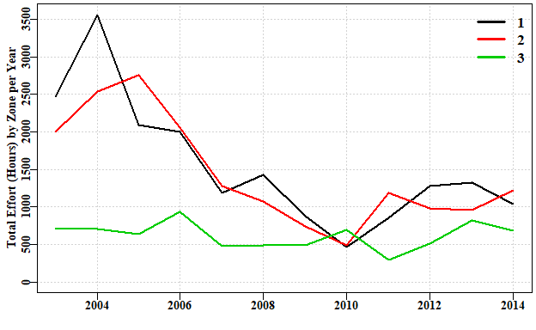

**Figure 1.** A plot of total effort by zone, showing that a visual illustration can often more easily highlight changes in a fishery’s dynamics.

DayNight is another factor that can have large consequences for catches and catch rates.

tapsum(sps,"catch_kg","Year","DayNight")

## D M N  
## 2003 80.54300 81.3930 59.9440  
## 2004 226.67300 153.7910 92.0420  
## 2005 157.21800 133.5640 88.0870  
## 2006 127.24900 104.6120 52.5300  
## 2007 72.13700 61.5024 36.7400  
## 2008 75.67900 56.9030 32.2350  
## 2009 35.10710 34.7680 26.6710  
## 2010 39.00500 25.8060 24.8750  
## 2011 46.14625 44.6535 32.6935  
## 2012 52.92000 59.4950 38.4370  
## 2013 72.16750 66.8170 49.9830  
## 2014 52.40750 64.0420 63.0720

One of the most influential factors within each fishery is the vessel doing the catching.

Often this is also a reflection of the skipper of the vessel as well as the relative performance of the boat itself. Nevertheless, it is often the case the vessel name is the only information available about the vessel’s relative fishing power. It is possible to pay special attention to catch-per-vessel, although the following analysis is more general than that: it provides a sub-total of catch by vessel number and year, and can be applied to, for example, catch-by-month relative to Depth Category.

cbv <- tapsum(sps,"catch_kg","Vessel","Year") # often more vessels than years  
total <- rowSums(cbv,na.rm=TRUE)  
cbv1 <- cbv[order(total,decreasing = TRUE),] # sort by total catch  
kable(cbv1[1:20,],digits=c(1,1,1,1,1,1,1,1,1,1,1,1))

|  |  |  |  |  |  |  |  |  |  |  |  |  |
| --- | --- | --- | --- | --- | --- | --- | --- | --- | --- | --- | --- | --- |
|  | 2003 | 2004 | 2005 | 2006 | 2007 | 2008 | 2009 | 2010 | 2011 | 2012 | 2013 | 2014 |
| 2 | 52.5 | 154.8 | 97.3 | 86.0 | 63.0 | 85.4 | 50.5 | 34.6 | 59.5 | 57.5 | 70.5 | 38.4 |
| 1 | 1.7 | 107.3 | 73.1 | 32.6 | 23.3 | 25.1 | 18.3 | 17.1 | 30.7 | 42.9 | 31.4 | 80.2 |
| 7 | 45.3 | 37.8 | 61.5 | 49.7 | 14.1 | 20.7 | 11.5 | 6.2 | 6.3 | 16.2 | 23.0 | 3.2 |
| 3 | 31.6 | 15.7 | 39.9 | 32.8 | 21.7 | 16.3 | 12.3 | 25.8 | 20.0 | 21.4 | 41.7 | 15.0 |
| 13 | 8.6 | 8.2 | 10.1 | 4.3 | 26.7 | 9.5 | 1.1 | 4.0 | 0.3 | 9.3 | 8.9 | 17.1 |
| 5 | 0.1 | 27.7 | 40.8 | 29.5 |  |  |  |  |  |  |  | 9.2 |
| 8 | 38.6 | 32.1 | 17.2 |  |  |  |  |  |  |  |  |  |
| 6 | 19.4 | 41.7 | 3.7 | 13.8 |  |  |  |  |  |  |  |  |
| 9 | 1.2 | 9.3 | 1.4 | 6.1 | 15.0 | 6.4 | 2.1 | 1.9 | 5.8 | 3.2 | 12.5 | 13.2 |
| 10 | 9.8 | 18.0 | 22.8 | 22.0 |  |  |  |  |  |  |  |  |
| 14 | 6.2 | 0.3 | 0.6 | 4.6 | 6.1 | 1.2 | 0.5 |  |  |  | 0.0 | 0.1 |
| 12 | 3.0 | 4.9 | 1.2 | 3.0 |  |  | 0.1 |  |  |  |  |  |
| 4 | 0.3 | 11.0 |  |  |  |  |  |  |  |  |  |  |
| 11 | 0.0 | 3.7 | 7.5 |  |  |  |  |  |  |  |  |  |
| 25 |  |  |  |  |  |  |  | 0.1 | 0.1 |  | 0.7 | 2.8 |
| 17 | 2.5 |  |  |  |  |  |  |  |  |  |  |  |
| 19 | 0.0 |  |  |  |  |  | 0.1 | 0.0 | 0.8 | 0.4 | 0.3 | 0.2 |
| 23 |  |  | 1.2 |  |  |  |  |  |  |  |  |  |
| 24 |  |  | 0.2 |  | 0.6 |  |  |  |  |  |  |  |
| 20 | 0.8 |  |  |  |  |  |  |  |  |  |  |  |

Obviously some vessels will be much more influential than others, simply because they catch a great deal more than others and hence introduce many more records into the database.

# plotprep(width=8,height=6) # not needed in the vignette  
to <- turnover(cbv1)  
yearBubble(cbv1,ylabel="sqrt(catch-per-vessel)",  
 diam=0.125,txt=c(2,3,4,5),hline=TRUE)

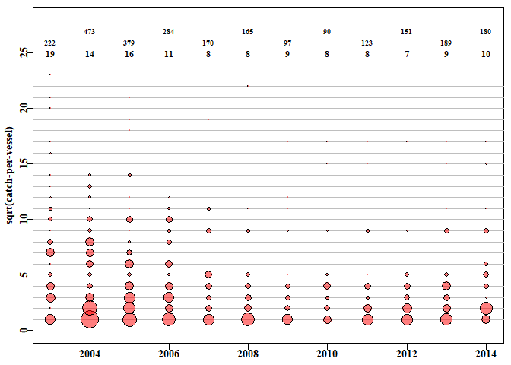

**Figure 2.** This hypothetical fishery is clearly dominated by four or five vessels with numerous minor players. Additionally, before 2007 there were a few more productive fishers present (this reflects the structural adjustment in the Commonwealth from which this simulated data derives). The optional horizontal lines merely delineate the individual vessels. The top two rows of numbers is the total catch per year and the bottom row of numbers is the number of vessels reporting in each year.

It is likely that if the data from the nine vessels with the lowest catches were omitted there would be no effect on any results as their catches are so minor in a relative sense. It is clear those vessels are merely casual occurrences within the fishery (Figure 2).

While the main vessels were reasonably consistent in terms of reporting from this fishery, other vessels came and went. To summarize such activity, one can use the *turnover* function which summarizes the year-to-year changes in which vessels report being active.

print(to)

## Continue Leave Start Total  
## 2003 19 0 0 19  
## 2004 14 5 0 14  
## 2005 13 1 3 16  
## 2006 11 5 0 11  
## 2007 7 4 1 8  
## 2008 7 1 1 8  
## 2009 7 1 2 9  
## 2010 7 2 1 8  
## 2011 8 0 0 8  
## 2012 7 1 0 7  
## 2013 7 0 2 9  
## 2014 9 0 1 10

The Continue column lists how many vessels continued from the preceding year, the Leave column designates how many left relative to the previous year, while the Start column is literally how many vessels started reporting in that year. The Total is the total number of vessels reporting in each year. No attempt is made to follow individual vessels.

### The Addition of CPUE data

You will have noticed that the sps data came with catch and effort but not CPUE, so we need to calculate that. In the following I test for the presence of zeros in the catch and effort to avoid generating errors of division (divide by zero errors will stop the analysis) and when taking logarithms. In fact, as the *properties* call showed, there were no *NA* values, but it remains worth checking.

While we are adding CPUE we can also group the depth data into depth classes to provide that option as an explanatory variable when standardizing the CPUE data.

sps$CE <- NA # make space in the data.frame  
sps$LnCE <- NA  
pick <- which((sps$catch_kg > 0) & (sps$Effort > 0))  
sps$CE[pick] <- sps$catch_kg[pick]/sps$Effort[pick]  
sps$LnCE[pick] <- log(sps$CE) # natural log-transformation  
# categorize Depth  
range(sps$Depth,na.tm=TRUE) # to aid selection of depth class width

## [1] 1 366

sps$DepCat <- NA  
sps$DepCat <- trunc(sps$Depth/25) * 25  
table(sps$DepCat)

##   
## 0 25 50 75 100 125 150 175 200 225 250 275 300 325 350   
## 6 19 224 1569 4583 3593 1393 74 66 21 15 21 7 5 7

It is clear from the summary of records by depth that most of the fishing occurs in waters of 150 metres or less.

Typically, with fisheries data, one might plot each variable, such as catch, effort, log(CPUE), depth, etc., by year to see whether changes have occurred through time. Such changes might adversely affect any analysis applied so it is always a good idea to examine (explore) one’s data before using it. ***cede*** provides a function *histyear* that an plot a histogram of a selected variable by year.

outH <- histyear(sps,Lbound=-1.75,Rbound=8.5,inc=0.25,pickvar="LnCE",  
 years="Year",varlabel="log(CPUE)",plots=c(4,3))

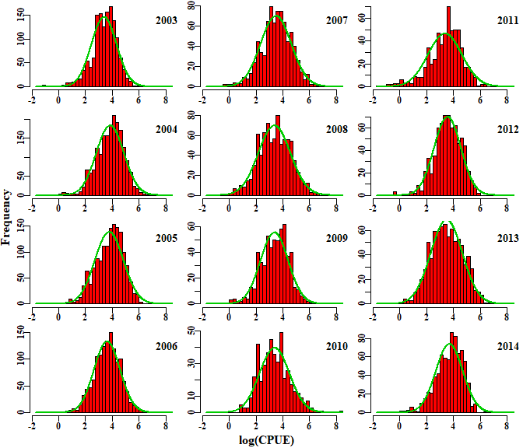

**Figure 3.** The distribution of the log(CPUE) each year for which data is available. The smooth green lines are fitted normal distributions there for reference (log-transformation should normalize log-normal data).

outH <- histyear(sps,Lbound=0,Rbound=375,inc=12.5,pickvar="Depth",  
 years="Year",varlabel="Depth (m)",plots=c(4,3),vline=120)

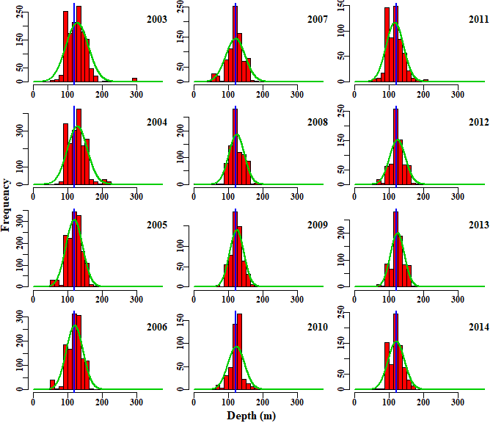

**Figure 4.** The distribution of reported mean depth of fishing each year. The green lines are fitted normal distributions there for reference, the blue lines are merely reference lines to ease comparisons between years.

outH <- histyear(sps,Lbound=0,Rbound=10,inc=0.25,pickvar="Effort",  
 years="Year",varlabel="Effort (Hrs)",plots=c(4,3),vline=NA)

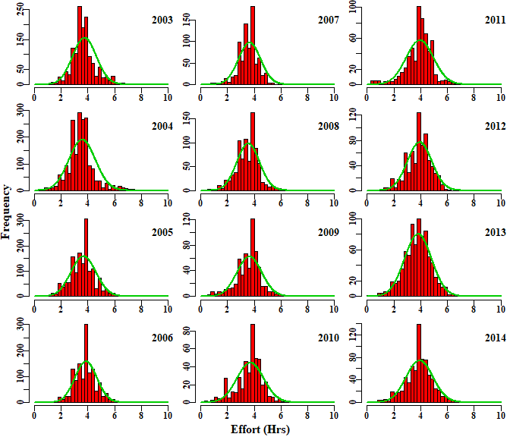

**Figure 5.** The distribution of reported Effort each year. The green lines are fitted normal distributions there for reference. Note the spikes of reporting four hours.

Spikes can be seen in each of the graphs and the question needs to arise whether these are due to rounding by the fishers or are real phenomena. In fact, unless dealing with counts of fish caught (quite possible in some fisheries) then rounding invariably occurs when estimating catches by weight, but also in effort. The following plot can help diagnose whether values are clustered due to rounding.

par(mfrow=c(1,1),mai=c(0.45,0.45,0.05,0.05))   
par(cex=0.85, mgp=c(1.35,0.35,0), font.axis=7,font=7,font.lab=7)   
plot(sps$Effort,sps$catch_kg,type="p",pch=16,col=rgb(1,0,0,1/5),  
 ylim=c(0,500),xlab="Effort (Hrs)",ylab="Catch (Kg)")  
abline(h=0.0,col="grey")

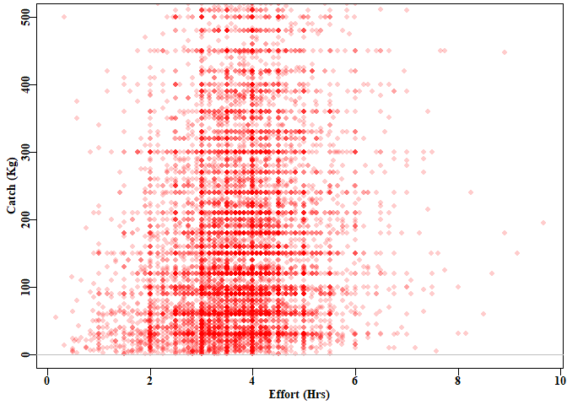

**Figure 6.** A plot of catch against effort for each record in the *sps* data.frame. The catch axis has been truncated at 500 kg so as to allow the rounding of catches to be less compressed and more visually obvious. It should be clear there is rounding at every half hour between 2 - 6 hours. In addition, there is rounding at about 30 kg steps from 30 - 300 kg, with other categories above that. The 30-33kg rounding reflects a belief that a standard fish bin contains about 30-33Kg of fish.

The uneven, grid-like nature of the catch and effort data is reflected in the CPUE data, which might make one sceptical about the notion of a predictive model attempting to predict such values. While the residuals (that are the basis of the statistical model fitting) might be smoother in their distribution, they do derive from a comparison of smooth predicted values with the grouped observed values, so any results are likely to be uncertain and to under-estimate any inherent variation.

Despite such problems, it is possible to derive useful information even from rounded fisheries data. It is generally recognized that fisheries data is noisy and potentially contains many errors, especially when considering the less important species that fall into the data-poor category. Nevertheless, the challenge remains of attempting to obtain useful and useable information from analysing such data.

### Plotting Sketch Maps of Lat-Long data

Since the advent of GPS and GPS plotters, very many fishers use this equipment, and fisheries departments have started to ask for precise location data accordingly. If such latitude and longitude data are available, it is often informative to plot such data as a literal map to illustrate the focus and range of a fishery. ***cede*** also provides the capacity to generate such sketch maps (instead of using a full Geographical Information System projected co-ordinate system). The idea here is not to conduct detailed spatial analyses, for which a GIS is better suited. Instead the idea is simply to gain a rapid impression of the spatial extent and distribution of a fishery’s effort. Of course, care needs to be taken with such plots, as they very obviously contain confidential information (such as exactly where fishers have been operating). This is especially important when there are very few fishers involved in a fishery. While such images may not be able to be displayed in meetings, they remain useful for data exploration purposes.

leftlong <- 143.0; rightlong <- 150.0  
uplat <- -40.0; downlat <- -44.6  
plotaus(leftlong,rightlong,uplat,downlat,gridon=1.0)  
addpoints(sps,intitle="Location of Catches")

## 11603 1 4500

plotLand(incol="blue")

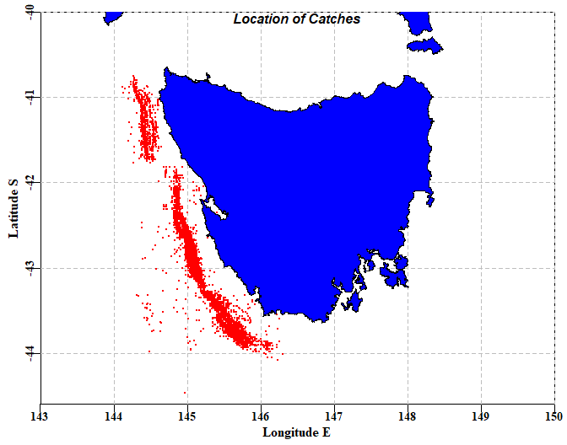

**Figure 7.** A sketch map of the Lat Long data within the *sps* data set. There are clearly a number of points reported to be out over the abyssal plain, but the majority of points define the range of the fishery.

Rather than show individual points it is also possible, by using the function *plotpolys*, to aggregate catches into different geographical sub-divisions (e.g. 0.25 or 0.5 degree squares, definable with plotpolys’ *gridon* parameter). If these are coloured relative to the density of total catches the locations where most of the yield of a fishery derives from becomes apparent. The output from the function includes the plotting, but also the sub-divisions used, and the counts of each of those sub-divisions. The final plotting of the land is merely to provide a tidy plot as it covers any points that accidently fall on land.

leftlong <- 143.0; rightlong <- 150.0  
uplat <- -40.0; downlat <- -44.6  
plotaus(leftlong,rightlong,uplat,downlat,gridon=1.0)  
plotpolys(sps,leftlong,rightlong,uplat,downlat,gridon=0.2,leg="left",  
 intitle="0.2 degree squares",mincount=2)

## subdiv 87.057 8.7057 0.87057 0.087057   
## counthot 0 0 0 0   
## 494.8624 500 250 100 50 10 5 1 0.001   
## countpoly 0 2 6 6 11 4 16 31

plotLand(incol="pink")

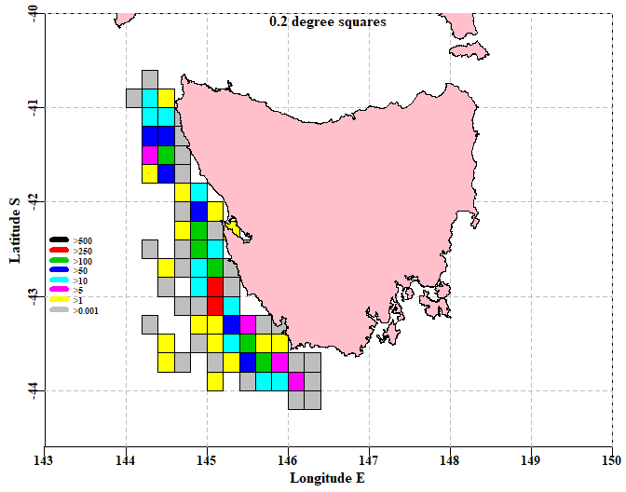

**Figure 8.** A sketch map of the Lat Long data within the *sps* data set with catches aggregated into 0.2 degree squares. By requiring at least 2 records in each square forinclusion, some (although not all) of the deeper water extraneous records have been eliminated. The red, green, and royal blue squares denote the areas generating the greatest yields.

Such sketch maps can be helpful, especially when plotting single years of data, to illustrate how the spatial extent of a fishery varies through time. There are obvious limitations: i) there is no formal map projection; one merely alters the width and height of the plot until the visual representation of the land looks acceptable; and ii) there are islands missing so as to limit the size of the underlying coastal definition data set (to see this, try entering *head(cede:::aus,30)* into the console).

## CPUE Standardization

### Introduction

If one were to search online for catch-per-unit-effort (CPUE) standardization, it would quickly become apparent that this is a very large subject with many alternative approaches and strategies. Here I will introduce two approaches: General and Generalized Linear Models (LMs and GLMs), and Generalized Additive Models (GAMS). This will only be a brief introduction to the subject, but the hope is that such an introduction would enable users to explore further and develop approaches best suited to their own fisheries.

Commercial CPUE data are used in very many fishery stock assessments in Australia as indices of relative abundance. Using CPUE in this way assumes there is a direct relationship between catch rates and exploitable biomass. However, many other factors can influence catch rates, including vessel, gear (fishing method), depth, season, area, and time of fishing (e.g. day or night). The use of CPUE as an index of relative abundance requires the statistical removal of the effects of variation due to changes in factors other than stock biomass, on the assumption that what remains will provide a better estimate of the underlying biomass dynamics. This process of adjusting the time series for the effects of other factors is known as standardization and the accepted way of doing this is to use some statistical modelling procedure that focuses attention onto the annual average catch rates adjusted for the variation in the averages brought about by all the other factors identified. Idiosyncrasies between species and methods across Australia means that each fishery/stock for which standardized catch rates are required entails its own set of conditions and selection of data (Sporcic and Haddon, 2016).

### The Limits of Standardization

The use of commercial CPUE as an index of the relative abundance of exploitable biomass can be misleading when there are factors that significantly influence CPUE but cannot be accounted for in a statistical standardization analysis. Over the last few decades the management of many Australian fisheries has undergone significant changes. For example, in the Commonwealth fisheries, there was the introduction of the quota management system into the South Eastern Scalefish and Shark Fishery (SESSF) in 1992, and the introduction of the Commonwealth Harvest Strategy Policy (HSP) and associated structural adjustment from 2005 - 2007. The combination of limited quotas and the HSP is now controlling catches in such a way that many fishers have been altering their fishing behaviour to take into account the availability of quota and their own access to quota needed to land the species taken in the mixed species SESSF.

## Methods

### Initial Data Selection

Fisheries data is often noisy and can contain obvious errors (e.g. an inshore species reportedly being caught in 6000 m of water). The data exploration mentioned earlier should allow one to defensibly select data for further analysis. Often such data selection is aimed at identifying records that represent typical activities in each fishery concerned, and removing obvious errors. In particular some selection criteria are aimed at focussing on records where the species is being targeted. For example, most species have a depth range within which they are typically caught. Ideally, an agreed depth range should be used so that it becomes standard to select data records between some minimum and maximum depth range. A second example relates to one vessel in the SESSF catching a particular species by a particular gear having catch rates 10 - 20 times those of other vessels fishing in the same places at the same time. Further exploration indicated that the vessel concerned had misunderstood how to fill in the log book so their data were removed from subsequent analysis. Whatever decisions are made about the selection of data, each choice should be defensible, and it should be possible to present the evidence for the selection made (e.g. illustrate extreme values, typical depth ranges, unusual vessels).

Once a defensible set of data records have been selected, there are other modifications needed. At its most basic, a linear model is very similar to a regression analysis. If you imagine conducting a regression of Log(CPUE) against Year so as to evaluate how those catch rates have changed through time then all that would come out would be a single line having two parameters, an intercept and gradient. There are only two parameters because it would treat the factor ‘Year’ as a continuous variable. What we actually want is a separate index for each year, we need to treat the ‘Year’ factor as a categorical factor rather than as a continuous variable. Below we will illustrate the use of using all categorical factors and then a different illustration showing how to include a continuous variable such as depth, into a standardization.

### Standardization

The use of *properties* indicates that in the *sps* data set contains six clear factors: Year, Month, Vessel, Depth or DepCat, DayNight, and Zone. The Zone factor is a subdivision of mainly the Latitude factor although longitude is also in there to a lesser extent.

First we need to convert some of the factors into categorical factors. For the *sps* data set there are six factor. It is good practice not to over-write your original data.frame so here the *sps* name is slightly modified to *sps1*.

kable(properties(sps),digits=c(0,0,0,0,6,6,6))

|  |  |  |  |  |  |  |  |
| --- | --- | --- | --- | --- | --- | --- | --- |
|  | Index | isNA | Unique | Class | Min | Max | Example |
| Year | 1 | 0 | 12 | numeric | 2003.000000 | 2014.000000 | 2004 |
| Month | 2 | 0 | 12 | numeric | 1.000000 | 12.000000 | 4 |
| Vessel | 3 | 0 | 23 | numeric | 1.000000 | 27.000000 | 1 |
| catch_kg | 4 | 0 | 442 | numeric | 1.000000 | 4500.000000 | 220 |
| Long | 5 | 0 | 447 | numeric | 144.116670 | 146.300000 | 145.1167 |
| Lat | 6 | 0 | 512 | numeric | -45.833330 | -40.750000 | -43.06667 |
| Depth | 7 | 0 | 191 | numeric | 2.000000 | 366.000000 | 125 |
| DayNight | 8 | 0 | 3 | character | 0.000000 | 0.000000 | N |
| Effort | 9 | 0 | 377 | numeric | 0.160000 | 9.660000 | 4 |
| Zone | 10 | 0 | 3 | numeric | 1.000000 | 3.000000 | 1 |
| CE | 11 | 0 | 3624 | numeric | 0.222222 | 4140.000000 | 55 |
| LnCE | 12 | 0 | 3596 | numeric | -1.504077 | 8.328451 | 4.007333 |
| DepCat | 13 | 0 | 15 | numeric | 0.000000 | 350.000000 | 125 |

labelM <- c("Year","Zone","Vessel","Month","DayNight","DepCat")  
sps1 <- makecategorical(labelM,sps)  
kable(properties(sps1),digits=c(0,0,0,0,6,6,6))

|  |  |  |  |  |  |  |  |
| --- | --- | --- | --- | --- | --- | --- | --- |
|  | Index | isNA | Unique | Class | Min | Max | Example |
| Year | 1 | 0 | 12 | factor | 0.000000 | 0.000000 | 2004 |
| Month | 2 | 0 | 12 | factor | 0.000000 | 0.000000 | 4 |
| Vessel | 3 | 0 | 23 | factor | 0.000000 | 0.000000 | 1 |
| catch_kg | 4 | 0 | 442 | numeric | 1.000000 | 4500.000000 | 220 |
| Long | 5 | 0 | 447 | numeric | 144.116670 | 146.300000 | 145.1167 |
| Lat | 6 | 0 | 512 | numeric | -45.833330 | -40.750000 | -43.06667 |
| Depth | 7 | 0 | 191 | numeric | 2.000000 | 366.000000 | 125 |
| DayNight | 8 | 0 | 3 | factor | 0.000000 | 0.000000 | N |
| Effort | 9 | 0 | 377 | numeric | 0.160000 | 9.660000 | 4 |
| Zone | 10 | 0 | 3 | factor | 0.000000 | 0.000000 | 1 |
| CE | 11 | 0 | 3624 | numeric | 0.222222 | 4140.000000 | 55 |
| LnCE | 12 | 0 | 3596 | numeric | -1.504077 | 8.328451 | 4.007333 |
| DepCat | 13 | 0 | 15 | factor | 0.000000 | 0.000000 | 125 |

Note that after using *makecategorical*, the factors of interest within *sps1* are now listed as factors rather than numeric, and that is enough to alter the analysis to something more like an analysis of variance (ANOVA) than a regression analysis, so that we obtain a parameter for each level of the factors used.

labelM <- c("Year","Zone","Vessel","Month","DayNight","DepCat")  
sps1 <- makecategorical(labelM,sps)  
mod <- makeonemodel(labelM)  
mod

## LnCE ~ Year + Zone + Vessel + Month + DayNight + DepCat  
## <environment: 0x0000000010ebab78>

class(mod)

## [1] "formula"

Each of the standardization methods we will use requires that each statistical model to be examined needs to be a **formula**. If you enter *makeonemodel*, without brackets, into the R console you will see the final form <- as.formula(form), which achieves this requirement.

If we are going to use a simple linear model then we can proceed using the function *dosingle* (try ?dosingle or just dosingle). We point the output of this function to the *out* object because there is an enormous amount of information generated. You can see this by using just *str(out)*.

labelM <- c("Year","Zone","Vessel","Month","DayNight","DepCat")  
sps1 <- makecategorical(labelM,sps)  
mod <- makeonemodel(labelM)  
out <- dosingle(mod,sps1)  
str(out,max.level=1)

## List of 7  
## $ Results : num [1:12, 1:2] 0.855 1.351 1.26 1.077 0.949 ...  
## ..- attr(*, "dimnames")=List of 2  
## $ StErr : num [1:12, 1:2] 0 0.0377 0.0399 0.0413 0.0473 ...  
## ..- attr(*, "dimnames")=List of 2  
## $ Optimum : num 2  
## $ modelcoef: num [1:63, 1:4] 3.8949 0.3697 0.1962 -0.0137 -0.2159 ...  
## ..- attr(*, "dimnames")=List of 2  
## $ optModel :List of 13  
## ..- attr(*, "class")= chr "lm"  
## $ modelG :List of 13  
## ..- attr(*, "class")= chr "lm"  
## $ years : Factor w/ 12 levels "2003","2004",..: 1 2 3 4 5 6 7 8 9 10 ...

One of the components of the *out* object is the *optModel*, which, not surprisingly, represents the optimum model. It is possible to run the generic functions *summary* and *anova*. The *summary* function (summary(out)) will generate the parameters (on the log-scale) and a few other details. the *anova* function determines the significance of each factor.

anova(out$optModel)

## Analysis of Variance Table  
##   
## Response: LnCE  
## Df Sum Sq Mean Sq F value Pr(>F)  
## Year 11 371.6 33.78 35.072 < 2.2e-16  
## Zone 2 809.2 404.58 420.019 < 2.2e-16  
## Vessel 22 374.6 17.03 17.675 < 2.2e-16  
## Month 11 281.3 25.57 26.546 < 2.2e-16  
## DayNight 2 223.4 111.69 115.950 < 2.2e-16  
## DepCat 14 432.7 30.91 32.087 < 2.2e-16  
## Residuals 11540 11115.7 0.96

#### The Mean Year Estimates

For the lognormal model, the expected back-transformed year effect involves a bias-correction to account for the log-normality; this then focuses on the mean of the distribution rather than the median:

where is the Year coefficient for year *t* and is the standard deviation of the log transformed data (obtained from the analysis). The year coefficients were all divided by the average of all the Year coefficients to simplify the visual comparison of catch rate changes.

where is the yearly coefficients from the standardization, is the arithmetic average of the yearly coefficients, *n* is the number of years of observations, and is the final time series of yearly index of relative abundance. All of this can be obtained in two ways. Within the *out* object there is the *Results* matrix which contains both the geometric mean estimates (labelled Year) along with the optimum statistical model. *StErr* within *out* contains the standard error estimates for each of those.

cbind(out$Results,out$StErr)

## Year optimum Year optimum  
## 2003 0.8551563 1.0803147 0.00000000 0.00000000  
## 2004 1.3506682 1.5644932 0.03774809 0.03629678  
## 2005 1.2600506 1.3154374 0.03988160 0.03897411  
## 2006 1.0769724 1.0665040 0.04131560 0.04084128  
## 2007 0.9487208 0.8715249 0.04731264 0.04691162  
## 2008 0.8429911 0.8105254 0.04670561 0.04604055  
## 2009 0.8422759 0.8031273 0.05292345 0.05183217  
## 2010 0.8511003 0.8000413 0.05818629 0.05697959  
## 2011 0.8379600 0.7449298 0.05251125 0.05168512  
## 2012 1.0175412 0.9594120 0.04949327 0.04872046  
## 2013 0.9505466 0.9162404 0.04723900 0.04669282  
## 2014 1.1660166 1.0674496 0.04849594 0.04877541

Alternatively, if all the details are wanted, there is another function *getfact*, which provides these.

kable(getfact(out$optModel,"Year"),digits=c(4,4,4,4,4,4))

|  |  |  |  |  |  |  |
| --- | --- | --- | --- | --- | --- | --- |
|  | Coeff | SE | LogCE | Scaled | t value | Prob |
| Year | 1.0000 | 0.0000 | 0.0000 | 1.0803 |  |  |
| Year2004 | 1.4482 | 0.0363 | 0.3697 | 1.5645 | 10.1841 | 0.0000 |
| Year2005 | 1.2176 | 0.0390 | 0.1962 | 1.3154 | 5.0330 | 0.0000 |
| Year2006 | 0.9872 | 0.0408 | -0.0137 | 1.0665 | -0.3355 | 0.7373 |
| Year2007 | 0.8067 | 0.0469 | -0.2159 | 0.8715 | -4.6015 | 0.0000 |
| Year2008 | 0.7503 | 0.0460 | -0.2884 | 0.8105 | -6.2637 | 0.0000 |
| Year2009 | 0.7434 | 0.0518 | -0.2978 | 0.8031 | -5.7462 | 0.0000 |
| Year2010 | 0.7406 | 0.0570 | -0.3020 | 0.8000 | -5.2996 | 0.0000 |
| Year2011 | 0.6895 | 0.0517 | -0.3731 | 0.7449 | -7.2178 | 0.0000 |
| Year2012 | 0.8881 | 0.0487 | -0.1199 | 0.9594 | -2.4604 | 0.0139 |
| Year2013 | 0.8481 | 0.0467 | -0.1658 | 0.9162 | -3.5513 | 0.0004 |
| Year2014 | 0.9881 | 0.0488 | -0.0132 | 1.0674 | -0.2700 | 0.7872 |

The standardizations provide parameters for each level of each factor, except for the first level in each case. These first levels are all assumed to have a log-transformed (reference) value of 0.0 (= 1.0 on the nominal scale). All the other parameters (when log-normal errors are used), are proportional to the first level. Thus the LogCE column is the output from the standardization. The bias-adjusted transformation back to the nominal scale is described in the equations above. The ‘Scaled’ column is the same as the ‘Coeff’ column except it is has been divided through by the mean of the series. This sets the average value to 1.0, which permits simple visual comparison with other time-series. The ‘SE’ column provides the basis for generating the log-normally distributed confidence intervals.

# plotprep(width=7,height=4.5)  
plotstand(out,bars=TRUE)

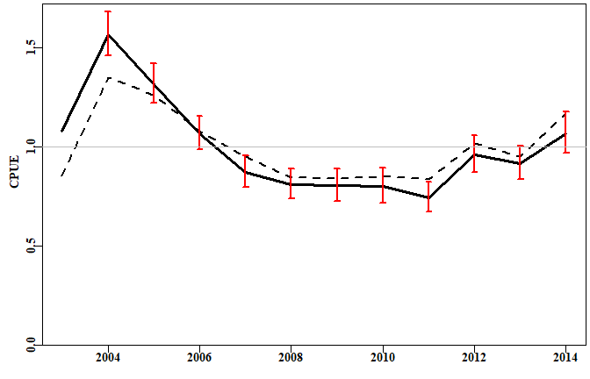

**Figure 9.** The standardization of the CPUE data within the *sps* data set. The dashed line is the geometric mean CPUE while the solid line with 95% confidence intervals is the standardized CPUE. In places, the difference between the standardized CPUE and the geometric mean CPUE is greater than the 95% log-normal confidence intervals.

One issue with the scaling of this plot is that it makes little sense to industry members who are more used to the nominal scale at which they personally operate. Given that the average of both the geometric mean and the optimum model is 1.0, both can be multiplied by a constant to rescale the plots. If we calculate the geometric mean CPUE for the whole fishery, we can use that as a multiplier, and that will place each time-series on a recognizable nominal scale. This can be done using the function *geomean* and including the *geo* option of *plotstand*.

# plotprep(width=7,height=4.5)  
geom <-geomean(sps$CE)  
plotstand(out,bars=TRUE,geo=geom)

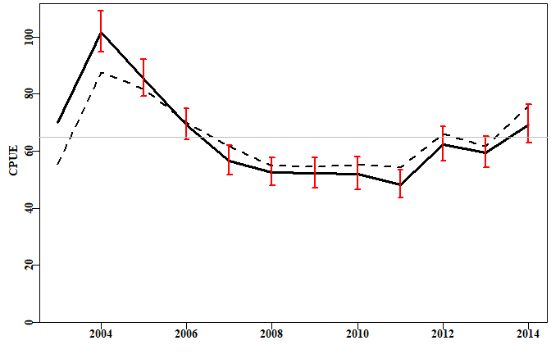

**Figure 10.** The standardization of the CPUE data within the *sps* data set. The dashed line is the geometric mean CPUE, while the solid line with 95%. These trajectories both have an average of the overall geometric mean CPUE.

It is often helpful to examine the standardizations as they increase in complexity, so that the relative influence of each factor becomes clearer. However, to do this requires a little more R code.

# first make a matrix to hold the results  
labelM <- c("Year","Zone","Vessel","Month","DayNight","DepCat")  
columns <- c("adjR2","incR2","RSS","MSS","Npar","nobs","AIC")  
nummod <- length(labelM)  
results <- as.data.frame(matrix(0,nrow=nummod,ncol=length(columns),  
 dimnames=list(labelM,columns)))  
for (i in 1:nummod) { # sequentially build the models  
 mod <- makeonemodel(labelM[1:i]) # When i = 1 LnCE ~ Year  
 out <- dosingle(mod,sps1)  
 outsum <- summary(out$optModel)  
 aov <- anova(out$optModel) # Extract a range of results   
 RSS <- tail(aov$"Sum Sq",1)  
 df <- aov$Df  
 nobs <- sum(df) + 1  
 numfact <- length(df) - 1  
 npars <- sum(df[1:numfact]) + 1  
 AIC <- nobs * log(RSS/nobs) + (2 * npars)  
 results[i,] <- c(outsum$adj.r.squared,NA,RSS,sum(aov$"Sum Sq") - RSS,npars,nobs,AIC)  
}  
results[2:nummod,"incR2"] <- results[2:nummod,"adjR2"]-results[1:(nummod-1),"adjR2"]  
round(results,4)

## adjR2 incR2 RSS MSS Npar nobs AIC  
## Year 0.0264 NA 13236.77 371.6062 12 11603 1552.5217  
## Zone 0.0857 0.0594 12427.62 1180.7589 14 11603 824.6352  
## Vessel 0.1116 0.0259 12053.06 1555.3196 36 11603 513.5497  
## Month 0.1315 0.0199 11771.79 1836.5924 47 11603 261.5701  
## DayNight 0.1478 0.0163 11548.41 2059.9662 49 11603 43.2834  
## DepCat 0.1788 0.0309 11115.70 2492.6736 63 11603 -371.8236

By looking at the increments to the adjusted-R2 (“adjR2”) it is clear that the factor *DepCat* has a larger impact on the variation accounted for than even *Vessel*, so strictly the analysis should be repeated after re-ordering the different factors within labelM. The *AIC* column identifies the optimum combination of factors with the smallest value indicating the optimum. It would be worthwhile repeating the analysis with the re-ordering. Typically, if one plots each standardization on the same plot, typically, while the later factors can be statistically significant, their effect upon the trajectory of the standardized CPUE can be minimal or appear to contribute mainly noise. If the standardization is to be used within an assessment it is the trend that matters so those final few factors may only have a minor effect.

### Alternative Standardization Strategies

So far we have only considered General Linear Models (which with log-normal errors give the same results as simple linear models). If we wish to use alternative residual error structures then it would be necessary to use true GLMs (as in Generalized Linear Models). These would be necessary if, for example, there was a wish to attempt using perhaps a Gamma distribution instead of log-normal. Such alternate error structures require different syntax. The standard approach when using the Gamma distribution would be to use a log-link in the GLM. In such cases, the dependent variable would then be *CE* rather than *LnCE*. The functions described so far have been designed for use with log-normal residual errors that need a bias-correction, Gamma residual errors do not require such a bias-correction, so we will need to work directly with the estimated coefficients.

labelM <- c("Year","Zone","Vessel","Month","DayNight","DepCat","Month:Zone")  
sps1 <- makecategorical(labelM,sps)  
mod <- makeonemodel(labelM,dependent="CE")  
  
model4 <- glm(mod,family=Gamma(link="log"),data=sps1)  
m4 <- summary(model4)$coefficients # combine these with empty first year  
yrval <- rbind(c(0,0,0,0),m4[grep("Year",rownames(m4)),])  
gamres <- cbind(yrval,exp(yrval[,"Estimate"]))  
rownames(gamres) <- 2003:2014  
gamres

## Estimate Std. Error t value Pr(>|t|)   
## 2003 0.000000000 0.00000000 0.00000000 0.000000e+00 1.0000000  
## 2004 0.333489137 0.04141384 8.05260025 8.901627e-16 1.3958299  
## 2005 0.232479826 0.04412451 5.26872275 1.398554e-07 1.2617250  
## 2006 0.003738450 0.04620812 0.08090461 9.355192e-01 1.0037454  
## 2007 -0.123979553 0.05282090 -2.34716857 1.893353e-02 0.8833979  
## 2008 -0.139742192 0.05204407 -2.68507408 7.261757e-03 0.8695824  
## 2009 -0.226946891 0.05850235 -3.87927840 1.053499e-04 0.7969631  
## 2010 -0.079275668 0.06427291 -1.23342264 2.174433e-01 0.9237852  
## 2011 -0.147106194 0.05832505 -2.52217851 1.167642e-02 0.8632023  
## 2012 -0.080927349 0.05495370 -1.47264600 1.408738e-01 0.9222607  
## 2013 -0.002500419 0.05314454 -0.04704940 9.624747e-01 0.9975027  
## 2014 0.023195520 0.05528536 0.41955987 6.748148e-01 1.0234666

plotstand(out,bars=TRUE)  
lines(2003:2014,exp(yrval[,"Estimate"]),lwd=2,col=4)

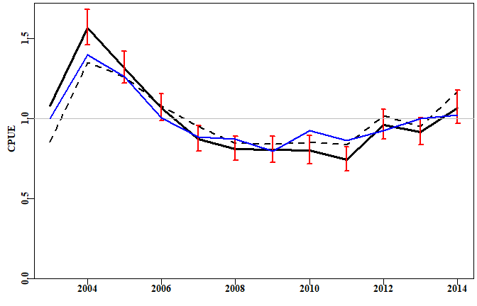

**Figure 11.** The standardization of the cpue data within the *sps* data set comparing a LM using log-normal with a GLM using Gamma residual errors. The dashed line is the geometric mean CPUE while the solid black line with 95% confidence intervals is the log-normal error standardization. Finally, the blue line is the Gamma error standardization.

### The Use of GAMs

Generalized Additive Models (GAMs) are an extension of GLMs in which at least some of the factors are replaced by fitting smooth surfaces to some of the factors that are considered to have a non-linear relationship with catch rates.In order to run them, however, it is necessary to install a number of additional R packages.

As an example, we could use a GAM to add a smoother to the Lat - Long data in the *sps* data set. We would actually use the sps1 data set as the remaining categorical factors are also included in the analysis. A possible workflow might involve the following code:

# install and call these R packages and their dependencies  
library(nlme)  
library(mgcv)  
library(gamm4)  
# note the use of gam rather than lm or glm (see the examples in ?gam for more  
# details.   
modelGam <- gam(LnCE ~ s(Long,Lat) + Year + Zone + Vessel + Month +   
 DayNight + DepCat, data = sps1)  
anova(modelGam)

##   
## Family: gaussian   
## Link function: identity   
##   
## Formula:  
## LnCE ~ s(Long, Lat) + Year + Zone + Vessel + Month + DayNight +   
## DepCat  
##   
## Parametric Terms:  
## df F p-value  
## Year 11 54.145 <2e-16  
## Zone 2 0.778 0.459  
## Vessel 22 16.549 <2e-16  
## Month 11 26.175 <2e-16  
## DayNight 2 112.842 <2e-16  
## DepCat 14 9.269 <2e-16  
##   
## Approximate significance of smooth terms:  
## edf Ref.df F p-value  
## s(Long,Lat) 26.96 28.69 19.14 <2e-16

We should not be surprised that the *Zone* factor is no longer sinificant. By including the Lat - Long surface including the *Zone* factor becomes redundant so we should really repeat the analysis without *Zone* included.

modelGam <- gam(LnCE ~ s(Long,Lat) + Year + Vessel + Month +   
 DayNight + DepCat, data = sps1)  
anova(modelGam)

## Family: gaussian   
## Link function: identity   
##   
## Formula:  
## LnCE ~ s(Long, Lat) + Year + Vessel + Month + DayNight + DepCat  
##   
## Parametric Terms:  
## df F p-value  
## Year 11 54.039 <2e-16  
## Vessel 22 16.635 <2e-16  
## Month 11 26.237 <2e-16  
## DayNight 2 112.859 <2e-16  
## DepCat 14 9.297 <2e-16  
##   
## Approximate significance of smooth terms:  
## edf Ref.df F p-value  
## s(Long,Lat) 27.14 28.74 26.65 <2e-16

We can use the *getfact* function to extract the results we need. The Coeff column contains the LogCE transformed back to the linear scale and Scaled is the Coeff re-scaled to a mean of 1.0. Once again if it is desired to scale this to the nominal CPUE from the fishery so as to improve communication with industry and managers then we can use *geomean* to estimate the overall geometric mean to re-scale the ‘Scaled’ column to something more meaningful to industry members.

answer <- getfact(modelGam,"Year")  
opti <- answer[,"Scaled"]  
round(answer,5)

## Coeff SE LogCE Scaled t value Prob  
## Year 1.00000 0.00000 0.00000 1.11779 NA NA  
## Year2004 1.43698 0.03557 0.36191 1.60624 10.17322 0.00000  
## Year2005 1.18326 0.03826 0.16754 1.32263 4.37886 0.00001  
## Year2006 0.94500 0.04009 -0.05737 1.05631 -1.43110 0.15243  
## Year2007 0.76003 0.04616 -0.27546 0.84955 -5.96784 0.00000  
## Year2008 0.72439 0.04523 -0.32344 0.80972 -7.15074 0.00000  
## Year2009 0.70430 0.05095 -0.35185 0.78725 -6.90523 0.00000  
## Year2010 0.69154 0.05594 -0.37039 0.77300 -6.62073 0.00000  
## Year2011 0.66716 0.05075 -0.40601 0.74575 -7.99956 0.00000  
## Year2012 0.85665 0.04794 -0.15587 0.95755 -3.25124 0.00115  
## Year2013 0.82559 0.04588 -0.19271 0.92283 -4.19995 0.00003  
## Year2014 0.94059 0.04789 -0.06240 1.05138 -1.30282 0.19266

We can gain an impression of the surface fitted to the Lat - Long data using the *plot* function, which recognizes the output from a GAM and can react accordingly.

#plotprep(width=4.5,height=7)  
 plot(modelGam,ylim=c(-44.5,-40),xlim=c(143.5,146.5),se=FALSE,xlab="",ylab="")  
 title(ylab=list("Latitude", cex=1.0, font=7),  
 xlab=list("Longitude", cex=1.0, font=7))  
 plotLand("pink")

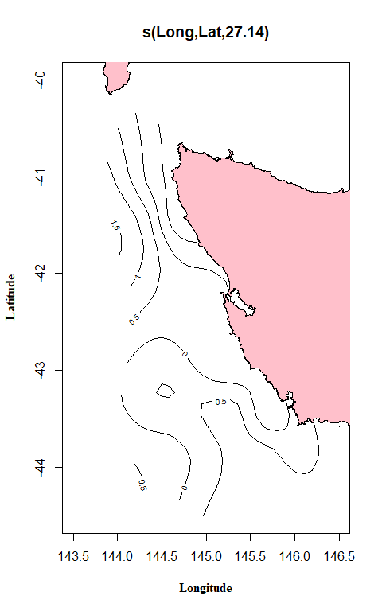

**Figure 12.** A plot of the surface fitted to the output from the gam function.

The effect on the year parameters is what we are really interested in for the purposes of stock assessment, and we can compare the outcome of the GAM with the previous GLM.

#plotprep(width=7,height=4.5)  
plotstand(out,bars=TRUE)  
lines(facttonum(out$years),opti,col=4,lwd=2)  
legend("bottomleft",c("GLM","GAM"),col=c(1,4),lwd=3,bty="n",cex=1.2)

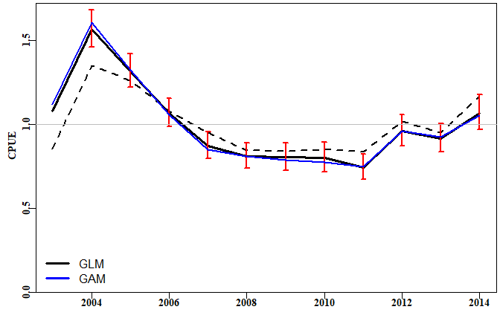

**Figure 13.** The standardization of the CPUE data within the *sps* data set comparing an LM using log-normal residual errors with a GAM having a surface fitted to the Lat/Long data. The dashed line is the geometric mean CPUE while the solid black line with 95% confidence intervals is the log-normal error standardization. Finally, the blue line is the Generalized Additive Model.

# *catch-MSY*

## Introduction

### Which Stock Assessment?

Which stock assessment method to apply to fisheries for data-poor to data-moderate species will depend upon what fisheries and biological data are available but also, importantly, on what management objectives need to be met within the jurisdiction in question. It may be the case that the fishery for a particular species is of sufficient size and value to warrant on-going monitoring and management towards some defined goal for the stock. In such a case the assessment used should obviously be capable of generating some notion of the current state of the fishery and indicate what management actions may be required to eventually achieve the agreed management goals. But some fisheries may be so minor that trying to actively manage them would be inefficient both practically and economically. Nevertheless, to meet the requirements of the Status of key Australian Fish Stocks (SAFS) one still requires some form of defensible stock assessment capable of determining whether the current level of fishing is sustainable.

## Modified Catch-MSY

The Catch-MSY method (Martell and Froese, 2013) could be termed a ‘model-assisted’ stock assessment method. It only requires a complete time-series of catches and a set of strong assumptions to conduct a stock assessment. As only a brief description of how it is considered to work is given here, it is recommended that users read the original paper to gain an understanding of what the method does and how it does it.

The underlying stock dynamics are described by the simple model used, which in the case implemented here is a Schaefer surplus production model with parameters *r*, the population growth rate, and *K*, the population carrying capacity or unfished biomass. The model uses ratios of the initial and final catches relative to the maximum catch to set up arrays of potential values for the initial and final depletion levels as well as for the potential range of *r* and *K* values (all of which are now modifiable by the user). The method sequentially steps through the years of the fishery by randomly selects pairs of *r-K* values from the wide initial ranges, which defines the initial biomass, subtracting the catches, and moving the population dynamics forward each year using the predictions from the simple model. Essentially this is a stock reduction that removes catches from a known set of dynamics. However, the very many *r-K* pairs used (at least 20000) are combined with a fixed set of initial depletion levels (about 20 steps between the minimum and maximum initial depletion set) to generate often 100,000s of possible stock reduction trajectories. Criteria are included (e.g. no trajectory is kept if it predicted zero biomass or biomass above *K*) that lead to numerous potential trajectories being rejected. Those that are left after all criteria for acceptance have been completed constitute the set of trajectories deemed to be consistent with the known catches. The implications of these successful trajectories are used to produce an assessment of the possible status of the stock.

In this section we will describe how to conduct a catch-MSY analysis, how to extract the results from that analysis, as well as plot out illustrations of those results. In addition, we will examine how to project the successful trajectories under constant catch scenarios to determine what level of catches should lead to the majority of trajectories moving in a desired direction (rebuilding to a target, staying stable, or declining to a target depletion).

A standard workflow might consist of:

1. read in data and use **checkdata** to determine which analyses are possible
2. set the run-time parameters to conduct the desired catch-MSY analysis (see later)
3. use **run_cMSY** to conduct a catch-MSY analysis. One sensitivity you should run is to set sigpR (the proxy for process error) to 1e-10 (a very small number) to see deterministic trajectories. Do other sensitivities (see text).
4. use **cMSYphaseplot** to determine status for SAFS, if more is wanted.
5. use **summarycMSY** to generate a summary object of the answer.
6. use **plottrajectory** to illustrate either all successful trajectories along with the successful harvest rates (use option *oneplot = TRUE*), or just a sample of 7 or 15 biomass trajectories.
7. use **plotcMSY6** to plot up the overview of successful and failed r - K combinations.
8. use **pulloutStats** to obtain summary statistics regarding MSY and depletion
9. use **plotconstC** with $deplet from the object output from *pulloutstats* to plot up the successful trajectories depicting stock depletion.
10. use **doconstC** to conduct constant catch projections to find a level of catch that lead, on average, to the population decreasing, staying stable, or increasing (possibly to some selected target within a particular time).
11. optionally, use **trendMSY** to illustrate the relationship between the estimated MSY and the average MSY of the successful trajectories.

## Some Formal Details

The Catch-MSY method described here can be regarded as a model-assisted data-poor method. It uses a form of stock reduction analysis where the productivity of a given stock (its unfished biomass and its reproductive rate) is characterized within the parameters of a simple mathematical model, and how that modelled stock responds to the history of known catches (a stock reduction analysis) forms the basis of the alternative methods used to characterize productivity in management useable terms.

The Catch-MSY method (Martell and Froese, 2013) uses the relatively simple Schaefer surplus production model as the basis for describing the dynamics of the stock being described:

where *Bt* represents the stock biomass in year *t*, *r* represents a population growth rate that includes the balance between recruitment and natural mortality, *K* is the maximum population size (the carrying capacity), and *Ct* being the catch in year *t*. The represents a density dependent term that trends linearly to zero as *Bt* tends towards *K*.

Importantly, for our purposes, one of the properties of the discrete Schaefer surplus production model is that MSY can be estimated very simply from the parameter estimates:

which reflects the symmetric production function implied by the model dynamics. A relatively simple future possible development would be to include the option of using Fox model dynamics instead of the Schaefer.

Such surplus-production (or biomass dynamic) models usually require both a time-series of total catches (landings plus discards) and a time-series of an index of relative abundance (Haddon, 2011). In Australia the index of relative abundance is most often a time-series of CPUE (ideally standardized CPUE).

### Empirical Harvest Strategies

In the Southern and Eastern Scalefish and Shark Fishery (SESSF), rather than using surplus production models or other simple approaches that attempt to model the underlying population dynamics of a stock, empirical harvest strategies have been developed that use such time-series in empirical relationships that give rise directly to management related advice on catch levels (Little et al., 2011; Haddon, 2014). Such empirical harvest strategies can provide the needed management advice but do not determine stock status unless the reference period, often used in such approaches, is assumed to be a proxy for the target reference point (and associated limit reference point) for sustainability. A weight-of-evidence argument would need to be made to support the use of such a proxy. In the SESSF, this so-called Tier 4 harvest strategy is used to determine whether a stock is over-fished or not but currently cannot be used to determine whether over-fishing is occurring. In addition, there is the strong assumption made that the commercial catch rates are a direct reflection of the stock biomass. There are, however, some species, for example mirror dory (*Zenopsis nebulosa*), where catch rates increase when catches increase, and then decline once catches begin to decline. They appear to be fisheries based on availability rather than the fishery being the major influence on the stock biomass and other aspects of the environment of the species appear to be driving its dynamics. The use of CPUE may thus be misleading in such cases, or at best lead to simply reactive management decisions (CPUE goes up so can catches, CPUE goes down so must catches).

More widely than the SESSF, there are many fisheries within Australia that may only have a time-series of catches with only limited information related to a useable index of relative abundance. In addition, such catch time-series may not be available from the beginning of the fishery, which means that methods such as Depletion-Based Stock Reduction Analysis (Dick and MacCall, 2011) cannot be validly applied (although, as shown in Haddon et al, 2015, if sufficient years of catches are present (perhaps >25) then the method can still provide approximate estimates of management related parameters). Under such data-limited situations, other catch-only based assessment methods can provide the required estimates of management interest.

### Stock Reduction Analyses

As with many of the more capable catch-only data-poor approaches the Catch-MSY method evolved from the stock reduction analyses of Kimura and Tagart (1982), Kimura et al. (1984), and eventually Walters et al. (2006). It uses a discrete version of the Schaefer surplus production model (Schaefer, 1954, 1957; Haddon, 2011) to describe the stock dynamics in each case. The Catch-MSY requires

* a time-series of total removals
* prior ranges for the *r* and *K* parameters of the Schaefer model, and
* possible ranges of the relative stock size (depletion levels) in the first and last years of the time-series.

As described by Martell and Froese (2013), the range of initial depletion levels can be divided into a set of initial values, and a stock reduction using the known total removals, applied to each of these multiple initial depletion levels combined with pairs of *r-K* parameters randomly drawn from uniform distributions across the prior ranges of those parameters. Each of these parameter pairs, plus each of the initial depletion levels, are projected using the total catch trajectory, leading to a stock biomass trajectory, which is either accepted or rejected depending on whether the stock collapses or exceeds the carrying capacity, and whether the final depletion level falls within the assumed final range. Take especial note that no model fitting is involved in the catch-MSY analysis, it is purely a case of searching for parameter combinations that are consistent with what is known about the fishery and it properties.

The initial and final depletion ranges can be relatively broad. Other criteria can be included to further constrain the biomass trajectories, if extra evidence is available. Such additional constraints are still under development. For example, in some of the examples you will notice that the annual harvest rates for some accepted trajectories can be very high (> 0.5), which for many (though not all) Australian species can be considered to be implausible. Now it is possible to conduct a sensitivity analysis where trajectories implying some pre-defined harvest rate will also be rejected. These high fishing mortality trajectories are only possible for the more productive parameter combinations so removing such trajectories will likely reduce the predicted MSY (maximum productivity).

We can use the *invert* data set of catches to exemplify the process of applying the Catch-MSY method.

### The data-file format

As can be seen in the R-code below, the data for the catch_MSY analysis is read into an R object containing fish, *glb*, and others if present. Using the *data* command places the data object, in the example it is called *invert*, into the global environment. Using the *readdata* command with a “named.csv” file also produces one large object. The actual data requirements of the different methods available differs greatly. The catch-MSY method really only requires two columns in *fish*, one being “year”, the other being “catch”. The surplus production modelling also requires a “cpue” column, and the age-structured surplus production model also requires various biological properties relating to weight-at-age, maturity-at-age, and selectivity-at-age. These are tested by the *checkdata* function.

**Table 1.** The format of the fish object. Not all fields are required for all analyses.

|  |  |  |  |  |  |  |
| --- | --- | --- | --- | --- | --- | --- |
| year | catch | cpue | se | geom | vessel | records |
| 1986 | 283.434 | 0.7005 | 0.000 | 71.7 | 47 | 1592 |
| 1987 | 185.612 | 0.8842 | 0.038 | 93.0 | 47 | 1764 |
| 1988 | 285.942 | 0.9786 | 0.041 | 124.6 | 41 | 1395 |
| 1989 | 234.523 | 0.8371 | 0.043 | 139.3 | 39 | 1143 |
| 1990 | 329.837 | 1.5811 | 0.049 | 174.5 | 25 | 727 |
| 1991 | 461.521 | 1.3874 | 0.050 | 182.9 | 29 | 734 |
| 1992 | 668.453 | 1.0286 | 0.058 | 166.3 | 19 | 434 |
| 1993 | 574.393 | 1.2245 | 0.050 | 172.4 | 21 | 673 |
| 1994 | 482.073 | 1.1569 | 0.050 | 170.3 | 26 | 661 |
| 1995 | 529.336 | 0.9135 | 0.044 | 105.0 | 25 | 1070 |
| 1996 | 424.963 | 0.8085 | 0.042 | 95.4 | 25 | 1216 |
| 1997 | 473.406 | 0.7581 | 0.047 | 86.8 | 21 | 855 |

The use of *checkdata* indicates that both *catch-MSY* and *spm* analyses are possible with this data. This does not mean that the results of such analyses will always be valid with the given data, only that the required data to conduct these analyses are present.

The *answer* object contains all the results from the catch-MSY analysis and is used by other R functions to generate summaries and plots of those results.

#library(simpleSA)  
  
glb <- invert$glb # contains available biological data  
checkdata(invert)

## Method Possible  
## catch-MSY TRUE TRUE  
## spm TRUE TRUE  
## aspm aspm FALSE  
## catch-curves catch-curves FALSE

# normally one would run at least 20000 iterations, preferably more  
reps <- 5000   
# read the help for run_cMSY to understand each input parameter   
answer <- run_cMSY(fish,glb,n=reps,sigpR=0.025,maximumH=1.0)  
str(answer,max.level=1)

## List of 13  
## $ R1 :List of 3  
## $ ell : num [1:1011, 1:23] 0 0 0 0 0 0 0 0 0 0 ...  
## ..- attr(*, "dimnames")=List of 2  
## $ rK : num [1:1011, 1:5] 0.345 0.168 0.309 0.219 0.22 ...  
## ..- attr(*, "dimnames")=List of 2  
## $ parbound :List of 5  
## $ Statistics :List of 3  
## $ Rfirst :List of 3  
## $ firstparbound :List of 5  
## $ startbd : num [1:23] 0.15 0.175 0.2 0.225 0.25 0.275 0.3 0.325 0.35 0.375 ...  
## $ outtab :'data.frame': 11 obs. of 2 variables:  
## $ initialDepletion: num [1:5000, 1:23] 0.15 0.175 0.2 0.225 0.25 0.275 0.3 0.325 0.35 0.375 ...  
## ..- attr(*, "dimnames")=List of 2  
## $ finaldepletion : num [1:5000, 1:23] 0 0 0 0 0 ...  
## ..- attr(*, "dimnames")=List of 2  
## $ B0 : num [1:5000, 1:23] 6311 4751 2683 2462 2275 ...  
## ..- attr(*, "dimnames")=List of 2  
## $ MaximumH : num 1

### SAFS Status

A summary and illustration of the stock status can be obtained by extracting the average stock biomass trend, along with the average fishery harvest rate trend from the successful trajectories.

Using the average estimate of the *r* - *K* pairs it is also possible to generate an estimate of the production curve, from which it is possible to derive estimates of *Bmsy*, *0.2K* or *0.2B0*, and target harvest rate, *Htarg*, and limit harvest rate, *Hlim*, with which the phase plot can be subdivided to provide a visual representation of the how the history of catches from the fishery are reflected in predicted changes in the biomass and harvest rate. Whether over-fishing is occurring (leading to a status of ‘depleting’) is determined by whether the current point lies above the *Htarg* or above the *Hlim*, which in turn is decided by the management objectives adopted in each jurisdiction. A status of ‘depleted’ or ‘sustainable’ currently corresponds to whether the current year’s point is to the left or right of the *0.2B0* line.

out <- cMSYphaseplot(answer,fish)

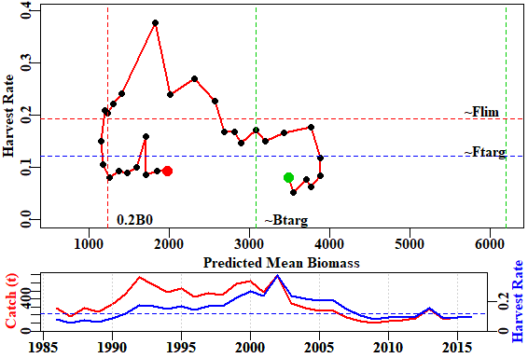

**Figure 14.** A phase plot of the man predicted biomass and harvest rates through the years observed. The first year of data is a green point and the last a red point. The axes for the bottom plot are identified through the colour of the axis titles,

The results are synthesized within the contents of *out*.

str(out)

## List of 6  
## $ medianB: Named num [1:31] 3499 3552 3711 3775 3887 ...  
## ..- attr(*, "names")= chr [1:31] "1986" "1987" "1988" "1989" ...  
## $ medianH: Named num [1:31] 0.081 0.0522 0.0771 0.0621 0.0849 ...  
## ..- attr(*, "names")= chr [1:31] "1986" "1987" "1988" "1989" ...  
## $ msy : num 375  
## $ Bmsy : num 3088  
## $ Hmsy : num 0.121  
## $ Hlim : num 0.193

### Other Potential Outputs from catch-MSY

A useful summary of the catch-MSY analysis containing the primary results can be obtained using the *summarycMSY* function.

summcMSY <- summarycMSY(answer,fish,final=TRUE)  
str(summcMSY,max.level=1) # try max.level = 2

## List of 11  
## $ countcolour: Named num [1:5] 3989 694 210 89 18  
## ..- attr(*, "names")= chr [1:5] "red_0" "black_2" "blue_4" "yellow_6" ...  
## $ meanmsy : num [1:4, 1:2] 381 375 381 278 72 ...  
## ..- attr(*, "dimnames")=List of 2  
## $ meanr : num [1:4, 1:2] 0.252 0.2419 0.2522 0.14 0.0723 ...  
## ..- attr(*, "dimnames")=List of 2  
## $ meanK : num [1:4, 1:2] 6315 6197 6322 3911 1176 ...  
## ..- attr(*, "dimnames")=List of 2  
## $ r : num [1:1011] 0.345 0.168 0.309 0.219 0.22 ...  
## $ K : num [1:1011] 5526 6913 5047 7823 6690 ...  
## $ msy : num [1:1011] 477 290 390 428 368 ...  
## $ pickC :List of 6  
## $ years : num [1:31] 1986 1987 1988 1989 1990 ...  
## $ parbound :List of 5  
## $ fish :'data.frame': 31 obs. of 7 variables:

As can be seen from the series of large objects in *summcMSY*, such as the *r*, *K*, and *msy* components, only a portion of the *n=5000* trials succeeded in meeting the constraints that define an acceptable trajectory. This has removed all the parameter combinations that were not productive enough or those that were too productive and retained only those that were at least realistic/plausible enough to be consistent with what is known about the fishery. If you run the last three lines of R code a few times and examine the structure of the *summcMSY* object you will notice that each time the length of the *r*, *K*, and *msy* objects usually differs. This merely exemplifies the fact that the randomly selected parameter combinations lead to different numbers of successful trajectoris each time through. To obtain a visual representation of a selection of the successful trajectories you can use the function *plottrajectory* (see its help function for a description of all the options).

It should be noted that the catch-MSY method uses a two stage strategy. Unless set otherwise, it first sets the initial *K* values between the maximum catch and 60 times the maximum catch. This invariably leads to very many successful trajectories that suggest a very large initial biomass combined with a very low population growth rate. While mathematically this may match the productivity of the stock, as suggested by the time-series of catches, it is biologically less plausible than lower *K* values associated with higher *r* values (these two parameters are negatively correlated). To avoid the less plausible combinations in their original code Martell and Froese (2013) search for the smallest *K* value that will still give rise the overall average *MSY* value across the successful trajectories found in the first run through. Once a more restricted initial *K* range has been found then the *n* replicates are repeated and the final result put into the *R1* object inside *answer*. The results from the first run through the replicates are put inside the *Rfirst* object.

Once the *summcMSY* object has been generated (**Figure 16**) the results can be summarized by using the *plotcMSY6* function. This generates a plot of the combinations of *r* and *K* and whether they succeeded or not. In addition it displays the distribution of the successful *r*, *K*, and *MSY* values.

out <- plottrajectory(answer$R1,fish$year,fish$catch,answer$parbound,  
 oneplot=FALSE,Bmax=25000,  
 scalar=1.0,plotout=TRUE,plotall=15)

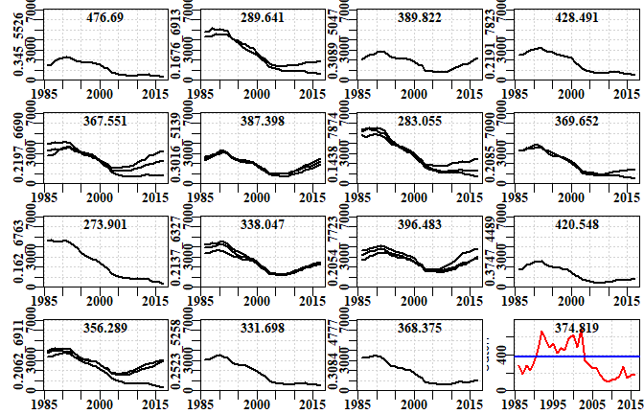

**Figure 15.** 15 examples of different *r-K* combinations only illustrating those trajectories that were plausible. The number at the top of each plot is the predicted MSY for the given parameter pair. The r and K values are the y-axis labels in each case. The final plot is the catch history with the predicted average MSY as the blue line.

plotcMSY6(summcMSY,fish[,"catch"],label=glb$spsname)

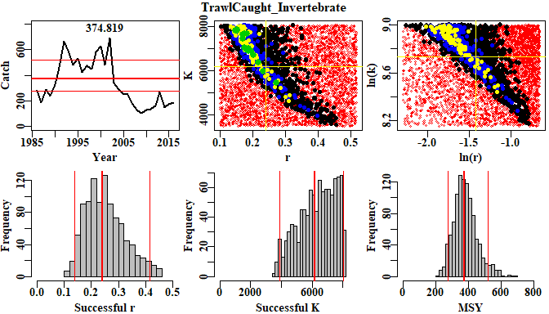

**Figure 16.** A plot of the catch trajectory with the MSY and its 90th percentiles shown as horizontal lines. The two colour plots are a plot of the *K* vs *r* combinations with the red dots depicting failure and then the colours from black to green denote more combinations of initial depletion that succeeded for each *r-K* pair. The right-hand plot is the log-transformed version of the left-hand plot. The histograms describe the distributions of the successful *r-K* pairs and the resulting MSY. The red lines are the median and the 90th percentile confidence intervals.

### Interpretation of the plotcMSY6 plot

The histograms along the bottom row of Figure 16 illustrate the distribution of the successful values of each parameter and the resulting MSY from the parameter pairs. Because of the truncation of the *K* values in the two phase operation of the analysis it should not be surprising if the ‘Successful K’ histogram is flat up against the right hand bound. However, if either of the *r* or left-hand side of the *K* plots is hard up against the bounds, it would be worthwhile exploring whether different initial values of the *r* and *K* values are less constrained. This can be done using a different *resilience* value or by explicitly altering the *start_r* and the *start_K* values. Around the jurisdictions, examples were seen where parts of the *r* or *K* histograms were flat topped, which suggests there is insufficient information in the catches to adequately discriminate between potentially successful trajectories and failures.

Reading Martell and Froese (2013), one can see that the method relies on the notion that a fishery is expected to begin small, build up catches, and then those catches lead to depletion, so that they cannot be maintained and the catches drop. Of course, in Australia there can be many reasons for catches to drop other than the stock becoming depleted. There may be management interventions that lead to reduced catches (imposed catch limits, large marine closures, gear restrictions, and other management steps). In such situations where catches are reduced before stock depletion leads to reduced catches, the catch-MSY seems likely to generate conservative estimates of sustainable production. Other issues that can arise are that catches have only ever increased or stayed stable. Without an on-going decline in catches at some period in the fishery, the model used inside the catch-MSY will have no way in which to characterize maximum productivity, and it may give simply an approximate estimate of the average catches. Obviously care should be taken to understand the data and the fishery, when interpreting the outputs from the catch-MSY analysis.

The Catch-MSY method requires a catch history and some prior notion of the relative resilience or expected productivity of the species being fished. The basic idea is that the method begins with a given range of initial depletion and final depletion levels along with initial ranges of the two parameters describing the Schaefer model; these are the *r* and *K* parameters representing the un-restricted population growth rate and the population carrying capacity respectively. The catch-MSY method is based on a review of very many catch histories and relies on an expectation of catches increasing as a fishery develops and then decreasing as the catches impact the stock. The statistics can begin at the start of a fishery or after it has already developed, hence the initial depletion is set by comparing the initial catches with the maximum catches. The initial ranges for the model parameters depend on the assumed productivity or resilience of the species of which four options exist - “verylow”, “low”, “medium”, and “high”, with associated *r* ranges of (0.015 - 0.125), (0.1 - 0.6), (0.3 - 0.8), and (0.6 - 1.5). In the original code associated with the Martell and Froese (2013) paper they only used three resilience categories, omitting the “medium”. The initial range of the unfished biomass is also very broad with a minimum set at the maximum catch and a maximum set at 60 times the maximum catch.

In case these particular combinations do not suit what is known or suspected of a particular species, the *run_cMSY* function now includes the option to set your own limits on both the initial values for *r* and *K*. A call to either *formals(run_CMSY)* or to *?run_cMSY* will illustrate the syntax and the names of *start_r* and *start_K*. In each case they require a short vector of two numbers (e.g. *start_r=c(0.015,0.3)*)

### Results from the Catch-MSY Analysis

The plots above (Figures 15 and 16) illustrate the results and provide some information, but it is also helpful to obtain a tabulation of the outcome of the analysis. For that we use the *pulloutStats* function. This generates another object containing a matrix of *r*, *K*, *MSY*, and current depletion percentiles and mean values. In addition, it contains the successful biomass trajectories and those same trajectories translated into depletion levels.

results <- pulloutStats(answer$R1)  
print(str(results,max.level=1))

## List of 3  
## $ output : num [1:4, 1:8] 1.38e-01 4.19e+03 2.61e+02 6.95e-02 2.42e-01 ...  
## ..- attr(*, "dimnames")=List of 2  
## $ traject: num [1:2208, 1:35] 1479 4303 4816 2069 2498 ...  
## ..- attr(*, "dimnames")=List of 2  
## $ deplet : num [1:2208, 1:35] 0.268 0.622 0.697 0.41 0.319 ...  
## ..- attr(*, "dimnames")=List of 2  
## NULL

**Table 2.** The results$output statistics from the Catch-MSY analysis. The 2.5%Perc and 97.5%Perc are the respective percentiles describing the spread of the trajectories (i.e. not confidence intervals around the mean). The % columns are the quantiles so that the 50% columns represents the medians.

|  |  |  |  |  |  |  |  |  |
| --- | --- | --- | --- | --- | --- | --- | --- | --- |
|  | 2.5%Perc | Mean | 97.5%Perc | 2.5% | 5% | 50% | 95% | 97.5% |
| r | 0.14 | 0.24 | 0.43 | 0.14 | 0.15 | 0.24 | 0.39 | 0.41 |
| K | 4188.76 | 6196.66 | 9167.06 | 3911.06 | 4220.37 | 6479.79 | 7940.26 | 8016.45 |
| MSY | 260.69 | 374.82 | 538.92 | 264.36 | 277.55 | 373.90 | 518.97 | 554.18 |
| CurrDepl | 0.07 | 0.32 | 0.57 | 0.07 | 0.09 | 0.34 | 0.49 | 0.49 |

These results are fine as far as they go, but in order to obtain some notion of stock status it is necessary to trace the successful trajectories in terms of how their depletion has changed through time. For this we can use the same *plottrajectory* function as used previously, only this time changing the *oneplot* parameter to TRUE, which overrides the *plotal*l parameter. The *Bmax* parameter can be adjusted to obtain an acceptable spread of the results.

out <- plottrajectory(answer$R1,fish$year,fish$catch,answer$parbound,  
 oneplot=TRUE,scalar=1.0,plotout=TRUE,plotall=7)

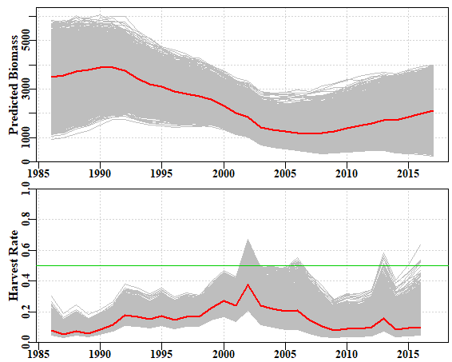

**Figure 17.** The top plot is of the successful biomass trajectories and the red line is the mean in each year. The bottom plot is of the annual harvest rate; note a few seemingly successful trajectories lead to harvest rates > 0.5. Associated with these high harvest rates note also that the final biomass for many trajectories is very low, which may also be deemed unrealistic.

Given each biomass trajectory has an associated *K* value, it is possible to translate the biomass trajectories into depletion trajectories. There are two ways to do this. The simplest way is to use the *pulloutStats* function (see example above) which outputs both the biomass and depletion matrices as a byproduct to estimating the mean *MSY* and current depletion.

results <- pulloutStats(answer$R1)  
# Note the use of constC=0, we are not doing any projections yet so no constant catches  
effectC <- plotconstC(results$deplet,endyear=2017,constC=0,limit=0.2,target=0.4,  
 console=TRUE,intensity=NA,contours=TRUE)

## Year PltLim% PgtTarg% Mean Median Pincrease  
## 2013 2013 0.2595109 0.05525362 0.2682119 0.2715415 0.1942935  
## 2014 2014 0.2758152 0.07835145 0.2682592 0.2754918 0.1376812  
## 2015 2015 0.2468297 0.16666667 0.2873085 0.3004043 0.1621377  
## 2016 2016 0.2318841 0.26811594 0.3039083 0.3187994 0.1884058  
## 2017 2017 0.2182971 0.35009058 0.3201295 0.3389702 0.0000000

abline(h=c(0.2,0.3,0.4),col=3,lwd=2)

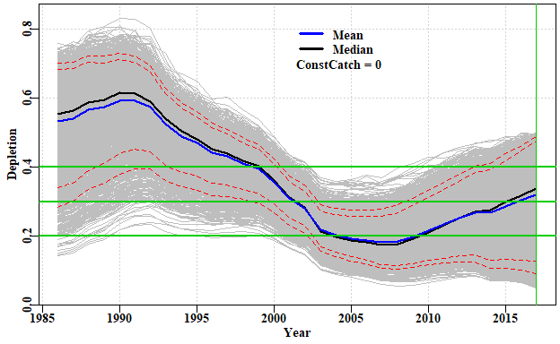

**Figure 18.** A plot of the successful depletion trajectories with the mean and median annual depletion marked. The lower red line is the default 0.2B0 limit reference point, while the upper is the input target reference point. The green line denotes the end of the final year in which data are available. If the abbreviated table under the plot is not wanted (all the information will be in *effectC*) then the *console=TRUE* should be set to *console=FALSE*. The red dashed lines are the inner 80th and 90th percentile bounds but if not wanted set *contours=FALSE*.

The PltLim% column in the console output is the proportion of trajectories that are < *limit*, whereas the PgtTarg% is the proportion of trajectories that are greater than the target. Given the great uncertainty in these analyses it should not be surprising that both of these increase over time, which suggests the total spread of the outcomes is increasing. The question that needs answering is whether the average is increasing or decreasing. Here, both the mean and median are increasing, though only by about 4 - 5 % across the five years prior to the final year of data. As the average stock size increases, the rate of increase would be expected to first increase and then decline as the stock moved, on average, above the biomass that produces the maximum productivity (*BMSY*).

The default plot of the depletion in Figure 18 has grey lines of equal density, but if one wants to attempt to generate a plot with the density of colour matched to the density of trajectories, then it is possible to include a number in the *intensity* parameter (Figure 19). The value input determines the density of the trajectories required to obtain full colour intensity and this will undoubtedly vary by fishery and so will need to be used interactively to find a value that generates a satisfactory plot. If the plot is to be printed then be sure to save the plot as a bit map or .png file so that the varying density and transparency is retained in the plot.

effectC <- plotconstC(results$deplet,endyear=2017,constC=0,limit=0.2,target=0.4,  
 console=FALSE,intensity=30)   
abline(h=c(0.2,0.3,0.4),col=3,lwd=2)

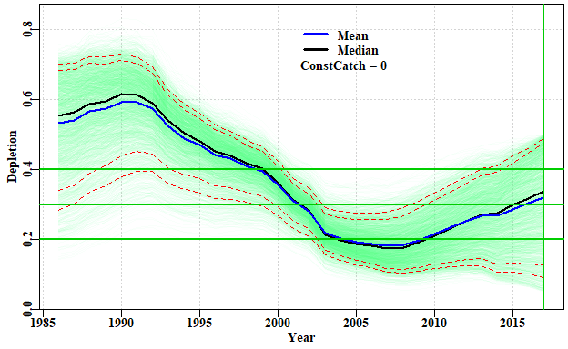

**Figure 19.** A plot of the successful depletion trajectories with the mean and median annual depletion marked, with the density of trajectories represented by different intensity of colour. The lower red line is the default 0.2B0 limit reference point, while the upper is the input target reference point. The green line denotes the end of the final year in which data are available. The intensity value may need to be adjusted empirically to obtain a satisfactory plot.

In Figure 19 different intensity of colours are used to denote the paths followed by most trajectories. In this case between 1995 and about 2001 most lines are towards the top of the overall path, but are moving downwards until between 2002 and 2008, when the median line is biased low, with it being closer to the bottom of all paths than the top. After that most paths are moving upwards with the median once again shifting closer to the upper margin than the lower.

### Constant Catch Projections

From the table and the plot it is clear that the average depletion is quite a way below the selected target. We need to remember that this is a data-poor assessment and that currently there are no agreed harvest strategies or harvest control rules. Nevertheless, if we project the currently potentially successful trajectories forward under different constant catch scenarios we will be able to determine what levels of catch will lead to the stock increasing (on average) and what will lead to decreases (on average). Depending on where the assessment indicates a species is laying will then determine what management action to advise to manage a stock in a desired direction (whether that be to increase or decrease its current state).

output <- doconstC(answer$R1,projn=10,constCatch=250,lastyear=2017,limit=0.2,  
 target=0.48,console=FALSE)

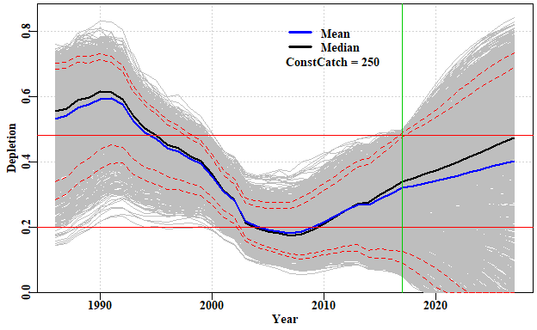

## Year PltLim% PgtTarg% Mean Median Pincrease  
## 2017 2017 0.2182971 0.08333333 0.3201295 0.3389702 0.0000000  
## 2018 2018 0.2264493 0.15670290 0.3272867 0.3501942 0.7047101  
## 2019 2019 0.2336957 0.22780797 0.3344058 0.3627125 0.7047101  
## 2020 2020 0.2382246 0.28260870 0.3420144 0.3745919 0.7047101  
## 2021 2021 0.2409420 0.32201087 0.3502623 0.3864780 0.7047101  
## 2022 2022 0.2418478 0.35552536 0.3589386 0.4010272 0.7047101  
## 2023 2023 0.2454710 0.38768116 0.3678768 0.4158672 0.7047101  
## 2024 2024 0.2477355 0.42527174 0.3769153 0.4300547 0.7047101  
## 2025 2025 0.2527174 0.45018116 0.3859903 0.4440718 0.7047101  
## 2026 2026 0.2558877 0.47554348 0.3948929 0.4597548 0.7047101  
## 2027 2027 0.2567935 0.49592391 0.4036456 0.4741102 0.7047101

**Figure 20.** A plot of the successful depletion trajectories followed by five years of projection. The limit and target reference points are depicted by the two fine red lines. The green line denotes the end of the final year in which data are available, with projections to the right. The mean depletion varies away from the median because an array of trajectories go extinct on projection

The projections suggest that a total catch of about 250 t would be expected to lead, on average, to a small increase in stock levels over the five years. By exploring the outcomes with smaller and larger constant catches, the implications can be made clear and appropriate decisions about catch levels or triggers could then be made in an attempt to meet whatever objective is desired for the fishery. What seems to be implied by Figure 20 is that the stock in question was overfished between about 2003 – 2010, but as the plot of catches vs *MSY* from the *plotcMSY6* analysis illustrate, after 2003 catches were reduced significantly and that led to the stock rebuilding, until in 2017 it was estimated (with great uncertainty) to be about 30% B0. In 2017, given the stock is rebuilding and is already above the limit reference point, it can be claimed that it is sustainable and that over-fishing is not occurring.

### Robustness of MSY Estimate

While it is true that the ranges of the successful *r* and *K* combinations is quite wide, because there is a strong negative correlation between these two parameters, the spread of the MSY estimates is not so large in relative terms. This can be illustrated by using the *trendMSY* function which estimates the *MSY* implied by a series of slices down the *K* axis from the scatter of *r - K* combinations. Given that a function of *r* and *K*, it is possible to map estimated *MSY* onto the plot of *r - K* combinations, along with the estimated mean trend from the successful *r - K* combinations (Figure 21).

r <- summcMSY$r  
K <- summcMSY$K  
meanmsy <- trendMSY(summcMSY$r,summcMSY$K,inc=300)  
centr <- central(r)  
centK <- central(K)  
means <- central(summcMSY$msy)  
avMSY <- means["Geometric","Mean"]  
# plotprep(width=7,height=4.0)  
par(mfrow=c(1,1),mai=c(0.45,0.45,0.05,0.05),oma=c(0.0,0,0.0,0.0))   
par(cex=0.85, mgp=c(1.35,0.35,0), font.axis=7,font=7,font.lab=7)  
plot(r,K,type="p",pch=16,col=rgb(1,0,0,1/3),panel.first=grid())  
rval <- seq(0.1,0.6,length=100)  
kval <- (4 * avMSY)/rval # calculate the K value that would generate avMSY  
lines(rval,kval,col=4,lwd=2)  
pickvalid <- which(meanmsy[,"N"] > 0)  
lines(meanmsy[pickvalid,"rcenter"],meanmsy[pickvalid,"Kcenter"],lwd=2,col=3)  
points(centr[2,1],centK[2,1],pch=16,cex=2,col=1)

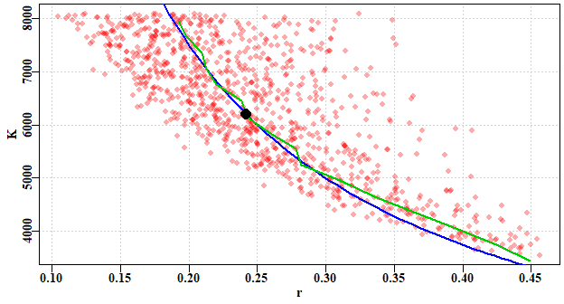

**Figure 21.** A plot of the successful *r - K* combinations with the estimated mean *MSY* overlaid in blue, and the mean *MSY* for horizontal slices of the cloud of successful *r - K* combinations derived from *trendMSY*. Note that the overall mean *MSY* (the black dot) coincides approximately with the point at which the blue and the green lines begin to diverge (as *r* increases and *K* decreases).

One can imagine contours of MSY running across the *r - K* parameter space, and the catch-MSY analysis discovering which *r - K* combinations are consistent with the possibilities (Figure 22).

r <- summcMSY$r  
K <- summcMSY$K  
avMSY <- seq(100,600,100)   
nMSY <- length(avMSY)  
# plotprep(width=7,height=4.0)  
par(mfrow=c(1,1),mai=c(0.45,0.45,0.05,0.05),oma=c(0.0,0,0.0,0.0))   
par(cex=0.85, mgp=c(1.35,0.35,0), font.axis=7,font=7,font.lab=7)  
plot(r,K,type="p",pch=16,col=rgb(1,0,0,1/3),panel.first=grid(),ylim=c(2500,9000))  
rval <- seq(0.1,0.6,length=100)  
for (i in 1:nMSY) {  
 kval <- (4 * avMSY[i])/rval # calculate the K value that would generate avMSY  
 lines(rval,kval,col=4,lwd=2)  
}  
x <- seq(0.15,0.375,length=nMSY)  
yval <- 4 * (avMSY/x)  
for (i in 1:nMSY) text(x[i],yval[i],avMSY[i],cex=1,font=7,pos=4)

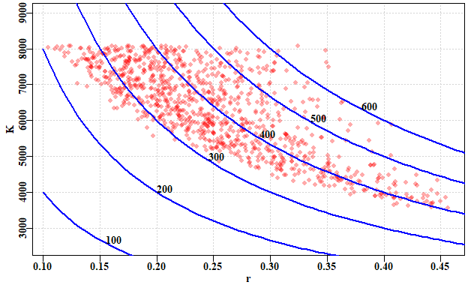

**Figure 22.** A plot of the successful *r - K* combinations with an array of implied *MSY* values, as implied contours across the *r - K* parameter space. Some contours would under-estimate the implied productivity while others would over-estimate what was consistent with available observations.

## Significant Unknown Recreational Catches

It is often the case that obtaining accurate estimates of recreational catch is rarely done, even when it is known that they can rival commercial catches. In jurisdictions where there are significant recreational catches of commercial species, there remains a need to assess the stock status of such species and likely also provide management advice as to what would constitute sustainable commercial catches. As long as there is some notion of the proportion of recreational catches, it is still possible to apply the catch-MSY assessment method to a time-series of commercial catches. To demonstrate the effect of having significant amounts of recreational catch on top of a commercial catch, we can conduct an analysis using one of the data sets internal to ***simpleSA***, then that can be compared to the same analysis after the catches have been proportionally reduced in some manner as if the total catch was made up of known commercial catches and unknown recreational catches. In this preliminary exploration we will examine a deterministic reduction, keeping just 80%, and 60% of known commercial catches while repeating the analysis. To include some variation we can reduce the original catches by a randomly varying proportion around some selected mean. Finally, we can conduct the analysis on a deterministically reducing commercial proportion down from say 80% to 50% over the time period of data available.

We can use the *invert* data set. First, we obtain the expected outcome by analysing the full data set.

library(simpleSA)  
data(invert)  
fish <- invert$fish  
glb <- invert$glb  
  
reps <- 5000 # one would run at least 20000, preferably more  
answer <- run_cMSY(fish,glb,n=reps,sigpR=0.025)  
summcMSY <- summarycMSY(answer,fish,final=TRUE)  
ans <- pulloutStats(answer$R1)  
round(ans$output[,1:3],3)

## 2.5%Perc Mean 97.5%Perc  
## r 0.127 0.231 0.421  
## K 4309.742 6480.576 9744.866  
## MSY 253.399 374.364 553.074  
## CurrDepl 0.059 0.312 0.566

So, the mean current depletion is estimated to be about 0.31, with an MSY of about 370 tonnes. Now we can answer what would happen if the commercial catch data was only 80% of the original (with variation about that 80% each year; this implies there would be unknown recreational catches of about 20% plus or minus some variable amount each year) while the CPUE data remains unchanged. The deterministic reductions gave very precise results, so this exposition begins with the somewhat more realistic variation around a given average proportion of recreational catches.

commprop <- 0.8  
propcom <- rnorm(31,mean=commprop,sd=0.025) # 31 equals the number of years  
fishC <- fish  
fishC[,"catch"] <- fishC[,"catch"]*propcom  
answerC <- run_cMSY(fishC,glb,n=5000,sigpR=0.025)  
ansC <- pulloutStats(answerC$R1)  
#str(ans10)  
round(ansC$output[,1:3],3)

## 2.5%Perc Mean 97.5%Perc  
## r 0.119 0.222 0.412  
## K 3540.525 5416.386 8286.128  
## MSY 196.170 299.956 458.653  
## CurrDepl 0.056 0.308 0.561

round(ans$output[,1:3],3)

## 2.5%Perc Mean 97.5%Perc  
## r 0.127 0.231 0.421  
## K 4309.742 6480.576 9744.866  
## MSY 253.399 374.364 553.074  
## CurrDepl 0.059 0.312 0.566

msy <- ansC$output["MSY","Mean"]/ans$output["MSY","Mean"]  
depl <- ansC$output["CurrDepl","Mean"]/ans$output["CurrDepl","Mean"]  
cat("reduced catch MSY/full catch MSY = ", msy, mean(propcom),"\n")

## reduced catch MSY/full catch MSY = 0.8012429 0.8057442

cat("Proportion of Current Depetion = ",depl,"\n")

## Proportion of Current Depetion = 0.9873974

You could try different values for the *commprop* value to see the effect of the recreational proportion increasing. But it appears that the impact of a 20% decrease in known catches is to reduce the sustainable production available to commercial operators by about 20% (and, similarly, a 40% reduction leads to about a 40% reduction in production).

As opposed to the mean recreational catch proportion staying approximately stable through time, it is also possible to examine the effect of a temporal trend in the proportion of commercial catches. Here we inspect the effect of the commercial proportion changing from 80% to 50% (unknown recreational catches change from 20% to 50%) over a 31 year period. Normally one would use at least 20000 replicates rather than 5000, but for purposes of run time, the example is limited to the latter.

propcom <- seq(0.8,0.5,length=31) # 31 equals the number of years  
fishC <- fish  
fishC[,"catch"] <- fishC[,"catch"]*propcom  
answerC <- run_cMSY(fishC,glb,n=5000,sigpR=0.025)  
ansC <- pulloutStats(answerC$R1)  
round(ansC$output[,1:3],3)

## 2.5%Perc Mean 97.5%Perc  
## r 0.111 0.205 0.376  
## K 3321.514 4953.451 7387.198  
## MSY 165.480 253.686 388.910  
## CurrDepl 0.063 0.313 0.563

round(ans$output[,1:3],3)

## 2.5%Perc Mean 97.5%Perc  
## r 0.127 0.231 0.421  
## K 4309.742 6480.576 9744.866  
## MSY 253.399 374.364 553.074  
## CurrDepl 0.059 0.312 0.566

msy <- ansC$output["MSY","Mean"]/ans$output["MSY","Mean"]  
depl <- ansC$output["CurrDepl","Mean"]/ans$output["CurrDepl","Mean"]  
cat("reduced catch MSY/full catch MSY = ", msy, mean(propcom),"\n")

## reduced catch MSY/full catch MSY = 0.6776468 0.65

cat("Proportion of Current Depletion = ",depl,"\n")

## Proportion of Current Depletion = 1.003029

If this code chunk is run numerous times the outcomes suggest that the estimate of sustainable commercial catch may be biased slightly high but, on the other hand the depletion level is invariably very close to that obtained when using all the catch data.

These two sets of scenarios suggest that if we consider an unknown recreational catch to reflect one of these two scenarios (randomly varying around some relatively constant proportion of the commercial catch or approximately following some trajectory from one proportion to a higher proportion of recreational catch) then it should still be possible to get an estimate of the stock’s current depletion level while, at the same time, generating potential management advice concerning the commercial fishery. These explorations need to be more fully investigated but, at least with the Catch-MSY approach, the conclusions appear to be acceptable. The results can even provide a phase plot of predicted biomass against harvest rate, but obviously only for the commercial component. These results are consistent with those of Rudd and Branch (2017) who found very similar results using fitted stock assessments in a management strategy evaluation framework rather than catch-only methods.

cMSYphaseplot(answerC,fishC)

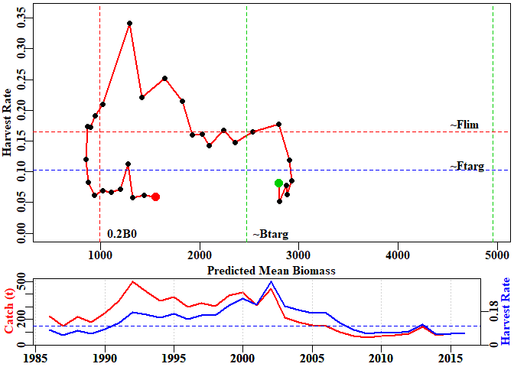

This phase plot can then be compared with the analysis that derived from the full dataset of catches:

cMSYphaseplot(answer,fish)

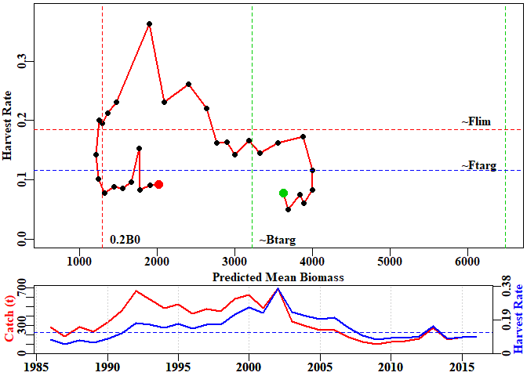

There are clear differences between the two phase plots in that the analysis of partial catch suggests that there was a time that the stock went below the limit reference point but overall, the trajectory obtained is approximately the same as that for the full catch data set.

It is not surprising that differences occur between those analyses that capture all catches and those that include a proportion of unknown catches, because the productivity now appears to be different. Nevertheless, the same general pattern observed with all data remains, even with the truncated data using only the commercial catches. In reality, with a fishery having a significant recreational proportion, we would only have the ‘truncated’ data but these explorations indicate that it should still be possible to obtain both a status and management advice (at least for the commercial proportion of the fishery) under the assumption that the relative proportion would not change further. Of course, if there is a temporal trend in the proportion of recreational take relative to the commercial take, then only advice in the short term could be deemed useful.

## Plausible Levels of Harvest Rate

Even though the overall productivity of the diverse Australian fisheries may be relatively high, the productivity of many individual Australian fisheries tends not to be as great as equivalent fisheries in the northern hemisphere. Many commercial Australian fish species seem to live longer than northern hemisphere counterparts, and have lower overall productivity by species, and hence naturally cannot have such high catches. It seems unlikely, therefore, that the fishing mortalities observed in places such as the North Sea, where *F* values of 1.0 (equivalent to harvest rates of between 0.6 and 0.7 each year) have been common, are not plausible, and certainly not sustainable, here. The catch-MSY method only uses the available time-series of catches, and its random selection of *r-K* combinations can select highly productive combinations which enable the stock to grow well beyond plausible bounds (which are rejected). There are other combinations of r and K, whose implied productivity (from the Schaefer model used within the catch-MSY to reflect the stock dynamics) is far too low, so that any trajectories go extinct (also rejected). Then there are the combinations that imply a productivity that allows for the catches taken but stays within the other constraints implied by the resilience and starting catch levels for the species (accepted trajectories). However, within those accepted trajectories there will be some parameter sets that imply productivities at which the populations only barely survive within the constraints. It is also implied that some of these trajectories reflect relatively high annual harvest rates. For example, using the *invert* data set we can obtain some trajectories with harvest rates greater than 0.5 (50% of exploitable biomass taken every year).

# library(simpleSA)  
data(invert)  
fish <- invert$fish  
glb <- invert$glb   
answer <- run_cMSY(fish,glb,n=5000,sigpR=0.025,finaldepl=c(0.05,0.5),maximumH=1.0)  
ans <- pulloutStats(answer$R1)  
round(ans$output[,1:3],3)

## 2.5%Perc Mean 97.5%Perc  
## r 0.116 0.216 0.403  
## K 4477.619 6897.759 10625.978  
## MSY 243.057 372.339 570.386  
## CurrDepl 0.056 0.309 0.561

out <- plottrajectory(answer$R1,fish$year,fish$catch,answer$parbound,  
 oneplot=TRUE,scalar=1.0,plotout=TRUE,plotall=7)

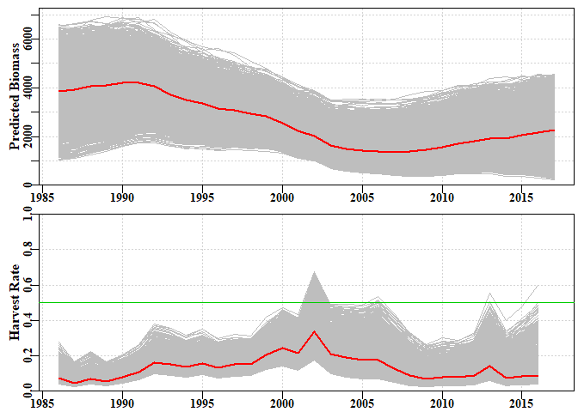

**Figure 23.** A plot of the implied successful biomass trajectories and their implied annual harvest rates generated by the function *plottrajectory* with the option *oneplot* set to *TRUE*. The red lines are the median values, the green line is at a harvest rate of 0.5, for reference.

In Figure 23, some of the harvest rates in the final years approach 0.5, but between 2000 and about 2007, some trajectories fully breach the 0.5 line and often stay close to it. Part of this reflects the default final depletion range of c(0.05,0.5) given if catches in the final year are less than half the maximum catch (a selection which ignores the fact that management intervention or marketing issues may have controlled catches, rather than an inability to catch). However, even if we change the lower final depletion value to, for example, 0.15, the final year high harvest rates that survive, the period from 2000 still appears to be exceptional, even though most of them were reduced.

In order to conduct a sensitivity on the implications of there being an upper limit of harvest rate, a new *maximumH* parameter has been added to the *run_cMSY* function. Its default value is set to 1.0, so that all harvest rates are possible (obviously one could not take more than 100% of what is present!). If we alter the value to 0.5, the outcome changes.

With this extra constraint, the successful biomass trajectories are much more restricted, and the harvest rates far lower. This change only improves the depletion level by about 3%, but the productivity, as measured by the MSY is reduced from about 370 t down to 333 t, a reduction of 10%. It may appear counterintuitive that removing some of the lower trajectories (note the increase in the lower 95th percentile) leads to a lower productivity, but the important parts are reflected in the mean values of *r*, the population growth rate. By comparing the outputs related to Figures 23 and 24, the reduction in *r* should be clear. It is this reduction that has led to the decrease in productivity.

Such a sensitivity to *maximumH* is very dependent upon local knowledge of the history of any fishery. Productivity is also partly determined by the resilience attributed to a species. One could also run sensitivities on what resilience was given to a species. The importance of that is that the resilience determines the implied bounds on *r* used in the search for successful trajectories. Of course, it is possible to modify these, if it is felt necessary, by directly entering values for *start_r* as a vector of two numbers.

answer <- run_cMSY(fish,glb,n=5000,sigpR=0.025,finaldepl=c(0.05,0.5),maximumH=0.5)  
ans <- pulloutStats(answer$R1)  
round(ans$output[,1:3],3)

## 2.5%Perc Mean 97.5%Perc  
## r 0.114 0.174 0.265  
## K 6038.608 7737.059 9913.227  
## MSY 234.142 336.988 485.009  
## CurrDepl 0.085 0.325 0.564

out <- plottrajectory(answer$R1,fish$year,fish$catch,answer$parbound,  
 oneplot=TRUE,scalar=1.0,plotout=TRUE,plotall=7)

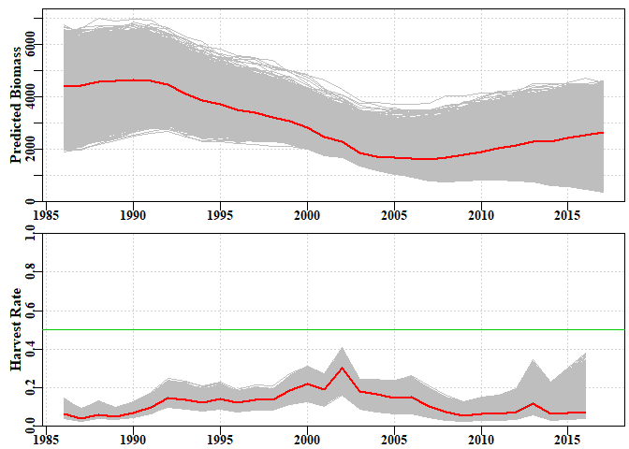

**Figure 24.** A plot of the implied successful biomass trajectories and their implied annual harvest rates generated by the function *plottrajectory* with the option *oneplot* set to *TRUE* and the *maximumH* parameter set to 0.5. The red lines are the median values, the green line is at a reference harvest rate of 0.5.

### Other Sensitivities

We have seen it is possible to examine the implications of changing the *initdepl* and *finaldepl*, along with changing the *start_r* and *start_K*. A further sensitivity that ought to be conducted relates to the process error term *sigpR*. This term aims to attempt to capture un-accounted for variation in the stock dynamics between the years. The simple model is so simple it fails to capture many sources of natural variation. It is worthwhile examining alternative values for *sigpR*. In particular, it is worthwhile effectively turning this source of variation off to see the effect of almost deterministic dynamics. This can be achieved by setting *sigpR = 0*.

# library(simpleSA)  
# normally one would run 20000+ replicates, but for speed we use 5000  
answer <- run_cMSY(fish,glb,n=5000,sigpR=0,finaldepl=c(0.05,0.5),maximumH=1.0)  
ans <- pulloutStats(answer$R1)  
round(ans$output[,1:3],3)

## 2.5%Perc Mean 97.5%Perc  
## r 0.127 0.231 0.421  
## K 4279.238 6586.085 10136.503  
## MSY 261.929 380.815 553.661  
## CurrDepl 0.054 0.307 0.560

out <- plotconstC(ans$deplet,endyear=2017,constC=0)

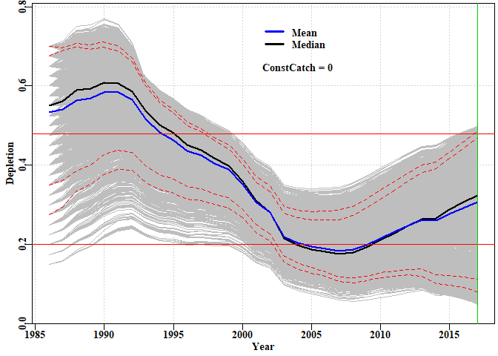

**Figure 25.** A plot of the implied successful depletion trajectories when the *sigpR* parameter is set to 0. The 23 different starting depletion levels between the default 0.15 - 0.7 can now be clearly seen. The lowest values are the most sparse in terms of successful trajectories.

## Year PltLim% PgtTarg% Mean Median Pincrease  
## 2013 2013 0.2857741 0.00000000 0.2619774 0.2644233 0.2230126  
## 2014 2014 0.3087866 0.00000000 0.2610978 0.2668415 0.1631799  
## 2015 2015 0.2744770 0.00000000 0.2780376 0.2879090 0.1824268  
## 2016 2016 0.2560669 0.00292887 0.2927127 0.3070091 0.1945607  
## 2017 2017 0.2476987 0.06820084 0.3065656 0.3233666 0.0000000

The assumption that a final depletion level of 5% (0.05) is plausible should be questioned for many Australian fisheries when the catches remain about 1/3 of the maximum and the CPUE barely changes. As always, such data-poor stock assessments should only form part of a weight-of-evidence argument supporting a claim for a set of management advice and stock status determinations.

plotfishery(fish,glb)

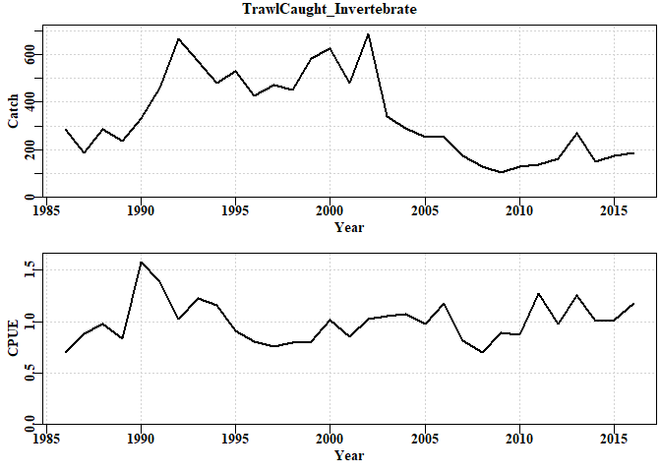

**Figure 26.** A plot of the reported catch history and the standardized CPUE for the example data set used in the vignette.

##### 

# spm - Surplus Production Models

## Introduction

### Which Assessment to Apply

Which stock assessment method to apply to fisheries for data-poor to data-moderate species will depend upon what fisheries and biological data are available but also, importantly, on what management objectives need to be met within the jurisdiction in question. It may be the case that the fishery for a particular species is of sufficient size and value to warrant on-going monitoring and management towards some defined goal for the stock. In such a case the assessment used should obviously be capable of generating some notion of the current state of the fishery and indicate what management actions may be required to eventually achieve the agreed management goals. But some fisheries may be so minor that trying to actively manage them would be inefficient. Nevertheless, to meet the requirements of the Status of key Australian Fish Stocks (SAFS) one still requires some form of defensible stock assessment capable of determining whether the current level of fishing is sustainable.

## Surplus Production Modelling = spm

Surplus production models are one of the simplest analytical methods available that provides for a full fish stock assessment of the population dynamics of the stock being examined. First described in the 1950s (Schaefer, 1954, 1957), modern versions with discrete dynamics are relatively simple to apply. This is partly because they pool the overall effects of recruitment, growth, and mortality (all the aspects of positive production) into a single production function. The stock is considered solely as undifferentiated biomass; that is, age and size structure, along with sexual and other differences, are ignored (this is one reason these models are also called “biomass-dynamic models”). Details of the equations used in the following analyses are provided in the Appendix of this vignette. You will also find details of the parameters and other aspects in the help files for each of the functions (try *?spm* or *?simpspm*, or even *?simpfox*). In brief, the model parameters are

* the net population rate of increase (combined individual growth in weight, recruitment, and natural mortality),
* , the population carrying capacity or median unfished biomass ()(not to be confused with (sometimes, in other contexts confusingly, also called )), and
* , which is only required if the index of relative abundance data (usually CPUE) only becomes available after the fishery has been running for a few years, and after the stock has been depleted to some extent. is set equal to if no initial depletion is assumed. If early catches are known to be small relative to the maximum catches taken (< 10 - 25% of maximum), then it may well be true that initial depletion is only minor and might not be distinguishable from unfished.

The minimum data requirements needed to estimate parameters for such models are

* a time-series of an index of relative abundance, and
* a time series of associated catch data.

The catch data can extend either end of the index data if it is available. In Australia the index of relative stock abundance is most often catch-per-unit-effort (CPUE), but could also be some fishery-independent abundance index (e.g., from trawl surveys, acoustic surveys), or both abundance indices could be used. The analysis will permit the production of on-going management advice as well as a determination of stock status.

In this section we will describe the details of how to conduct a surplus production analysis, and how to extract the results from that analysis, as well as plot out illustrations of those results. Example code will be developed that a user can take and modify to suit their own needs.

A standard workflow might consist of:

1. read in time-series of catch and relative abundance data. It would also be possible to use the function **checkdata** to ensure all data columns required are present; you could also consider the functions **makespmdat** and **checkspmdat** for similar purposes, check their help files.
2. use a **ccf** analysis to determine whether the CPUE data are likely to be informative and thus provide plausible results from the spm (or not!).
3. define/guess a set of initial parameters containing *r* and *K*, and optionally = initial biomass - used if it is suspected that the fishery data starts after the stock has been somewhat depleted. The mean values from a catch-MSY analysis might be suitable.
4. use **DisplayModel** to plot up the implications of the assumed initial parameter set for the dynamics. This is useful when searching for plausible initial parameters sets.
5. use **optim** or **fitSPM** to search for the optimum parameters once a potentially viable initial parameter set are input.
6. use **DisplayModel** using the optimum parameters to illustrate the implications of the optimum model and its relative fit (especially using the residual plot).
7. ideally one should examine the robustness of the model fit by using multiple different initial parameter sets as starting points for the model fitting procedure.
8. once satisfied with the robustness of the model fit use **spmphaseplot** to plot out the phase diagram so as to determine and illustrate the stock status visually .
9. use **bootspm** to characterize uncertainty in the model fit and outputs.
10. Document and defend any conclusions reached.

Two versions of the dynamics are currently available: the classical Schaefer model (Schaefer, 1954) and the Fox model (Fox, 1970). Both are described in Haddon (2011). Prager (1994) provides many additional forms of analysis that are possible using surplus production models and practical implementations are also provided in Haddon (2011). See the model equations in the appendix for more details of each model.

## Application of the spm assessment

The minimum data requirements for a surplus production analysis are a time series of catches and a time series of an index of relative abundance (CPUE). The years of catch information can be longer than the years of cpue data. We will use the *dataspm* data set built into the package to illustrate the use of the *spm* function. The *checkdata* function indicates it would be possible to apply the catch-MSY, the spm, and the aspm analyses to this data.

# library(simpleSA) # include the library before starting analysis  
data(dataspm)  
fish <- dataspm$fish  
# check data.frame has all required columns; not usually required; use head(fish,10)  
checkdata(dataspm)

## Method Possible  
## catch-MSY TRUE TRUE  
## spm TRUE TRUE  
## aspm TRUE TRUE  
## catch-curves catch-curves FALSE

### Are the CPUE data informative?

The first step is to try to discover whether or not the available index data provide more information than the catches alone. With a developed fishery, if the fishing (that is, the catches), do indeed influence the stock dynamics, which would in turn affect the CPUE, then we would expect that if catches increased the catch rates would eventually respond by declining. We would also expect that, if catches declined, then the CPUE would, in turn, eventually increase. Such a time-lagged negative correlation is something we can look for statistically, if we have sufficiently long time-series of catches and associated CPUE. To determine whether there are any significant negative correlations of CPUE with catches, we need to conduct a sequence of correlation analyses on the original data (timelag=0), then lag the CPUE data backwards by successive years, and repeat the correlation analysis (e.g. the first time, with n-1 years this time, lag=-1).. Rather than do this manually, it is possible to use a built-in R function *ccf*. To simplify things further, there is a wrapper function in ***simpleSA*** called *getlag*. This uses the *ccf* function to run the analysis, which can also generate a plot immediately. Alternatively, its output can be used to produce a more visually appealing plot for inclusion in a report (check out *str(ans)*).

ans <- getlag(fish,plotout=FALSE)  
par(mfrow=c(1,1),mai=c(0.5,0.45,0.05,0.05),oma=c(0.0,0,0.0,0.0))   
par(cex=1.0, mgp=c(1.35,0.35,0), font.axis=7,font=7,font.lab=7)   
plot(ans,lwd=3,col=2,main="",ylab="Cross-Correlation")  
minim <- which.min(ans$acf)  
text(0,-0.6,paste0("Optimum Lag = ",ans$lag[minim]),cex=1.1,font=7,pos=4)

It should not be forgotten that when correlating catches and CPUE, we have catches inside the CPUE, so it occurs in both variables invovled in the correlation analysis, so we should expect to see correlations. If effort were relatively constant, however, then if availability increased and catchability remained the same, then catches would increase and so would CPUE. Thus, the correlation at lag = 0 would be high. Despite such complications it still appears to be the case that if no significant correlations at negative time lags occur, then valid spm or aspm model fits to the CPUE data do not seem to occur.

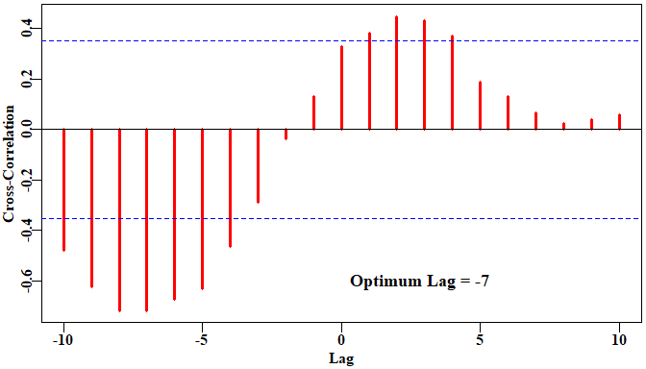

**Figure 27.** A plot of the *ccf* function output when applied to the fishery data within the built in *dataspm* data set. The strong negative correlation at lags of -7 and -8 suggest an spm or aspm analysis will likely generate plausible results, although the relatively strong correlation at a lag of 0, may weaken any valid relationship between the catches and subsequent CPUE values.

### Fitting the spm Model

The first step is to start guessing initial parameter sets until an approximate solution presents itself. This eases the way for the minimization of the negative log-likelihood (-verLL) used to fit the model to the data. If the initial guesses are too far from the final solution, then the numerical methods used to conduct the minimization may fail to converge on a viable solution. If the stock is thought to have been depleted before the collection of data began, then three parameters (*r* , *K* , and *Binit*)are required, otherwise only two are needed. In the example below these parameters are *r* =0.16, *K* = 6700, and *Binit* = 3500 (which implies an initial depletion of 3500/6700, which is ~52%). When making these initial guesses it is helpful to both plot the implied predicted trajectory of CPUE against the observed CPUE, and include the estimation of the negative log-likelihood. In that way, if the guessed model fit to the data begins to improve it is easily detected by the negative log-likelihood getting smaller (more negative in this case).

The plot in Figure 28 merely represents the first guess at the parameters, so it is not surprising that the model fit to data is not particularly impressive. Guessing a set of parameters and displaying their implications is an important first step to get the predicted CPUE vaguely approximating the observed CPUE. Only once such an approximation is produced should you think about trying to fit the model to the data formally. Model fitting may produce sensible results before an approximate solution is found, but often it does not. It is possible to use the catch-MSY method to generate first guesses at the *r* and *K* parameters, but producing initial values for *Binit*, if it is to be used, is currently down to trial and error.

# display the dynamics for a set of guessed initial parameters  
pars <- c(0.16,6700,3500) # r, K, and Binit  
negLL(pars,fish,simpspm)

## [1] -2.862565

ans <- displayModel(pars,fish,schaefer=TRUE,target=0.48,addrmse=TRUE)

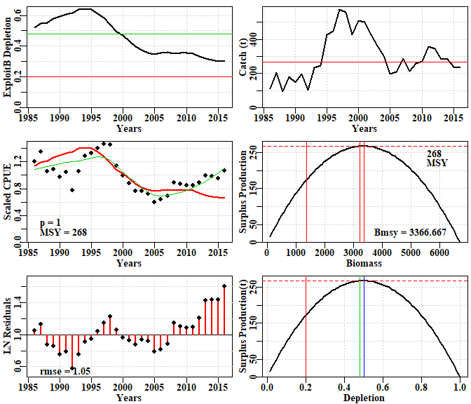

**Figure 28.** A summary plot depicting the fit of the model using the guessed input parameters. These initial parameters have not been fitted. The plots include the predicted depletion and catch through time. The green line is a loess fit to the observed CPUE, while the red line is the fit using the parameters. The surplus production curve is given twice, once with biomass and once with depletion on the x-axis. Finally, the log-normal residuals between the fit and the data are illustrated.

Rules of thumb can also be used when attempting to find suitable starting points. A possible approximation for the unfished biomass (*K* parameter) can be obtained by multiplying the maximum catch by 10 to 15. As in the catch-MSY method, if the initial catches in the available data are a reasonable proportion of the maximum catch then the stock can be assumed to have been somewhat depleted prior to data collection. A value between 0.5 to 0.7 times the selected *K* value could be used for a *Binit* value. One might then search for an *r* value perhaps starting at something like 0.3. Remember that the *r* parameter as a combination of both the reproductive rate and the natural mortality rate is a net population growth rate, not only the reproductive rate. This means it may be lower than a simple consideration of the species’ life history might suggest. A plausible set of parameters would be where the implied predicted CPUE trajectory even roughly approximates the observed trajectory. The next step after finding a plausible starting point is to attempt to use numerical methods to fit the data to the model.

The production curves are an expression of the *r* - *K* parameters where, for the Schaefer model, the MSY is assumed to occur at half the unfished biomass (*K*; see the model equations appendix). Using the production curve it will be possible to estimate the predicted catch at and , and from those it will be possible to estimate the harvest rates at the target and limit reference points. Two of the potential input parameters to the *displayModel* function are the *limit* and *target*, which default to 0.2 and 0.48. Obviously these can be set to whatever is relevant to the jurisdiction involved.

### Fitting the Model to the Data

There are three functions available for working with the dynamics of surplus production models. The most comprehensive in its output is *spm*, which generates the full dynamics and returns a matrix of all values (try *out <- spm(inp=pars, indat=fish, schaefer = TRUE)*. The default Schaefer model dynamics are defined by the *schaefer = TRUE* parameter value. To use the Fox model, the option *schaefer = FALSE* should be used. The model fitting only compares the observed CPUE with the predicted CPUE and does not require the full dynamics to be produced. Thus, in order to speed up the iterative process of numerically searching for a model fit, we also have a simplified *simpspm* function that only outputs the predicted CPUE. This function also has a *schaefer* parameter to determine whether to use a Schaefer or the Fox model. The *simpspm* function is used in the model fitting, whereas if you inspect the code for *displayModel*, you will find that it uses *spm*. In the following we will use *optim* which is a solver or minimizer that comes as part of the base R installation. Check out *?optim* or *formals(optim)*, or more thoroughly you could read the *Optimization* task view at <https://cran.r-project.org/>. The code below is a template that should work for you. The control list is not always needed but it usually helps to keep the solver stable. If you check the code for *negLL* by typing that in the R console without brackets, you will see there is code (*na.rm=TRUE*) to exclude records where there may be catch data but no observed CPUE data. Ideally one has data for both in each year, which generally leads to more stable outcomes, but in reality this does not always occur.

Instead of using *optim* or one of the other non-linear minimizers in R, it is possible to use *fitSPM*, which is a wrapper within **simpleSA** that contains two runs through the optim fitting routine (see later).

pars <- c(0.16,6700,3500) # r, K, and Binit, implies a depletion of ~0.52  
cat("initial -ve log-likelihood ",negLL(pars,fish,simpspm),"\n")

## initial -ve log-likelihood -2.862565

bestSP <- optim(par=pars,fn=negLL,callfun=simpspm,indat=fish,  
 control=list(maxit = 1000, parscale = c(1,1000,1000)))  
outoptim(bestSP) # outoptim just prints the results more compactly.

## $par : 0.2424071 5173.363 2845.831   
## $value : -12.12879   
## $counts : 192 NA iterations, gradient  
## $convergence : 0   
## $message :

# read the help files to understand what each component means.  
# Schaefer model dynamics is the default so no need for schaefer=TRUE

Now plot up the optimum solution, in this case using the Schaefer model. Note in this case that the final depletion is close to the approximate target green line defined by the loess smoother fit to the observed data (a result of the *addrmse=TRUE*). Note also that the years in which catches were greater than the MSY (the red line in the top right plot) were the years in which the stock declined.

ans <- displayModel(bestSP$par,fish,schaefer=TRUE,addrmse=TRUE)

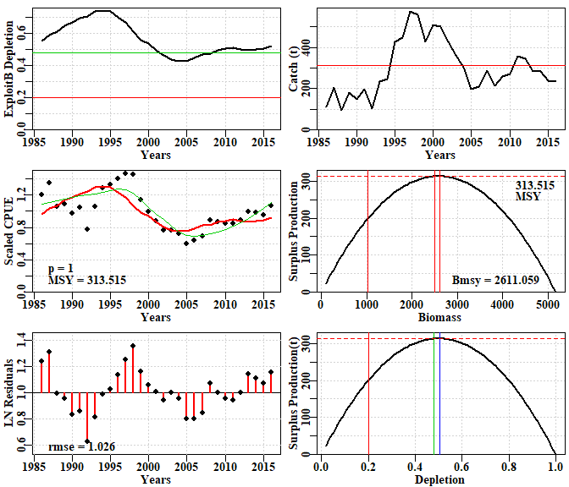

**Figure 29.** A summary plot depicting the fit of the optimum parameters. The plots include the predicted depletion and catch through time. The green line is a loess fit to the CPUE data and the red line is the fit to CPUE using the parameters. The surplus production curve is given with biomass and depletion on the x-axes (note the symmetry of the production curve). Finally, the residuals between the fit and the data are illustrated.

There are some patterns in the residuals which may suggest there are other factors at play on the fishery dynamics: it is clear there are some changes occurring which the model is not sufficiently flexible to fit. Such simple surplus production models ignore good and bad recruitment years and so some deviations from the observed are to be expected. Whether this is a sufficient reason for such patterned deviations would require extra independent evidence to be determined.

str(ans)

## List of 11  
## $ Dynamics :List of 5  
## ..$ outmat : num [1:31, 1:8] 2846 3043 3141 3344 3448 ...  
## .. ..- attr(*, "dimnames")=List of 2  
## .. .. ..$ : chr [1:31] "1986" "1987" "1988" "1989" ...  
## .. .. ..$ : chr [1:8] "ModelB" "Catch" "CPUE" "PredCE" ...  
## ..$ q : num 0.00034  
## ..$ msy : num 314  
## ..$ parameters: num [1:3] 0.242 5173.363 2845.831  
## ..$ sumout : Named num [1:9] 0.242 5173.363 2845.831 313.515 1 ...  
## .. ..- attr(*, "names")= chr [1:9] "r" "K" "B0" "msy" ...  
## $ BiomProd : num [1:100, 1:2] 100 151 202 254 305 ...  
## ..- attr(*, "dimnames")=List of 2  
## .. ..$ : NULL  
## .. ..$ : chr [1:2] "x" "y"  
## $ rmseresid: num 1.03  
## $ MSY : num 313  
## $ Bmsy : num 2611  
## $ Dmsy : num 0.505  
## $ Blim : num 1022  
## $ Btarg : num 2509  
## $ Ctarg : num 313  
## $ Dcurr : Named num 0.522  
## ..- attr(*, "names")= chr "2016"  
## $ rmse : num 0.137

The object output from displayModel has a number of parts including the dynamics, various statistics relating to the model fit, the model parameters, and the production curve. These are used by other functions to summarize and plot the outcomes. However, first it would be best to be confident that one has a unique and optimum model fit.

The model fitted was the Schaefer model, so it may be worth considering the outcome had the alternative Fox model been used. This can be implemented by making simple changes to the same functions, as before. In this particular case the initial values that enabled a solution for the Schaefer model also work for the Fox model, but this is not always the case. Note the fit is slightly better, but in fact the predicted CPUE trajectories barely differ. Note also the use of magnitude to estimate the scale of each parameter and hence simplify the use of the *parscale* option within the control list.

pars <- c(0.16,6700,3500) # r, K, and Binit, implies a depletion of ~0.52  
cat("initial -ve log-likelihood ",negLL(pars,fish,simpspm,schaefer=FALSE),"\n")

## initial -ve log-likelihood -5.998584

parscl <- magnitude(pars)  
bestSP <- optim(par=pars,fn=negLL,callfun=simpspm,indat=fish,schaefer=FALSE,  
 control=list(maxit = 1000, parscale = parscl))  
outoptim(bestSP )

## $par : 0.1382109 6129.655 2757.171   
## $value : -12.35283   
## $counts : 160 NA iterations, gradient  
## $convergence : 0   
## $message :

# Fox model dynamics is set by schaefer=FALSE

ans <- displayModel(bestSP$par,fish,schaefer=FALSE,addrmse=TRUE)

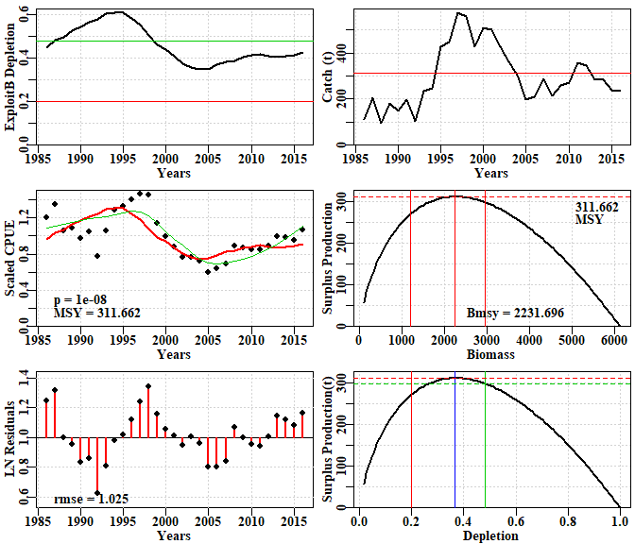

**Figure 30.** A summary plot depicting the fit of the optimum parameters. The plots include the predicted depletion and catch through time. The green line is a loess fit to the CPUE data and the red line is the fit to CPUE using the parameters. The surplus production curve is given with biomass and depletion on the x-axes (note the asymmetry of the production curve). Finally, the residuals between the fit and the data are illustrated.

str(ans)

## List of 11  
## $ Dynamics :List of 5  
## ..$ outmat : num [1:31, 1:8] 2757 2949 3041 3240 3342 ...  
## .. ..- attr(*, "dimnames")=List of 2  
## .. .. ..$ : chr [1:31] "1986" "1987" "1988" "1989" ...  
## .. .. ..$ : chr [1:8] "ModelB" "Catch" "CPUE" "PredCE" ...  
## ..$ q : num 0.00035  
## ..$ msy : num 312  
## ..$ parameters: num [1:3] 0.138 6129.655 2757.171  
## ..$ sumout : Named num [1:9] 1.38e-01 6.13e+03 2.76e+03 3.12e+02 1.00e-08 ...  
## .. ..- attr(*, "names")= chr [1:9] "r" "K" "B0" "msy" ...  
## $ BiomProd : num [1:100, 1:2] 100 161 222 283 344 ...  
## ..- attr(*, "dimnames")=List of 2  
## .. ..$ : NULL  
## .. ..$ : chr [1:2] "x" "y"  
## $ rmseresid: num 1.03  
## $ MSY : num 312  
## $ Bmsy : num 2232  
## $ Dmsy : num 0.364  
## $ Blim : num 1196  
## $ Btarg : num 2963  
## $ Ctarg : num 298  
## $ Dcurr : Named num 0.425  
## ..- attr(*, "names")= chr "2016"  
## $ rmse : num 0.137

### Is the Solution the Global Optimum?

In the ideal world you should always try solving from multiple starting points. A general function is under development, but in the meantime you could try using the *fitSPM* function, which runs through the fitting process twice (in case the first run through failed to find the best solution) (try *?fitSPM* or just *fitSPM* with no brackets):

pars <- c(0.16,6700,3500) # the original starting point  
 origpar <- pars  
 N <- 20 # the number of random starting points to try  
 scaler <- 10 # how variable; smaller = more variable  
 # define a matrix for the results  
 columns <- c("ir","iK","iB0","iLike","r","K","Binit","-veLL","MSY","Iters")  
 results <- matrix(0,nrow=N,ncol=length(columns),dimnames=list(1:N,columns))  
 pars <- cbind(rnorm(N,mean=origpar[1],sd=origpar[1]/scaler),  
 rnorm(N,mean=origpar[2],sd=origpar[2]/scaler),  
 rnorm(N,mean=origpar[3],sd=origpar[3]/scaler))  
 # this randomness ignores the strong correlation between r and K  
 for (i in 1:N) {  
 bestSP <- fitSPM(pars[i,],fish,schaefer=TRUE)  
 opar <- bestSP$par  
 msy <- opar[1]*opar[2]/4  
 origLL <- negLL(pars[i,],fish,simpspm)  
 results[i,] <- c(pars[i,],origLL,bestSP$par,bestSP$value,msy,bestSP$counts[1])  
 }  
 cat("\n\n\n")

kable(results[order(results[,"-veLL"]),],digits=c(0,3,3,3,3,3,3,3,3,3,0))

|  |  |  |  |  |  |  |  |  |  |  |
| --- | --- | --- | --- | --- | --- | --- | --- | --- | --- | --- |
|  | ir | iK | iB0 | iLike | r | K | Binit | -veLL | MSY | Iters |
| 12 | 0 | 7054.497 | 4293.170 | -3.715 | 0.242 | 5173.514 | 2846.040 | -12.129 | 313.513 | 284 |
| 13 | 0 | 8145.097 | 2969.235 | 3.457 | 0.242 | 5173.634 | 2846.102 | -12.129 | 313.513 | 174 |
| 17 | 0 | 6990.304 | 3561.189 | 12.675 | 0.242 | 5173.596 | 2846.153 | -12.129 | 313.514 | 176 |
| 11 | 0 | 7268.679 | 3221.805 | -7.749 | 0.242 | 5173.411 | 2846.070 | -12.129 | 313.517 | 152 |
| 8 | 0 | 6261.529 | 3812.002 | -5.681 | 0.242 | 5173.579 | 2845.957 | -12.129 | 313.514 | 148 |
| 15 | 0 | 8272.553 | 3682.467 | -4.294 | 0.242 | 5173.522 | 2846.076 | -12.129 | 313.512 | 286 |
| 19 | 0 | 7360.068 | 3673.318 | -10.776 | 0.242 | 5173.531 | 2845.885 | -12.129 | 313.514 | 178 |
| 4 | 0 | 6662.154 | 3159.226 | -4.168 | 0.242 | 5173.644 | 2846.229 | -12.129 | 313.515 | 232 |
| 3 | 0 | 6962.042 | 3375.847 | -8.338 | 0.242 | 5173.402 | 2845.870 | -12.129 | 313.517 | 196 |
| 16 | 0 | 6670.589 | 3317.342 | -10.705 | 0.242 | 5173.573 | 2846.273 | -12.129 | 313.514 | 204 |
| 18 | 0 | 6350.766 | 3392.096 | 19.590 | 0.242 | 5173.231 | 2846.066 | -12.129 | 313.519 | 150 |
| 6 | 0 | 6025.200 | 2799.990 | 55.220 | 0.242 | 5173.480 | 2845.871 | -12.129 | 313.510 | 110 |
| 2 | 0 | 7157.476 | 3917.461 | -10.720 | 0.242 | 5173.980 | 2846.404 | -12.129 | 313.509 | 156 |
| 14 | 0 | 6166.552 | 3612.957 | 10.208 | 0.242 | 5173.961 | 2846.218 | -12.129 | 313.511 | 126 |
| 10 | 0 | 6549.646 | 3707.303 | 54.352 | 0.242 | 5173.852 | 2845.990 | -12.129 | 313.506 | 154 |
| 7 | 0 | 7244.823 | 3637.724 | 14.967 | 0.242 | 5173.886 | 2846.159 | -12.129 | 313.513 | 212 |
| 20 | 0 | 5961.728 | 3425.592 | 53.339 | 0.242 | 5173.220 | 2845.616 | -12.129 | 313.511 | 112 |
| 5 | 0 | 6463.095 | 2924.876 | 47.923 | 0.242 | 5174.464 | 2846.192 | -12.129 | 313.497 | 122 |
| 1 | 0 | 6189.280 | 2904.257 | 43.275 | 0.242 | 5174.868 | 2847.300 | -12.129 | 313.490 | 92 |
| 9 | 0 | 6374.195 | 3467.723 | 12.473 | 0.243 | 5168.933 | 2842.278 | -12.129 | 313.572 | 124 |

cat("\n\n")

kable(apply(results,2,range),digits=c(0,3,3,3,3,3,3,3,3,3,0))

|  |  |  |  |  |  |  |  |  |  |
| --- | --- | --- | --- | --- | --- | --- | --- | --- | --- |
| ir | iK | iB0 | iLike | r | K | Binit | -veLL | MSY | Iters |
| 0 | 5961.728 | 2799.99 | -10.776 | 0.242 | 5168.933 | 2842.278 | -12.129 | 313.490 | 92 |
| 0 | 8272.553 | 4293.17 | 55.220 | 0.243 | 5174.868 | 2847.300 | -12.129 | 313.572 | 286 |

cat("\n\n")

round(apply(results,2,median),3)

## ir iK iB0 iLike r K Binit -veLL MSY Iters   
## 0.160 6666.371 3446.658 6.832 0.242 5173.576 2846.073 -12.129 313.513 155.000

By repeating that analysis multiple times (more than 20, and try changing the *scaler* variable) you will eventually find solutions that fall far from the most common optimum. This is valuable in demonstrating that the initial starting values can be influential on the final solution and that one should not immediately trust a solution found numerically until it has been tested and pushed around to determine how robust it is to initial conditions. Notice that any outlying values, if they occur, are not common, so the use of the median will usually exclude them from an estimate of the central tendency for the parameters and stock properties such as MSY. We can use the median values of the optimum estimates when we are plotting up a phase plot of biomass against fishing mortality to illustrate the stock status. Had we used a single *optim* run instead of the two found inside *fitSPM*, more failures to find the optimum are likely to have occurred.

### Produce a Phase Plot

In the SAFS process, determining the stock status is an important component. This is simply achieved once you have run the function *displayModel* using the optimum parameters. First fit an optimum model (here we use the median estimates of a set of runs like those produced in the previous example). Once we have applied the *displayModel* function using the optimum parameter estimates, we can produce the phase plot.

pars <- c(0.2424, 5173.5972, 2846.0953) # r, K, and Binit, median values  
bestSP <- fitSPM(pars,fish,schaefer=TRUE)  
ans <- displayModel(bestSP$par,fish,schaefer=TRUE,addrmse=TRUE)

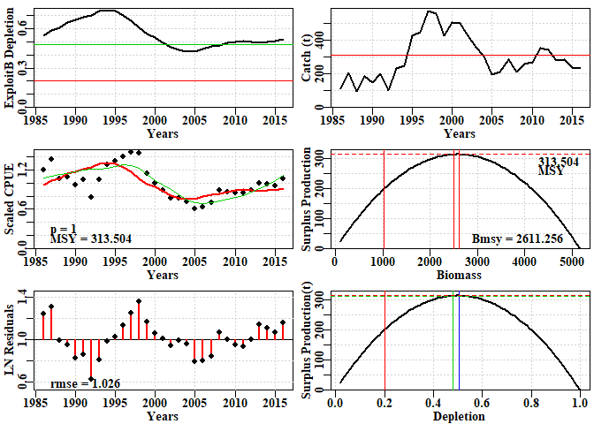

**Figure 31.** A summary plot depicting the fit after using the median optimum parameters from the repeated starting points depicted in the analysis above. The plots include the predicted depletion and catch through time. The green line is a loess fit to the CPUE data and the red line is the fit to CPUE using the parameters. The surplus production curve is given with biomass and depletion on the x-axes. Finally, the residuals between the fit and the data are illustrated.

The object output by *displayModel* is used to generate a phase plot of the trajectory of stock status implied by the surplus production model’s description of the fishery’s dynamics.

# plotprep(width=7,height=5.5) # to avoid using the RStudio plot window  
spmphaseplot(ans,fnt=7)

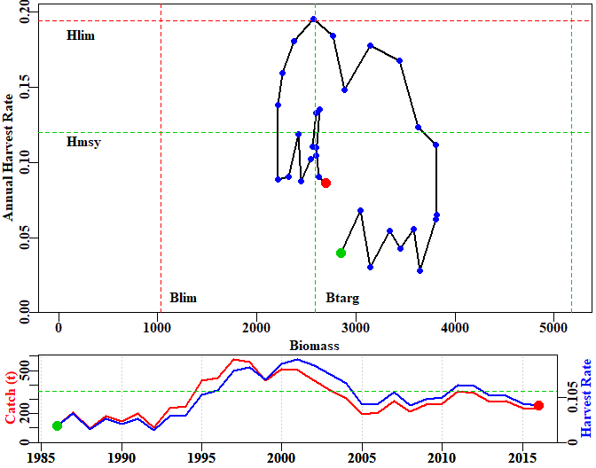

**Figure 32.** The top plot is a phase plot of the predicted stock biomass versus the predicted annual harvest rate for the optimum model fit. The green dot is the starting year and the red dot the final year. The limit reference points and tentative target reference points are included to aid interpretation. The catch history and related harvest rates are illustrated in the lower plot also, with an aim to aid interpretation of the status trajectory (in which time is only implied).

In the case illustrated, the current status is both above the limit and the target biomass reference points, and below the limit and target harvest rate reference points, and so can be safely concluded to be sustainable. A more detailed summary would conclude no over-fishing and that the stock is not over-fished. The catch history indicates that the first eight years of catches led to harvest rates sufficiently low as to allow the stock to increase in size, but that as catches increased from 1994 onwards, they quickly rose above the harvest rate that would, in theory, maintain the stock at its target. This led to the stock declining over the following 10 years, after which catches declined again, so that the stock slowly recovered back up to the target biomass over the next 10 years, with occasional increases in harvest rate close to the target rate.

### Generate Bootstrap Confidence Intervals

Every fishery analysis is invariably uncertain and an effort should always be made to include at least an indication of that uncertainty into any report of a stock assessment. One such characterization included in ***simpleSA*** for the *spm* and *aspm* models is the generation of percentile confidence intervals around parameters and model outputs (MSY, etc.) by taking bootstrap samples of the log-normal residuals associated with the CPUE. These are used to generate new bootstrap CPUE samples with which to replace the original CPUE time-series (Haddon, 2011). Each time such a bootstrap sample is made, the model is re-fitted, and the solutions obtained are stored for further analysis. To conduct such an analysis, one uses the *bootspm* function. Once we have found suitable starting parameters we use the *fitSPM* function, which uses optim twice sequentially with a negative likelihood approach to obtain an optimum fit.

data(dataspm)  
fish <- dataspm$fish  
colnames(fish) <- tolower(colnames(fish))  
pars <- c(r=0.25,K=5500,Binit=2900)  
ans <- fitSPM(pars,fish,schaefer=TRUE,maxiter=1000) #Schaefer version  
answer <- displayModel(ans$par,fish,schaefer=TRUE,addrmse=TRUE)

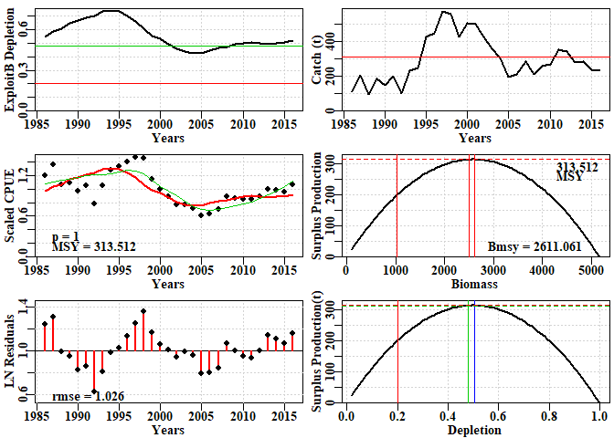

**Figure 33.** A summary plot depicting the fit of the optimum parameters to the dataspm dataset. The residuals between the fit and the CPUE data are illustrated at the bottom left. These are what are bootstrapped: each sample is multiplied by the optimum predicted CPUE time-series to obtain each bootstrap CPUE time-series.

Once we have an optimum fit, we can proceed to conduct a bootstrap analysis. Here, we are only running 100 replicates for computational speed, but you would usually run at least 1000, even though that might take a few minutes to complete.

reps <- 100 # this might take ~60 seconds, be patient  
startime <- Sys.time() # how long will this take  
boots <- bootspm(ans$par,fishery=fish,iter=reps,schaefer=TRUE)  
print(Sys.time() - startime)

## Time difference of 4.887969 secs

str(boots)

## List of 3  
## $ dynam : num [1:100, 1:31, 1:5] 2846 3553 2739 3480 2860 ...  
## ..- attr(*, "dimnames")=List of 3  
## .. ..$ : chr [1:100] "1" "2" "3" "4" ...  
## .. ..$ : chr [1:31] "1986" "1987" "1988" "1989" ...  
## .. ..$ : chr [1:5] "ModelB" "BootCE" "PredCE" "Depletion" ...  
## $ bootpar : num [1:100, 1:6] 0.242 0.271 0.31 0.265 0.234 ...  
## ..- attr(*, "dimnames")=List of 2  
## .. ..$ : chr [1:100] "1" "2" "3" "4" ...  
## .. ..$ : chr [1:6] "r" "K" "Binit" "MSY" ...  
## $ negativepars: num 0

The output contains the dynamics of each run with the predicted model biomass, each bootstrap CPUE sample, the predicted CPUE for each bootstrap sample, the depletion time-series, and the annual harvest rate time-series. Each of these can be used to illustrate and summarize the outcomes and uncertainty within the analysis. Given the relatively large residuals in Figure 33, one might expect a relatively high degree of uncertainty.

dynam <- boots$dynam  
bootpar <- boots$bootpar  
rows <- colnames(bootpar)  
columns <- c(c(0.025,0.05,0.5,0.95,0.975),"Mean")  
bootCI <- matrix(NA,nrow=length(rows),ncol=length(columns),  
 dimnames=list(rows,columns))  
for (i in 1:length(rows)) { # i=1  
 tmp <- sort(bootpar[,i])  
 qtil <- quantile(tmp,probs=c(0.025,0.05,0.5,0.95,0.975),na.rm=TRUE)  
 bootCI[i,] <- c(qtil,mean(tmp,na.rm=TRUE))  
}  
kable(bootCI,digits=c(3,3,3,3,3,3))

|  |  |  |  |  |  |  |
| --- | --- | --- | --- | --- | --- | --- |
|  | 0.025 | 0.05 | 0.5 | 0.95 | 0.975 | Mean |
| r | 0.109 | 0.143 | 0.256 | 0.359 | 0.373 | 0.250 |
| K | 3635.081 | 3671.058 | 5082.288 | 7894.464 | 10086.318 | 10509.205 |
| Binit | 1648.772 | 1801.246 | 2796.433 | 5668.114 | 7736.649 | 3161.843 |
| MSY | 268.633 | 280.265 | 319.086 | 353.151 | 361.007 | 342.134 |
| Depl | 0.387 | 0.394 | 0.541 | 0.655 | 0.682 | 0.526 |
| Harv | 0.047 | 0.055 | 0.085 | 0.118 | 0.124 | 0.087 |

Such percentile confidence intervals can be visualized using histograms and including the respective selected percentile CI.

par(mfrow=c(3,2),mai=c(0.45,0.45,0.15,0.05),oma=c(0.0,0,0.0,0.0))   
par(cex=0.85, mgp=c(1.35,0.35,0), font.axis=7,font=7,font.lab=7)   
hist(bootpar[,"r"],breaks=25,col=2,main="",xlab="r")  
abline(v=c(bootCI["r",c(2,3,4,6)]),col=c(3,3,3,4),lwd=c(1,2,1,2))  
hist(bootpar[,"K"],breaks=25,col=2,main="",xlab="K")  
abline(v=c(bootCI["K",c(2,3,4,6)]),col=c(3,3,3,4),lwd=c(1,2,1,2))  
hist(bootpar[,"Binit"],breaks=25,col=2,main="",xlab="Binit")  
abline(v=c(bootCI["Binit",c(2,3,4,6)]),col=c(3,3,3,4),lwd=c(1,2,1,2))  
hist(bootpar[,"MSY"],breaks=25,col=2,main="",xlab="MSY")  
abline(v=c(bootCI["MSY",c(2,3,4,6)]),col=c(3,3,3,4),lwd=c(1,2,1,2))  
hist(bootpar[,"Depl"],breaks=25,col=2,main="",xlab="Final Depletion")  
abline(v=c(bootCI["Depl",c(2,3,4,6)]),col=c(3,3,3,4),lwd=c(1,2,1,2))  
hist(bootpar[,"Harv"],breaks=25,col=2,main="",xlab="Final Harvest Rate")  
abline(v=c(bootCI["Harv",c(2,3,4,6)]),col=c(3,3,3,4),lwd=c(1,2,1,2))

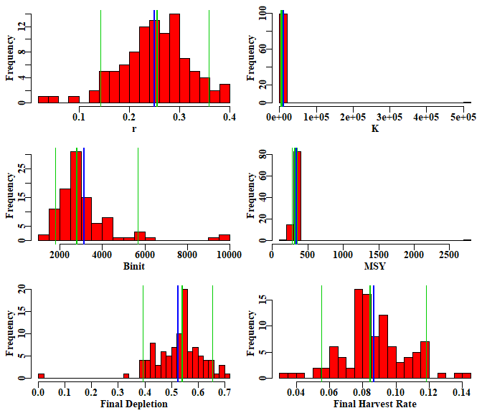

**Figure 34.** The bootstrap replicates from the optimum spm fit to the dataspm data set. The vertical green lines, in each case, are the median and 90th percentile confidence intervals and the blue lines are the mean values. There is little evidence of bias with the ‘r’ and ‘MSY’, estimates, although both the median ‘K’ and ‘Binit’ values appear biased somewhat low, while the depletion and harvest rates appear slightly biased high.

Of course, with only 100 replicates in such a variable analysis, these results remain only very approximate. One would expect 1000 replicates would provide for a smoother response and more representative confidence bounds (we reiterate that 100 replicates were used simply to demonstrate the principle within a short time; this may be sped up later using C++). Note that the confidence bounds are not necessarily symmetrical around either the mean or the median estimates. Notice also that, with the final year depletion estimates, the 10th percentile CI is well above 20%B0, implying that even though this analysis is uncertain, the current depletion level is above the default limit reference point with more than a 90% likelihood (again more replicates are required before this claim could be more defensibly validated).

The fitted trajectories can also provide an indication of the uncertainty surrounding the analysis.

years <- fish[,"year"]  
par(mfrow=c(1,1),mai=c(0.45,0.45,0.05,0.05),oma=c(0.0,0,0.0,0.0))   
par(cex=0.85, mgp=c(1.35,0.35,0), font.axis=7,font=7,font.lab=7)   
ymax <- getmaxy(c(dynam[,,"PredCE"],fish[,"cpue"]))  
plot(fish[,"year"],fish[,"cpue"],type="n",ylim=c(0,ymax),xlab="Year",  
 ylab="CPUE",panel.first = grid())  
for (i in 1:reps) lines(years,dynam[i,,"PredCE"],lwd=1,col="grey")  
lines(years,answer$Dynamics$outmat[,"PredCE"],lwd=2,col=2)  
points(years,fish[,"cpue"],cex=1.1,pch=16,col=4)  
percs <- apply(dynam[,,"PredCE"],2,quants)  
arrows(x0=years,y0=percs["5%",],y1=percs["95%",],length=0.03,angle=90,code=3,col=2)

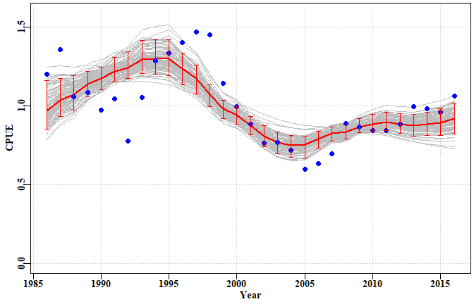

**Figure 35.** A plot of the original observed CPUE (blue dots), the optimum predicted CPUE (solid red line), the bootstrap predicted CPUE (the grey lines), and the 90th percentile confidence intervals around those predicted values.

There are clearly some major deviations between the predicted and the observed CPUE values, but the median estimates and the confidence bounds around them remain well defined.

## Discussion

In the Southern and Eastern Scalefish and Shark Fishery (SESSF), rather than using surplus production models or other simple dynamic approaches, empirical harvest strategies have been developed that use such time-series in empirical relationships that give rise directly to management-related advice on catch levels (Little et al., 2011; Haddon, 2014). Such empirical harvest strategies can provide the needed management advice, but do not determine stock status unless the reference period, used in such approaches, is assumed to be a proxy for the target reference point (and its implied limit reference point) for sustainability. In the SESSF, this “Tier 4” harvest strategy is used to determine whether a stock is over-fished or not, but currently cannot be used to determine whether over-fishing is occurring. In addition, there is the strong assumption made that the commercial catch rates are a direct reflection of the stock biomass. There are, however, some species, for example mirror dory (*Zenopsis nebulosa*), where catch rates increase when catches increase, and then decline once catches begin to decline (see the discussion above about whether the CPUE is informative). They appear to be fisheries driven by availability, as opposed to the fishery being the major influence on the stock biomass. That is, other aspects of the environment of the species appear to be driving its dynamics. The use of CPUE may thus be misleading in such cases.

### Management Advice with spm

If working with a species that requires ongoing management, then it is necessary to produce advice with respect to acceptable catches that will lead to a sustainable fishery - or whatever other management goal is in place for the fishery. To generate such advice, some form of harvest strategy (HS) is required to allow the outputs from the assessment to be converted into a recommended biological catch (RBC; noting that informal HSs are less repeatable than formal HSs). This RBC may then be modified by fishery managers taking into account potential rates of change within a fishery or social or economic drivers of management decisions. It was possible to put forward suggestions for new harvest strategies that use the catch-MSY method, although none are currently available; that put forward here is only a suggestion for consideration. Putting forward a proposed harvest control rule for the spm approach without consultation with jurisdictional fisheries managers could produce suggestions incompatible with a particular jurisdiction’s objectives. There are harvest control rules that can be used once limit and target reference points are agreed upon and these can be utilized where considered appropriate. The SAFS process, however, does not currently require a target reference point, even though most harvest control rules do require one.

## Appendix: Surplus Production Model Equations

The surplus production model is used to describe the dynamics of the stock in terms of its exploitable biomass. In general terms, where the dynamics are designated a function of the biomass at the start of a given year *t*:

where represents the stock biomass at the start of year , represents a production function in terms of stock biomass (accounting for recruitment or new individuals, growth of biomass of current individuals, and natural mortality), and is the catch in year .

The model dynamics are also used to generate predicted values for the catch rate index of relative abundance in each year:

where is the predicted or estimated value of the index of relative abundance, which is compared to the observed indices to fit the model to the data, is the fishing effort in year , and is the catchability coefficient (defined as the amount of biomass/catch taken with one unit of effort).

A number of functional forms have been put forward to describe production. In ***simpleSA*** we have implemented two: the Schaefer model, and a modified form of the Fox model:

The Schaefer (1954) model uses:

while the Fox (1970) uses:

Alternatively, a formulation from Polacheck *et al*. (1993) provides a general equation for the population dynamics that can be used for both the Schaefer and the Fox model depending on the value of a single parameter *p*.

When *p* is set to 1.0, this equation reduces to the Schaefer model. But when *p* is set to a very small number, say 1e-0.8, then the formulation becomes equivalent to the Fox model’s dynamics.

The Schaefer model assumes a symmetrical production curve with maximum surplus production (MSY) at 0.5K. The Fox model generates asymmetrical production curves with the maximum production at some lower level of depletion. The Schaefer model can be regarded as more conservative than the Fox, in that it requires the stock size to be higher for maximum production, and generally leads to somewhat lower levels of catch.

Other production functions could be added later. represents a population growth rate that includes the balance between recruitment, growth in current biomass, and natural mortality, and is the maximum population size (the carrying capacity). The part in brackets, , represents a density dependent term that trends linearly to zero as . This tends towards in the Schaefer model. In the Schaefer mdoel the production curve is symmetric with maximum production occurring at 0.5. In the Fox model, the density dependent terms introduces some non-linearity, which generates an asymmetrical production curve with the point of maximum production moved to < 0.5 (see later diagrams of the prodution curves; see Haddon (2011) for further details).

Thus for the Schaefer model we would have:

where = or , depending on whether the stock was deemed to be depleted when data from the fishery first became available.

It appears that fitting the model to data would require at least three parameters: the , the , and the ( might also be needed). However, it is possible to used what is known as a “closed-form” method for estimating the catchability coefficient :

which is the back-transformed geometric mean of the observed CPUE divided by the exploitable biomass.

### Sum of Squared Residuals

Such a model can be fitted using least squares or, more properly, the sum of squared residual errors:

The log-transformations are required as CPUE is considered typically to be distributed log-normally, and the least-squares method implies normal random errors. The least squares approach tends to be more robust when first searching for a set of parameters that enable a model to fit to available data. However, once close to a solution, more options become available if one then uses maximum likelihood methods.

Maximum likelihood methods, as the name dictates, entail maximizing the likelihood of the available data given the model and a proposed set of parameters. Very often the likelihoods involved when fitting models are very small numbers. To avoid rounding errors (even when using 64 bit computers), it is standard to use log-likelihoods rather than likelihoods (in that way, the log-likelihoods can be individually added together rather than the individual likelihoods multiplied). Additionally, rather than maximizing a log-likelihood, minimization often best matches our intuitions about model fitting. As such, an optimal fit is obtained by minimizing the negative log-likelihood. The full log-normal negative log likelihood is:

Fortunately, the negative log-likelihood can be simplified (Haddon, 2011), to become:

where the maximum likelihood estimate of the standard deviation, is given by:

Note the division by *n* rather than by *n-1*. Strictly the negative log-likelihood is followed by an additional term:

This is the sum of the log-transformed observed catch rates. But as this will be constant, it is usually omitted.

### Estimating Management Statistics

The Maximum Sustainable Yield (*MSY*) can be calculated for the Schaefer model simply by using:

However, for the more general equation using the *p* parameter from Polacheck *et al* (1993) one needs to use:

# aspm - Age-Structured Production Models

## Introduction

### Which Stock Assessment?

Which stock assessment method to apply to fisheries for data-poor to data-moderate species will depend upon what fisheries and biological data are available but also, importantly, on what management objectives need to be met within the jurisdiction in question. It may be the case that the fishery for a particular species is of sufficient size and value to warrant on-going monitoring and management towards some defined goal for the stock. In such a case the assessment used should obviously be capable of generating some notion of the current state of the fishery and indicate what management actions may be required to eventually achieve the agreed management goals. But some fisheries may be so minor that trying to actively manage them would be inefficient. Nevertheless, to meet the requirements of the Status of key Australian Fish Stocks (SAFS) one still requires some form of defensible stock assessment capable of determining whether the current level of fishing is sustainable.

## Age-Structured Production Model

### Introduction to ASPM

The age-structured production model (ASPM or **aspm**) is literally a surplus production model which is based upon an age-structured model of production rather than an accumulated biomass model (see the vignette on *spm*).

There are some specific data requirements for fitting an age-structured production model to fishery data. The following data from the fishery need to included, as a minimum:

* an accurate catch time-series plus
* an index of relative abundance for at least some of the years within the catch time-series.
* In addition, information (or defensible assumptions) is needed for the species concerned in relation to the description of
  + its natural mortality
  + its growth
  + its maturation, and
  + the selectivity of the fishery (maturity and selectivity could be knife-edge).

If just the catches and CPUE data are available, then one might try fitting a simple, aggregated biomass, surplus production model. But if the above biological data and information are also available, then an age-structured production model opens the way to on-going improvements with respect to the inclusion of occasional age-composition data or other observations that could be predicted by a suitable model, and hence included in the model fitting process.

More details on age-structured production models can be found in Punt et al. (1995). The model equations are provided in the appendix. It would be helpful to the user to read the spm vignette, as the theory in there also applies to age-structured production models.

### A Typical Workflow

A typical workflow for using an age-structured production model might be something like:

1. Read in the available data and use *checkdata* to ensure it can be used with **aspm**.
2. Search for suitable initial parameter values using *dynamics*, *aspmLL*, and *plotASPM*. This will include deciding on the use of a two parameter model (no initial depletion) or a three parameter model that accounts for an initial depletion level.
3. Given suitable initial parameters, use *fitASPM*, or, more basically, *optim*, to fit the model to the available data.
4. Once successfully fitted, it is best to plot the solution using *plotASPM* to determine visually how close the model fit is to the data. One approach to improving this is to include confidence intervals around the index of relative abundance (CPUE). This is done first using *getLNCI* and then including the output of this into *plotASPM* or, for a closer look, in *plotceASPM*. Eventually, improved confidence intervals for the model outputs can be obtained using bootstrap samples (see below).
5. A better test of the robustness of the solution is to test how sensitive it is to the initial conditions. This can be done by randomly varying the initial parameters and determining whether the model fitting outcomes vary. Suitable example code is given in the vignette.
6. After finally deciding on the overall optimum solution it would be sensible to use the optimum parameters to determine the implied production curve, so that management statistics such as MSY, the target catch, and the limit and target reference points, can be defined. This can be done using *getProductionC*, the *C* post-fix denoting this is a C++ function (used for speed), the results of which can be plotted and summarized using *prodASPM*.
7. One can produce a classical phase plot of predicted biomass vs harvest rate to aid in the determination of the stock status.For this we would use *aspmphaseplot*.
8. Finally, to obtain a better notion of the uncertainty in the analysis, we use *bootASPM*, which facilitates the application of a bootstrap analysis.

### An Example

The data requirements for the **aspm** are described above. For the next example we will use the *dataspm* built-in data set. First, we will examine an example using only two parameters (assuming the population begins in an unfished state), and then extend the model fitting to include the possibility of an initially depleted state. The two parameters being fitted are

* the average unfished recruitment level and
* the standard deviation of the errors around the CPUE data.

We load *dataspm*, which contains a dataframe of the catches and CPUE by year (*fish*), and other parameters used for the age-structured production model.

library(simpleSA)  
data(dataspm)  
fish <- dataspm$fish  
props <- dataspm$props # length-,weight-,maturity-and selectivity-at-age

While a simple, aggregated biomass surplus production model only requires the specification of the species name in the *glb* data object, an **aspm** requires information on the

* growth
* selectivity
* weight-at-age
* steepness of the stock-recruit relationship, and
* natural mortality.

The global parameters (*glb*), in addition to the *spsname*, need to contain the population ages (*maxage* and *ages*), natural mortality (*M*), von Bertalanffy growth parameters (*Linf*, *K* and *t0*), weight-at-age parameters (*Waa* and *Wab*), age at 50% maturity, delta (*M50a* and *deltaM*), age that 50% of the population are selected by the gear and delta (*sela50* and *deltaS*) and the *steepness* of the stock-recruitment relationship. The number of years (*nyrs*) of over which catch and CPUE are available (including missing years) is calculated from the *fish* dataframe. A starting value for the log of the initial recruitment (*R0*) also needs to be provided, although this will be estimated along with the standard deviation of the errors around the CPUE data.

We inspect the global parameters specified in *dataspm*.

(glb <- dataspm$glb)

## $maxage  
## [1] 20  
##   
## $M  
## [1] 0.225  
##   
## $Linf  
## [1] 103.4  
##   
## $K  
## [1] 0.2  
##   
## $t0  
## [1] -3.139  
##   
## $Waa  
## [1] 0.0029  
##   
## $Wab  
## [1] 3.139  
##   
## $M50a  
## [1] 5  
##   
## $deltaM  
## [1] 2.5  
##   
## $steep  
## [1] 0.75  
##   
## $R0  
## [1] 13.7  
##   
## $sela50  
## [1] 3.5  
##   
## $deltaS  
## [1] 1  
##   
## $resilience  
## [1] "low"  
##   
## $nages  
## [1] 21  
##   
## $ages  
## [1] 0 1 2 3 4 5 6 7 8 9 10 11 12 13 14 15 16 17 18 19 20  
##   
## $nyrs  
## [1] 31  
##   
## $spsname  
## [1] "TrawlCaught_Scalefish"

Just as with the **spm** model, fitting an **aspm** model entails first finding initial parameter estimates that lead to predicted CPUE time-series that approximate the observed series. Thus, one might begin something like this, and use *aspmLL* to determine the negative log-likelihood (-veLL), then *dynamics* to calculate the dynamics of the **aspm**, and finally *plotASPM* to illustrate the quality of fit, to help decide whether changes are required to the initial guesses:

pars <- c(12.9,0.25)  
aspmLL(pars,infish=fish,inglb=glb,inprops=props)

## [1] 386.8754

fishery <- dynamics(pars,infish=fish,inglb=glb,inprops = props)  
plotASPM(fishery)

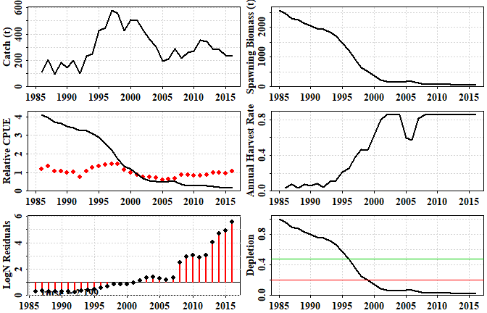

**Figure 36.** The outcome of a first guess at a two parameter version of the **aspm**. Clearly the fit is very poor, and the strong trends in the predicted CPUE, the log-normal residuals, and the annual harvest rate bumping up against the built-in upper limit of 0.85 across numerous years, provide a strong indication that the initial guess at unfished average recruitment parameter (*R0*) is too small. Try increasing it slowly to see its effect on the model fit to the data.

Once reasonable starting values have been found for the parameters (, the unfished average recruitment, and , the standard deviation associated with fitting the observed CPUE), then an attempt at formally fitting the model to the data can be made using code something like this:

pars <- c(13.7,0.19)  
ans <- fitASPM(pars,infish=fish,inglb=glb,inprops=props)  
outoptim(ans) # a tidier way of printing the list output from optim

## $par : 13.69138 0.189471   
## $value : -7.582633   
## $counts : 55 NA iterations, gradient  
## $convergence : 0   
## $message :

fishery <- dynamics(ans$par,infish=fish,inglb=glb,inprops = props)

##### 

**Table 1.** The output from the *fitASPM* function and the *dynamics* function.

kable(fishery,digits=c(0,3,3,3,3,3,4,4,3))

|  |  |  |  |  |  |  |  |  |  |
| --- | --- | --- | --- | --- | --- | --- | --- | --- | --- |
|  | Year | Catch | PredC | SpawnB | ExploitB | FullH | CPUE | PredCE | Deplete |
| 0 | 1985 |  |  | 5643.463 | 6216.733 |  |  |  | 1.000 |
| 1 | 1986 | 112.9 | 112.9 | 5547.856 | 6119.538 | 0.018 | 1.2006 | 1.2731 | 0.983 |
| 2 | 1987 | 206.3 | 206.3 | 5381.150 | 5955.372 | 0.034 | 1.3547 | 1.2532 | 0.954 |
| 3 | 1988 | 95.7 | 95.7 | 5325.183 | 5910.455 | 0.016 | 1.0585 | 1.2196 | 0.944 |
| 4 | 1989 | 183.1 | 183.1 | 5208.120 | 5799.303 | 0.031 | 1.0846 | 1.2104 | 0.923 |
| 5 | 1990 | 147.4 | 147.4 | 5136.775 | 5735.954 | 0.025 | 0.9738 | 1.1876 | 0.910 |
| 6 | 1991 | 198.9 | 198.9 | 5034.632 | 5638.377 | 0.035 | 1.0437 | 1.1747 | 0.892 |
| 7 | 1992 | 102.1 | 102.1 | 5027.222 | 5638.064 | 0.018 | 0.7759 | 1.1547 | 0.891 |
| 8 | 1993 | 235.5 | 235.5 | 4914.029 | 5523.921 | 0.042 | 1.0532 | 1.1546 | 0.871 |
| 9 | 1994 | 247.8 | 247.8 | 4801.433 | 5414.330 | 0.045 | 1.2840 | 1.1312 | 0.851 |
| 10 | 1995 | 426.8 | 426.8 | 4552.038 | 5165.789 | 0.079 | 1.3327 | 1.1088 | 0.807 |
| 11 | 1996 | 448.0 | 448.0 | 4310.173 | 4933.418 | 0.087 | 1.4014 | 1.0579 | 0.764 |
| 12 | 1997 | 577.4 | 577.4 | 3991.273 | 4623.718 | 0.117 | 1.4687 | 1.0103 | 0.707 |
| 13 | 1998 | 558.5 | 558.5 | 3726.747 | 4374.663 | 0.121 | 1.4493 | 0.9469 | 0.660 |
| 14 | 1999 | 427.9 | 427.9 | 3607.166 | 4275.655 | 0.098 | 1.1420 | 0.8959 | 0.639 |
| 15 | 2000 | 509.3 | 509.3 | 3447.541 | 4121.138 | 0.119 | 0.9957 | 0.8756 | 0.611 |
| 16 | 2001 | 502.4 | 502.4 | 3314.139 | 3991.335 | 0.122 | 0.8818 | 0.8440 | 0.587 |
| 17 | 2002 | 429.6 | 429.6 | 3256.173 | 3938.955 | 0.108 | 0.7635 | 0.8174 | 0.577 |
| 18 | 2003 | 360.2 | 360.2 | 3264.635 | 3951.252 | 0.091 | 0.7668 | 0.8066 | 0.578 |
| 19 | 2004 | 306.2 | 306.2 | 3319.664 | 4007.258 | 0.077 | 0.7198 | 0.8092 | 0.588 |
| 20 | 2005 | 195.7 | 195.7 | 3460.581 | 4149.242 | 0.049 | 0.5997 | 0.8206 | 0.613 |
| 21 | 2006 | 210.0 | 210.0 | 3578.106 | 4256.624 | 0.051 | 0.6336 | 0.8497 | 0.634 |
| 22 | 2007 | 287.3 | 287.3 | 3615.276 | 4278.291 | 0.067 | 0.6936 | 0.8717 | 0.641 |
| 23 | 2008 | 214.2 | 214.2 | 3698.766 | 4357.911 | 0.050 | 0.8894 | 0.8761 | 0.655 |
| 24 | 2009 | 260.6 | 260.6 | 3733.374 | 4387.110 | 0.060 | 0.8644 | 0.8924 | 0.662 |
| 25 | 2010 | 272.2 | 272.2 | 3751.418 | 4403.947 | 0.062 | 0.8442 | 0.8984 | 0.665 |
| 26 | 2011 | 356.9 | 356.9 | 3696.506 | 4346.717 | 0.081 | 0.8427 | 0.9019 | 0.655 |
| 27 | 2012 | 345.0 | 345.0 | 3654.393 | 4308.073 | 0.079 | 0.8849 | 0.8902 | 0.648 |
| 28 | 2013 | 282.7 | 282.7 | 3669.508 | 4331.070 | 0.066 | 0.9964 | 0.8822 | 0.650 |
| 29 | 2014 | 285.1 | 285.1 | 3686.377 | 4351.140 | 0.066 | 0.9804 | 0.8869 | 0.653 |
| 30 | 2015 | 237.8 | 237.8 | 3742.829 | 4410.295 | 0.055 | 0.9570 | 0.8911 | 0.663 |
| 31 | 2016 | 233.3 | 233.3 | 3799.558 | 4464.794 | 0.053 | 1.0629 | 0.9032 | 0.673 |

Note that the predicted catches are identical to the observed catches. The catches are assumed to be known accurately, and so as to ensure a close match between the predicted and observed catches, *aspmLL* has a simple sum-of-squared deviations penalty built into it (try *aspmLL*, without brackets in the console). This is usually sufficient to force the solution to generate a close match, once plausible parameter values are found. Note that with respect to reproduction, only the average unfished recruitment is estimated. In its current form, the **aspm** cannot take into account strong and weak cohorts; this remains a very simple model of the dynamics.

To visualize the output of the model fitting we can plot some of the variables from the fishery information generated by the *dynamics* function.

plotASPM(fishery,CI=NA)

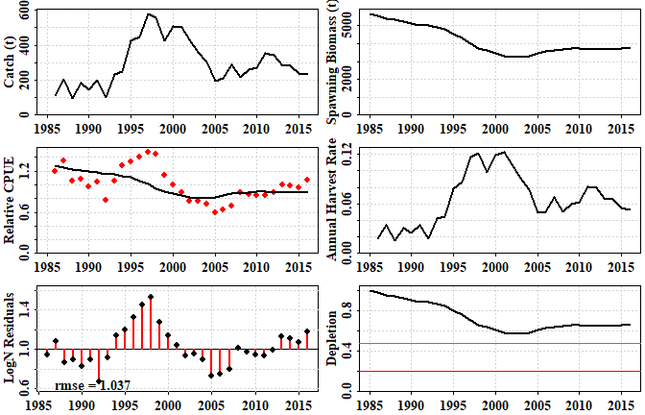

**Figure 37.** The outcome of fitting a two parameter age-structured production model to the available data. Included is a plot of the catch history, the predicted spawning biomass, the CPUE, the harvest rate, the log-normal residuals for the CPUE, and the predicted depletion.

The two-parameter model manages to capture the main CPUE trends but fails to capture some of the more obvious and more rapid consistent changes in CPUE (Figure 37). The example fishery in question was known to have been fished prior to 1985, so in the year the data begin to be available, the stock can be expected to be depleted to some extent. Thus, an alternative might be to fit the model using three parameters. The first approach, with only one parameter of real interest, required data from the beginning of the fishery. However, there are many fisheries for which data are only available after the fishery has been running for a number of years. In such cases, it is necessary to estimate the level of depletion and its effect upon recruitment, and thus requires two parameters of interest to the dynamics. The first is, as before, the unfished recruitment level, , but then we use a parameter that defines the initial depletion at the start of the observations (). If this parameter is present in *pars* a search is made for the constant harvest rate that, when applied to the initial unfished stock, leads to the predicted initial depletion level. Only then does the model fitting proceed. Any initial depletion will influence the recruitment depending on the assumed steepness of the stock recruitment relationship, which is assumed to be a Beverton-Holt relationship.

The *dataspm* data set is not particularly suited to a two-parameter model. Even though that arrangement was able to provide a result, these assessments should not be done automatically: it always takes some background knowledge to ensure that any methods or choices applied are valid.

As an alternative two-parameter example, the deep water fishery data *data(fishdat)* was a deepwater fishery with catch data from the very start of the fishery, which means it is better suited to using a simple two parameter model.

data(fishdat)  
fish <- fishdat$fish  
glb <- fishdat$glb  
props <- fishdat$props  
pars <- c(14,0.3)  
ans <- fitASPM(pars,infish=fish,inglb=glb,inprops = props)  
outoptim(ans)

## $par : 13.98282 0.2956361   
## $value : 3.606029   
## $counts : 71 NA iterations, gradient  
## $convergence : 0   
## $message :

fishery <- dynamics(ans$par,infish=fish,inglb=glb,inprops = props)  
kable(fishery,digits=c(0,3,3,1,1,3,3,3,3))

|  |  |  |  |  |  |  |  |  |  |
| --- | --- | --- | --- | --- | --- | --- | --- | --- | --- |
|  | Year | Catch | PredC | SpawnB | ExploitB | FullH | CPUE | PredCE | Deplete |
| 0 | 1985 |  |  | 18014.3 | 17693.0 |  |  |  | 1.000 |
| 1 | 1986 | 3924.912 | 3924.912 | 14248.2 | 13994.0 | 0.222 |  | 7.553 | 0.791 |
| 2 | 1987 | 5117.988 | 5117.988 | 9428.1 | 9259.9 | 0.366 |  | 5.974 | 0.523 |
| 3 | 1988 | 4722.200 | 4722.200 | 5129.8 | 5038.3 | 0.510 |  | 3.953 | 0.285 |
| 4 | 1989 | 1365.128 | 1365.128 | 4105.5 | 4032.3 | 0.271 | 1.490 | 2.151 | 0.228 |
| 5 | 1990 | 801.567 | 801.567 | 3641.7 | 3576.7 | 0.199 | 1.849 | 1.721 | 0.202 |
| 6 | 1991 | 625.407 | 625.407 | 3369.2 | 3309.1 | 0.175 | 1.501 | 1.527 | 0.187 |
| 7 | 1992 | 1108.241 | 1108.241 | 2707.0 | 2658.7 | 0.335 | 2.997 | 1.413 | 0.150 |
| 8 | 1993 | 964.409 | 964.409 | 2201.1 | 2161.8 | 0.363 | 1.415 | 1.135 | 0.122 |
| 9 | 1994 | 800.618 | 800.618 | 1858.5 | 1825.4 | 0.370 | 1.139 | 0.923 | 0.103 |
| 10 | 1995 | 962.399 | 962.399 | 1413.5 | 1388.3 | 0.527 | 0.700 | 0.779 | 0.078 |
| 11 | 1996 | 1180.349 | 1180.031 | 845.1 | 830.1 | 0.850 | 0.469 | 0.593 | 0.047 |
| 12 | 1997 | 297.003 | 297.003 | 925.3 | 908.8 | 0.358 | 0.303 | 0.354 | 0.051 |
| 13 | 1998 | 316.131 | 316.131 | 1007.3 | 989.4 | 0.348 | 0.356 | 0.388 | 0.056 |
| 14 | 1999 | 210.529 | 210.529 | 1165.6 | 1144.8 | 0.213 | 0.390 | 0.422 | 0.065 |
| 15 | 2000 | 169.337 | 169.337 | 1365.7 | 1341.4 | 0.148 | 0.439 | 0.489 | 0.076 |
| 16 | 2001 | 200.843 | 200.843 | 1559.3 | 1531.5 | 0.150 | 0.489 | 0.573 | 0.087 |
| 17 | 2002 | 255.735 | 255.735 | 1722.4 | 1691.7 | 0.167 | 0.431 | 0.654 | 0.096 |
| 18 | 2003 | 217.502 | 217.502 | 1916.4 | 1882.2 | 0.129 | 0.520 | 0.722 | 0.106 |
| 19 | 2004 | 283.110 | 283.110 | 2064.5 | 2027.7 | 0.150 | 0.777 | 0.804 | 0.115 |
| 20 | 2005 | 264.607 | 264.607 | 2225.4 | 2185.7 | 0.130 | 1.322 | 0.866 | 0.124 |
| 21 | 2006 | 139.316 | 139.316 | 2484.6 | 2440.2 | 0.064 | 1.412 | 0.933 | 0.138 |
| 22 | 2007 | 28.571 | 28.571 | 2838.9 | 2788.3 | 0.012 |  | 1.042 | 0.158 |
| 23 | 2008 | 3.331 | 3.331 | 3224.3 | 3166.8 | 0.001 |  | 1.190 | 0.179 |
| 24 | 2009 | 13.859 | 13.859 | 3608.2 | 3543.8 | 0.004 |  | 1.352 | 0.200 |
| 25 | 2010 | 21.440 | 21.440 | 3988.3 | 3917.1 | 0.006 |  | 1.513 | 0.221 |
| 26 | 2011 | 31.426 | 31.426 | 4358.7 | 4281.0 | 0.008 |  | 1.672 | 0.242 |
| 27 | 2012 | 17.253 | 17.253 | 4737.4 | 4652.9 | 0.004 |  | 1.828 | 0.263 |
| 28 | 2013 | 35.940 | 35.940 | 5093.6 | 5002.8 | 0.008 |  | 1.986 | 0.283 |
| 29 | 2014 | 22.087 | 22.087 | 5453.2 | 5355.9 | 0.004 |  | 2.136 | 0.303 |
| 30 | 2015 | 16.206 | 16.206 | 5806.4 | 5702.9 | 0.003 |  | 2.287 | 0.322 |

The output contains the estimates of the optimum parameters, the final log-likelihood estimate, the number of iterations needed to find the optimum, and some diagnostic information. The statement *convergence: int 0* implies the solution appears valid, and the lack of warning messages is also encouraging, but see later concerning how to test the robustness of such model fitting. If we put the fitted optimum parameters into the function *dynamics*, we can see the time-series of the more important population variables implied by the model fit.

The use of *fitASPM* is basically shorthand for using *bestL <- optim(pars, aspmLL, method=“Nelder-Mead”, infish=fish, inglb=glb, inprops=props, control=list(maxit = 1000, parscale = c(10,1)))* twice in a row. Examine its code by using *fitASPM* without brackets in the R console window.

Note that the harvest rate in 1996 appears to have bumped up against the upper limit of 0.85 hardwired into the R-code (try typing *dynamics* into the R console without brackets to see the code). So, the 1180 tonnes of catch in 1996 was likely to have been damaging. However, the predicted catch is only slightly less than the reported catch, so this spike in harvest rate has some support in the data. Plotting up the fishery results enables the visualization of the impact of the fishery, and the effect of cutting back catches.

ceCI <- getLNCI(fishery[,"PredCE"],ans$par[2])  
plotASPM(fishery,CI=ceCI)

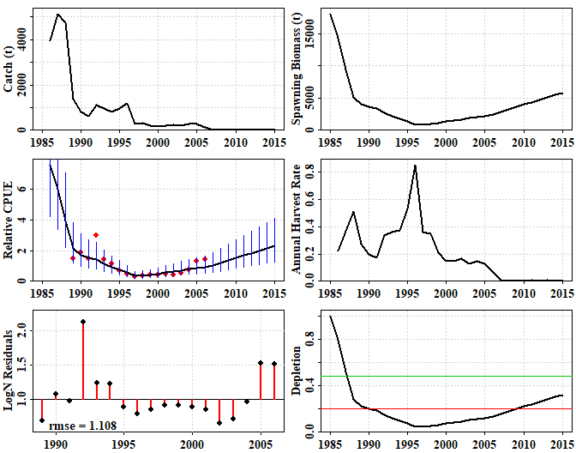

**Figure 38.** The outcome of fitting a two parameter age-structured production model to the deep-water fishery data. If the function *plotceASPM* is used, then only the CPUE with confidence intervals are plotted.

The modelling suggests that once catches were reduced to an average of about 246 t between 1997 - 2005 the stock began to very slowly recover. Then, after catches were further reduced from 2007 onwards (due to a deep-water closure and cessation of targeting) the rate of recovery was predicted to have increased. The model predicts that the stock breached the 0.2 limit reference point in about 2010. However, extrapolation beyond the data must always be treated with a great deal of caution. The uncertainty about the catch rates is relatively large, especially because the records from 1992, 2005, and 2006 deviate so much from the rest of the trend. Without confirmation from other data, the predicted recovery from 2007 onwards is purely driven by the predictions from the fitted model. The predicted recovery should not be accepted on the basis of the model fit alone: there need to be other data confirming such a recovery. To confirm whether the predicted recruitment from the model actually occurred would require auxiliary information or data to corroborate the prediction. With this low productivity deep water fishery, because the fishery was so short lived and they only mature between 31 - 35 years of age, the biology suggests that the fishable stock is still receiving unfished recruitment levels, which can be expected to decline once the recruits produced from the depleted population begin entering the fishery. However, given that the lowest point of the stock is predicted to have occurred in 1996, the expected minimum in recruitment should occur in about 2026 - 2030.

One way of estimating confidence intervals around the CPUE is to use the standard deviation estimates from the likelihood fitting of the CPUE (parameter 2) and set up log-normal error bars, but later we will consider bootstrap percentile confidence intervals as an alternative.

It is not surprising that the bounds on the predicted CPUE become very wide in the regions where there are no CPUE data. But even where there are data, the bounds are wide. A better estimation of the uncertainty is more likely to be generated by the bootstrap analysis. The variation expressed is primarily driven by the elevated values in 1992 and in 2005 and 2006. The period from 1989 - 2006 is assumed to relate to when aggregations were not being targeted, but occasionally, no doubt, smaller aggregations would have added heterogeneity to the CPUE data. Certainly given this uncertainty it remains questionable whether one could validly claim that the likelihood of the limit reference point being passed was high, based only on these data. It would be best to test the robustness of this result to the initial conditions by trialling the model fit using a large array of initial parameter values, just to see whether the optimum result was repeatable and stable. We will consider this after introducing the three parameter models.

## A three parameter model

Returning to the *dataspm* data set, it is possible to use a three parameter model to fit this data, accepting that the observations began when the stock had already been fished and would be expected to have been partially depleted. There are details that need attention if we are to assume such a model structure. These are mathematical models and, unless controlled, they can exhibit mathematical artefact behaviour, such as negative recruitment or initial depletions much greater than 1.0. To avoid initial depletions > 1.0 , which should not be possible when assuming average recruitment, we have implemented a slightly different maximum likelihood function, so we should use *aspmPENLL* instead of *aspmLL*. In this case, where the initial depletion is estimated to be a long way below 1.0, it might not matter, but such penalties can stabilize even such supposedly safe parameter sets.

data(dataspm)  
fish <- dataspm$fish  
glb <- dataspm$glb  
props <- dataspm$props  
pars <- c(14,0.19,0.6) # Fit 3 par__aspm__with penalty  
# pars <- c(13.2794439,0.1731744,0.4933178) # Ln(R0), sigmaCE, InitDepletion   
scalepar <- magnitude(pars)  
bestL <- optim(pars,aspmPENLL,method="Nelder-Mead",  
 infish=fish,inglb=glb,inprops=props,  
 control=list(maxit = 1000,parscale=scalepar))  
outoptim(bestL)

## $par : 13.33983 0.1746212 0.6233444   
## $value : -10.1113   
## $counts : 116 NA iterations, gradient  
## $convergence : 0   
## $message :

fisheryPen <- dynamics(bestL$par,infish=fish,inglb=glb,inprops=props)  
ceCI <- getLNCI(fisheryPen[,"PredCE"],bestL$par[2])  
plotASPM(fisheryPen,CI=ceCI)

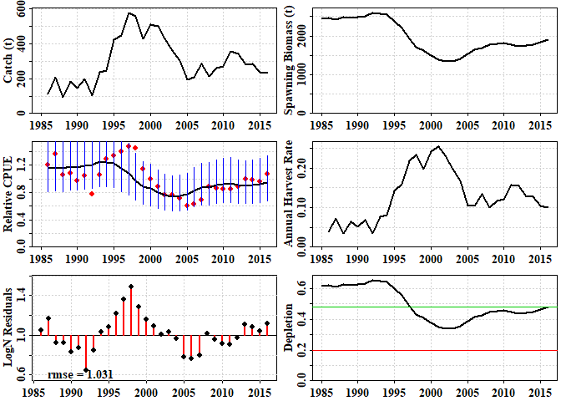

**Figure 39.** The outcome of fitting a three-parameter age-structured production model to the slope fishery data.

Once again the model fails to capture the more rapid changes in the predicted dynamics, but does capture the general trends through time (Figure 39). Unlike the two-parameter model, it predicts a final depletion close to 50% rather than 60%, but this time suggests that the starting depletion was about 65% rather than 100%. However, the -ve log-likelihood in this case is -9.95, rather than -7.58 as with the two-parameter model, indicating a slightly better fit (an improvement > 1.96 for each additional parameter suggests a better fit; Venzon and Moolgavkar, 1988).

Despite the improved fit to the data, the confidence intervals around the CPUE remain very large. Thus, when using the three parameter model, one should test the robustness of this fit to the initial conditions, to determine whether or not the outcome is stable following the model fitting or whether there is variation (uncertainty), and, if so, how much.

### Testing the Robustness of the Model Fit

The sensitivity of the model fit to the initial parameter values is important to explore, to gain greater confidence that the solution one finds is a global optimum rather than some local minima on the log-likelihood surface.

To test for robustness of the model fit we can use the original optimal model parameters or the original guesses, add variation to them, and re-fit the model. The intent is to explore the robustness of the model fitting so the starting point can influence this. If the initial guesses are used then other initial guesses might be tried as a starting point. This process should enable an analysis of the stability of the modelling outcomes. If the optimum parameters are used, then more should be added to ensure the parameter space is covered. The first parameter is , so, to simplify the selection of random variations away from the original, it helps to return that parameter to the linear scale and return it to the log-scale only when finished.

set.seed(12335) # to get repeatable results, normally not done  
 data(fishdat)  
 fish <- fishdat$fish  
 glb <- fishdat$glb  
 props <- fishdat$props  
 pars <- c(14,0.3)  
 out <- robustASPM(pars,fish,glb,props,scaler=20,N=15,console=FALSE)  
 kable(out$results,digits=c(3,3,2,3,3,4,1,1,0))

str(out,max.level=1)

|  |  |  |  |  |  |  |  |  |  |
| --- | --- | --- | --- | --- | --- | --- | --- | --- | --- |
|  | iLnR0 | isigmaCE | iLike | LnR0 | sigmaCE | -veLL | MSY | B0 | Iters |
| 9 | 14.034 | 0.290 | 9.12 | 13.983 | 0.296 | 3.6060 | 2.399000e+02 | 1.801430e+04 | 71 |
| 15 | 13.992 | 0.303 | 4.40 | 13.983 | 0.296 | 3.6060 | 2.399000e+02 | 1.801430e+04 | 71 |
| 5 | 14.055 | 0.285 | 11.63 | 13.983 | 0.296 | 3.6060 | 2.399000e+02 | 1.801430e+04 | 71 |
| 11 | 13.993 | 0.307 | 4.50 | 13.983 | 0.296 | 3.6060 | 2.399000e+02 | 1.801430e+04 | 71 |
| 8 | 13.977 | 0.304 | 10.27 | 13.983 | 0.296 | 3.6060 | 2.399000e+02 | 1.801430e+04 | 71 |
| 12 | 14.014 | 0.283 | 7.03 | 13.983 | 0.296 | 3.6060 | 2.399000e+02 | 1.801430e+04 | 71 |
| 2 | 14.009 | 0.270 | 6.78 | 13.983 | 0.296 | 3.6060 | 2.399000e+02 | 1.801430e+04 | 69 |
| 10 | 14.092 | 0.308 | 13.68 | 13.983 | 0.296 | 3.6060 | 2.399000e+02 | 1.801430e+04 | 69 |
| 14 | 14.012 | 0.281 | 6.85 | 13.983 | 0.296 | 3.6060 | 2.399000e+02 | 1.801430e+04 | 69 |
| 4 | 13.985 | 0.290 | 3.76 | 13.983 | 0.296 | 3.6060 | 2.399000e+02 | 1.801430e+04 | 69 |
| 7 | 14.038 | 0.303 | 8.98 | 13.983 | 0.296 | 3.6060 | 2.399000e+02 | 1.801430e+04 | 67 |
| 6 | 13.966 | 0.297 | 49.14 | 42.176 | 0.660 | 18.0638 | 4.209864e+14 | 3.161862e+16 | 23 |
| 13 | 13.937 | 0.301 | 314.81 | 41.204 | 0.660 | 18.0638 | 1.592507e+14 | 1.196069e+16 | 25 |
| 3 | 13.960 | 0.320 | 91.58 | 46.792 | 0.660 | 18.0638 | 4.254969e+16 | 3.195738e+18 | 21 |
| 1 | 13.939 | 0.300 | 292.89 | 41.314 | 0.660 | 18.0638 | 1.777260e+14 | 1.334829e+16 | 21 |

## List of 3  
## $ results: num [1:15, 1:9] 14 14 14.1 14 14 ...  
## ..- attr(*, "dimnames")=List of 2  
## $ range : num [1:2, 1:9] 13.94 14.09 0.27 0.32 3.76 ...  
## ..- attr(*, "dimnames")=List of 2  
## $ medians: Named num [1:9] 13.993 0.3 9.119 13.983 0.296 ...  
## ..- attr(*, "names")= chr [1:9] "iLnR0" "isigmaCE" "iLike" "LnR0"

Starting with the deep water fishery data *fishdat,* we find that 11 out of 15 generate one solution, which appears to be optimum, while the remaining four, which all began with highly unlikely first guesses (i.e. *iLike*, the initial likelihood was large) all gave implausible outcomes. It would be sensible to explore this lack of robustness further by using many more iterations. However, given the variation in the CPUE data, this is not a surprising result.

If we test the robustness of the model fit to the *dataspm* data set (a three parameter model) similar outcomes arise.

set.seed(12235)   
 data(dataspm)  
 fish <- dataspm$fish  
 glb <- dataspm$glb  
 props <- dataspm$props  
 pars <- c(14,0.2,0.6)  
 out <- robustASPM(pars,fish,glb,props,scaler=15,N=10,console=FALSE)  
 kable(out$results,digits=c(2,2,2,2,3,2,2,2,1,1,0))

|  |  |  |  |  |  |  |  |  |  |  |  |
| --- | --- | --- | --- | --- | --- | --- | --- | --- | --- | --- | --- |
|  | iLnR0 | isigmaCE | iDepl | iLike | LnR0 | sigmaCE | Depl | -veLL | MSY | B0 | Iters |
| 10 | 13.94 | 0.21 | 0.63 | -0.91 | 13.279 | 0.17 | 0.49 | -10.37 | 343.8 | 3738.2 | 102 |
| 7 | 13.93 | 0.20 | 0.58 | 1.44 | 13.279 | 0.17 | 0.49 | -10.37 | 343.8 | 3738.2 | 261 |
| 6 | 13.83 | 0.21 | 0.57 | -0.81 | 13.279 | 0.17 | 0.49 | -10.37 | 343.8 | 3738.2 | 104 |
| 9 | 14.10 | 0.18 | 0.64 | 3.23 | 13.279 | 0.17 | 0.49 | -10.37 | 343.8 | 3738.2 | 112 |
| 4 | 14.07 | 0.23 | 0.51 | 4.64 | 13.279 | 0.17 | 0.49 | -10.37 | 343.8 | 3738.2 | 183 |
| 2 | 13.97 | 0.17 | 0.59 | 4.60 | 13.280 | 0.17 | 0.49 | -10.37 | 343.8 | 3738.3 | 181 |
| 1 | 14.04 | 0.21 | 0.60 | 1.67 | 13.282 | 0.17 | 0.49 | -10.37 | 344.7 | 3747.6 | 186 |
| 3 | 14.04 | 0.20 | 0.53 | 5.71 | 13.301 | 0.17 | 0.55 | -10.29 | 351.4 | 3821.2 | 125 |
| 8 | 14.09 | 0.18 | 0.58 | 5.74 | 13.301 | 0.17 | 0.55 | -10.29 | 351.4 | 3821.1 | 119 |
| 5 | 13.92 | 0.18 | 0.60 | 2.11 | 13.315 | 0.17 | 0.57 | -10.27 | 356.2 | 3872.8 | 124 |

kable(out$range,digits=c(2,2,2,2,3,2,2,2,1,1,0))

|  |  |  |  |  |  |  |  |  |  |  |
| --- | --- | --- | --- | --- | --- | --- | --- | --- | --- | --- |
| iLnR0 | isigmaCE | iDepl | iLike | LnR0 | sigmaCE | Depl | -veLL | MSY | B0 | Iters |
| 13.83 | 0.17 | 0.51 | -0.91 | 13.279 | 0.17 | 0.49 | -10.37 | 343.8 | 3738.2 | 102 |
| 14.10 | 0.23 | 0.64 | 5.74 | 13.315 | 0.17 | 0.57 | -10.27 | 356.2 | 3872.8 | 261 |

Here we find that the four final negative log-likelihoods (*iLike*) differ from the optimum, although in this case the differences are not too far from the optimum. Very slight differences in the parameters even with the optimum -veLL lead to small differences in the derived statistics such as MSY and . Once again the variation in the CPUE data is what leads to any instability, although in this particular case the parameter set appears relatively stable. Whatever the case it is to be hoped that these examples illustrate that one should never accept the final result of fitting a model, even if the diagnostics look acceptable (i.e. the plot, the -veLL value, and optim gives convergence = 0). Without testing the robustness, it is possible that one is settling for only a local minima. This is one reason why it is usually a good idea to run a fitting routine twice, once from the initial parameter guesses, the second time from the solution of the first time.

When testing the robustness ideally one would run very many trials (at least 100 to allow for proportional attribution of variation), in which case it becomes a reasonable proposition to plot the results. The correlations between the parameters can also be calculated (they tend to be very high).

cor(out$results[,c("LnR0","Depl","-veLL","MSY")])#correlations between outputs

## LnR0 Depl -veLL MSY  
## LnR0 1.0000000 0.9926413 0.9882819 0.9999921  
## Depl 0.9926413 1.0000000 0.9986348 0.9922690  
## -veLL 0.9882819 0.9986348 1.0000000 0.9877160  
## MSY 0.9999921 0.9922690 0.9877160 1.0000000

#plotprep(width=8,height=6)  
intensity <- 2 # how many points overlapping = maximum colour  
pairs(out$results[,c("LnR0","Depl","-veLL","MSY")],pch=16,  
 col=rgb(1,0,0,1/intensity),font=7,font.labels = 7)

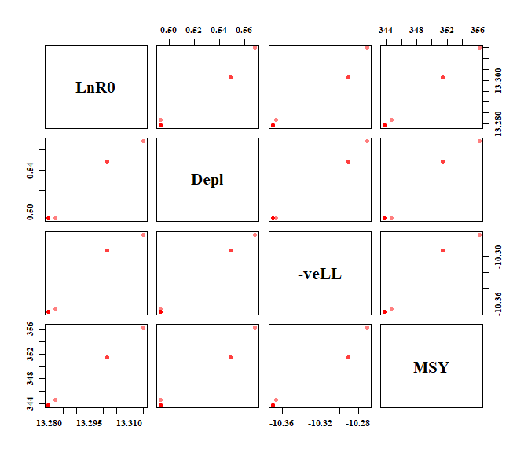

**Figure 40.** The correlations between outputs from repeated trials starting from different initial parameter values. Usually one would use many more trials than the example of 10, then these plots might be more informative. Histograms of these values might also indicate the variation present.

### The Production Curve and Statistics

Using two runs through the *optim* function each time, the median of the different trials is very similar to the optimum model fit, so we will use those values to determine the production curve predicted by a model We can then use that to estimate the biomass at the target reference point (default = 0.48) and at the limit reference point of 0.2. In addition, by estimating the yield expected at those reference points and dividing that through by the biomass at those reference points we can calculate the target and limit harvest rate reference points. The contents of *prod* can be used to determine other statistics such as the sustainable yield over the range of the current predicted depletion levels. This can be illustrated using a 3 parameter model on the *dataspm* data-set.

data(dataspm)  
fish <- dataspm$fish  
glb <- dataspm$glb  
props <- dataspm$props  
pars <- c(13.75,0.189667,0.6) # Fit 3 par__aspm__with penalty  
bestL <- optim(pars,aspmPENLL,method="Nelder-Mead",  
 infish=fish,inglb=glb,inprops=props,  
 control=list(maxit = 1000, parscale = c(10,1,0.1)))  
# two times through  
bestL <- optim(bestL$par,aspmPENLL,method="Nelder-Mead",  
 infish=fish,inglb=glb,inprops=props,  
 control=list(maxit = 1000, parscale = c(10,1,0.1)))  
par <- bestL$par  
print(par)

## [1] 13.2794896 0.1731791 0.4934525

prod <- getProductionC(exp(par[1]),fish,glb,props,  
 Hrg=c(0.01,0.45,0.005),nyr=50)  
head(round(prod,3),6)

## Harvest SpawnB ExploitB Yield Depletion  
## 0 0.000 3738.229 4117.963 NA 1.000  
## 0.01 0.010 3503.303 3896.605 38.966 0.937  
## 0.015 0.015 3393.404 3792.697 56.890 0.908  
## 0.02 0.020 3288.158 3692.955 73.859 0.880  
## 0.025 0.025 3187.299 3597.142 89.929 0.853  
## 0.03 0.030 3090.581 3505.037 105.151 0.827

tail(round(prod,3),6)

## Harvest SpawnB ExploitB Yield Depletion  
## 0.425 0.425 425.115 702.960 298.758 0.114  
## 0.43 0.430 414.797 688.847 296.204 0.111  
## 0.435 0.435 404.686 674.933 293.596 0.108  
## 0.44 0.440 394.777 661.213 290.934 0.106  
## 0.445 0.445 385.066 647.683 288.219 0.103  
## 0.45 0.450 375.547 634.339 285.452 0.100

anspen <- prodASPM(prod,target=0.48,console=FALSE,plot=TRUE)

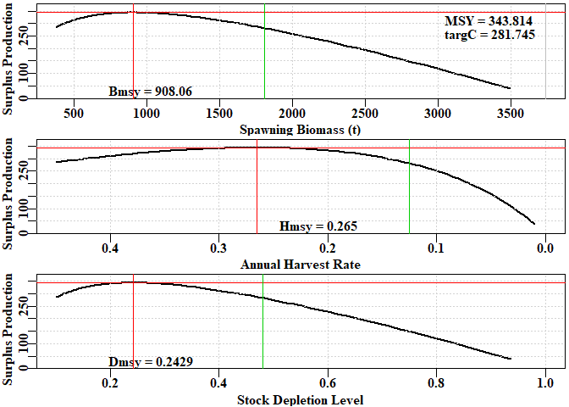

**Figure 41.** Production curves for the optimum fitting three parameter age-structured production model fitted to the slope fishery data in *dataspm*. The target in this case is 0.48, designated by the vertical green lines. The results contained within *anspen* are used as labels. In this case the model is suggesting that is down at 0.243 so using a target of 0.48 means that the harvest rate, and presumably effort, would be halved, the stock kept at a much higher presumably more resilient level, and the catch only reduced on average by about 18%.

round(anspen,3)

## MSY Bmsy Hmsy Dmsy B0 targC Htarg Btarg   
## 343.814 908.060 0.265 0.243 3738.229 281.745 0.125 1809.504

### A Phase Plot

The final part of age-structured production modelling would entail generating a phase plot of predicted biomass against the predicted harvest rates. The previous functions and analyses will provide all the information we require to feed into the function *aspmphaseplot*.

# plotprep(width=7,height=5.5)  
fisheryPen <- dynamics(bestL$par,infish=fish,inglb=glb,inprops=props)  
outs <- aspmphaseplot(fisheryPen,prod,anspen,Blim=0.2,fnt=7)

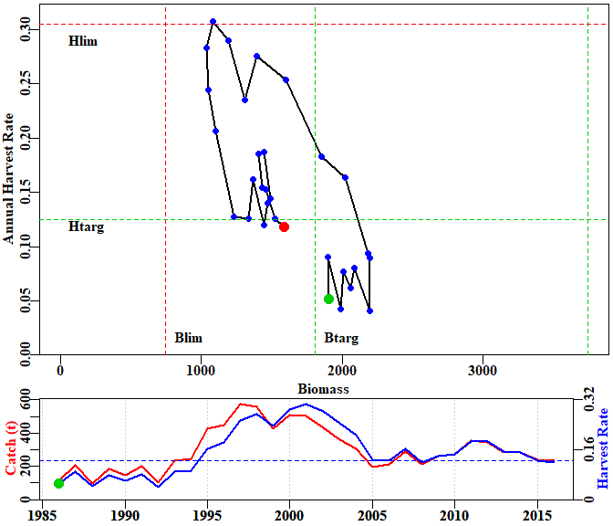

**Figure 42.** Phase plot of predicted biomass vs predicted harvest rate for the optimum fitting three parameter age-structured production model fitted to the slope fishery data in *dataspm*. The target, in this case at 0.48, is designated by the green lines, while the limit reference points are designated by the red lines.

The phase plot (Figure 42) suggests that the biomass is a little below the target but the fishing mortality is very close to its target. In addition the fishery appears relatively stable at present indicating it is not declining. In the SAFS system, this fishery could defensibly be claimed to be sustainable, although the uncertainty in the analysis would need to be noted explicitly.

### Characterization of Uncertainty

When only fitting to CPUE, it is possible to use many replicate bootstrap samples, followed by re-analysis to generate a detailed characterization of uncertainty. The following example code illustrates the approach. First, we need to obtain the optimum solution.

# library(simpleSA)  
library(simpleSA)  
data(dataspm)  
fish <- dataspm$fish  
glb <- dataspm$glb  
props <- dataspm$props  
pars <- c(13.5,0.18,0.5)  
bestL <- fitASPM(pars,fish,glb,props,callfun=aspmPENLL)  
fishery <- dynamics(bestL$par,fish,glb,props)  
kable(fishery,digits=c(0,1,1,3,3,3,3,3,3))

|  |  |  |  |  |  |  |  |  |  |
| --- | --- | --- | --- | --- | --- | --- | --- | --- | --- |
|  | Year | Catch | PredC | SpawnB | ExploitB | FullH | CPUE | PredCE | Deplete |
| 0 | 1985 |  |  | 1844.493 | 2201.515 |  |  |  | 0.493 |
| 1 | 1986 | 112.9 | 112.9 | 1905.994 | 2281.700 | 0.051 | 1.201 | 1.075 | 0.510 |
| 2 | 1987 | 206.3 | 206.3 | 1897.882 | 2279.923 | 0.090 | 1.355 | 1.115 | 0.508 |
| 3 | 1988 | 95.7 | 95.7 | 1986.162 | 2377.159 | 0.042 | 1.058 | 1.114 | 0.531 |
| 4 | 1989 | 183.1 | 183.1 | 2005.773 | 2396.363 | 0.077 | 1.085 | 1.161 | 0.537 |
| 5 | 1990 | 147.4 | 147.4 | 2059.854 | 2478.526 | 0.062 | 0.974 | 1.171 | 0.551 |
| 6 | 1991 | 198.9 | 198.9 | 2082.974 | 2518.471 | 0.080 | 1.044 | 1.211 | 0.557 |
| 7 | 1992 | 102.1 | 102.1 | 2193.351 | 2640.207 | 0.041 | 0.776 | 1.230 | 0.587 |
| 8 | 1993 | 235.5 | 235.5 | 2193.924 | 2633.084 | 0.089 | 1.053 | 1.290 | 0.587 |
| 9 | 1994 | 247.8 | 247.8 | 2180.129 | 2615.893 | 0.094 | 1.284 | 1.286 | 0.583 |
| 10 | 1995 | 426.8 | 426.8 | 2019.514 | 2445.747 | 0.163 | 1.333 | 1.278 | 0.540 |
| 11 | 1996 | 448.0 | 448.0 | 1851.779 | 2279.545 | 0.183 | 1.401 | 1.195 | 0.495 |
| 12 | 1997 | 577.4 | 577.4 | 1599.185 | 2025.283 | 0.253 | 1.469 | 1.114 | 0.428 |
| 13 | 1998 | 558.5 | 558.5 | 1389.703 | 1821.336 | 0.276 | 1.449 | 0.989 | 0.372 |
| 14 | 1999 | 427.9 | 427.9 | 1310.586 | 1759.085 | 0.235 | 1.142 | 0.890 | 0.351 |
| 15 | 2000 | 509.3 | 509.3 | 1188.966 | 1631.779 | 0.290 | 0.996 | 0.859 | 0.318 |
| 16 | 2001 | 502.4 | 502.4 | 1082.984 | 1518.972 | 0.308 | 0.882 | 0.797 | 0.290 |
| 17 | 2002 | 429.6 | 429.6 | 1038.707 | 1473.711 | 0.283 | 0.764 | 0.742 | 0.278 |
| 18 | 2003 | 360.2 | 360.2 | 1049.518 | 1485.656 | 0.244 | 0.767 | 0.720 | 0.281 |
| 19 | 2004 | 306.2 | 306.2 | 1099.426 | 1537.854 | 0.206 | 0.720 | 0.726 | 0.294 |
| 20 | 2005 | 195.7 | 195.7 | 1227.569 | 1673.737 | 0.127 | 0.600 | 0.751 | 0.328 |
| 21 | 2006 | 210.0 | 210.0 | 1336.509 | 1772.734 | 0.125 | 0.634 | 0.818 | 0.358 |
| 22 | 2007 | 287.3 | 287.3 | 1368.358 | 1784.647 | 0.162 | 0.694 | 0.866 | 0.366 |
| 23 | 2008 | 214.2 | 214.2 | 1441.816 | 1857.291 | 0.120 | 0.889 | 0.872 | 0.386 |
| 24 | 2009 | 260.6 | 260.6 | 1471.771 | 1884.847 | 0.140 | 0.864 | 0.907 | 0.394 |
| 25 | 2010 | 272.2 | 272.2 | 1489.268 | 1907.019 | 0.144 | 0.844 | 0.921 | 0.398 |
| 26 | 2011 | 356.9 | 356.9 | 1441.380 | 1859.230 | 0.187 | 0.843 | 0.932 | 0.386 |
| 27 | 2012 | 345.0 | 345.0 | 1407.928 | 1830.919 | 0.186 | 0.885 | 0.908 | 0.377 |
| 28 | 2013 | 282.7 | 282.7 | 1430.753 | 1865.664 | 0.154 | 0.996 | 0.894 | 0.383 |
| 29 | 2014 | 285.1 | 285.1 | 1457.524 | 1897.810 | 0.153 | 0.980 | 0.911 | 0.390 |
| 30 | 2015 | 237.8 | 237.8 | 1522.403 | 1968.634 | 0.125 | 0.957 | 0.927 | 0.407 |
| 31 | 2016 | 233.3 | 233.3 | 1588.181 | 2033.085 | 0.119 | 1.063 | 0.962 | 0.425 |

Having run the model through *optim* twice inside *fitASPM*, the optimum fit is used to characterize the dynamics using *dynamics*. The basis of the bootstrap sampling is that the log-normal residuals (*CPUE*/*PredCE*) are randomly sampled with replacement, with each such bootstrap then being multiplied by the optimum model’s predicted CPUE. If, for example, we take the original residuals and multiply them by the original predicted CPUE, we would re-generate the original observed CPUE. All we are doing in the bootstrap procedure is reordering the residuals by randomly resampling them with replacement. The ‘with replacement’ bit implies that some values may be omitted and others may be repeated more than once.

Such bootstrap samples are generated within *bootASPM*. This function generates replicate numbers of optimal fitting parameters in *param*, estimates of unfished biomass in *B0*, and finally a matrix of five time-series of spawning biomass, fully selected harvest rate, each bootstrap CPUE series, the optimum predicted CPUE, and the depletion level through time. Here we are only running 100 replicates so as to speed the process, but in a real analysis one might use at least 1000 replicates.

reps <- 20  
starttime <- Sys.time()  
answer <- bootASPM(fish,glb,props,bestL$par,iter=reps)

## 20

Sys.time() - starttime

## Time difference of 13.00663 secs

str(answer,max.level=1)

## List of 3  
## $ result: num [1:20, 1:32, 1:5] 1844 2330 1607 1883 2442 ...  
## ..- attr(*, "dimnames")=List of 3  
## $ B0 : num [1:20] 3738 4004 3741 3816 3973 ...  
## $ param : num [1:20, 1:3] 13.3 13.3 13.3 13.3 13.3 ...  
## ..- attr(*, "dimnames")=List of 2

Once the bootstraps are completed there are multiple ways of displaying the resultant information. Initially one can generate classical percentile confidence intervals from the bootstrap replicates (Haddon, 2011).

yrs <- fishery[,"Year"]  
nyrs <- length(yrs)  
par(mfrow=c(2,2),mai=c(0.45,0.45,0.05,0.05))   
par(cex=0.85, mgp=c(1.35,0.35,0), font.axis=7,font=7,font.lab=7)   
label <- names(answer$result[1,1,])  
label <- label[-3] # remove CPUE  
numvar <- length(label)  
bootvar <- answer$result[,nyrs,label[1]]  
for (i in 1:numvar) { # i=3  
 bootvar <- answer$result[,nyrs,label[i]]  
 quantCI <- quantile(bootvar,probs=c(0.05,0.5,0.95),na.rm=TRUE)  
 hist(bootvar,breaks=30,main="",xlab=label[i],col="red")  
 abline(v=quantCI,col=c(4,4,4),lwd=c(1,2,1))  
}

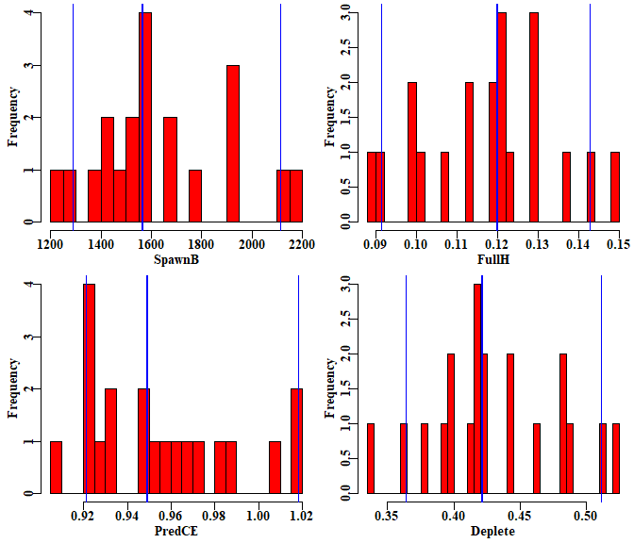

**Figure 43.** Histograms of the final years’ spawning biomass, fully selected harvest rate, predicted CPUE, and the stock depletion level. Of course 20 replicates is completely inadequate but each bootstrap replicate can take a significant time (note the time taken to run the example). One thing that can be noted is the asymmetrical percentile confidence bounds.

With only 20 replicates, no conclusions can be drawn, but the plots still illustrate the principle behind the bootstraps. The percentile confidence intervals can illustrate the uncertainty in the assessments and the potential risk of falling below limit reference points.

pickvar <- "Deplete"  
bootvar <- answer$result[,,pickvar]  
yrs <- as.numeric(colnames(bootvar))  
nyrs <- length(yrs)  
quantCI <- t(apply(bootvar,2,quants))  
kable(quantCI,digits=c(3,3,3,3,3,3))

|  |  |  |  |  |  |  |
| --- | --- | --- | --- | --- | --- | --- |
|  | 2.5% | 5% | 50% | 90% | 95% | 97.5% |
| 1985 | 0.302 | 0.319 | 0.497 | 0.650 | 0.670 | 0.702 |
| 1986 | 0.328 | 0.346 | 0.513 | 0.652 | 0.672 | 0.700 |
| 1987 | 0.339 | 0.357 | 0.511 | 0.637 | 0.657 | 0.681 |
| 1988 | 0.375 | 0.393 | 0.534 | 0.648 | 0.666 | 0.687 |
| 1989 | 0.392 | 0.410 | 0.540 | 0.643 | 0.659 | 0.678 |
| 1990 | 0.417 | 0.435 | 0.554 | 0.648 | 0.663 | 0.679 |
| 1991 | 0.431 | 0.449 | 0.560 | 0.646 | 0.661 | 0.676 |
| 1992 | 0.469 | 0.486 | 0.589 | 0.668 | 0.682 | 0.695 |
| 1993 | 0.476 | 0.493 | 0.590 | 0.662 | 0.676 | 0.688 |
| 1994 | 0.480 | 0.496 | 0.586 | 0.654 | 0.668 | 0.679 |
| 1995 | 0.443 | 0.460 | 0.541 | 0.609 | 0.625 | 0.635 |
| 1996 | 0.404 | 0.421 | 0.495 | 0.563 | 0.581 | 0.590 |
| 1997 | 0.342 | 0.360 | 0.427 | 0.495 | 0.516 | 0.525 |
| 1998 | 0.291 | 0.309 | 0.370 | 0.439 | 0.462 | 0.470 |
| 1999 | 0.274 | 0.292 | 0.349 | 0.417 | 0.440 | 0.449 |
| 2000 | 0.246 | 0.264 | 0.316 | 0.384 | 0.409 | 0.417 |
| 2001 | 0.220 | 0.239 | 0.288 | 0.355 | 0.382 | 0.389 |
| 2002 | 0.209 | 0.228 | 0.276 | 0.343 | 0.371 | 0.378 |
| 2003 | 0.212 | 0.229 | 0.279 | 0.346 | 0.374 | 0.381 |
| 2004 | 0.224 | 0.241 | 0.292 | 0.360 | 0.387 | 0.395 |
| 2005 | 0.257 | 0.274 | 0.326 | 0.393 | 0.421 | 0.428 |
| 2006 | 0.285 | 0.303 | 0.355 | 0.422 | 0.449 | 0.456 |
| 2007 | 0.292 | 0.309 | 0.364 | 0.431 | 0.458 | 0.465 |
| 2008 | 0.310 | 0.327 | 0.383 | 0.451 | 0.478 | 0.484 |
| 2009 | 0.316 | 0.334 | 0.391 | 0.460 | 0.486 | 0.492 |
| 2010 | 0.320 | 0.337 | 0.396 | 0.465 | 0.491 | 0.497 |
| 2011 | 0.307 | 0.323 | 0.383 | 0.453 | 0.479 | 0.485 |
| 2012 | 0.298 | 0.314 | 0.374 | 0.445 | 0.470 | 0.476 |
| 2013 | 0.305 | 0.320 | 0.380 | 0.450 | 0.475 | 0.481 |
| 2014 | 0.314 | 0.327 | 0.387 | 0.456 | 0.481 | 0.487 |
| 2015 | 0.332 | 0.345 | 0.405 | 0.472 | 0.496 | 0.502 |
| 2016 | 0.352 | 0.364 | 0.422 | 0.488 | 0.512 | 0.517 |

ymax <- getmaxy(bootvar)  
par(mfrow=c(1,1),mai=c(0.45,0.45,0.05,0.05))   
par(cex=0.85, mgp=c(1.35,0.35,0), font.axis=7,font=7,font.lab=7)  
plot(yrs,bootvar[1,],type="n",lwd=1,col=0,ylim=c(0,ymax),  
 panel.first = grid(),xlab="",ylab=pickvar)  
for (i in 1:reps) lines(yrs,bootvar[i,],lwd=1,col="grey")  
lines(yrs,quantCI[,"50%"],lwd=2,col="red")  
arrows(x0=yrs,y0=quantCI[,"5%"],y1=quantCI[,"95%"],  
 col=2,lwd=1,length=0.035,angle=90,code=3)

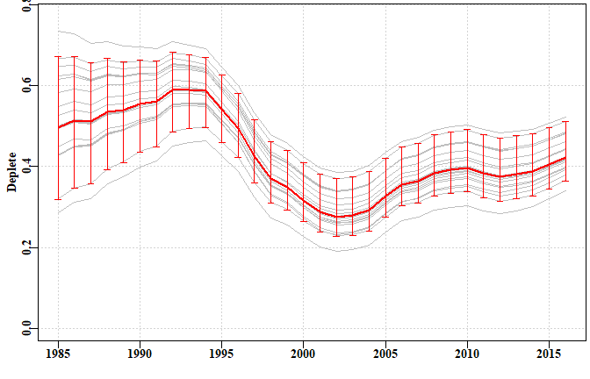

**Figure 44.** The bootstrapped trajectories of stock depletion of the *dataspm* data set. Note that 20 replicates are far too few to provide sensible or valid percentile confidence intervals.

The output from the *bootASPM* function includes the bootstrap optimum parameters. These can be used along with the *fish*, *glb*, and *props* objects from the data set used to generate productivity curves and determine target catches, MSY, and other fishery outputs for each set of parameters. This means that percentile confidence intervals can be generated for such assessment outputs.

### Management Advice with aspm

If working with a species that requires on-going management then it is necessary to produce advice with respect to acceptable catches that will lead to a sustainable fishery or whatever other management goal is in place for the fishery. To generate such advice formal harvest strategies are required to allow the outputs from the assessment to be converted into a recommended biological catch. This may then be modified by fishery managers taking into account potential rates of change within a fishery or social or economic drivers of management decisions.

It was possible to put forward suggestions for new harvest strategies using the catch-MSY method because none were available previously and that put forward was only a suggestion for a possible consideration. Putting forward a proposed harvest control rule for the spm approach without consultation with jurisdictional fisheries managers could produce suggestions incompatible with a particular jurisdiction’s objectives. There already are harvest control rules that can be used once limit and target reference points are agreed upon, and these can be utilized where considered appropriate with either the spm or aspm models. The SAFS process, however, does not currently require a target reference point even though most harvest control rules do require one. No specific harvest control rules are provided so as to avoid such things appearing as recommendations when none are intended.

## Appendix: Age-Structured Production Model Equations

### Initiation of an Age-Structured Model

At equilibrium, in an un-exploited population, the age-structure is assumed to be the result of natural mortality acting alone upon constant average unfished levels of recruitment. The equilibrium result would be a stable age distribution determined by those constant average recruitments and natural mortality. At the start of a time series, let us say in year 1, this is defined as:

where is the numbers of age , in year 1, is the maximum age modelled (the plus-group), and is the instantaneous rate of natural mortality. In a pre-exploitation population there is no fishing mortality and the final component the above equation (where = ), is referred to as the plus group because it is the series which combines ages and all older ages that are not modelled explicitly. This requires the inclusion of the divisor to force the equation to be the sum of an exponential series. The is the constant unfished recruitment level, . Sometimes this also has an term, depending on the timing of spawning. If the natural mortality term is included, then the estimated value will be somewhat higher than if it is omitted (by ), so it is usually simpler to omit it. This stable age distribution can also be obtained by first calculating the numbers-at-age for a recruitment of 1, or the numbers-at-age per recruit, and then multiplying that vectors of numbers by , which is how it is implemented in *simpleSA::dynamics*

### Biological Characteristics

Length-at-age of fish is defined by the von Bertalanffy growth function:

where is the mean length at age , is the asymptotic average maximum length, is the grow rate coefficient, and is the length at age zero.

The mass-at-age relationship is defined as:



where is the mass at age , and *W* and *W* are the coefficients that define the power relationship between length and mass.

### Spawning Stock Recruitment Relationship

The biomass can be defined as the mature stock biomass that would develop given a constant recruitment level of one (i.e. in the above equation). Thus, at a biomass of , distributed across a stable age distribution, the resulting average recruitment level would be . acts as a scaling factor in the recruitment equations by providing the link between and

where is the proportion mature at age , is the virgin number of animals per recruit of age in year 1, and is the weight of an animal of age . The average unfished recruitment level, , is directly related to the virgin mature, or recruited, biomass,

By determining , from a constant recruitment level of one, the recruitment levels from realistic levels can be obtained by applying the above equation. Once has been determined, the unfished number at age distribution can be obtained by substituting into the first equation. The spawning stock – recruitment relationship can be described by the deterministic form of the Beverton – Holt relationship:

where is the mature, or spawning biomass in the year .

A re-parameterization of the Beverton-Holt parameters in terms of steepness, , and is to specify and such that:

Using this re-parameterization the number of recruits produced in year from the spawning biomass in year is:

### Stock dynamics

To describe the dynamics subsequent to population initiation (i.e. the generation of , the number at age in year , for years other than 0), requires the inclusion of the stock recruitment relationship and the impact of fishing mortality. Not all age classes are necessarily fully selected, thus the fishing mortality term must be multiplied by the selectivity associated with the fishing gear for age , , described by a logistic curve:

where is the age at which 50% of individuals are selected by the fishing gear, and is a parameter that determines the width or steepness of the selectivity ogive. Such logistic curves are also used to describe the development of maturity within the population, but in such a case the refers to the age at 50% maturity.

A term is also needed for the recruitment in each year (stock-recruit relationship above), and this is assumed to be a function of the spawning biomass of the stock at the end of the previous year , .

The spawning biomass for a year is:

When applied to the unfished stable age distribution, this would provide an estimate of the unfished spawning biomass-per-recruit. When using difference equations (rather than continuous differential equations) the dynamics of the fishery, in terms of the order in which growth, natural, and fishing mortality occur, are important when defining how the numbers at age change. If the transition of numbers at age in year into numbers at age in year is broken down into a number of steps, this simplifies the calculation of internally consistent estimates of exploitable biomass, catch rates, and harvest rates. If it is assumed that the dynamics of a population entails that fish first grow from year to year , then undergo half of natural mortality before they are fished, and only then undergo the final half of natural mortality, this would imply two steps to define the transition from one year to the next. The first step entails recruitment, growth from each age class to the next, and the application of the effect of half of natural mortality:

where is defined by the stock - recruit relationship, ages 1 to -1 are modelled by adding 1.0 to the previous year’s ages 0 to – 2, and imposing the survivorship from half the natural mortality, and the plus group () is modelled by adding 1.0 to the previous year’s age – 1, and adding those to the numbers in the previous year’s age and then applying the survivorship from half the natural mortality. The above equation thus leads to the mid-year exploitable biomass (mid-year being the reason for the ) in year being defined as:

The dynamics within any year are completed by the application of the survivorship following fishing mortality across all ages (expressed as an annual harvest rate), followed by the survivorship following the remainder of natural mortality. Natural mortality is not applied directly to the new recruits until they grow into the next year:

In the above equation, the refer the numbers in age at the end of year (i.e. after all the dynamics have occurred). The predicted harvest rate, , given an observed or recommended catch level in year , , is estimated as

where is defined above. The catch at age, in numbers, is therefore defined by:

and the total catch by mass is the sum of the separate catches at age multiplied by their respective average weights for all ages:

Predicted catch rates also derive from the exploitable biomass and the average catchability coefficient, :

### Likelihoods

Maximum likelihood methods, as the name dictates, entail maximizing the likelihood of the available data given the model and a proposed set of parameters. Very often the likelihoods involved when fitting models are very small numbers. To avoid rounding errors (even when using 64 bit computers) it is standard to use log-likelihoods rather than likelihoods (in that way the log-likelihoods can be individually added together rather than multiply the individual likelihoods). Additionally, rather than maximizing a log-likelihood, minimization often best matches our intuitions about model fitting and this involves minimizing the negative log-likelihood. The full log-normal negative log likelihood for the **aspm** is similar to that used for the **spm** but with a few parameter changes, and it estimates the directly rather than using a closed form:

# References

Dick, E.J. and A.D. MacCall (2011) Depletion-based stock reduction analysis: a catch-based method for determining sustainable yields for data-poor fish stocks. Fisheries Research 110(2): 331-341

Fox, W.W. (1970) An exponential surplus-yield model for optimizing exploited fish populations. *Transactions of the American Fish Society*,**99**: 80-88.

Haddon, M. (2011). Modelling and quantitative methods in fisheries, second edition. CRC press. 465pp.

Haddon, M. (2014) Tier 4 analyses in the SESSF, including deep water species. Data from 1986 – 2012. Pp 352 – 461 in Tuck, G.N. (ed) (2014) Stock Assessment for the Southern and Eastern Scalefish and Shark Fishery 2013. Part 2. Australian Fisheries Management Authority and CSIRO Marine and Atmospheric Research, Hobart. 313p.

Haddon, M., Klaer, N., Wayte, S., and G. Tuck (2015) Options for Tier 5 approaches in the SESSF and identification of when data support for harvest strategies are inappropriate. CSIRO. FRDC Final Report 2013/200. Hobart. 115p.

Kimura, D.K. and J.V. Tagart (1982) Stock Reduction Analysis, another solution to the catch equations. Canadian Journal of Fisheries and Aquatic Sciences 39: 1467 - 1472.

Kimura, D.K., Balsiger, J.W., and D.H. Ito (1984) Generalized stock reduction analysis. Canadian Journal of Fisheries and Aquatic Sciences 41: 1325–1333.

Little, L.R., Wayte, S.E., Tuck, G.N., Smith, A.D.M., Klaer, N., Haddon, M., Punt, A.E., Thomson, R., Day, J. and M. Fuller (2011) Development and evaluation of a cpue-based harvest control rule for the southern and eastern scalefish and shark fishery of Australia. ICES Journal of Marine Science 68(8): 1699-1705.

Martell, S. and R. Froese (2013) A simple method for estimating MSY from catch and resilience. Fish and Fisheries 14: 504-514

Prager, M.H. (1994) A suite of extensions to a non-equilibrium surplus-production model. Fishery Bulletin, 92: 374-389.

Polacheck, T., Hilborn, R. and A.E. Punt (1993) Fitting surplus production models: Comparing methods and measuring uncertainty. Canadian Journal of Fisheries and Aquatic Sciences 50: 2597–2607.

Punt, A.E., Butterworth, D.S. and A.J. Penney (1995) Stock assessment and risk analysis for the South Atlantic population of albacore Thunnus alalunga using an age-structured production model South African Journal of Marine Science 16: 287-310. <http://dx.doi.org/10.2989/025776195784156476>

R Core Team (2017). R: A language and environment for statistical computing. R Foundation for Statistical Computing, Vienna, Austria. URL <https://www.R-project.org/>. see also <https://cran.r-project.org/>

RStudio (2016) www.rstudio.com

Rudd, M.B. and T.A. Branch (2017) Does unreported catch lead to over-fishing? Fish and Fisheries 18: 313-323.

Schaefer, M.B. (1954) Some aspects of the dynamics of populations important to the management of the commercial marine fisheries. Bulletin, Inter-American Tropical Tuna Commission, 1: 25-56.

Schaefer, M.B. (1957) A study of the dynamics of the fishery for yellowfin tuna in the Eastern Tropical Pacific Ocean. Bulletin, Inter-American Tropical Tuna Commission, 2: 247-285

Sporcic, M. and M. Haddon (2016) Statistical CPUE standardizations for selected SESSF species (data to 2015). Report prepared for the October 2016 SERAG meeting. CSIRO Oceans and Atmosphere, Hobart, 206 p.

Venzon, D.J. and S.H. Moolgavkar (1988) A method for computing profile-likelihood-based confidence intervals. Applied Statistics, 37: 87-94.

Walters, C.J., Martell, S.J.D. and J. Korman (2006) A stochastic approach to stock reduction analysis. Canadian Journal of Fisheries and Aquatic Sciences 63: 212 - 223.

|  |  |  |
| --- | --- | --- |
|  | | |
| CONTACT US  t 1300 363 400  +61 3 9545 2176  e enquiries@csiro.au  w www.csiro.au  Your CSIRO  Australia is founding its future on science and innovation. Its national science agency, CSIRO, is a powerhouse of ideas, technologies and skills for building prosperity, growth, health and sustainability. It serves governments, industries, business and communities across the nation. |  | For further information  CSIRO Oceans and Atmosphere  Paul Burch  t +61 3 6232 5394  e Paul.Burch@csiro.au |

1. Table 1 is repeated from page 13.