CS381 — Web Application Development
Project 1: YIC IT Support Portal
Phase 1 — Planning & Architecture Design

Problem Description
The YIC IT Support Portal is a web application designed to streamline the process of reporting and resolving technical issues at Yanbu Industrial College. Students can submit support tickets describing their IT problems, track the status of their requests, and read responses from the technical team. Administrators can view all submitted tickets, assign them to technicians, update ticket statuses, and communicate with students through the system. The application is built using HTML5, CSS3, vanilla JavaScript, PHP with PDO, and MySQL — with no external frameworks.

1. Hand-Drawn Wireframes

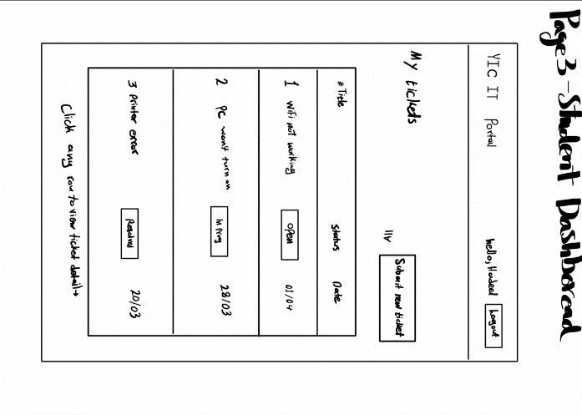
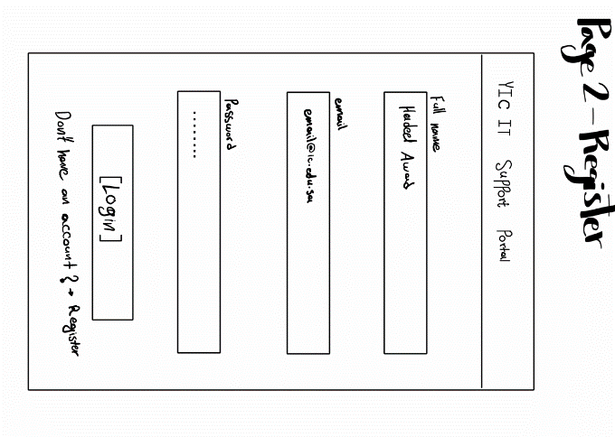
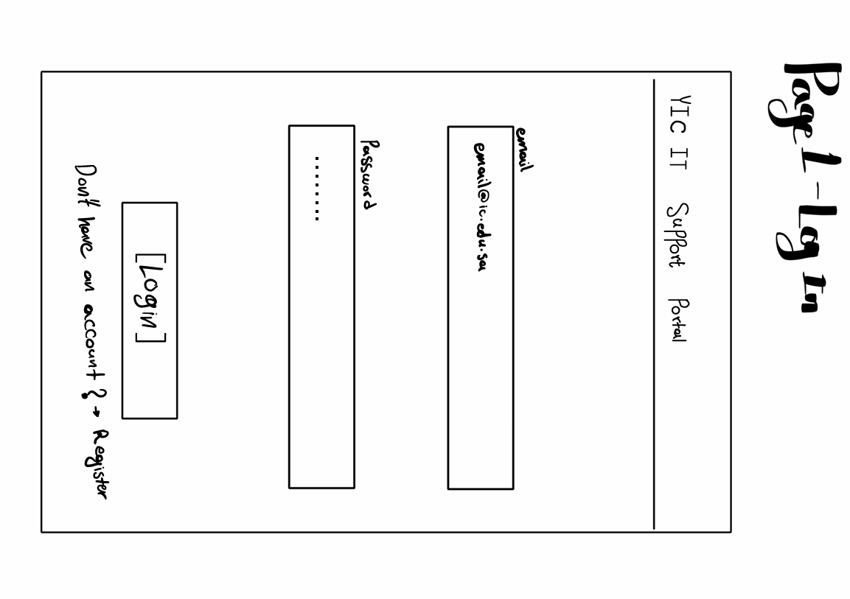
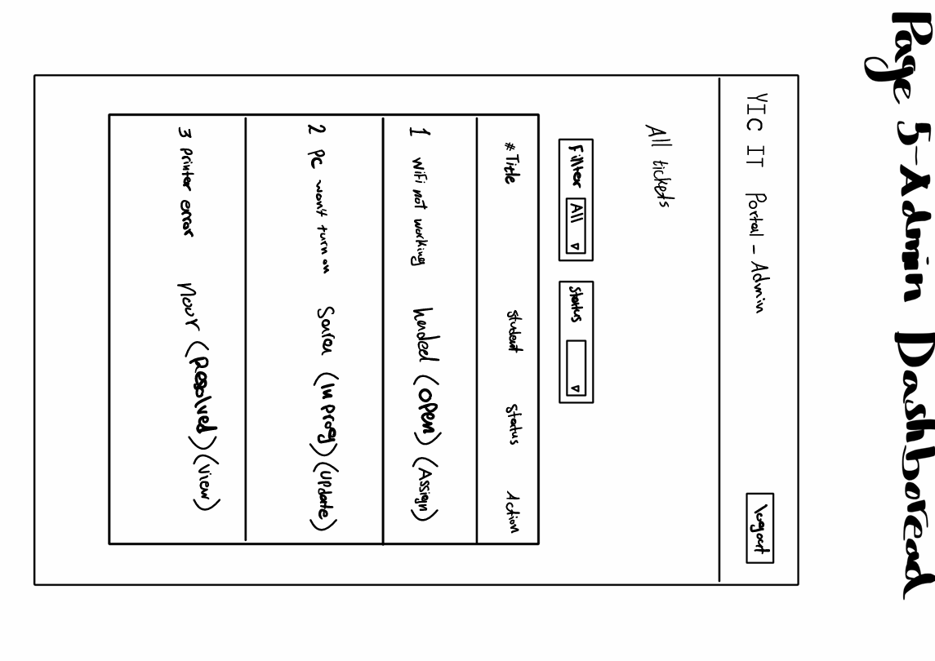
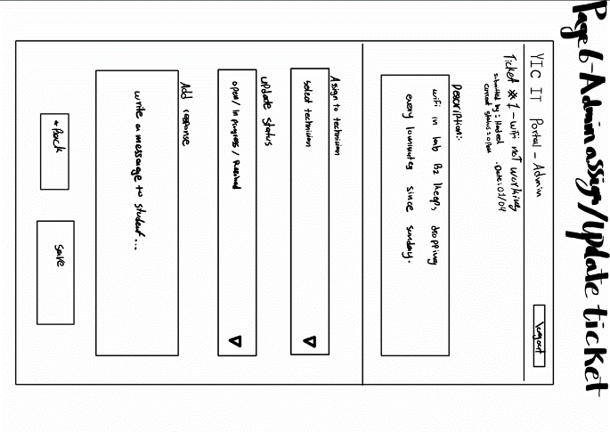
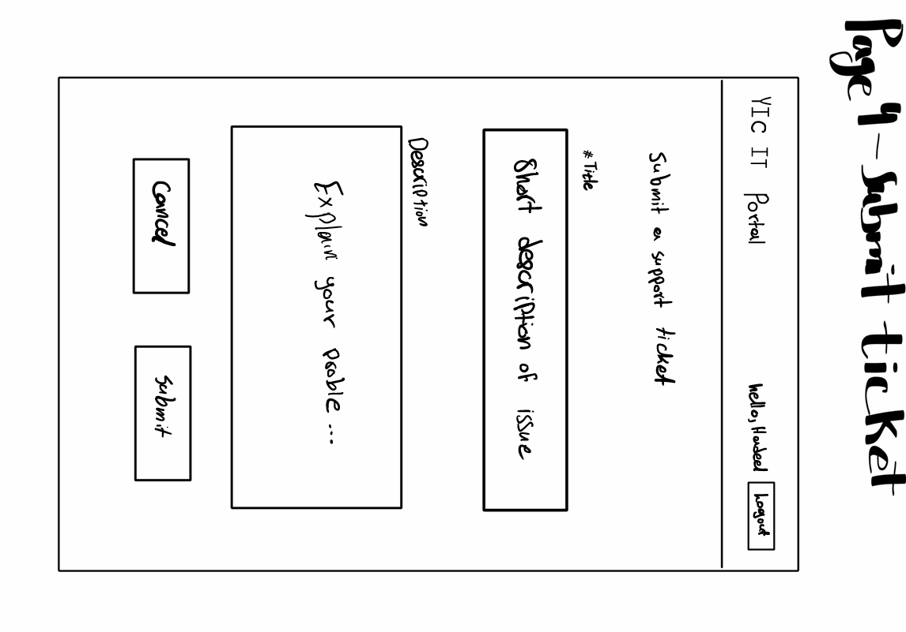

2. System Architecture Diagram
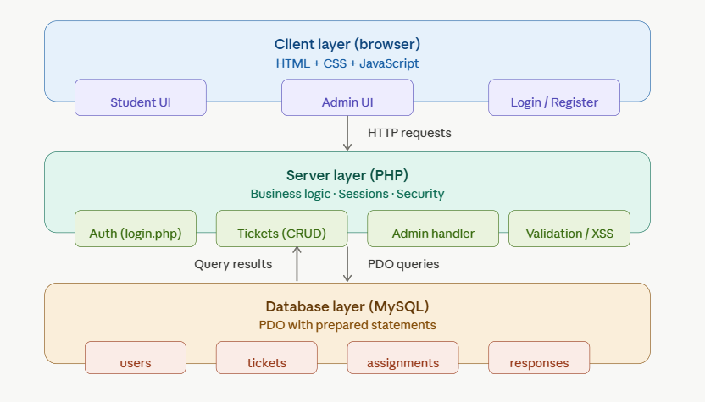

3. File / Folder Structure
yic-it-portal/
├── index.php ← redirects to login
├── login.php
├── register.php
├── logout.php
│
├── student/
│ ├── dashboard.php ← my tickets list
│ ├── submit_ticket.php
│ └── ticket_detail.php
│
├── admin/
│ ├── dashboard.php ← all tickets
│ ├── assign_ticket.php
│ └── update_status.php
│
├── includes/
│ ├── db.php ← PDO connection
│ ├── auth.php ← session helpers
│ └── functions.php ← sanitize, validate
│
├── css/
│ └── style.css
│
├── js/
│ └── main.js
│
└── database/
└── schema.sql ← tables + sample da

4. Database Design (ER Diagram)
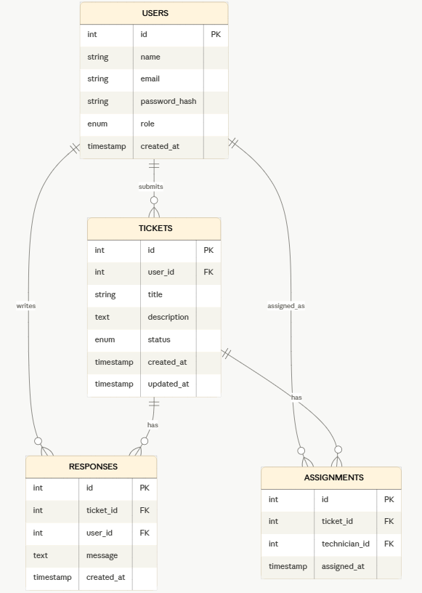

5. Page Flow Diagram

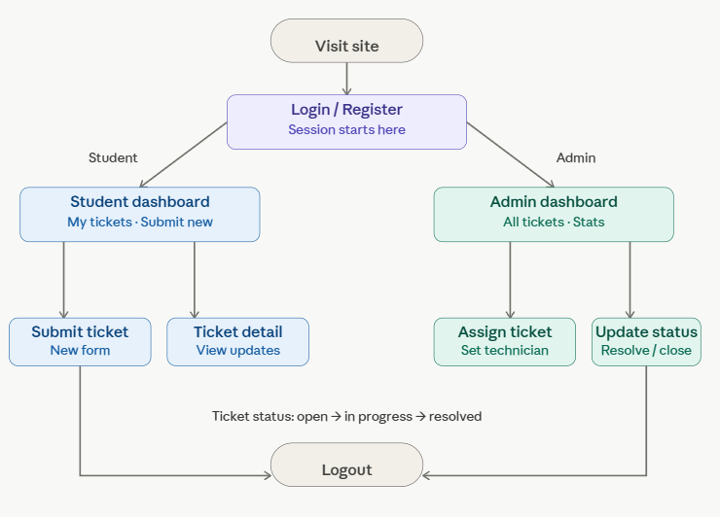

6. Feature List

Student features
- Register a new account (name, email, password)
- Login and logout with PHP session management
- Submit a support ticket with title and description
- View all my own submitted tickets with current status
- View full ticket detail including admin responses
- Track status changes: open → in progress → resolved

Admin features
- Login to a separate admin dashboard
- View all tickets submitted by all students
- Assign a ticket to a technician by name
- Add a written response to any ticket
- Update ticket status (open / in_progress / resolved)
- Mark a ticket as resolved / closed

Security features
- Password hashing using password_hash() and password_verify()
- PDO prepared statements — prevents SQL injection
- htmlspecialchars() on all output — prevents XSS
- CSRF tokens on all form submissions
- Role-based access control — students blocked from /admin/

7. User Stories
# | As a... | I want to... | So that... | Role
1 | student | register an account | I can access the portal | Student
2 | student | submit a support ticket | I can report an IT problem | Student
3 | student | view all my tickets | I can track what I reported | Student
4 | student | see the status of my ticket | I know if it is being handled | Student
5 | student | read admin responses on my ticket | I can follow up on my issue | Student
6 | admin | view all submitted tickets | I can prioritize which to handle first | Admin
7 | admin | assign a ticket to a technician | the right person handles it | Admin
8 | admin | update the status of a ticket | students know their issue is in progress | Admin
9 | admin | add a response to a ticket | I can communicate with the student | Admin
10 | admin | mark a ticket as resolved | the issue is officially closed | Admin

