Computer Science And Engineering Department  Academic Year 1447- 1448 / 2025- 2026  Second Semester | Project 1  CS381  Web Application Development

Date: | 3/5/2026 | Time Allowed: | 0 0 Hours: 00 Minutes

Student Name 1: |  | Hadeel Awad | ID Number: | 441500454
Teacher’s Name: | Mai Nabeel |  | Section: | 1

Please read the following instructions carefully:
- Write your name, I.D. number and section number in the space provided above.
- Read each question carefully before answering.
- Answer all questions.
- Support materials are not allowed in the examination Hall except those provided by instructor.
- Do not use digital or printed dictionary.
- Do not use pencils for answering except for drawing.

For Instructor Use Only
CLO. |  | Mark Assigned |  | Mark Attained
1.3 |  | 5
2.1 |  | 5
3.1 |  | 5
3.2 |  | 5
 |  |  | Total:

Marked by: | Mr. Muhammad Rafiq | Signature:

Signature:
Dr. Mai Nabeel

Project Evaluation Rubric

Grading Rubric
Component | CLO | Marks | Excellent (100%) | Good (75%) | Needs Work (50%) | Poor (25%)
Architecture Design | 3.1 | 20 | Complete system diagram, clear file structure, detailed ER with relationships, logical page flow | All diagrams present, minor issues | Some diagrams missing or unclear | Poor or no architecture planning
Phase 1: Planning | 3.1 | 10 | Clear wireframes, complete user stories | Most components present | Basic planning | Incomplete
Phase 2: Frontend | 1.3 | 10 | Semantic HTML, responsive CSS (no frameworks), working vanilla JS | Good HTML/CSS, basic JS | Works but not semantic | Broken or uses frameworks
Phase 3: Backend | 1.3 | 10 | Full CRUD, auth, proper PDO, follows planned architecture | CRUD works, basic auth | Partial functionality | Major issues
Phase 4: Integration & Security | 2.1 | 10 | Everything works, secure, matches architecture | Most features work | Some features broken | Not integrated
Code Quality | 2.1 | 10 | Clean, organized, commented, follows file structure | Mostly organized | Messy but works | Disorganized, hard to read
Video Walkthrough | 3.2 | 10 | Clear demo, face shown, all features | Good demo, minor issues | Basic demo | Missing/poor quality
Project Defense (Viva) | 3.2 | 20 | Explains code AND architecture confidently | Explains most code/design | Struggles with explanations | Cannot explain own code
 | TOTAL |  | 100 marks

Table of Contents
Project Evaluation Rubric 2
Grading Rubric 2
Table of Contents 3
1. Problem Description 5
3. Phase 1 — Planning & Architecture Design 6
3.1 System Architecture Diagram 6
3.2 Database Design — ER Diagram 7
3.3 File / Folder Structure 9
3.4 Page Flow Diagram 9
3.5 Wireframes 10
3.6 Feature List 11
3.7 User Stories 12
4. Phase 2 — Frontend Development 13
4.1 Design Decisions 13
4.2 CSS Architecture 13
4.3 JavaScript Validation 13
4.4 Responsive Design 15
4.5 Screenshots — Desktop 15
4.6 Screenshots — Mobile 16
5. Phase 3 — Backend & Database 17
5.1 Database Schema 17
5.2 includes/db.php — Database Connection 18
5.3 includes/auth.php — Authentication 18
5.4 includes/functions.php — Helper Functions 19
5.5 Student Pages — PHP Logic 20
5.6 Admin Pages — PHP Logic 22
5.7 CRUD Operations Summary 24
6. Phase 4 — Security & Final Integration 24
6.1 CSRF Protection 24
6.2 Password Hashing 25
6.3 SQL Injection Prevention 25
6.4 XSS Prevention 25
6.5 Role-Based Access Control 26
6.6 Session Management 26
6.7 Security Summary Table 26
7. Updated ER Diagram 27
8. AI Disclosure 27
9. Challenges 27
10. Future Improvements 28
11. Conclusion 28

1. Problem Description
Yanbu Industrial College students and staff frequently face IT issues such as network connectivity problems, hardware failures, software errors, and account access issues. Currently, there is no centralized system to report, track, or manage these issues. Students must contact the IT department directly by phone or in person, with no way to follow up on their requests or know when they will be resolved.

This creates several problems:
- Students have no visibility into the status of their requests
- The IT team has no organized way to prioritize and track issues
- There is no history or record of past issues
- Communication between students and the IT team is inefficient

The YIC IT Support Portal solves all of these problems by providing a web-based ticketing system where students can submit support requests online, track their status in real time, and communicate directly with the IT support team — all through a secure, role-based interface that works on both desktop and mobile devices.

2. Description of System
The YIC IT Support Portal is a full-stack web application that provides a complete IT ticketing workflow. The system supports two distinct user roles with different permissions and interfaces:

Student Role:
- Register a new account and login securely
- Submit support tickets with detailed information (category, title, description, location, priority)
- View all personal tickets and their current status
- Open any ticket to see the full conversation thread with the support team
- Reply to admin messages to provide additional information

Admin Role:
- View all tickets submitted by all students in one dashboard
- Assign tickets to specific technicians
- Update ticket status (open / in progress / resolved)
- Reply to students with updates and solutions

The application is built from scratch using vanilla technologies with no external frameworks, as required by the course guidelines. It uses HTML5 for structure, CSS3 for styling, JavaScript for client-side interactivity, PHP for server-side logic, and MySQL for data storage.

3. Phase 1 — Planning & Architecture Design

3.1 System Architecture Diagram
The application follows a classic 3-tier architecture that separates concerns between presentation, logic, and data. This design ensures security, maintainability, and scalability.

Client Layer (Browser):
This is what the user sees and interacts with. The browser loads the HTML structure, applies CSS styling, and runs JavaScript for interactive behavior such as form validation and tab switching. All of this happens on the user's device. The client layer never communicates with the database directly.

Server Layer (PHP):
When a user submits a form or navigates to a page, the browser sends an HTTP request to a PHP file on the server. PHP processes the request — it checks the user's session, validates input, applies business logic, and communicates with the database. PHP acts as the gatekeeper between the user and the data.

Database Layer (MySQL):
MySQL stores all application data. PHP uses PDO (PHP Data Objects) to communicate with MySQL through prepared statements. Users never interact with the database directly — all access is controlled through PHP.

The request flow is always: Browser → PHP → MySQL → PHP → Browser. This one-directional flow ensures security and data integrity.

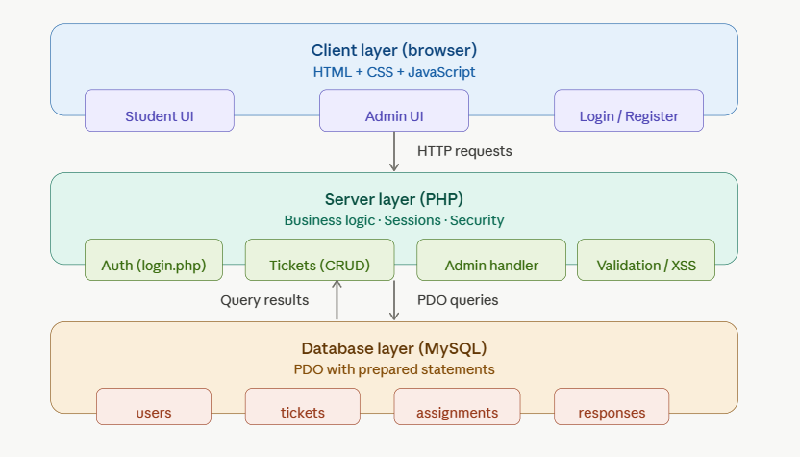

3.2 Database Design — ER Diagram
The database consists of 4 tables that work together to support the full ticketing workflow. Each table has a specific purpose and is linked to others through foreign keys.

Table: users
Stores all system users — both students and admins — in a single table. The role column (ENUM: 'student' or 'admin') determines what each user can see and do. This single column drives the entire role-based access system.
- id — Primary key, auto-incremented
- name — Full name of the user
- email — Unique email address used for login
- password — Hashed password (never stored as plain text)
- role — Either 'student' or 'admin'
- created_at — Timestamp of registration

Table: tickets
Every support request submitted by a student is stored here. The user_id foreign key links each ticket to the student who submitted it. The status column tracks the lifecycle of the ticket from open to resolved.
- id — Primary key
- user_id — Foreign key referencing users(id)
- title — Short summary of the issue
- description — Full detailed description
- category — Type of issue (network, hardware, software, etc.)
- priority — Urgency level (low, medium, high)
- location — Where the issue occurred
- status — Current state (open, progress, resolved)
- created_at — When the ticket was submitted

Table: assignments
When an admin assigns a ticket to a technician, a record is created in this table. It links a ticket to the technician responsible for handling it.
- id — Primary key
- ticket_id — Foreign key referencing tickets(id)
- technician_id — Foreign key referencing users(id)
- assigned_at — When the assignment was made

Table: responses
Every message in the conversation thread of a ticket is stored here. Both students and admins can add responses. The user_id identifies who wrote each message.
- id — Primary key
- ticket_id — Foreign key referencing tickets(id)
- user_id — Foreign key referencing users(id)
- message — The response text
- created_at — When the message was sent

Relationships:
- users → tickets: One user can submit many tickets (one-to-many)
- tickets → responses: One ticket can have many responses (one-to-many)
- tickets → assignments: One ticket can have one assignment (one-to-many)
- users → responses: One user can write many responses (one-to-many)

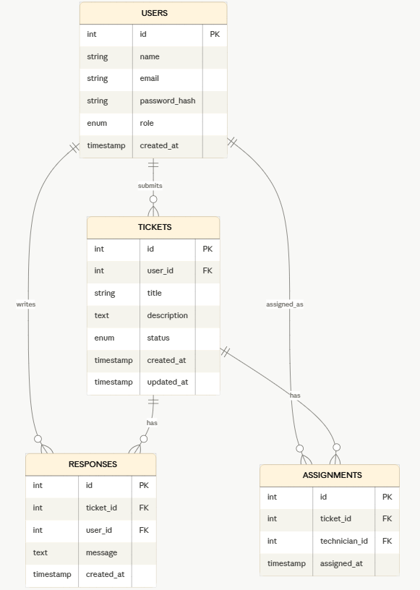

3.3 File / Folder Structure
The project files are organized into a clear structure that separates concerns and enforces role-based access at the folder level.

Project_CS381/
├── app/
│ ├── login.php ← Login and Register page
│ ├── logout.php ← Destroys session and redirects
│ ├── css/
│ │ └── style.css ← Shared styles for all pages
│ ├── includes/
│ │ ├── db.php ← PDO database connection
│ │ ├── auth.php ← Login, register, logout logic
│ │ └── functions.php ← Helper functions (sanitize, CSRF)
│ ├── database/
│ │ └── schema.sql ← Tables + sample data
│ ├── student/ ← Student-only pages
│ │ ├── dashboard.php
│ │ ├── submit_ticket.php
│ │ └── ticket_detail.php
│ └── admin/ ← Admin-only pages
│ ├── dashboard.php
│ └── assign_ticket.php
└── report/
├── phase1/
├── phase2/
├── phase3/
├── phase4/
└── final/

The student/ and admin/ folders are separated so that role-based access is easy to enforce. Every page in admin/ checks at the top that the logged-in user is an admin. Every page in student/ checks that the user is a student. The includes/ folder holds shared PHP files that are reused across all pages.

3.4 Page Flow Diagram
The page flow shows how users navigate through the application depending on their role. The flow is enforced by PHP on the server, not just by the UI.

Entry Point:
All users start at login.php. If a user is already logged in (session exists), they are automatically redirected to their dashboard without needing to log in again.

Student Flow:
After login, the student is redirected to student/dashboard.php. From the dashboard they can either click 'New Ticket' to go to submit_ticket.php, or click 'View' on any ticket to go to ticket_detail.php. Students cannot access any page in the admin/ folder — PHP redirects them away if they try.

Admin Flow:
After login, the admin is redirected to admin/dashboard.php. From the dashboard they can click 'Manage' on any ticket to go to assign_ticket.php. Admins cannot access the student submit_ticket.php page — it is irrelevant to their role.

Logout:
Both roles can click Logout at any time. logout.php calls session_destroy() to clear all session data and redirects to login.php.

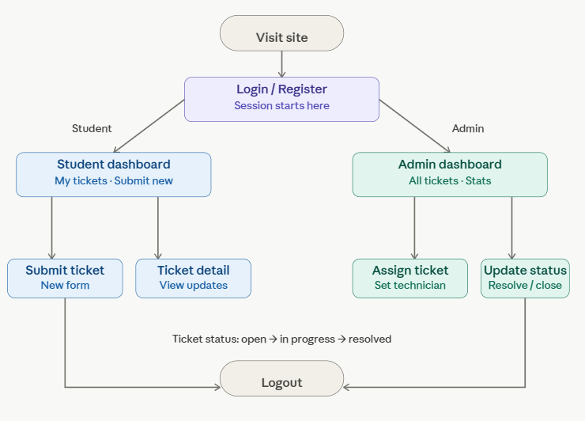

3.5 Wireframes
Hand-drawn wireframes were created for all 6 pages before any code was written. Wireframes serve as a blueprint that shows the layout and structure of each page. They help plan the design before spending time writing code.

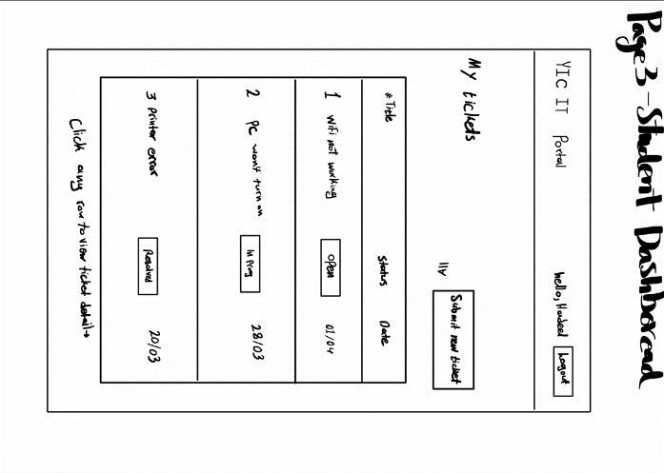
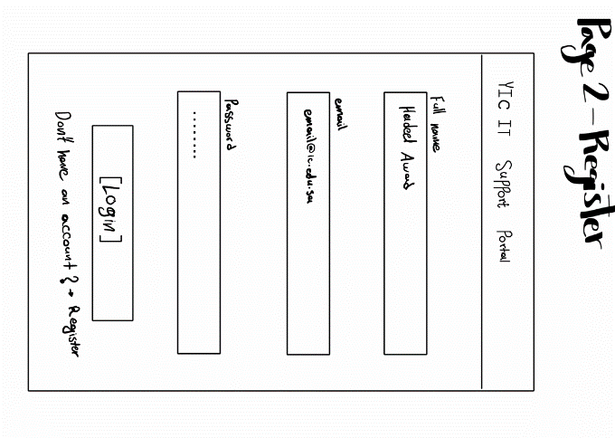
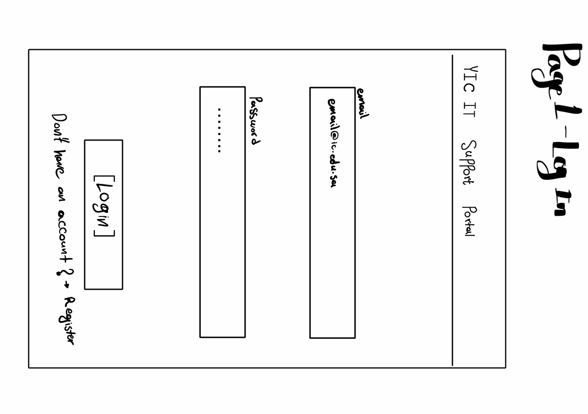
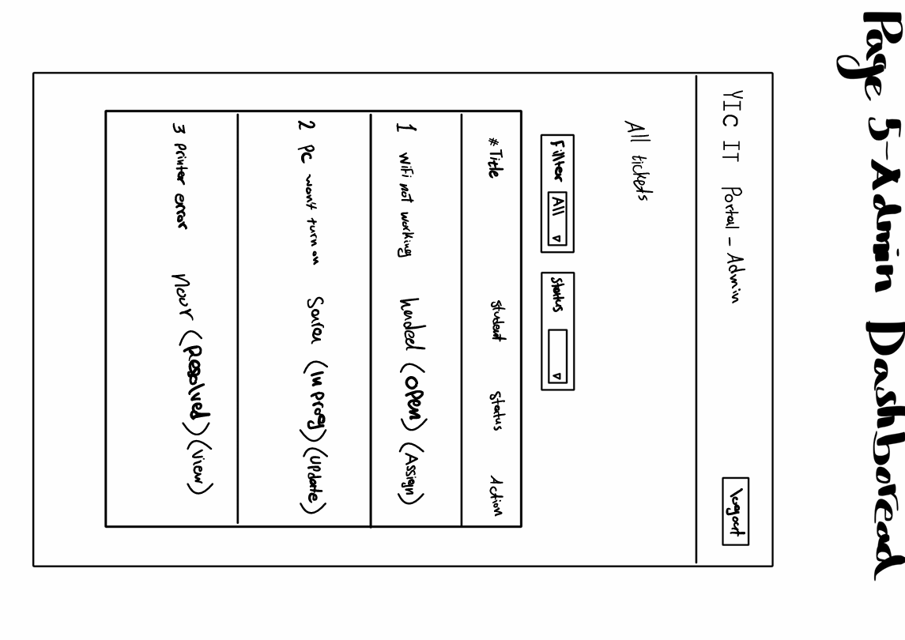
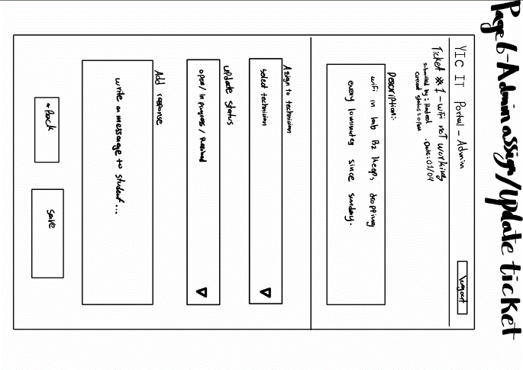
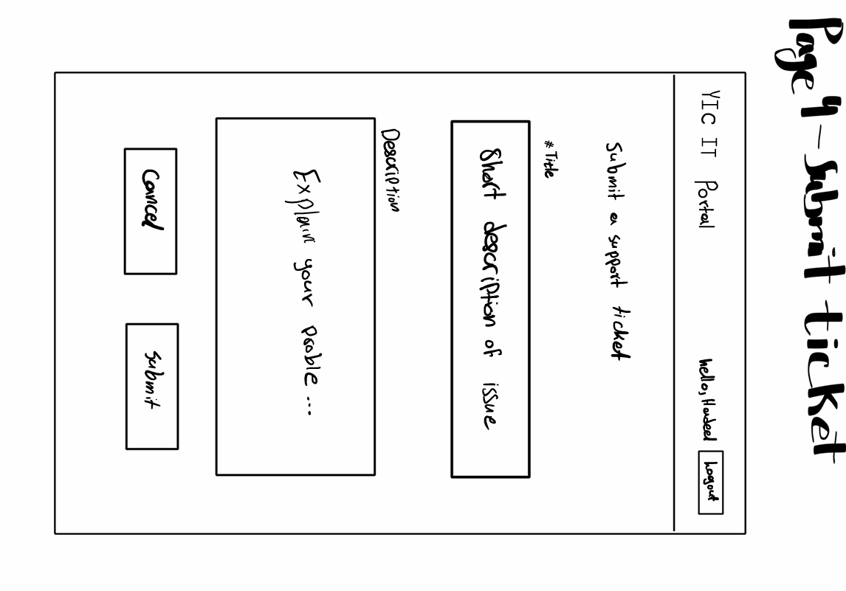

3.6 Feature List
Student Features:
- Register a new account with name, email, and password
- Login with email and password
- Logout that clears the session
- Submit a support ticket with category, title, description, location, and priority
- View all personal tickets with their current status in a table
- View stat cards showing total, open, in progress, and resolved counts
- Open a ticket to see full details and conversation thread
- Reply to admin messages on any open ticket

Admin Features:
- Login to a separate admin dashboard
- View all tickets from all students in one table
- See student name, category, priority, date, and status for each ticket
- Click Manage on any ticket to open the management page
- Assign a ticket to a technician from a dropdown
- Update ticket status (open / in progress / resolved)
- Reply to the student on any ticket

Security Features:
- Password hashing with password_hash() — passwords never stored as plain text
- PDO prepared statements on all queries — prevents SQL injection
- htmlspecialchars() on all output — prevents XSS attacks
- CSRF tokens on all forms — prevents cross-site request forgery
- Role-based access on every page — students cannot access admin pages
- Session management — session_destroy() on logout

3.7 User Stories
User stories describe the purpose of each feature from the perspective of the person who will use it. They follow the format: As a [role], I want to [action], so that [benefit].

# | As a... | I want to... | So that...
1 | Student | Register an account | I can access the portal
2 | Student | Submit a support ticket | I can report an IT problem
3 | Student | View all my tickets | I can track what I reported
4 | Student | See the status of my ticket | I know if it is being handled
5 | Student | Read admin responses on my ticket | I can follow up on my issue
6 | Student | Reply to the admin on my ticket | I can provide more information
7 | Admin | View all submitted tickets | I can prioritize which to handle first
8 | Admin | Assign a ticket to a technician | The right person handles it
9 | Admin | Update the status of a ticket | Students know their issue is in progress
10 | Admin | Reply to the student on a ticket | I can communicate with the student

4. Phase 2 — Frontend Development

4.1 Design Decisions
The application uses a dark theme with a purple and cyan color scheme. This was chosen to make the portal look modern and professional, and to differentiate it from typical university portals that use plain white designs. The design uses a glass-morphism effect on cards, achieved with CSS backdrop-filter and semi-transparent backgrounds.

The login page uses a split layout — a branding panel on the left with feature highlights, and a glass card form on the right. All inner pages use a sidebar navigation layout with the main content on the right. This makes navigation clear and consistent across all pages.

4.2 CSS Architecture
All shared styles are placed in a single external file: css/style.css. This file is linked by all 6 pages using a single line. This approach avoids repeating styles across files and ensures that any change to the design (such as a color or font change) only needs to be made in one place.

<link rel="stylesheet" href="../css/style.css"/>

The CSS file uses CSS custom properties (variables) defined in :root to centralize all colors and values. This makes the design consistent and easy to modify:

:root {
--purple: #8b5cf6;
--cyan: #06b6d4;
--dark-bg: #0d0d1a;
--dark-card: #0f0f1e;
--glass-bg: rgba(255,255,255,0.06);
--white: #ffffff;
--muted: rgba(255,255,255,0.38);
--radius: 12px;
}

Page-specific styles that are only needed on one page (such as the split layout on login.php) are placed in a <style> block inside that page only.

4.3 JavaScript Validation
JavaScript is used to validate all forms on the client side before they are submitted to PHP. This gives the user instant feedback without a page reload. Note that server-side validation also exists in PHP — client-side validation is an extra layer of usability, not a security measure.

Login validation:
function validateLogin() {
const email = document.getElementById('login-email').value.trim();
const pass = document.getElementById('login-pass').value;
if (!email || !pass) {
showMsg('login-msg', 'Please fill in all fields.', 'error');
return false; // stops form submission
}
return true; // allows form to submit to PHP
}

Register validation:
function validateRegister() {
const name = document.getElementById('reg-name').value.trim();
const email = document.getElementById('reg-email').value.trim();
const pass = document.getElementById('reg-pass').value;
const pass2 = document.getElementById('reg-pass2').value;
if (!name || !email || !pass || !pass2) {
showMsg('register-msg', 'Please fill in all fields.', 'error');
return false;
}
if (pass.length < 6) {
showMsg('register-msg', 'Password must be at least 6 characters.', 'error');
return false;
}
if (pass !== pass2) {
showMsg('register-msg', 'Passwords do not match.', 'error');
return false;
}
return true;
}

Tab switching on login page:
function switchTab(tab) {
document.querySelectorAll('.tab-btn').forEach((btn, i) => {
btn.classList.toggle('active',
(tab === 'login' && i === 0) || (tab === 'register' && i === 1));
});
document.getElementById('panel-login')
.classList.toggle('active', tab === 'login');
document.getElementById('panel-register')
.classList.toggle('active', tab === 'register');
}

4.4 Responsive Design
All pages are responsive. A CSS media query hides the sidebar on small screens and adjusts the layout to a single column. The login page hides the left branding panel on mobile, showing only the glass card form.

@media (max-width: 768px) {
.sidebar { display: none; }
.main { padding: 24px 18px; }
.left { display: none; } /* login page */
}

4.5 Screenshots — Desktop

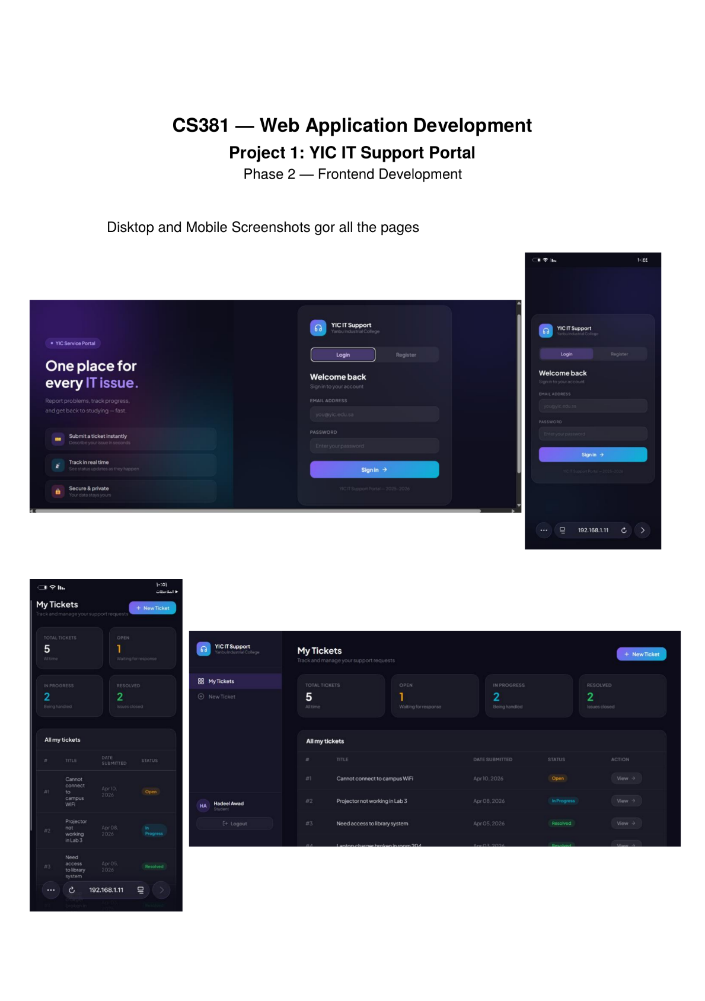
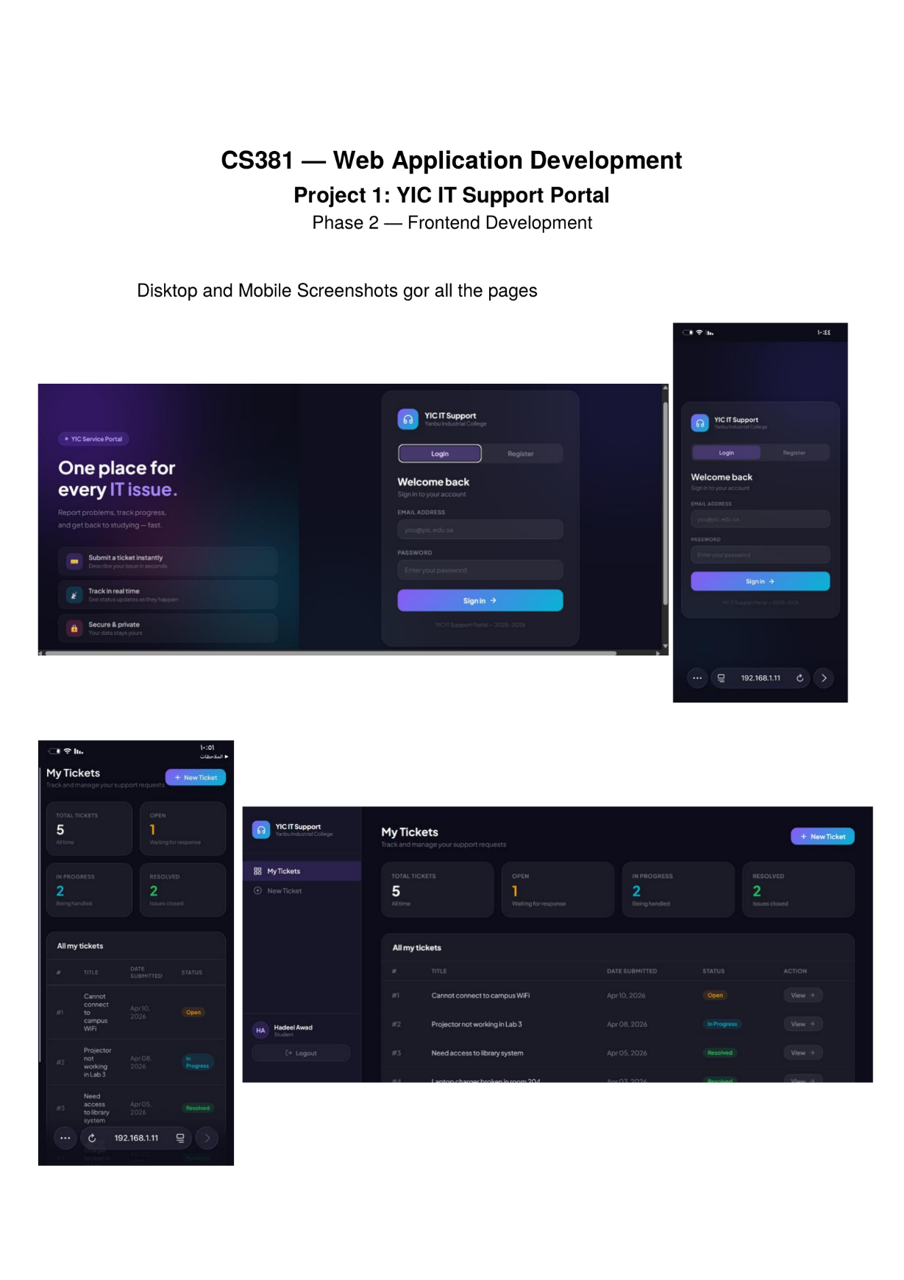

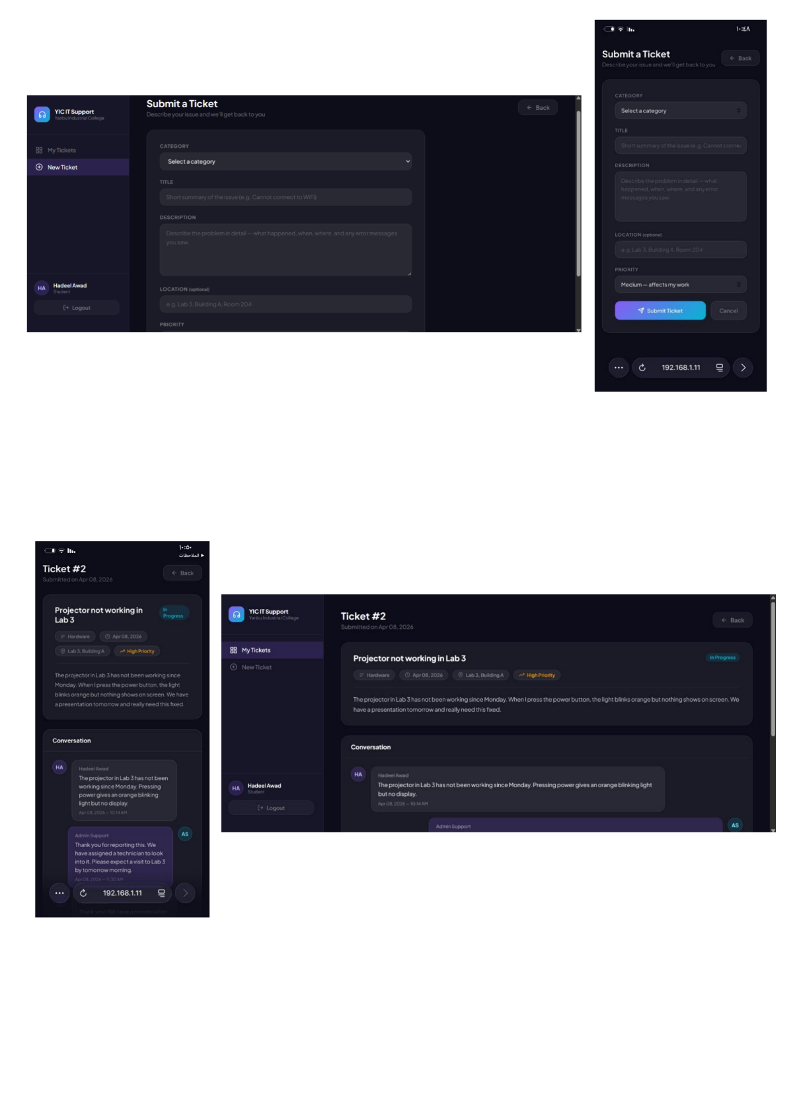
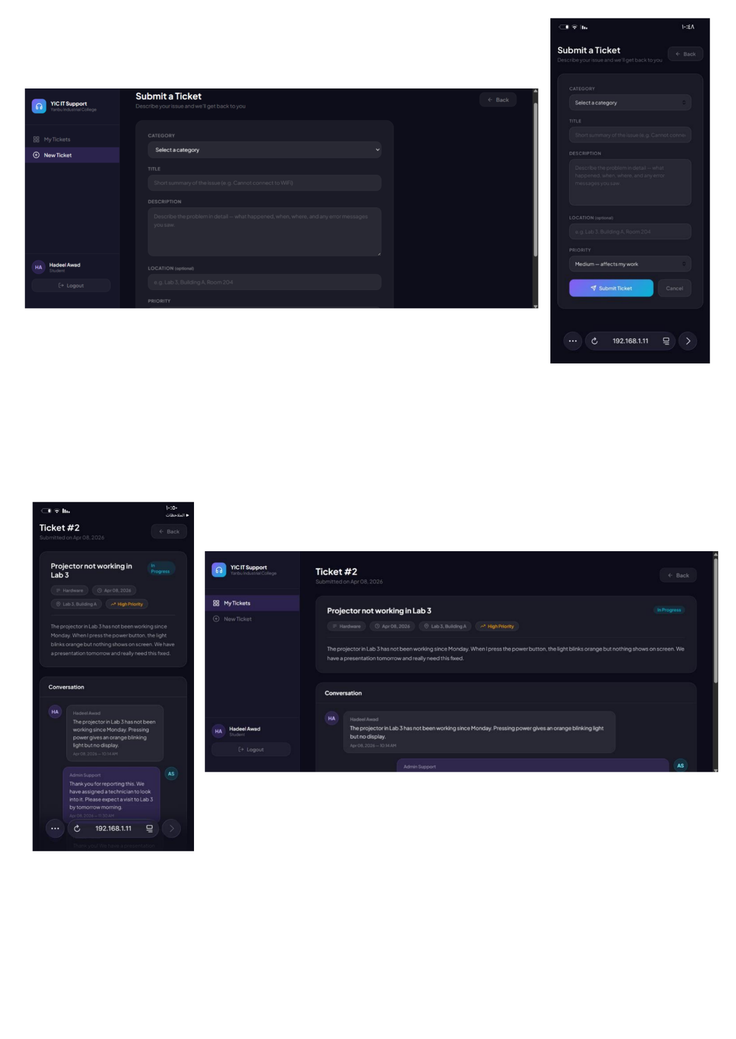

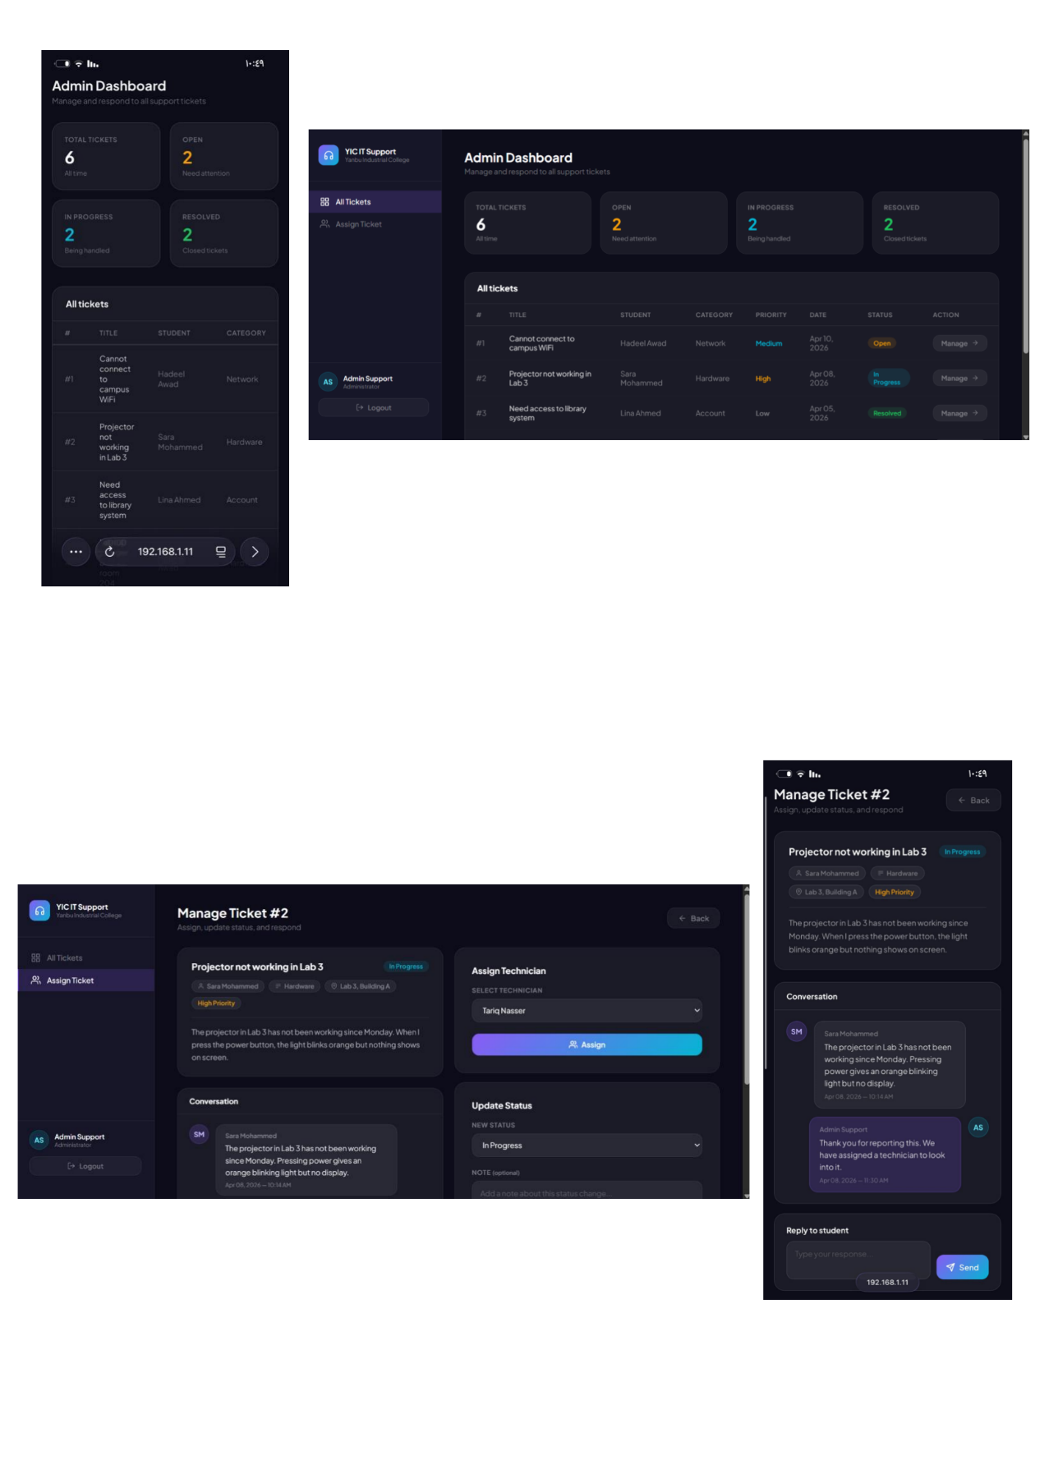
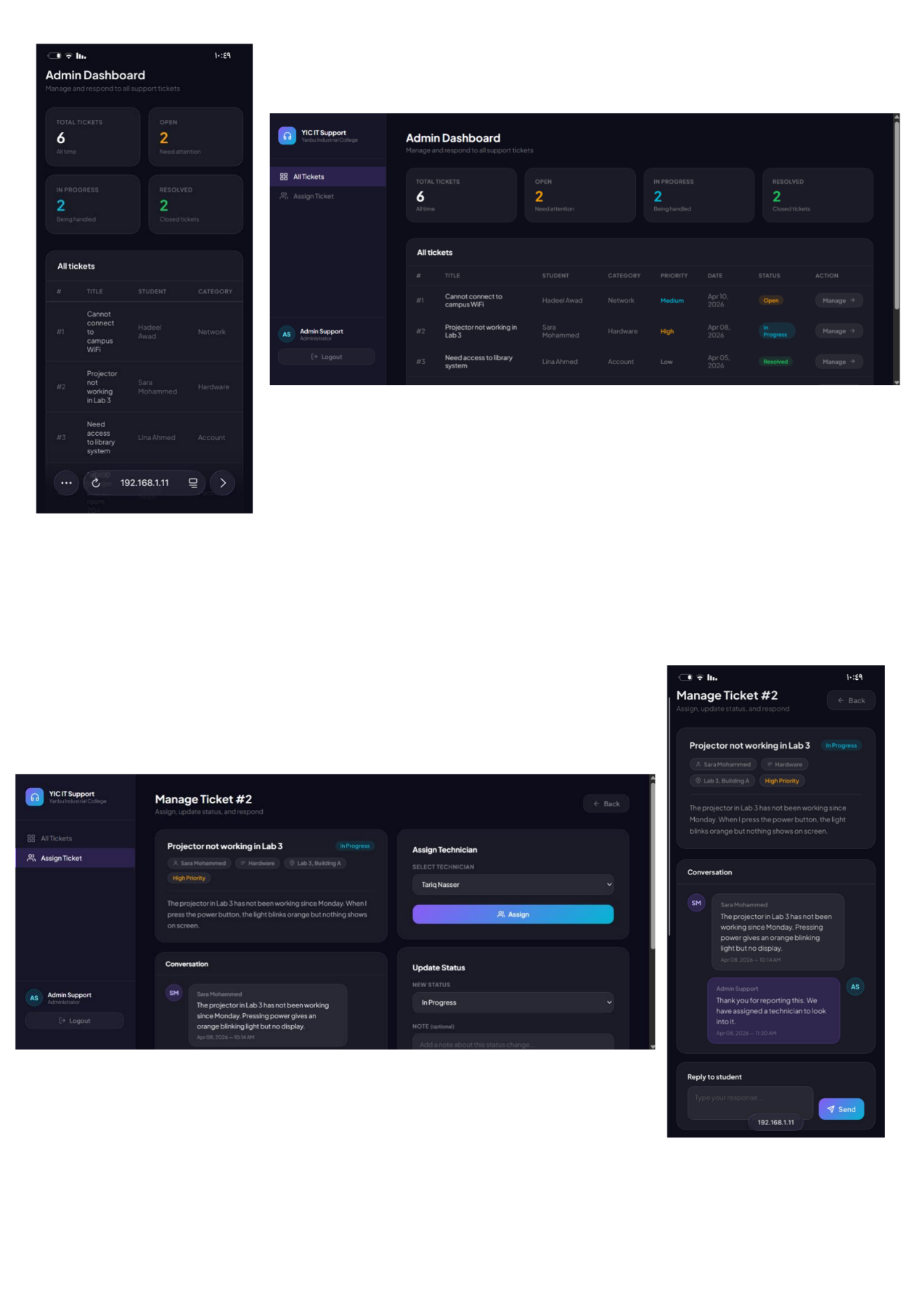

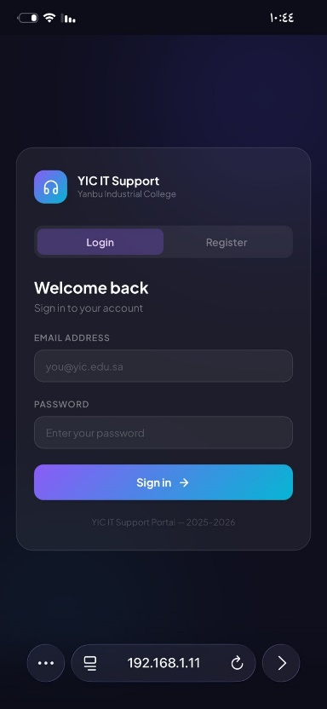
4.6 Screenshots — Mobile
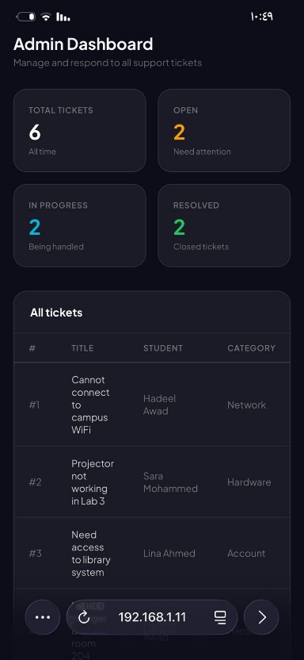
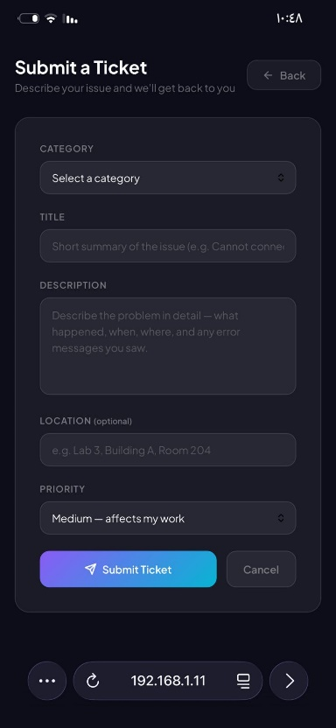
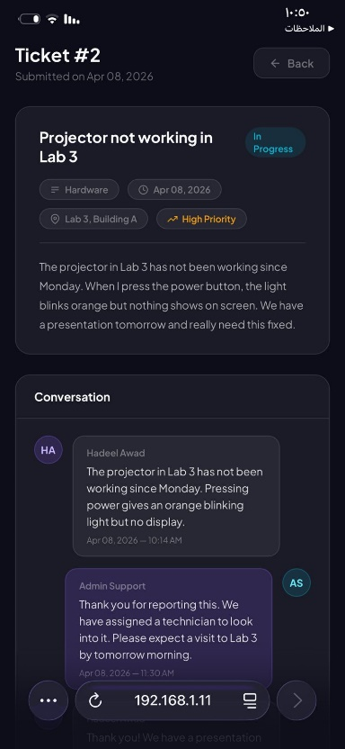
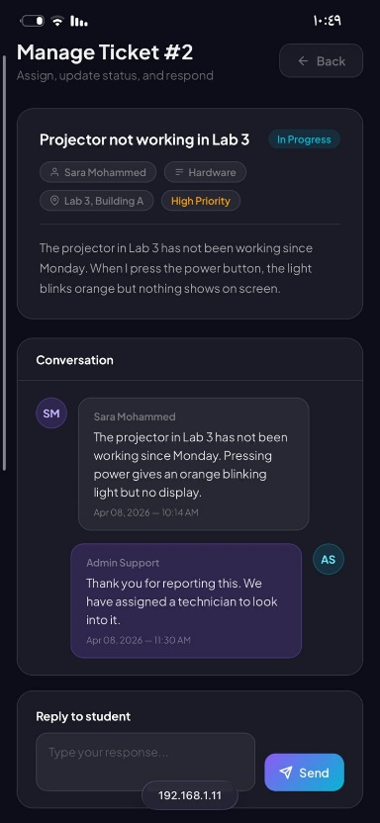
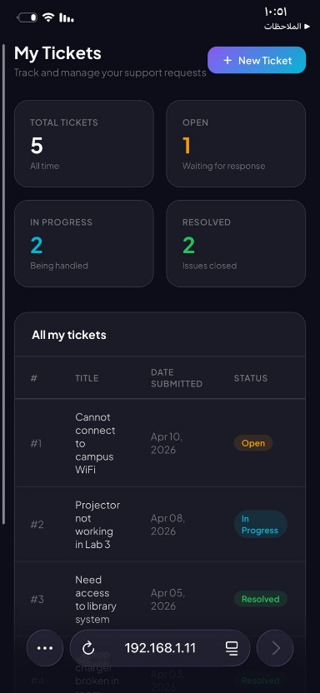

5. Phase 3 — Backend & Database

5.1 Database Schema
The full SQL code to create the database, all tables, and insert sample data:

CREATE DATABASE IF NOT EXISTS yic_support;
USE yic_support;

CREATE TABLE users (
id INT AUTO_INCREMENT PRIMARY KEY,
name VARCHAR(100) NOT NULL,
email VARCHAR(100) NOT NULL UNIQUE,
password VARCHAR(255) NOT NULL,
role ENUM('student','admin') NOT NULL DEFAULT 'student',
created_at TIMESTAMP DEFAULT CURRENT_TIMESTAMP
);

CREATE TABLE tickets (
id INT AUTO_INCREMENT PRIMARY KEY,
user_id INT NOT NULL,
title VARCHAR(200) NOT NULL,
description TEXT NOT NULL,
category VARCHAR(50),
priority ENUM('low','medium','high') DEFAULT 'medium',
location VARCHAR(100),
status ENUM('open','progress','resolved') DEFAULT 'open',
created_at TIMESTAMP DEFAULT CURRENT_TIMESTAMP,
updated_at TIMESTAMP DEFAULT CURRENT_TIMESTAMP ON UPDATE CURRENT_TIMESTAMP,
FOREIGN KEY (user_id) REFERENCES users(id)
);

CREATE TABLE assignments (
id INT AUTO_INCREMENT PRIMARY KEY,
ticket_id INT NOT NULL,
technician_id INT NOT NULL,
assigned_at TIMESTAMP DEFAULT CURRENT_TIMESTAMP,
FOREIGN KEY (ticket_id) REFERENCES tickets(id),
FOREIGN KEY (technician_id) REFERENCES users(id)
);

CREATE TABLE responses (
id INT AUTO_INCREMENT PRIMARY KEY,
ticket_id INT NOT NULL,
user_id INT NOT NULL,
message TEXT NOT NULL,
created_at TIMESTAMP DEFAULT CURRENT_TIMESTAMP,
FOREIGN KEY (ticket_id) REFERENCES tickets(id),
FOREIGN KEY (user_id) REFERENCES users(id)
);

5.2 includes/db.php — Database Connection
This file creates a secure PDO connection to the MySQL database. It is included at the top of every PHP page that needs database access using require '../includes/db.php'. PDO (PHP Data Objects) is used instead of mysqli because it supports prepared statements more cleanly and works with multiple database types.

<?php
$host = 'localhost';
$dbname = 'yic_support';
$username = 'root';
$password = '';

try {
$pdo = new PDO(
"mysql:host=$host;dbname=$dbname;charset=utf8",
$username,
$password
);
$pdo->setAttribute(PDO::ATTR_ERRMODE, PDO::ERRMODE_EXCEPTION);
} catch (PDOException $e) {
die("Connection failed: " . $e->getMessage());
}
?>

5.3 includes/auth.php — Authentication
This file handles all authentication actions. It reads the action value from the POST request and processes login, registration, or logout accordingly.

Login:
if ($action === 'login') {
$email = trim($_POST['email']);
$password = $_POST['password'];
// Fetch user from DB by email
$stmt = $pdo->prepare("SELECT * FROM users WHERE email = ?");
$stmt->execute([$email]);
$user = $stmt->fetch();
// Verify password against stored hash
if ($user && password_verify($password, $user['password'])) {
$_SESSION['user_id'] = $user['id'];
$_SESSION['user_name'] = $user['name'];
$_SESSION['user_role'] = $user['role'];
// Redirect based on role
if ($user['role'] === 'admin') {
header("Location: ../admin/dashboard.php");
} else {
header("Location: ../student/dashboard.php");
}
exit();
} else {
header("Location: ../login.php?error=invalid");
exit();
}
}

Register:
if ($action === 'register') {
$name = trim($_POST['name']);
$email = trim($_POST['email']);
$password = $_POST['password'];
$role = $_POST['role'] ?? 'student';
// Check if email already exists
$stmt = $pdo->prepare("SELECT id FROM users WHERE email = ?");
$stmt->execute([$email]);
if ($stmt->fetch()) {
header("Location: ../login.php?error=exists");
exit();
}
// Hash password before storing
$hashed = password_hash($password, PASSWORD_DEFAULT);
$stmt = $pdo->prepare(
"INSERT INTO users (name, email, password, role) VALUES (?, ?, ?, ?)");
$stmt->execute([$name, $email, $hashed, $role]);
// Auto-login after registration
$_SESSION['user_id'] = $pdo->lastInsertId();
$_SESSION['user_name'] = $name;
$_SESSION['user_role'] = $role;
header("Location: ../student/dashboard.php");
exit();
}

Logout:
if ($action === 'logout') {
session_destroy();
header("Location: ../login.php");
exit();
}

5.4 includes/functions.php — Helper Functions
This file contains reusable helper functions used across all pages. Any page that needs these functions includes this file at the top.

// Clean user input to prevent XSS
function sanitize($input) {
return htmlspecialchars(trim($input), ENT_QUOTES, 'UTF-8');
}

// Redirect to login if not authenticated
function requireLogin() {
if (!isset($_SESSION['user_id'])) {
header("Location: ../login.php");
exit();
}
}

// Redirect away if not admin
function requireAdmin() {
requireLogin();
if ($_SESSION['user_role'] !== 'admin') {
header("Location: ../student/dashboard.php");
exit();
}
}

// Generate CSRF token
function generateCSRF() {
if (!isset($_SESSION['csrf_token'])) {
$_SESSION['csrf_token'] = bin2hex(random_bytes(32));
}
return $_SESSION['csrf_token'];
}

// Verify CSRF token
function verifyCSRF() {
if (!isset($_POST['csrf_token']) ||
$_POST['csrf_token'] !== $_SESSION['csrf_token']) {
die('Invalid request.');
}
}

5.5 Student Pages — PHP Logic
student/dashboard.php:
Fetches all tickets belonging to the logged-in student and calculates status counts for the stat cards.

session_start();
require '../includes/db.php';
require '../includes/functions.php';
// Redirect if not logged in
if (!isset($_SESSION['user_id'])) {
header("Location: ../login.php"); exit();
}
// Redirect admin away from student page
if ($_SESSION['user_role'] === 'admin') {
header("Location: ../admin/dashboard.php"); exit();
}
// Get student name and initials from session
$student_name = $_SESSION['user_name'];
$student_initials = strtoupper(
substr($student_name, 0, 1) .
substr(strrchr($student_name, ' '), 1, 1)
);
// Fetch only this student's tickets
$stmt = $pdo->prepare(
"SELECT * FROM tickets WHERE user_id = ? ORDER BY created_at DESC");
$stmt->execute([$_SESSION['user_id']]);
$tickets = $stmt->fetchAll();
// Count by status for stat cards
$total = count($tickets);
$open = count(array_filter($tickets, fn($t) => $t['status'] === 'open'));
$progress = count(array_filter($tickets, fn($t) => $t['status'] === 'progress'));
$resolved = count(array_filter($tickets, fn($t) => $t['status'] === 'resolved'));

student/submit_ticket.php:
Handles the new ticket form. When submitted via POST, it saves the ticket to the database and redirects to the dashboard.

if ($_SERVER['REQUEST_METHOD'] === 'POST') {
verifyCSRF();
$title = trim($_POST['title']);
$description = trim($_POST['description']);
$category = $_POST['category'];
$priority = $_POST['priority'];
$location = trim($_POST['location'] ?? '');
$stmt = $pdo->prepare("INSERT INTO tickets
(user_id, title, description, category, priority, location)
VALUES (?, ?, ?, ?, ?, ?)");
$stmt->execute([
$_SESSION['user_id'], $title, $description,
$category, $priority, $location
]);
header("Location: dashboard.php");
exit();
}

student/ticket_detail.php:
Fetches a single ticket with its full conversation thread. Also handles the student reply form.

$ticket_id = $_GET['id'] ?? 0;
// Only fetch if ticket belongs to this student
$stmt = $pdo->prepare(
"SELECT * FROM tickets WHERE id = ? AND user_id = ?");
$stmt->execute([$ticket_id, $_SESSION['user_id']]);
$ticket = $stmt->fetch();
if (!$ticket) { header("Location: dashboard.php"); exit(); }

// Fetch responses with sender name and role
$stmt = $pdo->prepare("
SELECT responses.*, users.name as sender_name,
users.role as sender_role
FROM responses
JOIN users ON responses.user_id = users.id
WHERE responses.ticket_id = ?
ORDER BY responses.created_at ASC");
$stmt->execute([$ticket_id]);
$responses = $stmt->fetchAll();

// Handle student reply
if ($_SERVER['REQUEST_METHOD'] === 'POST') {
verifyCSRF();
$message = trim($_POST['message']);
if ($message) {
$stmt = $pdo->prepare("INSERT INTO responses
(ticket_id, user_id, message) VALUES (?, ?, ?)");
$stmt->execute([$ticket_id, $_SESSION['user_id'], $message]);
header("Location: ticket_detail.php?id=$ticket_id");
exit();
}
}

5.6 Admin Pages — PHP Logic
admin/dashboard.php:
Fetches all tickets from all students using a JOIN query to include the student's name.

// Block non-admins
if ($_SESSION['user_role'] !== 'admin') {
header("Location: ../student/dashboard.php"); exit();
}
// Fetch all tickets with student name
$stmt = $pdo->query("
SELECT tickets.*, users.name as student_name
FROM tickets
JOIN users ON tickets.user_id = users.id
ORDER BY tickets.created_at DESC");
$tickets = $stmt->fetchAll();
$total = count($tickets);
$open = count(array_filter($tickets, fn($t) => $t['status'] === 'open'));
$progress = count(array_filter($tickets, fn($t) => $t['status'] === 'progress'));
$resolved = count(array_filter($tickets, fn($t) => $t['status'] === 'resolved'));

admin/assign_ticket.php:
Handles 3 actions: assigning a technician, updating ticket status, and replying to the student.

// Assign technician
if (isset($_POST['action']) && $_POST['action'] === 'assign') {
verifyCSRF();
$stmt = $pdo->prepare("INSERT INTO assignments
(ticket_id, technician_id) VALUES (?, ?)");
$stmt->execute([$ticket_id, $_POST['technician_id']]);
header("Location: assign_ticket.php?id=$ticket_id"); exit();
}

// Update status
if (isset($_POST['action']) && $_POST['action'] === 'update_status') {
verifyCSRF();
$stmt = $pdo->prepare(
"UPDATE tickets SET status = ? WHERE id = ?");
$stmt->execute([$_POST['status'], $ticket_id]);
header("Location: assign_ticket.php?id=$ticket_id"); exit();
}

// Admin reply
if (isset($_POST['action']) && $_POST['action'] === 'reply') {
verifyCSRF();
$message = trim($_POST['message']);
if ($message) {
$stmt = $pdo->prepare("INSERT INTO responses
(ticket_id, user_id, message) VALUES (?, ?, ?)");
$stmt->execute([$ticket_id, $_SESSION['user_id'], $message]);
header("Location: assign_ticket.php?id=$ticket_id"); exit();
}
}

5.7 CRUD Operations Summary
Operation | SQL | Page | Description
Create | INSERT | submit_ticket.php | Save new ticket to DB
Create | INSERT | ticket_detail.php | Save student reply
Create | INSERT | assign_ticket.php | Save admin reply + assignment
Read | SELECT | dashboard.php | Fetch tickets for user
Read | SELECT + JOIN | ticket_detail.php | Fetch ticket + responses
Read | SELECT + JOIN | admin/dashboard.php | Fetch all tickets + student names
Update | UPDATE | assign_ticket.php | Change ticket status

6. Phase 4 — Security & Final Integration

6.1 CSRF Protection
Cross-Site Request Forgery (CSRF) is an attack where a malicious website tricks a logged-in user into unknowingly submitting a form on another site. To prevent this, every form in the application includes a hidden CSRF token. The server generates this token once per session and verifies it on every POST request. If the token is missing or wrong, the request is rejected.

Token generation (functions.php):
function generateCSRF() {
if (!isset($_SESSION['csrf_token'])) {
$_SESSION['csrf_token'] = bin2hex(random_bytes(32));
}
return $_SESSION['csrf_token'];
}

Token verification (functions.php):
function verifyCSRF() {
if (!isset($_POST['csrf_token']) ||
$_POST['csrf_token'] !== $_SESSION['csrf_token']) {
die('Invalid request.');
}
}

Added to every form as a hidden field:
<input type="hidden" name="csrf_token"
value="<?php echo generateCSRF(); ?>"/>

6.2 Password Hashing
Passwords are never stored as plain text in the database. PHP's password_hash() function uses the bcrypt algorithm to create a one-way hash. Even if the database is compromised, the attacker cannot recover the original passwords. The password_verify() function is used during login to compare the entered password against the stored hash.

// When registering — hash before storing:
$hashed = password_hash($password, PASSWORD_DEFAULT);
$stmt->execute([$name, $email, $hashed, $role]);

// When logging in — verify against hash:
if ($user && password_verify($password, $user['password'])) {
// Login successful
}

6.3 SQL Injection Prevention
SQL injection is an attack where a user inserts malicious SQL code into a form field to manipulate the database. All database queries in this application use PDO prepared statements with parameter binding. The user input is never directly embedded in the SQL string — it is passed as a separate parameter that PDO handles safely.

// SAFE — prepared statement with binding:
$stmt = $pdo->prepare("SELECT * FROM users WHERE email = ?");
$stmt->execute([$email]);

// UNSAFE — direct string insertion (never done):
// $pdo->query("SELECT * FROM users WHERE email = '$email'");

6.4 XSS Prevention
Cross-Site Scripting (XSS) is an attack where a user injects malicious JavaScript into a page that is then executed in other users' browsers. All user-generated content displayed on the page is passed through htmlspecialchars() before being output. This converts dangerous characters like < > & into safe HTML entities.

// SAFE — sanitized before display:
echo htmlspecialchars($ticket['title']);
echo htmlspecialchars($r['message']);

// The sanitize() helper applies this consistently:
function sanitize($input) {
return htmlspecialchars(trim($input), ENT_QUOTES, 'UTF-8');
}

6.5 Role-Based Access Control
Every page checks the user's role from the session before showing any content. This check happens at the very top of each PHP file, before any HTML is output. Students cannot access admin pages, and admins cannot access student pages. Even if a user knows the URL of a restricted page, PHP will redirect them away.

// On student pages — block admins:
if ($_SESSION['user_role'] === 'admin') {
header("Location: ../admin/dashboard.php");
exit();
}

// On admin pages — block students:
if ($_SESSION['user_role'] !== 'admin') {
header("Location: ../student/dashboard.php");
exit();
}

6.6 Session Management
PHP sessions are used to maintain login state between page loads. After successful login, the user's ID, name, and role are stored in the session on the server. The browser only holds a session cookie with a random ID. On logout, session_destroy() removes all session data from the server.

// On login — store user data:
$_SESSION['user_id'] = $user['id'];
$_SESSION['user_name'] = $user['name'];
$_SESSION['user_role'] = $user['role'];

// On logout — destroy everything:
session_destroy();
header("Location: ../login.php");

6.7 Security Summary Table
Threat | Attack Type | Protection Used | Where Applied
CSRF | Forged form submission | CSRF tokens | All form pages
Password theft | Database breach | password_hash() bcrypt | auth.php
SQL Injection | Malicious SQL input | PDO prepared statements | All DB queries
XSS | Script injection | htmlspecialchars() | All output
Unauthorized access | Role bypass | Session role check | Every page
Session hijacking | Stolen session | session_destroy() on logout | logout.php

7. Updated ER Diagram
The final ER diagram after all phases of development. The database design remained consistent throughout the project with no structural changes needed.

8. AI Disclosure
Artificial intelligence tools were used to assist in the development of this project in the following ways:
- Claude (Anthropic) was used to help plan the project structure, generate HTML/CSS/PHP code, and explain concepts related to PDO, sessions, CSRF, and security
- All generated code was reviewed, understood, and adapted by the student before being used in the project
- AI tools were used as a learning and productivity aid, similar to using documentation or tutorials
- The report content, design decisions, and project understanding are the student's own work

9. Challenges
- planning and time management across all 4 phases
- Connecting the PHP backend to the existing HTML frontend required careful handling of form actions, method attributes, and session variables
- Password verification failed initially because the sample data hashes were not compatible with password_verify() — resolved by regenerating hashes using PHP directly
- CSRF token implementation required a clear understanding of PHP sessions and the difference between session data and POST data
- Debugging PDO queries required adding error display temporarily to identify connection and query issues

10. Future Improvements
- Add email notifications to students when their ticket status changes
- Add a search and filter function to the dashboards (filter by status, category, priority)
- Add file attachment support so students can upload screenshots with their tickets
- Add a ticket rating or feedback system after a ticket is resolved
- Implement real-time notifications using JavaScript (polling or WebSockets)
- Add a dedicated technician role separate from admin
- Add an analytics dashboard for admins showing ticket trends over time

11. Conclusion
The YIC IT Support Portal has been successfully developed across 4 phases, resulting in a complete, functional, and secure web application. The portal provides a real solution to a real problem at Yanbu Industrial College — the lack of a centralized IT support request system.

The application was built entirely from scratch using HTML5, CSS3, JavaScript, PHP, and MySQL without any external frameworks. This demonstrates a thorough understanding of core web development concepts including client-server architecture, database design, user authentication, session management, CRUD operations, and web security.

All four phases were completed successfully:
- Phase 1 — Complete planning with architecture diagrams, ER diagram, wireframes, and user stories
- Phase 2 — A fully responsive frontend with a modern dark glass design
- Phase 3 — A complete PHP backend with MySQL database, authentication, and CRUD operations
- Phase 4 — Full security implementation including CSRF, password hashing, SQL injection prevention, XSS prevention, and role-based access

The project was completed as a solo student, demonstrating the ability to plan, design, implement, and secure a full-stack web application independently.

