WRO Competition

For our car, we used 1 TT DC gear motor and a Servo, They are driven by the TB6612 chip. The driver chip is not directly connected to the Raspberry Pi pins. The Raspberry Pi communicates with L298 motor driver to control the DC motor, which allows the motor to move forward or backward.

To avoid the obstacles, one of the methods is the ultrasonic, we use 3 on the three sides, Echo and Trig pins are connected to the 18 and 16 pin of the Raspberry Pi board.

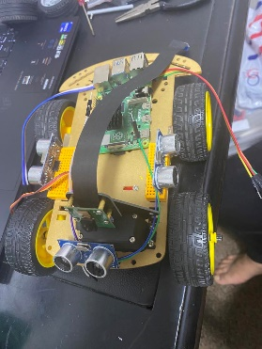As well as we use The Raspberry Pi Camera so it detects the green and the red cubes with a great strategy we'll talk about later.

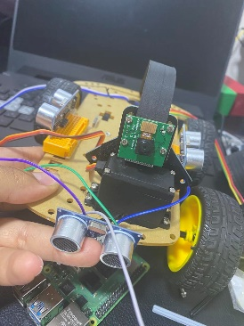

In order to count the rounds and stop when it's time, we use TCS3200 Color Sensor, by relying on the colored lines on the mat, it reads and counts them so we can use this output to stop the car later after counting 12 times.

