

The strategy for avoiding obstacles and cubes, which will be the first stage: avoiding the obstacles in the axis of the track without the cubes. Only the robot will avoid the obstacles that are in black by sensing the ultrasonic waves that bounce back to them. The second stage will be avoiding obstacles, in addition to the presence of two cubes in red and green.

Color sensor tcs3200 :

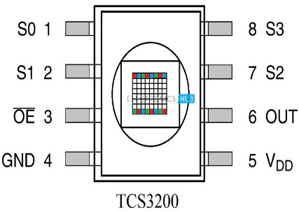 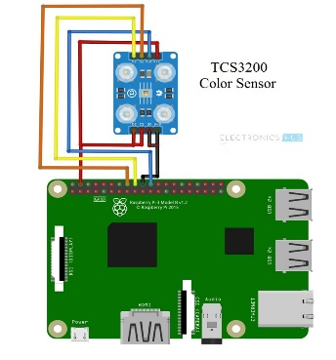

We used one TCs3200 color sensor:

Color sensor pins :

OE: It is the Output Enable Pins. It is an active LOW pin.

GND: Power Supply Ground Pin

VDD: Power Supply Pin (usually, +5V)

OUT: Output Pin

S2 and S3: S2 and S3 are the Photo Diode Selection pins

It was connected to the RPi and we used avoltage of 5 volts .

The first stage :

:

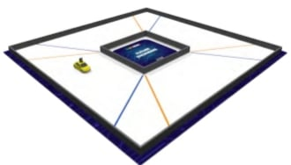

In the first stage, which is avoiding obstacles without the cubes, we used 3 ultrasonic sensors, two of them on the sides and one in the front

We used the TCS3200 color sensor to count the colored lines on the map and read them to stop when the reading reaches 12 times

The second phase :

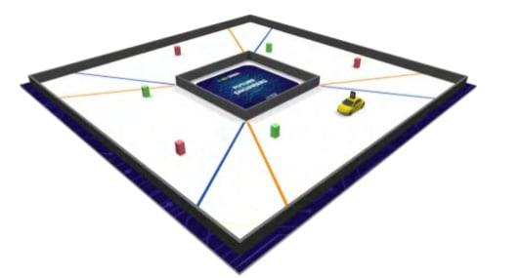

In the second stage, which is avoiding obstacles, in addition to the presence of cubes entering the track arena, which will be in red and green colors, and we used a Raspberry Pi camera to detect the presence of cubes on the track.

Camera RPi :

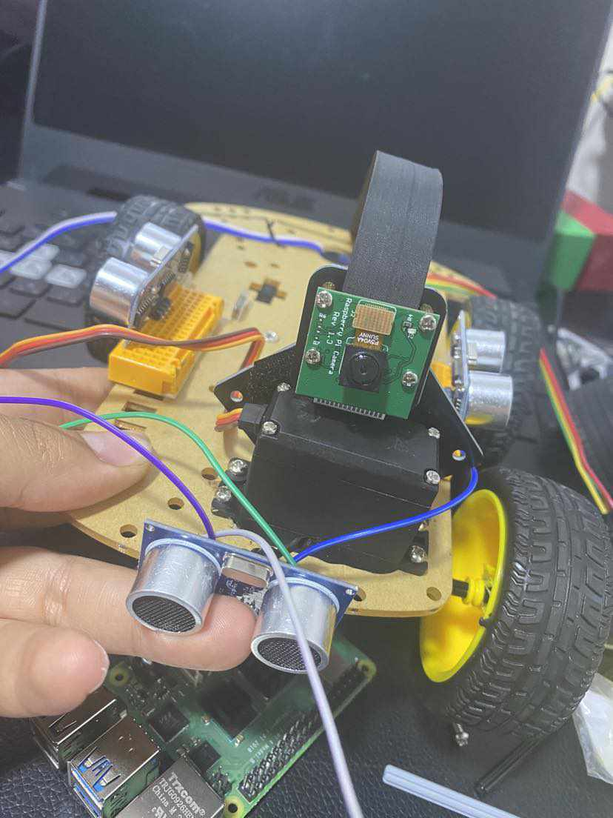

We used one Raspberry Pi camera to see the red and green cubes and differentiate between them….. and connected it to it and a 5-volt brother from Burbank .

Ultrasonic sensor:

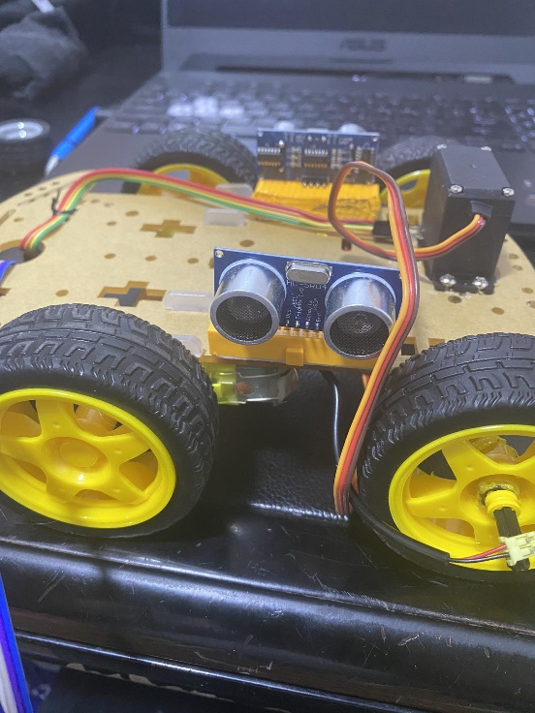 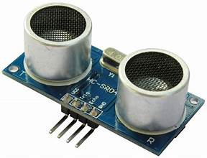

We used an ultrasonic sensor of the type HC-SR04 and connected it to the Raspberry Pi using the bread board .

We connected the sensors to the GPIO pins.

The controller used:

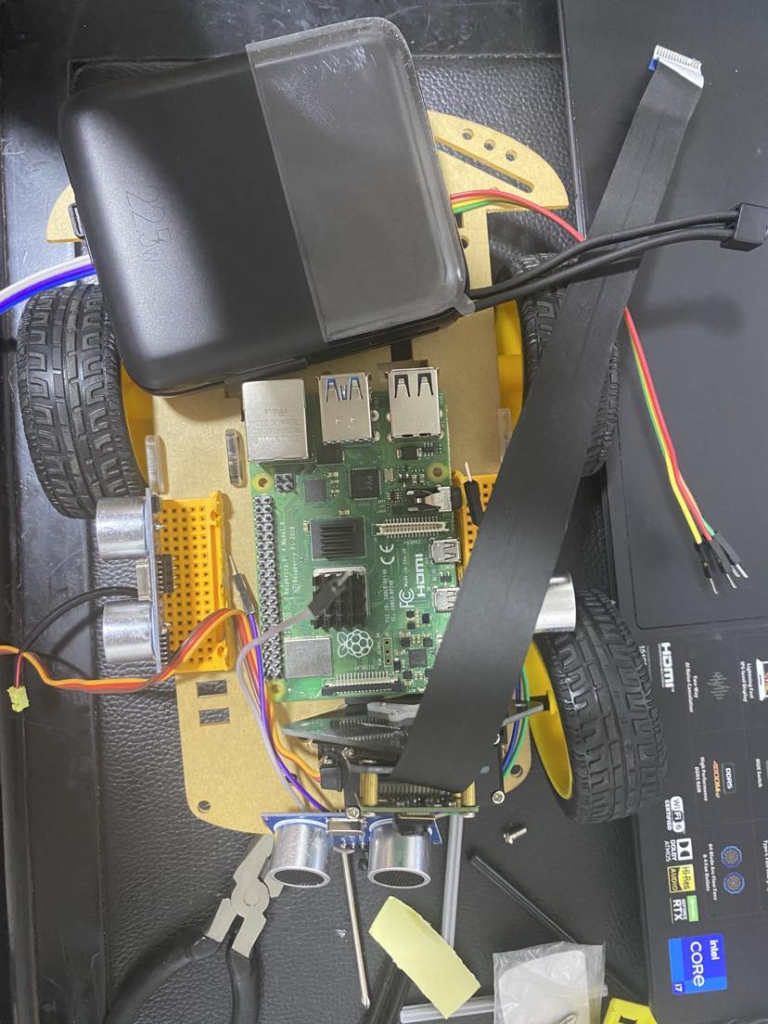

We used a Raspberry Pi controller and connected it to the power bank and took a voltage of 5 volts from it.

The motor used:

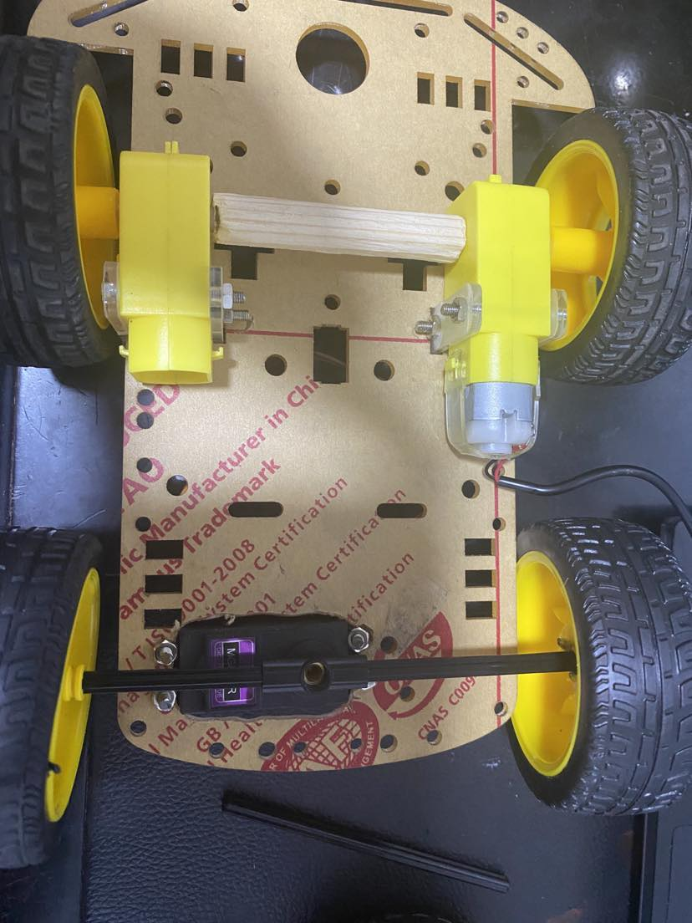

We used one DC motor.

Baseus opow power Bank:



It has a small design, weighing 190 grams, and its battery capacity is very high and it charges quickly .

. The exterior is made of a composite material of ABS and PC and its wire is hidden inside the battery and is made of durable plastic .

It has 4 charging ports, which helps charge 4 different devices at the same time

1-usb (2)

2- c ( port )

3-c (wire)

4-lightning (wire)

It has an LED indicator that shows the percentage of remaining battery, and there is a smart charging chip and a temperature reducer when charging, which extends the life of the battey and maintains the safety of the user

The current value is high, equivalent to 3 A, and it contains a 2-in-1 charging cable

It has a large capacity equivalent to 10,000 mAh, and it has a digital display screen to show t

the remaining charge percentage