1. 🡪This is a java program that can be used to detect changes between the lines of databases (databases can be two schema files you do not need to connect to databases).
2. 🡪 You can run this program in your PC to test it I submitted two sample database files (database.sql and database1.sql) which contains a demo database that I used while creating and testing this program.
3. 🡪The username of this program is 'hadees' and password is 'abc1' however you can reset the password by clicking yes on reset password option.

**Program Output**

Login page and Dashboard:

First user will see the Login page and when the correct login details will be provided then it will allow access to the Dashboard on which user can see three options notification panel, history and logout as shown in the picture below.

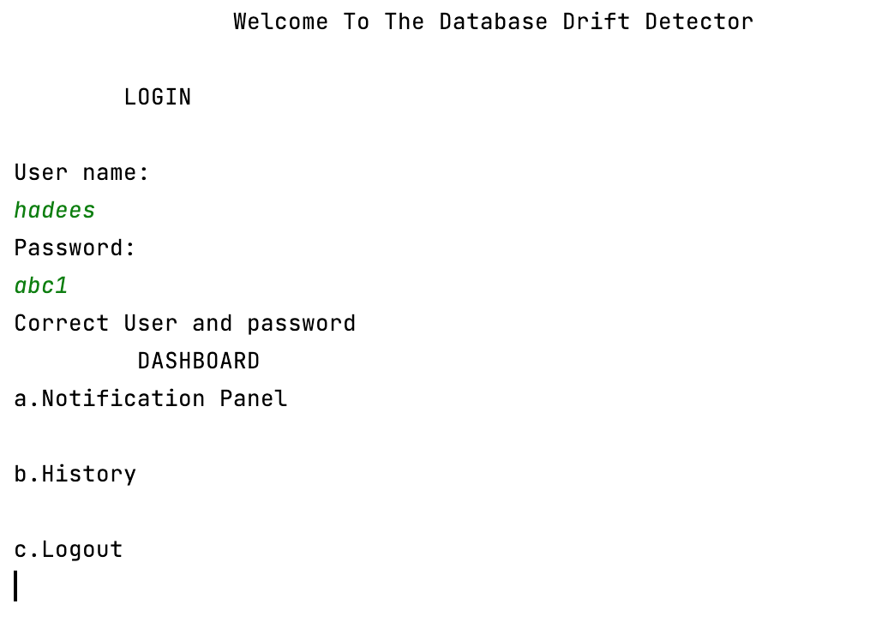

Notification panel:

When the user will access the notification panel It will see the notification and details of the line on which the drift has been detected or if there is no drift detected it will simply say no drift is detected as shown in the picture below.



History Log:

In history log of program the user can see the past drifts that have been detected in the database before as shown in the picture below.

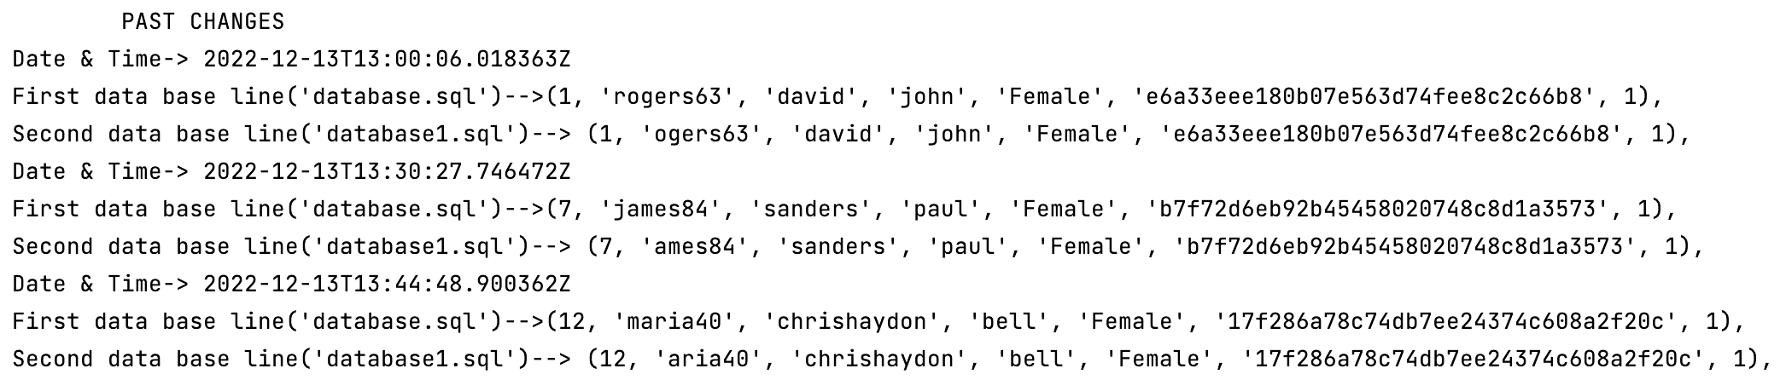

**References:**

Titus(2016), searching string from text file ,stack overflow ,Available at: <https://stackoverflow.com/questions/36519015/searching-string-from-text-filecase-insensitive> (Accessed: December 01,2022).

Ireeder(2013) ,how to write new line character to a file in java ,Stack overflow, Available at: <https://stackoverflow.com/questions/19084352/how-to-write-new-line-character-to-a-file-in-java> (Accessed: December 01, 2022)

hmjd(2012), Write file without deleting current data[duplicate] ,stack overflow, Available at:

<https://stackoverflow.com/questions/13938886/write-file-without-deleting-current-data> (Accessed: December 01, 2022).

ADMIN(2020),different ways to remove spaces from java string, Stacktaceguru, Available at: <https://stacktraceguru.com/java/remove_spaces_from_string#java_replace_method> (Accessed: December 01, 2022).

Mrinal(2015),How to get and set specified time in java, stackoverflow ,Aavailable at: <https://stackoverflow.com/questions/31786450/how-to-get-and-set-specified-time-in-java-time-instant> (Accessed: December 01, 2022).