 | <worksheet> <filename> “CP4807-6.doc” </filename>  Worksheet 6  Macros / subroutines |  | Introduction to  microcontrollers
 | In designing microcontroller systems we use code that is very repetitive and we can simplify the development by using software macros or subroutines. Pre-written libraries of code for hardware modules also save us a lot of time, and help us create more functional systems.  In this worksheet you explore the use of hardware and software macros. |  | 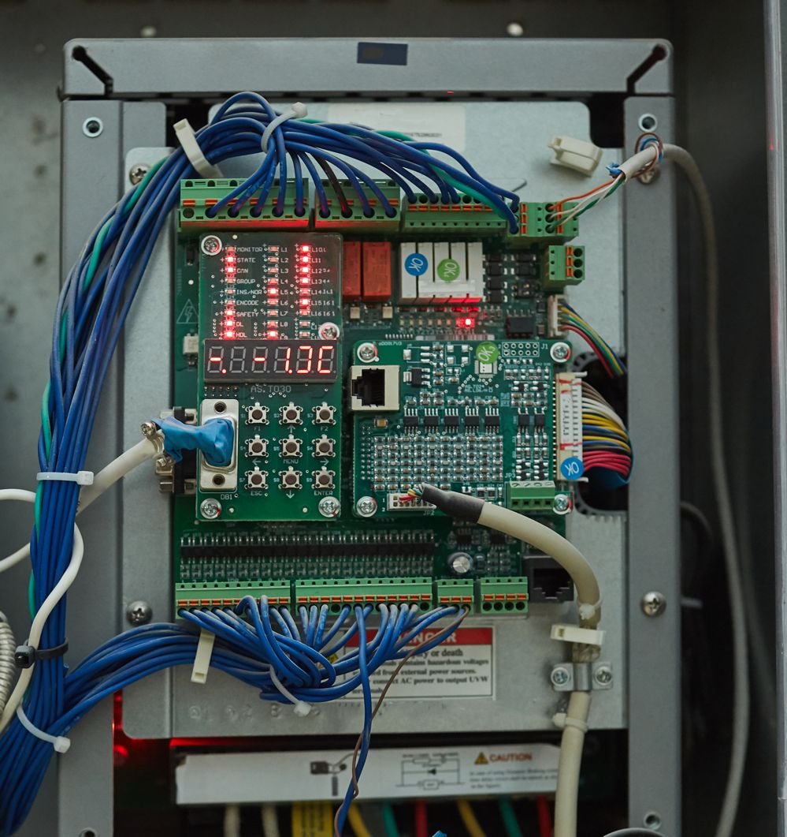

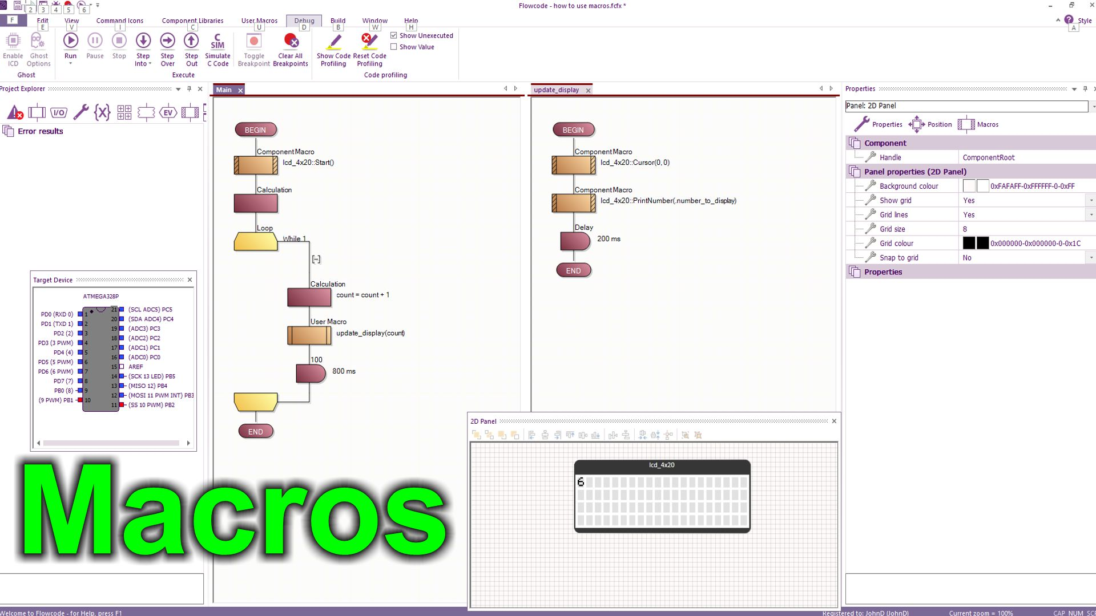
https://youtu.be/hNBSxdb72v4
Over to you:
Watch the video “Macros” on the Flowcode YouTube site.
Load the file “how to use macros". Set up the hardware appropriately, download it, and make sure you understand it.
Challenges:
Alter the program so that it Prints “Count is: “ then the count number
Alter the program so that it prints the number on the second line of the display rather than the first
Assign the text “Count is: “ to a variable and use the string variable in your program.
Add a second software macro to the program called “Initialise”.
Move the Start command to this macro and then call it from the Main routine.
Hints:
- Use the hardware macro PrintString to print a string (you need to use inverted commas in the dialogue box)
- Add a new variable “mystring” of Type String and length 20. Use PrintString to print this.
- Use the Cursor hardware macro to alter the print position.
Challenges:
Develop a program that uses the 7-segment displays on the Combo board to display the value of Count.
Create a document that tells someone new to your project how it works.
Hints:
- Use a BL0114 Combo board component from the Hardware group and the Seg_Showdigit macro
- Use three variables: Units, Tens Hundreds.
- Use some maths to convert Count into Units, Tens and Hundreds - Investigate the MOD mathematical function – see the Wiki for details.
- Use the FILE….EXPORT…as HTML option to create a HTML document of your project. There is a lot of information here. Identify the parts you want and use copy and paste to assemble a report on what you have done.

