

Introduction to microcontrollers

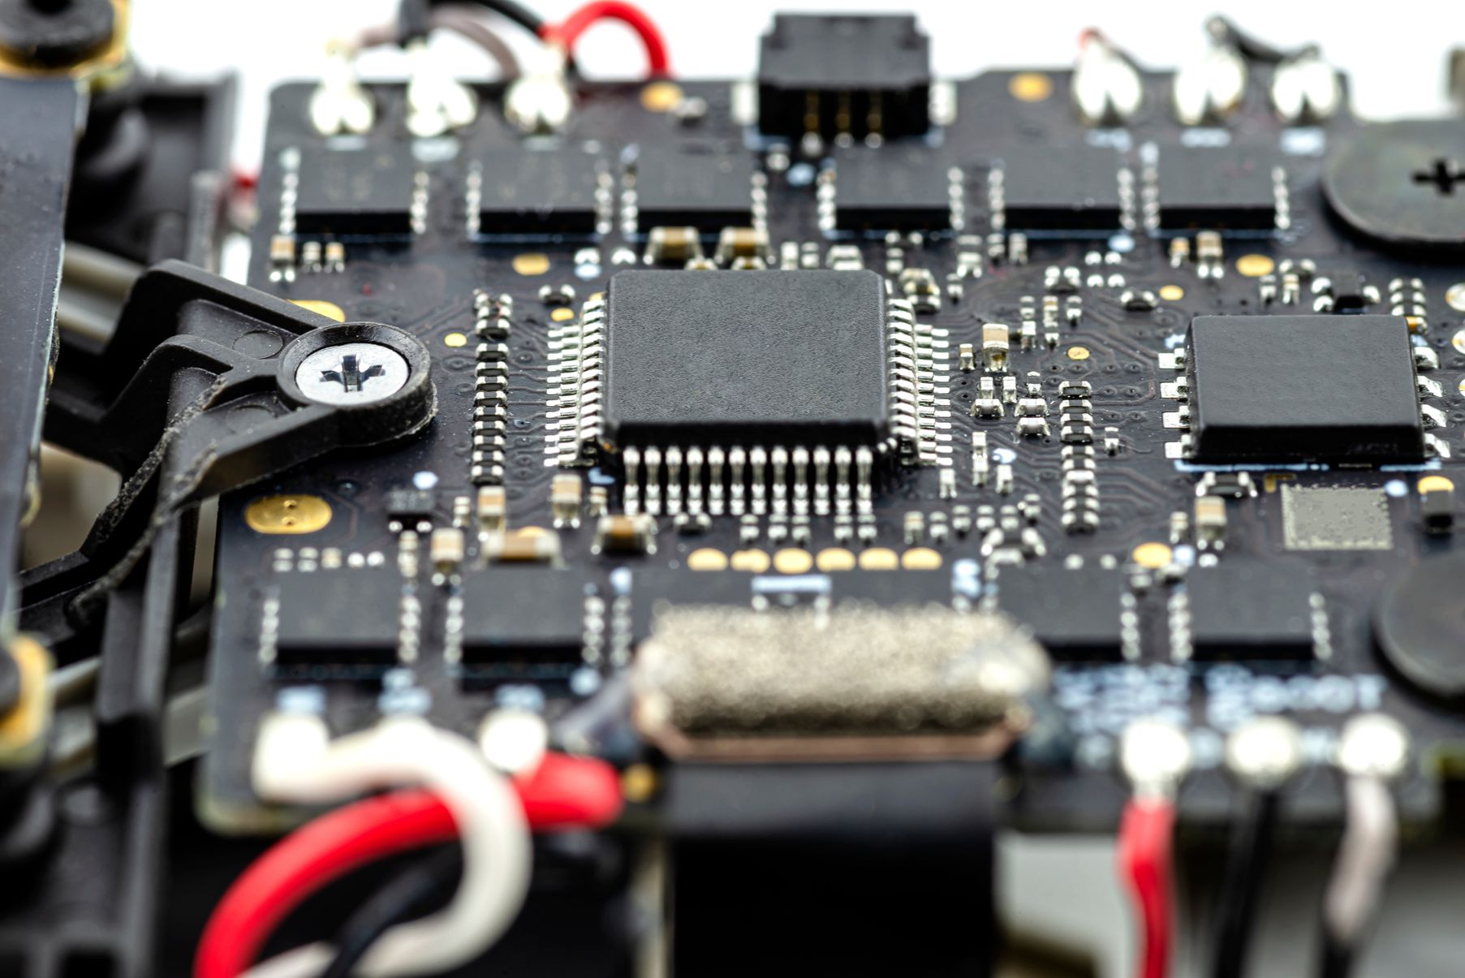
CP4807

