 | Preparation | Introduction to  microcontrollers
Before tackling the worksheets you will need to understand some basic information:
Microcontroller basics
This document gives a basic explanation as to how microcontrollers work.
Introduction to E-blocks
This document explains how the E-blocks system works.
E-blocks datasheet
This document gives the full schematics of all the E-blocks 3 circuit boards.
Flowcode Embedded getting started guide
This document shows you how to construct your first program from scratch.
Introduction to Flowcode Embedded video

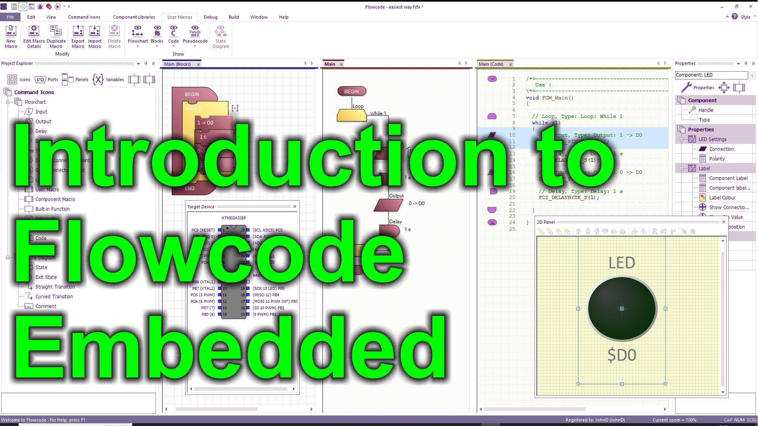
https://youtu.be/_9WAcrK9LjE
IMPORTANT
Before you start using Flowcode make sure that you have the latest libraries by selecting HELP…LIBRARY UPDATES…FULL DATABASE (FILES IN USE DROP BOX)…DOWNLOAD.

