 | Worksheet 1  First program |  | Introduction to  microcontrollers
 | This first program introduces you to several programming commands: OUTPUT, LOOP and DELAY.  In this first program you explore how to get a single output on the microcontroller turning on and off using these commands. |  | 

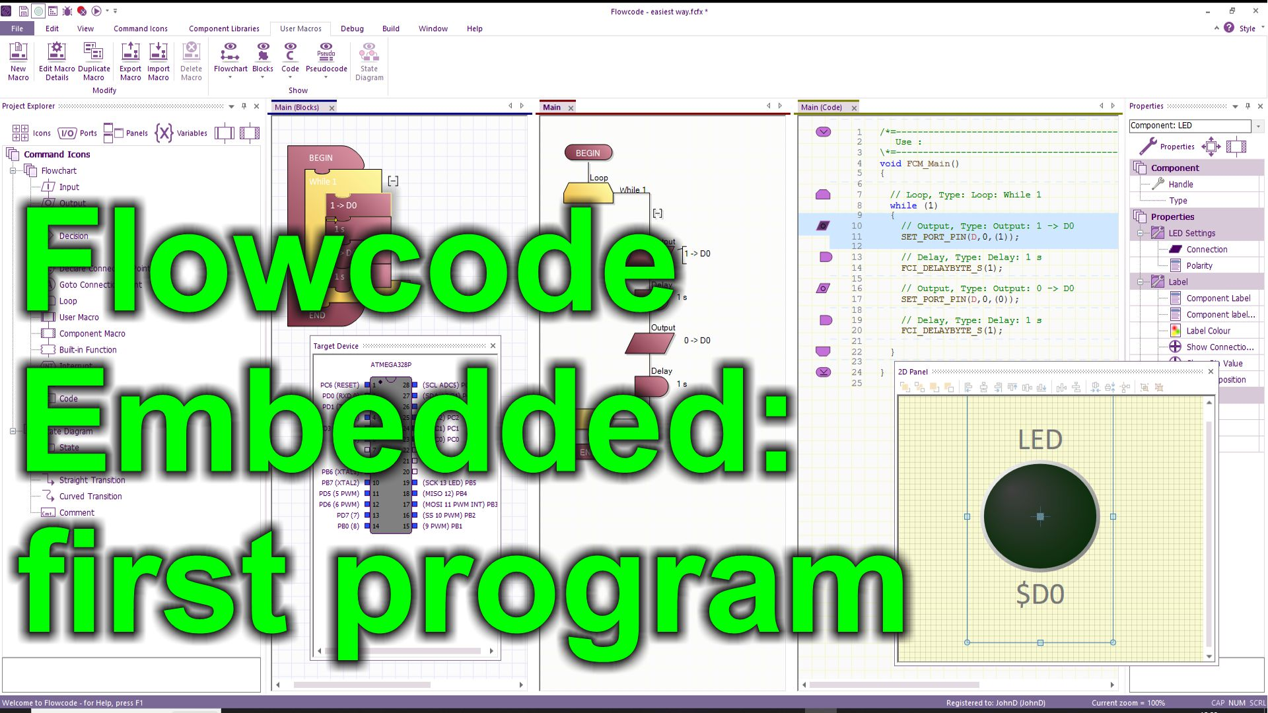
https://youtu.be/h8-7BsXBpLc
Over to you:
Watch the video “Flowcode Embedded: first program” on the Flowcode YouTube site.
Load the file “First program". Set up the hardware appropriately, download it, and make sure you understand it.
The program flashes a single LED on the combo board.
Challenges:
Delay: alter the delay period. Make sure you understand how the Delay command works.
Output: change the output to work with port A and port B. Output: Select Advanced options and alter the bit that is flashed
Loop: experiment with the loop dialogue box. Flash the LED for only 10 times.
Alter the program so that it flashes Port 1 bit 0 for 10 times, then Port 2 bit 1 for 9 times then port 2 bit 2 for 8 times.
Hints:
You can use three loops one after the other. Alter the Loop count in each one.
Use the Advanced options in the Output icon to control which output bit is used.
The examples are available directly from within the Flowcode package. From within Flowcode select: FILE…NEW PROJECT…OPEN EXAMPLE OR TEMPLATE…and select the example you want from the relevant worksheet pack.

