 | Worksheet 10  Timer interrupts |  | Introduction to  microcontrollers
 | Many microcontroller systems need some kind of timing system. Microcontrollers are designed to help us here as they have dedicated internal hardware that counts the number of internal clock pulses and converts them into time. When activated these internal counters can ‘interrupt’ the program to help you manage time-based code.  In this worksheet you explore how timer interrupts work. |  | 

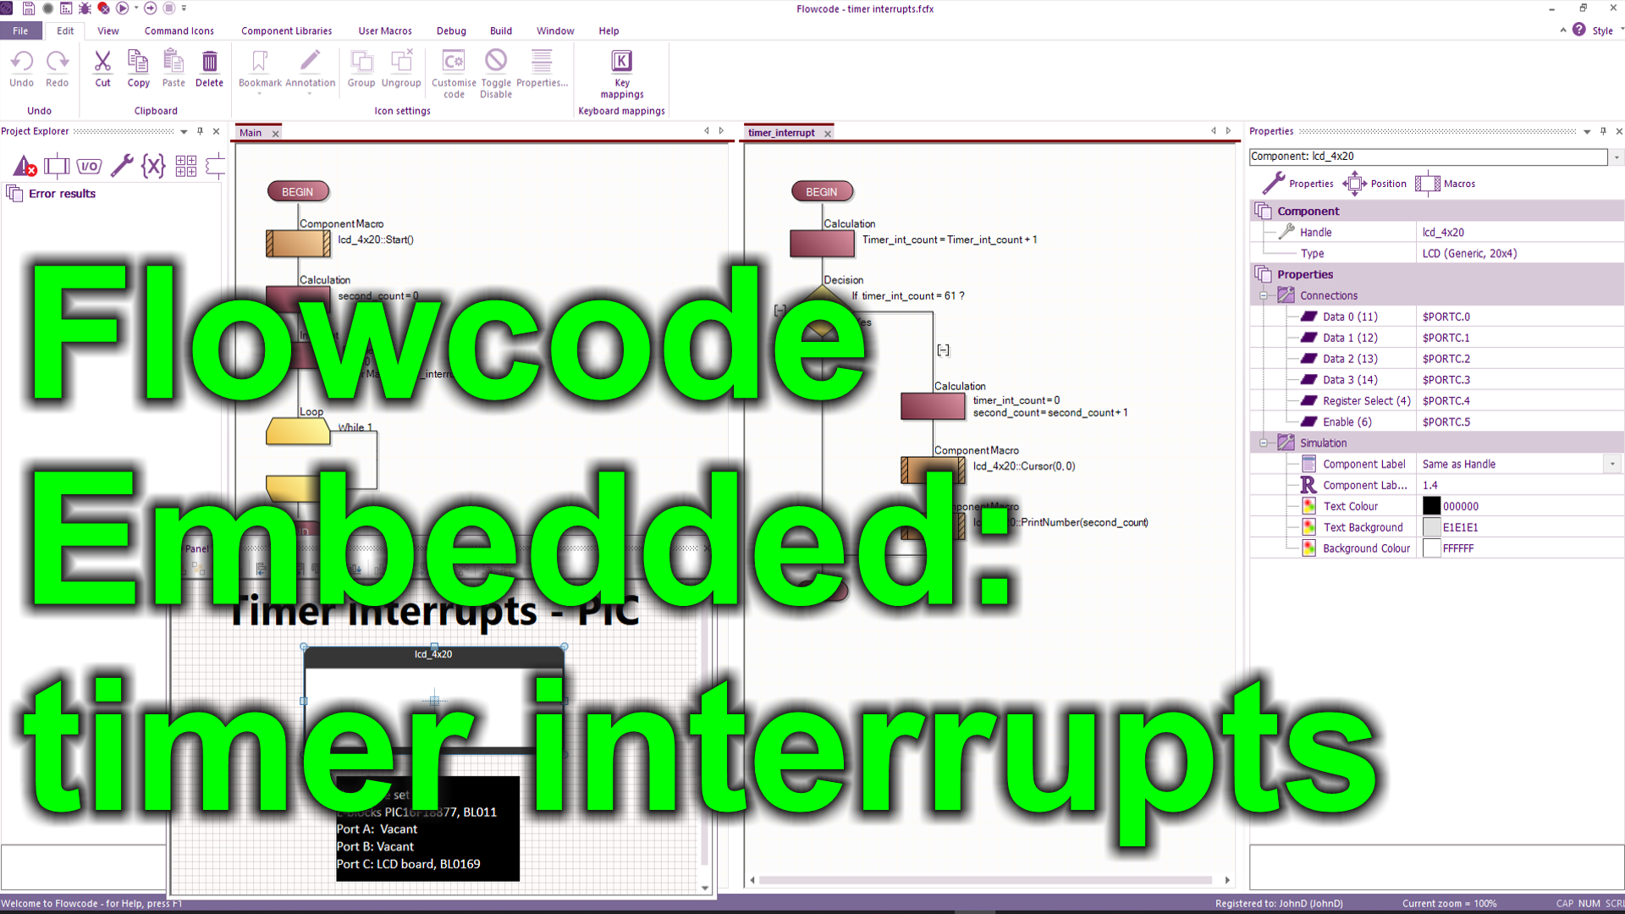
https://youtu.be/E5SWKxIjvno
Over to you:
Watch the video “Flowcode Embedded: timer interrupts” on the Flowcode YouTube site.
Load the file “timer interrupts". Set up the hardware appropriately.
Challenges:
Alter the program so that it calculates the hours, minutes and seconds that have elapsed.
Use a switch and a pin interrupt to clear the timer.
Hints:
- Create variables hour_count and minute_count
In the main loop use IF statements to track when second_count is more then 60 and reset it to 0 and increment minute_count Similarly for hour_count.
Keep the programming in the interrupt routine to a minimum – it is good practice
Create a new routine for a pin interrupt and use the code from the previous exercise to create the reset function.

