 | Worksheet 11  Touch control systems |  | Introduction to  microcontrollers
 | Touchscreen systems are replacing the use of switches, potentiometers, LEDs and other electronic devices. Using a graphical touch screen reduces costs and enhances functionality.  In this worksheet you learn how to develop a system that uses the touch screen display to control a simple system. |  | 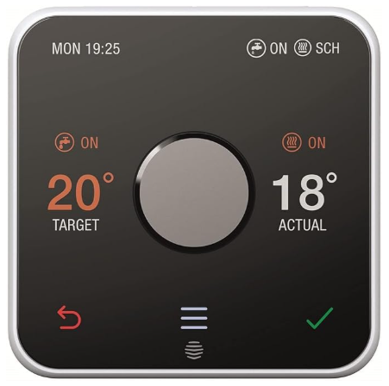

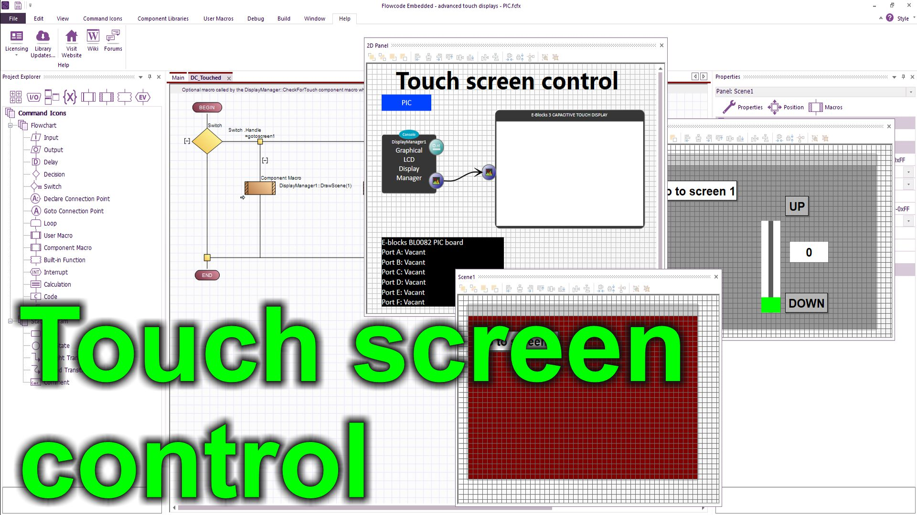
https://youtu.be/vS7P8RzybKc
Over to you:
Watch the video “Touch screen control” on the Flowcode YouTube site.
Load the file “Touch screen control”. Set up the hardware appropriately.
Download the file and make sure you understand how the program works.
Challenges:
Take the program you wrote in the Colour Graphical Displays program.
Modify it so that it has two touch buttons: ‘+’ and ‘-‘ and a text field
Use these to control an output variable and show this variable (between 0 and 255) on a port of 8 LEDs.
Your display will look something like this:
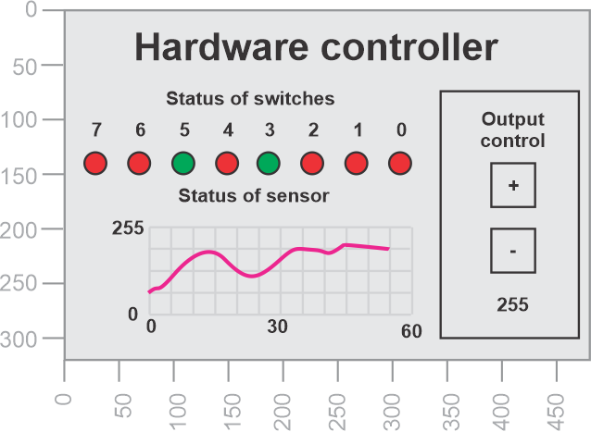
Hints:
- Use a new variable: Output
- Use the touch screen routine to detect when the ‘+’ and ‘-‘ text fields are touched and modify the variable Output accordingly
- Write the Output variable to a port to show its value.
- Note that the DC_touched macro is called by each display primitive as it is touched – this is set in the Touch callback property

