 | Worksheet 12  Web mirror |  | Introduction to  microcontrollers
 | Touchscreen systems are replacing the use of switches, potentiometers, LEDs and other electronic devices. Using a graphical touch screen reduces costs and enhances functionality.  In this worksheet you learn how to develop a more complex touch screen system |  | 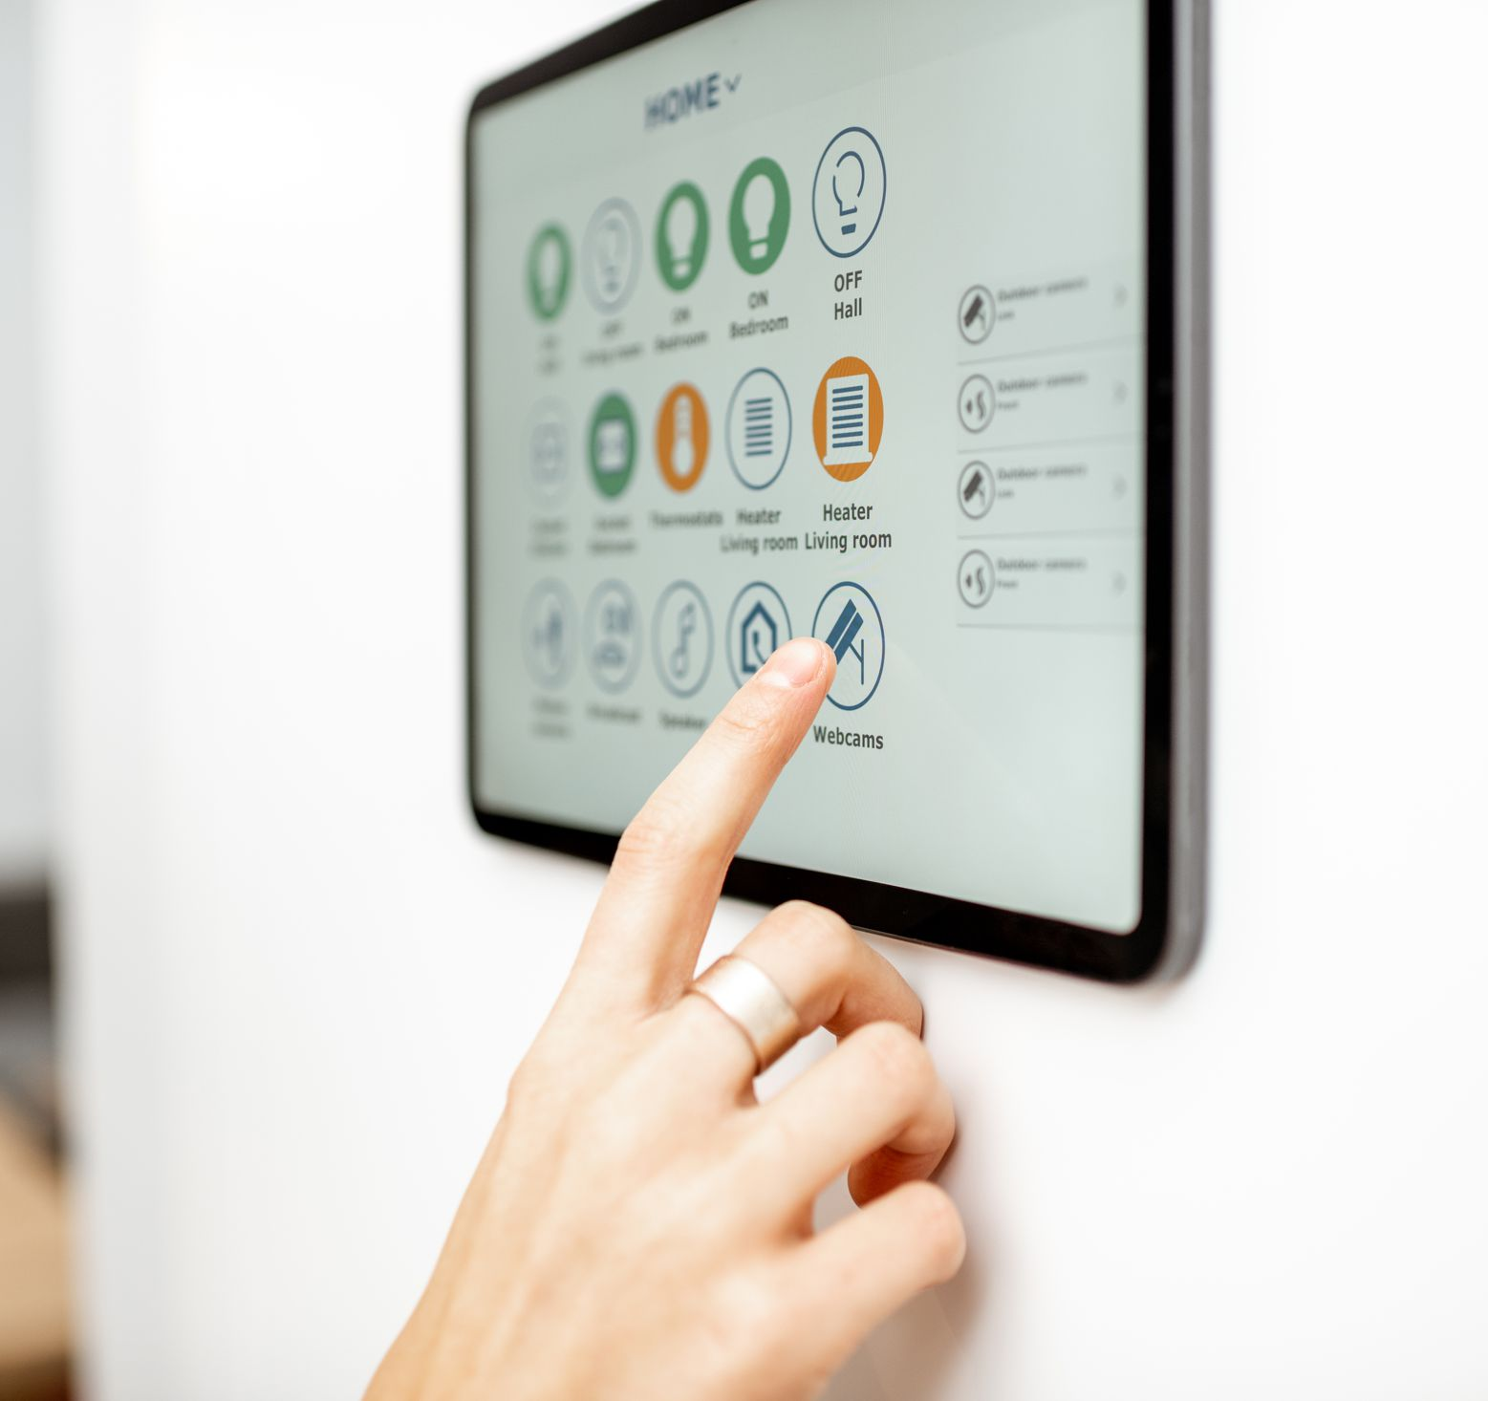

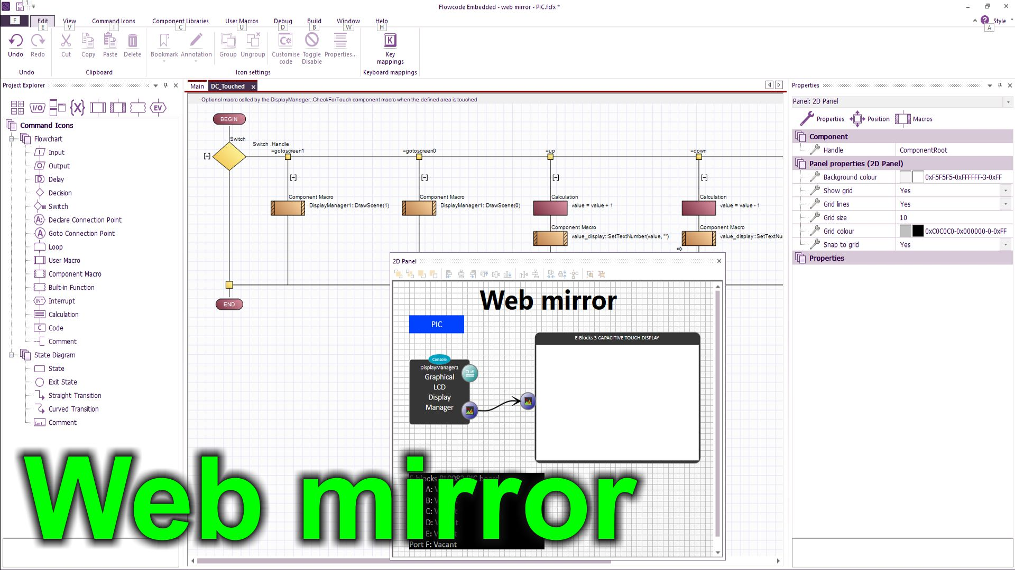
https://youtu.be/rdSOYW6AXn0
Over to you:
Watch the video “Web mirror” on the Flowcode YouTube site.
Load the file “Web mirror”. Set up the hardware appropriately. Change the EB3 Web Mirror settings of the Touch screen component and enter the name and password of your local server.
Download the file and make sure you understand how the program works.
Use your mobile phone camera to grab the URL of the remote server from the displayed QR code that allows you to control the system over the internet.
Challenges:
Take the program you wrote in the Touch control systems worksheet.
Change the EB3 Web Mirror settings of the Touch screen component to ‘Yes’ and enter the name and password of your local server.
Compile the program to hardware.
Make sure that you can use your program on your mobile phone to control and monitor your hardware.

