 | Worksheet 2  Performing calculations |  | Introduction to  microcontrollers
 | Microcontroller brains are not wired like human being’s. This has consequences for mathematics, variables and input output processes that you need to understand.  In this worksheet you explore calculations and binary and hexadecimal numbering systems. |  | 
 | Part 1

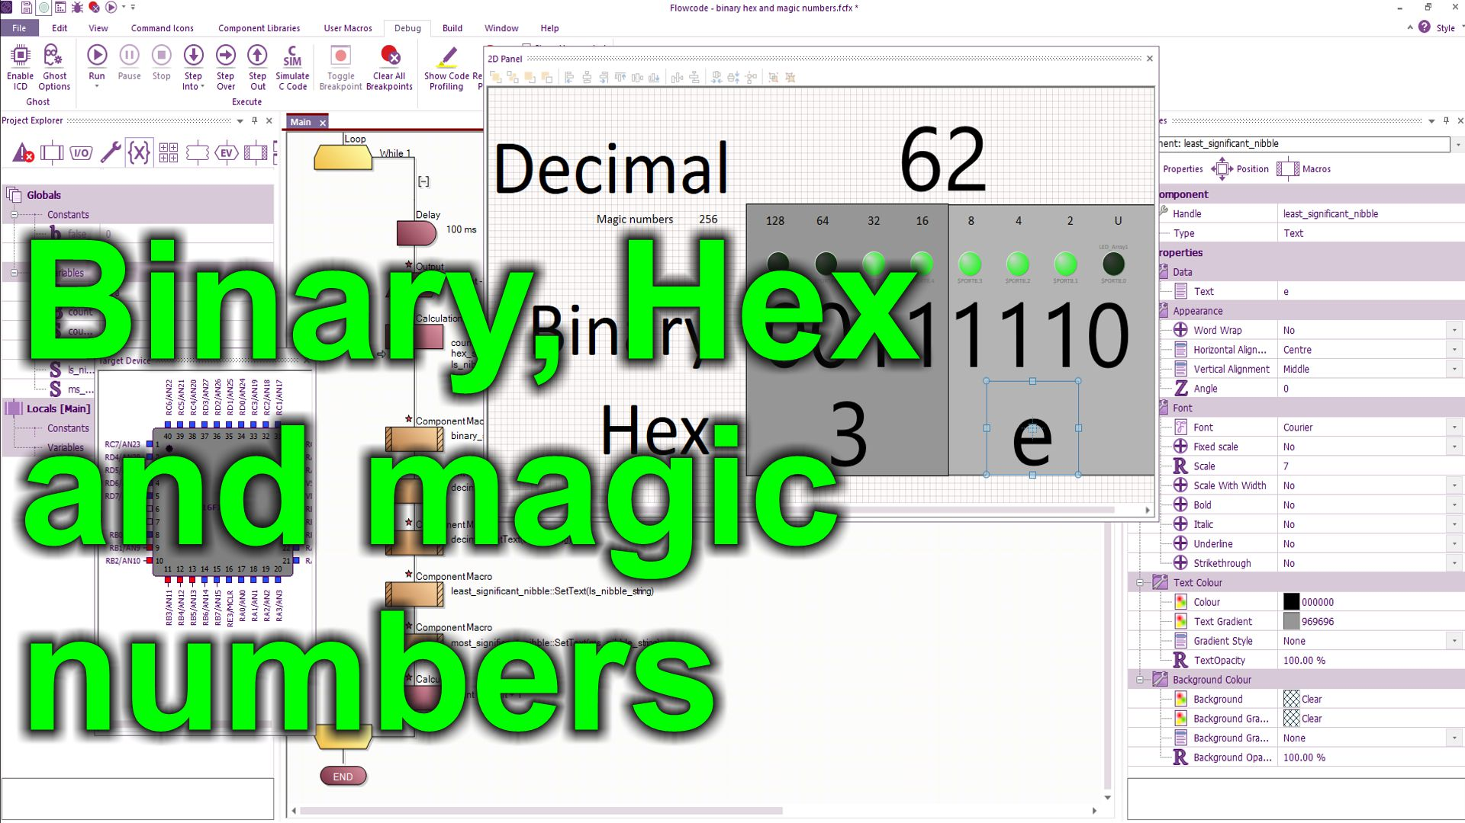
https://youtu.be/iEkocOsMj6Q
Over to you:
Watch the video “Binary, Hex and Magic numbers” on the Flowcode YouTube site.
Load the file “Binary Hex and magic numbers". This is a simulation only program.
There are some commands in here that you will not yet understand. Don’t worry about that for now: just look at the results of the simulation.
Challenges:
Simulate the program and pause it or slow it down to help you understand.
Make sure you understand conversion between Binary, Hex and Decimal.
Test yourself by selecting 3 decimal numbers between 0 and 100 and converting them to binary
Repeat the exercise but convert 3 binary 8 bit numbers into decimal.
If you are using an ESP32 microcontroller this worksheet will present difficulties as the ESP32 is a 32 bit system and chip input output connections are complex.
Part 2

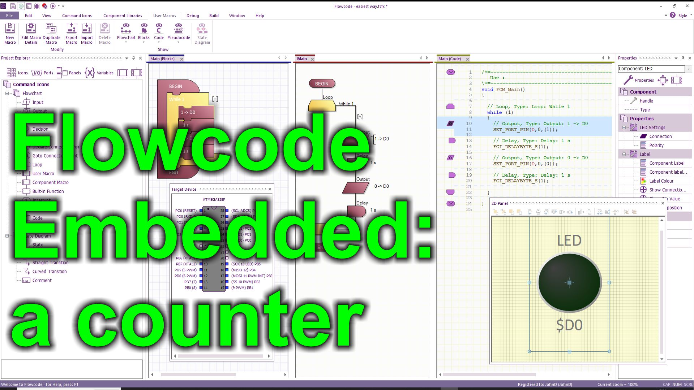
https://youtu.be/T7VX-QNLzeQ
Over to you:
Watch the video “Flowcode Embedded: a counter” on the Flowcode YouTube site.
Load the file “Counter". Set up the hardware appropriately, download it, and make sure you understand it.
The program counts in binary on a port of the microcontroller
Challenges:
Slow down the program by altering a delay. Make sure you understand the counting sequence.
In the Project Manager click on the variable Count to see the Variable dialogue control. Count is type Byte. Investigate the Types Bool, Int and Uint.
Alter the program so that initially Count = 1. Alter the calculation in the Loop so that Count = Count * 2 rather than Count = Count +1. Can you explain what happens when you run the program?
Alter the program so that after the 7th LED is lit up the program then lights bit 6, then bit 5 etc.
Hints:
- The Flowcode Wiki contains information on variable types
Use the Loop count so that the first loop executes 7 times. At this point bit 7 is lit up. Add a second loop that executes 7 times but use the divide ‘/’ operator in the calculation command rather than the times ‘*’ operator.

