 | Worksheet 5  Making decisions |  | Introduction to  microcontrollers
 | The behaviour of a program and its processes will often depend on the choices made by the user via a control panel or input from sensors. The way we make decisions in a program is through the IF statement and the SWITCH statement.  In this worksheet you explore how decisions are made in microcontroller programs. |  | 

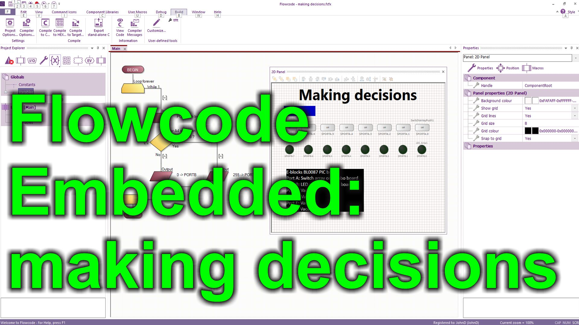
https://youtu.be/jBTPa4wSFsI
Over to you:
Watch the video “Flowcode Embedded: making decisions” on the Flowcode YouTube site.
Load the file “Making decisions". Set up the hardware appropriately, download it, and make sure you understand it.
Challenges:
- Alter the program so that when switch A.0 and switch A.4 are pressed all the LEDs on port B are lit.
Use a SWITCH command icon with 8 branches so that when the switch on A.0 is pressed the LED on B.7 is lit, when switch A.1 is pressed the LED on B.6 is lit etc.
Hints:
- Use your knowledge of binary to work out the input when A0 AND A4 are pressed.
- Write down the binary input for each switch press
- Set up a SWITCH statement with 8 branches which tests for each switch press

