 | Worksheet 7  Using prototype boards |  | Introduction to  microcontrollers
 | So far you have developed programs using boards which are manufactured for you. At some point you will need to create your own circuits. You can do this with a prototype board. This links to E-Blocks very easily to provide you with the connections and power supplies that you need.  In this worksheet you explore the use of prototype boards in microcontroller circuits. |  | 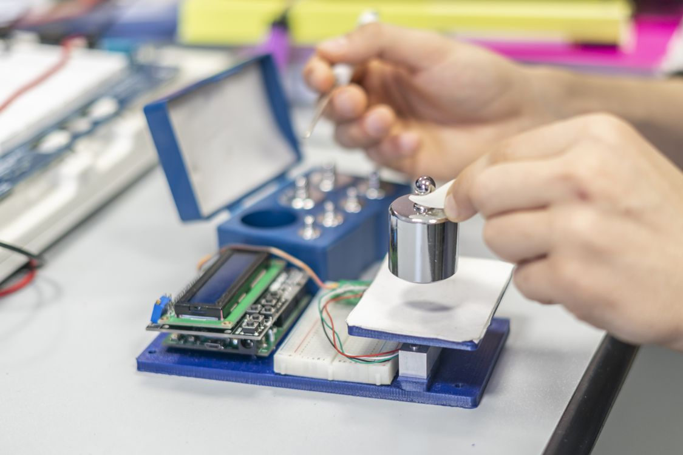
There is no video for this worksheet.
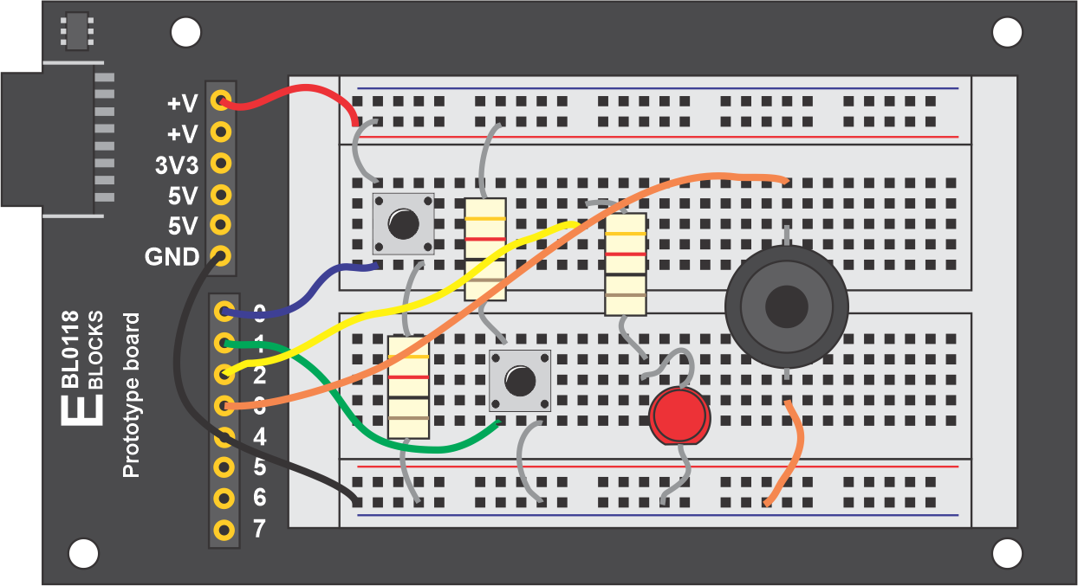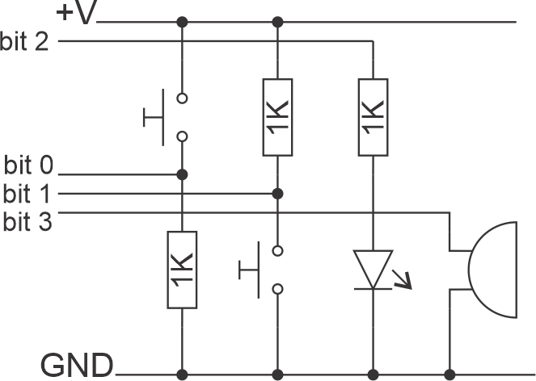
Over to you:
The diagrams above show you a circuit that you need to build. Two switches (active high and active low), a single LED and a buzzer.
Build this circuit and add it to your upstream E-blocks system on any port.
Develop a program that:
  - When both switches are pressed activates the buzzer.
  - Flashes the LED once a second
Hints:
- You can start from scratch of start from a previous program – perhaps the one on Digital inputs
- The main problem here is that there are two functions which need to be carried out at the same time. It is difficult to do both at once. (later you will learn how to use interrupts for this situation). Set up a loop with a 10ms delay. 100 of these loops gives you 1 second. Set up a variable to track a second has elapsed. Use this to change the state of the LED output.
- Use the && operator for the logic of both switches being pressed at once. One of your switches is active high and the other active low.

