 | Worksheet 8  Colour graphical displays |  | Introduction to  microcontrollers
 | Graphical displays extend the functionality of electronic systems, allow more information about be displayed, and allow information to be displayed in more easily understood formats: tables, graphics, graphs etc.  In this worksheet you explore how colour graphical displays work. |  | 

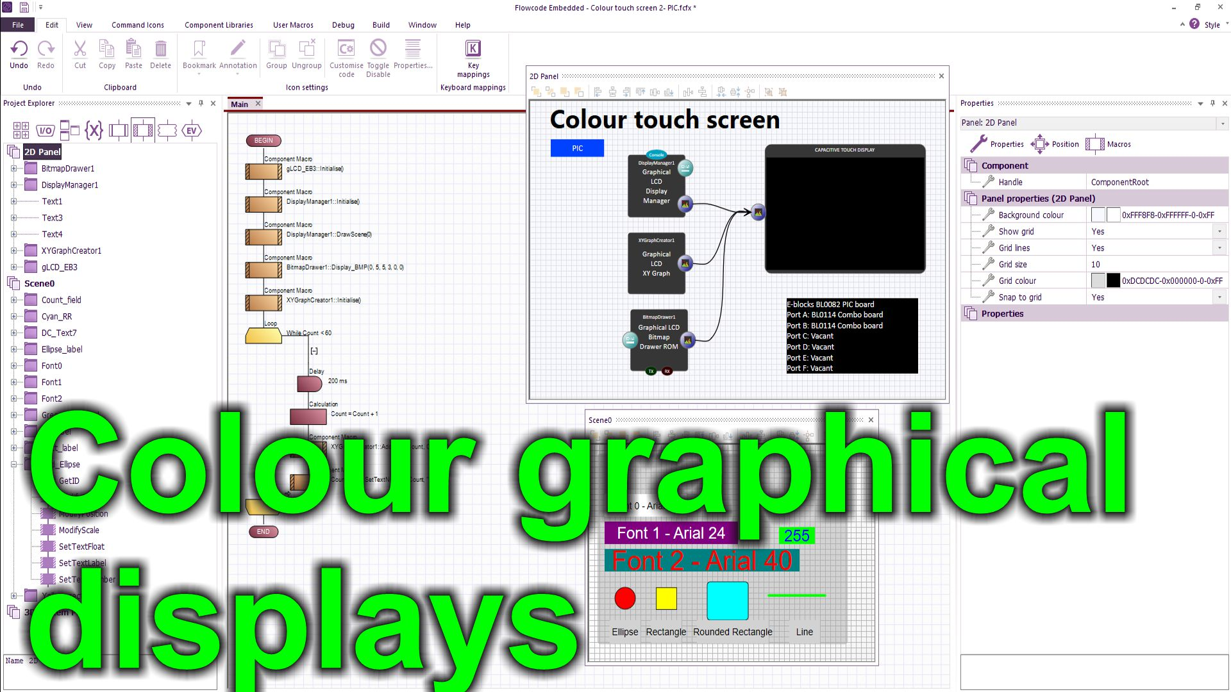
https://youtu.be/wBFTZGid_Ck
Over to you:
Watch the video “Colour graphical displays” on the Flowcode YouTube site.
Load the program “Colour graphical displays”. Set up the hardware appropriately, download it, and make sure you understand how the program works.
Challenges:
Create a program that uses the colour graphical display to show the status of 8 of the switches on the Combo board and the value of a potentiometer on an XY graph.
Your display will look something like this:
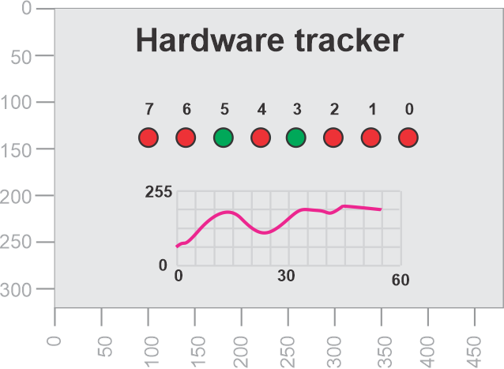
Hints:
- Use 8 ellipses to show the state of the switches. Each ellipse has a ModifyColour macro you can use to change ellipse colour – use red (255,0,0) for switch off and green (0, 255, 0) for switch on.
Use the graph component to show the value of the potentiometer. You may need to complete the first worksheet in Sensors and Microcontrollers to understand how to do get a value from a potentiometer.
Use text fields appropriately to label your components.
Modify colours on all components to make your screen look great.
If you can; create a bitmap using a graphics package and use the Bitmap drawer component to display it.
Refresh the graph every 60 seconds – you don’t need to clear the whole display.

