 | Worksheet 9  Pin interrupts |  | Introduction to  microcontrollers
 | In some systems there are possible events that are really important – like the kill switch on a factory machine. When switches like this are activated you need your program to stop whatever it is doing – ‘interrupt’ the program - and take action. Interrupts allow us to do this.  In this worksheet you explore how pin interrupts work. |  | 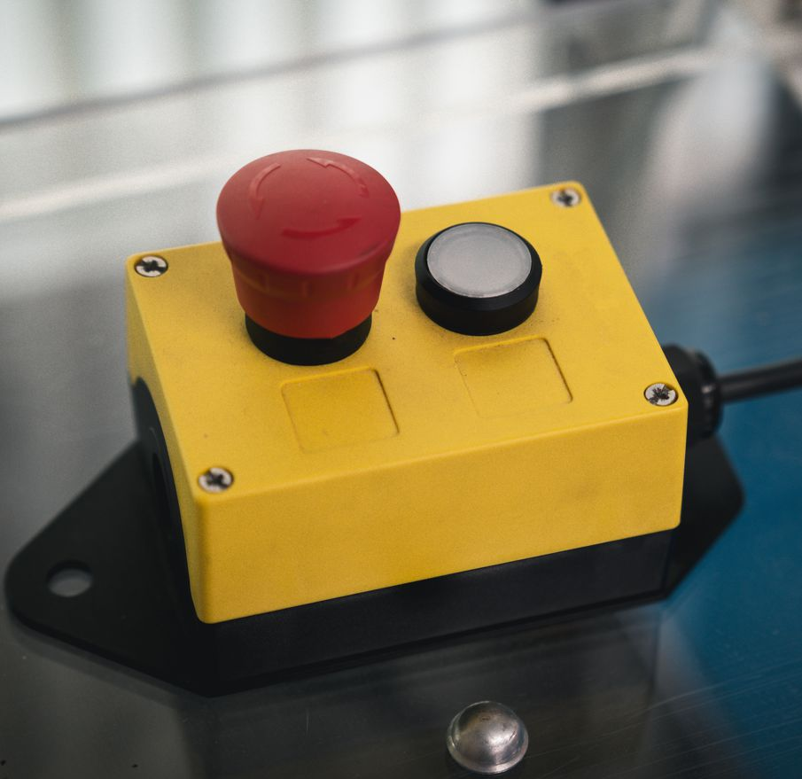

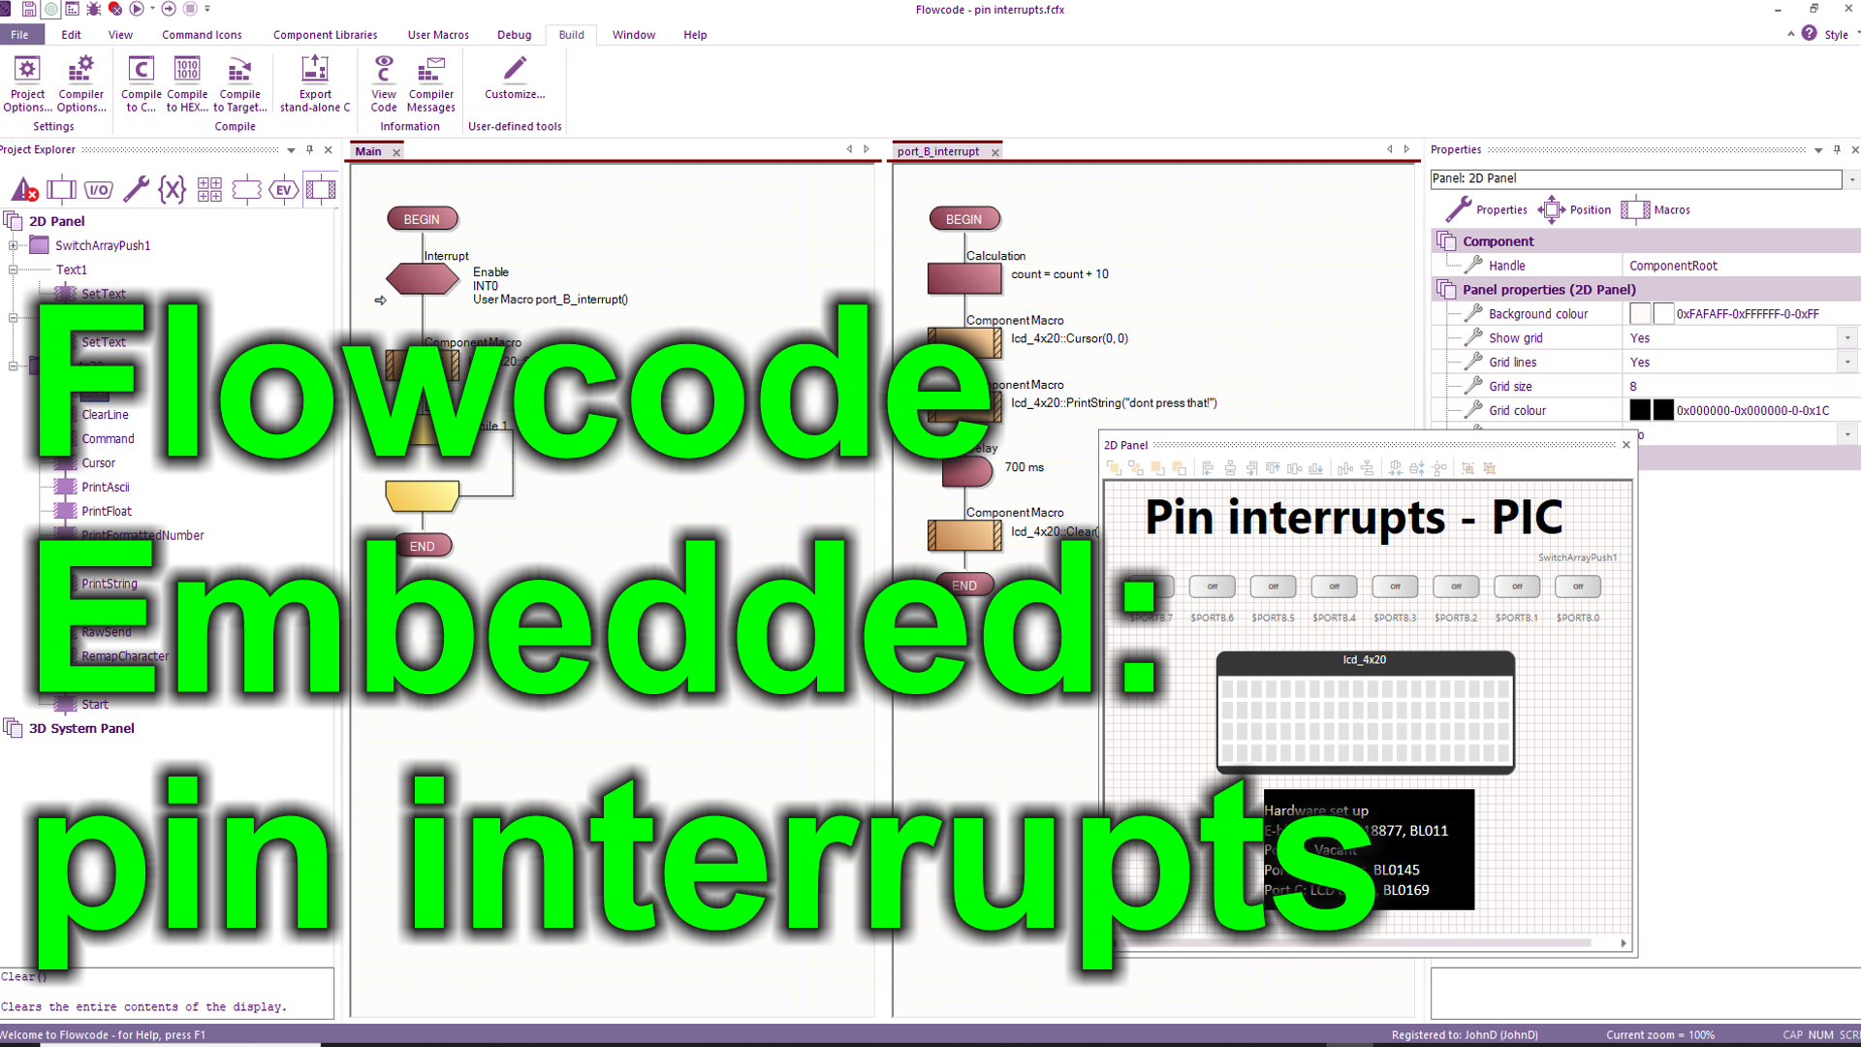
https://youtu.be/imTq19jX408
Over to you:
Watch the video “Flowcode Embedded: pin interrupts” on the Flowcode YouTube site.
Load the file “pin interrupts". Set up the hardware appropriately, download it, and make sure you understand it.
Challenges:
Alter the program so that a LED output flashes during normal operation.
Alter the program so that once the ‘stop switch’ on the interrupt pin is activated the program waits until a ‘clear’ switch is pushed before continuing the program.
Hints:
- Put a flashing LED routine in the main loop.
In the Interrupt routine insert a While…until loop.
Use a variable to track the status of the ‘clear’ switch.
In the loop test for the ‘clear’ switch being pressed.

