
Introduction to microcontrollers
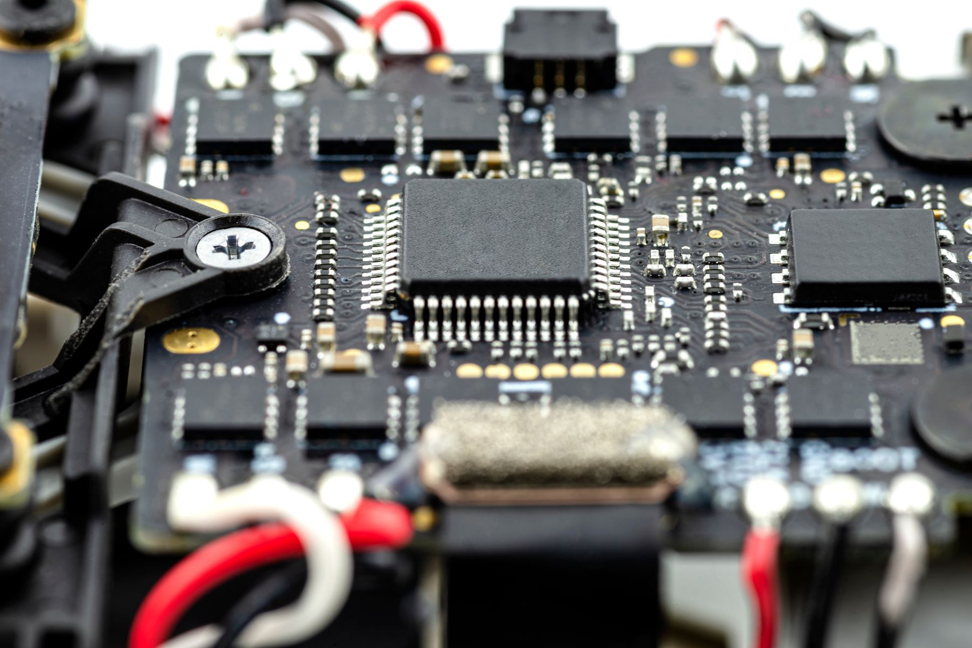
CP4807

