# PROJECT

## Title

The Future

### Description

The Future App will tell you, your future from the following sciences: Astrology, Tarot & Chinese Zodiac

### User Story

As a User, I want to see how my Stars project my futrue, when I enter my birthday and click submit;

As a user, I want to see Chinese Zodiac when I enter my year of birth and I click on submit;

As a user, I want to see my cards spread out to me when I give a random number and I click on submit;

### API

<li> Chinese Zodiac - https://fengshui-api.com/?ref=apilist.fun

                https://github.com/fengshui-api/restApi

<li>Astrology - https://rapidapi.com/HoroscopeApi/api/horoscope/endpoints

*<!-- Enter birthday date  - input -->*

<li>Tarot - https://github.com/ekelen/tarot-api

            https://rws-cards-api.herokuapp.com/api/v1/cards/random?n=10   *<!-- Get 10 random cards -->*

### Tasks assignment

Design – The team

Layout - Haden

Functionly - John

Feature - Cynthia

Divide task – Team

Future enchancements – Team

### Wireframe

See below Screenshot

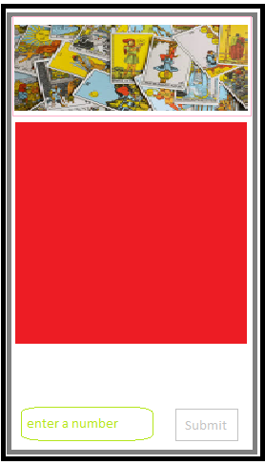

\* User inputs a random number between 1 – 10 and clicks on submit

\* The page then shows the response from the API

\* A return to main button and do it again

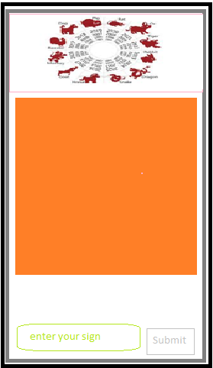

\* User enters year of birth

\* The page then shows the response from the API

\* A return to main button and do it again

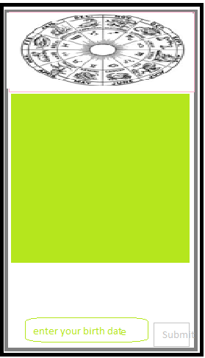

\* The user enters their birthday

\* The page then shows the response from the API

\* There is another button to return to main or display additional zodiacs