Support material / Material de apoyo
Learning activity 2 / Actividad de aprendizaje 2
Presentation / Presentación

- Function / Función
We use the present simple to talk about things or people we like. / Usamos el presente simple para hablar de cosas o personas que nos gustan.
- Examples / Ejemplos

- I like Italian food.
- She likes birds.
- He does not like tennis.
- I like wild animals like the lion.

- Structure / Estructura
like
I | do not | like | soccer
Do | you | like | soccer?

likes
He / she | does not | like | cats
Does | He / she | like | cats?

- Other expressions to talk about likes and dislikes / Otras expresiones para hablar de preferencias

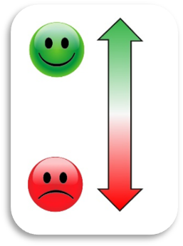
Love
Like
Enjoy
Don’t like
Hate
Can’t stand
Fuente: SENA

- Contractions / Contracciones
do not = don’t
I don’t like animals.
We don’t like soccer.
Practice / Práctica

Do the excercises and then compare them to the suggested answers sheet. / Desarrolle los ejercicios y luego compárelos con la hoja de respuestas sugerida.

- Complete the sentences according to the chart. / Complete las oraciones de acuerdo al cuadro.

 | Andrew | Matt | Rose
Rock music | 
Hockey |  | 
Cats
Cycling

Fuente de imágenes: SENA

- Andrew __________ cats.

- Rose __________ rock music and hockey.

- Andrew__________ cycling, but he __________hockey.

- Matt __________ cats, but he __________ cycling.

- Rose__________ cycling.

- Matt __________ rock music.

- Complete the crossword. / Complete el crucigrama.
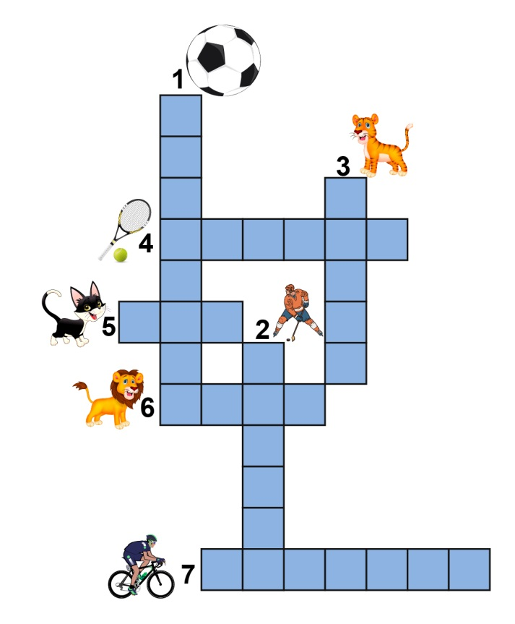
Fuente: SENA

- Read about Andy’s free time activities. / Lea sobre los pasatiempos de Andy.
My name is Andy, I am 20 years old, I am a student. In my free time I like swimming and I play football. I love football. I also like animals. My friend Luis has a dog. I like jogging with Luis’s dog.

According to the conversation, decide if the following statements are true or false. / Basado en la conversación, marque verdadero o falso:
- Andy has a dog. | T / F
- Andy likes swimming. | T / F
- Andy does not like animals. | T / F

Production / Producción

- Use 5 words from the crossword and write sentences about you. / Use 5 palabras del crucigrama y escriba oraciones sobre usted.

1. I like basketball.
2. _______________________________________________________
3. _______________________________________________________
4. _______________________________________________________
5. _______________________________________________________
6. _______________________________________________________

Document control / Control del documento

 | Name | Position | Dependence | Date
Author | Juan Carlos Solano | Theme expert  Asesor English Dot Works - Programa de bilingüismo | Dirección de formación profesional.  Dirección General | July  2014
Adaptation | Rachman  Bustillo Martínez | Copy editor – Línea de producción | Centro Agroindustrial. Regional Quindío | August  2014

