Support material / Material de apoyo
Learning activity 3 / Actividad de aprendizaje 3

You will learn more vocabulary about family members. / Usted aprenderá más vocabulario sobre miembros de la familia.

There are different relationships to talk about family members. If you are related by blood ties, law ties, religious ties or upbringing. / Hay diferentes lazos para hablar sobre miembros de la familia. Si usted está relacionado por lazos de consanguinidad, legales, religiosos o por crianza.
Presentation / Presentación

This is a summary about the vocabulary you can use to talk about family members. / Este es un resumen sobre el vocabulario que usted puede usar para hablar de miembros de la familia.
Family members related by blood ties. / Miembros de la familia relacionados por lazos de consanguinidad.
Mother | Madre
Father | Padre
Parents | Padres
Son | Hijo
Daughter | Hija
Sister | Hermana
Brother | Hermano
Aunt | Tía
Uncle | Tío
Cousin | Primo (a)
Grandmother | Abuela
Grandfather | Abuelo
Grandson | Nieto
Granddaughter | Nieta

Family members related by law ties. / Miembros de la familia relacionados por lazos legales.
Mother-in-law | Suegra
Father-in-law | Suegro
Parents-in-law | Suegros
Daughter-in-law | Nuera
Son-in-law | Yerno
Sister-in-law | Cuñada
Brother-in-law | Cuñado

Family members related by religious ties. / Miembros de la familia relacionados por lazos religiosos.
Godfather | Padrino
Godmother | Madrina
Godson | Ahijado
Goddaughter | Ahijada

Family members related by upbringing. / Miembros de la familia relacionados por crianza.

Stepfather | Padrastro
Stepmother | Madrastra
Stepsister | Hermanastra
Stepbrother | Hermanastro

Practice / Práctica

Do the excercises and then compare them to the suggested answers sheet. / Desarrolle los ejercicios y luego compárelos con la hoja de respuestas sugerida.
Family introductions

- Complete the introductions with the member of the family. / Complete las presentaciones con miembros de la familia.

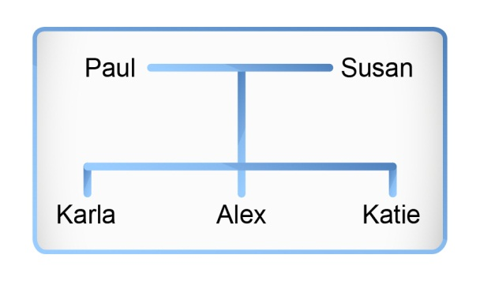
Example:

Alex introduces to his family:
My name is Alex. My father is Paul,
my mother is Susan and my sisters are
Karla and Katie.

Fuente: SENA

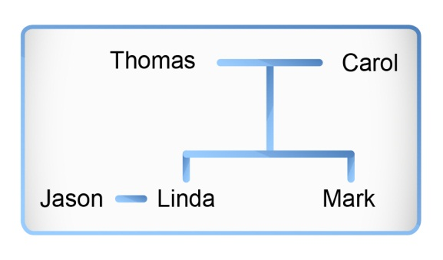
- My name is Linda. My a) _______ is
Carol. Thomas is my b) ______ and
my husband is Jason. I have one
c) _______, His name is Mark.

Fuente: SENA

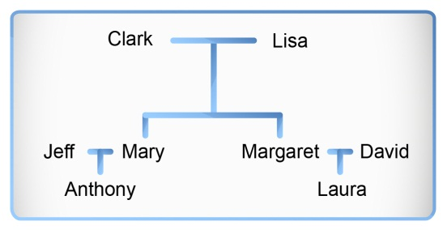
- My name is Laura. I have a big family.
My a) _______ is David and Margaret is my b) _______ Jeff is my c) _______ and Mary my d) _______ My e) _____’s name is Anthony. My f) _______ are Lisa and Clark.
Fuente: SENA

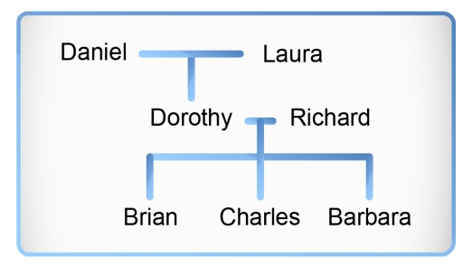
- My name is Barbara. I have two a) _______, Brian and Charles. Richard is my b) _______, Laura is my c) ________Dorothy is my d) ________ Daniel is my e) ________I love my family.
Fuente: SENA

- Complete with the correct possessive adjective: my or your. / Complete con el adjetivo posesivo my o your.

Example:

A: Hello!
B: What is your name?

- James answers some questions about his family.

Journalist: What are a) ________ parents’ names?
James: Donna and Kenneth.
Journalist: Is Amy b) ________ sister?
James: Yes, she is c) ________ sister.
Journalist: Is d) ________ brother at school?
James: No, e) ________ brother is not at school. He is only 2 years old.
Production / Producción

- Draw your family tree and write a text to introduce your family. / Dibuje su árbol genealógico y escriba un texto en el que presente a su familia.

Description | Family tree

- Write a paragraph about your family, including name, relationship and age.

Document control / Control del documento

 | Name | Position | Dependence | Date
Author | Johanna Méndez Sarmiento | Theme expert  Asesor English Dot Works - Programa de bilingüismo | Dirección de formación profesional.  Dirección General | July  2014
Adaptation | Rachman  Bustillo Martínez | Copy editor – Línea de producción | Centro Agroindustrial. Regional Quindío | August  2014

