Software Requirements Specification
Ask Holmes Application
Version 1.0

1. Introduction

1.1 Purpose
This Software Requirements Specification (SRS) document describes the functional and non-functional requirements for the Ask Holmes application. The purpose of this document is to provide a comprehensive overview of the system requirements, intended audience, and scope of the application. This document serves as a reference for developers, testers, and stakeholders involved in the development and deployment of the Ask Holmes application.

1.2 Document Conventions
This document follows standard SRS conventions. Requirements are identified using unique identifiers with the following prefixes:
- FR: Functional Requirements
- NFR: Non-Functional Requirements
- UX: User Experience Requirements

1.3 Intended Audience
This document is intended for the following audiences:
- Developers: To understand the technical requirements and implement the system accordingly.
- Testers: To develop test cases and validate the system against the specified requirements.
- Project Managers: To track project progress and ensure requirements are being met.
- Stakeholders: To review and approve the system requirements before development begins.

1.4 Product Scope
Ask Holmes is a web-based Retrieval-Augmented Generation (RAG) application that serves as an intelligent knowledge base for Sherlock Holmes literature. The system enables users to interact with classic Sherlock Holmes texts through a modern question-and-answer interface.
The application provides the following core capabilities:
- Question Management: Users can create, view, edit, and delete questions about Sherlock Holmes literature. Each question is securely associated with the authenticated user, ensuring data privacy and isolation.
- AI-Powered Answers: The application leverages advanced AI technology to generate accurate answers by searching through indexed Sherlock Holmes books. Using semantic search and large language models, the system retrieves relevant passages and synthesizes comprehensive responses grounded in the source material.
- Trusted Book Sources: Answers are derived exclusively from indexed Sherlock Holmes documents, ensuring authenticity and reliability. Users can trust that responses are based on the actual canon rather than fabricated information.
- Manual Answer Entry: Users have the flexibility to provide their own answers to questions, edit AI-generated responses, or maintain a personal knowledge base of Sherlock Holmes facts.

1.5 Product Overview
Ask Holmes addresses the need for an intelligent, user-friendly interface to explore and understand Sherlock Holmes literature. Traditional search methods often fail to provide contextual answers to complex questions about characters, plots, and themes. Ask Holmes solves this problem by combining modern AI techniques with classic literature.
Key Features:
- Create questions through an intuitive modal-based interface
- View all personal questions in an organized list format
- Edit existing questions and answers at any time
- Delete questions that are no longer needed
- Request AI-generated answers using the "Ask Documents" feature
- Answers are sourced from trusted, indexed Sherlock Holmes books
- User data is isolated and secure through authentication

1.6 References
The following references were used in the development of this SRS:
- IEEE Std 830-1998: IEEE Recommended Practice for Software Requirements Specifications
- Project Scope Document: Ask Holmes Application Scope
- Technical Architecture Document: System Design and Components

1.7 Definitions, Acronyms, and Abbreviations
This section provides definitions for terms, acronyms, and abbreviations used throughout this document to ensure clarity and consistent understanding.

1.7.1 Acronyms
AI - Artificial Intelligence: The simulation of human intelligence processes by computer systems, including learning, reasoning, and self-correction.
API - Application Programming Interface: A set of protocols and tools that allows different software applications to communicate with each other.
ARIA - Accessible Rich Internet Applications: A set of attributes that define ways to make web content more accessible to people with disabilities.
CORS - Cross-Origin Resource Sharing: A security mechanism that allows or restricts web applications running at one origin to access resources from a different origin.
CPU - Central Processing Unit: The primary component of a computer that performs most of the processing inside the computer.
CRUD - Create, Read, Update, Delete: The four basic operations of persistent storage in database applications.
CSS - Cascading Style Sheets: A stylesheet language used to describe the presentation and visual formatting of HTML documents.
DOM - Document Object Model: A programming interface for HTML documents that represents the page structure as a tree of objects.
E2E - End-to-End: A testing methodology that tests the complete flow of an application from start to finish.
GPU - Graphics Processing Unit: A specialized processor designed to accelerate graphics rendering and parallel processing tasks.
HTML - HyperText Markup Language: The standard markup language for creating web pages and web applications.
HTTP - HyperText Transfer Protocol: The foundation protocol used for transmitting data over the World Wide Web.
HTTPS - HyperText Transfer Protocol Secure: An encrypted version of HTTP that provides secure communication over a computer network.
IEEE - Institute of Electrical and Electronics Engineers: A professional association that develops standards for the electronics and computing industry.
JSON - JavaScript Object Notation: A lightweight data interchange format that is easy for humans to read and write and easy for machines to parse.
JSX - JavaScript XML: A syntax extension for JavaScript used in React that allows writing HTML-like code within JavaScript.
JWT - JSON Web Token: A compact, URL-safe means of representing claims to be transferred between two parties for authentication.
LLM - Large Language Model: An AI model trained on vast amounts of text data capable of understanding and generating human-like text.
MFA - Multi-Factor Authentication: A security system that requires multiple methods of verification from independent categories of credentials.
NLP - Natural Language Processing: A branch of AI that helps computers understand, interpret, and manipulate human language.
NPM - Node Package Manager: A package manager for JavaScript that allows developers to share and reuse code packages.
ORM - Object-Relational Mapping: A programming technique for converting data between incompatible type systems in object-oriented programming languages.
PDF - Portable Document Format: A file format developed by Adobe to present documents independent of application software, hardware, and operating systems.
PIP - Pip Installs Packages: The standard package manager for Python used to install and manage software packages.
PWA - Progressive Web Application: A type of web application that uses modern web technologies to deliver app-like experiences.
RAG - Retrieval-Augmented Generation: An AI framework that combines information retrieval with text generation to produce contextually relevant responses.
RAM - Random Access Memory: A type of computer memory that can be read and changed in any order, used to store working data.
REST - Representational State Transfer: An architectural style for designing networked applications using stateless client-server communication.
SDK - Software Development Kit: A collection of software development tools in one installable package used to develop applications.
SHA - Secure Hash Algorithm: A family of cryptographic hash functions used to verify data integrity.
SPA - Single Page Application: A web application that dynamically rewrites the current page rather than loading entire new pages from the server.
SQL - Structured Query Language: A domain-specific language used for managing and manipulating relational databases.
SRS - Software Requirements Specification: A document that describes what the software will do and how it is expected to perform.
SSL - Secure Sockets Layer: A cryptographic protocol designed to provide secure communication over a computer network.
TLS - Transport Layer Security: A cryptographic protocol that provides secure communication over a network, successor to SSL.
UI - User Interface: The visual elements through which users interact with a software application.
URL - Uniform Resource Locator: The address used to access resources on the internet.
UTF-8 - Unicode Transformation Format 8-bit: A variable-width character encoding capable of encoding all valid Unicode code points.
UUID - Universally Unique Identifier: A 128-bit identifier used to uniquely identify information in computer systems.
UX - User Experience: The overall experience of a person using a product, especially in terms of how easy or pleasing it is to use.
WSGI - Web Server Gateway Interface: A specification for a universal interface between web servers and Python web applications.
XSS - Cross-Site Scripting: A security vulnerability that allows attackers to inject malicious scripts into web pages viewed by other users.

1.7.2 Definitions
Anthropic: An AI safety company that develops large language models, including the Claude family of AI assistants used in this application.
Authentication: The process of verifying the identity of a user, typically through credentials such as email addresses or passwords.
Authorization: The process of determining what permissions an authenticated user has to access specific resources or perform certain actions.
Backend: The server-side portion of a web application that handles data processing, business logic, and database operations.
Blueprint: In Flask, a way to organize a group of related views and other code, allowing modular application development.
Chunk: A segment of text extracted from a document, typically 500 characters with overlap, used for efficient retrieval and processing.
Claude: A family of large language models developed by Anthropic, with Claude Haiku being the fast and cost-effective variant used in this application.
Component: In React, a reusable piece of UI that encapsulates its own structure, style, and behavior.
Context API: A React feature that provides a way to pass data through the component tree without having to pass props manually at every level.
Cosine Similarity: A mathematical measure of similarity between two vectors, used to find semantically similar text chunks.
Docker: A platform for developing, shipping, and running applications in isolated containers.
Embedding: A numerical representation of text as a vector in high-dimensional space, capturing semantic meaning for similarity comparisons.
Endpoint: A specific URL path in an API that accepts requests and returns responses for a particular resource or operation.
Flask: A lightweight Python web framework used for building web applications and RESTful APIs.
Frontend: The client-side portion of a web application that users interact with directly, typically running in a web browser.
Gunicorn: A Python WSGI HTTP server commonly used to run Python web applications in production environments.
Hook: In React, a function that lets you use state and other React features in functional components.
Indexing: The process of extracting text from documents, generating embeddings, and storing them in a database for efficient retrieval.
IVFFlat: An index type in pgvector that uses inverted file indexing for approximate nearest neighbor search.
Modal: A dialog box or popup window that appears on top of the main content, requiring user interaction before returning to the main view.
Nginx: A high-performance web server and reverse proxy server commonly used to serve static files and proxy requests to backend applications.
Node.js: A JavaScript runtime built on Chrome's V8 JavaScript engine, used for building server-side applications.
pgvector: A PostgreSQL extension that adds support for vector similarity search, enabling semantic search capabilities.
PostgreSQL: An open-source relational database management system known for reliability, feature robustness, and extensibility.
Props: In React, read-only properties passed from parent components to child components to configure their behavior and display.
PyPDF2: A Python library used for extracting text, merging, splitting, and manipulating PDF files.
Query: A request for data or information from a database, or in RAG context, a user's question submitted for answer generation.
React: A JavaScript library for building user interfaces, particularly single-page applications, developed by Facebook.
Semantic Search: A search technique that understands the contextual meaning of terms to find relevant results beyond exact keyword matching.
Sentence Transformers: A Python library for computing dense vector representations of sentences and paragraphs.
SQLAlchemy: A Python SQL toolkit and Object-Relational Mapping library for database operations.
State: In React, an object that holds data that may change over the lifetime of a component, triggering re-renders when updated.
Toast: A brief notification message that appears temporarily on the screen to provide feedback about an operation.
Token: In LLM context, a unit of text (word, subword, or character) that the model processes; used for billing and context limits.
Vector: A mathematical representation of data as a list of numbers, used in this application for semantic similarity comparisons.
Vector Database: A database optimized for storing and querying high-dimensional vector embeddings for similarity search.
Viewport: The visible area of a web page in the browser window, which varies based on the device and screen size.

1.7.3 Technical Terms
all-MiniLM-L6-v2: A sentence transformer model that produces 384-dimensional embeddings, balancing performance and efficiency.
Connection Pooling: A technique of maintaining a cache of database connections that can be reused for future requests.
CRUD Operations: The four basic database operations: Create (insert new records), Read (retrieve records), Update (modify records), Delete (remove records).
Data Isolation: A security principle ensuring that each user can only access their own data and cannot view or modify other users' data.
Dependency Injection: A design pattern where dependencies are provided to a component rather than created by the component itself.
Environment Variable: A dynamic value stored outside the application code that can affect the behavior of running processes.
Factory Pattern: A design pattern that provides an interface for creating objects without specifying their concrete classes.
Foreign Key: A field in a database table that references the primary key of another table, establishing a relationship between tables.
Horizontal Scaling: Adding more machines or instances to distribute load, as opposed to vertical scaling which adds more power to existing machines.
Idempotent: An operation that produces the same result regardless of how many times it is executed.
Middleware: Software that acts as a bridge between an operating system or database and applications, handling requests and responses.
Primary Key: A unique identifier for each record in a database table, ensuring no duplicate entries.
Rate Limiting: A technique used to control the number of requests a client can make to an API within a specified time period.
Reverse Proxy: A server that sits in front of web servers and forwards client requests to those servers.
Service Layer: An architectural pattern that defines an application's boundary with a layer of services that establishes business logic.
Singleton Pattern: A design pattern that restricts the instantiation of a class to a single instance.
Stateless: A system design where no client context is stored on the server between requests; each request contains all information needed to process it.
Three-Tier Architecture: A software architecture pattern that separates an application into three logical layers: presentation, application, and data.
Timeout: A specified period after which an operation is automatically terminated if not completed.
Timestamp: A sequence of characters representing the date and time at which a certain event occurred.

2. Project Requirements
This chapter defines the detailed functional and non-functional requirements for the Ask Holmes application. Each requirement is assigned a unique identifier for traceability and testing purposes.

2.1 Functional Requirements
Functional requirements describe the specific behaviors, features, and functions that the Ask Holmes application must provide. These requirements are organized by functional area.

2.1.1 User Authentication Requirements
FR-AUTH-001: User Registration
- Description: The system shall allow new users to register by providing a valid email address.
- Acceptance Criteria:
- 1. User enters email address in the registration form
- 2. System validates email format (contains @ and valid domain)
- 3. System checks if email is not already registered
- 4. System creates new user account with unique UUID
- 5. System displays success message upon successful registration
- Priority: High
FR-AUTH-002: User Login
- Description: The system shall allow registered users to log in using their email address.
- Acceptance Criteria:
- 1. User enters registered email address
- 2. System validates email exists in database
- 3. System authenticates user and creates session
- 4. System stores user ID in browser local storage
- 5. System redirects user to home page
- Priority: High
FR-AUTH-003: User Logout
- Description: The system shall allow authenticated users to log out of the application.
- Acceptance Criteria:
- 1. User clicks logout button in header
- 2. System clears user session from local storage
- 3. System redirects user to login page
- 4. System prevents access to protected pages without re-authentication
- Priority: High
FR-AUTH-004: Session Persistence
- Description: The system shall maintain user session across browser refreshes and new tabs.
- Acceptance Criteria:
- 1. User ID is stored in browser local storage upon login
- 2. Application checks local storage on page load
- 3. If valid user ID exists, user remains authenticated
- 4. User can open multiple tabs without re-authenticating
- Priority: Medium

2.1.2 Question Management Requirements
FR-Q-001: Create Question
- Description: The system shall allow authenticated users to create new questions through a modal interface.
- Acceptance Criteria:
- 1. User clicks "Add Question" button on home page
- 2. Modal dialog opens with question input form
- 3. User enters question text (required field)
- 4. User optionally enters answer text
- 5. User clicks "Save" button to submit
- 6. System validates question is not empty
- 7. System saves question with user ID and timestamp
- 8. Modal closes and question appears in list
- 9. Success toast notification is displayed
- Priority: High
FR-Q-002: View Questions List
- Description: The system shall display all questions belonging to the authenticated user.
- Acceptance Criteria:
- 1. Home page displays list of user's questions
- 2. Questions are sorted by creation date (newest first)
- 3. Each question shows question text and answer preview
- 4. Questions without answers show "No answer yet" indicator
- 5. Only questions belonging to current user are displayed
- 6. Empty state message shown when no questions exist
- Priority: High
FR-Q-003: Edit Question
- Description: The system shall allow users to edit their existing questions.
- Acceptance Criteria:
- 1. User clicks edit option from question menu
- 2. Modal opens pre-populated with existing question and answer
- 3. User modifies question text and/or answer
- 4. User clicks "Save" to submit changes
- 5. System validates question is not empty
- 6. System updates question with new updated_at timestamp
- 7. Modal closes and list reflects changes
- 8. Success toast notification is displayed
- Priority: High
FR-Q-004: Delete Question
- Description: The system shall allow users to permanently delete their questions.
- Acceptance Criteria:
- 1. User clicks delete option from question menu
- 2. Confirmation dialog appears with warning message
- 3. User confirms deletion by clicking "Delete" button
- 4. System permanently removes question and associated answer
- 5. Question is removed from the displayed list
- 6. Success toast notification is displayed
- 7. User can cancel deletion by clicking "Cancel" or pressing Escape
- Priority: High
FR-Q-005: Question Validation
- Description: The system shall validate question input before saving.
- Acceptance Criteria:
- 1. Question text is required and cannot be empty
- 2. Question must contain at least one non-whitespace character
- 3. Leading and trailing whitespace is trimmed
- 4. Answer field is optional (can be empty)
- 5. Validation error message displayed for invalid input
- 6. Save button disabled when form is invalid
- Priority: Medium

2.1.3 Answer Management Requirements
FR-A-001: Manual Answer Entry
- Description: The system shall allow users to manually enter answers to their questions.
- Acceptance Criteria:
- 1. Answer textarea is available in question creation/edit modal
- 2. User can enter free-form text as answer
- 3. Answer is saved with the question
- 4. Empty answer is stored as null in database
- 5. Answer can be added to questions that previously had none
- Priority: High
FR-A-002: AI Answer Generation
- Description: The system shall generate AI-powered answers using the RAG pipeline.
- Acceptance Criteria:
- 1. "Ask Documents" button is visible in question form
- 2. Button is disabled when question field is empty
- 3. Clicking button triggers RAG query with question text
- 4. Loading indicator shown during answer generation
- 5. Generated answer is populated in answer textarea
- 6. User can edit generated answer before saving
- 7. Error message displayed if generation fails
- Priority: High
FR-A-003: Answer Editing
- Description: The system shall allow users to edit both manual and AI-generated answers.
- Acceptance Criteria:
- 1. Existing answers are editable in the edit modal
- 2. AI-generated answers can be modified before saving
- 3. Answers can be cleared (set to empty)
- 4. Changes are saved when user clicks "Save"
- 5. Updated timestamp reflects modification time
- Priority: Medium
FR-A-004: Answer Regeneration
- Description: The system shall allow users to regenerate AI answers.
- Acceptance Criteria:
- 1. "Ask Documents" button can be clicked multiple times
- 2. Each click generates a new answer based on current question
- 3. New answer replaces previous content in textarea
- 4. Saved answers are not affected until user clicks "Save"
- Priority: Low

2.1.4 RAG Pipeline Requirements
FR-RAG-001: Document Upload
- Description: The system shall allow uploading PDF documents for indexing.
- Acceptance Criteria:
- 1. File upload button accepts PDF files only
- 2. Selected file is uploaded to server books folder
- 3. Upload progress indicator is displayed
- 4. Success message shown upon completion
- 5. Error message shown for invalid file types
- Priority: Medium
FR-RAG-002: Document Indexing
- Description: The system shall process and index uploaded PDF documents.
- Acceptance Criteria:
- 1. System extracts text content from PDF files
- 2. Text is split into chunks of 500 characters with 50-character overlap
- 3. Each chunk is converted to 384-dimensional vector embedding
- 4. Chunks and embeddings are stored in database
- 5. Document metadata (filename, hash, chunk count) is recorded
- 6. Duplicate documents are detected via file hash
- Priority: High
FR-RAG-003: Semantic Search
- Description: The system shall perform semantic similarity search on indexed documents.
- Acceptance Criteria:
- 1. User question is converted to vector embedding
- 2. System searches for most similar document chunks
- 3. Top 3 most relevant chunks are retrieved
- 4. Cosine similarity is used for matching
- 5. Search completes within acceptable time limit
- Priority: High
FR-RAG-004: Answer Generation
- Description: The system shall generate answers using retrieved context and LLM.
- Acceptance Criteria:
- 1. Retrieved chunks are assembled as context
- 2. Question and context are sent to Claude Haiku LLM
- 3. LLM generates natural language answer
- 4. Answer is grounded in the provided context
- 5. Response is returned within 60-second timeout
- 6. Error handling for API failures
- Priority: High
FR-RAG-005: Document Management
- Description: The system shall allow viewing and deleting indexed documents.
- Acceptance Criteria:
- 1. List of indexed documents is viewable
- 2. Document details show filename and chunk count
- 3. Documents can be deleted from the index
- 4. Deleting document removes all associated chunks
- Priority: Low

2.1.5 User Interface Requirements
FR-UI-001: Responsive Layout
- Description: The system shall provide a responsive layout for desktop and tablet devices.
- Acceptance Criteria:
- 1. Layout adapts to screen sizes 1024px and above
- 2. All features are accessible on desktop browsers
- 3. Content is readable without horizontal scrolling
- 4. Interactive elements are appropriately sized
- Priority: Medium
FR-UI-002: Modal Dialogs
- Description: The system shall use modal dialogs for question creation and editing.
- Acceptance Criteria:
- 1. Modal opens centered on screen with backdrop overlay
- 2. Modal can be closed by clicking X button
- 3. Modal can be closed by pressing Escape key
- 4. Modal can be closed by clicking backdrop
- 5. Focus is trapped within modal when open
- Priority: Medium
FR-UI-003: Toast Notifications
- Description: The system shall display toast notifications for user feedback.
- Acceptance Criteria:
- 1. Success messages shown for successful operations
- 2. Error messages shown for failed operations
- 3. Toasts appear briefly and auto-dismiss
- 4. Toasts are positioned consistently on screen
- Priority: Low
FR-UI-004: Loading States
- Description: The system shall display loading indicators during async operations.
- Acceptance Criteria:
- 1. Loading spinner shown while fetching questions
- 2. Loading indicator shown during AI answer generation
- 3. Buttons are disabled during loading states
- 4. Loading states prevent duplicate submissions
- Priority: Medium
FR-UI-005: Error Handling
- Description: The system shall gracefully handle and display errors.
- Acceptance Criteria:
- 1. Network errors display appropriate message
- 2. Validation errors show inline feedback
- 3. API errors are caught and displayed to user
- 4. Application does not crash on errors
- Priority: High

2.1.6 Data Management Requirements
FR-DATA-001: Data Isolation
- Description: The system shall ensure users can only access their own data.
- Acceptance Criteria:
- 1. Questions are associated with user ID on creation
- 2. API endpoints filter data by authenticated user
- 3. Attempts to access other users' data return 403 error
- 4. User ID is validated on all protected endpoints
- Priority: High
FR-DATA-002: Data Persistence
- Description: The system shall persist all user data to the database.
- Acceptance Criteria:
- 1. Questions are stored in PostgreSQL database
- 2. Data survives application restarts
- 3. Timestamps are recorded for all records
- 4. UUIDs are used for primary keys
- Priority: High
FR-DATA-003: Cascade Deletion
- Description: The system shall properly handle related data when deleting records.
- Acceptance Criteria:
- 1. Deleting a user removes all associated questions
- 2. Deleting a document removes all associated chunks
- 3. No orphaned records remain after deletion
- Priority: Medium

2.2 Non-Functional Requirements
Non-functional requirements define the quality attributes, constraints, and characteristics that the Ask Holmes application must exhibit. These requirements address performance, security, usability, and other system qualities.

2.2.1 Performance Requirements
NFR-PERF-001: API Response Time
- Description: The system shall respond to API requests within acceptable time limits.
- Requirement: CRUD operations shall complete within 2 seconds under normal load.
- Measurement: Server response time measured from request receipt to response sent.
- Priority: High
NFR-PERF-002: RAG Query Response Time
- Description: The system shall generate AI answers within acceptable time limits.
- Requirement: RAG answer generation shall complete within 60 seconds.
- Measurement: Time from query submission to answer receipt.
- Priority: High
NFR-PERF-003: Page Load Time
- Description: The system shall load pages within acceptable time limits.
- Requirement: Initial page load shall complete within 3 seconds on broadband connection.
- Measurement: Time from navigation to fully rendered page.
- Priority: Medium
NFR-PERF-004: Concurrent Users
- Description: The system shall support multiple simultaneous users.
- Requirement: System shall support 100 concurrent users under normal operation.
- Maximum Capacity: System shall handle up to 500 concurrent users at peak load.
- Priority: Medium
NFR-PERF-005: Database Query Performance
- Description: The system shall execute database queries efficiently.
- Requirement: Question list queries shall complete within 500ms.
- Requirement: Vector similarity search shall complete within 2 seconds.
- Priority: Medium

2.2.2 Security Requirements
NFR-SEC-001: Data Isolation
- Description: The system shall enforce strict data isolation between users.
- Requirement: Users shall only access their own questions and answers.
- Implementation: Server-side validation of user ownership on all requests.
- Priority: High
NFR-SEC-002: Input Validation
- Description: The system shall validate and sanitize all user inputs.
- Requirement: All inputs shall be validated for type, length, and format.
- Requirement: Input sanitization shall prevent XSS attacks.
- Priority: High
NFR-SEC-003: SQL Injection Prevention
- Description: The system shall prevent SQL injection attacks.
- Requirement: All database queries shall use parameterized statements via ORM.
- Implementation: SQLAlchemy ORM with bound parameters.
- Priority: High
NFR-SEC-004: Secure Communication
- Description: The system shall encrypt all network communications.
- Requirement: All client-server communication shall use HTTPS/TLS 1.2+.
- Requirement: API keys shall never be exposed to client-side code.
- Priority: High
NFR-SEC-005: API Key Protection
- Description: The system shall securely manage API credentials.
- Requirement: Anthropic API keys shall be stored as environment variables.
- Requirement: API keys shall not be committed to version control.
- Priority: High
NFR-SEC-006: Error Message Security
- Description: The system shall not expose sensitive information in error messages.
- Requirement: Error messages shall not reveal system internals or stack traces to users.
- Requirement: Detailed errors shall only be logged server-side.
- Priority: Medium

2.2.3 Reliability Requirements
NFR-REL-001: Data Persistence
- Description: The system shall reliably persist all user data.
- Requirement: Data shall survive application restarts and server reboots.
- Implementation: PostgreSQL database with ACID compliance.
- Priority: High
NFR-REL-002: Error Recovery
- Description: The system shall gracefully handle errors and recover when possible.
- Requirement: Application shall not crash due to user input errors.
- Requirement: Network failures shall display appropriate messages without data loss.
- Priority: High
NFR-REL-003: External Service Failure
- Description: The system shall handle external service failures gracefully.
- Requirement: Anthropic API failures shall display user-friendly error messages.
- Requirement: Core functionality (CRUD) shall work without external services.
- Priority: Medium
NFR-REL-004: Data Integrity
- Description: The system shall maintain data integrity at all times.
- Requirement: Database operations shall be atomic (all-or-nothing).
- Requirement: Foreign key constraints shall prevent orphaned records.
- Priority: High

2.2.4 Usability Requirements
NFR-USA-001: Intuitive Interface
- Description: The system shall provide an intuitive and easy-to-use interface.
- Requirement: New users shall be able to create a question within 2 minutes without training.
- Requirement: Primary actions shall be discoverable without documentation.
- Priority: Medium
NFR-USA-002: Consistent Design
- Description: The system shall maintain consistent design patterns throughout.
- Requirement: UI elements shall follow consistent styling and behavior.
- Requirement: Navigation patterns shall be predictable across pages.
- Priority: Medium
NFR-USA-003: Feedback
- Description: The system shall provide clear feedback for all user actions.
- Requirement: Success and error states shall be clearly communicated.
- Requirement: Loading states shall indicate ongoing operations.
- Priority: Medium
NFR-USA-004: Error Messages
- Description: The system shall display helpful error messages.
- Requirement: Error messages shall explain what went wrong.
- Requirement: Error messages shall suggest corrective actions when possible.
- Priority: Low

2.2.5 Accessibility Requirements
NFR-ACC-001: Keyboard Navigation
- Description: The system shall support keyboard navigation.
- Requirement: All interactive elements shall be accessible via keyboard.
- Requirement: Tab order shall follow logical reading order.
- Priority: Medium
NFR-ACC-002: Screen Reader Support
- Description: The system shall be compatible with screen readers.
- Requirement: Interactive elements shall have appropriate ARIA labels.
- Requirement: Dynamic content changes shall be announced.
- Priority: Low
NFR-ACC-003: Color Contrast
- Description: The system shall maintain sufficient color contrast.
- Requirement: Text shall have minimum 4.5:1 contrast ratio against background.
- Requirement: Interactive elements shall be distinguishable without color alone.
- Priority: Low
NFR-ACC-004: Focus Indicators
- Description: The system shall provide visible focus indicators.
- Requirement: Focused elements shall have visible outline or highlight.
- Requirement: Focus state shall not rely on color alone.
- Priority: Low

2.2.6 Maintainability Requirements
NFR-MAINT-001: Code Organization
- Description: The system shall follow established code organization patterns.
- Requirement: Backend shall use service layer pattern for business logic.
- Requirement: Frontend shall use component-based architecture.
- Priority: Medium
NFR-MAINT-002: Separation of Concerns
- Description: The system shall maintain clear separation of concerns.
- Requirement: Presentation, business logic, and data access shall be separated.
- Requirement: API routes shall delegate to service layer.
- Priority: Medium
NFR-MAINT-003: Configuration Management
- Description: The system shall externalize configuration.
- Requirement: Environment-specific values shall be configurable via environment variables.
- Requirement: No hardcoded credentials or environment-specific values in code.
- Priority: High

2.2.7 Scalability Requirements
NFR-SCALE-001: Horizontal Scalability
- Description: The system shall support horizontal scaling.
- Requirement: Application shall be stateless to allow multiple instances.
- Requirement: Session data shall be stored externally (database/local storage).
- Priority: Low
NFR-SCALE-002: Database Scalability
- Description: The system shall use scalable database patterns.
- Requirement: Database queries shall use proper indexing.
- Requirement: Connection pooling shall be implemented.
- Priority: Medium
NFR-SCALE-003: Document Volume
- Description: The system shall handle growing document volumes.
- Requirement: Vector search shall remain performant with up to 100,000 chunks.
- Requirement: IVFFlat index shall be used for efficient similarity search.
- Priority: Low

2.2.8 Compatibility Requirements
NFR-COMPAT-001: Browser Compatibility
- Description: The system shall support modern web browsers.
- Supported Browsers:
- - Google Chrome 100+
- - Mozilla Firefox 100+
- - Microsoft Edge 100+
- - Apple Safari 15+
- Priority: High
NFR-COMPAT-002: Screen Resolution
- Description: The system shall support standard screen resolutions.
- Requirement: Minimum supported resolution shall be 1024x768 pixels.
- Requirement: Layout shall be optimized for desktop and tablet viewports.
- Priority: Medium
NFR-COMPAT-003: JavaScript Requirement
- Description: The system shall require JavaScript for full functionality.
- Requirement: Application requires JavaScript to be enabled in browser.
- Requirement: Graceful message displayed if JavaScript is disabled.
- Priority: Low

2.2.9 Deployment Requirements
NFR-DEPLOY-001: Containerization
- Description: The system shall support containerized deployment.
- Requirement: Application shall be deployable via Docker containers.
- Requirement: Docker Compose shall orchestrate multi-container setup.
- Priority: Medium
NFR-DEPLOY-002: Environment Configuration
- Description: The system shall support multiple deployment environments.
- Requirement: Configuration shall be managed via environment variables.
- Requirement: Same container image shall work in different environments.
- Priority: Medium
NFR-DEPLOY-003: Database Migration
- Description: The system shall support database schema management.
- Requirement: Database schema shall be initialized via SQL scripts.
- Requirement: Schema changes shall be versioned and repeatable.
- Priority: Low

3. Use Case Diagram
This chapter presents the Use Case Diagram for the Ask Holmes application, illustrating the interactions between actors and the system. The diagram identifies all primary and secondary actors, use cases organized by functional packages, and the relationships between them.

3.1 Actors
The following actors interact with the Ask Holmes application:
Actor 1: User (Primary Actor)
- Type: Human
- Description: A registered user of the Ask Holmes application who can create, view, edit, and delete questions, as well as request AI-generated answers from indexed Sherlock Holmes literature.
- Goals: Manage personal Q&A knowledge base, obtain accurate answers about Sherlock Holmes literature.
- Characteristics: Low to moderate technical expertise, familiar with web applications.
Actor 2: Administrator (Primary Actor)
- Type: Human
- Description: A system administrator who has all User capabilities plus the ability to upload, index, and manage PDF documents that serve as the knowledge base for the RAG system.
- Goals: Maintain the document repository, ensure indexed content is accurate and up-to-date.
- Characteristics: Moderate to high technical expertise, understands document management.
- Relationship: Inherits from User (specialization)
Actor 3: Claude API (Secondary Actor)
- Type: External System
- Description: Anthropic's Claude Haiku large language model API that generates natural language answers based on retrieved document context.
- Goals: Provide accurate, contextual answers grounded in the source material.
- Interface: HTTPS REST API
Actor 4: Embedding Model (Secondary Actor)
- Type: External System
- Description: Sentence Transformers all-MiniLM-L6-v2 model that generates 384-dimensional vector embeddings for semantic similarity search.
- Goals: Convert text to numerical representations for similarity matching.
- Interface: Local Python library

3.2 Use Cases by Package

3.2.1 Authentication Package
UC-AUTH-001: Register Account
- Actor: User
- Description: Allows a new user to create an account by providing a valid email address.
- Preconditions: User is not logged in, email is not already registered.
- Postconditions: New user account created with unique UUID, user is logged in.
- Main Flow:
- 1. User navigates to registration page
- 2. User enters email address
- 3. System validates email format
- 4. System checks email availability
- 5. System creates new user record
- 6. System logs user in automatically
- 7. System redirects to home page
- Includes: Validate Email Format, Check Email Availability
UC-AUTH-002: Login
- Actor: User
- Description: Allows a registered user to authenticate and access the application.
- Preconditions: User has a registered account, user is not logged in.
- Postconditions: User is authenticated, session is created.
- Main Flow:
- 1. User navigates to login page
- 2. User enters registered email address
- 3. System validates email exists in database
- 4. System creates user session
- 5. System stores user ID in local storage
- 6. System redirects to home page
- Includes: Maintain Session
UC-AUTH-003: Logout
- Actor: User
- Description: Allows an authenticated user to end their session and log out.
- Preconditions: User is logged in.
- Postconditions: User session is terminated, user is redirected to login page.
- Main Flow:
- 1. User clicks logout button
- 2. System clears session from local storage
- 3. System redirects to login page
UC-AUTH-004: Maintain Session
- Actor: System
- Description: Maintains user authentication state across page refreshes and browser tabs.
- Preconditions: User has previously logged in.
- Postconditions: User remains authenticated if session is valid.

3.2.2 Question Management Package
UC-Q-001: Create Question
- Actor: User
- Description: Allows user to create a new question with optional answer.
- Preconditions: User is logged in.
- Postconditions: New question is saved to database, question appears in list.
- Main Flow:
- 1. User clicks "Add Question" button
- 2. System opens modal dialog
- 3. User enters question text (required)
- 4. User optionally enters answer text
- 5. User clicks "Save" button
- 6. System validates question is not empty
- 7. System saves question with user ID and timestamp
- 8. System closes modal and refreshes list
- 9. System displays success toast
- Includes: Open Modal Dialog, Validate Question Input, Display Toast Notification
UC-Q-002: View Questions List
- Actor: User
- Description: Displays all questions belonging to the authenticated user.
- Preconditions: User is logged in.
- Postconditions: User's questions are displayed in sorted order.
- Main Flow:
- 1. User navigates to home page
- 2. System fetches questions for current user
- 3. System sorts questions by creation date (newest first)
- 4. System displays questions with answer previews
- Includes: Display Empty State (when no questions exist)
UC-Q-003: Edit Question
- Actor: User
- Description: Allows user to modify an existing question and/or answer.
- Preconditions: User is logged in, question exists, question belongs to user.
- Postconditions: Question is updated with new values and timestamp.
- Main Flow:
- 1. User clicks edit option from question menu
- 2. System opens modal with pre-populated data
- 3. User modifies question text and/or answer
- 4. User clicks "Save" button
- 5. System validates and updates question
- 6. System closes modal and refreshes list
- Includes: Open Modal Dialog, Validate Question Input, Display Toast Notification
UC-Q-004: Delete Question
- Actor: User
- Description: Allows user to permanently remove a question.
- Preconditions: User is logged in, question exists, question belongs to user.
- Postconditions: Question and associated answer are permanently deleted.
- Main Flow:
- 1. User clicks delete option from question menu
- 2. System displays confirmation dialog
- 3. User confirms deletion
- 4. System deletes question from database
- 5. System removes question from list
- 6. System displays success toast
- Includes: Confirm Deletion, Display Toast Notification

3.2.3 Answer Management Package
UC-A-001: Enter Manual Answer
- Actor: User
- Description: Allows user to manually type an answer to a question.
- Preconditions: User is logged in, question form is open.
- Postconditions: Answer is saved with the question.
UC-A-002: Request AI Answer
- Actor: User
- Description: Requests an AI-generated answer using the RAG pipeline.
- Preconditions: User is logged in, question text is entered, documents are indexed.
- Postconditions: AI-generated answer is displayed in answer field.
- Main Flow:
- 1. User enters question text
- 2. User clicks "Ask Documents" button
- 3. System displays loading indicator
- 4. System triggers RAG pipeline
- 5. System receives generated answer
- 6. System populates answer in textarea
- Includes: Generate Answer from Documents, Show Loading Indicator
- Extends: Display Error Message (on failure)
UC-A-003: Edit Answer
- Actor: User
- Description: Allows user to modify an existing answer (manual or AI-generated).
- Preconditions: User is logged in, answer exists.
- Postconditions: Answer is updated.
UC-A-004: Regenerate AI Answer
- Actor: User
- Description: Allows user to request a new AI-generated answer.
- Preconditions: User is logged in, question text is entered.
- Postconditions: New answer replaces previous content in textarea.
- Includes: Generate Answer from Documents

3.2.4 RAG Pipeline Package
UC-RAG-001: Generate Answer from Documents
- Actor: System
- Description: Core RAG process that generates answers from indexed documents.
- Preconditions: Documents are indexed, question is provided.
- Postconditions: Generated answer is returned.
- Main Flow:
- 1. System creates embedding for user question
- 2. System searches for similar document chunks
- 3. System retrieves top 3 matching chunks
- 4. System assembles context from chunks
- 5. System sends question and context to Claude API
- 6. Claude generates natural language answer
- 7. System returns answer to caller
- Includes: Create Query Embedding, Search Similar Chunks, Assemble Context, Generate LLM Response
- Extends: Handle Generation Error (on failure)
UC-RAG-002: Search Similar Chunks
- Actor: System
- Description: Performs vector similarity search on indexed document chunks.
- Preconditions: Query embedding is created, chunks are indexed.
- Postconditions: Top matching chunks are returned with similarity scores.
UC-RAG-003: Create Query Embedding
- Actor: Embedding Model
- Description: Converts question text to 384-dimensional vector embedding.
- Preconditions: Question text is provided.
- Postconditions: Embedding vector is returned.
UC-RAG-004: Generate LLM Response
- Actor: Claude API
- Description: Generates natural language answer using Claude Haiku.
- Preconditions: Question and context are provided.
- Postconditions: Generated answer is returned.

3.2.5 Document Management Package
UC-DOC-001: Upload PDF Document
- Actor: Administrator
- Description: Uploads a PDF file to the server for indexing.
- Preconditions: Admin is logged in, file is valid PDF.
- Postconditions: PDF is stored in books folder.
- Includes: Detect Duplicate Document
UC-DOC-002: Index Document
- Actor: Administrator
- Description: Processes and indexes a PDF document for RAG search.
- Preconditions: PDF is uploaded, admin is logged in.
- Postconditions: Document is indexed with embeddings stored.
- Main Flow:
- 1. Admin triggers indexing
- 2. System extracts text from PDF
- 3. System splits text into chunks (500 chars, 50 overlap)
- 4. System generates embedding for each chunk
- 5. System stores chunks and embeddings in database
- 6. System records document metadata
- Includes: Extract Text, Split Chunks, Generate Embeddings, Store Metadata
UC-DOC-003: View Indexed Documents
- Actor: Administrator
- Description: Displays list of all indexed documents with metadata.
- Preconditions: Admin is logged in.
- Postconditions: Document list is displayed.
UC-DOC-004: Delete Indexed Document
- Actor: Administrator
- Description: Removes a document and its chunks from the index.
- Preconditions: Admin is logged in, document exists.
- Postconditions: Document and all associated chunks are deleted.

3.2.6 User Interface Package
UC-UI-001: Open Modal Dialog
- Actor: System
- Description: Opens a modal dialog for user interaction with focus trapping.
UC-UI-002: Close Modal Dialog
- Actor: User/System
- Description: Closes modal via X button, backdrop click, or Escape key.
UC-UI-003: Display Toast Notification
- Actor: System
- Description: Shows temporary success or error notification that auto-dismisses.
UC-UI-004: Show Loading Indicator
- Actor: System
- Description: Displays loading state and disables interactive elements during async operations.
UC-UI-005: Display Error Message
- Actor: System
- Description: Shows error feedback via toast or inline message.

3.3 Relationships Summary
Include Relationships (required behavior):
- Register Account includes Validate Email Format, Check Email Availability
- Login includes Maintain Session
- Create Question includes Open Modal, Validate Question, Display Toast
- Edit Question includes Open Modal, Validate Question, Display Toast
- Delete Question includes Confirm Deletion, Display Toast
- Request AI Answer includes Generate Answer from Documents, Show Loading
- Generate Answer includes Query Embedding, Search Chunks, Assemble Context, LLM Response
- Index Document includes Extract Text, Split Chunks, Generate Embeddings, Store Metadata
- Upload PDF includes Detect Duplicate
Extend Relationships (optional behavior):
- Handle Generation Error extends Generate Answer from Documents
- Display Error Message extends Request AI Answer
Generalization Relationships (inheritance):
- Administrator inherits from User (has all user capabilities plus admin functions)

3.4 PlantUML Diagram Code
The following PlantUML code can be used to generate a visual representation of the Use Case Diagram. This code can be rendered using PlantUML online editor, VS Code PlantUML extension, or any compatible tool.
File location: diagrams/use_case_diagram.puml
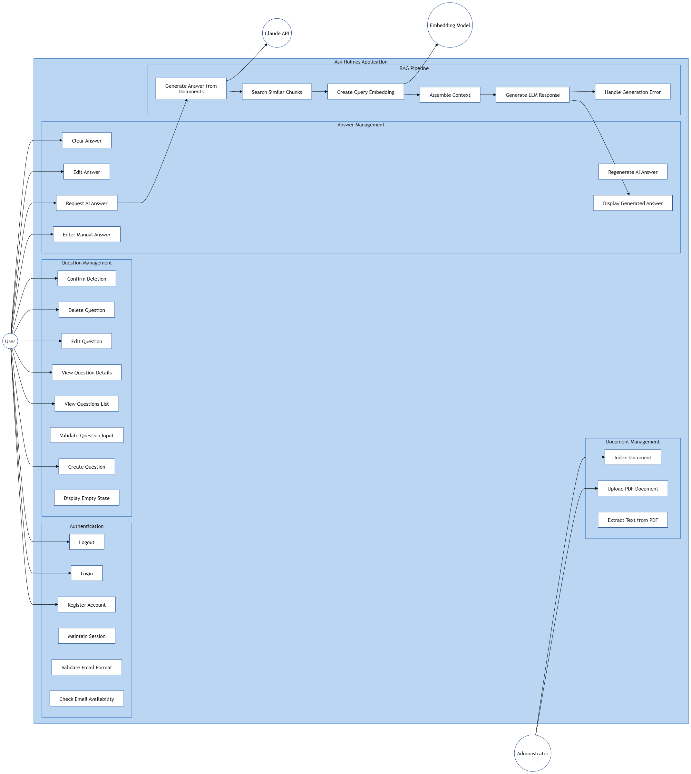
Figure 1: Use Case Diagram for Ask Holmes Application

4. Activity Diagram - Questions CRUD Operations
This chapter presents the activity diagrams for the basic CRUD (Create, Read, Update, Delete) operations on questions within the Ask Holmes application. These diagrams illustrate the flow of activities between the User and the System for each operation.

4.1 Create Question
Actors: User, System
Precondition: User is authenticated and on the Questions page
Postcondition: New question is created and displayed in the list
Flow of Activities:
- 1. User clicks "New Question" button
- 2. System opens Create Question Modal with empty form
- 3. User enters question title
- 4. User enters question content
- 5. User clicks "Save" button
- 6. System validates input
- 7. If valid: System sends POST request to /api/questions
- 8. System creates question in database with timestamp
- 9. System closes modal and displays success toast
- 10. System refreshes questions list
Alternative Flow (Invalid Input):
- 6a. System displays validation error message
- 6b. System highlights invalid fields
- 6c. User corrects input errors and returns to step 5

4.2 Read Questions (View List)
Actors: User, System
Precondition: User is authenticated
Postcondition: Questions list is displayed
Flow of Activities:
- 1. User navigates to Questions page
- 2. System sends GET request to /api/questions
- 3. System fetches user questions from database
- 4. If questions exist: System renders questions list with cards
- 5. Each card displays title, preview, and date
Alternative Flow (No Questions):
- 4a. System displays empty state message
- 4b. System shows "Create your first question" prompt

4.3 Read Question (View Details)
Actors: User, System
Precondition: User is on Questions list page
Postcondition: Question details are displayed with answer section
Flow of Activities:
- 1. User clicks on question card
- 2. System sends GET request to /api/questions/{id}
- 3. System fetches question details and associated answer
- 4. System navigates to Question Details page
- 5. System displays question title and content
- 6. If answer exists: System displays answer with Edit/Clear buttons
Alternative Flow (No Answer):
- 6a. System displays empty answer section
- 6b. System shows "Enter Answer" and "Ask Holmes" buttons

4.4 Update Question
Actors: User, System
Precondition: User is viewing a question they own
Postcondition: Question is updated with new content
Flow of Activities:
- 1. User clicks "Edit" button on question
- 2. System opens Edit Question Modal
- 3. System populates form with existing question data
- 4. User modifies question title and/or content
- 5. User clicks "Save Changes" button
- 6. System validates input
- 7. If valid: System sends PUT request to /api/questions/{id}
- 8. System updates question and modified timestamp
- 9. System closes modal and displays success toast
- 10. System refreshes question display
Alternative Flow (Invalid Input):
- 6a. System displays validation error message
- 6b. System highlights invalid fields
- 6c. User corrects input errors and returns to step 5

4.5 Delete Question
Actors: User, System
Precondition: User is viewing a question they own
Postcondition: Question and associated answer are deleted
Flow of Activities:
- 1. User clicks "Delete" button on question
- 2. System opens confirmation dialog
- 3. System displays "Are you sure?" message
- 4. User clicks "Confirm Delete" button
- 5. System sends DELETE request to /api/questions/{id}
- 6. System deletes question and associated answer from database
- 7. System closes dialog and displays success toast
- 8. System removes question from list
- 9. System navigates to Questions list page
Alternative Flow (Cancel Deletion):
- 4a. User clicks "Cancel" button
- 4b. System closes confirmation dialog
- 4c. System returns to previous state

4.6 PlantUML Diagram Code
The following PlantUML code can be used to generate a visual representation of the Activity Diagram. This code can be rendered using PlantUML online editor, VS Code PlantUML extension, or any compatible tool.
File location: diagrams/activity_diagram_questions_crud.puml
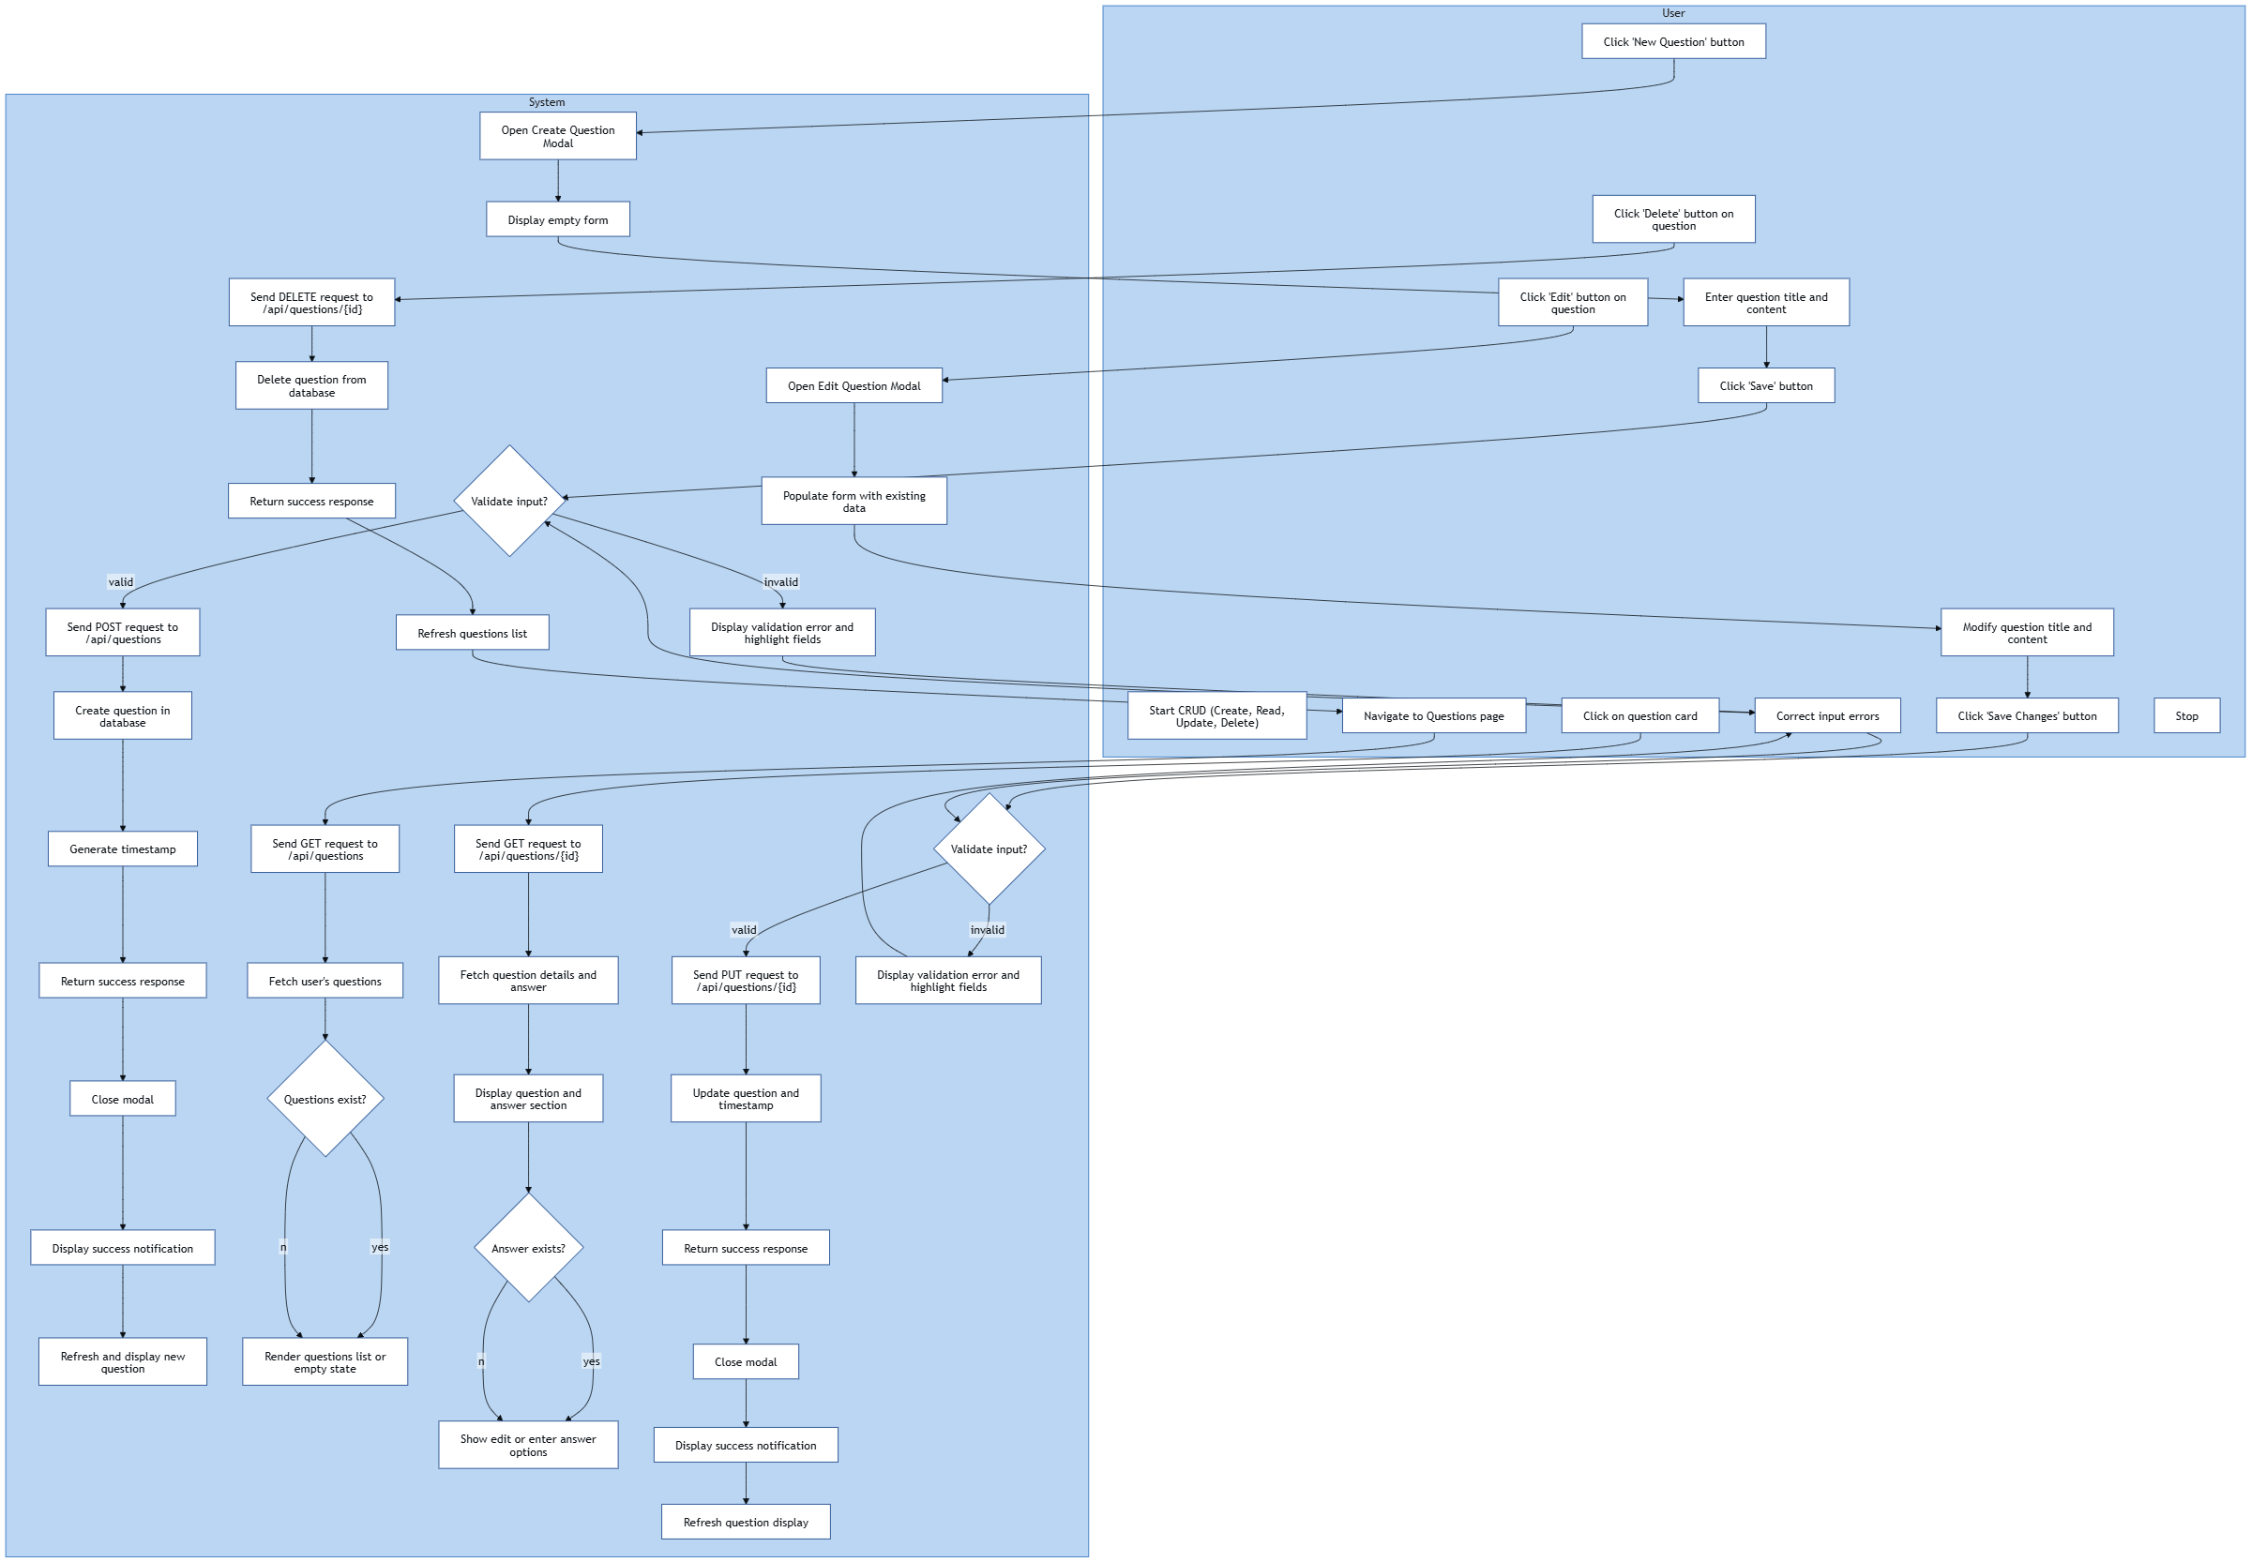
Figure 2: Activity Diagram for Questions CRUD Operations

5. Sequence Diagram - Questions CRUD Operations
This chapter presents the sequence diagrams for the basic CRUD (Create, Read, Update, Delete) operations on questions within the Ask Holmes application. These diagrams illustrate the interactions between the User, React Frontend, Flask API Backend, and PostgreSQL Database over time for each operation.

5.1 Participants
- User: The actor initiating all operations
- React Frontend: The client-side user interface handling user interactions and state management
- Flask API: The backend server processing requests and business logic
- PostgreSQL: The database storing questions and answers data

5.2 Create Question Sequence
- 1. User clicks New Question button
- 2. Frontend opens CreateQuestionModal and displays empty form
- 3. User enters title and content, clicks Save
- 4. Frontend validates input
- 5. Frontend sends POST /api/questions to Backend
- 6. Backend validates request and gets current user from session
- 7. Backend inserts question into Database
- 8. Database returns new question ID
- 9. Backend returns 201 Created to Frontend
- 10. Frontend closes modal, updates state, displays success toast

5.3 Read Questions (List) Sequence
- 1. User navigates to Questions page
- 2. Frontend sends GET /api/questions to Backend
- 3. Backend gets current user from session
- 4. Backend queries Database for user questions
- 5. Database returns questions array
- 6. Backend returns 200 OK with questions list
- 7. Frontend renders questions list or empty state

5.4 Read Question (Details) Sequence
- 1. User clicks on question card
- 2. Frontend sends GET /api/questions/id to Backend
- 3. Backend gets current user and queries question from Database
- 4. Backend queries associated answer from Database
- 5. Backend returns 200 OK with question and answer data
- 6. Frontend navigates to details page and displays content

5.5 Update Question Sequence
- 1. User clicks Edit button
- 2. Frontend opens EditQuestionModal with existing data
- 3. User modifies title/content and clicks Save Changes
- 4. Frontend validates input
- 5. Frontend sends PUT /api/questions/id to Backend
- 6. Backend validates and verifies ownership in Database
- 7. Backend updates question in Database
- 8. Backend returns 200 OK with updated question
- 9. Frontend closes modal, updates state, displays success toast

5.6 Delete Question Sequence
- 1. User clicks Delete button
- 2. Frontend opens confirmation dialog
- 3. User clicks Confirm Delete
- 4. Frontend sends DELETE /api/questions/id to Backend
- 5. Backend verifies ownership in Database
- 6. Backend deletes associated answer from Database
- 7. Backend deletes question from Database
- 8. Backend returns 200 OK
- 9. Frontend closes dialog, removes from state, displays success toast
- 10. Frontend navigates to questions list

5.7 Sequence Diagram
File location: diagrams/sequence_diagram_questions_crud.puml
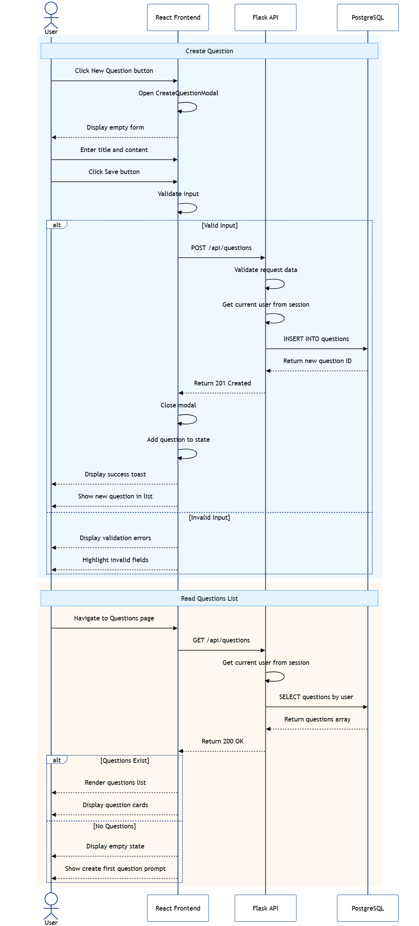
Figure 3: Sequence Diagram for Questions CRUD Operations

