Questions

1. Web Scraping

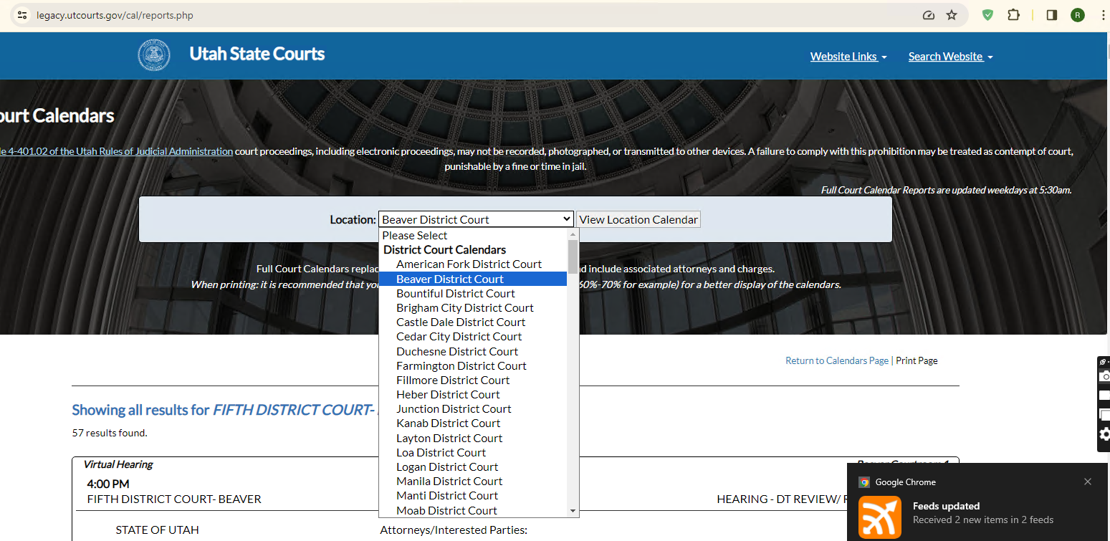

As you can see, there are a lot of locations in <https://legacy.utcourts.gov/cal/reports.php>.

So, my question is that client want to check all locations or their specific location?

1. Search Result Show

You mentioned that there will be unique fields of Case_number, Trial_type, Court_time and Court_date.

Do you mean every record will be identified by the combination of these 4 fields or every field will be unique for every record?

And do you want to show search result like legacy.utcourts.gov page?

I am not sure what records will be showed there.

Do you want to show all records at start time, then show filtered results by search?

1. AWS Account Credentials

I need AWS account credentials when I start the project.

I need to setup AWS Lambda for python script, AWS RDS or some database for database.

So, I need AWS account credentials for setup.

1. Payment

Will you pay the payment for every work phase?

I think it should be paid for every phase or milestone.

1. Estimated Time and Budget for Work scope

Hourly Rate: $35/hr.

1. Initial Phase – 1 day: 8 hours
2. Confirmed access to all environments, sites and applications
3. Verification that you have access to the public Utah State Courts site and an understanding of the data that it presents.
4. WordPress Phase – 4 days: 32 hours
5. Search Box functional – Global Search of all Published WordPress Posts for the site.

Ensure that the mobile view of the page allows for easy use of the search box.

2 days: 16 hours

1. Visually Appealing white space/padding around the image, creating visual white space between the image and the text for the post listing.  Ensure that the mobile view is equally visually appealing.

1 day: 8 hours

1. Updated image replacement for Hero sections of “Practice Areas” on the site.  Images in webp format for optimal image rendering for web and mobile viewing.

1 day: 8 hours

1. Web Scraping and WordPress Grid Page: 8 days/64 hours
2. New Page hosting grid with searchable access to the court cases.  Will have the ability to search against any column in the grid.  Please use datatables JS library for this grid.  Search and Paging should be an AJAX call, as the number of court cases can be rather large, and may cause slowdowns or timeouts when displaying the number of rows.  Please show 50 lines per page.

3 days: 24 hours

1. AWS Lambda Function for scraping.  This will be a python solution (one or many files) and I will have my cloud engineer setup the scheduled running.

3 days: 24 hours

1. Testing to ensure that the function and page work together.

2 days: 16 hours

Total Days/Hours: 13 days/104 hours/$3640(35*104)