CSCI 6406 Visualization – Project Updates

**D3 Visualization Research and Implementation**

**The trends of new house price index in Canada**

Song Zhao B00694453

**Summary of the updates**

The works have done:

* Data clean.
* Build local web server.
* Convert dataset to json and load it to the project.
* Implemented simple bar chart by the dataset.
* Added simple interaction.
* Read more research paper.

The works need to complete:

* Adding complex interaction -Animation.
* Use geo map to present the data.
* Adding more implements from research paper.
* Write the report.

The project implement has done probably 30% currently. Due to busy on other courses before, the project progress is slower than expected. I will focus on the project start from this month and try to finish it soon. The detail of completed works at below.

1. Data clean

I got the original dataset from Statistics Canada. The dataset includes many entries, some of them are not necessary or not good formatting for the project. I have removed some columns such as DGUID, UOM, UI_ID, SCALAR, STATUS, SYMBOL. In addition, I used pandas [1] to reformat date columns and removed some redundancy entries. The dataset has been optimized for the project with a minimum size. In figure 1, the cleaned dataset only includes 4 columns, which are date, location, vector, coordinate and value. There are totally 4586 rows which includes 10 years housing price index data for all provinces of Canada.

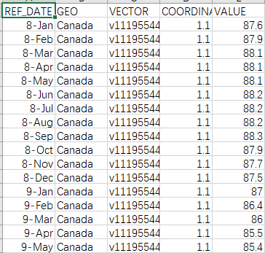

Figure 1. screenshot of the cleaned dataset.

1. Build local web server

For AJAX reason, I built a local server to present the project implement. The Running Environment are: i5-6300HQ,2.30GHz,4cores,16GB RAM. With XAMPP v3.2.2 (apache THHP server, Mysql, php). The local server has tested and reset the document root to the project folder.

1. Convert dataset to json and load it to the project

I have converted the dataset.csv the json file by using an online tool [2], since the json type is light than csv, it is good for web environment. After that, in figure 2. I used “XMLHttpRequest” to load the dataset.json into the project.

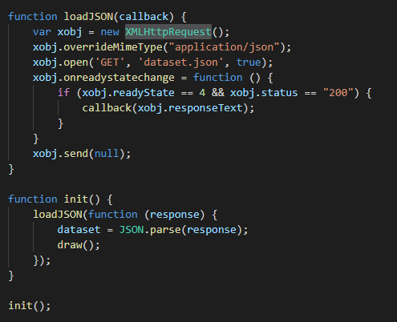

Figure 2. load json function by using XMLHttpRequest.

1. Implemented simple bar chart by the dataset

By using the dataset, I created a simple bar chart with date and housing price index. And tested it in the local host. My plan is to add more complex animation based the bar chart and geo map to present the data. In figure 3. This is screenshot of the dataset. There are totally 4586 bars.

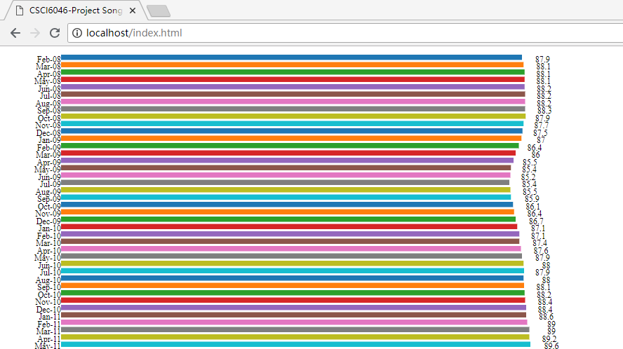

Figure 3. The screenshot of bar chart of the dataset.

1. Added simple interaction

The simple interactions have added to the chart. Which includes color and size change when mouse over and out. More complex interaction should be added later.

1. Read more research paper

I have read 2 more research paper which names are:

* A Web-based visual analytics system for real estate data [3]
* HomeSeeker: A visual analytics system of real estate data [4]

From the paper, I would like to use the combine method to present the geographical distribution of the houses with clusters and the stacked graph (or other graph style) view housing price index together [3]. In addition, add animation to present the housing price index in the 10 years.

There is still a lot work need to be done. The works need to complete. Before the due day, I should finish the implements at below:

1. Adding complex interaction -Animation.

The current difficulty level is not enough. I found a cool data present animation from YouTube. I would like to implement my project by part of idea by that way, and do some changes based on the animation. In figure 4, the screenshot presents the global GPD in past 100 year and expectation on future 50 years (The video link at blew the figure 4). My changes should be added different colour in a same province by different year. In addition, to add more simple animations combined with the main animations. To makes the overall visual effects better (I hope so, if not, I will modify it later).

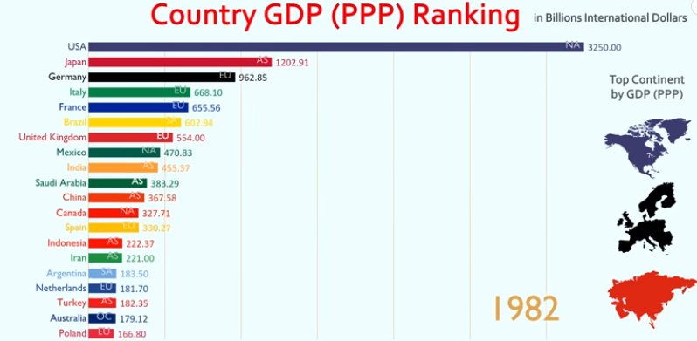

Figure 4. Top 20 Country GDP Ranking History

<https://www.youtube.com/watch?v=O1WC2Sl2jgg>

1. Use geo map to present the data.

I will also use a Canada map to present the dataset. The province color should be changed dynamically, when the housing price index over or lower than a threshold. In addition, as mentioned method in [3]. I will combine the Canada map and bar chart animation together in a same screen and present them synchronously.

1. Adding more implements from research paper.

If I have enough time, I should read more paper and find out if there are any new ideas I can use in the project. I found some paper but have not start to read. Which are:

* Cooperative Integrated Web-Based Negotiation and Decision Support System for Real Estate [5]
* THE APPLICATION OF GIS 3D MODELING AND ANALYSIS TECHNOLOGY IN REAL [6]

ESTATE MASS APPRAISAL

* Using and Evaluating Augmented Reality for Mobile Data Visualization in Real Estate Classified

Ads [7]

1. Write the report.

After I done the basic function of the report, I will start to write the report. The report should include abstract, background, Introduction, implementation, analysis, experiment and conclusion.

Reference:

1. Pandas. https://pandas.pydata.org/
2. Convertcsv.com. http://www.convertcsv.com/csv-to-json.htm
3. Sun GD, LIANG RH, WU FL, QU HM. A Web-based visual analytics system for real estate data. May 2013. doi: 10.1007/s11432-013-4830-9.
4. Li MZ, Bao ZF, Sellis T, Yan S, Zhang R. HomeSeeker: A visual analytics system of real estate data. June 2017. doi.org/10.1016/j.jvlc.2018.02.001
5. Kaklauskas A, Zavadskas E, Andruskevicius A. Cooperative Integrated Web-Based Negotiation and Decision Support System for Real Estate. CDVE 2005, LNCS 3675, pp. 235 – 242, 2005
6. Zhang H, Liu B, Liu C. THE APPLICATION OF GIS 3D MODELING AND ANALYSIS TECHNOLOGY IN REAL ESTATE MASS APPRAISAL- TAKING LANDSCAPE AND SUNLIGHT FACTORS AS THE EXAMPLE. The International Archives of the Photogrammetry, Remote Sensing and Spatial Information Sciences, Volume XL-4, 2014
7. Macedo D, Rodrigues M, Furtado J, Furtado E, Chagas D. Using and Evaluating Augmented Reality for Mobile Data Visualization in Real Estate Classified Ads. doi.org/10.2316/Journal.202.2014.1.202-3737