**CSCI 6406 Visualization – Final Report**

**D3 Visualization Research and Implementation**

**A web visual tool for analyzing house price of Canada**

By

Song Zhao B00694453

Mar 31.2019

**Abstracts**

D3 is a useful JavaScript library for data visualization, it could simplify complex tasks. This report introduces a web visual tool which has been implemented for the project by using D3 library. The tool for analyzing house price trend, it could help house buyer to make decision. In the tool, a Canada map is generated by Geo data. The map could help user for area selecting. After that, a set of house price index data are presented by bar charts next of the map. A dataset has included ten years (2008 – 2018) house price index of Canada which will be used for testing the tool. In addition, this report discusses effects of data presenting with performance and future work.

Table of Contents

Introduction 3

Background 3

Methods 4

Discussion 7

Conclusion 8

Recommendation 8

Reference 8

# Introduction

Data visualization is a popular field in the today’s society. A growing number of people start to use exquisite diagrams on their work domain. How to implement a great diagram which is an important part of Data visualization. D3 is a powerful JavaScript library for data visualization. It can simplify complex visualization tasks. Therefore, the D3 can present a high-quality work in a short time. In the report, a web visual tool will be introduced. The tool is implemented by D3 library, it is for analyzing house price trend in both short and long term. The two major components of the tool are Canada map view and bar chart view. The map is generated by geo data which from [1]. A province can be selected when user mouse move over on the map. After that, house price index data of this province will display on the bar chart view. User can easy to see a data changes on the chart view. In addition, the colour of bars will change from green to blue as time goes on, however, if the house price index is higher than base year, the colour changes to red automatically. The feature sends a warning to user for distinguishing price index. There is a drop-down list in the map view, which can help user to select a specific year. Then the chart view display bigger bars when user selects a province. The web tool is easy to use and agile. It can help house buyer or investor to make a fast and accurate decision in a real estate market. Moreover, the report also includes system optimizing and performance, since the system need to load a lot of data and filter and display them in a short time. Finally, in recommendation section, there some suggestions relative to D3 update and better to use by developers.

# Background

The house price rapidly rising in many countries in recent decades. Same thing happens in Canada. Some big cities such as Toronto or Vancouver, the house price has increased several times or more in the last 10 years. Own a house or apartment has become to the harder thing for people. A home buyer or investor make loss lots of money, if they cannot make a correct decision in a real estate’s market. Therefore, the demand of analysis tools of real estate market is growing in Canada and other countries. For economic reason or breaking the unfair current situation, the developers created many real estate analysis tools. This report exhibitions one of the sample analysis tool for real estate market. The tool has created for the visualization course by the author.

# Methods

A part of design idea is based on two paper [2] [3]. In the paper, the author implemented a web real estate analysis tool with 4 views (Map view, Stacked graph view, Pixel-bar view and Treemap view) which integrated in one window. In my tool, I added map view, bar chart view which are similar with the paper. In additional, I also added a pie chart view, a data filter option and several interactive features with animation for the tool.

The major techniques, tools and equipment’s use for the tool at below:

* Programming language: JavaScript, HTML, CSS.
* Development IDE: Visual studio Code.
* Library: D3.
* Local web server: XAMPP v3.2.2 – apache HTTP server.
* Running environment: i5-6300HQ,2.30GHz,4cores,16GB RAM, GTX-960m graphic card.

A brief description of the implementation procedures.

1. Work has done before project updates.

* Data clean. The original dataset of house price index from Statistics Canada [6]. Some unnecessary columns have been removed and removed. The cleaned dataset includes 4 columns, which are date, location, vector, coordinate and value. There are totally 4586 rows which includes 10 years housing price index data for all provinces of Canada. The data is stored as json format.
* Build local web server. For AJAX reason, a local server has been built to present the project implement. Use “XMLHttpRequset” method [9] to load json file.
* Implemented a simple bar chart by the dataset base on the tutorial [7].

1. Work has done after project updates.

* Canada map. In figure 1, based on tutorial [8], a Canada map is generated in the system by using Canada geo-data json file. The provinces were filled in different colours. If no data in a province, use light gray to fill it. Each province is clickable with animation.

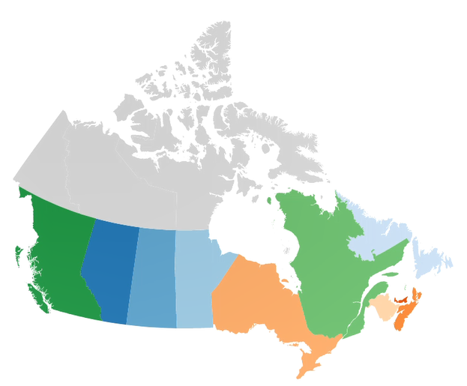

*Figure 1. Canada map in the system.*

* Improved bar chart. In figure 2, the bar chart can display overall data or enter to a specified year. The colour will be changed from green to blue due to time lapse. However, if a house price higher than base price in any moment, the colour will be filled in red. All bars, dates and values added interactive animation.

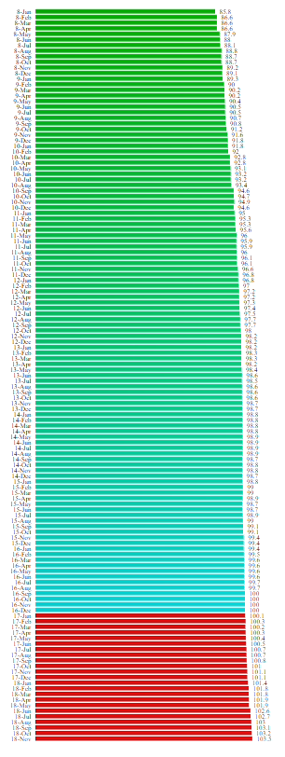 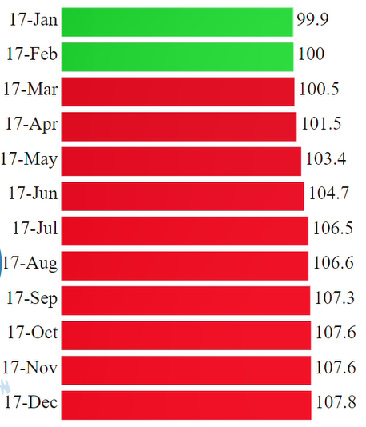

*Figure 2. An example of improved bar chart.*

* Added a drop-down list which tutorial from [10] for data selecting. In figure 3, user can check a specific data by year. The year selection based on keywords in the dataset file. To obtain and store the specific subset by traversing the dataset.

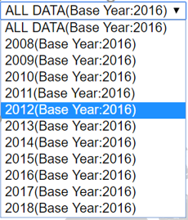

*Figure 3. drop-down list in the tool.*

* Added privonce flag when presenting data. In figure 4, a flag of province will be displayed when mouse move over a province on the map view data. It makes the tool more intuitive and artistic. The flags stored in a flags(local) folder in the project.

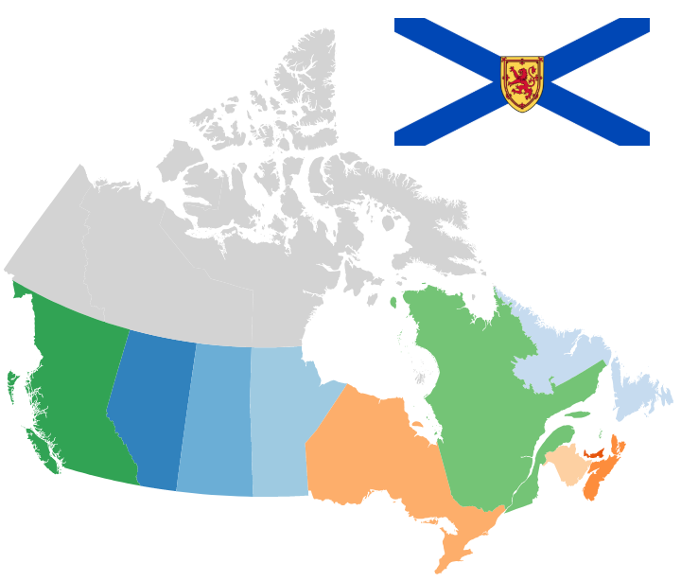

*Figure 4. Nova scotia flag on the Canada map.*

* Added bar chart beside of the map view. In the figure 5. A province will be selected when mouse move over a place. After that, based on the down-down list selection. The specific data will be displayed in the right of the map, meanwhile, display the province flag at the middle.

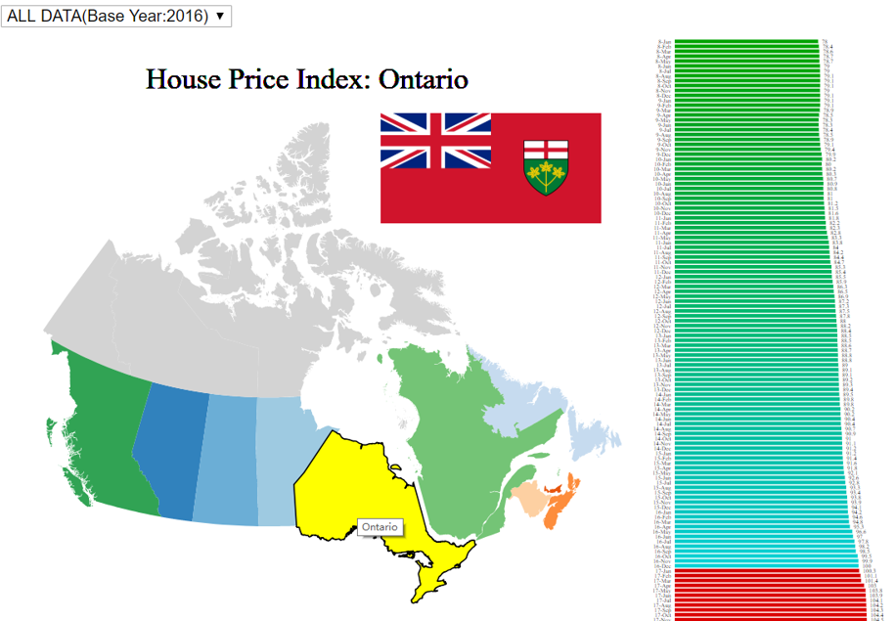

*Figure 5. Overview of the web visual tool.*

* Finally, added a piechart to display a proportion of price increase in a province during a selected time. The pie chart is turn to visible when mouse move over a bar chart. In the figure 6, the orange area represents the over price, the dark blue represents current price index and the light blue represents the price index of base year.

*Figure 6. The overall view with pie chart.*

# Discussion

D3 JavaScript library is a good helper to generate visual data. It could help developer create a beautiful view in a short time. However, a performance issue could be happened if there are any inappropriate coding in the program. Because a large dataset could be loaded in many scenarios. If handled data improperly, system stuck can happen frequently. In this project, the system was running slow when load data(8000+entries). Based on the suggestion at [4] and [5], we used three optimized methods to solve the problem. First, optimized the dataset again. All data which is not called for the system has been moved from the json file. Second, use global variable to store filtered data and canvas when the system was running. If the data is loaded frequently or new canvas is created frequently, the system cost will be too much. Third, do not call “select” or “selectAll” methods in a mouseover function. It must slow the system. Due to the algorithm reason, the “select” or “selectAll” will traverse whole elements to find the target. In mouseover scenario, the “select” or “selectAll” methods will be called very frequently. Also, it will trigger Multithreaded traversal. Our solution is that create a global variable to store an element which will be used later. After that, just add remove method of the element in mouse out action. By using the three ways, our system is running smooth to present large data right now.

# Conclusion

D3 is a powerful JavaScript library which can help create exquisite visual data. It can make data analysis easier. In real estate market or other relative fields, a tool of visual data is very important. Because it can help house buyer or investor to make a fast and accurate decision. It is very utility, since the tool can both save time and money. Our web visual tool has implemented by D3 library, which for analyzing house price index of Canada. Good performance allows the tool available to load large dataset. It is benefit to users. In addition, add more features to the tool and performance balance could be future works.

# Recommendation

The D3 is at the fifth version currently, a fast version updating is a benefit for visualization developer. However, lots of calling method have changed due to the updating. It may bring trouble to some developer who is getting used to old coding style. It should be good if there are fixed calling methods in future versions. In addition, some methods such as “select” and “selectAll” could be optimized deeper. Overall, D3 is a great visualization tool, it should be used by more developers.

# Reference

[1] Mdgnkm, Raw.github.com, 2019. [Online]. Available:

https://raw.github.com/mdgnkm/SIG-Map/master/canada.json. [Accessed: 31- Mar- 2019].

[2] Sun GD, LIANG RH, WU FL, QU HM. A Web-based visual analytics system for real estate data. May 2013. doi: 10.1007/s11432-013-4830-9.

[3] Li MZ, Bao ZF, Sellis T, Yan S, Zhang R. HomeSeeker: A visual analytics system of real estate data. June 2017. doi.org/10.1016/j.jvlc.2018.02.001

[4] T. Tiberghien, "React + D3.js: Balancing Performance & Developer Experience", Medium, 2019. [Online]. Available: https://medium.com/@tibotiber/react-d3-js-balancing-performance-developer-experience-4da35f912484. [Accessed: 01- Apr- 2019].

[5] T. Simmons, "D3 SVG chart performance", Scott Logic, 2019. [Online]. Available: https://blog.scottlogic.com/2014/09/19/d3-svg-chart-performance.html. [Accessed: 01- Apr- 2019].

[6] Statistic Canada [online] Available at:

https://www150.statcan.gc.ca/t1/tbl1/en/tv.action?pid=1810020501 [Accessed 8 Feb. 2019].

[7] P. Block, "DashBoard", Bl.ocks.org, 2019. [Online]. Available:

http://bl.ocks.org/NPashaP/96447623ef4d342ee09b. [Accessed: 01- Apr- 2019].

[8] Mdgnkm, "Making Maps on D3 — Tutorial", Social Innovation Simulation, 2019. [Online]. Available: https://socialinnovationsimulation.com/2013/07/11/tutorial-making-maps-on-d3/. [Accessed: 01- Apr- 2019].

[9] "Using XMLHttpRequest", MDN Web Docs, 2019. [Online]. Available: https://developer.mozilla.org/en-US/docs/Web/API/XMLHttpRequest/Using_XMLHttpRequest. [Accessed: 01- Apr- 2019].

[10] C. Williams, "Updating bar chart with dropdown", Bl.ocks.org, 2019. [Online]. Available: http://bl.ocks.org/williaster/10ef968ccfdc71c30ef8. [Accessed: 01- Apr- 2019].