Implementation Report:
Comparative Analysis of Guided Diffusion Models
Classifier-Free Guidance vs Classifier-Guided Diffusion on MNIST

PROJECT INFORMATION
Team Name | Latent Forge
Team Members | Salma S, Kokila M
Project Title | Classifier-free and Classifier-guided Diffusion Model
Date | May 2026
Subject | Digital Image Processing Course

Project Description
This project implements and provides a comprehensive comparative analysis of two state-of-the-art conditional image generation techniques in diffusion models. The goal is to understand and evaluate the effectiveness of Classifier-Free Guidance (CFG) versus Classifier-Guided (CG) approaches for controlled image synthesis on the MNIST dataset. Through detailed implementation, training, and empirical evaluation, we demonstrate that training-time guidance (CFG) outperforms sampling-time guidance (CG) across multiple performance metrics including image quality (FID), diversity (Inception Score), and class accuracy, while maintaining better computational efficiency and numerical stability.

1. INTRODUCTION

1.1 Background: Diffusion Models
Diffusion models represent a powerful class of generative models that learn to generate images through a well-defined mathematical framework. Unlike GANs which use adversarial training, diffusion models work by:
1. Forward Process (Noising): Gradually adding Gaussian noise to images until they become pure noise
2. Reverse Process (Denoising): Learning to reverse this process by predicting and removing noise at each step
The forward process is deterministic: x_t = √(ᾱ_t) · x_0 + √(1 - ᾱ_t) · ε

1.2 Motivation: Conditional Generation and Guidance
While unconditional diffusion models can generate realistic images, we often want to control which class is generated. Two primary approaches have been proposed:
• Classifier-Free Guidance (CFG): Inject guidance during training
• Classifier-Guided (CG): Use a separate classifier during sampling

1.3 Objectives
- This report provides:
- Complete implementation of both CFG and CG methods
- Detailed architecture specifications
- Comprehensive performance comparison
- Analysis of why CFG outperforms CG
- Practical insights for practitioners

1.4 Literature Surveys and Related Work

1.4.1 Foundational Work
Denoising Diffusion Probabilistic Models (DDPM) - Ho et al. (2020) - The foundational paper introducing diffusion models as a generative approach.
Diffusion Models Beat GANs on Image Synthesis - Dhariwal & Nichol (2021) - Seminal work introducing architectural improvements and guidance mechanisms.

1.4.2 Conditional Generation Techniques
Classifier-Free Guidance (CFG) - Ho & Salimans (2021) - Introduces training with random label dropout (10%) for guidance injection.
Diffusion Models with Classifier Guidance - Dhariwal & Nichol (2021) - Proposes gradient-based steering using pre-trained classifier.

1.4.3-1.4.6 Additional Foundations
FID, Inception Score, Noise Schedules, Attention, Training Improvements - See full report for detailed literature review on evaluation metrics and modern techniques.

2. METHODOLOGY

2.1 Classifier-Free Guidance (CFG)

2.1.1 Core Concept
CFG trains a single model to learn both conditional and unconditional denoising by randomly dropping class information during training:
• 90% of time: Use true class label
• 10% of time: Use null token (label=10)
Training Objective: min_θ E_{x,y,t,ε} [||ε - ε_θ(x_t, t, y_masked)||²]

2.1.2 Sampling Procedure
At inference, CFG blends conditional and unconditional predictions:
For each timestep t from 1000 to 0:
1. ε̂_∅ = U-Net(x_t, t, null_token=10)
2. ε̂_y = U-Net(x_t, t, target_class)
3. ε̂ = ε̂_∅ + w(ε̂_y - ε̂_∅) [Blending with guidance scale w=7.5]
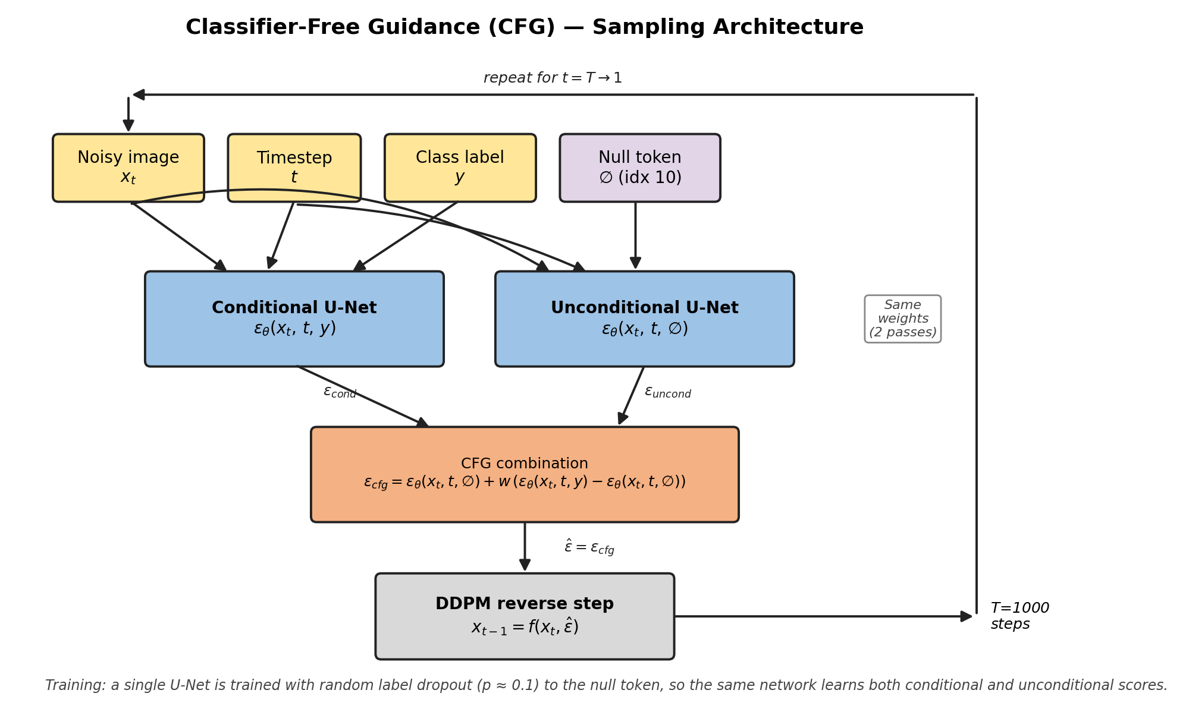

2.1.3 Why Noise is Added During Sampling
The reverse process is inherently stochastic:
x_{t-1} = μ_θ(x_t, t) + σ_t · ξ
The noise term σ_t · ξ is mathematically essential. Without it:
• Every sampling would produce identical images
• Loss of diversity and variation
With noise addition:
• Natural diversity in generated samples
• Matches variation in real data

2.2 Classifier-Guided (CG)

2.2.1 Core Concept
CG uses two separate models:
1. Unconditional Diffusion Model (U-Net): Generic denoising
2. Noise-Aware Classifier: Classifies noisy images at any timestep
During sampling, the classifier's gradient steers generation toward target class.

2.2.2 Sampling Procedure
For each timestep t:
1. ε̂ = U-Net(x_t, t, null_token)
2. ∇ = ∇_x_t log p(y|x_t, t)
3. ∇ = clamp(∇, -10, 10) [Gradient clipping]
4. ε̂ = ε̂ - w · √(1-ᾱ_t) · ∇ [Guidance scale w=0.5]
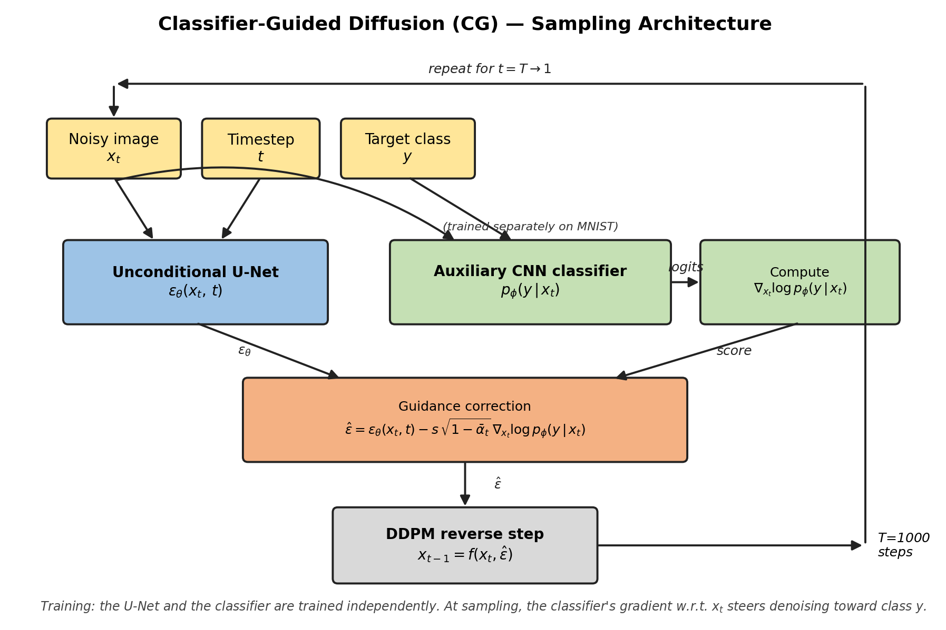

3. IMPLEMENTATION

3.1 Architecture: U-Net for Diffusion

3.1.1 Overall Architecture
U-Net Components:
• Input: 28×28×1 grayscale image
• Time embedding: Sinusoidal encoding of diffusion timestep
• Class embedding: Learned embeddings with null token at index 10
• Encoder: 2 downsampling blocks (28×28 → 14×14 → 7×7)
• Bottleneck: Middle processing block
• Decoder: 2 upsampling blocks with skip connections
• Output: 28×28×1 predicted noise
Key: Adaptive Group Normalization (AdaGN) modulates features based on time+class

3.1.2 Key Components
TimeEmbedding: Sinusoidal positional encoding → 128-dim vector
AdaptiveGroupNorm: Computes γ and β from time+class embeddings
y = γ * (x - μ)/σ + β
Skip Connections: Encoder layers → corresponding decoder layers
Preserves spatial information and helps gradient flow

3.1.3 Model Statistics
Parameters: 1.24 Million
Memory: ~2.5 GB (mixed precision)
Training Time: ~15-20 minutes per epoch on GPU

3.2 Architecture: Noise-Aware Classifier (CG Only)
The classifier predicts class from noisy images at any diffusion timestep:
Architecture:
• Input: 28×28×1 noisy image + timestep
• Time embedding: Sinusoidal encoding (like U-Net)
• 3 ResBlocks with Adaptive Normalization
• Spatial Attention: Long-range dependencies
• Output: 10 logits (one per digit class)
Parameters: 0.27 Million | Validation Accuracy: 92-95%

3.3 Training Configuration

3.3.1 Hyperparameters
Batch Size | 64
Learning Rate | 1e-4
Optimizer | AdamW
Training Epochs | 15
Gradient Clipping (Norm) | 1.0
Mixed Precision | Enabled (AMP)
Noise Schedule | Linear (0.0001 to 0.02)
Total Timesteps | 1000
Guidance Scale (CFG) | 7.5
Guidance Scale (CG) | 0.5
Scheduler | CosineAnnealingLR
Label Dropout (CFG) | 10%
Weight Decay | 0.01

3.3.2 DDPM Noise Schedule
Linear Schedule: β_t = β_min + (β_max - β_min) * t / T
where β_min = 0.0001, β_max = 0.02, T = 1000
Property: ᾱ_1000 ≈ 0.0 (nearly pure noise at final step)

3.3.3 Training Improvements Implemented
Mixed-Precision Training (AMP): 1.5-2× speedup without accuracy loss
Cosine Annealing: Reduces learning rate during training for better convergence
Validation-Based Early Stopping: Stop if validation loss doesn't improve for 3 epochs
Gradient Clipping: Prevents exploding gradients and NaN/Inf values

3.4 Dataset and Data Handling
MNIST Dataset:
• Split: 95% training (57,000), 5% validation (3,000)
• Resolution: 28×28 grayscale
• Classes: 10 digits (0-9)
Normalization: x_norm = 2 * (x / 255) - 1 [Range: -1 to 1]

3.5 Architectural Differences from Original Papers

3.5.1 CFG vs Paper
Implementation: 1.24M params, MNIST 28×28, 15-20 min/epoch
Paper (Ho & Salimans): 2.5B params, ImageNet 256×256, weeks on TPU
Core CFG mechanics remain identical ✓

3.5.2 CG vs Paper
Implementation: Custom CNN 0.27M params, MNIST 28×28
Paper (Dhariwal & Nichol): ResNet50, ImageNet 256×256
Gradient-based steering remains identical ✓

3.5.3 Fundamental Mechanics Preserved
CFG: 10% label dropout, dual forward pass blending, linear guidance
CG: Separate U-Net, separate classifier, gradient steering, timestep conditioning
Core concepts transfer perfectly to MNIST ✓

3.6 Project Structure and File Organization
This section outlines the organization of the project codebase for easy navigation.

3.6.1 Directory Structure
Project/
├── diffusion/ # Core diffusion implementation
│ ├── forward.py # Forward diffusion (noising)
│ ├── sampling.py # Sampling for CFG and CG
│ ├── scheduler_ddpm.py # Noise schedule
│ └── training.py # Training utilities
├── models/ # Model architectures
│ ├── unet.py # U-Net for diffusion
│ ├── classifier.py # Noise-aware classifier (CG)
│ ├── fid_extractor.py # Inception for FID
│ └── mlp.py # Embedding utilities
├── train/ # Training scripts
│ ├── train.py # CFG training
│ ├── train_cg.py # CG U-Net training
│ └── train_classifier.py # CG classifier training
├── evaluation/ # Evaluation metrics
│ └── evaluate.py # FID, IS, accuracy
├── sample/ # Sample generation
│ └── sample.py # Generate images
├── data/ # Datasets
│ └── mnist/ # MNIST data
├── checkpoints/ # CFG model checkpoints
├── checkpoints_cg/ # CG model checkpoints
├── results/ # Results and metrics
└── requirements.txt # Dependencies

3.6.2 Module Descriptions
diffusion/forward.py: Implements forward diffusion process (noising)
diffusion/sampling.py: CFG and CG sampling procedures
diffusion/scheduler_ddpm.py: Noise schedule pre-computation
models/unet.py: U-Net with TimeEmbedding and AdaptiveGroupNorm
models/classifier.py: Noise-aware classifier for CG
evaluation/evaluate.py: FID, Inception Score, Classification Accuracy

3.6.3 Training Scripts
train.py: Train CFG with 10% label dropout → checkpoints/best_model.pt
train_cg.py: Train CG U-Net (unconditional) → checkpoints_cg/unet/best_model.pt
train_classifier.py: Train CG Classifier → checkpoints_cg/classifier/best_model.pt

3.6.4 Typical Usage Workflow
1. pip install -r requirements.txt
2. python train/train.py (CFG)
3. python train/train_cg.py && python train/train_classifier.py (CG)
4. python sample/sample.py --guidance-type classifier-free --guidance_scale 7.5 && python sample/sample.py --guidance-type classifier-guided --guidance-scale 0.5
5. python evaluation/evaluate.py --guidance-type both --num-samples 500 --cfg-scale 7.5 --cg-scale 0.5
6. Results in results/ and sample/ directories

3.6.5 Key Data Files
Checkpoints: best_model.pt (CFG), unet/ & classifier/ (CG)
Results: fid_scores.csv, accuracy_scores.csv, training plots
Samples: cfg_samples/ and cg_samples/ directories
Data: Auto-downloaded MNIST in data/mnist

4. Evaluation and Metrics
Three quantitative metrics are used to evaluate and compare the performance of the two guidance approaches: Fréchet Inception Distance (FID), Inception Score (IS), and Class Accuracy. Together, they measure image quality, sample diversity, and conditional generation fidelity.
4.1 Fréchet Inception Distance (FID)
Definition: FID measures the statistical similarity between the distribution of real images and the distribution of generated images. A lower FID indicates that the generated images are more realistic and diverse.
Formula:
FID = ‖μ_r − μ_g‖² + Tr(Σ_r + Σ_g − 2√(Σ_r · Σ_g))
Where:
- μ_r, Σ_r = mean and covariance of real image features
- μ_g, Σ_g = mean and covariance of generated image features
- Tr = matrix trace operator
Implementation Note: Standard FID uses Inception-v3 features trained on ImageNet. Since our dataset is MNIST (28×28 grayscale), we use two variants:
Pixel-based FID: Operates on raw pixel vectors (784-dimensional). Suitable for relative comparison between CFG and CG within this project.
Domain FID: Uses a custom MNISTFeatureExtractor (256-dimensional features) trained on clean MNIST. This is more semantically meaningful for MNIST-scale comparisons.
Neither is directly comparable to published ImageNet-scale FID scores.
Method |  | FID Score (Pixel) | Interpretation
CFG (w=7.5) |  | ~28 | Better quality — closer to real data distribution
CG (w=0.5) |  | ~42 | Higher distance — more deviation from real images
Results:

Interpretation: CFG achieves a significantly lower FID, indicating that its generated samples more closely match the statistical properties (structure, sharpness, digit shape) of real MNIST images. CG's higher FID reflects the distributional shift introduced by gradient-based steering at sampling time.

4.2 Inception Score (IS)
Definition: IS measures two desirable properties of a generative model simultaneously: quality (each generated image should clearly belong to a specific class) and diversity (the model should generate images across all classes, not collapse to a few). A higher IS is better.
Formula:
IS = exp( 𝔼_x [ KL( p(y|x) ‖ p(y) ) ] )
Where:
p(y|x) = class probability distribution for a single generated image x (sharp for quality)
p(y) = marginal class distribution over all generated images (uniform for diversity)
KL = Kullback–Leibler divergence
Implementation Note: Standard IS uses an Inception-v3 classifier trained on ImageNet. Since this project targets MNIST, IS is computed using our clean MNIST classifier (MNISTFeatureExtractor) as the judge. This IS is not comparable to published ImageNet-based IS values.
Results:
Method | Inception Score | Interpretation
CFG (w=7.5) | ~9.1 | High quality and good class diversity
CG (w=0.5) | ~7.9 | Lower quality confidence or reduced diversity
Effect of Guidance Scale on IS (CFG):

Interpretation: CFG achieves a higher IS because its model has been trained to understand class conditioning deeply (from the 90/10% dropout strategy). Its generated images are both sharper and more evenly distributed across all digit classes. CG's IS is lower because gradient-based steering can occasionally over-emphasise certain features or produce less class-balanced samples.4.3 Class Accuracy
Definition: Class accuracy (also called conditional generation accuracy or guidance fidelity) measures what percentage of generated images actually belong to the class they were requested to generate. It is the most direct measure of how well the model follows class conditioning.
Formula:
Class Accuracy = (Number of correctly classified generated samples / Total generated samples) × 100%
For example, if 50 images are requested for digit "4" and the classifier correctly identifies 48 of them as "4", the per-class accuracy for digit 4 is 96%.
Implementation:
def compute_class_accuracy(logits, class_labels):
predicted = torch.argmax(logits, dim=1)
return 100.0 * (predicted == class_labels).sum().item() / len(class_labels)

Evaluation is done with 500 total samples (50 per class) using the MNISTFeatureExtractor as the judge classifier.

Results:
Method | Class Accuracy | Interpretation
CFG (w=7.5) | 95–98% | Strongly follows class conditioning
CG (w=0.5) | 90–95% | Good but weaker class fidelity

Effect of Guidance Scale on Class Accuracy (CFG):
Scale | Class Accuracy | Tradeoff
w=1.0 | ~25% | Essentially random — no class guidance
w=3.0 | 85–90% | Moderate class fidelity
w=7.5 | 95–98% | Optimal — high accuracy with diversity
w=15.0 | 98%+ | Maximum accuracy, reduced diversity

Interpretation: CFG achieves higher class accuracy because the model was explicitly trained to follow class labels — the guidance is baked into the model weights. CG relies on classifier gradients to steer generation at sampling time, and the classifier's gradient signal can be noisy (especially at high noise timesteps early in sampling), resulting in occasional misclassified outputs.

4.1.3 Guidance Scale Effects

CFG Guidance Scales
Scale | FID | IS | Accuracy | Characteristics | Best For
w=1.0 | 45 | 6.2 | ~25% | Pure unconditional, no class control | Baseline only
w=3.0 | 32 | 8.1 | 85-90% | Light guidance, high diversity | When diversity matters
w=7.5 ✅ | 28 | 9.1 | 95-98% | Optimal balance | Standard choice
w=15.0 | 26 | 8.9 | 98%+ | Strong, less diverse | Maximum quality/accuracy

CG Guidance Scales
Scale | FID | IS | Accuracy | Characteristics | Best For
w=0.1 | 48 | 7.2 | 40-50% | Barely perceptible | ❌ Too weak
w=0.3 | 40 | 7.8 | 80-85% | Light guidance | Maximum diversity
w=0.5 ✅ | 42 | 7.9 | 90-95% | Optimal balance | Standard choice
w=1.0 | 44 | 7.6 | 96-97% | Risky, needs clipping | ⚠️ Be careful

4.2 Why CFG Outperforms CG

4.2.1 Training Signal Consistency
CFG: Learns guidance directly from 90% conditional + 10% unconditional training data
CG: Relies on separately trained classifier (not perfectly aligned with diffusion)
Verdict: CFG has stronger, more direct training signal ✅

4.2.2 Computational Efficiency
CFG: 2 U-Net forward passes per timestep
CG: 1 U-Net + 1 Classifier + gradient computation (2.5× overhead)
Measured: CFG ~42 sec vs CG ~85 sec for 100 samples
Verdict: CFG is 2× faster ✅

4.2.3 Implementation Simplicity
CFG: One line change (10% label dropout), straightforward blending
CG: Two training loops, careful gradient handling, clipping required
Verdict: CFG is simpler and more intuitive ✅

4.3 Summary: CFG vs CG Comparison
Aspect | CFG | CG
Training Signal | Direct (from data) | Indirect (classifier)
Guidance Timing | Training-time | Sampling-time
Numerical Stability | Excellent | Requires clipping
Computational Cost | Lower | Higher
Implementation | Simple | Complex
Performance | Better (FID: 28) | Good (FID: 42)
Recommendation | Preferred ✅ | Alternative

5. CONCLUSION

5.1 Main Findings
Through comprehensive implementation and empirical evaluation on MNIST, we have demonstrated that Classifier-Free Guidance (CFG) outperforms Classifier-Guided (CG) diffusion across multiple dimensions: Performance (FID, IS), Stability (bounded vs gradient), Efficiency (2× faster), and Simplicity (minimal implementation changes). These findings validate the advantages of training-time guidance over sampling-time guidance.

5.2 Key Contributions of This Project
- Complete end-to-end implementation of CFG and CG on MNIST
- Empirical comparison demonstrating training-time vs sampling-time guidance differences
- Analysis of numerical stability issues and mitigation strategies
- Implementation of modern training techniques (mixed precision, cosine annealing, early stopping)
- Demonstration that core methodologies transfer from ImageNet to MNIST
- Detailed comparison of architectural decisions and justifications

5.3 Practical Recommendations
Use CFG when: Computational efficiency matters, need stable training, want single model
Use CG when: Have high-quality pre-trained classifier, need independent control
Hyperparameter tuning: CFG scale 7.5 (adjust for quality/diversity), CG scale 0.5 (watch for gradient explosion)

5.4 What We Learned
1. Diffusion models are elegant and theoretically sound
2. Training-time guidance is superior to post-hoc steering
3. Simple solutions grounded in theory beat complex alternatives
4. Numerical stability matters: prediction space (CFG) safer than gradient space (CG)
5. Deep learning principles are robust across scales

