1. **What are the first and last packets for the POST request?**

From packet **4** which has sequence number **1** to packet **199** which has sequence number **164041**.

We can find information about these segments in Wireshark in the packet-detail pane.

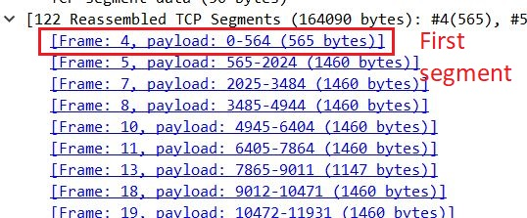

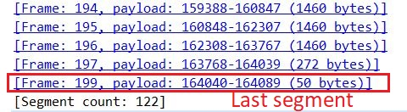

1. **What is the IP address and the TCP port number used by the client computer (source) that is transferring the file to gaia.cs.umass.edu?**

192.168.1.102 and port number is 1161. See information below!



1. **What is the IP address of gaia.cs.umass.edu? On what port number is it sending and receiving TCP segments for this connection?**

128.119.245.12 and port 80 is used for this connection. See information below!



1. **What is the sequence number of the TCP SYN segment that is used to initiate the TCP connection between the client computer and gaia.cs.umass.edu? What is it in the segment that identifies the segment as a SYN segment?**

Actual sequence number for TCP SYN is 232129012. It has a flag (SYN) that indicates this segment is a SYN.

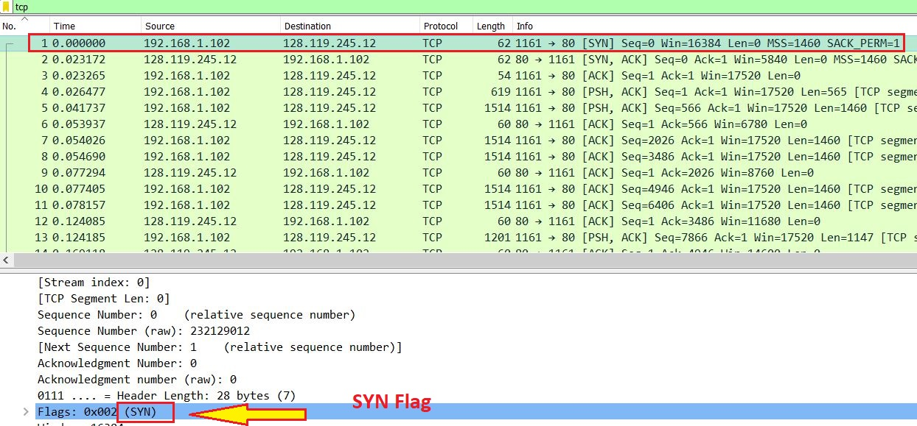

1. **What is the sequence number of the SYNACK segment sent by gaia.cs.umass.edu to the client computer in reply to the SYN? What is the value of the ACKnowledgement field in the SYNACK segment? How did gaia.cs.umass.edu determine that value? What is it in the segment that identifies the segment as a SYNACK segment?**

Sequence number: **883061785**

ACKnowledgment number: **232129013**

This number is based on the last packet sequence number. In this case the last sequence number is **232129012** and therefore the gaia.cs.umass.edu send acknowledgement with number **232129013** which means that it has received data from to **232129012**.

The flag name (SYN, ACK) is displayed in the segment field.

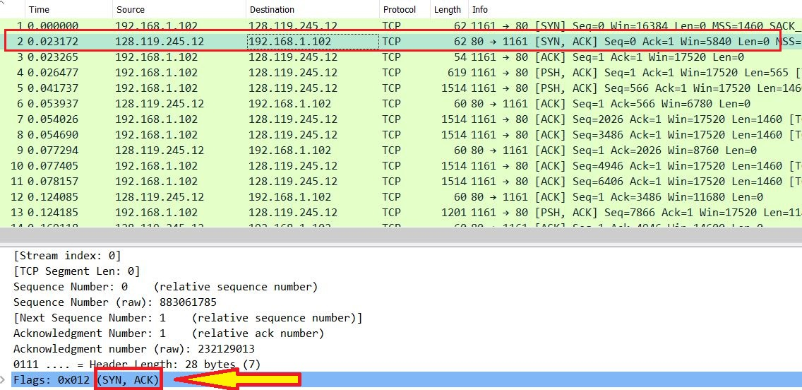

1. **What is the sequence number of the TCP segment containing the HTTP POST command?**

Packet 4: **232129013**. See picture below!

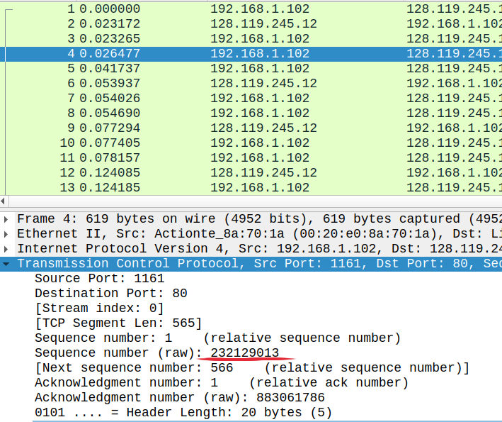

1. **Consider the TCP segment containing the HTTP POST as the first segment in the TCP connection. What are the sequence numbers of the first six segments in the TCP connection (including the segment containing the HTTP POST)? At what time was each segment sent? When was the ACK for each segment received? Given the difference between when each TCP segment was sent, and when its acknowledgement was received, what is the RTT value for each of the six segments? What is the EstimatedRTT value (see Section 3.5.3, page 269 in text) after the receipt of each ACK? Assume that the value of the EstimatedRTT is equal to the measured RTT for the first segment, and then is computed using the EstimatedRTT equation on page 270 for all subsequent segments.**

*Note: Wireshark has a nice feature that allows you to plot the RTT for each of the TCP segments sent. Select a TCP segment in the “listing of captured packets” window that is being sent from the client to the gaia.cs.umass.edu server. Then select: Statistics->TCP Stream Graph->Round Trip Time Graph.*

* + **4**. 232129013 sent time: **0.026477** Ack time: 0.053937 **(6)**
  + **5**. 232129578 sent time: **0.041737** Ack time: 0.077294 **(9)**
  + **7**. 883061786 sent time: **0.054026** Ack time: 0.124085 **(12)**
  + **8.** 232131038 sent time: **0.054690** Ack time: 0 .169118 **(14)**
  + **10**. 232132498 sent time: **0.077405** Ack time: 0.217299 **(15)**
  + **11**. 883061786 sent time: **0.078157** Ack time: 0.267802 **(16)**

Here is an example of how we calculated RTT for each segment. Note that this information can be found in Wireshark also.

**RTT value for segment 4** = 0.053937 - 0.026477 **= 0.02746**

**RTT values**

**4 = 0.02746**

**5 = 0.03555**

**7 = 0.07005**

**8 = 0.11442**

**10 = 0.13989**

**11 = 0.18964**

***EstimatedRTT = 0.875 * EstimatedRTT + 0.125 * SampleRTT****(RTT value)*

An example how we calculate Estimated RTT for packet 5:

**Estimated RTT(5)= *0.875(constant) \** 0.0274 (prev. EstRTT) + *0.125(constant) \**  0.03555(RTT value)**

**Estimated RTT**

**4 = 0.0274**

**5 = 0.0285**

**7 = 0.0337**

**8 = 0.0437**

**10 = 0.0558**

**11 = 0.0725**

1. **What is the length of each of the first six TCP segments?**

**4**. 565

**5**. 1460

**7**. 1460

**8.** 1460

**10**. 1460

**11**. 1460

This information is taken from the packet-listing pane in Wireshark but also can be found in packet-detail pane for each segment as well.

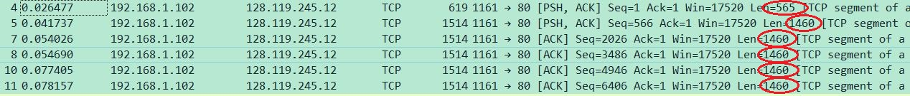

1. **What is the minimum amount of available buffer space advertised at the receiver for the entire trace? Does the lack of receiver buffer space ever throttle the sender?**

Minimum amount buffer space is 5840 bytes which has sequence number 883061785.

The lack of receiver buffer space never throttles the sender because the available size of buffer at server increases after each ACK sent. Because the maximum amount of bytes in each segment is 1460 there is no limit for sender to decrease the amount of sended data.

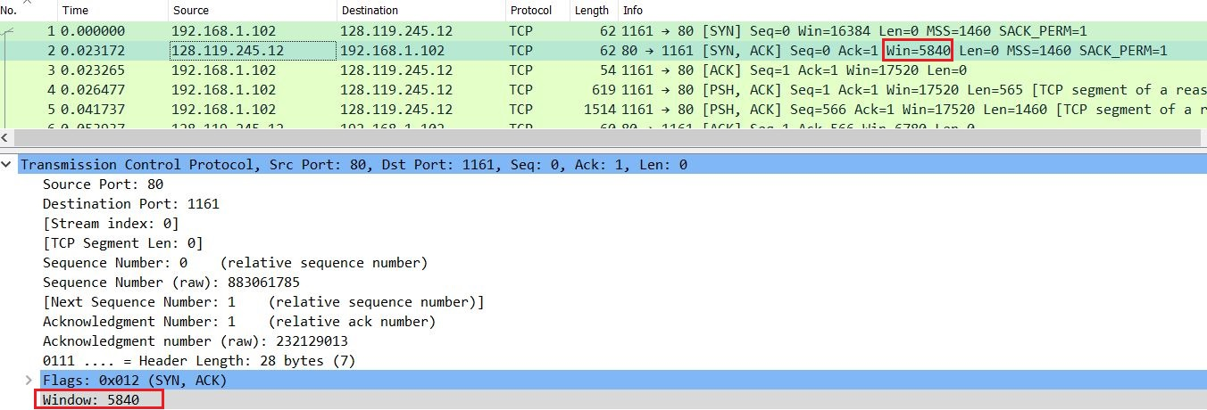

1. **Are there any retransmitted segments in the trace file? What did you check for (in the trace) in order to answer this question?**

No, we used following filter which shows retransmitted segments in Wireshark:

***tcp.analysis.retransmission***

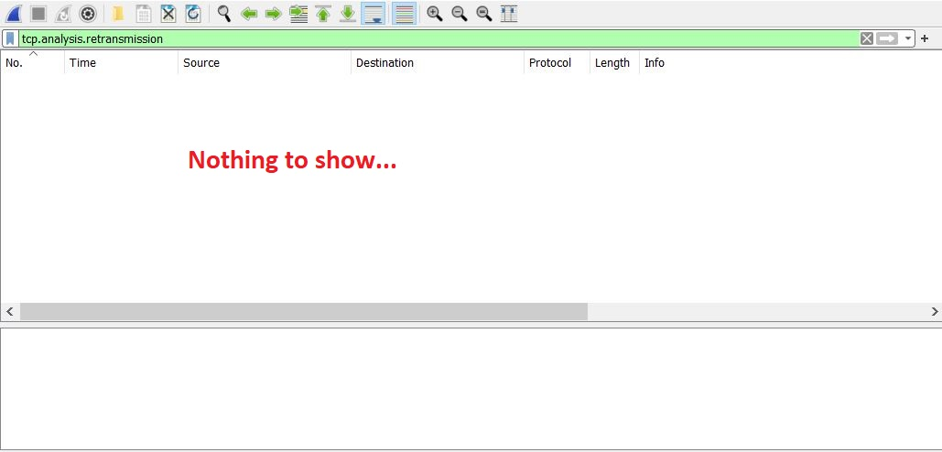

1. **How much data does the receiver typically acknowledge in an ACK? Can you identify cases where the receiver is ACKing every other received segment (see Table 3.2 on page 278 in the text).**

Receiver typically acknowledge 1460 bytes in an ACK, which after observing the ACKs sent by receiver we discovered that receiver is ACKing every 1460 bytes.

Yes, for example packet No 69 is an ACK that acknowledges two segments (segment No 63 and 64). We can see that both packet No 63 and 64 are 1460 bytes long. The sum of these packets together is 2920 bytes. And when we calculate the difference between ACK No 62 and 69 which is 44701−41781 = 2920. We can obviously see that also that there are no ACKs that acknowledge packet 63 but instead ACK No 69 ACKs both packet 64 of length 1460 and packet 63 of length 1460 which is totally 2920.

In the same manner this situation can be found in packets No 79 and 80. We are missing an ACK for packet No 76 and the reason is that packet No 80 ACKs both packet No 76 and 77 together. And again we can observe it by some calculation.

Packet No 79 ACKs for 55813

and then

Packet No 80 ACKs for 58165

which means (packet No 76 length + packet No 77 length) is equal to difference between these two ACKs.

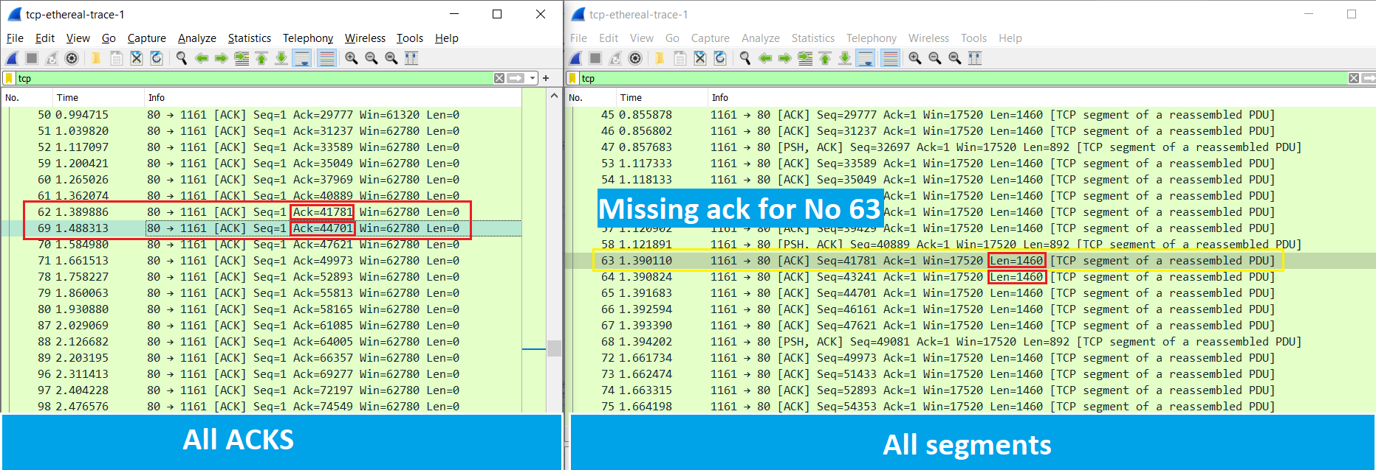

1. **What is the throughput (bytes transferred per unit time) for the TCP connection? Explain how you calculated this value**.

*Throughput = amount of data transmitted / time incurred*

Throughput = 164090 / (5,455830 - 0,026477) = 30222.753 B/s

We found amount of data transmitted in packet-detail pane (see following screenshot)

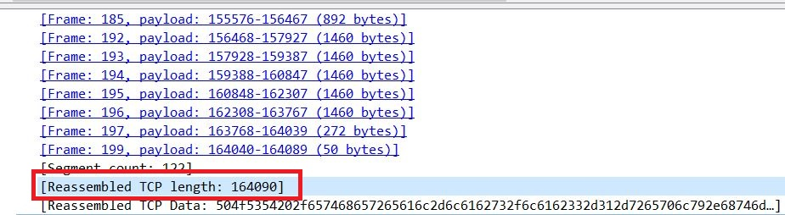By dividing the amount of data transmitted by the time passed for transmission we calculated the throughput. Note that we calculated the time from which the first TCP segment after triple-handshake was sent which is packet No 4.

**TASK A:**

According to our observations from the questions, we got to understand that there is a three-way handshake needed in order to establish a connection between client and the server. This way, the client sends a SYN packet including it’s sequence number asking the server for permission to establish the connection. Then the server responds to the client with a SYNACK packet including a sequence number which means that it confirms the request. At last, the client ACKs the server’s response and starts sending the segments. The next steps will be taken recursively, which means that for every packet sent by client, the server ACKs the packets and determines the next packet by telling it’s sequence number.

EstimatedRTT is the estimated round trip time that client determines itself to know the time it takes for the server to ACK the packets. In case, there is no signal from the server in the EstimatedRTT, then the client assumes that the packet is lost and will opt to send the packet again, this is how clients interpret packet losses.

**TASK B:**

1. **Use the *Time-Sequence-Graph (Stevens)* plotting tool to view the sequence number versus time plot of segments being sent from the client to the gaia.cs.umass.edu server. Can you identify if and where TCP's *slow start* phase begins and ends, as well as if and where *congestion avoidance* takes over? Comment on ways in which the measured data differs from the idealized behavior of TCP that we've studied in the text.**

By studying outstanding data as we calculate in the following table we observe that the amount of data that is not being acknowledged never grows enough to reach congestion avoidance. The maximum outstanding data in this connection is **8192** and for the first Data being sent is **565** bytes. By knowing that **(1)** the receiver side buffer size, rwnd, is 62780 byte (taken from Wireshark) and **(2)** outstanding data must be the minimum of receiver buffer size and congestion window size at the sender (taken from textbook and showed in the following line):

**LastByteSent – LastByteAcked <= min{cwnd, rwnd**}

we can say that cwnd is **8192** bytes in maximum and **566** bytes in minimum. On the other hand we never see any rapid growth of this number which means that it’s not possible to see the end of TCP slow-start in this case. It has never pushed data aggressively enough to reach congestion state.

|  |  |  |  |  |
| --- | --- | --- | --- | --- |
| Type | No. | No. | ACKed seq. | Outstanding data |
| Data | 4 | 1 |  | 565 |
| Data | 5 | 566 |  | 2025 |
| ACK | 6 |  | 566 | 1460 |
| Data | 7 | 2026 |  | 2920 |
| Data | 8 | 3486 |  | 4380 |
| ACK | 9 |  | 2026 | 2920 |
| Data | 10 | 4946 |  | 4380 |
| Data | 11 | 6406 |  | 5840 |
| ACK | 12 |  | 3486 | 4380 |
| Data | 13 | 7866 |  | 5527 |
| ACK | 14 |  | 4096 | 4917 |
| ACK | 15 |  | 6006 | 3007 |
| ACK | 16 |  | 7866 | 1147 |
| ACK | 17 |  | 9013 | 0 |
| Data | 18 | 9013 |  | 1460 |
| Data | 19 | 10473 |  | 2920 |
| Data | 20 | 11933 |  | 4380 |
| Data | 21 | 13393 |  | 5840 |
| Data | 22 | 14853 |  | 7300 |
| Data | 23 | 16313 |  | 8192 |
| ACK | 24 |  | 10473 | 6732 |
| ACK | 25 |  | 11933 | 5272 |

The difference here is that the idealized TCP is supposed to be more aggressive at sending data to the receiver because it needs to reach the maximum allowed rate of bytes in that specific TCP connection. Idealized TCP follows different algorithms and starts slowly but trying to increase congestion window size exponentially. Here we don’t see any aggressive attempt to send data. This might be because of the size of the file which means that TCP connection ends before it shifts to congestion avoidance phase.

1. **Explain the relationship between (i) the congestion window (cwnd), (ii) the receiver advertised window (rwnd), (iii) the number of unacknowledged bytes, and (iv) the effective window at the sender (i.e., the window effectively limiting the data transmission).**

**congestion window(cwnd):** is an additional variable in TCP congestion-control mechanism which determines the amount of unacknowledged data at a sender.

Suppose Host **A** is sending Host **B** a large file over a TCP connection. The number of ***unacknowledged bytes*** that **A** sends cannot exceed the size of the receive buffer.

**receiver advertised window(rwnd):** is a variable that provides the flow-control service. It is typically the free spare space in the receiving buffer. How? Host **B** tells Host **A** how much spare room it has in the connection buffer by placing its current value of *rwnd* in the receive window field of every segment it sends to **A**.

**effective window:** The size of the recent advertised window depends on each ACK sent by the server to the client.

*LastByteSent – LastByteAcked <= min{cwnd, rwnd}*

1. **Is it generally possible to find the congestion window size (cwnd) and how it changes with time, from the captured trace files? If so, please explain how. If not, please explain when and when not. Motivate your answer and give examples.**

*According* ***RFC5681****, CONGESTION WINDOW (cwnd): A TCP state variable that limits the amount of data a TCP can send. At any given time, a TCP MUST NOT send data with a sequence number higher than the sum of the highest acknowledged sequence number and the minimum of cwnd and rwnd.*

So it is not generally possible to find the ***cwnd*** size as it is not advertised, However it is possible to find the ***rwnd*** size, because it is advertised.

**TASK C:**

1. **What is the throughput of each of the connections in bps (bits per second)? What is the total bandwidth of the host on which the clients are running? Discuss the TCP fairness for this case.**

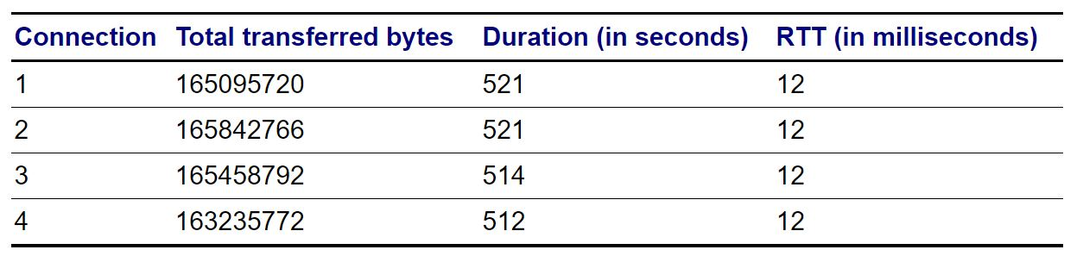

**Connection1:** 165095720 / 521 * 8 = 2535059,04 b/s

**Connection2:** 165842766 / 521 * 8 = 2546529,99 b/s

**Connection3**: 165458792 / 514 *8 = 2575234.12 b/s

**Connection4:** 163235772 / 512 * 8 = 2550558.94 b/s

**Total bandwidth =** 10207382,09 bits

In this case, we have almost similar durations and identical RTTs.

By looking at the throughput in each connection we do not see very large differences so we assume that it is a fair TCP connection.

1. **What is the throughput of each of the connections in bps (bits per second)? What is the total bandwidth of the host on which the clients are running? Discuss the TCP fairness for this case**

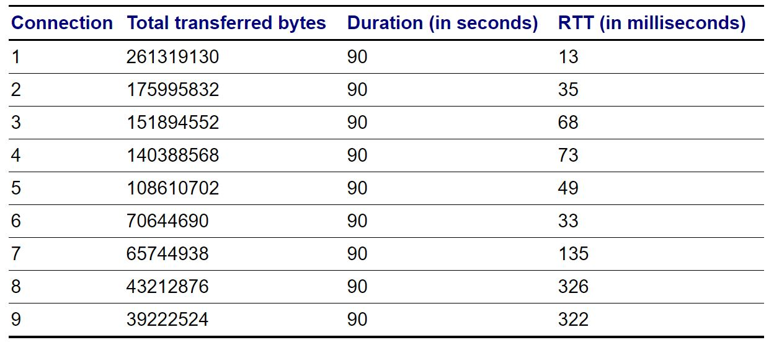

**Connection 1:** 261319130 / 90 * 8 = 23,228,367.1111 b/s

**Connection 2:** 175995832 / 90 * 8 = 15,644,073.9556 b/s

**Connection 3**: 151894552 / 90 * 8 = 13,501,737.9556 b/s

**Connection 4:** 140388568 / 90 * 8 = 12,478,983.8222 b/s

**Connection 5:** 108610702 / 90 * 8 = 9,654,284.62222 b/s

**Connection 6:** 70644690 / 90 * 8 = 6,279,528 b/s

**Connection 7**: 65744938 / 90 *8 = 5,843,994.4889 b/s

**Connection 8:** 43212876 / 90 * 8 = 3,841,144.5334 b/s

**Connection 9:** 39222524 / 90 * 8 = 3,486,446.5778 b/s

**Total bandwidth is** : 93958561.06682

In this case, we have almost identical durations but different RTTs.

On contrary to the previous question, we see a very large difference in throughput between these 9 connections which means that TCP is not fair in this case and bandwidth has been unfairly shared between these 9 clients (running in the same host).

1. **Discuss the TCP fairness for this case. How does it differ from the previous cases, and how is it affected by the use of BitTorrent?**

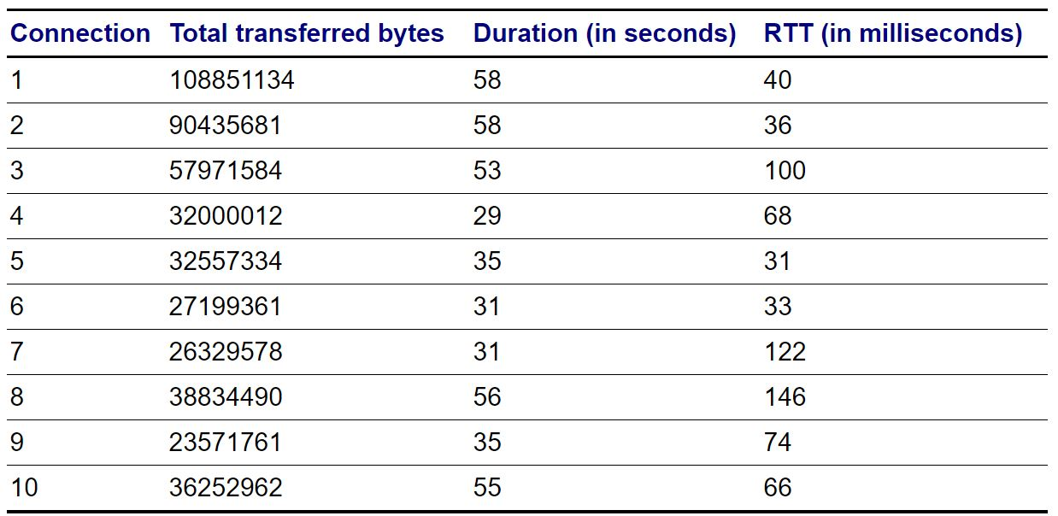

Group1:

**Connection 1:** 108851134 / 58 * 8 = 15013949.5172 b/s

**Connection 2:** 90435681 / 58 * 8 = 12473887.0345 b/s

**Connection 6:** 27199361 / 31 * 8 = 7019189.93548 b/s

**Connection 5:** 32557334 / 35 * 8 = 7441676.34286 b/s

Group2:

**Connection 4:** 32000012 / 29 * 8 = 8827589.51724 b/s

**Connection 9:** 23571761 / 35 * 8 = 5387831.08571 b/s

**Connection 10:** 36252962 / 55 * 8 = 5273158.10909 b/s

Group3:

**Connection 3**: 57971584 / 53 *8 = 8750427.77358 b/s

**Connection 7**: 26329578 / 31 *8 = 6794729.80645 b/s

**Connection 8:** 38834490 / 56 * 8 = 5547784.28571 b/s

We divided this connection into three groups to discuss TCP fairness. In each group there are connections with roughly the same RTT.

In this case, unlike the previous two questions, we have different durations and RTTs. However when we compare connections throughput with each other in the same group, we see that they are more likely to be **unfair**. For example in group 3, connections 3, 7 and 8 there are some differences between throughput. The same for connections 4, 9 and 10, and same for connections 1, 2, 5 and 6.

However these clients benefit from using BitTorrent and help each other with downloading the same file from the server. Each client may share those parts of data it downloaded to another client and it causes a more fair connection.