Computer Animation Project: Animation of a rocket
Description
Through this project, I intended to create an animation of a rocket launch through the use of the different methods learned in class. The code relies heavily on the idea behind procedural animation, i.e. on mathematical formulas to simulate trajectories or movement dynamics. Thus, having already predefined the initial conditions and fed the mathematical formulation of the trajectory to the algorithm, it can launch on its own updating the positions of the objects at every time step through a predefined timer, creating an animation. A simple collision technique was also used to detect the arrival of the boosters on the ground, as well as affine transformations alike rotation for the satellite for example.
The final goal of this project was to have an interesting animation where the rocket launches and separates its two stages launching a satellite around earth’s orbit. Below are some images of what has been accomplished, although results can better be seen in the attached video.
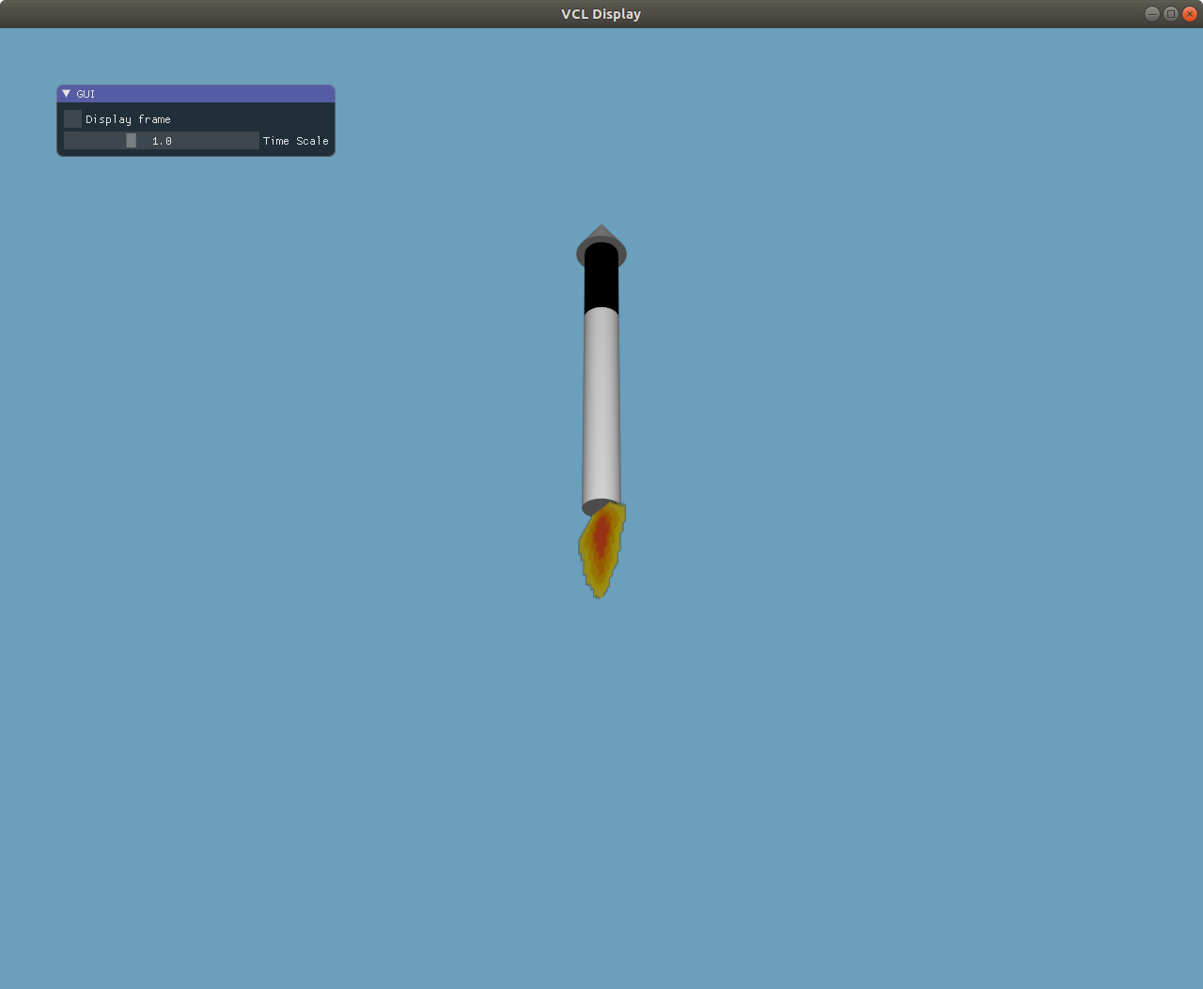
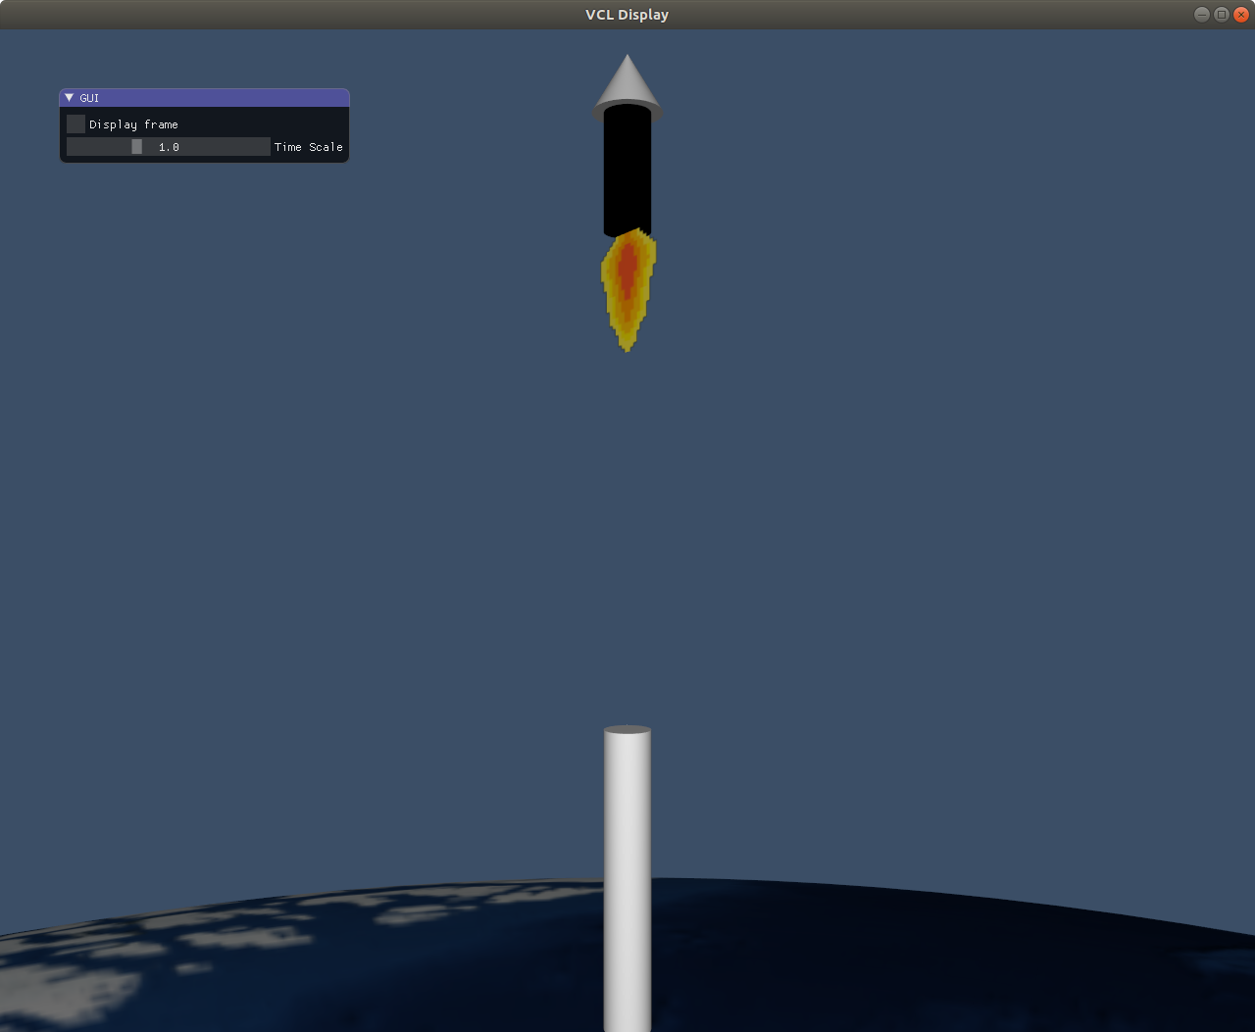
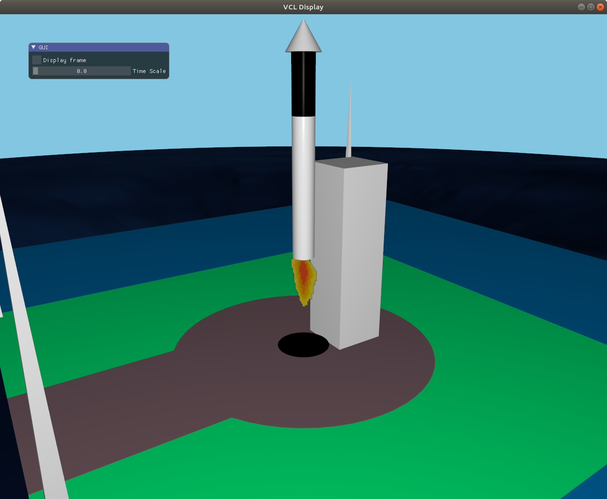
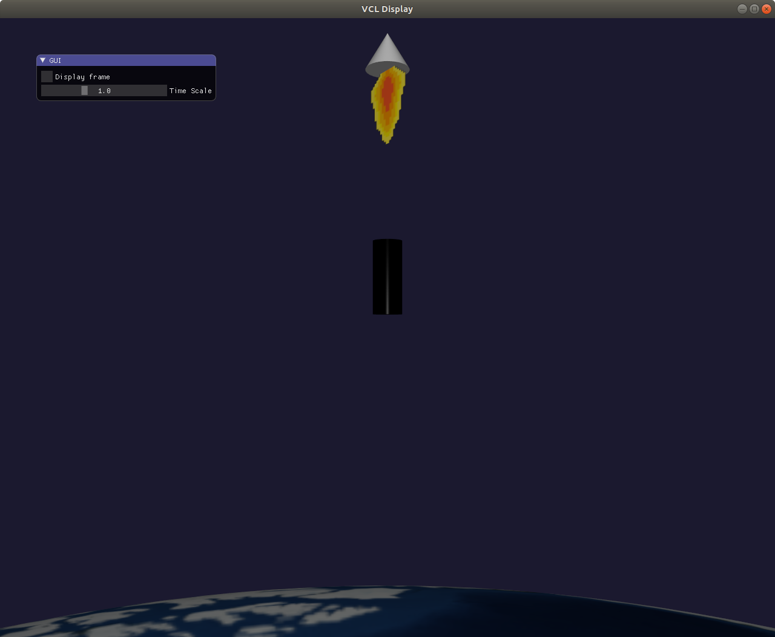

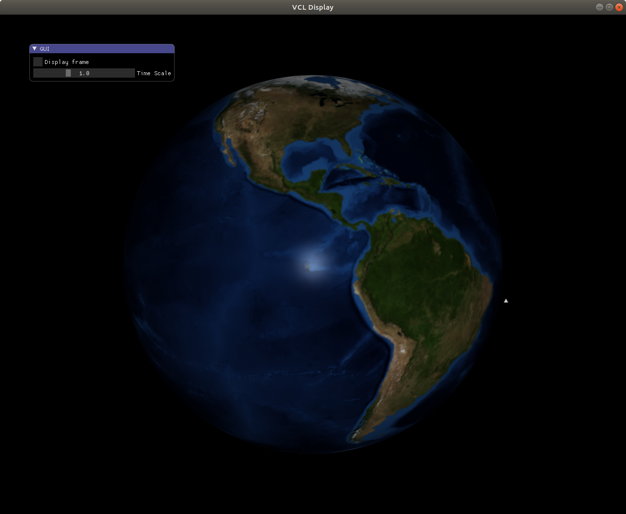

The implementation
The work is based on what was done in the first practical of the class, taking as example the code used to create the bouncing spheres animation.
Five structures were created, respectively for the global structure of the rocket, the first stage booster, the second stage booster, the payload fairing and last the satellite.

These help keep the code clear and understandable, and also help keep track of the positions and velocities of each and every stage, and easily update them when an update is needed after the object’s movement.
Drawable meshes are also present in large numbers, to help render the rocket launch site with a minimum objective of realism. Some depict for example the towers that are normally present around a launch site (Faraday cage), others help depict the ground (road + launch space), etc. .
Finally, some useful variables are defined first thing before the function declarations, like the radius of the rotation of the satellite around the earth, the radius of the earth itself, and most importantly, the timer which will help coordinate the animation.
In what follows, I will briefly sketch out the code’s functions main objective, and some key points that made some aspects of the animation possible.
Main function
It handles calls to standard OpenGL functions for the creation of the window as well as the callbacks, but also comprises the main rendering loop, as with all real-time rendering code. Something worth pointing is that the sky color change in the animation was coded through the glClearColor, which decides the background screen color every time the scene is reloaded. Giving the function a range of colors makes it possible to switch smoothly from sky blue to black between the rocket launch time and the satellite orbit start time for example, which was done in the code.
Initialize Data function
In this function, as indicated by its name, meshes, as well as initial positions of the rocket stages and the rocket itself, are initialized. In the code, you may see mesh_primitive_cuboid as well as mesh_primitive_pentahedron which were not included in the VCL but were implemented as supplement to render some shapes for the towers (pentahedron) and the building complex of the launch pad (cuboid) for example. The codes for these functions were as follows:
mesh mesh_primitive_cuboid(vec3 const& center, float edge_length, float height){
vec3 u = edge_length*vec3{1,1,0};
vec3 v = height*vec3(0,0,1);
vec3 p000 = center - u/2.0f;
vec3 p100 = p000 + u*vec3{1,0,0};
vec3 p110 = p000 + u*vec3{1,1,0};
vec3 p010 = p000 + u*vec3{0,1,0};
vec3 p001 = p000 + v;
vec3 p101 = p001 + u*vec3{1,0,0};
vec3 p111 = p001 + u*vec3{1,1,0};
vec3 p011 = p001 + u*vec3{0,1,0};

mesh shape;
shape.push_back(mesh_primitive_quadrangle(p000, p100, p101, p001));
shape.push_back(mesh_primitive_quadrangle(p100, p110, p111, p101));
shape.push_back(mesh_primitive_quadrangle(p110, p010, p011, p111));
shape.push_back(mesh_primitive_quadrangle(p010, p000, p001, p011));
shape.push_back(mesh_primitive_quadrangle(p001, p101, p111, p011));
shape.push_back(mesh_primitive_quadrangle(p100, p000, p010, p110));

return shape;
}
//another preferable method would have been to implement with center of base quadrangle and height as arguments
mesh mesh_primitive_pentahedron(vec3 const& p0, vec3 const& p1, vec3 const& p2, vec3 const& p3, vec3 const& p4){
mesh shape;
shape.push_back(mesh_primitive_quadrangle(p0,p1,p2,p3));
shape.push_back(mesh_primitive_triangle(p0,p1,p4));
shape.push_back(mesh_primitive_triangle(p1,p2,p4));
shape.push_back(mesh_primitive_triangle(p2,p3,p4));
shape.push_back(mesh_primitive_triangle(p3,p0,p4));
return shape;
}
Display Scene
This is the most important function of the code, that not only displays the meshes initialized in the aforementioned function, but also calculates the new positions of the moving meshes at time t through the given mathematical functions, and moves them to these new positions. Going through this function fast (which is done by the loop in the main function) gives the sense of animation, whilst the underlying functioning is discrete time incrementation and translation of the meshes.
- Before the satellite orbit start time / if statement
For the global movement of the rocket, the predetermined movement equation is one with a stable speed and an initial position on the launch pad. The rocket fires its engines (thrust depicted through an image billboard of static fire) and moves with a constant speed on the z-axis.
The first and second stages, in the pre-separation phase, follow along the rocket. Once the first phase separation time (which is set in the initialize data function) is hit by the timer, the first stage separates then goes along an opposite direction trajectory, with the trajectory taking into account the gravitational pull of the earth:
firstStage.v = -g*(current_time-t_separation_first) + firstStage.v0;
firstStage.p = -0.5*g*(current_time-t_separation_first)*(current_time-t_separation_first) + firstStage.v0*(current_time-t_separation_first) + firstStage.p0;
When the booster touches the ground, i.e. its z coordinate turns negative, its position is then adjusted to ground level, which makes for a simple collision detection with the ground. Thus, this is why three cases are present for the first stage booster movement handling.
The same goes for the second stage booster. When in the satellite orbit phase, you can see the boosters both back at the launch pad (which is a very simplified way of depicting what happens in real life):
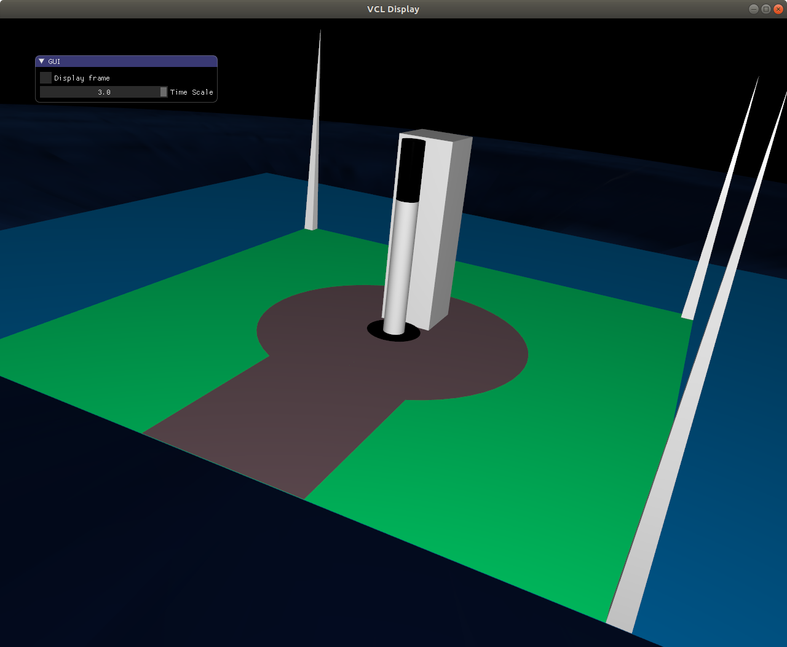

For the third stage, the payload fairing stage, the scenario is different. This stage will keep moving at a constant speed on the z-axis until the time of satellite orbit time is reached, at which time the payload fairing will be replaced by the satellite, which has the same shape (a cone) but is scaled as for the user to be able to see it when zooming out from the earth (the camera far component had to be changed too for this to work):
rocket_payload_fairing = mesh_drawable(mesh_primitive_cone(0.6f,1.f,vec3(0,0,7),vec3(0,0,1),true,60,60));
satellite_mesh = mesh_drawable(mesh_primitive_cone(12.f,20.f,vec3(0,0,7),vec3(0,0,1),true,60,60));
Also, we should not forget the thrust’s position, which has to be changed according to the stage at which the animation is. For example, if the first stage has already separated, the thrust should be now tailing the second stage and so on, which is done via:
if(!first_stage_separated){
thrust.transform.translate = {firstStage.p.x,firstStage.p.y,firstStage.p.z} ; //thrust follows first stage
}else if(first_stage_separated && !second_stage_separated){
thrust.transform.translate = {secondStage.p.x,secondStage.p.y,secondStage.p.z+5} ; //thrust is now coming from second stage
}else if(first_stage_separated && second_stage_separated){
thrust.transform.translate = {payloadFairing.p.x,payloadFairing.p.y,payloadFairing.p.z+7} ; //thrust is now coming from payload fairing
}
Finally, the meshes are drawn through calls to the draw function.
- After the orbit start time
The payload fairing is replaced by the satellite mesh, which starts orbiting around the earth with a radius of earth_radius + payload_fairing’s z component right before the switch to the orbit phase.
Rotation is managed manually through cosine and sine functions, and using the formulae for rotation around a random point in space we had derived in class (explanations in code comments).
Finally, the meshes are drawn through calls to the draw function.

Following this function are OpenGL callback functions. The one of interest is the keyCallback, which I implemented so as to have a set of keys to press or hold, to respectively switch to a better view of the camera or follow a moving object along. The set of keys are:
- Hold number 1 button: Follow the first stage
- Hold number 2 button: Follow the second stage
- Hold number 3 button: Follow the payload fairing
- Hold number 4 button: Follow the satellite
- Press B button: Return to base (launch pad). Camera is looking to the sky. If you wait, you could sse the satellite pass.
- Press L button: Go to locked camera state, which is a predeterrmined state that I coded so you could have the best view of each phase of the animation.

Limitations and possible ameliorations
You can see that the animation is quite simplistic because of the trajectory of the rocket, the boosters stacking themselves again at the launch pad and falling vertically, etc.
Some features I would have loved to implement but did not have the time to are the following:
- A more realistic movement of the rocket in the launch phase, following the rocket propulsion equation and a more realistic trajectory
- Subsequently a more realistic separation of the stages and more realistic modeling of their free fall
- Maneuvers on the rocket and boosters and possibility to light one of three engines to control their direction
- Possibility to land boosters on droneships in the sea like SpaceX does (https://www.youtube.com/watch?v=1sJlFzUQVmY)
- Some special effects, like earth vibration, and a better thrust visualization, maybe through a particle system
- Launch of satellite around another planet from earth, for example mars

Thank you for reading, hope you enjoy the animation !

