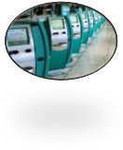
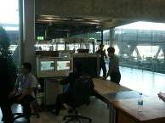
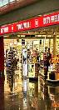
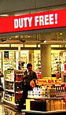
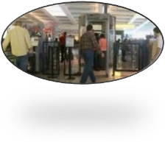
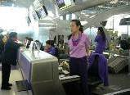
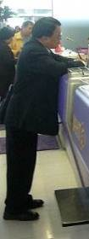
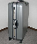

Name:.......................................................... Class: .................... Date: ........ /....... /.......
At the Airport
Checking in at the Check in Counter
Clerk: Good morning. May I have your passport and ticket, please?
Customer: Here you go.
Clerk: Oh, you have an e-ticket. You can print out your boarding pass at the kiosk.
Customer: I already printed out my boarding pass at home. Here it is.
Clerk: Good. How many bags are you checking?
Customer: Two.
Clerk: Please put them on the scale. Oh, this one is too heavy. You have to pay an
overweight fee or take out some items.
Customer: I will pay the overweight fee. How much is it?
Clerk: It is $50. If you pre-pay over the
web it is cheaper.
Customer: OK. Thanks. Good to know.
Checking in at the Check in Counter (continued)
Clerk: Your seat is 22F. The flight leaves from Terminal A, Gate 14 at 2:15.
Customer: OK Thanks. Could you point me in the direction of Gate 14?
Clerk: Straight ahead and to the left. Follow the signs.
Customer: Thanks. Is there any place to buy something to drink after the security check point?.
Clerk: Yes. There are kiosks that sell coffee and drinks.
Customer: Is there a duty free shop?
Clerk: Yes.
Customer: Thank you very much.

Clerk: May I help the next customer?
Next Customer: Hello...
Going Through the Security Check Point
Clerk: Do you have any liquids in containers over 3 ounces?
Customer: No.
Clerk: Did anyone give you anything, or did you leave your luggage unattended at any time in the airport?
Customer: No.
Clerk: OK. Please remove your shoes and put them in the bin to be scanned.
Customer: Remove my shoes? I didn’t have to remove my shoes in Bonn, but OK.
Clerk: Please empty all items from your pockets and place your jacket in a bin to be scanned.
Customer: OK. How about my laptop and camera?
Clerk: Yes. They go in the bins, too. All electronic items must be
removed from your bags and placed in bins for scanning.
Customer: OK.
Clerk: Step through the metal detector, please.
Customer: OK.

Clerk: Would the next person come through
the metal detector, please?
Next Customer: Hello...
True or false
___ There is a duty free shop.

___After going through the security check
point you cannot eat or drink
anything.
True or false
___ The fee for overweight luggage is cheaper if you pre-pay it online.

___ We can print out our boarding pass at the kiosk, with an electronic ticket.

True or false
___ You can bring liquids onboard the plane in small containers that do not exceed 3 ounces.

___All electronic items must be packed in your luggage and checked in before boarding the plane.
Watch this video on the TSA (Transportation Security Administration) airport security check system. http://en.wikipedia.org/wiki/File:TSA-_How_It_Works.ogv
What do you think of the TSA? Is it making travelers safer? Is it too rigid and annoying or a good way to target terrorists? Have you ever traveled abroad? Describe an experience you or someone you know had when traveling. Were there any problems? Was it easy? What was the hardest? What preparations should one undertake for traveling?

