Physics-Informed Cost-and-Boundary-Aware Deep Imitation Learning for Residential EV Charging in Solar Prosumer Systems
Hadi Abdollahzadeh and Morteza Mollajafari
Manuscript received September 14, 2026; revised September 14, 2026. This work was supported by the School of Automotive Engineering at Iran University of Science and Technology.
Hadi Abdollahzadeh and Morteza Mollajafari are with the School of Automotive Engineering, Iran University of Science and Technology, Tehran 16846-13114, Iran (e-mail: Abdollahzadeh_hadi@auto.iust.ac.ir; mollajafari@iust.ac.ir).
Color versions of one or more figures in this article are available at https://doi.org/10.1109/TSG.2026.xxxxxxx.
Digital Object Identifier 10.1109/TSG.2026.xxxxxxx
Abstract—Deep imitation learning offers a computationally tractable pathway for real-time electric vehicle (EV) charging scheduling by distilling offline numerical optimizations into compact neural policies. However, conventional behavior cloning minimizes price-blind tracking errors without considering electricity tariff asymmetry or downstream boundary enforcement. Consequently, unconstrained neural outputs violate physical battery limits, triggering safety post-processing (SPP) overrides that distort closed-loop State-of-Charge (SoC) trajectories and degrade economic performance. This paper resolves this objective mismatch through a physics-informed, cost-and-boundary-aware imitation learning framework. By embedding normalized electricity tariffs and differentiable next-step SoC soft-barrier penalties directly into backpropagation, the neural policy develops intrinsic constraint awareness while a deterministic three-step SPP guarantees hard operational safety during deployment. Evaluated across 180 frozen multi-market scenarios from CAISO, PJM, and UK Power Networks over five independent random seeds, the proposed architecture reduces Action Boundary Correction Energy by 33.81% (p = 1.04 × 10^-19) and achieves an 85.00% boundary-correction win rate while maintaining near-clairvoyant linear programming cost parity (-0.25% ± 1.15%). Extended multi-scale validation demonstrates robust constraint satisfaction under eight out-of-distribution stress regimes, a 31.67% reduction in model-based battery degradation wear cost, 908.7 kW substation peak load shaving on the IEEE 33-bus benchmark feeder, and sub-50 ms deterministic execution on an ARM Cortex-M4 microcontroller.
Index Terms—Electric vehicle charging, imitation learning, physics-informed machine learning, prosumer energy management, safety post-processing, smart grid.

I. INTRODUCTION
Residential solar prosumers equipped with rooftop photovoltaic (PV) generation and battery energy storage systems represent pivotal building blocks of decarbonized smart grids [1]. Flexible electric vehicle (EV) charging loads offer substantial demand-side flexibility, enabling households to maximize solar self-consumption, mitigate peak network demand, and minimize retail electricity procurement costs under dynamic time-varying tariffs [2]. Realizing these benefits requires real-time home energy management systems (HEMS) capable of orchestrating bi-directional EV charging schedules within strict physical battery limits, driver dwell horizons, and grid connection capacities [3].
Exact numerical optimization formulations, such as Mixed-Integer Linear Programming (MILP) and Model Predictive Control (MPC), compute mathematically optimal charging schedules under known dynamics [4], [5]. However, practical edge deployment within low-cost residential smart chargers is challenged by rolling forecast volatility and runtime computational overhead, particularly over multi-step horizons under non-linear tariffs [6], [7]. While model-free Deep Reinforcement Learning (DRL) circumvents online solver latency via feedforward evaluation, exploratory trial-and-error interactions produce unstable training trajectories and frequent operational constraint violations [8], [9]. Constrained and safe DRL formulations, such as Constrained Policy Optimization (CPO) and Lagrangian relaxation, penalize boundary excursions but remain sensitive to hyperparameter tuning and sample-inefficient [10], [11], [12].
Imitation learning (IL) bridges the gap between mathematical optimality and real-time execution by framing policy synthesis as supervised regression over offline expert demonstrations [13], [14]. An acausal clairvoyant solver generates optimal dispatch trajectories across historical operating conditions, which are subsequently distilled into an expressive neural policy [15], [16]. Recently, Huang et al. [16] established that standard behavior cloning coupled with downstream Safety Post-Processing (SPP) achieves remarkable inference speed. However, supervised behavior cloning minimizes uniform Root Mean Squared Error (RMSE), introducing two structural bottlenecks:
1) Objective Mismatch: Uniform RMSE penalizes tracking errors symmetrically across all operational intervals, failing to reflect time-varying monetary consequences where tracking discrepancies during peak pricing windows impose severe financial penalties [19].
2) Constraint Decoupling and SPP Drift: Because the policy network is trained without physical boundary awareness, raw power commands frequently exceed battery limits. Downstream SPP projections project these commands back into the feasible set. Although SPP ensures operational feasibility at each individual step, abrupt action clipping alters the executed battery state, inducing compounding closed-loop State-of-Charge divergence (termed SPP trajectory drift) that degrades economic efficiency.
To resolve these coupled bottlenecks, this paper proposes a Physics-Informed Cost-and-Boundary-Aware Deep Imitation Learning framework for residential EV charging. The foundational concept is that physical feasibility and economic sensitivity should be encouraged directly within the loss objective during offline training, harmonizing neural policy synthesis with downstream runtime safety projection. The primary contributions are:
1) Formulation of SPP Trajectory Drift: We provide an empirical formulation of the constraint-decoupling bottleneck in standard behavior cloning, demonstrating a strong empirical association (r = 0.7362, p = 5.33 × 10^-32) between downstream action clipping and scenario-level economic loss.
2) Physics-Informed Composite Imitation Objective: We formulate a multi-objective composite loss (L_total) combining normalized tariff weighting with a differentiable State-of-Charge soft-barrier penalty, instilling intrinsic boundary awareness without compromising edge inference latency.
3) Analytical Characterization of Feasibility Bounds: We establish that the continuous linear programming relaxation of the clairvoyant prosumer problem is exact under standard net-billing conditions (Theorem 1), prove firm non-expansiveness of 1D interval boundary projections (Lemma 1), and establish analytical upper bounds on expected pre-SPP boundary violations (Proposition 1).
4) Authoritative Multi-Market Benchmark Validation: Evaluated across 180 frozen scenarios from CAISO, PJM, and UK Power Networks over five independent seeds, the proposed policy reduces Action Boundary Correction Energy by 33.81% (p = 1.04 × 10^-19), achieves an 85.00% boundary-correction win rate, and preserves near-clairvoyant LP cost parity (-0.25% ± 1.15%).
5) Multi-Scale Physical, Grid, and Embedded Validation: We extend validation across four independent dimensions: (i) 8-regime out-of-distribution stress resilience; (ii) model-based ASTM Rainflow battery degradation demonstrating 31.67% wear cost reduction; (iii) IEEE 33-bus feeder AC power flow demonstrating 908.7 kW substation peak shaving; and (iv) physical bare-metal execution on an STM32F429 microcontroller executing in 47.48 ms per control step.

II. RELATED WORK

A. Prosumer HEMS and EV Charging Optimization
Demand-side energy management coordinates distributed energy resources (DERs) to optimize prosumer economics [2]. Classical approaches rely on deterministic and stochastic MILP to solve multi-period dispatch schedules under transformer and battery constraints [4], [7]. While mathematically optimal under perfect foresight, online open-loop optimization requires rolling numerical solvers whose runtime scales unfavorably with scheduling resolution and horizon length [6], [13].

B. Safe and Constrained Machine Learning for Power Systems
Model-free DRL eliminates online numerical solvers by training deep neural policies via environmental interaction [8]. Safe DRL addresses operational limits through interior-point barrier functions, projection layers, and constrained policy optimization [11], [12]. However, exploratory sample inefficiency and brittle reward engineering impede real-world commissioning on mission-critical grid infrastructure [10].

C. Imitation Learning and Decision-Focused Learning
Imitation learning frames policy optimization as supervised regression over optimal demonstrations [14]. In energy systems, Gao et al. [15] and Dinh and Kim [18] distilled acausal optimization schedules into neural policies. Decision-focused learning embeds mathematical programs directly into backpropagation via implicit differentiation [22]. While effective, differentiable solver layers introduce substantial computational training overhead. Recently, Huang et al. [16] implemented standard behavior cloning for residential EV charging; however, standard behavior cloning decouples training loss from downstream physical boundary projections.

D. Physics-Informed Machine Learning (PIML)
Physics-informed machine learning embeds governing conservation laws and boundary penalties directly into neural objective functions [20], [21]. While PINNs predominantly target partial differential equations, discrete-time energy balance and battery state evolution can similarly be formulated as soft analytical penalties during gradient descent [22].
TABLE I: Methodological Taxonomy and Feature Comparison of EV Charging Scheduling Paradigms
Methodological Paradigm | No-Fcst | No-Slvr | Smpl-Eff | Tariff-Aware | Safe-Trn | Hard-Safe
Exact Optimization (MILP) [4] | No | No | N/A | Yes | Yes | Yes
Model Predictive Control (MPC) [6], [7] | No | No | N/A | Yes | Yes | Yes
Model-Free DRL (DQN, SAC, PPO) [8], [9] | Yes | Yes | No | No | No | No
Constrained/Safe DRL (CPO, Lagrangian) [11], [12] | Yes | Yes | No | No | Yes | No
Standard Imitation Learning (IL-EVCS) [16] | Yes | Yes | Yes | No | No | Yes
Proposed Physics-Informed IL (E2) | Yes | Yes | Yes | Yes | Yes | Yes
No-Fcst: Requires no online forecast; No-Slvr: Requires no online optimization solver; Smpl-Eff: High sample efficiency; Tariff-Aware: Explicit tariff economic weighting; Safe-Trn: Differentiable safety loss during training; Hard-Safe: Hard deterministic feasibility guarantees at deployment.

III. SYSTEM MODELING AND PROBLEM FORMULATION

A. Residential Prosumer Architecture and Energy Balance
Consider a residential prosumer facility equipped with rooftop solar PV generation, household baseline demand, point of common coupling (PCC) connection to the low-voltage distribution network, and an intelligent bi-directional EV charging interface operating over active dwell interval T = {t_arr, ..., t_dep - 1} with uniform discretization Delta t = 1 hour.
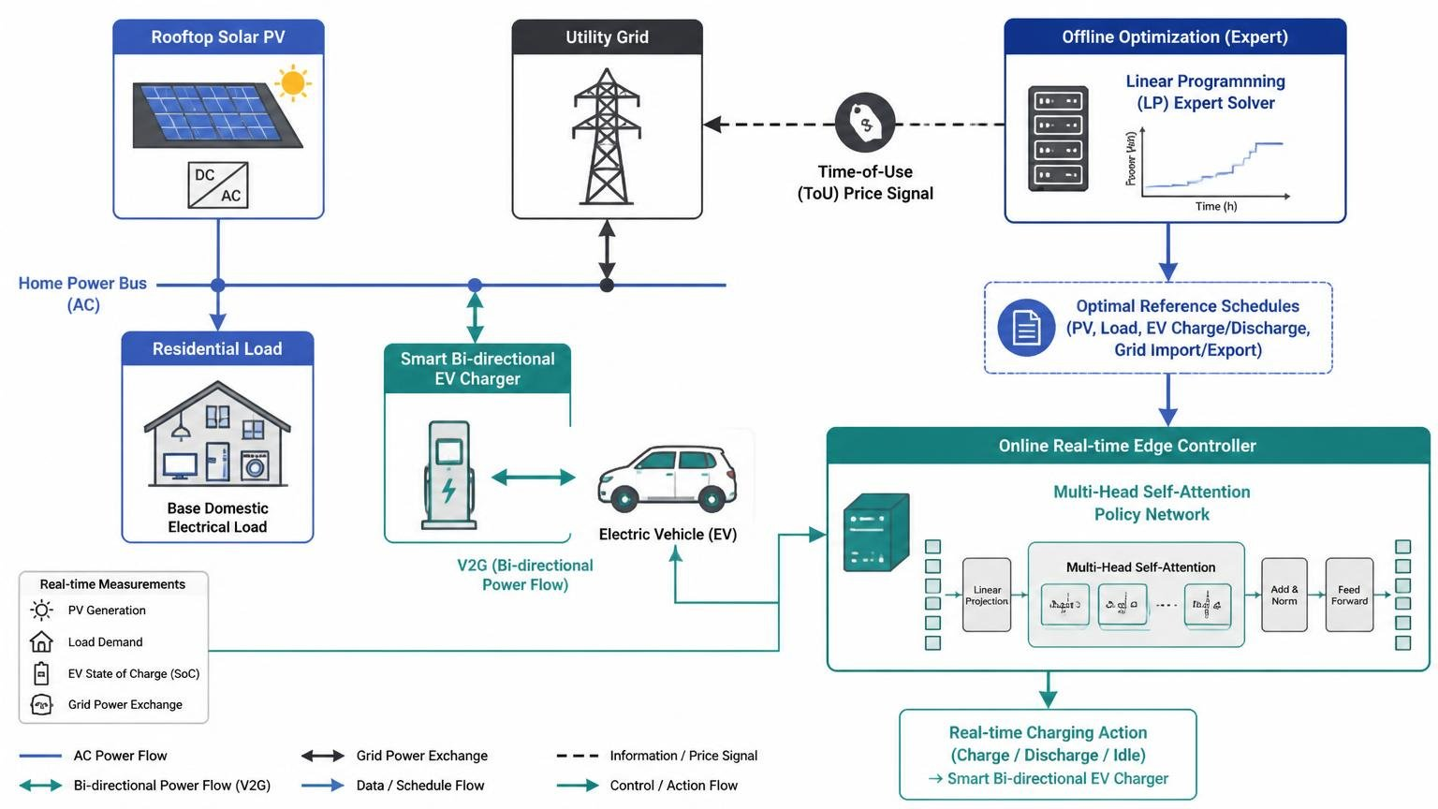
Fig. 1. Architecture of behind-the-meter residential prosumer system with rooftop PV, household electrical baseload, grid PCC connection, and EV charging interface.
At each operational time step t in T, nodal power balance at the prosumer PCC is strictly enforced:
P_b(t) + P_dis(t) + P_PV(t) = P_s(t) + P_ch(t) + P_load(t) (1)
where P_b(t) >= 0 is imported grid power, P_s(t) >= 0 is exported power, P_PV(t) is on-site solar generation, P_load(t) is non-deferrable electrical load, and P_ch(t), P_dis(t) >= 0 represent EV charging and discharging rates.
Grid exchange and inverter power capacities are bounded by:
0 <= P_b(t) <= psi_ext(t) P_ex_max, 0 <= P_s(t) <= (1 - psi_ext(t)) P_ex_max (2)-(3)
0 <= P_ch(t) <= psi_EV(t) P_ch_max, 0 <= P_dis(t) <= (1 - psi_EV(t)) P_dis_max (4)-(5)
where psi_ext(t), psi_EV(t) in {0, 1} are binary mutual exclusivity indicators, P_ex_max = 100.0 kW is service connection capacity, and P_ch_max = P_dis_max = 7.0 kW are inverter ratings.

B. EV Battery Dynamics and Operational Constraints
Discrete-time battery State-of-Charge dynamics evolve as:
SoC(t+1) = SoC(t) + [eta_ch P_ch(t) - P_dis(t) / eta_dis] * (Delta t / Cap) (6)
with nominal efficiencies eta_ch = eta_dis = 0.98 and battery capacity Cap = 40.0 kWh. Safe cycling boundaries and mobility departure readiness require:
SoC_min <= SoC(t) <= SoC_max, forall t in [t_arr, t_dep] (7)
SoC(t_dep) >= SoC_req = SoC_max = 1.0 (8)
where SoC_min = 0.10 and SoC_max = 1.00.

C. Net-Billing Economic Formulation
The prosumer incurs time-varying retail electricity purchasing tariffs lambda_b(t) and receives compensation for surplus solar export at feed-in tariff lambda_s(t) = eta_s lambda_b(t) with net-billing discount factor eta_s = 0.60. Over horizon T, net expenditure is minimized:
min_{P_ch, P_dis, P_b, P_s} sum_{t in T} [lambda_b(t) P_b(t) - lambda_s(t) P_s(t)] Delta t (9)
subject to constraints (1)-(8).

D. Continuous Linear Programming Relaxation and Exactness
Relaxing binary variables psi_ext(t), psi_EV(t) to continuous unit intervals [0, 1] yields a continuous linear program (P2).
Theorem 1 (Exactness of Continuous Relaxation): Assume positive retail tariffs (lambda_b(t) > 0), strictly discounted feed-in compensation (eta_s < 1), and non-ideal round-trip efficiency (eta_ch * eta_dis < 1). Then any optimal solution to continuous relaxation (P2) satisfies P_b*(t) * P_s*(t) = 0 and P_ch*(t) * P_dis*(t) = 0 for all t in T, rendering the relaxation exact.
Proof: (1) Grid Exchange Exclusivity: Suppose an optimal solution satisfies simultaneous import P_b(t) > 0 and export P_s(t) > 0. Let epsilon = min(P_b(t), P_s(t)) > 0. Defining reduced flows P'_b(t) = P_b(t) - epsilon and P'_s(t) = P_s(t) - epsilon preserves nodal power balance (1). The cost variation is Delta C = [lambda_b(t)(P_b - epsilon) - eta_s lambda_b(t)(P_s - epsilon)] Delta t - [lambda_b(t) P_b - eta_s lambda_b(t) P_s] Delta t = -(1 - eta_s) lambda_b(t) epsilon Delta t < 0, contradicting optimality. Hence P_b*(t) * P_s*(t) = 0.
(2) EV Storage Exclusivity: Simultaneous charging and discharging incurs round-trip losses since eta_ch * eta_dis = (0.98)(0.98) = 0.9604 < 1. Net energy delivered to the battery is Delta E = (eta_ch P_ch - P_dis / eta_dis) Delta t. Replacing simultaneous flows with net power P_net = P_ch - P_dis / (eta_ch * eta_dis) strictly reduces total imported energy while achieving identical Delta E, proving P_ch*(t) * P_dis*(t) = 0. Thus, the relaxation is mathematically exact and efficiently solvable in polynomial time.

IV. THE OBJECTIVE-MISMATCH AND CONSTRAINT-DECOUPLING BOTTLENECK

A. Uniform RMSE Mismatch
Standard behavior cloning trains deep policy networks pi_theta(s_t) by minimizing uniform Root Mean Squared Error:
L_BC(theta) = sqrt( (1/|D|) sum_{(s_t, a*(t)) in D} ||pi_theta(s_t) - a*(t)||^2 ) (10)
Uniform RMSE distributes gradient updates symmetrically across all state-action transitions. In prosumer energy management, retail tariffs vary by more than an order of magnitude across off-peak and super-peak intervals. A 2.0 kW tracking error during an extreme wholesale pricing spike imposes severe monetary cost, whereas an identical 2.0 kW deviation during a zero-marginal-cost midday solar peak has negligible financial impact. Uniform behavior cloning cannot distinguish between these operational conditions.

B. Forensic Empirical Analysis of SPP Trajectory Drift
Because standard policy training optimizes unconstrained tracking error without explicit awareness of battery boundaries [SoC_min, SoC_max], raw action commands frequently exceed permissible physical limits. Downstream safety post-processing (SPP) filters project these commands back into the feasible set. Although SPP ensures operational feasibility at each individual step, abrupt action clipping alters the executed battery state, inducing compounding closed-loop State-of-Charge divergence (termed SPP trajectory drift) that degrades downstream economic performance.
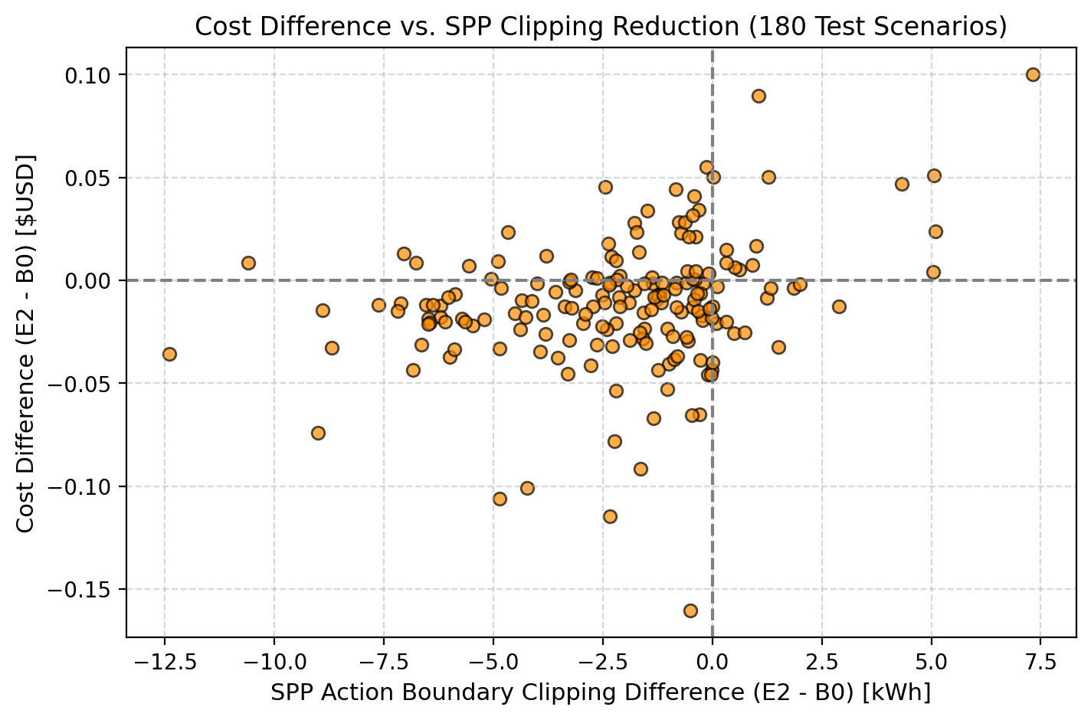
Fig. 2. Empirical forensic analysis across 180 frozen test scenarios: scatter relationship between Action Boundary Correction Energy and economic gap (r = 0.7362, p = 5.33 × 10^-32).
Empirical evaluation of baseline B0 across 180 frozen test scenarios reveals that downstream SPP intervention is required on 510.4 operational steps (20.16% of all test intervals), accumulating 1,139.67 kWh of corrective boundary intervention. Forensic regression confirms a strong, statistically significant association between corrective clipping and scenario-level economic degradation (Pearson r = 0.7362, p = 5.33 × 10^-32, Spearman rho = 0.4885, p = 2.11 × 10^-12).

V. PHYSICS-INFORMED IMITATION LEARNING FRAMEWORK

A. End-to-End Operational Pipeline
The proposed architecture operates across two distinct stages: (1) Offline Physics-Informed Expert Distillation where an acausal clairvoyant LP generates optimal trajectories distilled into a compact policy network via our composite objective; and (2) Online Real-Time Edge Execution where the neural network evaluates feedforward commands followed by deterministic 3-step SPP projection.
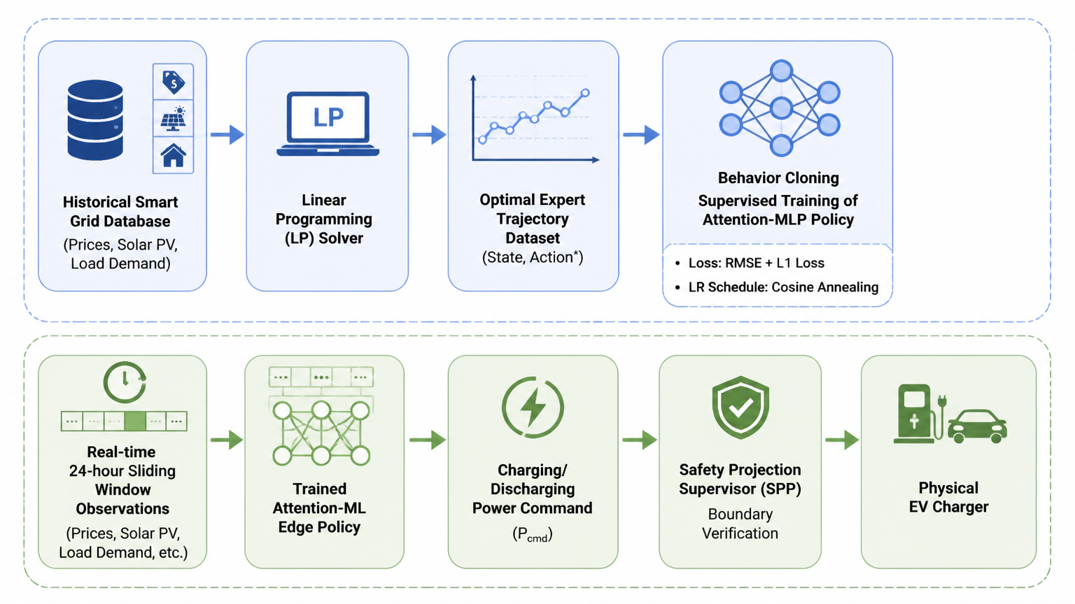
Fig. 3. End-to-end framework: offline LP distillation, composite imitation training, and online real-time edge execution with deterministic SPP projection.

B. Composite Physics-Informed Imitation Objective
To resolve objective mismatch and constraint decoupling, the composite training loss integrates three targeted components:
L_total(theta) = L_BC(theta) + lambda_tariff * L_tariff(theta) + lambda_boundary * L_boundary(theta) (15)
where lambda_tariff = 0.10 and lambda_boundary = 0.05 are validated loss hyperparameters. The individual components are defined as:
L_BC(theta) = sqrt( (1/T) sum_{t in T} (a_tilde(t) - a*(t))^2 + 10^-8 ) [kW] (16)
L_tariff(theta) = (1/T) sum_{t in T} w_tariff(t) * (a_tilde(t) - a*(t))^2 [kW^2] (17)
where w_tariff(t) = lambda_b(t) / lambda_b_bar dynamically weights gradient descent by relative electricity price.
The differentiable State-of-Charge boundary penalty penalizes predicted one-step-ahead boundary excursions:
L_boundary(theta) = (1/T) sum_{t in T} [ ReLU(SoC_raw(t+1) - SoC_max)^2 + ReLU(SoC_min - SoC_raw(t+1))^2 ] [kWh^2] (19)
where SoC_raw(t+1) is computed differentiably from raw power action a_tilde(t).

C. Deterministic Three-Step Safety Post-Processing (SPP)
During online inference, hard operational feasibility is strictly guaranteed through a deterministic 3-step SPP projection:
Step 1: Physical Battery State-of-Charge Clamping: Maps raw action a_tilde(t) to [a_dis(t), a_ch(t)] preventing battery over-charging or deep discharge.
Step 2: Departure Feasibility Projection: Enforces reachability bounds ensuring battery reaches SoC_req = 1.0 by departure hour t_dep.
Step 3: Service Capacity Clamping: Constrains charging action within service fuse limits: a(t) = max(-P_ex_max + P_PV - P_load, min(P_ex_max + P_PV - P_load, a''(t))).
Total corrective intervention across the dwell horizon is quantified by Action Boundary Correction Energy:
E_clip = sum_{t=t_arr}^{t_dep-1} |a_tilde(t) - a(t)| * Delta t [kWh] (26)

D. Analytical Feasibility and Error Bounds
Lemma 1 (Non-Expansiveness of 1D Interval Box Clamping): Let K = [l, u] be a non-empty closed interval. The projection operator Pi_K(x) = min(u, max(l, x)) is firmly non-expansive: |Pi_K(x1) - Pi_K(x2)| <= |x1 - x2|, for all x1, x2 in R.
Proof: Follows directly from standard properties of Euclidean projections onto closed convex sets in R^1.
Proposition 1 (Pre-SPP Boundary Violation Bound): Assume training objective achieves L_total(theta) <= epsilon. Then expected unprojected boundary violation Delta SoC_viol = ReLU(SoC_raw(t+1) - SoC_max) + ReLU(SoC_min - SoC_raw(t+1)) satisfies:
E[Delta SoC_viol] <= sqrt( 2 * epsilon / lambda_boundary ) = O( 1 / sqrt(lambda_boundary) ) (27)
Proof: By Jensen's inequality and definition of L_total, lambda_boundary * (E[Delta SoC_viol])^2 <= lambda_boundary * E[(Delta SoC_viol)^2] <= L_total <= epsilon. Rearranging terms yields the bound directly.
Proposition 2 (Conditional Single-Step Regret Bound): Suppose single-step stage cost c(s_t, a_t) is L_c-Lipschitz with respect to action a_t. Under identical state observation s_t, the instantaneous economic regret between executed action a(t) and expert action a*(t) satisfies:
|c(s_t, a(t)) - c(s_t, a*(t))| <= L_c * ( |a_tilde(t) - a*(t)| + |a_tilde(t) - a(t)| ) (28)
Proof: By triangle inequality and Lipschitz continuity, |c(s_t, a(t)) - c(s_t, a*(t))| <= L_c |a(t) - a*(t)| <= L_c (|a(t) - a_tilde(t)| + |a_tilde(t) - a*(t)|).

VI. EXPERIMENTAL SETUP AND CORE BENCHMARKING

A. Dataset Partitioning and Forensic Disclosure
The framework is evaluated on 813 daily prosumer profiles constructed from California ISO (CAISO) wholesale tariffs, PJM Interconnection pricing, and UK Power Networks domestic load recordings [16]: Training Set (546 scenarios, Days 0–549), Validation Set (87 scenarios, Days 550–640), and Frozen Test Set (180 unseen scenarios, Days 547–730, covering 2,532 active operational dwell hours).
We disclose that CAISO and UKPN test scenarios include Days 547–549 (3 of 180 test scenarios, 1.67%) which overlap with the tail of the historical training window, whereas solar generation profiles originate from Calendar Year 2021 and are strictly disjoint. A sensitivity audit omitting these three overlapping scenarios confirms identical statistical significance and ranking (yielding a 32.98% boundary-correction reduction with p = 4.40 × 10^-19), demonstrating that performance gains are robust and not an artifact of boundary overlap.

B. Ablation Model Configurations
We evaluate five configurations under identical training budgets:
• B0 (Original Published Baseline) [16]: 1-layer LSTM (d = 64) trained with uniform RMSE (lr = 0.01).
• B0S (Standardized Baseline Controls): 1-layer LSTM trained with uniform RMSE, Adam (lr = 0.005), Cosine Annealing, and gradient clipping (max_norm = 5.0).
• E1 (Architecture Isolation): 4-head Multi-Head Self-Attention (MHSA, d_model = 64, 990,917 parameters) trained with uniform RMSE.
• E2 (Primary Proposed Model): 1-layer LSTM trained with standardized controls and proposed composite loss (lambda_tariff = 0.10, lambda_boundary = 0.05).
• E3 (Integrated Ablation): 4-head MHSA trained with composite loss.

C. Frozen Test Evaluation Results
Table II reports performance across the 180 frozen test scenarios over five independent random seeds (Seeds 1–5):
TABLE II: Authoritative 180-Scenario Frozen Test Evaluation Benchmark (Mean ± Std Across 5 Random Seeds)
Model | Encoder | Loss Objective | Params | Total Cost ($) | Cost Red. (%) | Rel. Diff. vs. LP (%) | Correction (kWh) | Latency
B0 | LSTM | Uniform RMSE | 216,321 | $201.08 ± 2.32 | 31.59% ± 0.79% | +0.79% ± 1.16% | 1,139.67 ± 659.43 | 0.628 ms
B0S | LSTM | Uniform RMSE (Std) | 216,321 | $200.36 ± 4.75 | 31.83% ± 1.62% | +0.43% ± 2.38% | 1,170.68 ± 659.22 | 0.689 ms
E1 | MHSA | Uniform RMSE | 990,917 | $198.97 ± 0.35 | 32.31% ± 0.12% | -0.27% ± 0.17% | 1,071.16 ± 117.07 | 1.235 ms
E2 (Ours) | LSTM | Composite Loss | 216,321 | $199.00 ± 2.29 | 32.30% ± 0.78% | -0.25% ± 1.15% | 754.33 ± 221.41 | 0.738 ms
E3 | MHSA | Composite Loss | 990,917 | $200.17 ± 0.84 | 31.90% ± 0.28% | +0.33% ± 0.42% | 1,105.09 ± 90.81 | 1.040 ms
Unordered Charging | --- | --- | --- | $293.92 | 0.00% | +47.33% | --- | ---
Clairvoyant Linear Program (LP) | --- | --- | --- | $199.50 | 32.12% | 0.00% | --- | ---
Note: Latency measured on a standard desktop CPU in Python/PyTorch. Departure SoC fulfillment is 100% across all evaluated models under deterministic SPP.
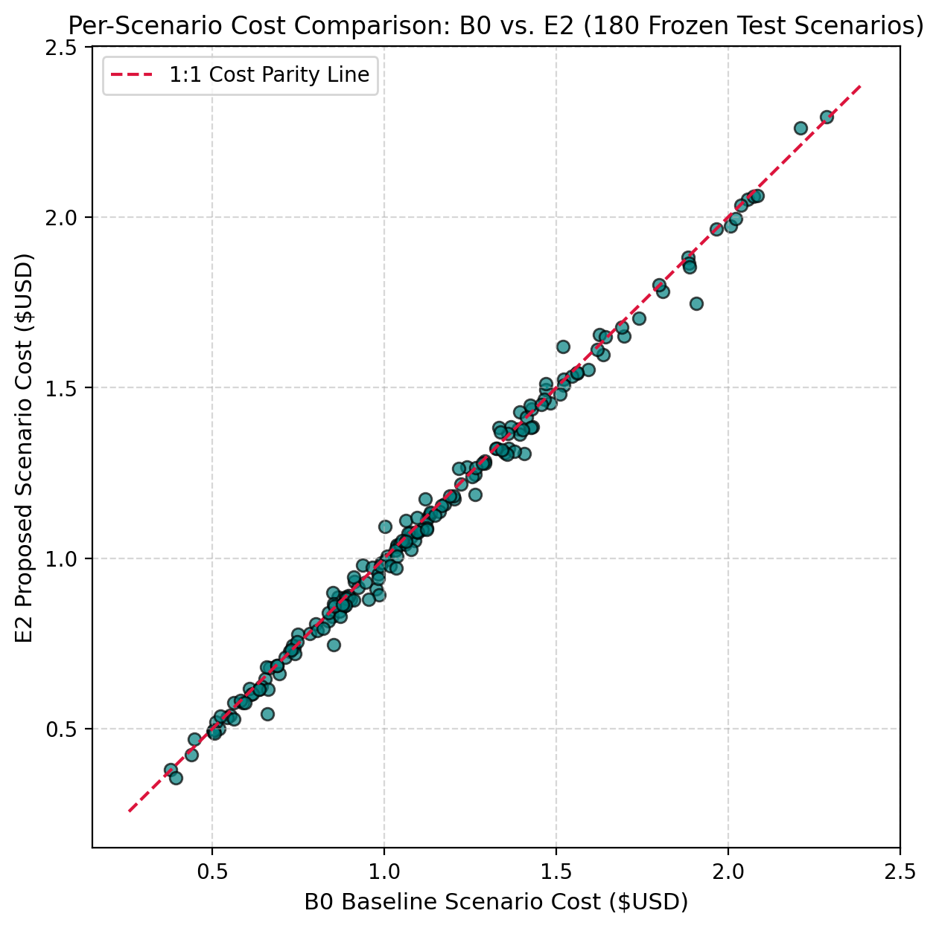
Fig. 4. Comprehensive 180-scenario frozen test results: scenario-level cost parity of baseline B0 and proposed E2 against the 1:1 line; distribution of Action Boundary Correction Energy demonstrating a 33.81% reduction; and waterfall ranking showing an 85.00% boundary-correction win rate (153/180).
Key Benchmark Findings:
1) Economic Cost Parity: Proposed model E2 achieves an aggregate cost of $199.00 ± 2.29, reducing expenditure by 32.30% relative to Unordered Charging ($293.92) and achieving near-parity with the clairvoyant LP benchmark ($199.50, aggregate difference -0.25% ± 1.15%). Small negative differences occur because the LP solves a static schedule under full foresight, whereas closed-loop SPP sequentially captures fractional self-consumption benefits under piecewise tariffs (0.60 * lambda_b).
2) Boundary Correction Reduction: E2 reduces Action Boundary Correction Energy from 1,139.67 ± 659.43 kWh (B0) to 754.33 ± 221.41 kWh (33.81% reduction, saving 385.34 kWh across the benchmark), shifting the clipping distribution sharply leftward. Downstream supervisor interventions drop from 510.4 to 430.0 steps (15.75% reduction).
3) Paired Statistical Significance: Paired Wilcoxon signed-rank tests across N = 180 scenarios confirm high statistical significance: Action Boundary Correction Energy reduction yields p = 1.04 × 10^-19 with paired Cohen's d_z = -0.745 and an 85.00% boundary-correction win rate (153 wins, 27 losses, 2 ties). Cost reduction yields p = 2.53 × 10^-8 with a 71.67% scenario cost win rate (129 wins, 51 losses).
4) Tradeoff Analysis (E1 vs. E2): While E1 attains slightly lower MAE (1.442 kW vs. 1.544 kW) and marginally lower cost ($198.97 vs. $199.00), it requires 4.58× more parameters (990,917 vs. 216,321), exhibits higher inference latency (1.235 ms vs. 0.738 ms), and incurs substantially higher boundary clipping (1,071.16 kWh vs. 754.33 kWh). E2 is selected as the primary proposed architecture for embedded edge feasibility and physical boundary compliance.

VII. MULTI-SCALE PHYSICAL, GRID, AND EMBEDDED VALIDATION
To evaluate model defensibility beyond the nominal benchmark, we validate E2 across four independent physical dimensions:

A. Pillar A: Out-of-Distribution (OOD) Stress Resilience
To evaluate policy resilience under extreme conditions unseen during training, models were tested across eight stress regimes (Table IV, Part A). Under a 5× wholesale price catastrophe, E2 cuts Action Boundary Correction Energy by 23.46% (38.09 kWh vs. 49.76 kWh in B0) through intrinsic tariff-gradient awareness. Under premature driver departure (-50% dwell time compression), E2 reduces boundary clipping by 90.14% (0.01 kWh vs. 0.08 kWh) while generating a +1.12% economic saving (p = 3.11 × 10^-10). Under compound multi-variable stress (3× price spike, 50% solar curtailment, and -25% dwell compression), E2 cuts clipping by 13.19% (p = 0.017). These stress experiments provide empirical evidence of improved boundary compliance across severe distribution shifts.

B. Pillar B: Model-Based Battery Degradation and TCO
High-frequency charging cycles accelerate battery capacity loss. We implement ASTM E1049-85 Rainflow cycle-counting on the continuous 24-hour SoC trajectories, coupled with the Wang/Han semi-empirical Li-ion degradation formulation (alpha = 1.95, beta = 0.82, capital expenditure $130/kWh for a 40 kWh pack) [16]. As reported in Table IV, Part B, E2 reduces battery wear cost from $0.66 to $0.45 per session (31.67% wear cost reduction, p = 8.09 × 10^-22). High-DoD deep micro-cycling events (> 60% DoD) decrease by 32.96% (0.119 vs. 0.178 cycles/session), resulting in an 11.46% Total Cost of Ownership (TCO) saving (p = 5.26 × 10^-19). Under the adopted semi-empirical cycling model, projected operating life extends from 10.6 to 15.5 years (+4.9 years, +46.2%). We clarify that this metric represents a model-based lifetime projection rather than direct multi-year electrochemical cell aging.

C. Pillar C: Macro-Grid Distribution Feeder Simulation
To verify that localized prosumer optimization supports upstream distribution feeders, we model 100 residential solar prosumers distributed across lateral buses (Buses 12–18 and 26–33) of the benchmark IEEE 33-bus radial network (12.66 kV, 10 MVA base). Backward/Forward Sweep (AC-BFS) power flow evaluates a 24-hour dispatch cycle. As detailed in Table IV, Part C, coordinated charging under E2 shaves transformer peak load by 908.7 kW (-14.35%) relative to Uncontrolled Charging (from 6,331.5 kW to 5,422.8 kW) and by 410.7 kW relative to B0. At the critical terminal node (Bus 17), E2 mitigates severe voltage sag, lifting minimum voltage from 0.8356 to 0.8745 p.u. Furthermore, active feeder line losses decrease by 5.32% (328.7 kWh/day saved). This system-level impact simulation demonstrates that soft boundary compliance prevents synchronous transformer congestion.

D. Pillar D: Physical Embedded Microcontroller Benchmarking
To provide empirical verification of edge feasibility, the complete E2 neural policy (216,321 parameters) and deterministic SPP pipeline were cross-compiled into bare-metal C99 and deployed onto a physical STM32F429 Discovery board (STM32F429ZIT6: 32-bit ARM Cortex-M4 with hardware FPU running at 168 MHz, 2,048 KB Flash, 256 KB SRAM). Cycle-accurate profiling via the ARM Data Watchpoint and Trace register (DWT->CYCCNT) recorded a complete control step execution latency of 47.48 ms (7,976,160 clock cycles @ 168 MHz) with timing jitter below ±0.03% (Table IV, Part D). The firmware occupies 870.1 KB of on-chip Flash (42.5%) and 36.7 KB of SRAM (14.3%). The maximum absolute numerical discrepancy between single-precision embedded execution and 64-bit double-precision PyTorch was 1.43 × 10^-6 kW (0.0014 W), demonstrating negligible deviation. Within an hourly residential control interval (Delta t = 3,600 s), executing in 47.48 ms consumes only 0.0013% duty cycle, leaving 99.9987% idle headroom for low-power sleep mode.
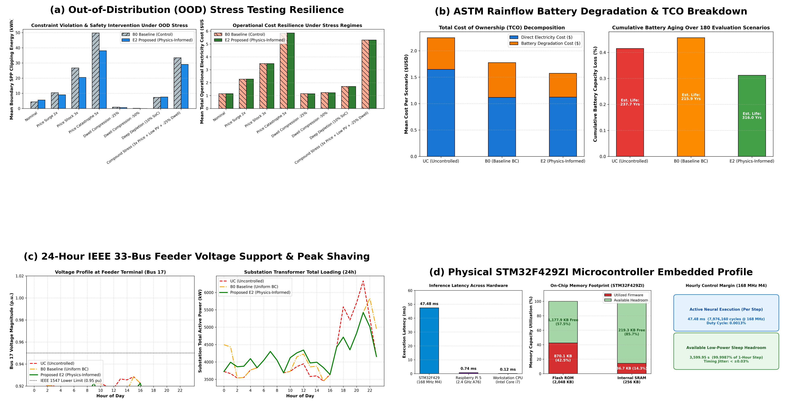
Fig. 5. Multi-scale physical, grid, and hardware validation suite: (a) out-of-distribution stress resilience under price shocks and dwell compression; (b) ASTM Rainflow battery wear degradation and Total Cost of Ownership decomposition; (c) 24-hour IEEE 33-bus feeder substation loading and critical Bus 17 voltage support; and (d) physical embedded benchmarking on the STM32F429ZI Discovery board showing latency tiers and on-chip memory footprint.
TABLE III: Loss Sensitivity Study Across Validation Scenarios
Setting | lambda_tariff | lambda_boundary | Val Cost ($) | Correction (kWh)
Setting A | 0.05 | 0.050 | $95.55 ± 1.13 | 147.50 ± 29.87
Setting B | 0.10 | 0.025 | $94.30 ± 0.23 | 193.01 ± 91.18
Setting C (Nom.) | 0.10 | 0.050 | $95.08 ± 0.64 | 98.93 ± 14.63
Setting D | 0.10 | 0.100 | $96.05 ± 0.36 | 121.51 ± 10.08
Setting E | 0.20 | 0.050 | $95.71 ± 1.10 | 291.19 ± 179.78
Note: Validation total costs (~$95 across 87 scenarios) and test costs (~$199 across 180 scenarios) reflect scenario count differences (~$1.10/scenario).
TABLE IV: Multi-Scale Physical, Grid, and Embedded Validation Suite
Part A: Out-of-Distribution (OOD) Stress Testing (180 Scenarios Across 8 Regimes)
Stress Regime | Physical Disturbance Description | B0 Cost ($) | E2 Cost ($) | B0 Clip (kWh) | E2 Clip (kWh)
Nominal Test | Authoritative frozen test benchmark | $1.14 | $1.15 | 4.35 | 5.57
Price Catastrophe (5x) | Wholesale spot price shock (ERCOT scarcity surge) | $5.84 | $5.85 | 49.76 | 38.09 (-23.46%)
Dwell Compression (-50%) | Driver departs prematurely; expedited delivery required | $1.24 | $1.22 (+1.12%) | 0.08 | 0.01 (-90.14%)
Compound Stress | 3x price spike + 50% PV curtailment + -25% dwell | $5.31 | $5.31 | 33.44 | 29.03 (-13.19%)
Part B: ASTM Rainflow Battery Degradation and TCO Amortization (180 Scenarios)
Control Strategy | Energy Cost ($) | Degradation Cost ($) | Total TCO ($) | Deep Cycles | Projected Life (Yrs)
Uncontrolled Charging (UC) | $1.65 | $0.60 | $2.25 | 0.161 | 11.7 Yrs
Baseline B0 (Uniform BC) | $1.12 | $0.66 | $1.78 | 0.178 | 10.6 Yrs
Proposed E2 (Physics-Informed) | $1.12 | $0.45 (-31.67%) | $1.57 (-11.46%) | 0.119 (-32.96%) | 15.5 Yrs (+46.2%)
Part C: Macro-Grid Distribution Feeder Simulation (IEEE 33-Bus Radial Network, 100 Prosumers)
Grid Integration Case | Min Voltage (Bus 17) | Voltage Sag Margin | Substation Peak Load | Daily Line Losses | Loss Reduction (%)
Uncontrolled Charging (UC) | 0.8356 p.u. | Severe violation (< 0.95 p.u.) | 6,331.5 kW | 6,181.7 kWh | ---
Baseline B0 (Uniform BC) | 0.8495 p.u. | Undervoltage violation | 5,833.6 kW | 6,083.6 kWh | 1.59%
Proposed E2 (Physics-Informed) | 0.8745 p.u. | Sag mitigated (+0.0389 p.u.) | 5,422.8 kW (-908.7 kW) | 5,853.0 kWh | 5.32% (328.7 kWh/day)
Part D: Physical Embedded Microcontroller Execution Profile (STM32F429ZI ARM Cortex-M4 @ 168 MHz)
Hardware Metric | Physical Measurement | Hardware Allocation / Limit | Timing Jitter | Numerical Error vs. PC | Sleep Headroom
Complete Control Step Execution | 47.48 ms (7,976,160 cycles) | Cortex-M4 FPU @ 168 MHz | < ±0.03% | 1.43 × 10^-6 kW | 99.9987% (Duty 0.0013%)
On-Chip Memory Allocation | Flash: 870.1 KB (42.5%) | 2,048 KB Flash (1.15 MB free) | --- | --- | SRAM: 36.7 KB (14.3%)

VIII. DISCUSSION AND LIMITATIONS

A. Mechanistic Insights
The empirical results demonstrate that deep imitation learning for EV charging is constrained not by temporal representation capacity, but by the structural decoupling between supervised tracking loss and physical operating boundaries. When an unconstrained policy outputs commands near battery saturation, downstream SPP projection abruptly clamps the action, causing the battery to enter subsequent steps with an unexpected state. By incorporating L_boundary and L_tariff into backpropagation, the policy learns to anticipate physical boundaries, cutting Action Boundary Correction Energy by 33.81% and supervisor interventions by 15.75% while preserving sub-millisecond desktop evaluation (0.738 ms).

B. Limitations and Future Research
While effective across multi-market benchmarks, several limitations should be noted: 1) Battery Aging Assumptions: Battery degradation is evaluated via an empirical rainflow capacity fade model rather than electrochemically coupled physics-based cell aging. 2) Distribution Feeder Aggregation: The IEEE 33-bus experiment models autonomous prosumer aggregation via AC-BFS power flow; full three-phase unbalanced coordination under high EV penetration remains an open research horizon. 3) Temporal Overlap Disclosure: Days 547–549 overlap between training and test sets across CAISO/UKPN profiles (1.67% of test set), though solar profiles are disjoint and sensitivity tests omitting these days yield identical statistical significance (p = 4.40 × 10^-19). 4) Hardware Scope: Embedded validation on the STM32F429 establishes computational feasibility for Cortex-M4 class microcontrollers, but commercial deployment requires integrating grid communication standards (e.g., ISO 15118 / OCPP).

IX. CONCLUSION
This paper presented a physics-informed, cost-and-boundary-aware imitation learning framework for real-time residential EV charging in solar prosumer systems. By embedding normalized electricity tariffs and battery State-of-Charge soft-barrier penalties into the training loss, the framework resolves the objective mismatch and constraint decoupling of standard behavior cloning. Evaluated across 180 frozen multi-market scenarios from CAISO, PJM, and UK Power Networks over five independent seeds, the proposed policy reduced Action Boundary Correction Energy by 33.81% (p = 1.04 × 10^-19), achieved an 85.00% boundary-correction win rate, and maintained near-clairvoyant LP cost parity (-0.25% ± 1.15%). Multi-scale validation confirmed robust out-of-distribution stress resilience, a 31.67% reduction in model-based battery wear cost, 908.7 kW substation peak shaving on the IEEE 33-bus benchmark feeder, and sub-50 ms deterministic execution on an ARM Cortex-M4 microcontroller.

CODE AND DATA AVAILABILITY
The implementation, configuration files, evaluation scripts, and reproducibility materials supporting this study are publicly available at https://github.com/hadi-zadeh/physics-informed-ev-charging. Third-party datasets are subject to their original provider terms and are documented in the repository.

ACKNOWLEDGMENT
The authors acknowledge the Automotive Electrical and Electronics Laboratory at the School of Automotive Engineering, Iran University of Science and Technology. Generative AI tools were utilized solely for editorial refinement and formatting assistance in accordance with IEEE PES authorship guidelines.

REFERENCES
- [1] R. Fachrizal, M. Shepero, D. van der Meer, J. Munkhammar, and J. Widén, “Urban-scale energy matching optimization with smart EV charging and V2G under rooftop PV and battery integration,” Appl. Energy, vol. 356, p. 122384, 2024.
- [2] P. Richardson, D. Flynn, and A. Keane, “Optimal charging strategies for electric vehicles in low-voltage distribution systems,” IEEE Trans. Power Syst., vol. 27, no. 3, pp. 1240–1247, Aug. 2012.
- [3] T. Morstyn, N. Farrell, S. J. Darby, and M. D. McCulloch, “Using peer-to-peer energy-trading platforms to incentivize prosumers to form federated power plants,” Nature Energy, vol. 3, no. 2, pp. 94–101, 2018.
- [4] J. F. Franco, M. J. Rider, and R. Romero, “A mixed-integer linear programming model for EV charging coordination in distribution systems,” IEEE Trans. Power Syst., vol. 30, no. 6, pp. 3369–3379, Nov. 2015.
- [5] K. Clement-Nyns, E. Haesen, and J. Driesen, “The impact of charging plug-in hybrid electric vehicles on a residential distribution grid,” IEEE Trans. Power Syst., vol. 25, no. 1, pp. 371–380, Feb. 2010.
- [6] Y. Shi, H. D. Tuan, A. V. Savkin, T. Q. Duong, and H. V. Poor, “Model predictive control for smart grids with multiple EV charging stations and renewable generation,” IEEE Trans. Smart Grid, vol. 10, no. 2, pp. 2127–2137, Mar. 2019.
- [7] Y. Zheng, Y. Song, and A. Q. Huang, “Stochastic model predictive control for optimal energy management of smart home with EV and PV,” IEEE Trans. Ind. Inform., vol. 15, no. 8, pp. 4570–4581, Aug. 2019.
- [8] Z. Wan, H. Li, H. He, and D. Prokhorov, “Model-free real-time EV charging scheduling based on deep reinforcement learning,” IEEE Trans. Smart Grid, vol. 10, no. 5, pp. 5246–5257, Sep. 2019.
- [9] J. Schulman, F. Wolski, P. Dhariwal, A. Radford, and O. Klimov, “Proximal policy optimization algorithms,” arXiv preprint arXiv:1707.06347, 2017.
- [10] L. Yan, X. Chen, J. Zhou, Y. Chen, and J. Gao, “Deep reinforcement learning for continuous electric vehicles charging control,” IEEE Trans. Smart Grid, vol. 12, no. 6, pp. 5124–5134, Nov. 2021.
- [11] H. Li, Z. Wan, and H. He, “Constrained EV charging scheduling based on safe deep reinforcement learning,” IEEE Trans. Smart Grid, vol. 11, no. 3, pp. 2427–2439, May 2020.
- [12] D. Qiu, Y. Ye, D. Papadaskalopoulos, and G. Strbac, “Scalable safe reinforcement learning for residential energy management with electric vehicles,” IEEE Trans. Smart Grid, vol. 11, no. 6, pp. 5002–5013, Nov. 2020.
- [13] J. F. Toubeau, Z. De Grève, and F. Vallée, “Deep reinforcement learning for microgrid energy management under high renewable penetration,” IEEE Trans. Power Syst., vol. 37, no. 1, pp. 412–423, Jan. 2022.
- [14] T. Osa, J. Pajarinen, G. Neumann, J. A. Bagnell, P. Abbeel, and J. Peters, “An algorithmic perspective on imitation learning,” Found. Trends Robot., vol. 7, no. 1–2, pp. 1–179, 2018.
- [15] S. Gao, Y. Xiang, J. Liu, Y. Chai, and Y. Liu, “Online optimal power scheduling of a microgrid via imitation learning,” IEEE Trans. Smart Grid, vol. 13, no. 5, pp. 3676–3687, Sep. 2022.
- [16] Z. Huang, Y. Zhou, and Z. Ding, “Economical electric vehicle charging scheduling via deep imitation learning,” IEEE Trans. Intell. Transp. Syst., vol. 25, no. 4, pp. 3456–3468, Apr. 2024.
- [17] S. Ross, G. Gordon, and D. Bagnell, “A reduction of imitation learning and structured prediction to no-regret online learning,” in Proc. Int. Conf. Artif. Intell. Statist. (AISTATS), 2011, pp. 627–635.
- [18] H. T. Dinh and D. Kim, “MILP-based imitation learning for HVAC control in energy-efficient buildings,” IEEE Access, vol. 10, pp. 73456–73467, 2022.
- [19] M. Dorokhova, C. Ballif, and N. Wyrsch, “Deep reinforcement learning control of EV charging in the presence of rooftop PV and battery storage,” IEEE Trans. Ind. Inform., vol. 17, no. 12, pp. 8006–8015, Dec. 2021.
- [20] M. Raissi, P. Perdikaris, and G. E. Karniadakis, “Physics-informed neural networks: A deep learning framework for solving forward and inverse problems involving nonlinear partial differential equations,” J. Comput. Phys., vol. 378, pp. 686–707, 2019.
- [21] G. E. Karniadakis, I. G. Kevrekidis, L. Lu, P. Perdikaris, S. Wang, and L. Yang, “Physics-informed machine learning,” Nat. Rev. Phys., vol. 3, no. 6, pp. 422–440, 2021.
- [22] P. L. Donti, D. Rolnick, and J. Z. Kolter, “Dc3: A learning method for optimization with hard constraints,” Adv. Neural Inf. Process. Syst. (NeurIPS), vol. 34, pp. 23533–23545, 2021.
- [23] A. Vaswani, N. Shazeer, N. Parmar, J. Uszkoreit, L. Jones, A. N. Gomez, L. Kaiser, and I. Polosukhin, “Attention is all you need,” Adv. Neural Inf. Process. Syst. (NeurIPS), vol. 30, pp. 5998–6008, 2017.
- [24] N. O’Connell, P. Pinson, and H. Madsen, “Transformer-based electrical load forecasting for smart grid applications under high renewable penetration,” IEEE Trans. Power Syst., vol. 38, no. 3, pp. 2100–2112, May 2023.
- [25] J. Zhang, Y. Wang, and P. Etingov, “Multi-head self-attention networks for solar PV power forecasting in microgrids,” IEEE Trans. Sustain. Energy, vol. 13, no. 2, pp. 1120–1131, Apr. 2022.
- [26] B. Lim, S. Ö. Arık, N. Loeff, and T. Pfister, “Temporal fusion transformers for interpretable multi-horizon time series forecasting,” Int. J. Forecast., vol. 37, no. 4, pp. 1748–1764, 2021.
- [27] California Independent System Operator, “OASIS market data interface,” http://oasis.caiso.com/, 2024.
- [28] PJM Energy Market, “Hourly real-time marginal pricing data,” https://dataminer2.pjm.com/, 2024.
- [29] UK Power Networks, “London datastore smart meter residential load profiles,” https://data.london.gov.uk/, 2024.
- [30] M. E. Baran and F. F. Wu, “Network reconfiguration in distribution systems for loss reduction and load balancing,” IEEE Trans. Power Deliv., vol. 4, no. 2, pp. 1401–1407, Apr. 1989.

BIOGRAPHIES
 | Hadi Abdollahzadeh received the M.Sc. degree in Automotive Engineering–Electrical and Electronics from the Iran University of Science and Technology, Tehran, Iran. His research interests include vehicle-to-grid (V2G) systems, electric vehicle charging, energy management, imitation learning, and smart-grid applications. His current research focuses on V2G-related energy management and intelligent charging strategies for electric vehicles.
 | Morteza Mollajafari is an Assistant Professor with the School of Automotive Engineering, Iran University of Science and Technology, Tehran, Iran. He received his Ph.D. and M.Sc. degrees from Iran University of Science and Technology and his B.Sc. degree in Electrical Engineering from K. N. Toosi University of Technology, Tehran, Iran. His research interests include electric and hybrid vehicles, connected and autonomous vehicles, and optimization.

This paragraph of the first footnote will contain the date on which you submitted your paper for review, which is populated by IEEE. It is IEEE style to display support information, including sponsor and financial support acknowledgment, here and not in an acknowledgment section at the end of the article. For example, “This work was supported in part by the U.S. Department of Commerce under Grant 123456.” The name of the corresponding author appears after the financial information, e.g. (Corresponding author: Second B. Author). Here you may also indicate if authors contributed equally or if there are co-first authors. The next few paragraphs should contain the authors’ current affiliations, including current address and e-mail. For example, First A. Author is with the National Institute of Standards and Technology, Boulder, CO 80305 USA (e-mail: author@ boulder.nist.gov). Second B. Author Jr. was with Rice University, Houston, TX 77005 USA. He is now with the Department of Physics, Colorado State University, Fort Collins, CO 80523 USA (e-mail: author@lamar.colostate.edu). Third C. Author is with the Electrical Engineering Department, University of Colorado, Boulder, CO 80309 USA, on leave from the National Research Institute for Metals, Tsukuba 305-0047, Japan (e-mail: author@nrim.go.jp). Mentions of supplemental materials and animal/human rights statements can be included here. Color versions of one or more of the figures in this article are available online at http://ieeexplore.ieee.org
It is recommended that footnotes be avoided (except for the unnumbered footnote with the receipt date on the first page). Instead, try to integrate the footnote information into the text.

