Bionexam
From Data to Publication
Week 1: Activity

Submitted by: Submission Date:
Hadia Riaz Ahmad 17/07/26

- Sequence Retrieval:
- Open NCBI
- Select data set as Nucleotide
- Type 16S rRNA gene of Pseudomonas putida
- Look for complete sequence
- Click on the required one
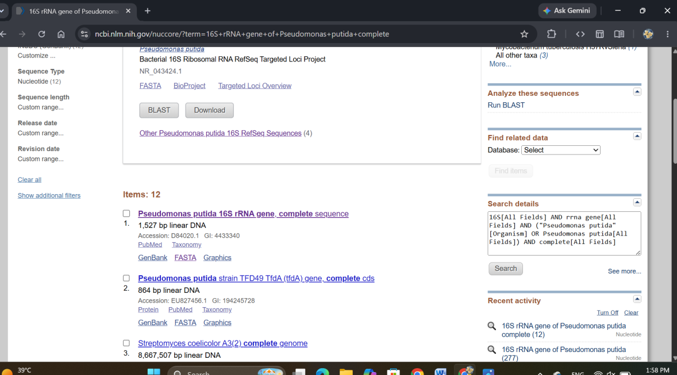

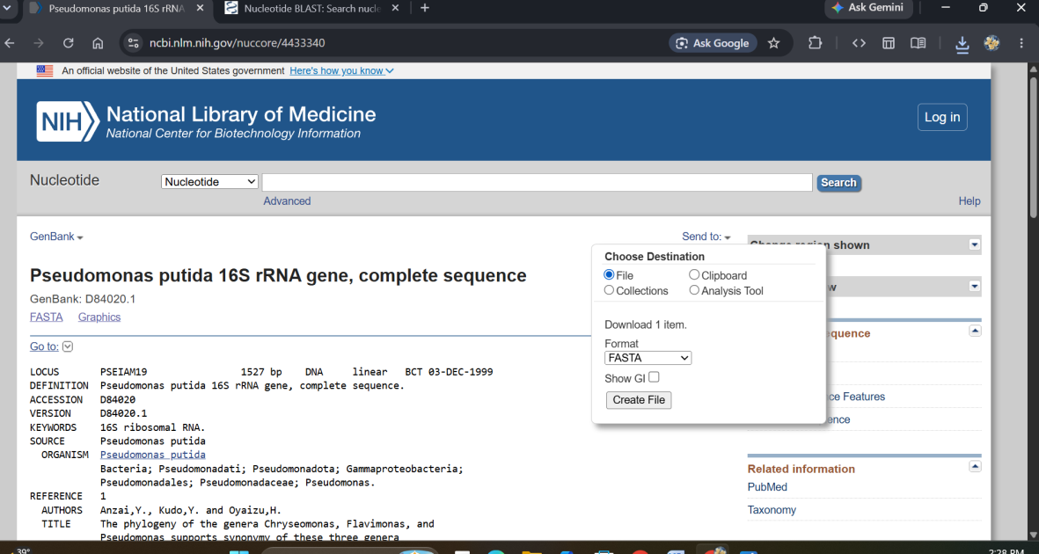
- Click on send to select the file format (.fasta) and download the sequence.

- BLAST Analysis and Sequence Alignment
- Go to NCBI Blast on browser.
- Since the downloaded sequence is of nucleotide, click on the Nucleotide Blast.
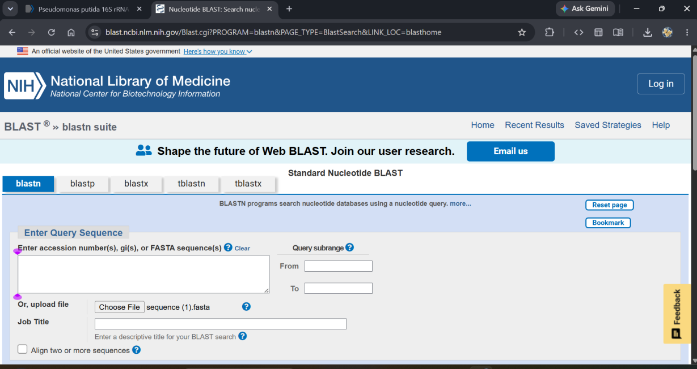
- In the enter Query section, upload the file of downloaded sequence.
- Scroll down and click Blast.

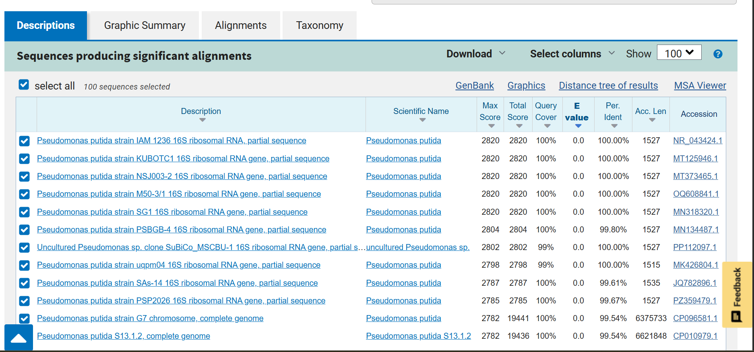

- Select the first five sequences.
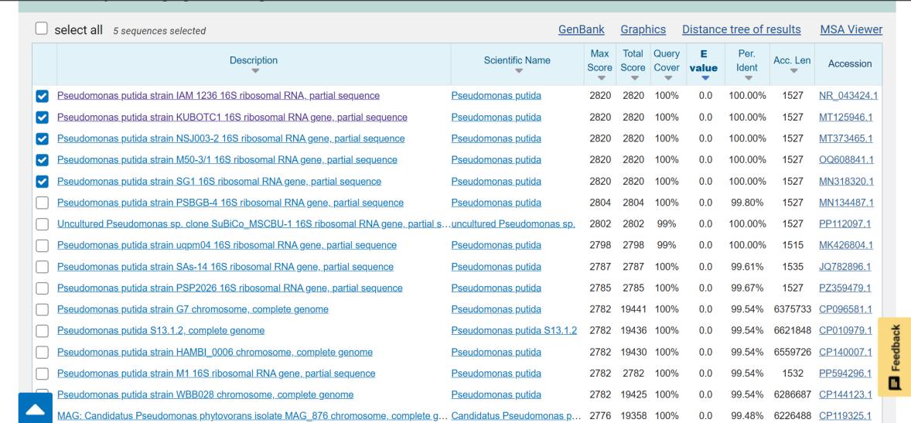

- MSA and phylogeny
- Go to ClustalW and upload the file of the 5 sequences downloaded.
- Upload the file, change the pace from fast/approximate to slow/accurate
- Change the sequence from protein to DNA.
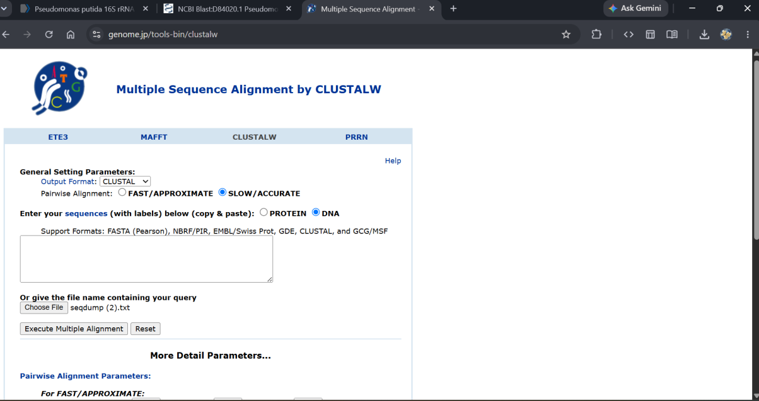

- Press Execute Multiple alignment button.
- Record the results.
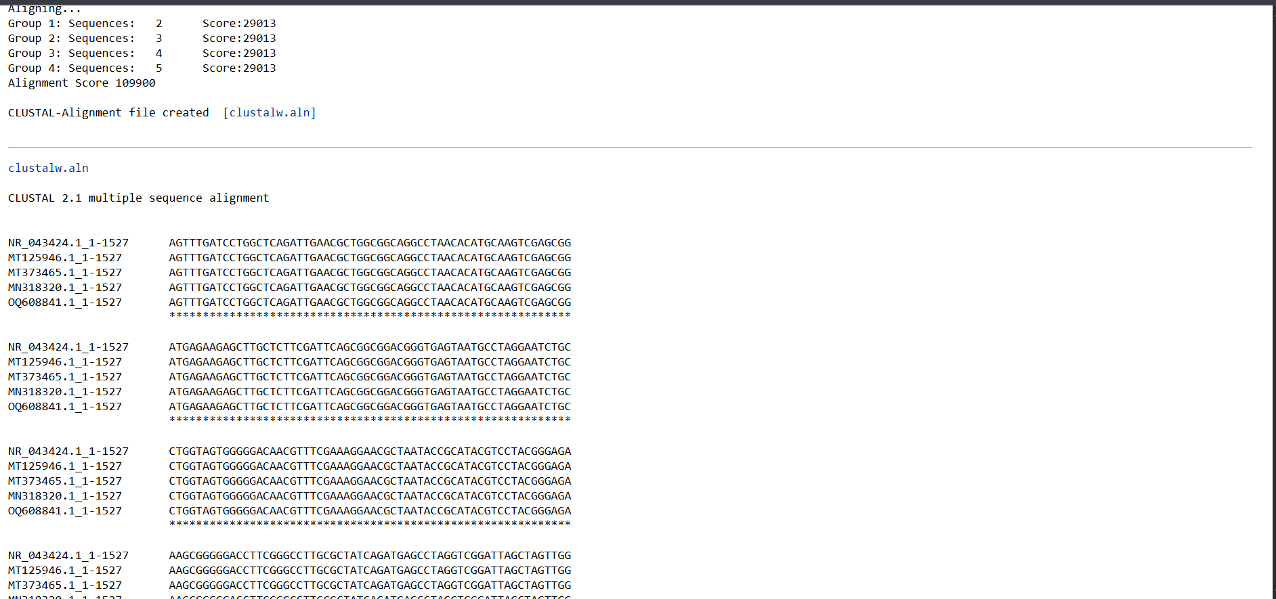
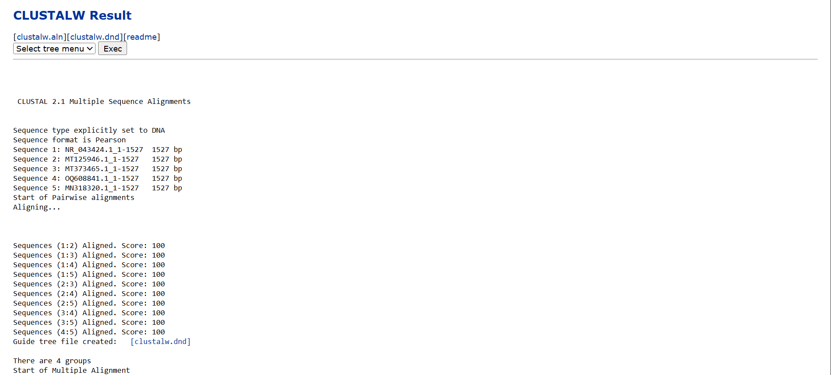

- Phylogeny
- Scroll down to the bottom
- Select the PhyML Bootstrap and press Execute.
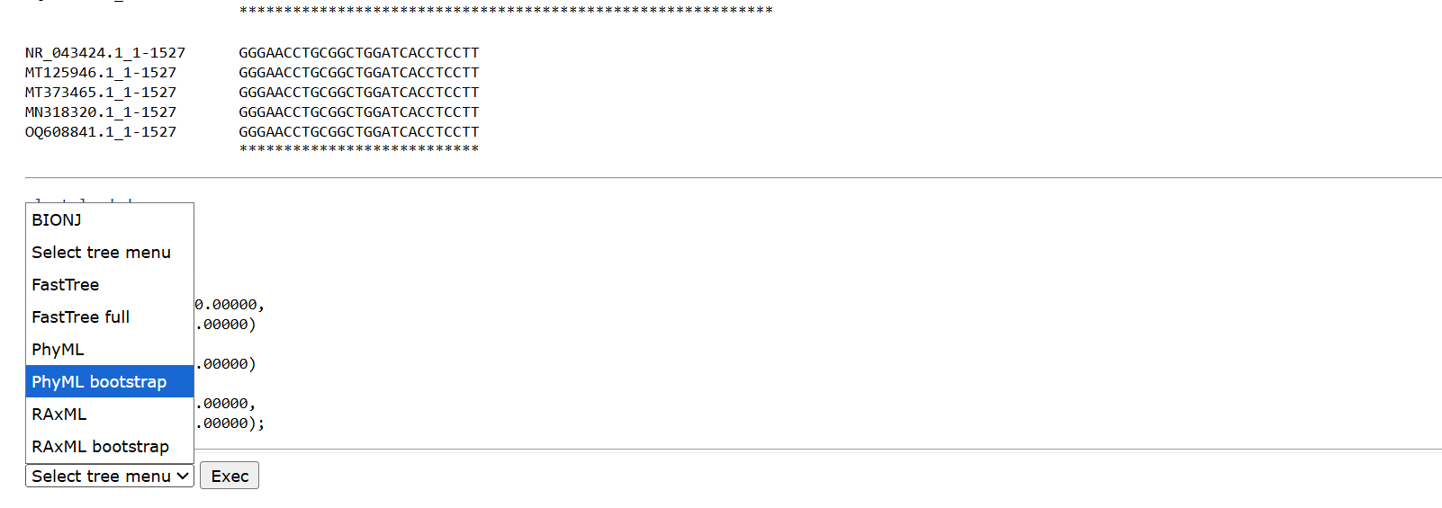

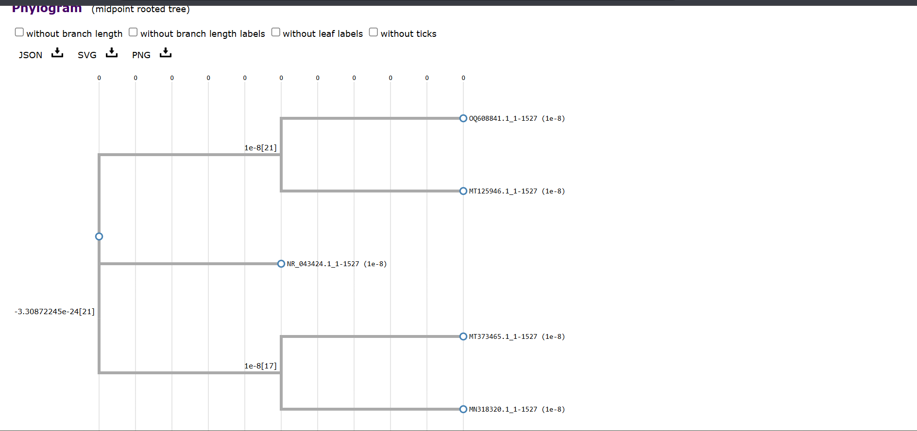
- Let the results come out.

- Download the tree in PNG format for future use.
