Internationally Recognized  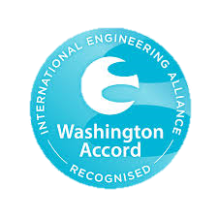  UET Graduates Are Eligible to Work Globally as It Is Associated with Washington Accord. Programs Offered in Computer Science Are Recognized By Washington Accord. |  | 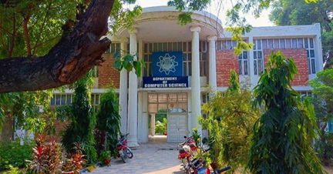  Visit us Online  Lms.uet.edu.pk  Cse.uet.edu.pk  Uet.acm@gmail.com | 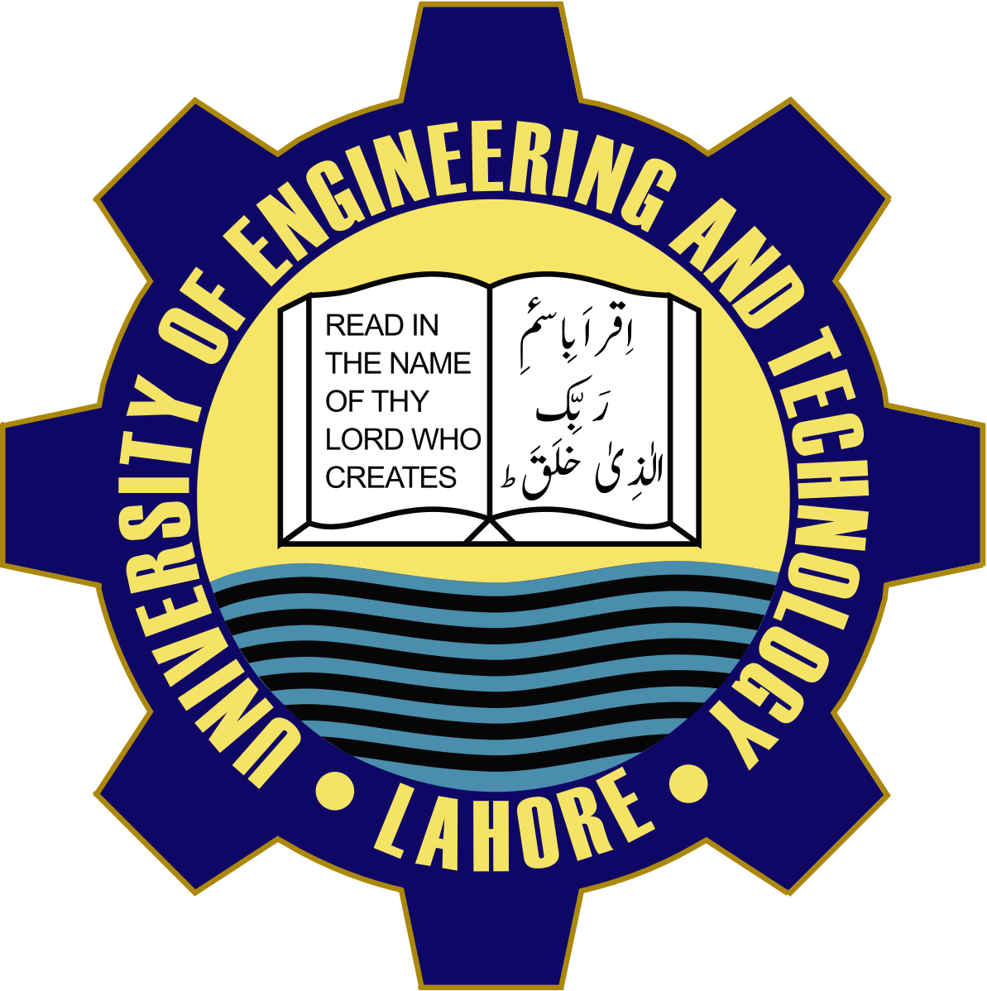  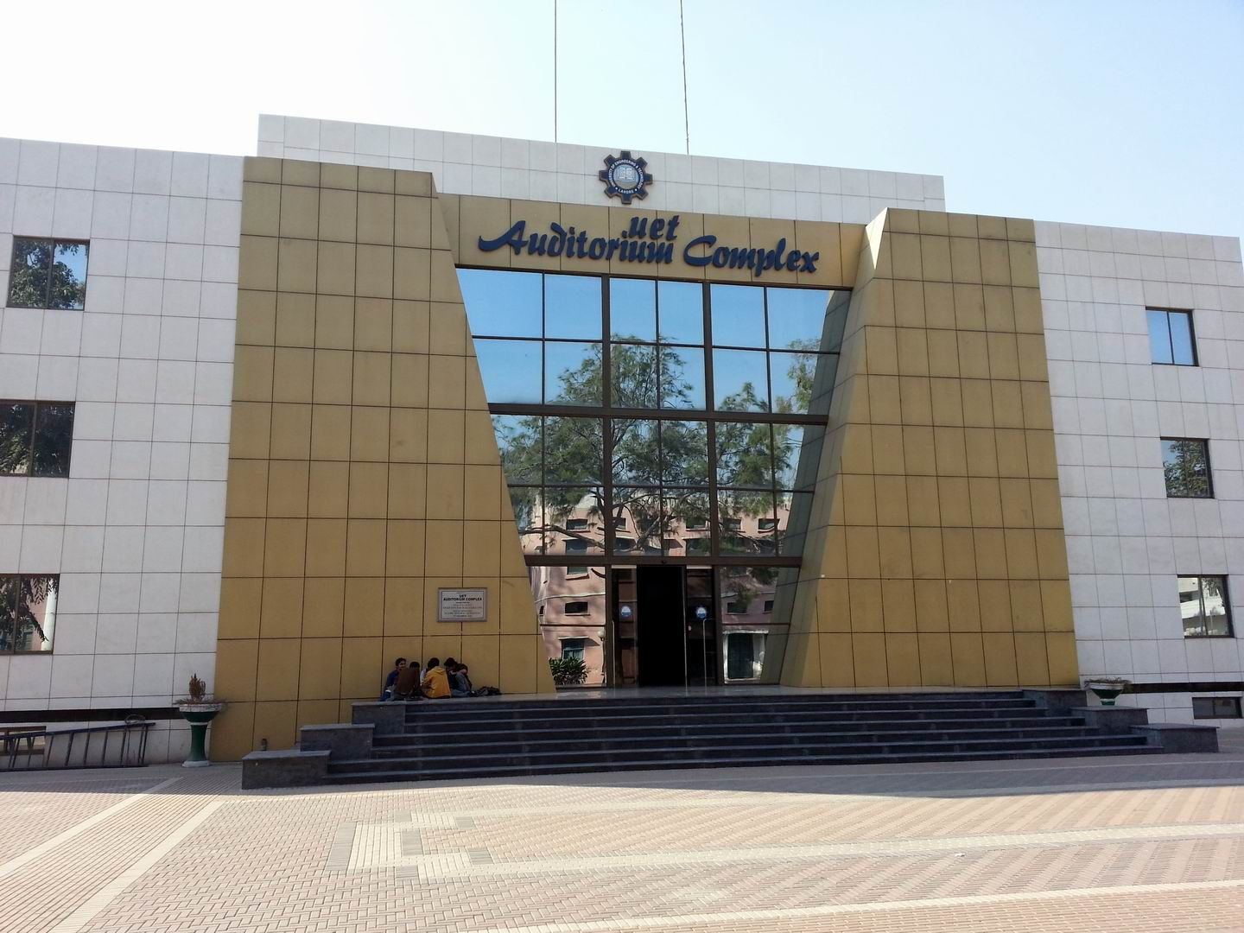

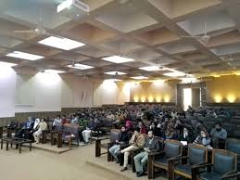  Courses Offered  - BSc. Computer Engineering  - BSc. Computer Science  - MSc. Computer Science  - MSc. Computer Engineering  Careers  - App Development  - Computer Networking  - Computer systems Administrators | THE SCIENCE OF TODAY IS THE TECHNOLOGY OF TOMMORROW  EDWARD TELLER  Technical Society  UET ACM is one of the celebrated scientific society which is actively participated in different events in collaboration with ICOSST (KICS)  - IEEE UET SOCIETY  - COMPUTER CLUB  - IET SOCIETY  COMPUTER FACILITIES  Computer cell is providing advanced internet services to all universities. | Dean: Prof. Dr Aftab Sohail  Chairman: Prof. Dr  Muhammad Shebaz  Contact Details  UET Admissions: 042-99029  216  Registrar: 042-99029227  Deputy Registrar: 042-99029  09  Assistant Registrar: 042-990  29417

