UNIVERSITY OF ENGINEERING AND TECHNOLOGY , LAHORE

DEPARTMENT OF COMPUTER SCIENCE

APPLICATIONS OF INFORMATION AND COMMUNICATION TECHNOLOGY LAB (AICTL)

MIDS PROJECT

Topic: “The Mirror Trap – Comparing Ourselves to Others”

Instructor: Ms. Ramsha Khalid
Semester: Fall 2025

GROUP MEMBERS:
Group leader: Hadia Nabeel (2025-CS-132)
MEMBERS:
1. Ayesha Siddiqa (2025-CS-148)
2.Amna Khan (2025-CS-153)
3 Sania Zahra (2025-CS-155)
4.Soha Batool (2025-CS-142)
5. Huda Shahzadi (2025-CS-146)

Contents:

1.INTRODUCTION: 3
2.DATA SUMMARY AND OBSERVATIONS: 4
3.FINDINGS AND DISCUSSIONS: 13
4.CONCLUSIONS: 14
5.SUGGESTIONS: 14
6.REFERENCES: 15

1.INTRODUCTION:
The Mirror Trap describes the tendency to measure our worth, success, or happiness by constantly comparing ourselves to others. Rather than focusing on our own growth, we often look at others’ lives especially through social media judge ourselves accordingly. This habit can easily lead to feelings of inadequacy, envy, and lower self-esteem.
Comparing ourselves to others is something most of us do naturally. From childhood, we notice the achievements, looks, and possessions of people around us and use them as a comparison for ourselves. But today, with social media providing constant glimpses into carefully well built life, comparison between people increases. Seeing others’ “perfect” moments can make us question our own reality.
Social media platforms act as mirrors that reflect only selected highlights: success stories, achievements, and idealized images. It’s easy to forget that behind these pictures and social media videos are struggles, mistakes, and ordinary moments. Comparing our behind-the-scenes to someone else’s highlights can drain our energy, increase anxiety, and create a constant need for validation. Among students and young adults, this pressure to keep up has become one of the most common emotional challenges.
This project, titled “The Mirror Trap – Comparing Ourselves to Others,” aims to explore how social comparison affects individuals in their daily lives. The focus is on understanding what triggers these comparisons, how they shape self-perception, and what strategies might help reduce their negative impact. By surveying university students, the study seeks to reveal patterns in self-comparison, social influence, and awareness of this psychological phenomenon.
Understanding the Mirror Trap is important because it not only affects self-esteem it can influence motivation, confidence, and relationships. By identifying these patterns and raising awareness, this project hopes to help individuals develop a healthier sense of self and reduce reliance on external validation. The insights gained may also guide future initiatives promoting balanced and mindful engagement with social media.
Survey Source:
The data in report was collected using the following Google Form:
https://forms.gle/MKoMD9xErrACNUYP8

2.DATA SUMMARY AND OBSERVATIONS:
Question no 1
Analysis of Question: Age Group
As shown in this chart:
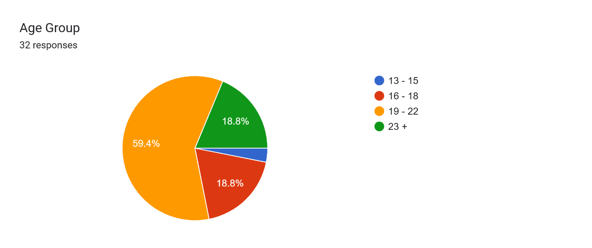
• Majority of the participants fall within the 19–22 age group (65.6%), indicating that the survey responses were primarily from young adults.
• 21.9% belong to the 16–18 age group, showing active participation from teenagers.
• Very few respondents are aged 23+ (12.5%) and 13–15 (3.1%), meaning the survey reached fewer individuals outside the young-adult segment.
Question no 2
Analysis of Question: Gender
As shown in this chart:
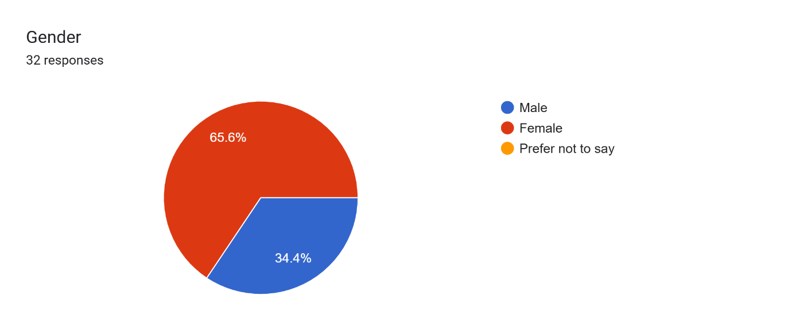
• Majority of the respondents were female (68.8%), showing that females engaged more actively with the survey.
• Only 31.2% of respondents were male, indicating lower male participation in the survey.
Question no 3
Analysis of Question: Have you ever wished to look or live like someone else you see online?
As shown in this chart:
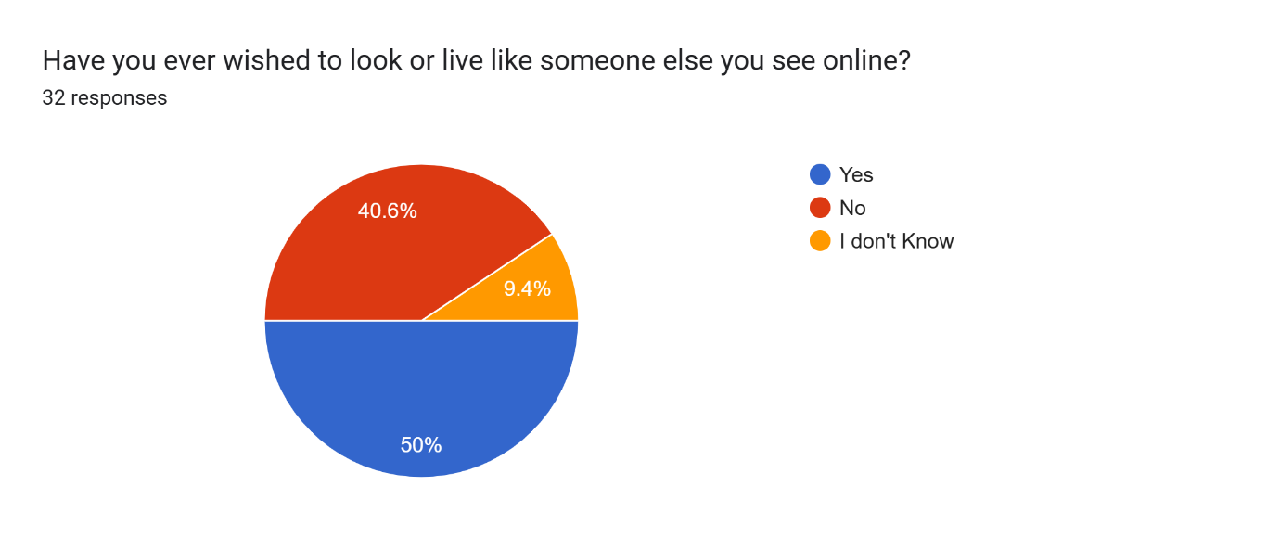
• Most participants (50%) answered “Yes,” indicating that a large majority have felt influenced by online appearance or lifestyle standards.
• 40.6% responded “No,” showing that some individuals remain unaffected by online comparisons.
• 9.4% were unsure, which suggests confusion or mixed feelings regarding comparison with online personas.
Question no 4
Analysis of Question: Where do you think most of your comparisons come from?
As shown in this chart:
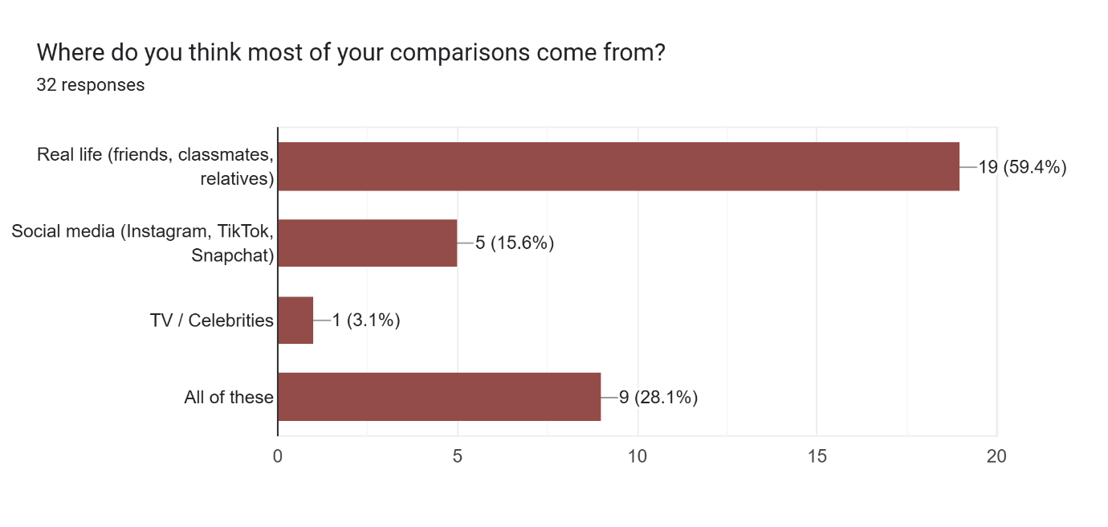
• The majority of respondents (59.4%) feel comparison mainly comes from real-life surroundings, such as classmates, friends, and relatives.
• 28.1% mentioned “All of these,” suggesting that comparison is influenced by multiple sources simultaneously.
• Only 15.6% attributed comparison solely to social media, and 3.1% to celebrities/media, indicating online comparison exists but is not the primary source for most people
Question no 5
Analysis of Question: If you had to visualize “The Mirror Trap,” what would it look like?
As shown in this chart:
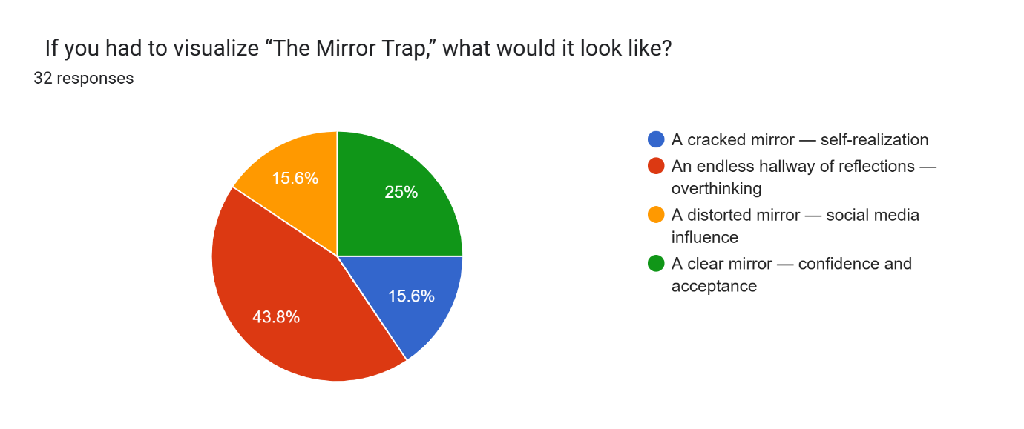
• Most participants (43.75%) visualized “The Mirror Trap” as an endless hallway of reflections, representing overthinking and constant comparison.
• 25% imagined a clear mirror, symbolizing confidence and self-acceptance.
• 15.6% pictured a cracked mirror, indicating self-realization through challenges.
• 15.6% chose a distorted mirror, reflecting the negative influence of social media on self-perception.
Question no 6
Analysis of Question: How much does social media increase comparison in your life?
As shown in this chart:
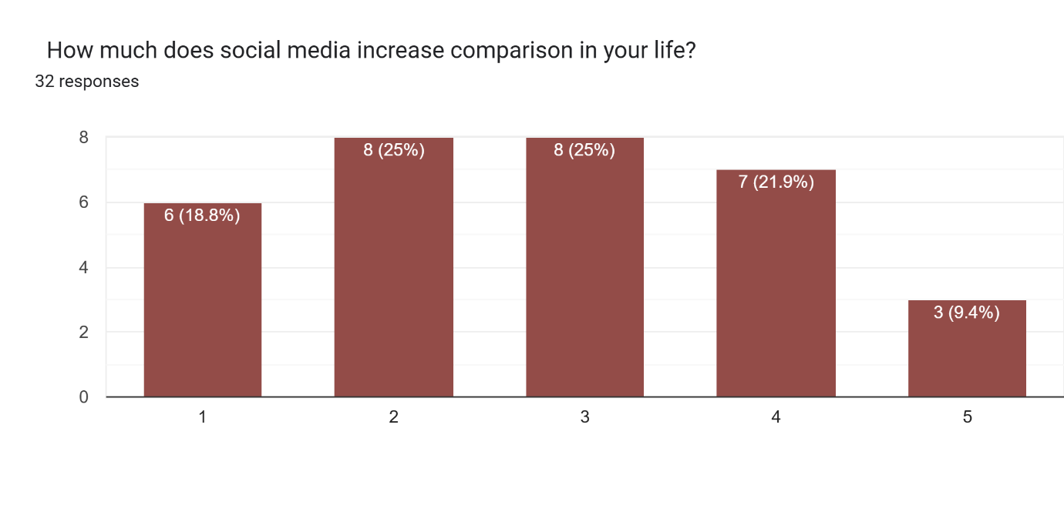
- Most participants (25%) feel social media increases comparison to a moderate level.
- 18.8% reported very high influence, and 25% reported high influence, showing a significant portion experience strong effect.
- Only 21.9% feel social media has low impact, and 9.4% feel very low impact.
Overall, social media contributes noticeably to comparison for the majority of respondents.
Question no 7
Analysis of Question: If you could describe social media in one word related to comparison, what would it be?
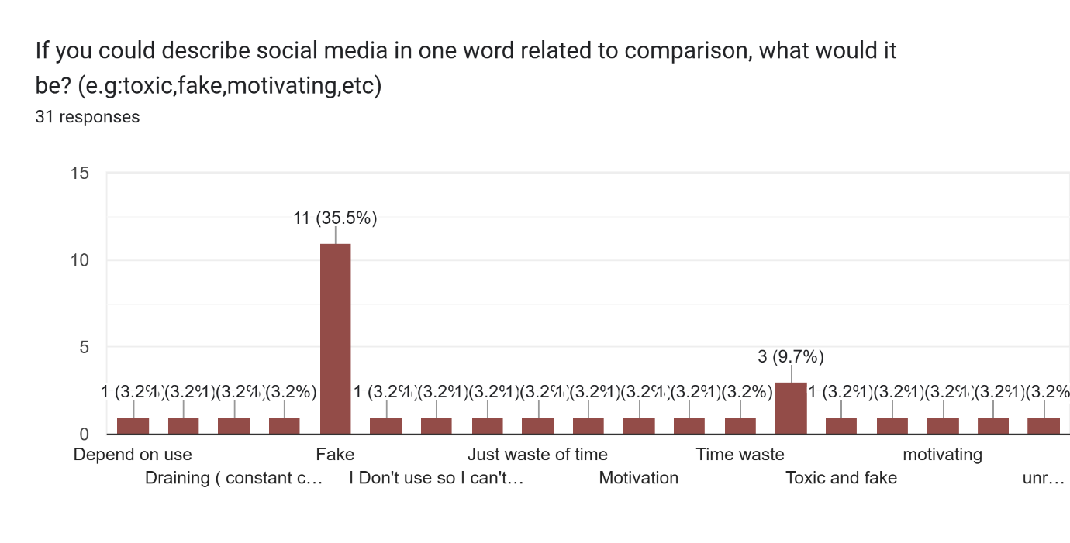
As shown in this chart:
• The majority of participants described social media negatively.
• The most frequently repeated word was “Fake”.
• Words such as “Toxic,” “Unrealistic,” “Time waste,” and “Draining” indicate emotional and mental pressure caused by social comparison.
• A small number of participants used positive words such as “Motivating” and “Entertainment”.
• A few responses were neutral or showed no opinion.
Question no 8
Analysis of Question: I sometimes hide my true self to look ‘better’ in front of others.
As shown in this chart:
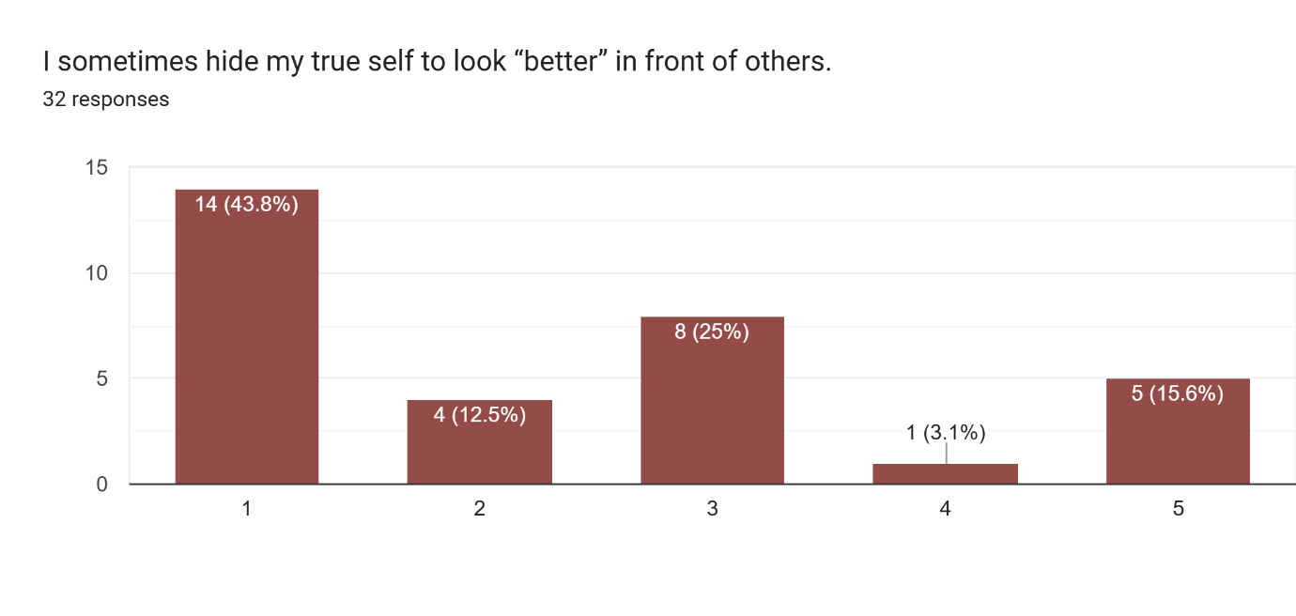
• 43.8% strongly agreed that they hide their true selves to appear better — showing strong pressure to look “perfect,” especially due to social media and comparison culture.
• 25% were neutral, indicating uncertainty or that it depends on the situation.
• Only 12.5% disagreed, meaning very few feel confident being completely authentic.
Question no 9
Analysis of Question: Seeing others doing better makes me feel…
As shown in this chart:
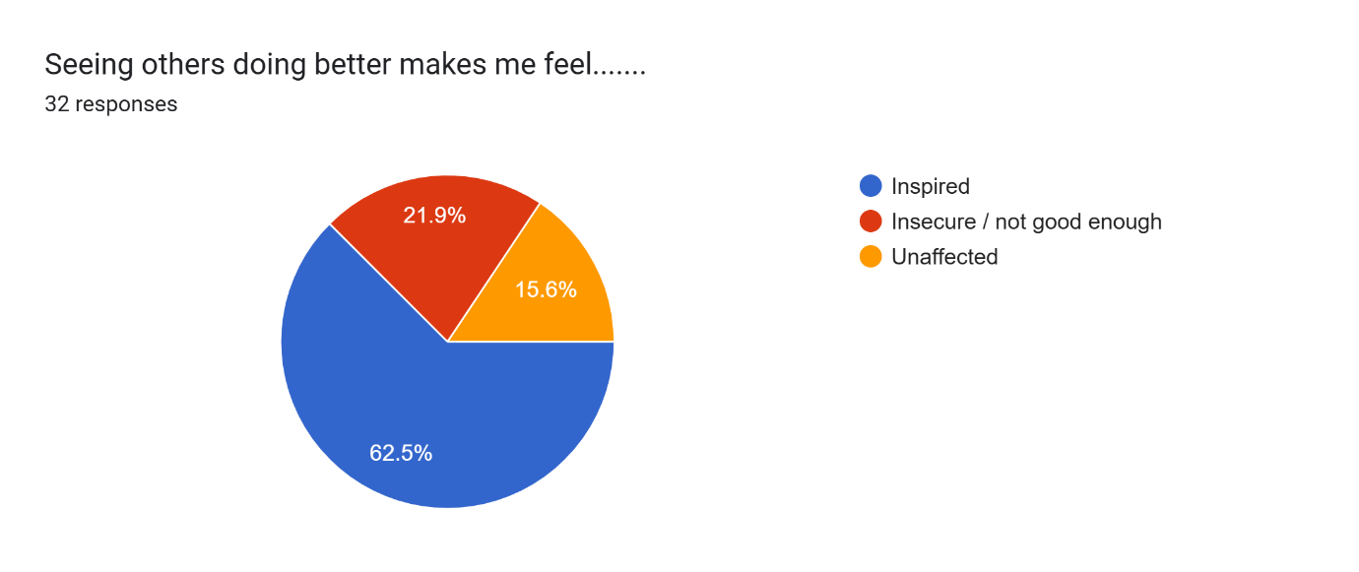
• 62.5% participants feel inspired when they see others doing better.
• 21.9% feel insecure / not good enough, showing negative emotional impact.
• 15.6% remain unaffected, meaning comparison doesn't influence them.
Question no 10
Analysis of Question: What helps you avoid comparison?
As shown in this chart:
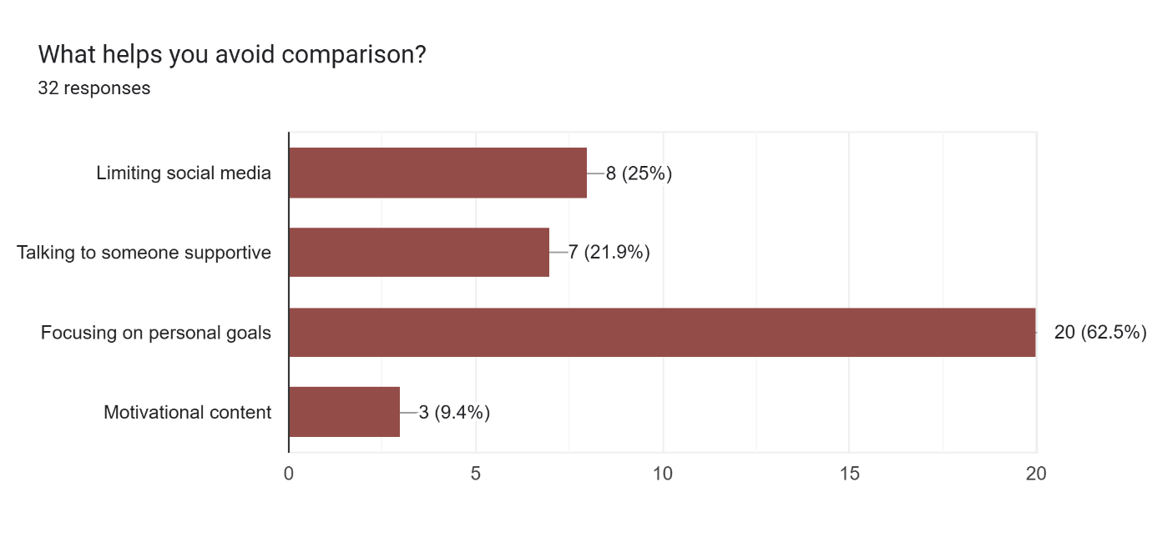
•s Most participants avoid comparison by focusing on their personal goals, showing that self-focus reduces negative comparison.
• Some participants avoid comparison by limiting social media use.
• A few manage comparison by seeking emotional support from supportive people.
• This shows that both self-discipline and a positive environment help reduce comparison
Question no 11
Analysis of Question: What makes you feel more confident?
As shown in this chart:
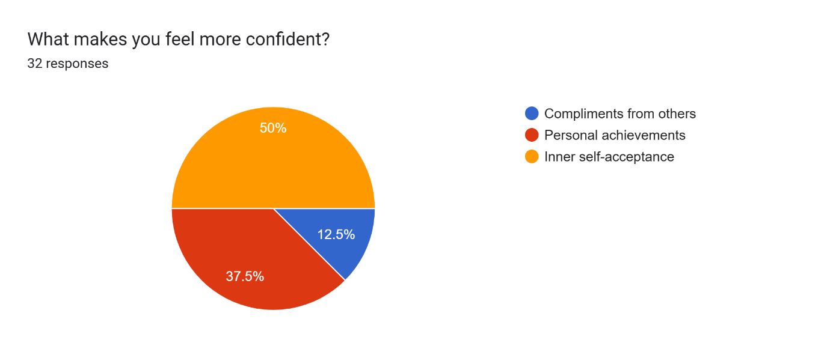
• Most participants (50%) feel more confident through inner self-acceptance.
This shows that internal validation plays a major role in confidence building.
• Personal achievements (37.5%) are the second most common factor.
Participants feel confident when they accomplish something or reach a goal.
• Only a small portion (12.5%) rely on compliments from others.
External validation matters, but not as much as personal belief and achievements.
Question no 12
Analysis of Question: If you could rate your self confidence (without comparing to others) what would it be?
As shown in this chart:
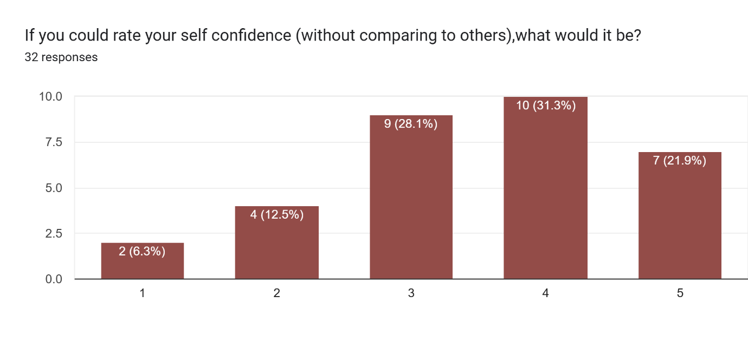
• Most participants rated their self-confidence as 4 (31.25%) or 3 (28.1%), showing that their confidence is generally stable but not extremely high.
• 7 participants (21.9%) rated themselves as 5, indicating strong self-confidence without comparison to others.
• Only a small number rated low confidence (2 or 1), showing that very few struggle with self-confidence.
Question no 13
Analysis of Question: Recall a moment when comparison hurt your confidence. What did that experience teach you about yourself?
• Most participants shared that comparison initially hurt their confidence, but later helped them learn valuable lessons such as focusing on self-growth, working harder, and believing in their own journey.
• Many respondents realized that everyone has their own pace and comparing with others is unfair and meaningless.
• Several participants mentioned that comparison motivated them to improve (e.g., studying harder, achieving better results later).
• A few responses indicated negative emotional reactions such as sadness, reduced interaction, and loss of confidence.
• Some participants highlighted that social media creates unrealistic standards, leading to unnecessary comparison.

3.FINDINGS AND DISCUSSIONS:
The data collected through the survey highlights a clear pattern of constant social comparison among respondents. A majority of participants admitted that they often compare their lives, achievements, or appearances with others, especially on social media platforms. This reflects how the “Mirror Trap” operates in daily life. People measure their self-worth by what they see in others rather than focusing on personal growth.
Most participants agreed that social media intensifies this habit. Platforms such as Instagram and TikTok create ideal images of success and happiness, leading users to feel inadequate or left behind. This finding aligns with Leon Festinger’s (1954) Social Comparison Theory, which states that individuals determine their own value based on how they feel about others. When they feels others are doing better than them they fall into the web of constant validation and start following trends.
These observations also tell us that most people create a false image of themselves on social media. Although users consciously know these portrayals are exaggerated, they subconsciously start comparing themselves to them, leading to broken self confidence and a desire to maintain a perfect online image. This pattern aligns with the findings of Vogel et al. (2014), who observed that viewing perfect social media profiles often results in lower self-esteem and negative self-comparison.
Robert Greene, in his book The Laws of Human Nature (2018), explains that people often unconciously compare themselves to others because of deep-rooted insecurities. He focuses that individuals create perfect versions of themselves to gain validation and admiration from others, which often leads to emotional exhaustion. This idea supports the findings of this report, where participants admit to forming perfect online images to maintain social approval. Greene’s perspective aligns with the concept of the “Mirror Trap,” as it reflects how people shape their personalities not based on authenticity but on societal expectations
The responses also show that only a small portion of individuals find comparison motivating. This suggests that while comparison can also motivate people to grow out of their comfort zone, in most cases it becomes psychologically draining and counterproductive. Many respondents reported decreased confidence after viewing others’ accomplishments, showing the emotional impact of the Mirror Trap.
These findings support previous studies emphasizing that constant comparison on social media is linked with anxiety, self-doubt, and lower life satisfaction. It highlights the need for digital mindfulness and self-acceptance practices among youth. Encouraging people to focus on self-growth rather than competition could reduce the negative impact of comparison and promote mental well-being.

4.CONCLUSIONS:

The survey results make it clear that social comparison, especially on social media, has become a deeply rooted habit in modern society. Most participants admitted to comparing themselves with others, often leading to decreased confidence, dissatisfaction, and a distorted sense of self-worth. This pattern reflects how the “Mirror Trap” operates, where individuals measure their value not by their personal progress but by external appearances and validation.
The findings align with established psychological theories, confirming that while comparison can sometimes cause improvement, it more often leads to emotional exhaustion and self-doubt. The creation of false online identities further worsens this cycle, as people seek approval through perfectly built images rather than authenticity.

5.SUGGESTIONS:
- Promote Digital Mindfulness: Individuals should be encouraged to limit screen time, unfollow triggering accounts, and consciously consume social media content that inspires rather than diminishes confidence.
- Encourage Self-Acceptance: Educational institutions and workplaces can organize workshops and seminars on self-esteem, emotional intelligence, and personal growth to help people focus on inner progress.
- Authentic Online Behavior: Users should be motivated to share realistic aspects of their lives online instead of idealized portrayals to normalize imperfection and reduce comparison pressure.
- Parental and Peer Support: Family and peers play a crucial role in reinforcing self-worth and discouraging harmful comparisons among youth.
- Integrate Awareness in Curriculum: Schools and universities should organize awareness programs or short courses on the psychological impact of social media comparison. Educating students about concepts like the “Mirror Trap” and social comparison theory can help them recognize and manage these behaviors early on.
In short, escaping the Mirror Trap requires a conscious shift from comparison to self acceptance ,valuing authenticity, growth, and self-awareness over artificial perfection.

6.REFERENCES:

[1] | F. L., "A Theory of Social Comparison Processes," Human Relations, vol. 7(2), pp. 117-140, 1954.
[2] | E. A. R. J. P. R. L. R. &. E. K. Vogel, "Social Comparison, Social Media, and Self-Esteem," Psychology of Popular Media Culture, vol. 3(4), pp. 206-222, 2014.
[3] | R. Greene, The Laws of Human Nature, Viking Press, 2018.

