Python-Based Network Port Scanner

Objective
Create a network port scanner that can detect open ports and display the name of the service running on them for a target host using Python.

Problem Statement
The goal of this project is to create a Python-based network port scanner that scans a set of ports on a target system, prints the open port numbers, prints common port names and adds timeout handling.

Tools and Technologies used.
The type of tools and technologies used.
- Python 3
- Visual Studio Code (VS Code):
- Python Socket Library
- Command Prompt/Terminal

Methodology
- Enter the target address (IP or hostname).
- User sets the start and end port numbers.
- The program translates the hostname to an IP address.
- The scanner tests all the ports on the range.
- If the port is open the program prints the port number and its service name.
- A timeout function has been added to avoid an indefinite wait for a reply.

Algorithm
- Start the program.
- Enter the host name or IP address of the target.
- Enter the starting/ending port numbers.
- Map hostname to an IP address.
- For every port between the following range:
- Create a socket.
- Set timeout.
- Attempt a connection.
- If it is connected, print the name of the service and the name of the port.
- Close the socket.
- Show a message when the scan is finished.
- End the program.

Features
- Scans a user-defined range of ports.
- Identifies open ports.
- Lists the common service names.
- Hostname and IP address scanning is supported.
- Implements timeout handling.
- Includes exception handling.

Screenshots

Source Code

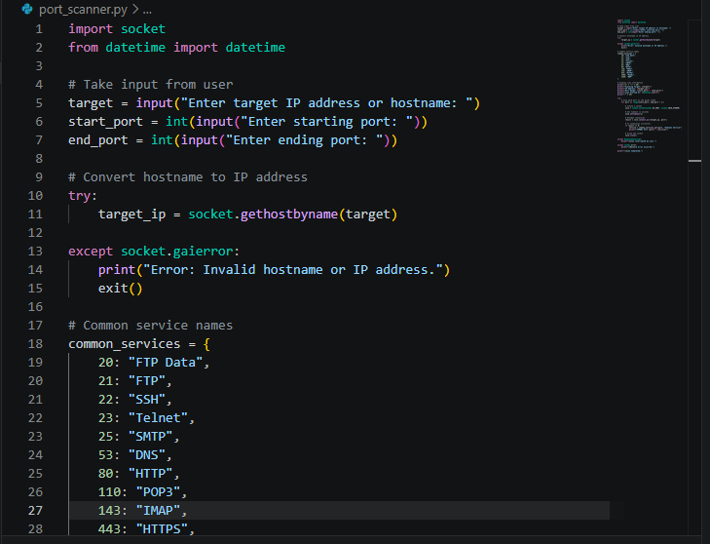

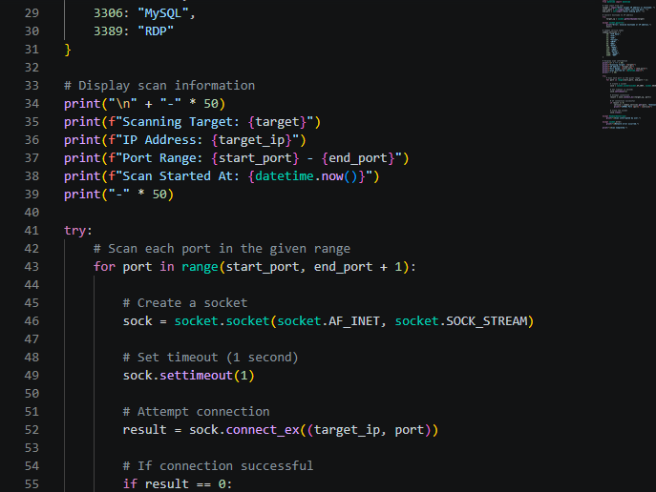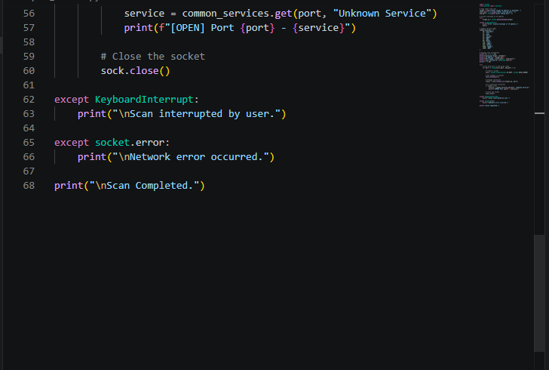

Program Execution

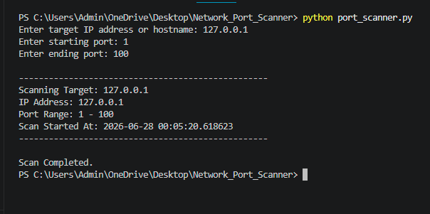

Conclusion
Working with Python, the Network Port Scanner scans a range of ports on a target host, reveals open ports and tells their service names. The project illustrates the implementation of Python sockets in cybersecurity and networking applications.

Author:
Hadia Qasim

