Awal chi bedi zid page lal visitor bye2der ychuf nafs litems yeli bl user dashboard ma3 nafs lfeatures(category,image,descriptions…)bas lama bedou ya3mel purchase nen2elou 3al register page

Kamen bedi ye ychuf loffers nafson akid bala lorders laanou menou user w bb5sous lswaping mafi de3i ychuf lswapping request bas enou eza fina nmare2lou fekret enou mawjud 3anna hal option w huwe eza hawal yefham aktar bedou ysir yetar ya3mel register w bisir user

(bi alb he luser dashboard bedi zid image hene mawjudin ka data base bas mena mawjude hon ya3ni fini zid ka admin image bas mena 3am tensed hon ma3 id litem

s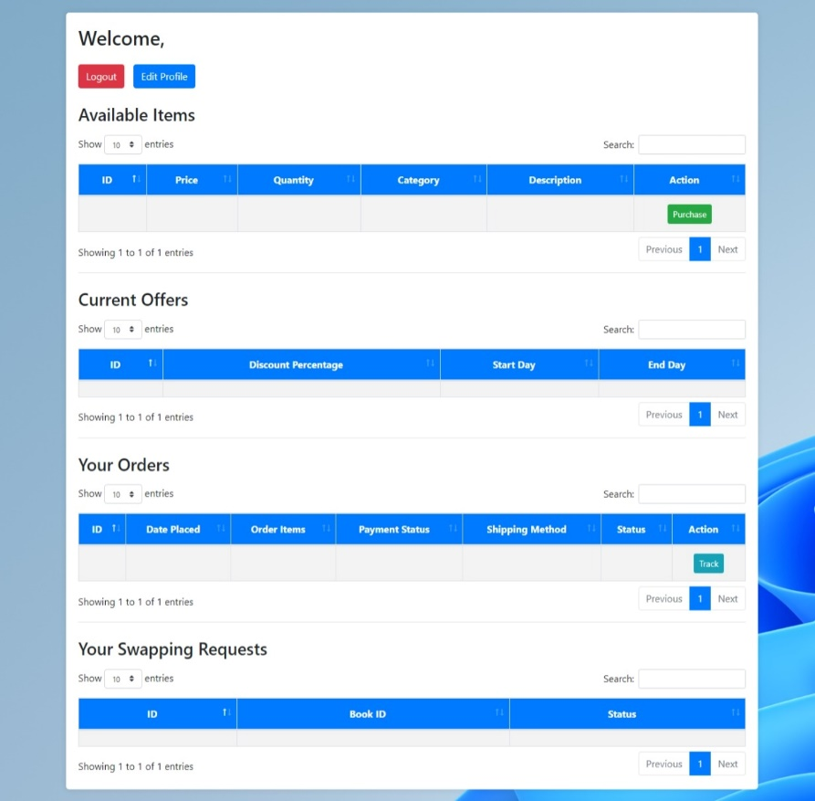

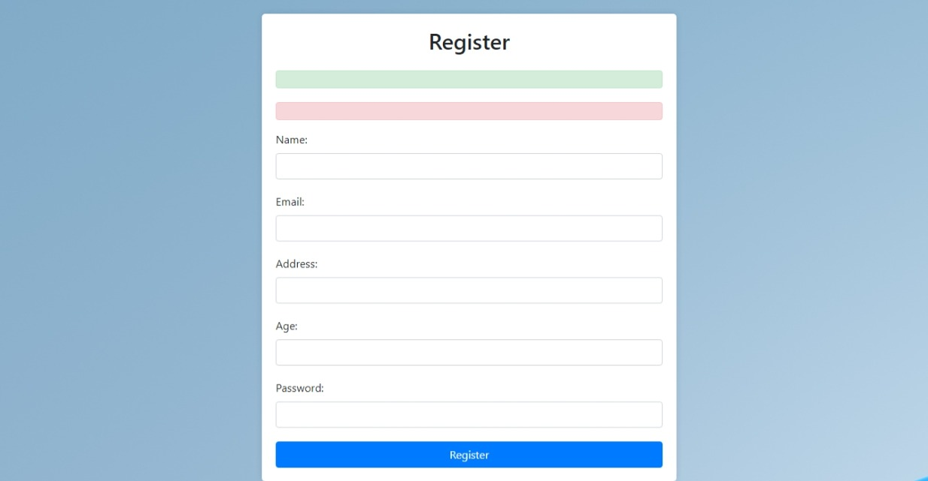Haydi hiye luser dashboard yeli hiye kaana homepage ma bteftah ella mn ba3d ma ya3mel register yerja3 ya3mel login

(Bedi zid 3a he lregister phone number )

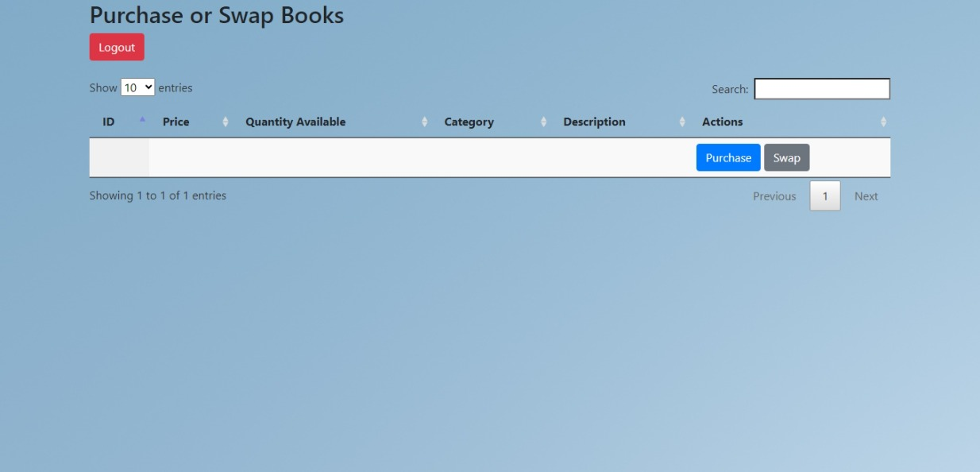

Bedi ye bas yef2os purchase yeji message eza bedou yena netwasal ma3ou by mail aw by phone number w bas ye5tar chu bedou mne5dou 3al page view delivery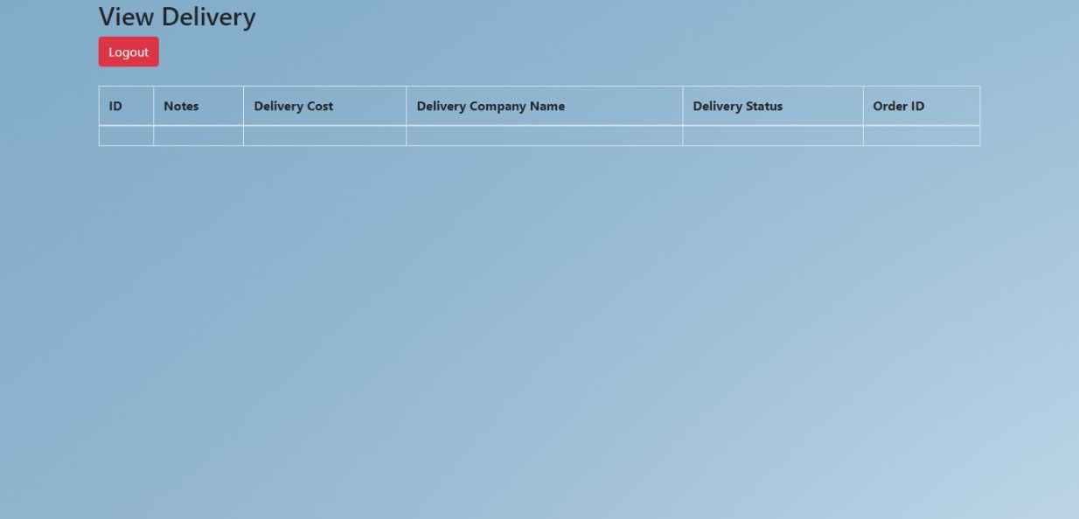

yeli 3amel lprojet mech ana fa fi page esma reservation w page esma favorite ma heset enou fi aya sila ben lpaget lba2we w hene fa kamen bedi el8iyon fi 7al ken fi aya sila ben ba3ed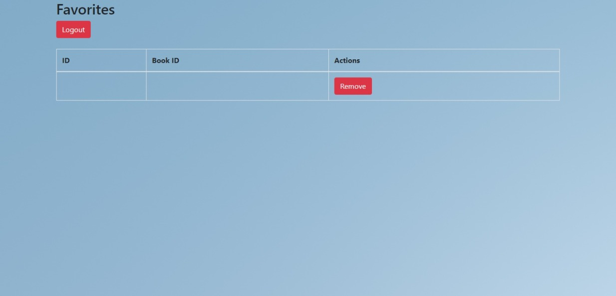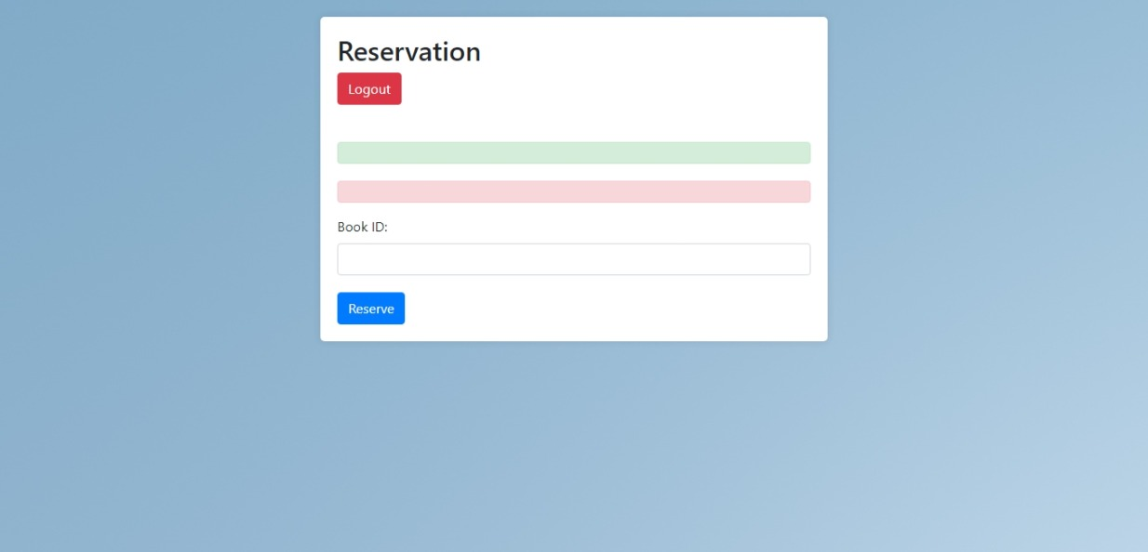

w cha8le a5ira bl register mn ba3d ma lwehed yda5el ma3loumetou mafi chi biredou 3al home page ella ma ya3mel login fa huwe ka visitor lama eja w 3emel register mafi yerja3 3a page lvisitor yle2iya t8ayret akid fa eza fina bi alb page el register nfawtou 3a page el login ta yfut 3al user dashboard.

w ana betchakarak m3alem 😊

w mn ba3d amrak li 3edalna 3layon 3adeli hene bl paget lba2we masalan zedna phone number fa akid lezem yenzed bl add user w bl edit user kamen la7 hetelak hon kelchi be2i paget ma3 asme2on hek btetbasat lessa 3lek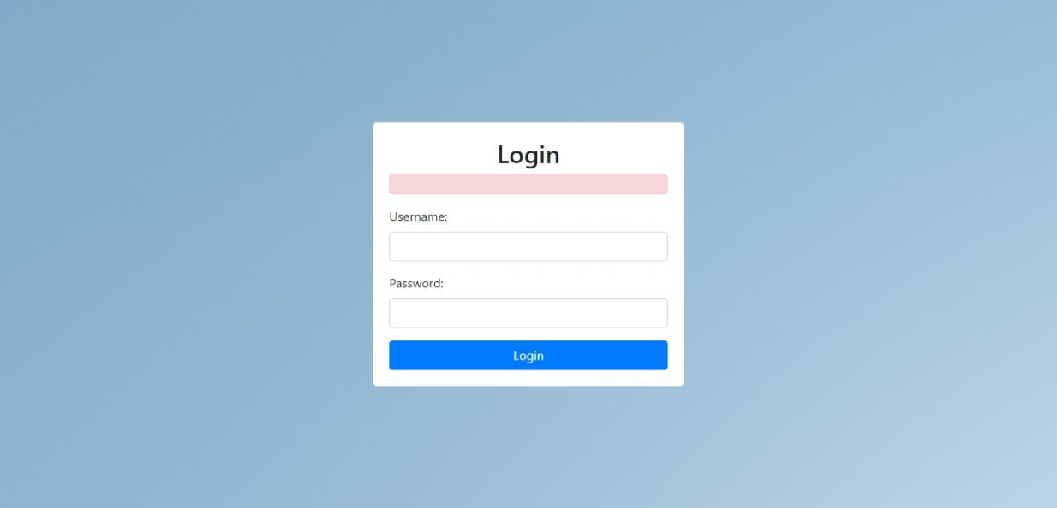admin login

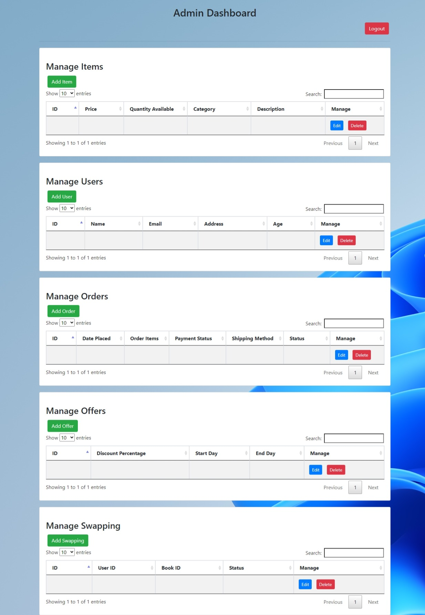admin dashboard bteftah mn ba3d el login de8ri

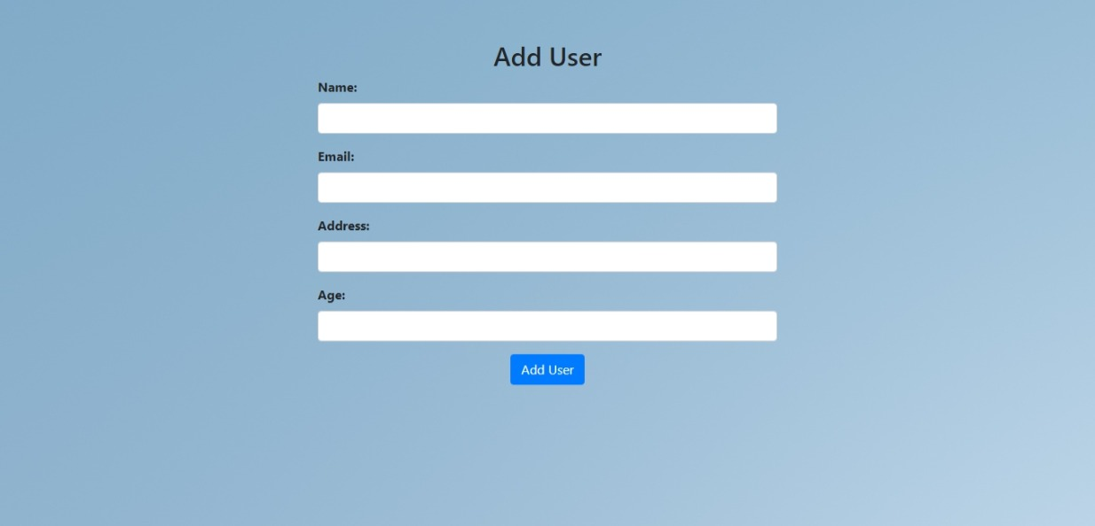

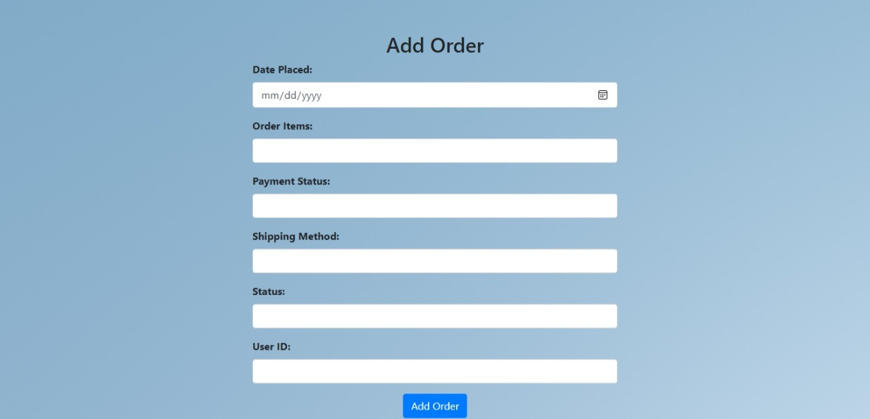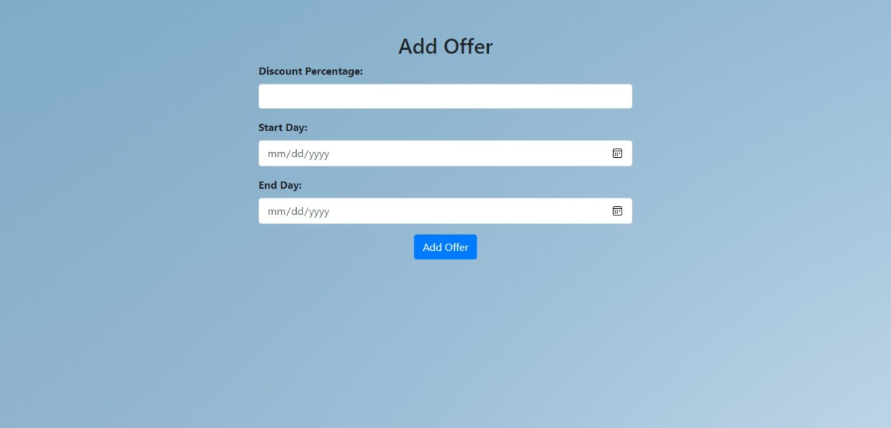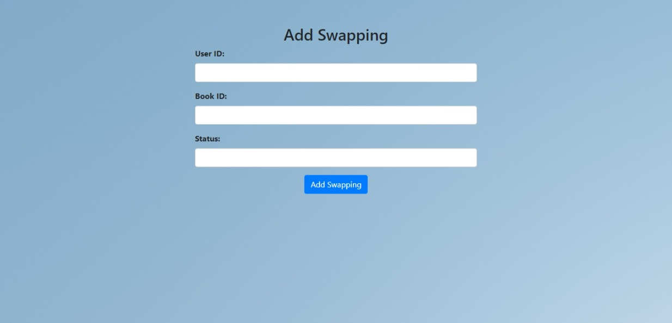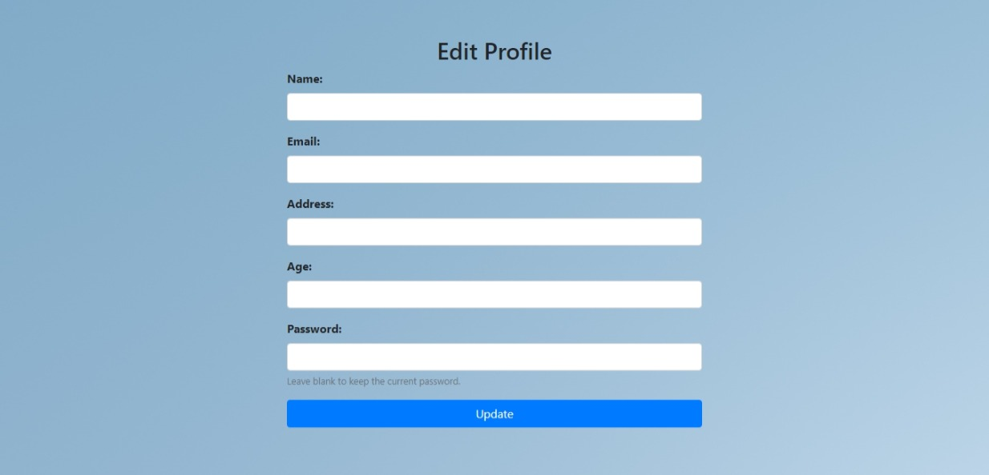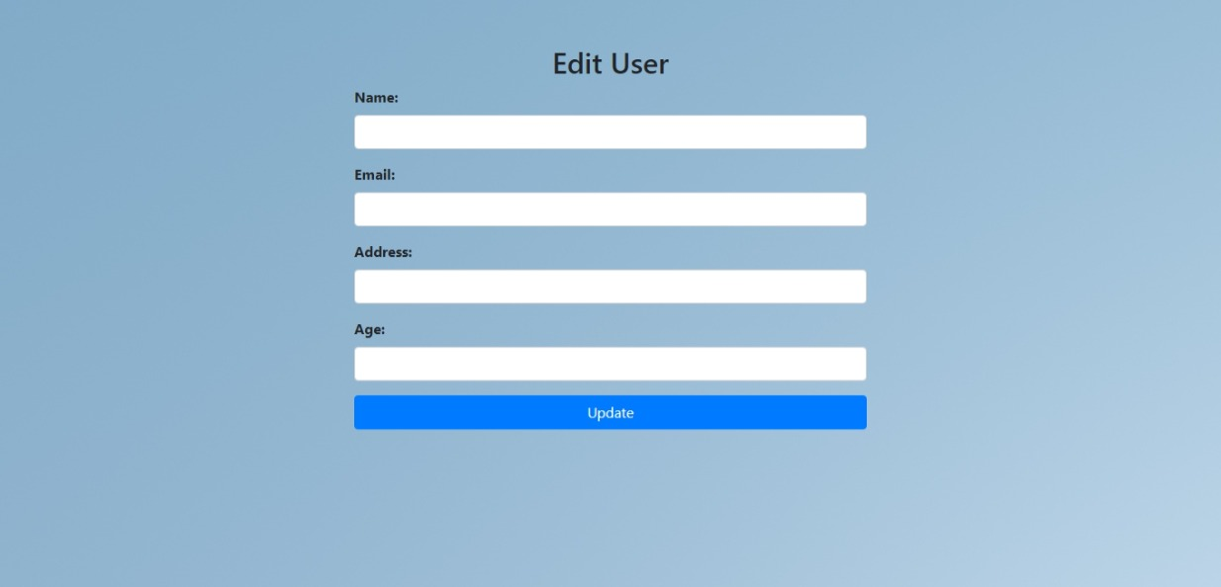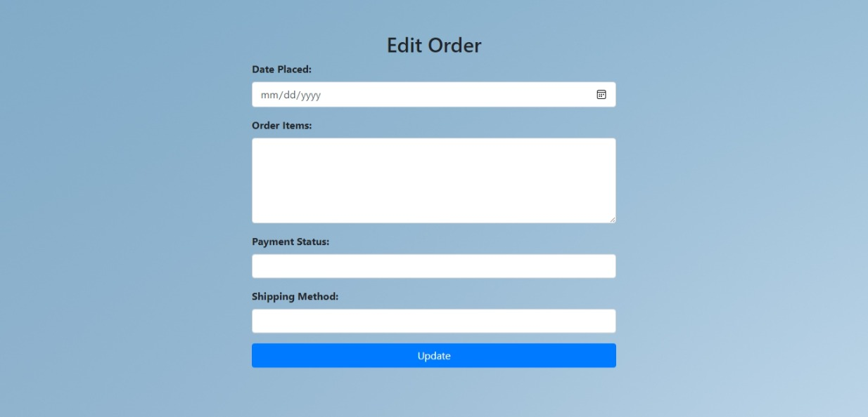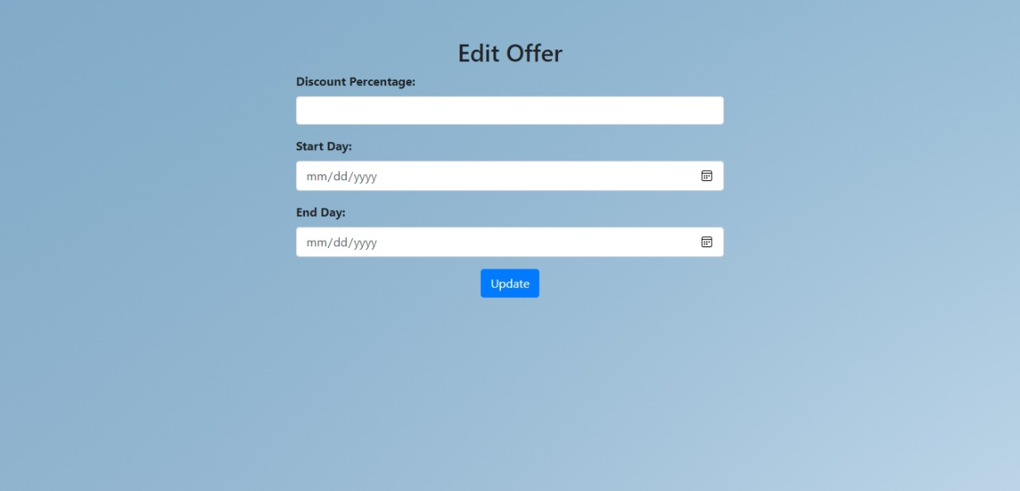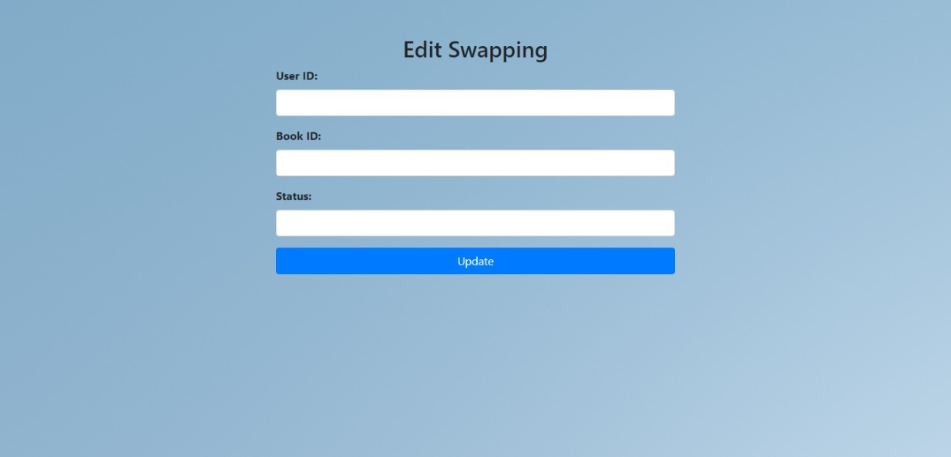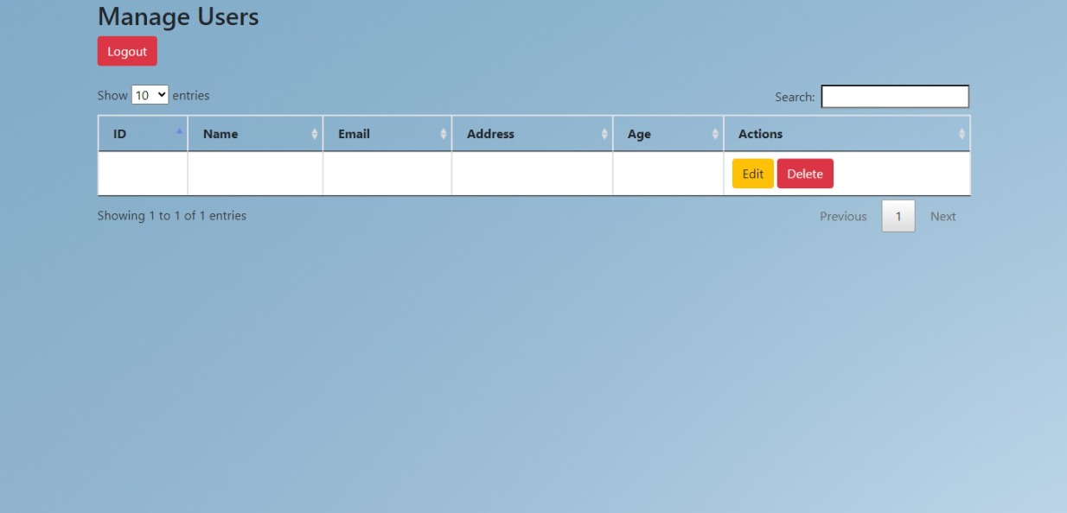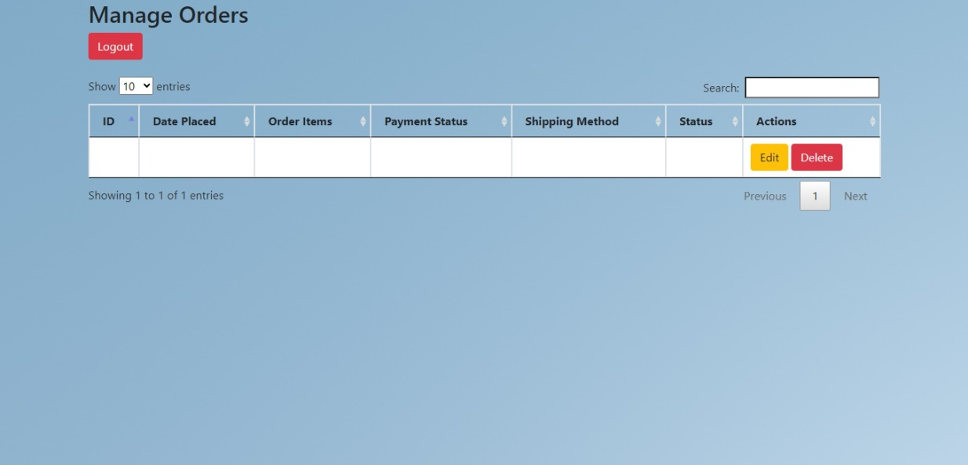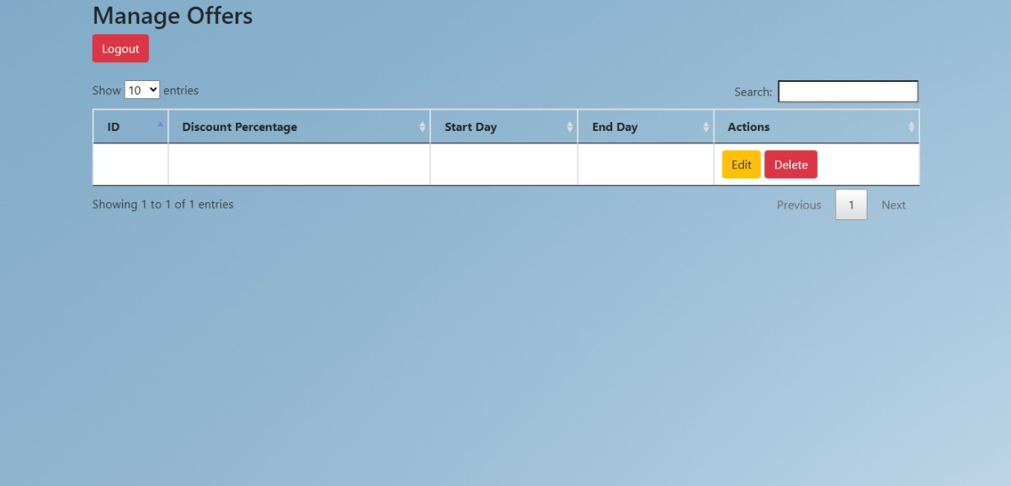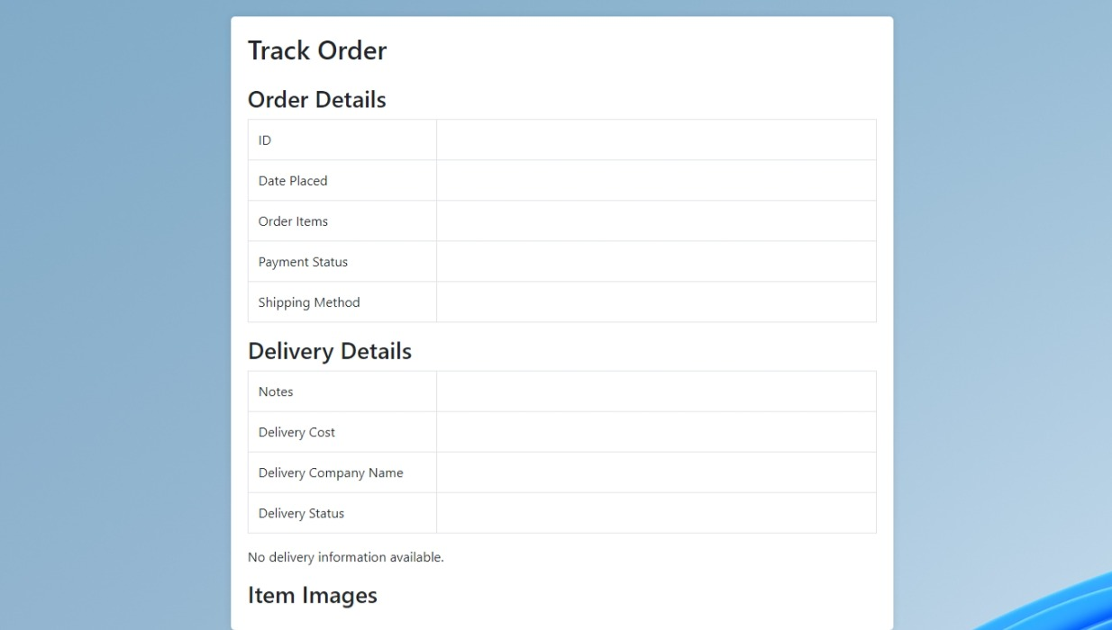

Fi 3anna mechekle enou ldelivery details li beda tetla3 hon mafrud tkoun mawjude mn 5ileli ana ka admin fa mafi page esma add delivery masalan michen 7ot ldelivery details li beda tkoun mawjude bl tracking hon wbl view delivery abel