
FATIMA JINNAH WOMEN UNIVERSITY
Department of Software Engineering

Assignment 01
“ Git, Gitea, GitHub, Git LFS, and GitHub Pages ”

Name : Hadia Eman Malik
Registration No. : FA24B1-SE-025
Course : Cloud Computing
Course Code : BSE 665
Section : A
GitHub Username : hadiaemaanmalik

This report documents the practical work for Assignment 01. All terminal work for Tasks 1, 2 and 3 was done on the Ubuntu server, and the terminal prompt shows the username hadiaemaanmalik and the hostname ubuntu.

Task 1: Install Gitea and Push a Repository from the Ubuntu Server

Step 1.1: Install and Run Gitea on the Ubuntu Server

Verify the installations
After reconnecting, Git, Docker and Docker Compose all display their installed versions.
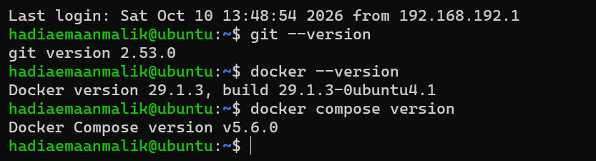

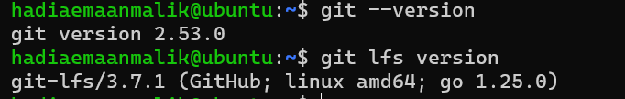

Clone the Gitea setup repository and start Gitea

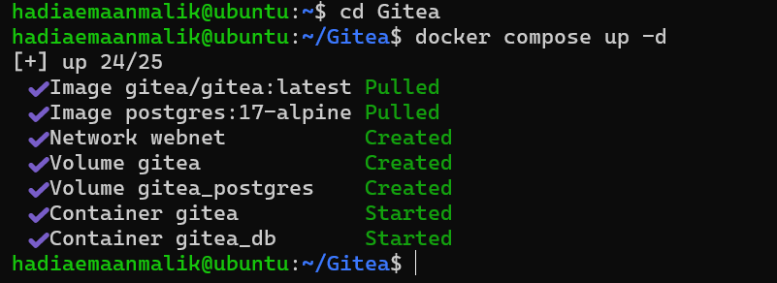

Open Gitea and create an account

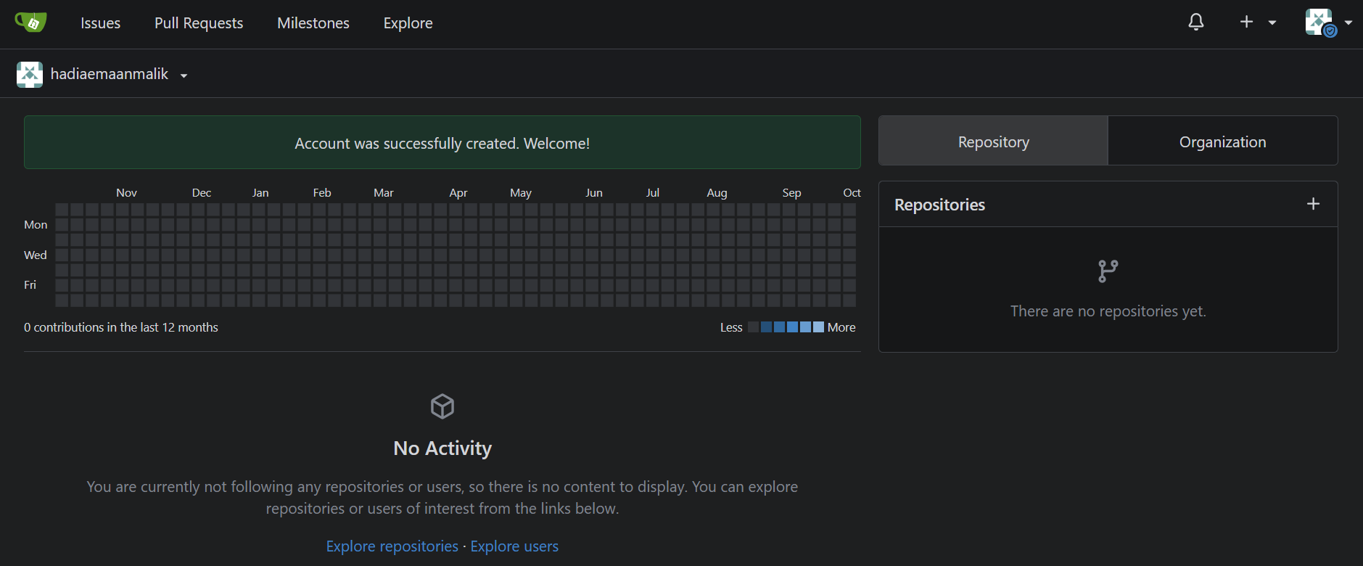

Confirm that both containers are running

Both the Gitea and PostgreSQL containers are running, and Gitea responds locally on port 3000 with HTTP status 200.

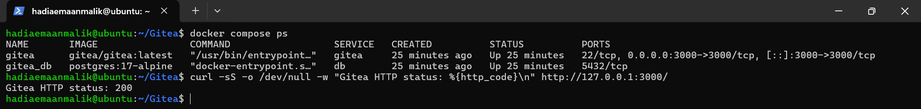

Step 1.2: Create and Push the Initial Repository

Create an empty public repository in Gitea
An empty public repository named Assignment01 was created in Gitea without a README, .gitignore or license.

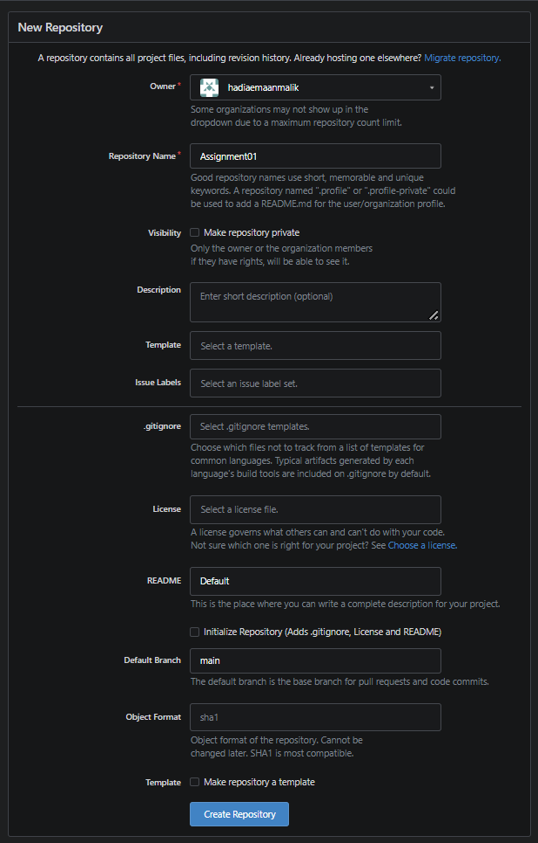

Create the local repository on the Ubuntu server

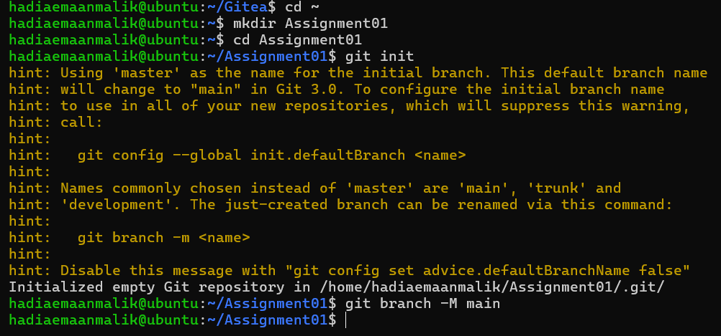

Create and commit README.md

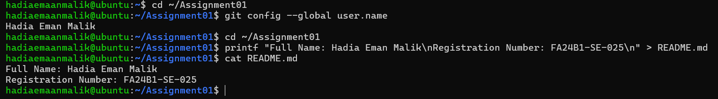

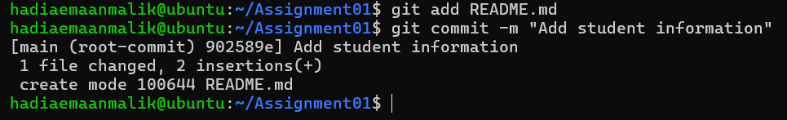

Generate a Gitea personal access token
A personal access token named ubuntu-server-token was generated in Gitea (Settings, Applications, Manage Access Tokens) with Read and Write repository permission. The token is not shown here and was not placed in any command or remote URL.
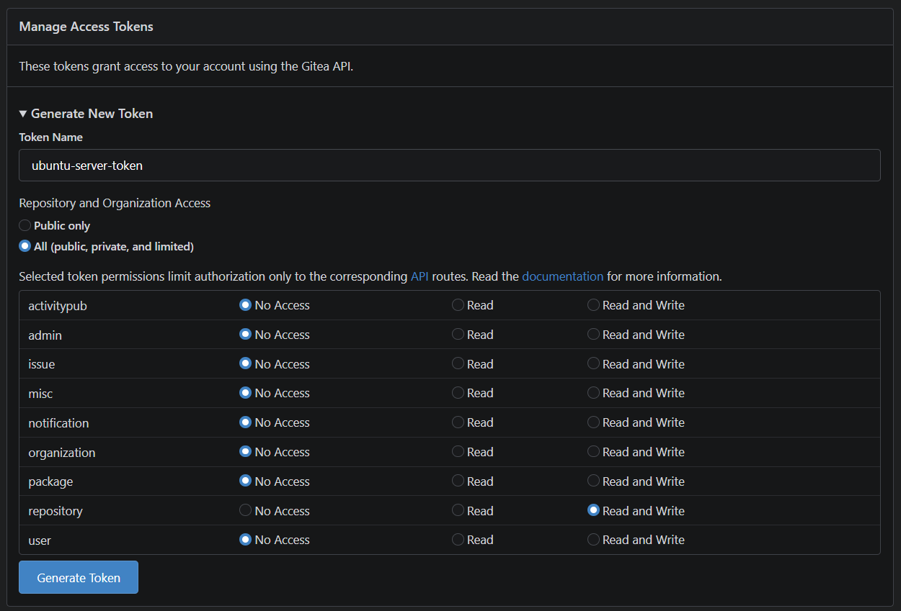

Add the gitea remote and push
The gitea remote was added with my username but without the token. The remote URL contains no password or token. The push succeeded, and the token was entered only at the password prompt.
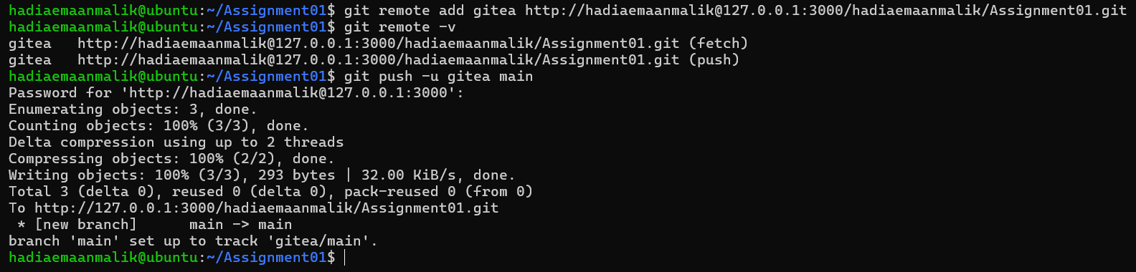

Step 1.3: Verify the Gitea Repository
The Assignment01 repository in Gitea is public and shows the repository owner and name. The rendered README.md shows my full name and registration number, and the Gitea URL is visible in the browser.
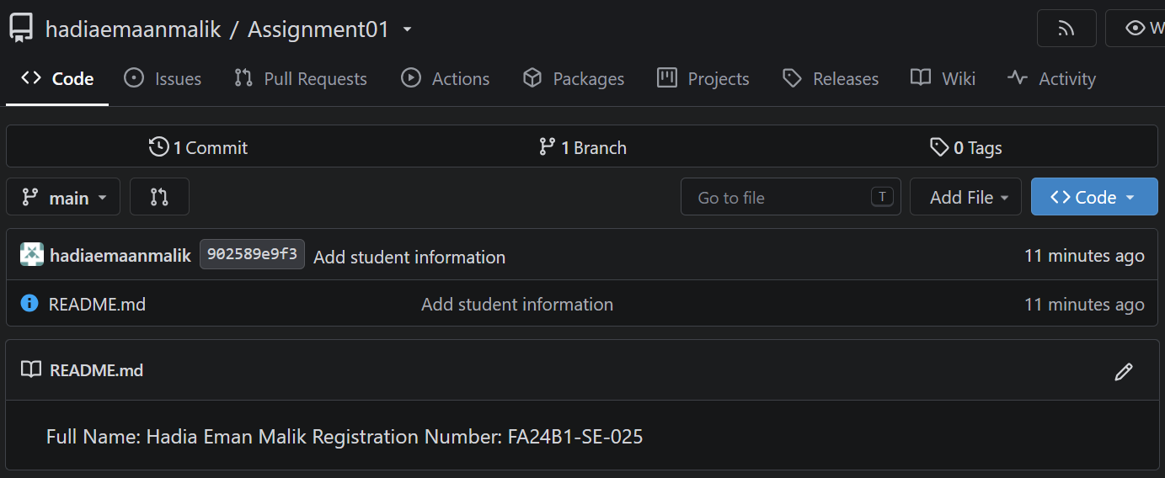

Task 1 result: Gitea was installed and run on the Ubuntu server, and a separate local repository was pushed to it over HTTP using the server's loopback address.

Task 2: Push the Same Repository to GitHub

Step 2.1: Create the GitHub Repository and Verify Both Remotes
An empty public GitHub repository named Assignment01 was created without a README, .gitignore or license.
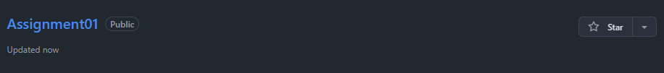
A GitHub personal access token was generated for authentication. It is not shown in this report.
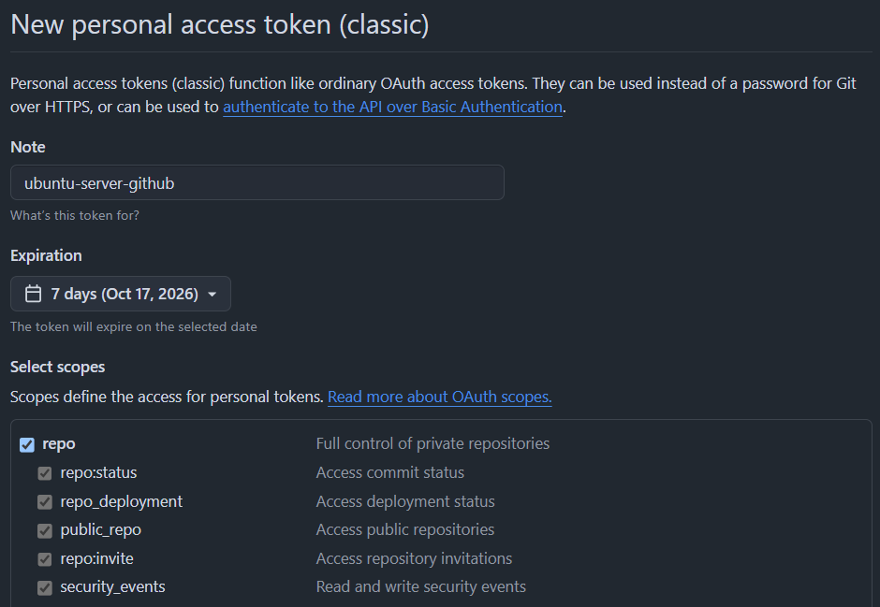

GitHub was added as the second remote. The output shows both the gitea and github remotes with their fetch and push URLs, and neither URL contains a token or password.

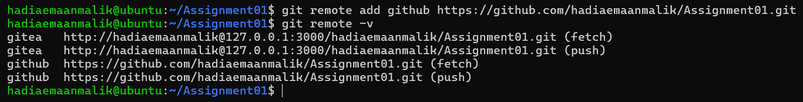

Step 2.2: Push to GitHub
The main branch was pushed to the GitHub remote successfully.
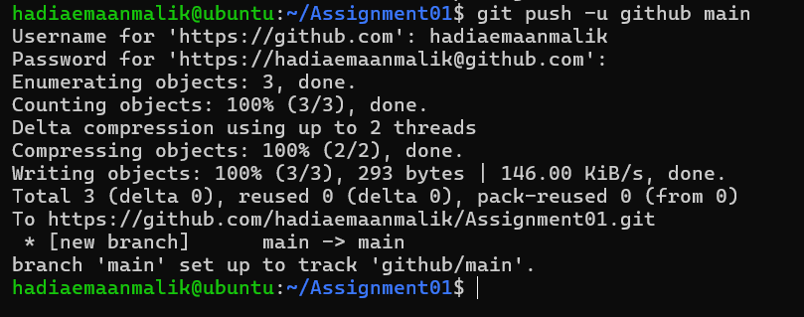

Step 2.3: Verify the GitHub Repository
The GitHub repository is owned by my account, is named Assignment01, is public, and its rendered README.md shows my full name and registration number.

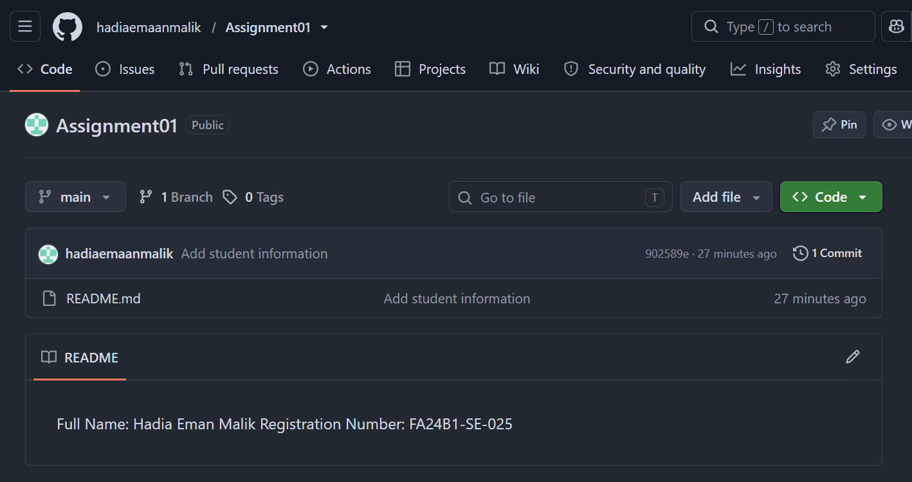

Task 2 result: The same local repository is connected to both Gitea and GitHub and is publicly available on GitHub.

Task 3: Track Three Large Files with Git LFS

Step 3.1: Configure Git LFS
Git LFS was initialized successfully, its version was confirmed, and tracking was configured for .bin files. The resulting *.bin rule is shown in .gitattributes.

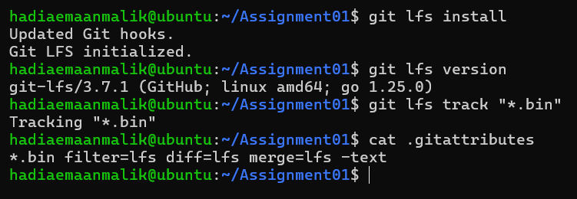

Step 3.2: Create and Verify Three LFS Files
Three different files, each larger than 100 MiB, were created and staged together with .gitattributes. The command output lists all three files as tracked by Git LFS with their sizes.

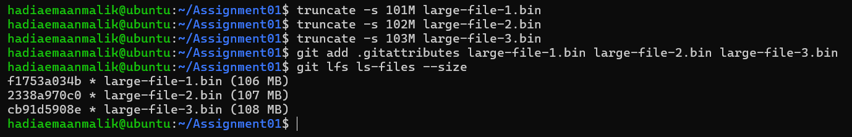

Step 3.3: Commit and Push the LFS Files
The files were committed and pushed to the GitHub Assignment01 repository. The Git LFS upload completed successfully at 100% (3/3).
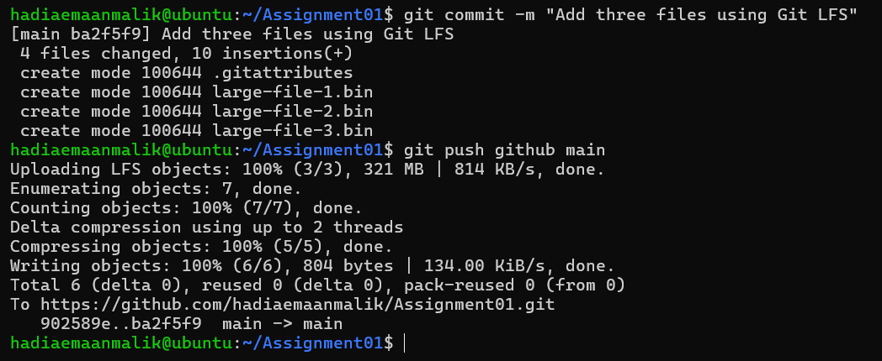

Task 3 result: Three files larger than 100 MiB are tracked with Git LFS and pushed to the GitHub Assignment01 repository.

Task 4: Create a Portfolio or CV with GitHub Pages

Step 4.1: Create and Push the Portfolio Repository
A public repository named hadiaemaanmalik.github.io was used for the portfolio. The portfolio was written in HTML and CSS using index.html and styles.css. It visibly contains the About Me, Education, Skills and Projects sections. The files were committed and pushed to the main branch.
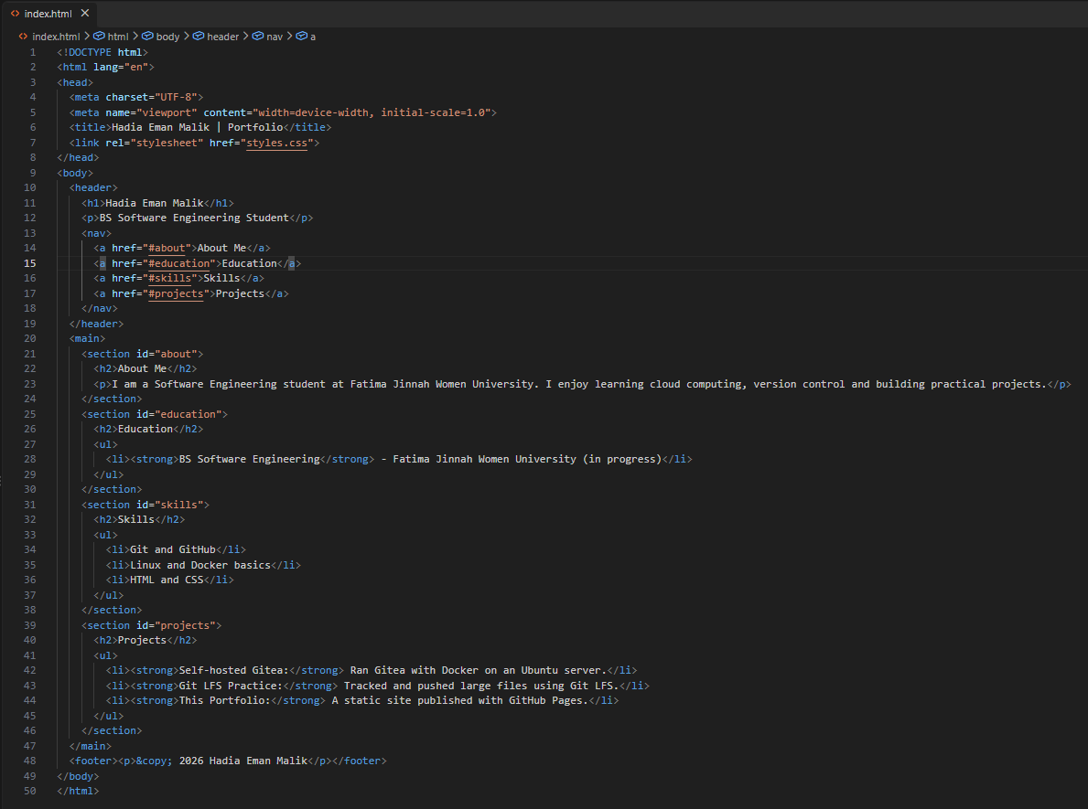
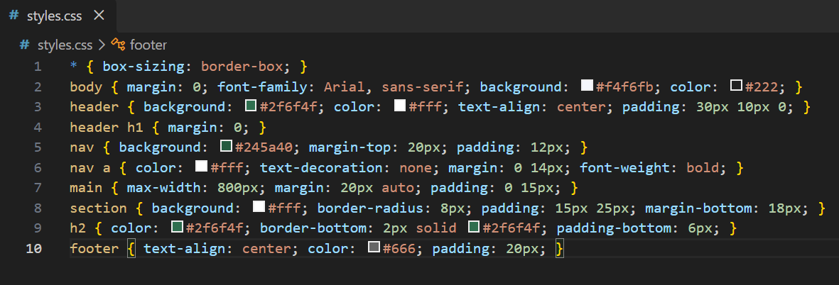
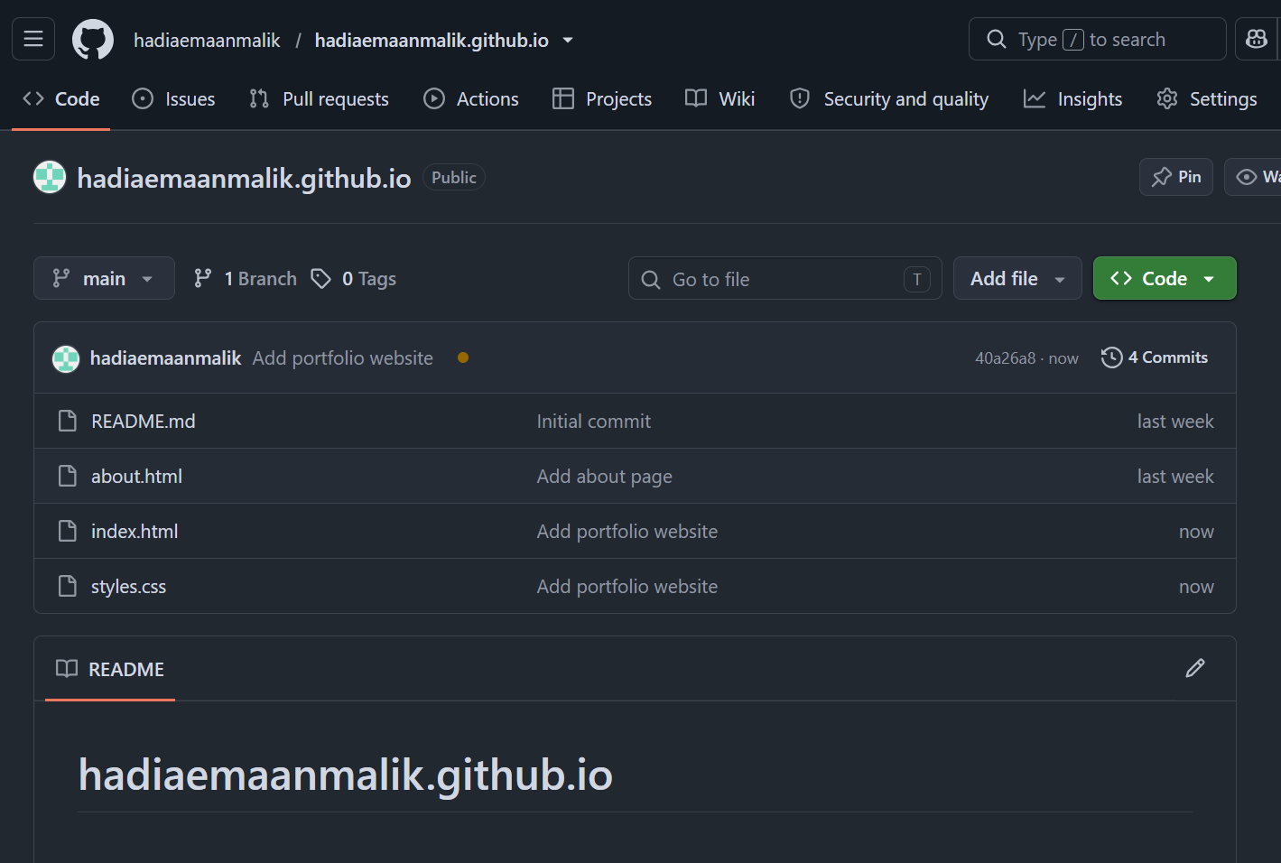

Step 4.2: Publish with GitHub Pages
In the repository Settings, under Pages, Deploy from a branch was selected with the main branch and the / (root) folder. GitHub reports that the site is live at https://hadiaemaanmalik.github.io/.
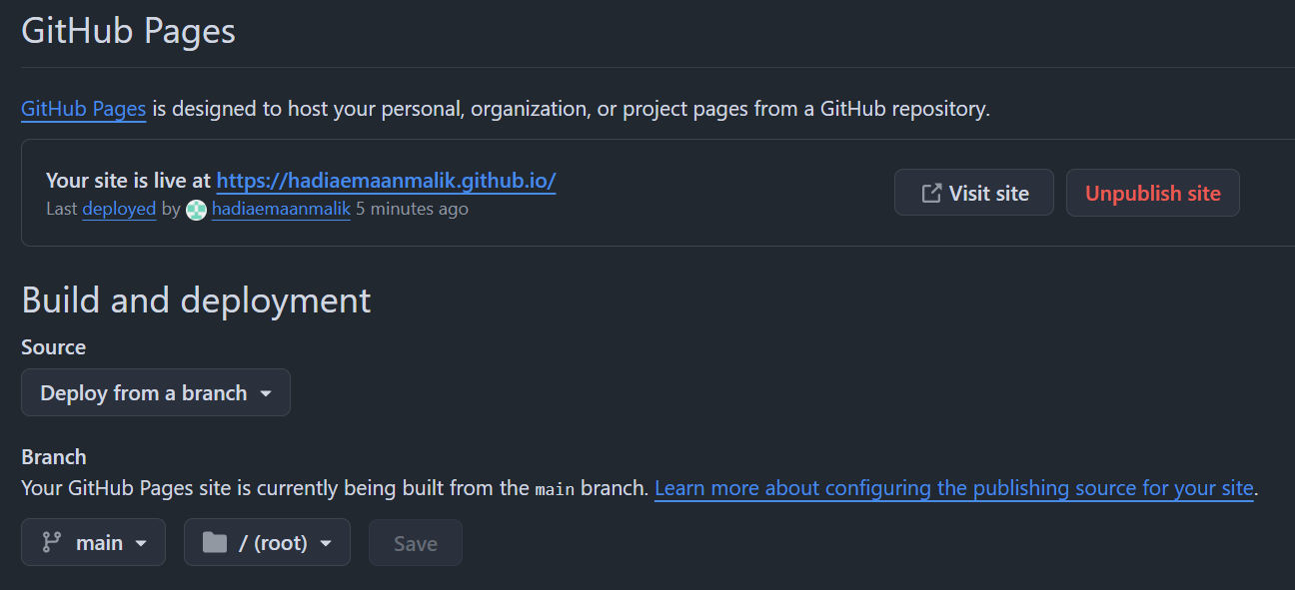

Step 4.3: Verify the Live Portfolio
The portfolio loads successfully at https://hadiaemaanmalik.github.io/ and shows the About Me, Education, Skills and Projects sections.
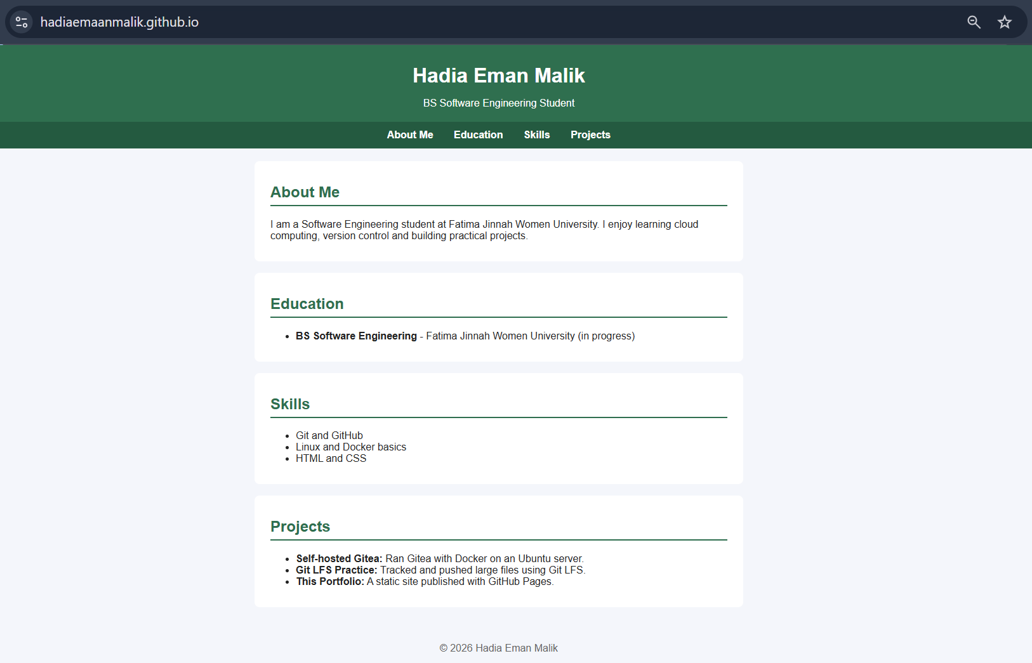

Task 4 result: The portfolio is stored in a public GitHub repository and published as a live GitHub Pages site.

Assignment Summary
In this assignment, I installed and ran Gitea on an Ubuntu server using Docker, pushed a local repository to both Gitea and GitHub using two remotes, tracked and pushed three large files with Git LFS, and published a portfolio with GitHub Pages. Authentication was done with personal access tokens entered at the password prompt, so no credentials were stored in remote URLs or shown in screenshots.

