National Textile University, Faisalabad


Department of Computer Science

Name: | HADIA IRFAN
Class: | BSCS-5th (A)
Registration No: | 24-NTU-CS-FL-1031
TASK: | HOMEWORK
Course Name: | IOT
Submitted To: | Sir NASIR
Submission Date: | 14-10-2026

Part A: Technical Theory

Q1. GPIO Configuration and Operation
GPIO modes
- INPUT: The pin only reads the voltage applied to it. It has no internal resistor, so if nothing is connected, the pin "floats" and returns random values.
- INPUT_PULLUP: The pin works as an input with the ESP32's internal pull-up resistor (to 3.3 V) enabled. It reads HIGH when the button is not pressed.
- OUTPUT: The pin sends out HIGH (3.3 V) or LOW (0 V) through digitalWrite(). It is used for LEDs, buzzers, and similar devices.
Button wiring with INPUT_PULLUP
Connect one leg of the button to the GPIO pin (GPIO 18 in my project) and the other leg to GND. No external resistor is required.
- Button released: Pin voltage is 3.3 V, and digitalRead() returns HIGH.
- Button pressed: Pin voltage is 0 V (GND), and digitalRead() returns LOW.
pinMode(18, INPUT_PULLUP);
if (digitalRead(18) == LOW) { }
Why GPIO selection and voltage limits matter
- ESP32 pins operate at 3.3 V and are not 5 V tolerant. A 5 V signal can damage the pin or the whole chip.
- Each pin can supply only a small current, so an LED needs a series resistor.
- GPIO 34 to 39 are input-only and have no internal pull-up, so INPUT_PULLUP does not work on them.
- GPIO 6 to 11 are connected to the flash memory and should be avoided.
- Strapping pins (0, 2, 5, 12, 15) influence the boot process. A button connected to them may prevent the board from starting or uploading code.

Q2. Timers and Non-Blocking Design
A timer is a counter driven by a clock. It measures time so the system can perform tasks at the right moment, such as reading a sensor every 100 ms or refreshing a display every second, without the CPU sitting idle and waiting.
delay() vs millis() / timer
- CPU:
  - delay() is blocking. The CPU waits and cannot do anything else.
  - millis() is non-blocking. loop() keeps running and only checks whether enough time has passed.
- Responsiveness:
  - With delay(), button presses and display updates are missed during the delay.
  - With millis(), all tasks continue to work normally.
- Multiple tasks:
  - With delay(), this is very difficult, because one delay halts everything.
  - With millis(), this is easy, because each task has its own time variable.
Example
An ESP32 needs to blink an LED every 500 ms, update the OLED every 1 second, and respond to a button. With delay(), the button would be ignored while the program waits. With millis(), all three tasks remain responsive:
unsigned long now = millis();
if (now - tLed >= 500) { tLed = now; toggleLed(); }
if (now - tOled >= 1000) { tOled = now; updateOLED(); }
if (digitalRead(18) == LOW) handleButton();

Q3. Interrupts and ISR
Interrupt: A signal that makes the CPU pause its current work and handle an urgent event immediately, such as a button edge or a finished timer. This avoids the need to keep checking repeatedly (polling).
ISR (Interrupt Service Routine): A short function that runs when the interrupt occurs. Once it finishes, the CPU returns to the point where it stopped.
Sequence from event to ISR
- The event occurs (for example, a falling edge on a pin).
- The interrupt request is recorded.
- The CPU completes the current instruction and saves its state.
- The CPU jumps to the ISR and executes it.
- The CPU restores its state and resumes the main program.
volatile bool pressed = false;
void IRAM_ATTR onButton() { pressed = true; }
attachInterrupt(digitalPinToInterrupt(18), onButton, FALLING);
Good ISR practices
- Keep the ISR very short. Only set a flag or update a counter, and do the actual work in loop().
- Declare shared variables as volatile.
- Place IRAM_ATTR before the ISR function on the ESP32.
- Never use delay() or any blocking code inside an ISR.
Why the display update or Serial.print should not be used in an ISR
- They take a long time, which delays or misses other interrupts and tasks, and the ESP32 may reset.
- I2C (display) and Serial rely on their own interrupts and locks, so calling them inside an ISR can freeze or crash the board.

- The correct approach is to set a flag in the ISR and perform the display update or printing in loop().

Q4. Switch Debouncing
A push button has metal contacts that do not close cleanly. When pressed, they bounce for roughly 1 to 20 ms before settling. Because the ESP32 reads the pin very quickly, it detects many LOW and HIGH changes and counts a single press as multiple presses.
Ideal: HIGH -----+ +----- HIGH
+--------------+ (LOW = pressed)
Real: HIGH -----+ +-+ +--------+ +-+ +----
+-+ +-+ +-+ +-+
bounce bounce
delay() debounce vs millis() debounce
- Method:
  - delay() debounce: Detect a change, wait 20 to 50 ms, then read again.
  - millis() debounce: Store the time of the change and accept it only after the input stays stable for long enough.
- CPU:
  - delay() debounce: Blocks everything while waiting.
  - millis() debounce: Non-blocking, so other tasks keep running.
- Use:
  - delay() debounce: Suitable only for very simple demos.
  - millis() debounce: Better for real systems.
Reliable state-based method (used in my project)
- Read the pin.
- If the reading differs from the last raw reading, save the current time (restart the timer).
- If the reading has stayed the same for the debounce time (50 ms) and differs from the accepted state, accept it as the new state.
- Count a press only when the accepted state changes from HIGH to LOW.
if (raw != lastRaw) { tChange = millis(); lastRaw = raw; }
if ((millis() - tChange) >= 50 && raw != stable) {
stable = raw;
if (stable == LOW) pressCount++;
}
Bounces shorter than 50 ms keep restarting the timer, so they are ignored and each press is counted only once.

Q5. OLED Display and I2C
The SSD1306 OLED communicates with the ESP32 through I2C, a two-wire bus. The ESP32 acts as the master and the OLED acts as a slave with its own address. The ESP32 sends the address, the OLED acknowledges, and then commands and pixel data are transferred.
OLED pins
- SDA (Serial Data): Carries the address, commands, and display data.
- SCL (Serial Clock): Clock signal from the ESP32 that keeps the data in sync.
- VCC (Power): Supplies power to the OLED (3.3 V from the ESP32).
- GND (Ground): Common ground shared with the ESP32.
Connections and address in our lab
VCC to 3V3, GND to GND, SDA to GPIO 21, and SCL to GPIO 22. The I2C address is 0x3C.
Roles of initialization, drawing, and display.display()
- Initialization: Wire.begin(21, 22) starts I2C, and display.begin(SSD1306_SWITCHCAPVCC, 0x3C) sets up the OLED. Without this step, the screen remains blank.
- Drawing text: Functions such as clearDisplay(), setCursor(), and print() only write to a memory buffer on the ESP32. Nothing appears on the screen yet.
- display.display(): Sends the buffer to the OLED over I2C so the new content becomes visible. It must be called after drawing.
display.clearDisplay();
display.setCursor(0, 0);
display.println("Hello");
display.display();

Part B — Practical Lab (one integrated task)

Wiring / Pin Table

Component / Pin | ESP32 Connection | Notes
SSD1306 OLED VCC | 3V3 | Power supply (3.3 V)
SSD1306 OLED GND | GND | Common ground
SSD1306 OLED SDA | GPIO 21 | I2C data line (address 0x3C)
SSD1306 OLED SCL | GPIO 22 | I2C clock line
Push button (leg 1) | GPIO 18 | INPUT_PULLUP; pressed reads LOW
Push button (leg 2) | GND | Completes the circuit when pressed

Comparison of Simulated and Physical Results

Results and Observations
In Wokwi and on the physical ESP32, the result was the same. After 10 button presses, both the OLED and the Serial Monitor showed a final count of 10, and the count increased by exactly one for each press. The same code and the same pins were used in both setups: the OLED on GPIO 21 and 22, and the button on GPIO 18 and GND.
The 50 ms millis() debounce produced no double counts and no missed presses. The only difference between the two setups is that the Wokwi button is ideal, while a real button can bounce, so debouncing matters more on physical hardware.
Issues and how they were solved
- Library issue: VS Code showed a "cannot open source file" error for Adafruit_GFX.h and Adafruit_SSD1306.h. This was solved by building the project so that PlatformIO downloaded the required libraries, and then rebuilding the IntelliSense index.
- Wiring and timing: No wiring or timing problems were encountered.

WOKWI TEST RESULTS

Wokwi Test (10 presses)
Press # | Expected count | Observed count (OLED and Serial) | Pass / Fail
1 | 1 | 1 | Pass
2 | 2 | 2 | Pass
3 | 3 | 3 | Pass
4 | 4 | 4 | Pass
5 | 5 | 5 | Pass
6 | 6 | 6 | Pass
7 | 7 | 7 | Pass
8 | 8 | 8 | Pass
9 | 9 | 9 | Pass
10 | 10 | 10 | Pass

3. Hardware Test (10 presses)
Press # | Expected count | Observed count (OLED and Serial) | Pass / Fail
1 | 1 | 1 | Pass
2 | 2 | 2 | Pass
3 | 3 | 3 | Pass
4 | 4 | 4 | Pass
5 | 5 | 5 | Pass
6 | 6 | 6 | Pass
7 | 7 | 7 | Pass
8 | 8 | 8 | Pass
9 | 9 | 9 | Pass
10 | 10 | 10 | Pass

Test Summary
Environment | Number of presses | Expected final count | Observed final count / Pass?
Wokwi | 10 | 10 | 10 / Pass
Hardware | 10 | 10 | 10 / Pass

Brief Implementation Explanation

Hardware and setup
- Used an ESP32 DevKit with the Arduino framework in PlatformIO.
- Connected the SSD1306 OLED over I²C: SDA to GPIO 21, SCL to GPIO 22, VCC to 3V3, GND to GND.
- Connected the push button between GPIO 18 and GND.
- Added the Adafruit SSD1306 and Adafruit GFX libraries in platformio.ini.

Button input
- GPIO 18 is set to INPUT_PULLUP, so the pin reads HIGH when released and LOW when pressed.
- No external resistor is needed.

Startup (setup())
- Starts the Serial Monitor at 115200 baud.
- Initializes the OLED at address 0x3C.
- Shows the title, the button status, and the counter starting at 0.

Non-blocking debounce (loop())
- Reads the button pin continuously.
- If the reading changes, saves the time using millis().
- If the reading stays the same for 50 ms, accepts it as the real button state.
- Counts only on the released-to-pressed change, so one physical press adds exactly 1.
- Uses no delay(), so the program never blocks.

Output
- The OLED shows “PRESSED” or “RELEASED” and the current count.
- The Serial Monitor prints each accepted press, such as Accepted press. Count = 5.
- The display and Serial output update only when the accepted state changes.

Testing
- Tested 10 presses in Wokwi and 10 presses on the physical hardware.
- Checked that the count increased by exactly 1 per press in both.

Evidence with Captions:
W1:

24-NTU-CS-FL-1031_W1_WokwiCircuit.png

CAPTION:

Complete Wokwi circuit of my project. The ESP32 DevKit is connected to the SSD1306 OLED (VCC to 3V3, GND to GND, SDA to GPIO 21, SCL to GPIO 22) and to a push button between GPIO 18 and GND. All wires and component labels are visible, which proves the circuit matches the required wiring.

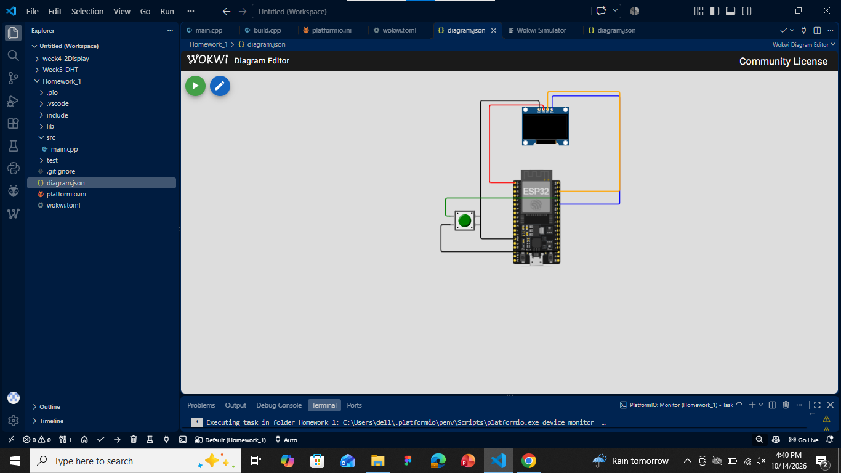

W2:

24-NTU-CS-FL-1031_W2_WokwiOutput.png

CAPTION:

Wokwi simulation while it is running. The OLED shows the project title, the button status (PRESSED/RELEASED), and a non-zero press counter of 10 after ten button presses. This proves the debounced counter and the OLED update work correctly in the simulator.

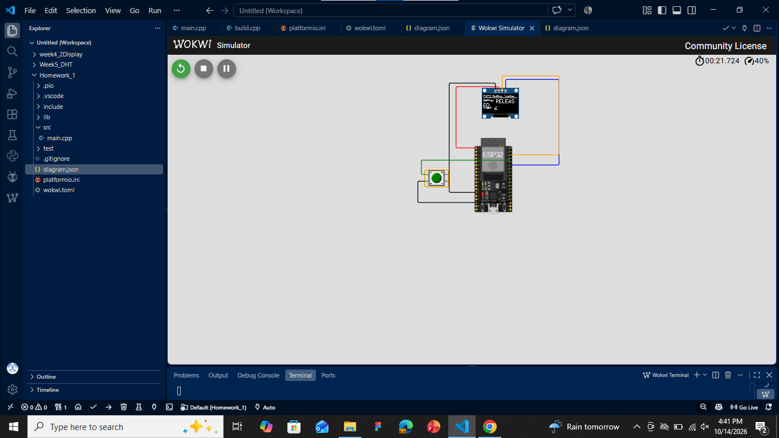
W3:

24-NTU-CS-fl-1031_W3_Build.png

CAPTION:

VS Code showing the organized project folder with platformio.ini, wokwi.toml, diagram.json and src/main.cpp, along with the debounce code in main.cpp. The terminal shows a successful PlatformIO build with no errors, which proves the program compiles correctly.

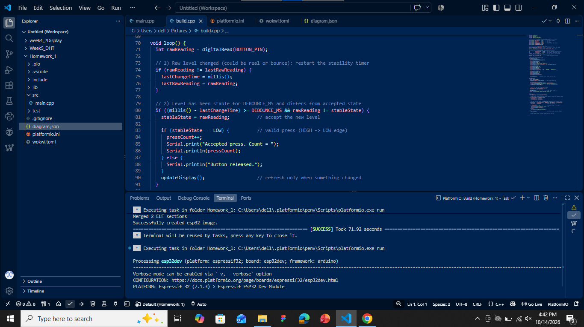

H1:

24-NTU-CS-FL-1031_H1_HardwareSetup.jpg

CAPTION:

My physical ESP32 kit, wired by me. The SSD1306 OLED is connected to 3V3, GND, GPIO 21 (SDA) and GPIO 22 (SCL), and the push button is connected to GPIO 18 and GND. The photo shows the real components and wiring, which proves the hardware matches the planned pin table.

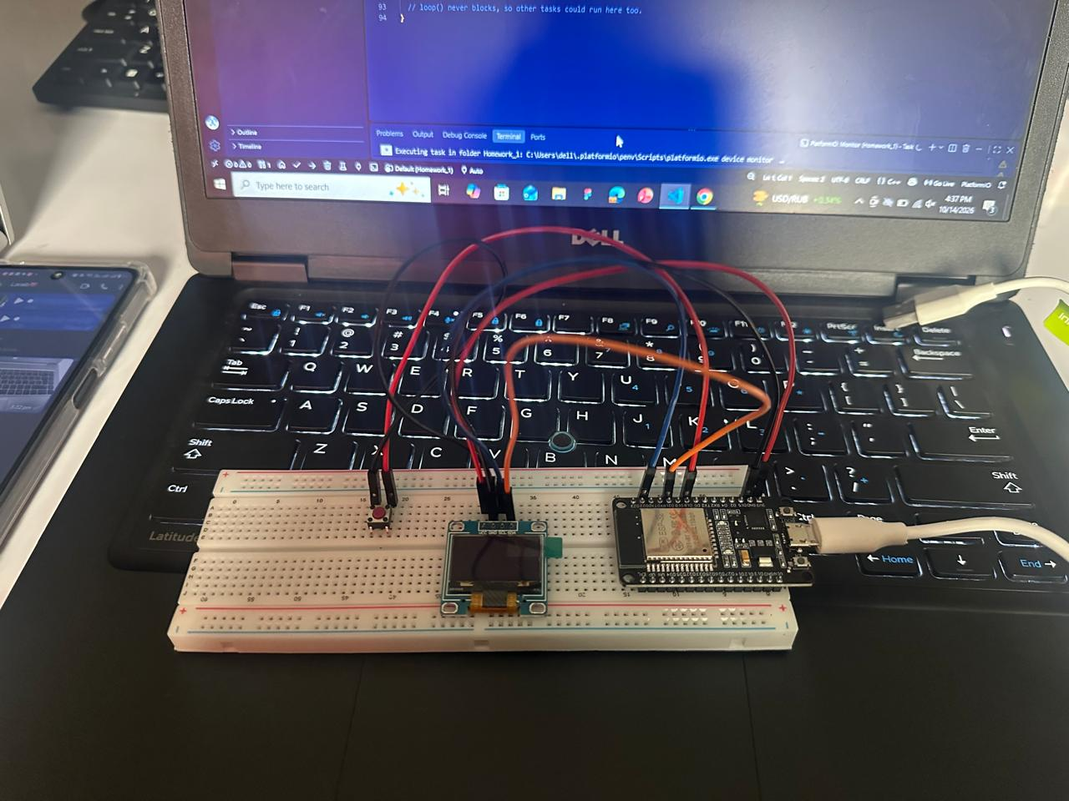

H2:

24-NTU-CS-FL-1031_H2_HardwareOutput.jpg

CAPTION:

The real OLED running my project on the physical ESP32. The display shows the title, the button status, and a non-zero press count of 10. The ESP32 board is visible in the same photo, which proves the program works on actual hardware.

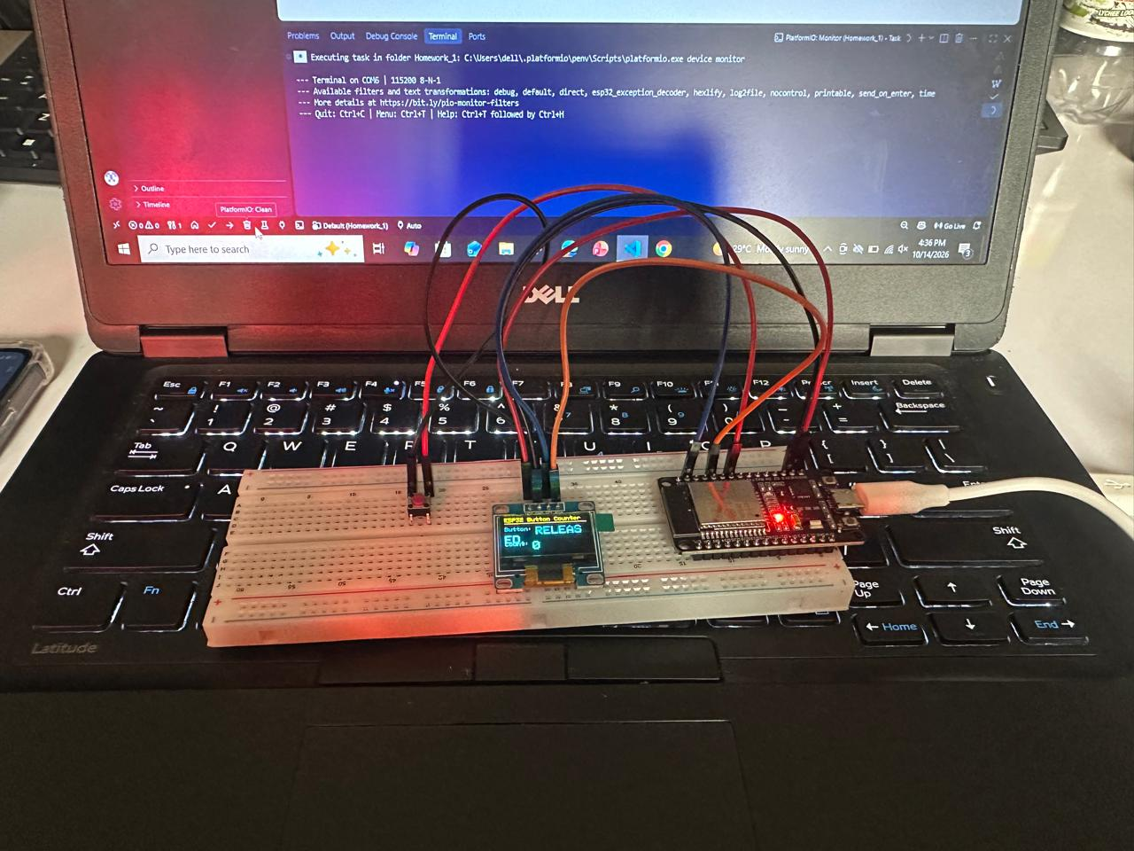

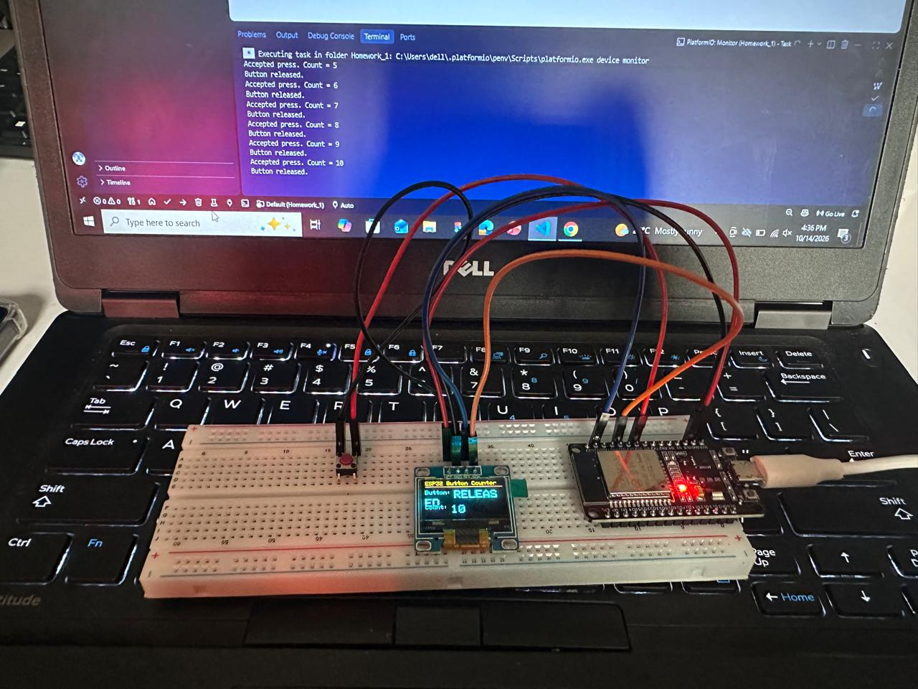
H3:

24-NTU-CS-FL-1031_H3_SerialMonitor.png

CAPTION:

Serial Monitor in VS Code connected to my physical ESP32 at 115200 baud. The output shows the startup message and the accepted press counts from 1 to 10, each increasing by exactly one. This proves the non-blocking debounce counts one press for each physical button press.

